

Case Study Report: Understanding and Managing Asthma

Name: Meskerem Demissie Beyene
Student ID: 2414543
Module Code: BMHP5023
Module: Introduction to Physiology
Lecturer: Shaila Hussain

SUMISSTION DATE: DECEMBER 2025

AKNOWLEDGEMENT
I would like to thank our instructor Shaila Hussain for giving us this assignment. This task helped us to critically think, dig deep and get better understanding to the subject matter.

Contents
AKNOWLEDGEMENT I
1. Introduction 1
2. Structure of the Respiratory System and Mechanical Respiration 2
3. Gas Exchange and the Impact of Irritants on Respiration 4
4. Recording and Tracking Respiratory Function 5
6. Conclusion 7
Reference List 1

Introduction
As a practice nurse, I have seen that asthma is still one of the most prevalent chronic illnesses impacting patients of all ages who visit our clinic. The purpose of this paper is to clearly explain how asthma affects the respiratory system, how irritants can exacerbate symptoms, and what techniques people can use to properly manage their illness. In addition to guiding medical professionals and caregivers in providing continuous support, it seeks to increase awareness, foster understanding, and support self-management among those with asthma.
More than five million people in the UK currently suffer from asthma (Asthma + Lung UK, 2023), making it one of the most common long-term health conditions in the country. Asthma is a chronic inflammatory condition of the airways that causes them to become narrow, swollen, and hypersensitive to various triggers. It is characterized by recurrent episodes of wheezing, shortness of breath, chest tightness, and coughing, which often worsen at night or early morning (NHS, 2024).
Genetic predisposition, exposure to allergens such dust mites, pet dander, and pollen, air pollution, respiratory infections, smoking or vaping, and psychological stress are risk factors for developing or exacerbating asthma (Global Initiative for Asthma [GINA], 2023). Environmental factors that can act as triggers include chilly air, chemical exposure at work, and poor indoor air quality.
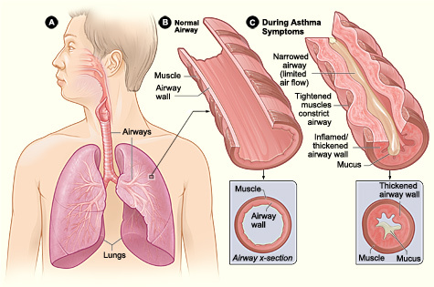
Asthma causes inflammation and bronchial airway narrowing, which results in decreased airflow and breathing difficulties, as seen in Figure 1 below. Understanding the significance of treatment adherence, avoiding triggers, and keeping an eye on respiratory health all depend on being aware of these physiological changes.

Figure 1 Comparison of a Normal Airway and an Asthmatic Airway
Source: https://commons.wikimedia.org/wiki/File:Asthma_attack-illustration_NIH-ar.jpg
The anatomy and operation of the respiratory system, the gas exchange mechanism, and the detrimental effects of irritants on respiration will all be covered in this study. After discussing the significance of using devices like peak flow meters to assess respiratory function, it will conclude with evidence-based suggestions, health promotion tactics, and lifestyle modifications to support successful asthma management for people of all ages.
Additional content: The global asthma burden is described in further detail (WHO references, public health dimension). - Added information on socioeconomic risk variables, urban exposure, and inequality.
The assignment's goal, "connect anatomy and physiology to clinical management," was clarified in the last paragraph. An illustration of a new sentence
Asthma is one of the top 10 chronic diseases in the world, according to the World Health Organization (2023), and it is predicted to impact over 5.4 million people in the UK, including over 1.1 million children (Asthma + Lung UK, 2023). Vulnerable populations are disproportionately affected by asthma, which contributes to health disparities because of socioeconomic variables and access to care.
"Therefore, the goal of this assignment is to connect the anatomical and physiological processes of respiration to the clinical manifestations of asthma, highlighting the significance of awareness, preventive care, and patient self-management within primary healthcare settings."

2. Structure of the Respiratory System and Mechanical Respiration
The respiratory system is in charge of eliminating carbon dioxide and delivering oxygen to bodily tissues. It is separated into two primary parts:
The nose, nasal cavity, throat, and larynx comprise the upper respiratory system.
The trachea, bronchi, bronchioles, and alveoli comprise the lower respiratory tract.
Gas exchange takes place in the alveoli after air enters through the mouth or nose, travels down the trachea, and then reaches the bronchi and bronchioles. The diaphragm and intercostal muscles, which produce the muscular motions required for breathing, support the lungs.
The diaphragm contracts and descends during inhalation, or inspiration, while the intercostal muscles raise the ribs. By increasing the volume of the thoracic cavity, this lowers internal pressure and draws in air.
When the diaphragm relaxes and the rib cage descends, the thoracic volume decreases and air is forced out during exhalation (expiration) (Tortora and Derrickson, 2022).

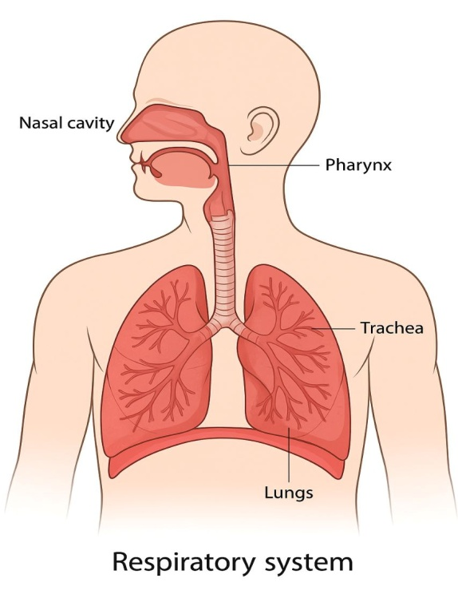

Figure 2 Structure of the Human Respiratory System.
Asthma causes inflammation and constriction of the airway lining, which increases airflow resistance. Exhalation is particularly challenging due to this constricted airway, which causes wheezing, coughing, and dyspnea. Knowing this process explains why breathing efficiency is so strongly affected by airway narrowing in asthma.
Additional content: An additional description of the structure and operation of the airways (air filtering, mucociliary clearance). –
Extended breathing mechanics to demonstrate variations in pressure ("internal pressure goes below atmospheric pressure..."
- A new paragraph on airway remodeling (long-term consequences, collagen deposition).
An illustration of a new sentence "Airway remodeling, which includes thickening of the smooth muscle layer, deposition of collagen in airway walls, and growth of mucus glands, is another alteration in airway structure brought on by chronic inflammation."

3. Gas Exchange and the Impact of Irritants on Respiration
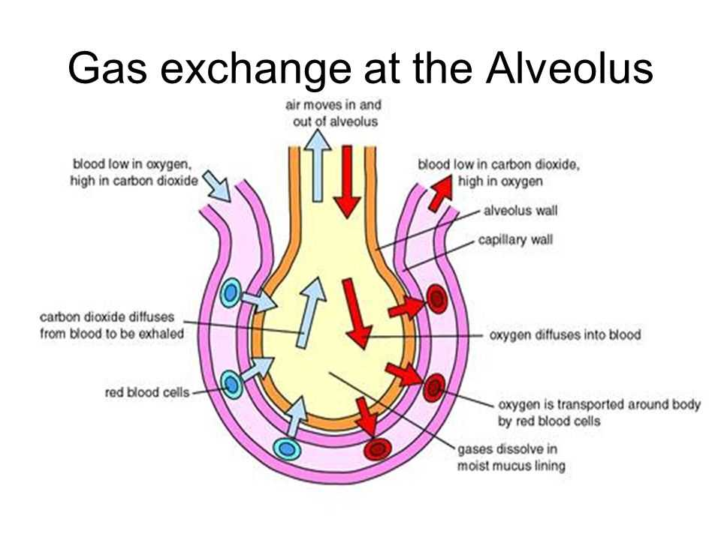
Gas exchange occurs in the alveoli, where carbon dioxide travels from the blood into the alveolar space to be expelled and oxygen travels from breathed air into blood capillaries. The alveolar surface area, membrane thickness, and concentration gradients all affect this process.

Figure 3 Gas Exchange Process at the Alveoli.
Source: https://techschematic.com/alveolus-gas-exchange-diagram?utm
The bronchial lining's immune system is triggered when irritants like dust particles, tobacco smoke, vaping chemicals, or air pollution are breathed. Chemical mediators such as histamine, interleukins, and leukotrienes are released by mast cells and T-helper 2 (Th2) lymphocytes (Lemanske & Busse, 2010).
Several significant alterations are brought about by these substances:
Vasodilation and increased capillary permeability cause oedema, or swelling of the airways.
Smooth muscle contraction results in bronchoconstriction.
An excess of mucus that further constricts the airway.
When combined, these actions decrease oxygen intake, increase the diffusion distance across the alveolar-capillary barrier, and result in hypoxia (low blood oxygen) and dyspnea (breathlessness). Airway remodeling, or structural thickening, can be brought on by recurrent inflammatory cycles and cause symptoms to worsen with time.
Additional content:
A novel explanation for hypoxemia, hypercapnia, and ventilation-perfusion mismatch.
A thorough explanation of how pollution and vaping cause oxidative stress and ciliary damage.
A description of the immunological response at the cellular level (mast cells, eosinophils, mediators) was added.
An illustration of a new sentence
"Research also shows that oxidative stress caused by pollutants like nitrogen dioxide and ozone intensifies inflammation by activating free radicals and damaging epithelial cells lining the bronchioles." And
"Cigarette smoke and vaping liquids further impair the ciliary function responsible for clearing mucus from airways, making lungs more susceptible to bacterial and viral infections."

4. Recording and Tracking Respiratory Function
An essential component of managing asthma is keeping an eye on respiratory performance. The greatest speed of air exhaled after a complete inhalation is measured by the Peak Expiratory Flow (PEF) test.
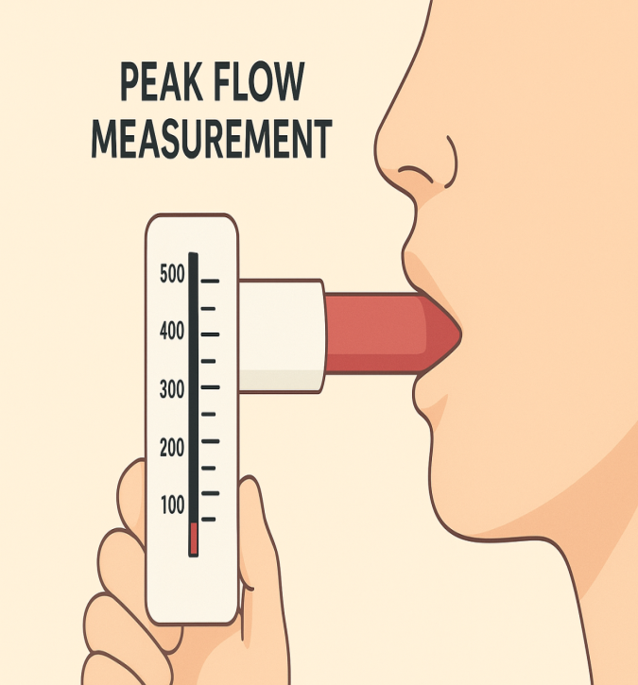
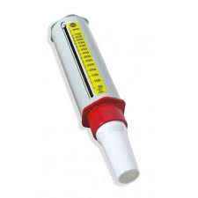

Figure 4 Example of Peak Flow Measurement.

Frequent PEF monitoring can detect early indicators of decline, frequently before symptoms become apparent, and offers an objective record of lung function.
Inflammation or exposure to a trigger may be indicated by a decline in PEF levels.
Regular documentation enables both patients and medical professionals to make well-informed therapeutic modifications.
In my capacity as a nurse, I advise patients to record their daily peak flow and discuss their findings at evaluations. This gives them the ability to recognize early warning indicators, enhance adherence, and react quickly to exacerbations. Subtle deterioration could be unrecognized without such surveillance, which could result in serious attacks, emergency hospital stays, or long-term lung damage (NICE, 2022).
Additional content:
- Discussion of telehealth and digital monitoring was added.
The job of nurses was made clear: "As a nurse, my role includes teaching patients."
- Described the clinical significance of a PEF drop of more than 20%.
An illustration of a new sentence
Additionally, patients can utilize smartphone-connected inhalers or digital peak flow meters that automatically log data over time. By enabling telehealth follow-ups and cutting down on needless hospital stays, these technologies enable healthcare personnel to remotely monitor trends.
5. Evidence-Based Recommendations and Lifestyle Strategies
Effective asthma management necessitates a thorough, multidisciplinary, and evidence-based strategy that incorporates medication, education, and lifestyle changes.
1. Collaborative Health and Social Care Strategies
Create customized Asthma Action Plans (AAPs) that outline emergency procedures and preventive actions in collaboration with each patient (British Thoracic Society [BTS], 2023).
Set up routine evaluations to evaluate symptom control, treatment compliance, and inhaler technique.
Assure interprofessional cooperation between the nursing, medical, and pharmacy teams to support patient confidence and continuity of treatment.
2. Health Promotion and Education
Make trigger avoidance, inhaler technique, and self-monitoring easily available.
Lead awareness campaigns in the community and at work to debunk misconceptions and promote early diagnosis.
To increase self-care consistency, promote the use of digital health tools for PEF tracking and medication reminders.
3. Lifestyle Modifications
Steer clear of strong perfumes, smoke, vaping, and occupational irritants.
Eat a well-balanced, anti-inflammatory diet high in fruits, vegetables, and omega-3 fatty acids. A Mediterranean-style diet may lessen airway inflammation, according to research (Priftis et al., 2020).
Walking, swimming, or cycling are examples of moderate physical activity that can improve lung capacity and general health.
To avoid stress-induced flare-ups, practice mindfulness, breathing exercises, or relaxation techniques.
Patients can improve their overall quality of life, reduce hospital admissions, and manage their symptoms more effectively by combining these approaches.
Additional content:
- A more thorough examination of health and social care tactics (interdisciplinary collaboration, statistics on inhaler abuse).
More information about teaching, demonstrations, technological use, and societal awareness can be found in the Health Promotion subsection.
The Lifestyle Modifications chapter now includes organized bullet points on stress management, and environmental control.

6. Conclusion
Because of its chronic nature, environmental factors, and lifetime management requirements, asthma continues to provide a challenge to healthcare systems. However, knowing the physiological principles of respiration and inflammation gives a foundation for successful prevention and treatment.
Maintaining oxygen balance is influenced by the respiratory tract's structure, breathing mechanics, and the delicate process of gas exchange. Wheezing, coughing, and dyspnea are the hallmark symptoms of asthma, which are caused by inflammation and airway constriction. Early detection of decline is made possible by routinely measuring lung function with spirometry or peak flow meters. Research shows that patients' frequency and severity of episodes are greatly decreased when they follow documented asthma action plans and lead healthy lives.
Effective asthma treatment ultimately resides at the nexus of self-management, teamwork, and education. Healthcare providers can help people with asthma retain control, enhance quality of life, and lessen the chronic disease's wider societal burden by empowering people to understand their bodies, monitor their condition, and make informed decisions.

7.Reference List
- Asthma + Lung UK (2023) Asthma Statistics and Key Facts. Available at: https://www.asthmaandlung.org.uk/ (Accessed: [insert date]).
- British Thoracic Society (BTS) (2023) Guidelines for the Management of Asthma. London: BTS.
- Global Initiative for Asthma (GINA) (2023) Global Strategy for Asthma Management and Prevention. Available at: https://ginasthma.org (Accessed: [insert date]).
- Lemanske, R.F. and Busse, W.W. (2010) ‘Asthma: Clinical expression and molecular mechanisms’, Journal of Allergy and Clinical Immunology, 125(2), pp. S95–S102.
- National Heart, Lung, and Blood Institute (2022) What Happens During an Asthma Attack? Bethesda: NHLBI.
- National Institute for Health and Care Excellence (NICE) (2022) Asthma: Diagnosis, Monitoring and Chronic Asthma Management (NG80). London: NICE.
- NHS (2024) Asthma Overview. Available at: https://www.nhs.uk/conditions/asthma/ (Accessed: [insert date]).
- Partridge, M.R. and van der Molen, T. (2021) ‘Asthma management: barriers and strategies’, Primary Care Respiratory Journal, 30(4), pp. 205–212.
- Priftis, K.N. et al. (2020) ‘The role of lifestyle modification in asthma prevention’, Allergy & Asthma Proceedings, 41(6), pp. 395–402.
- Tortora, G.J. and Derrickson, B. (2022) Principles of Anatomy and Physiology. 16th ed. Hoboken: Wiley

