STRATEGIC MANAGEMENT FOR LENOVO



DECEMBER 2022

MODULE NAME: Strategic Management (BMMB7013)

LECTURER NAME: Daniela Hellyer

STUDENT NAME: Lei Liu

STUDEND ID NUMBER: 2216376

TABLE OF CONTENTS

1. EXECUTIVE SUMMARY - 1 -
2. INTRODUCTION TO THE CONTEXT - 2 -
3. STRATEGIC ANALYSIS AND EVALUATION OF LENOVO’S STRATEGIC OPTIONS - 4 -
3.1 Porter’s Five Forces of Lenovo’s PC business sector - 4 -
3.2 SWOT analysis of Lenovo’s Laptop business sector - 6 -
3.3 RESOURCES BASED VIEWS - THE VRIO FRAMEWORK - 10 -
3.4 Value Chain Analysis (VCA) for Lenovo - 12 -
3.5 More findings and reasonable inferences - 15 -
4. CONCLUSIONS - 19 -
5. RECOMMENDATIONS - 20 -
6. REFERENCES - 20 -

LIST OF FIGURES

FIGURE 1 - The history of Lenovo 2
FIGURE 2 - 2021 Global Top 5 Notebook PC Vendor’s Results 4
FIGURE 3 - Partial Income Statements of Lenovo Group Ltd. (2020-2022) 7
FIGURE 4 - Partial Income Statements of HP Enterprise Co. (2019-2021) 8
FIGURE 5 - the 4-steps VRIO framework 10
FIGURE 6 - the Value-Chain analysis 12
FIGURE 7 - the Lenovo’s laptops family 13
FIGURE 8 - LENOVO vs. ASUS in the battle of laptop solutions with multi-screens 17

- EXECUTIVE SUMMARY
LENOVO, The ICT company originated from China, to be the current PC sales leader in the laptop market. Lenovo’s success is an epitome of globalization in past few decades, however Lenovo is encountering issues of strategic managements. This report has conducted analyses by Porter’s Five Forces, SWOT analysis, VRIO framework and Value Chain Analysis, plus few extra findings, are concluded below:
- Intense competitive environments.
- Insufficient R&D expenditure and profit margins to fund innovation.
- Above average resources deployment and value creation.
- Stumbled after acquisition due to deficiency of culture fusion and lacks of endogenous power.
- Race and battle in achieving better customer experiences are started.
Recommendations are also given as:
- Carefully think about resources allocation strategies between different laptop business units,moderately shrinking of laptop product lines is considerable due to low profit margins, while Lenovo should focus on those products which are potentially profitable.
- Innovations are truly indispensable for Lenovo, especially under the context of homogenization of electronic products. Innovations bring essential capabilities to successfully differentiate the markets in excavations of profitable segments. Additionally, Innovations act like beacons which exhibit customers how to provide better customer experiences both timely and unique.
- Providing personalized customer services is handful tool in dealing with customers’ diversified needs, as well as an effective approach to differentiate from other competitors. Lenovo is supposed to strengthen its capabilities in providing white-glove customer services for all its customers with better forms than those out of others.
- INTRODUCTION TO THE CONTEXT
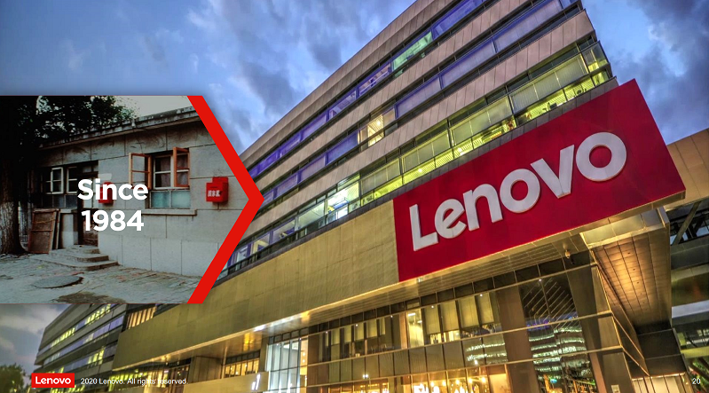
Figure 1 The history of Lenovo (Lenovo, 2022a).
LENOVO is a global ICT corporation company and well known PC maker which was established in China back to 1984. Today, Lenovo has already become “a Fortune Global 500 technology company and one of Fortune Magazine’s World’s Most Admired Companies”(Lenovo,2022b), which operates and serves customers in 180 countries world-wide with the world’s widest portfolio of technology products and services, categorized into six business units: Intelligent Device Group (IDG), Infrastructure Solutions Group (ISG), Solutions & Services Group (SSG), Lenovo Capital and Incubator Group (LCIG), Converged Network Group (CNG) and Data Intelligence Group (DIG) (Lenovo,2022b).
In 1984, the company started with the Chinese brand name ”联想”，which means and implies “association of ideas” or”imaginations” in Chinese. As a huge tree that fills one’s arm grows from a tiny seeding, Lenovo started up its business as agent and distributor of foreign brands IBM, Hewlett-Packard(HP) and SUN etc. The occurrence of a milestone event which truly emerged its ambition and aspiration to be a rising technology innovation company in 1986 when it invented the first Chinese character card that enabled computers to process Chinese language directly (Lenovo,2022a). Since 1990, Lenovo operated under the old name “Legend” that launched self-branded PCs in China and scored sales champion in 1997, had become common memory of many Chinese earliest PC users, thereafter carries special sentiments to them. Lenovo never ends up its aspiration as merely a Chinese domestic company, with the watershed event of acquiring the entire PC business sector out of IBM in 2005, when its strategies of globalization commenced. Till 2013, Lenovo had achieved around 16% in global PC market share based on units sold that surpassed Hewlett-Packard to be No. 1 in PC sales and the largest PC vendor globally, it has extended No. 1 leadership of global PC market with share of 25.2% till Q3 2022 (Alsop,2022).
It seems Lenovo’s endeavor of “kingship” should earn itself enough respects and worships especially from Chinese customers, however unlikely to Korean when they look at Samsung, Chinese customers reveal some kinds of neutral attitudes in their opinions about Lenovo, furthermore a portion of them have flipped to the aversion side of Lenovo and its PC products. The causes of this phenomenon are seemingly complicated and inexplicable, but Lenovo do face difficulties in seeking growths out of China market. Back to 2013 the year Lenovo just peaked in global market share, China market was the largest PC and smartphone market contributing 38% in the total revenue globally, compare with 21% out of Americas and 25% in aggregation of Europe, the Middle East and Africa (EMEA), however “Lenovo’s China revenue only grew 1.3% in 2013, while revenue from the EMEA and the Americas climbed roughly 30% each” (Holiday,2014). Even Lenovo’s CFO Wong Wai-Ming confessed that China market used to contribute 60 - 70% of Lenovo’s business but represented a smaller proportion nowadays and declining in a 10% YOY rate (Holiday,2014). Sounds unbelievable but this was the truths what Lenovo faced in China, that also reflected something went wrong in Lenovo’s strategic position in China market: does Lenovo really understand what customers demand in China? The answer is uncertain.
This report will focus on Lenovo’s notebook PC (laptop) products sector in order to explore the gain and loss on Lenovo’s strategic situation more deeply, and excavate viable ways to enhance customer care experiences towards possible improvements in notebook PC market.

- STRATEGIC ANALYSIS AND EVALUATION OF LENOVO’S STRATEGIC OPTIONS
Before the visual angle moves into Lenovo’s laptop business that starts focusing on any specific strategic issue, it’s important that external and internal environments should be take precedence of other factors in order to identify the position Lenovo is situated.
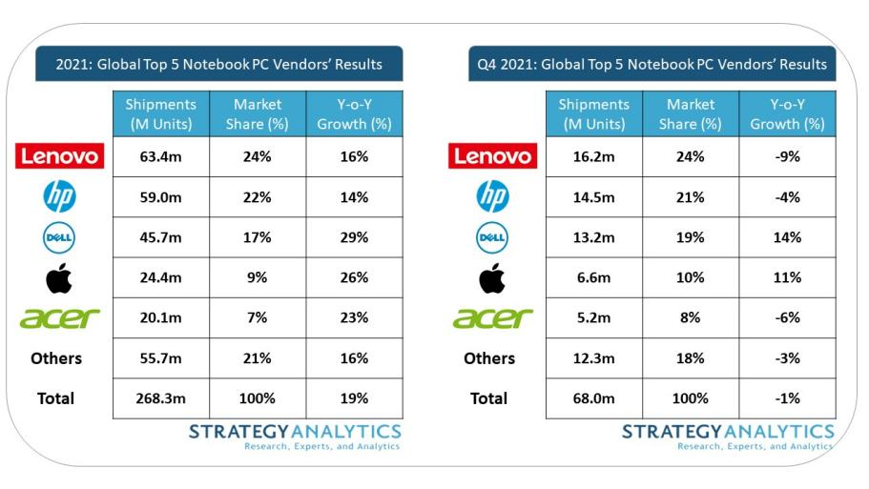
Figure 2 2021 Global Top 5 Notebook PC Vendor’s Results (StrategyAnalytics, Inc., 2022)
3.1 Porter’s Five Forces of Lenovo’s PC business sector
3.1.1 Competitive Rivalry is high. As many customers may sense, PC sector which is part of technology industry is most intensively competitive industries on the world. In this market, consists of lots of different types of participants who are classified by big or small, national or international, concentrating or diversifying in product lines, innovative or conforming in strategies etc, but the market is still concentrating. According to Figure 2.1 (Strategy Analytics, Inc.,2022) the top 3 vendors Lenovo, Hewlett-Packard (HP) and Dell jointly occupied more than 60% market share in the notebook PC business sector while 24% belongs to Lenovo. Due to relatively homogeneous competition, the products of these companies may differ very little in qualities and features. The main theme of competition usually centre on 2 aspects: bringing the latest innovation to the market ASAP, and providing better customer services. (Adamkasi, 2017). Thus, the launch date discrepancies of any similar innovative product from each top vendor probably differ merely in days. Common factors are sharing among these top vendors like strong financial conditions, decent R&D capabilities, well-organized distribution channels worldwide etc.
3.1.2 Threat of New Entrants is medium to high. The competition is intensive in the market, where the threat of new entrants exists all the time. The entry barriers was high in the past due to the high R&D costs and the buildup of a complete distribution networks as well as customer service networks etc., however rising number of new entrants get benefit of e-commerce such as B2C model and OEM (original equipment manufacturer) model, which significantly reduced the entry barriers. The gate for new player is always open, albeit it does demand time to build brand’s reputation and to achieve economies of scale to maximize profits. Razer is an example which has sufficiently sparkled in recent years as a new player in the laptop market. Razer owned some high values on its brand from previous reputation of PC peripherals producer, when it unveiled the first gaming notebook - the “Razer Blade” which claimed to be the world’s thinnest gaming laptop (Razer, 2022), it brought not merely revolutionary impact to the laptop market but a new business model which does not require own production facilities to be prerequisite of entering the market by seeking OEM model instead.
3.1.3 Bargaining power of Suppliers is strong. The bargaining power of suppliers that Lenovo confronts is likely to be the same compares with other competitors. Maybe a producer could maximize its degree of self-sufficiency as much as possible, nevertheless, it still need to outsource some essential hardware parts for its final products, CPU, GPU and SSD hard drives etc. In addition to acquiring operation system copies and other popular software preinstalled licenses, the fixed costs are relatively high and product features are relatively homogeneous for most of PC brands in the market due to the highly concentrated suppliers markets (eg. Intel or AMD in CPU market), economies of scale my reduce the costs slightly but compare with other big players, Lenovo’s advantages are surely insignificant.
3.1.4 Bargaining Power of Buyers is strong. Unfortunately due to the substantial variety of substitutes in the market, customers might easily find replacement over the vast majority of laptops with no or minimum switching cost. One of Lenovo’s fact is to provide products in bulk for corporate buyers who only require products with similar features and qualities what Lenovo’s competitors could simply offer too (Adamkasi, 2017).
3.1.5 Threat of Substitutes is high. Laptops had developed into heaps of sub-group nowadays, not simply classified by brands or screen sizes. In purpose, there are business laptops, workstations, netbooks, entertainment laptops, gaming laptops, not to mention the existence of “hybrid” laptops make the boundary of each group more ambiguous. Besides, tablets and smartphones are also common substitutes to laptops. Hence customers may choose from heaps of substitutes if they had clearly identified their actual needs and acceptable price ranges, the only thing matters is which brand or product is more favourable to them.
3.2 SWOT analysis of Lenovo’s Laptop business sector

3.2.1 THE STRENGTHS OF LENOVO
- Complete product portfolio march towards differentiation and focus strategies. Lenovo is the one of few laptop makers who own roughly full span of product lines in almost every segmented market of laptops, providing multi-dimensional solutions to meet dedicated needs for potential customers, even with implementation of focus strategy in particular niche market like Lenovo’s Thinkpad P-series workstations laptops for graphic professionals.
- Vertical Integration in competing for cost-leadership strategy. Lenovo sets its major production facilities in China where integrates most of laptop parts industrial chains, which grants Lenovo benefits in competing for cost leadership and gaining various conveniences like logistics.(Haque, 2022)
- Benefits of Merger and Acquisition. By acquiring IBM’s PC business unit, Lenovo had discovered shortcut going straight forward to top-of-the-line laptop-PC brand. After tasting the sweetness, Lenovo moved on to acquired Motorola from Microsoft and x86 server business from IBM during 2014 - 2018 (Lenovo,2022a), besides, Lenovo also initiated joint ventures with other ICT giants such as NEC, Fujitsu in order to obtain synergies from these collaborations.
- Advantages of Diversity. Lenovo is doing business in more than 180 markets, 15 R&D locations worldwide and 63,000 employees with multi-national background (Lenovo,2022a), while Lenovo is committed to providing a discrimination-free environment to its employees that created a relatively fair environment.

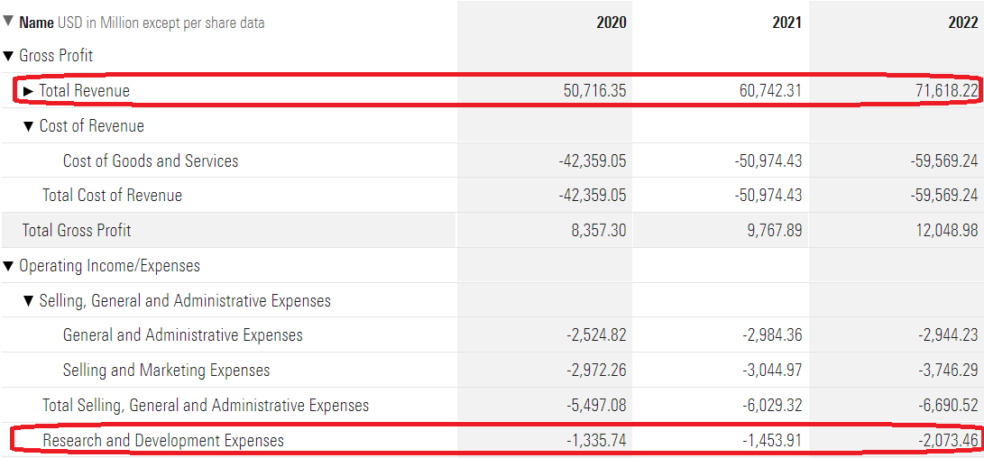
Figure 3 Partial Income Statements of Lenovo Group Ltd. (2020-2022)* (Morningstar, 2022a)

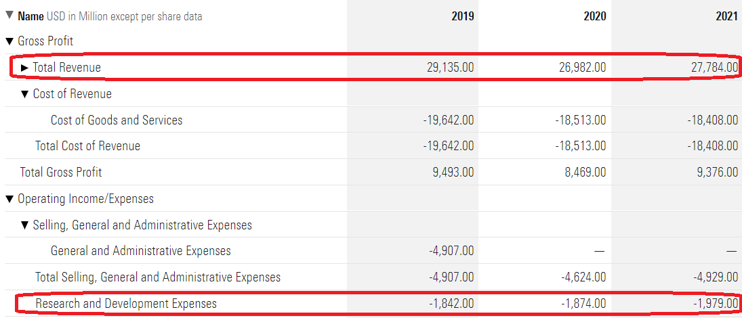
Figure 4 Partial Income Statements of HP Enterprise Co. (2019-2021) *(Morningstar, 2022b)
*Due to discrepancies of fiscal year end-date, recent 3 years are listed.

3.2.2 THE WEAKNESSES OF LENOVO
- Comparably low R&D expenses versus revenue. Although Lenovo claims to be one of the most innovative PC company in the industry, it doesn’t look like it that way from its financial data. According to Figure 2.2 (Morningstar, 2022a) and 2.3 (Morningstar,2022b), Lenovo’s R&D Expenses are amazingly lower than HP who is the closest competitor in first 2 fiscal years, with 1335.74, 1453.91 million USD versus 1842.00, 1874.00 million USD respectively, constrainedly exceeded HP in the recent year with 2073.46 versus 1979.00 million USD, but top revenue doubled to what HP had earned. This is also one of the major reason why Chinese customers critique on Lenovo with such low R&D expenditure ratio which is not matching Lenovo’s revenue and aspiration at all. Nevertheless, the figures above include aggregated data of all Lenovo business units, however the laptop unit as a branch of IDG wouldn’t be fortunate enough to beat other units for over-average R&D budgets.
- Low business profit margin. Another Lenovo’s weakness could be also spotted from Figure 2.2 and 2.3, while Lenovo’s total gross profits were not significantly apart from HP’s but accompanied with double revenues simultaneously which point out one fact that Lenovo’s gross profit margins were dramatically below competitor’s standard, only half of HP’s. It is questionable if Lenovo is urging to execute cost leadership strategy and intending to hold on #1 shipment units in industry albeit similar costs of production among those close competitors, a low profit margin is definitely not ideal way to maintain sustainability towards competitive advantages.

3.2.3 THE OPPORTUNITIES FOR LENOVO
- Increasing demand for portable devices and personalized customer services due to COVID pandemic. Coins always have two sides, when COVID pandemic is reshaping the world in an unwanted way, it has created increasing demand for laptops and other portable devices due to rising needs of remotely working and distanced learning etc. In Addition, physical isolation raise the concerns on how to provide meticulous customers cares in order to provision hyper-personalized customer experience.
- Call for better customer experiences incorporating with products. At this day, laptop products no longer stand alone in assembly parts, customer experiences are far more critical for any laptop brand to stay relatively competitive in industry. So does Lenovo and many laptop vendors who are striving to offer better customer experiences indulging customers like Apple did for its fans. This is also a suggestive approach to offer incredible customer experience which will certainly add values to the brand.

3.2.4 THE THREATS FOR LENOVO
- Growing intense competition. While barrier of entry reduced enormously for new entrant in results of highly integrated industrial chains and development of subcontract manufacturing (OEM/ODM) in laptop industry, deteriorated competition environment emerge one after another. Many OEM companies had turned to new competitors of Lenovo like Clevo and MSI who had initiated own laptop brands, rest of them stay in OEM but assist new player like Razer to reach their aspirations in the market. Additionally traditional vendors are struggling for more market share that make the involution of market even worse.
- Threat of economic downturn. Since the consequences of COVID-19 overlay with more downsides: China-US trade wars, hyperinflation in US and Europe, Russo-Ukrainian War etc., the global economic trend is frustrating and confusing. Nobody could predict if the increasing demand for laptops will be hedged by possible economic downturn.
The external and internal environments of Lenovo consists of both opportunities and challenges, despite SWOT analysis provides a comprehensive views in both of external and internal environment, many limitations apply to it including its non-dynamic perspective, isolation of strategies’ dimensions and strengths may indirectly relate to value creation (Dess et al.,2019,p.141). There are two frameworks work as complementary to SWOT analysis in accessing Lenovo’s internal environment more precisely, Resource-Based View (RBV) and Value-Chain Analysis (VCA) which are more handful analysis tools to explore the sustainability of Lenovo’s competitive advantages (Dess et al. ,2019, p. 141).

3.3 RESOURCES BASED VIEWS - THE VRIO FRAMEWORK
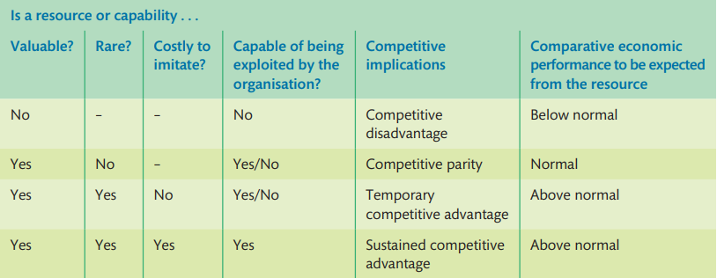
Figure 5 the 4-steps VRIO framework (Barney, 2002)
The RBV emphasizes how important is the individual resources of the organization in delivering the competitive advantages and value added to an organization. (Lynch,2015,p. 129). VRIO framework as a RBV analysis tool is designed for determining if an organization’s competitive advantages stand for long haul.
- V - Valuable: Lenovo certainly has capabilities consists of “tangible and intangible assets that enable a firm to take full advantage of the other resources it controls” (Barney and Hesterly 2010, p. 66), including brand values, reputation, mass production and distribution facilities, multi-cultural management team and employees etc..
- R - Rare: In the view of entire market, Lenovo is one of few brands who merely stand the test of time as a comprehensive laptop manufacturer that is capable in integrating cost-leadership and differentiation, even focus strategies simultaneously in order to develop competencies that both lower costs and add to uniqueness (Stead and Stead, 2017, p.147) rather than some competitors only focus on specific niche market or differentiate in particular segmented market. Thus to deliver rarity in such way.
- I - Imitativeness: While Lenovo’s success may not be imitated easily, nevertheless, it’s more simple to imitate any product Lenovo is offering. In the context of homogeneous laptop products and concentrated suppliers of critical electronic parts, any good-performing laptop product may easily attract imitators, this is not an exclusive phenomenon only for Lenovo whereas almost every player in the market encounters such experiences in common.
- O - Organization support: Although the barriers of entry had already minimized in contemporary laptop market, there is still too costly for any new entrant to grow rapidly in the way of replacing old market giants. Lenovo as a “big ship” might be inflexible in strategic changes and adjustments compare with those “tiny boat” companies, nevertheless, Lenovo owns more supportive resources to fund any critical strategic deployment and resistance to risk of uncertainties over those “newbies”, unquestionably gained more capabilities of organization support.
Thus, Lenovo is scoring 3 out of 4 in VIRO framework, which indicates a temporary competitive advantages against to its rivals at present, thereby an above-normal performance is expected and revealed in current market position.

3.4 Value Chain Analysis (VCA) for Lenovo
The Value-Chain Analysis (VCA) introduced by Michael Porter, is a strategic management tool can be used to analyse each of Lenovo’s activities from raw material input to final products deliveries and customer services, that provides better understanding of Lenovo’s sources of costs and market differentiation, which are the generic elements of competitive advantage (Stead and Stead, 2017, p.121). Competitive advantages can be achieved if and only if Lenovo’s value-creating activities cost less than rivals in order to deliver unique product and services to customers who are willing to either pay premium prices or reserve brand-loyalty (Stead and Stead, 2017, p.121).
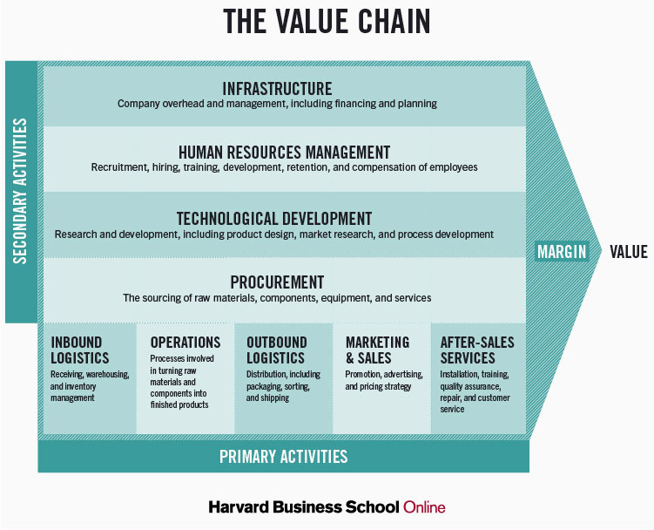
Figure 6 the Value-Chain analysis (Stobiersky, 2020)

3.4.1 Primary activities
- Inbound Logistics
While some suppliers’ markets are duopolies (CPU) or oligopolies (Display panels) markets, the bargaining power of Lenovo comparably stays at the same level of its major competitors albeit its championship in global unit sales, that means Lenovo is unable to purchase those critical parts cheaper than competitors do and vice versa. However, Lenovo had expanded the usage of other raw materials possibly in lower costs and more environmental concerns. For example, Lenovo is using post consumer recycled content such as recycled plastic bottles as laptops’ source of raw materials (Lenovo,2022a), that had created a new environment friendly approach which had reduced costs in inbound logistics as well as meeting Lenovo’s CSR targets.
- Operations
Includes both manufacturing and service operations, which are important for productivity improvements, efficiency maximization etc. to reach better economies of scale. Lenovo had done lots of efforts here, consists of approaches like using “a new and more sustainable process to build stronger, more reliable devices and conserve energy”, and introducing “lighter bio-based (bamboo and bagasse) packaging reduces the overall package size, resulting in a 6.7% efficiency improvement in transportation CO2 emissions”(Lenovo,2022a) for instance. These approaches are not simply for cost saving but also reflects the Lenovo’s ambition to confront its CSR.
- Outbound Logistics
Likely to other competitors in the market, Lenovo had adopted efficient approaches to deal with products warehousing, scheduling, order processing, transporting and delivering activities by using the latest technological supports, thus reached reasonable industrial average standard, perhaps neither “net” value added nor “net” value subtracted for sure.
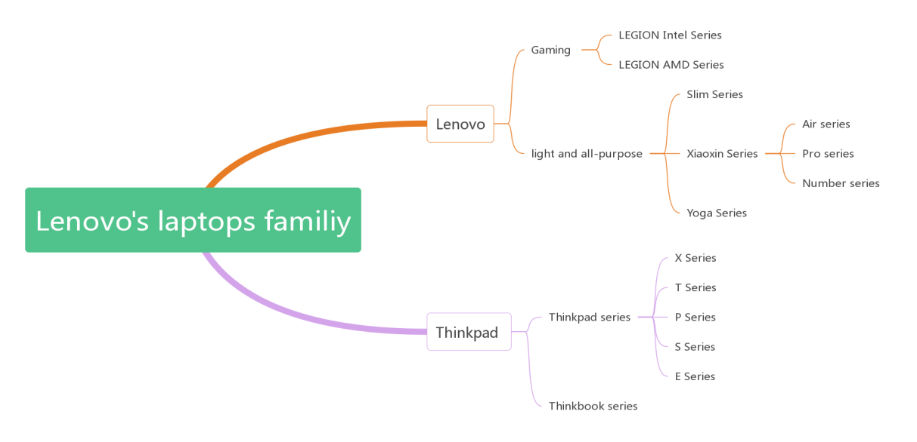
Figure 7 the Lenovo’s laptops family (created by author)
- Marketing and Sales
Refer to previous paragraph, Lenovo had developed an almost full span of laptop products lines, which is covering each of the existed differentiated market including even in some niche markets. Like Figure 4.1 demonstrates, Lenovo’s laptops fleets are comparably complete when comparing with major competitors such as HP, Dell even Apple, that had offered diversified solutions meeting customers’ personalized needs which had surely added values to Lenovo albeit it’s over costly.
- Customer Services
In Porter’s definition, customer services are narrowed to merely include after-sale customer services. Under this scope, due to the “parity” of products and customer service standards in the industry, Lenovo is nether doing exceptionally well nor too badly, all big brands tends to be “homogeneous” on after-sale customer services experiences nowadays, including formalized 24/7 call center, service stations among major cities, at least 1-Year warranty etc. But beyond the scope, the call on more personalized or dedicated customer care such as the concept “the care of one” (McKinsey, 2020) which do not just contain mechanized after-sale customer services is on its way to be the mainstream of future while all participants especially Lenovo can’t let slip.

3.4.2 Secondary activities
Secondary activities are also known as “support activities, on the other hand, provide inputs so that the primary activities can take place” (Stead and Stead, 2017), incorporating activities such as Infrastructure, information systems, planning systems, financing, HR management and legal services etc. There are particular activities for Lenovo to look out, like technological and innovative activities as per previous illustration, also some “pros” activities Lenovo might outperform slightly over competitors like HR management. In general, Lenovo is situated in an “average” level, where no apparent “net” values added or in other hand significantly “outperforming” other competitors in secondary activities.

3.5 More findings and reasonable inferences
Based on previous analysis, an interesting question emerges from the water which leads to previous query: If Lenovo’s laptop business is performing at or even above the average, why it sees a declining China market? Or it could be more straight forward: Why Chinese customers seem as falling in a trend that they are disliking Lenovo’s laptop products.
The reasons are obviously intricate, nevertheless, one example may take a peek at the tip of the iceberg. In 2005, when Lenovo’s acquisition of IBM’s PC business took place, this watershed event granted Lenovo a “double sided sword”: in one hand, Lenovo may exploited the brand name Thinkpad to take over IBM’s laptop market shares as benefits, in the other hand, Thinkpad was likely to be a gold deposit to Lenovo, that was too rich to exploit its existing values rather than a trump for innovation and evolution. Thinkpad as true industrial pioneer was the laptop industrial standard that also carried special meanings to PC users in China, thus many of them critiqued Lenovo who ruined the brand name Thinkpad since the acquisition, that innovation stayed halted afterwards(Sheesley, 2008). In the meanwhile, the R&D expenses of Lenovo in Figure 2.2 might prove it from the side view.
Besides, the acquisition brought unwanted hidden troubles to Lenovo’s organizational culture and structure what triggered shadowed consequences.
3.5.1 Perplexed organizational structure and indigestible cultural differences
Due to the failure of fusion between Lenovo’s native PC group and inherited IBM PC group, with the long-lasting internal friction, Lenovo decided to split the PC sector into two independent business groups - Lenovo Business Group (LBG) and Think Business Group (TBG) (Garreffa, 2020). This strategy was supposed to aid Lenovo in rebuilding the high end brand of Thinkpad while Thinkpad’s high end image kept fading after it helped Lenovo to crown global sales championship. However, when the PC industry has reached a post mature position, as well as the possible diminishing demands due to end of COVID-19 isolation (Witkowski,2022), the likelihood of industrial downturn causes Lenovo even harder to realize its aspiration.
Another side effect came from Lenovo’s organizational culture since the acquisition, that brought the merging predicament of Lenovo’s post acquisition organizational culture onto table. There are huge cultural differences between Lenovo’s Chinese and American colleagues, one observation lied on when Chinese managers only followed what their boss had decreed, but western managers were likely to challenge their seniors’ orders (Abdulai and Ibrahim, 2016). The difficulties of formation to a fitted organizational culture certainly make a note of the split of entire PC business unit mentioned earlier, that also interfered Lenovo to unify channels when facing customer service issues in order to reach ”one company, one voice(Omnichannel)” (McKinsey, 2020).

3.5.2 Know what customers truly desire
Of course Lenovo is not for nothing, while the laptop products are appearing homogeneous or in anther word “parity” among laptop brands, that dragged the barriers of entry into a lowering spiral, there are products from several brands surely bring surprises as breakthroughs which raise the roof of industry highly again.
ASUS is one example that initiated ROG (Republic of Gamers) subordinate brand owned varieties of epochal laptop products in contradiction of “homogenization”, ROG had become the successful subordinate brand which redefined the differentiated market of gaming laptops by introducing heaps of laptop series with creativity and unceasing innovation, just like their slogan ”by innovating products that offer an exceptional experience for all games, we can create a world without limit”(ROG,2022). ROG’s success is not an idiosyncratic case whereas a fulfillment of tenets in delivering hyper-personalized customer care: “Knowing your customers - truly knowing your customers” and “before they even know they need you” (McKinsey, 2020).
Delightfully, Lenovo or somebody in Lenovo had realized the magic, and quickly followed in. LEGION gaming laptop series is a successful attempt of Lenovo in reaching the industrial top of the line, that had brought great influences into the differentiated market and won the reputation of “water bucket machines” to itself, which implies laptops without any apparent shortage or disadvantage. Moreover, with strategy to benchmark talented competitors such as ASUS, Lenovo has brought “long-lost” aspiration of innovation to show potential customers some big splashes, which has revealed itself in the correct way to know what customers desire.

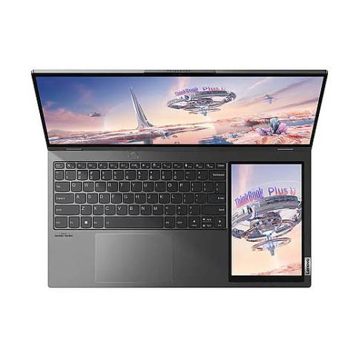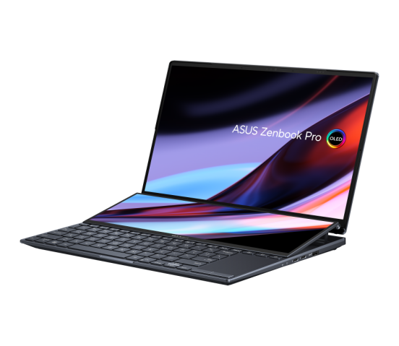
Figure 8 LENOVO vs. ASUS in the battle of laptop solutions with multi-screens (Lenovo, 2022c & Asus, 2022)
3.5.3 Providing multi-form personalized services
Lenovo realized the importance in providing personalized services to its customers and thrusted some initiatives to test the water. One of the initiatives, for example, is by introducing preinstalled comprehensive customer service client - the “Lenovo Device Manager” on its products. One ingenious function Lenovo Device Manager offers is the PC security module, unlikely to its competitors who usually attach copies directly from third party providers such as Norton or McAfee, Lenovo chose to integrate core of Huorong Security, which offered free services to public and subscribed services to enterprises, but in praise of ease in use. Additionally, Lenovo also integrates modules such as remote assistance which may assist customers in reaching Lenovo’s engineers for troubleshooting more quickly and conveniently, and a free software shop module that allow customers to customize their computers in the most simplest way. Moreover, Lenovo Device Manager had incorporated update function that is both quietly and timely, accomplish necessary updates even before customers’ awareness (Lenovo,2022d). Thus, Lenovo is trying to build a “highly sophisticated and cutting-edge customer service function” (McKinsey,2020) in provision of white-glove customer services for all.

- CONCLUSIONS
Lenovo is still the current laptop industry leader who was beneficiary of globalization despite anxieties about how long will it still be benefited. Based on previous analysis and observations, Lenovo is encountering several issues:
- Intense competitive environments.
High rivalry, heaps of substitutes, decreasing barrier of entry, strong bargaining power of customers and suppliers, had made the environments of laptop industry cruel and stressful.
- Insufficient R&D expenditure and profit margins to fund innovation.
Based on Lenovo’s financial statement and current situation of the industry, Lenovo lacks of Research and development investments, which reflected its deficiencies on relative strategies. Also, comparably low profit margins interfered Lenovo in deployment of big movements such as implementation of overall strategic changes.
- Above average resources deployment and value creation.
Above average means Lenovo is not going to suffer instantly macroscopic failures, with still enough resources or value creation to make any change, but time is also ticking.
- Stumbled after acquisition due to deficiency of culture fusion and lacks of endogenous power.
Lenovo’s acquisition of IBM’s PC business was both assets and liabilities, Lenovo did consume much benefits from it whereas the acquisition brought troubles in the formation of new organizational culture, and also made Lenovo stumbled over the strategic management.
- Race and battle in achieving better customer experiences are started.
No matter Lenovo wish or not, the battle or race of achieving next-generation customer experiences had already commenced, left Lenovo no options but stepping forward.

- RECOMMENDATIONS
Upon those findings in previous paragraphs, Lenovo seems to be stuck into dilemma of front-runner who is closely chased by some strong and/or talented players but with hazy road ahead. Though nobody is aware of the future of entire laptop industry, whereas logical pragmatism doubtlessly suggests players to stay ample in both vigor and endurance. Here are several tips for Lenovo to stay as much competitive as possible in the marathon race.
- Carefully think about resources allocation strategies between different laptop business units, for example in rebuilding of high end image of Thinkpad is not ideally to have a trade off of impairing other laptop units. But in the other hand, moderately shrinking of laptop product lines is considerable due to low profit margins, while Lenovo should focus on those products which are potentially profitable.
- Innovations are truly indispensable for Lenovo, especially under the context of homogenization of electronic products. Innovations bring essential capabilities to successfully differentiate the markets in excavations of profitable segments. Additionally, Innovations act like beacons which exhibit customers how to provide better customer experiences both timely and unique.
- Providing personalized customer services is handful tool in dealing with customers’ diversified needs, as well as an effective approach to differentiate from other competitors. Lenovo is supposed to strengthen its capabilities in providing white-glove customer services for all its customers with better forms than those out of others.

- REFERENCES
- Abdulai, M. and Ibrahim, H. (2016) ‘Merging Cultures in International Mergers and Acquisition: A Case Study of Lenovo’s Acquisition of IBM PC Division’, Journal of intercultural communication, (41), p. N_A–N_A.

- Adamkasi (2022) Porter Five Forces Analysis of Lenovo. Available at: https://www.porteranalysis.com/porter-five-forces-analysis-of-lenovo/ (Accessed: 29 Nov 2022)

- Alsop, T. (2022) PC vendor shipment share worldwide 2011-2022, by quarter. Available at: https://www.statista.com/statistics/269703/global-market-share-held-by-pc-vendors-since-the-1st-quarter-2009/ (Accessed: 28 Nov 2022)

- ASUS (2022) Zenbook Pro 14 Duo OLED. Available at: https://www.asus.com/laptops/for-creators/zenbook/zenbook-pro-14-duo-oled-ux8402/ (Accessed: 2 Dec 2022)

- Barney, J.B. (2002) Gaining and Sustaining Competitive Advantage. 2nd edn. New Jersey:Pearson Education Inc.

- Barney, J. and Hesterly, W. (2010) Strategic Management and Competitive Advantage. 3rd edn. NJ: Prentice Hall.

- Dess, G.G. et al. (2019) Strategic Management text & cases. 9th edn. New York: McGraw-Hill Eduction

- Garreffa, A. (2020) Lenovo will split into two new groups - Lenovo Business Group and Think Business Group - effective in April. Available at: https://www.tweaktown.com/news/27665/lenovo_will_split_into_two_new_groups_lenovo_business_group_and_think_business_group_effective_in_april/index.html (Accessed: 3 Dec 2022)

- Haque,F. (2022) Swot Analysis of Lenovo. Available at: https://www.thestrategywatch.com/swot-analysis-lenovo/ (Accessed: 29 Nov 2022)

- Holiday, K. (2014) Lenovo: China no longer our most lucrative market. Available at:
https://www.cnbc.com/2014/05/21/lenovo-china-no-longer-our-most-lucrative-market.html (Accessed: 28 Nov 2022)

- Lenovo (2022a) the Lenovo Story. Available at: https://p2-ofp.static.pub/ShareResource/na/about/whoweare/lenovo-about-who-we-are-lenovo-story.pdf (Accessed: 28 Nov 2022)

- Lenovo (2022b) Who we are. Available at: https://www.lenovo.com/us/en/about/whoweare/ (Accessed: 28 Nov 2022)

- Lenovo (2022c) Thinkbook Plus 17. Available at: https://tk.lenovo.com.cn/product/1023609.html (Accessed: 2 Dec 2022)

- Lenovo (2022d) Lenovo Device Manager. Available at: https://support.lenovo.com/us/en/solutions/ht512995-lenovo-device-manager (Accessed: 2 Dec 2022)

- Lynch, R. (2015) Strategic Management. 7th edn. Harlow:Pearson

- McKinsey & Company (2020) The care of one: Hyperpersonalization of customer care. Available at: https://www.mckinsey.com/capabilities/operations/our-insights/the-care-of-one-hyperpersonalization-of-customer-care (Accessed: 20 Nov 2022)

- Morningstar (2022a) Lenovo Group Ltd Financial Information. Available at: https://www.morningstar.com/stocks/pinx/lnvgf/financials (Accessed:30 Nov 2022)

- Morningstar (2022b) Hewlett Packard Enterprise Co Financial Information. Available at: https://www.morningstar.com/stocks/xnys/hpe/financials (Accessed:30 Nov 2022)

- Razer (2022) About Razer - History. Available at：https://www.razer.com/about-razer (Accessed: 29 Nov 2022)

- ROG (2022) About ROG - Mission. Available at: https://rog.asus.com/about-rog/ (Accessed: 2 Dec 2022)

- Sheesley, J. (2008) Has Lenovo ruined the ThinkPad? Available at: https://www.techrepublic.com/article/has-lenovo-ruined-the-thinkpad/ (Accessed: 2 Dec 2022)

- Stead, J.G. and Stead, W.E. (2017) Sustainable Strategic Management. 2nd edn. New York:Routledge

- Stobiersky, T. (2020) WHAT IS A VALUE CHAIN ANALYSIS? 3 STEPS. Available at: https://online.hbs.edu/blog/post/what-is-value-chain-analysis (Accessed: 1 Dec 2022)

- Strategy Analytics, Inc. (2022) Strategy Analytics: Notebook PCs Finish 2021 With Record Shipments of 268 Million Units. Available at: https://news.strategyanalytics.com/press-releases/press-release-details/2022/Strategy-Analytics-Notebook-PCs-Finish-2021-With-Record-Shipments-of-268-Million-Units/default.aspx (Accessed: 29 Nov 2022)

- Witkowski, W. (2022) PC industry suffered worst decline in years, but how bad it is depends on Apple. Available at: https://www.marketwatch.com/story/pc-shipments-plunging-consumer-demand-at-risk-of-perishing-in-the-long-term-analysis-finds-11657566344
(Accessed: 3 Dec 2022)

