Manufacturing systems and simulation (ACMA6002)

INVESTIGATION OF SITE CALIBRATION DEPARTMENT TO IDENTIFY SOURCES OF WASTE AND PROPOSE IMPROVEMENTS USING LEAN PRINCIPLES

ADAM BARTON
2116210

Contents
1 Introduction 3
2 Identifying Sources of Waste 4
2.1 What Adds Value? 4
2.2 Overview of the Calibration Service 5
2.3 Waiting and Inventory 6
2.4 Non-Value Added Processing 8
2.5 Transportation 9
2.6 Motion 10
2.7 Takt Time 11
3 Recommendations for Lean Improvements 12
3.1 Retirement of the Paper-Based Record System 12
3.1.1 Method of Improvement 12
3.1.2 Potential Problems 12
3.2 Abolition of Collection Points 13
3.2.1 Method of Improvement 13
3.2.2 Potential Problems 13
3.3 Staggered Calibration Recalls 13
3.3.1 Method of Improvement 13
3.3.2 Potential Problems 13
4 Conclusion 14
5 References 15
5.1 Tables and Figures 15

Introduction
Due to a decrease in staff following retirements, the site calibration department at BAE Systems, Land UK, has been selected for a review of its processes to make the work more efficient. This will be conducted using lean principles to identify areas of improvement by highlighting and reducing sources of waste.
Lean manufacturing is ‘a management philosophy aimed at generating the maximum amount of value for the customer with the least amount of waste’. (The Lean Six Sigma Company, n.d.)
There are 8 sources of waste, known as Muda (Skhmot, 2017):
- Defects
- Overproduction
- Waiting
- Non-Value-Added Processing
- Transportation
- Inventory
- Motion
- Unused Talent
The wastes in bold will be discussed in this document as they have been identified as the primary issues within the department.
The scope of this document concerns internal calibrations. Due to the additional complexity of external calibrations (occurring both on-site and off-site), this exercise has been limited to in-house activities only. On site representatives are also unable to be named when referenced due to the nature of the business.
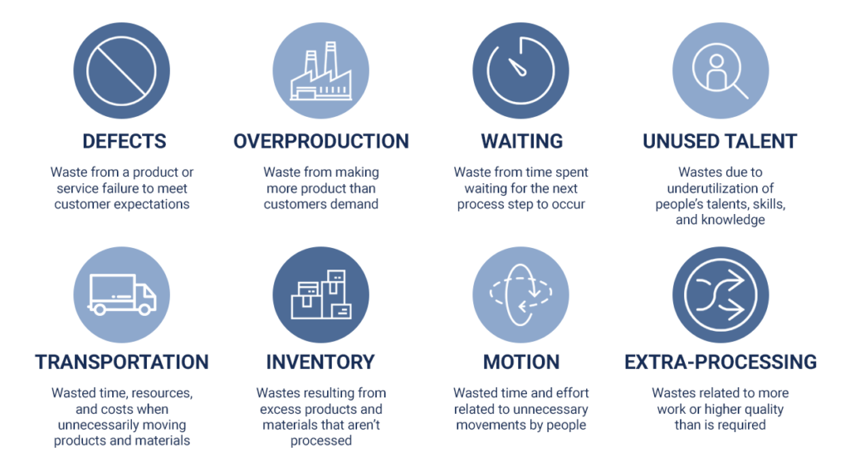
Figure 1

Identifying Sources of Waste

What Adds Value?
In order to make the calibration service leaner it is first important to understand what adds value from the perspective of the customer, which in this case is the person receiving the equipment (production or engineering personnel).
The value-added processes are:
- Calibration of the equipment
- Recording of results for traceability and future reference
- Labelling of equipment with new recalibration due date
- Prompt re-issue to customer on request
This means that any processes additional to these do not benefit the customer and may be considered as waste.
These core processes will need to be taken into consideration when analysing the overall service to identify what processes are necessary and what can be changed to achieve a leaner working environment.
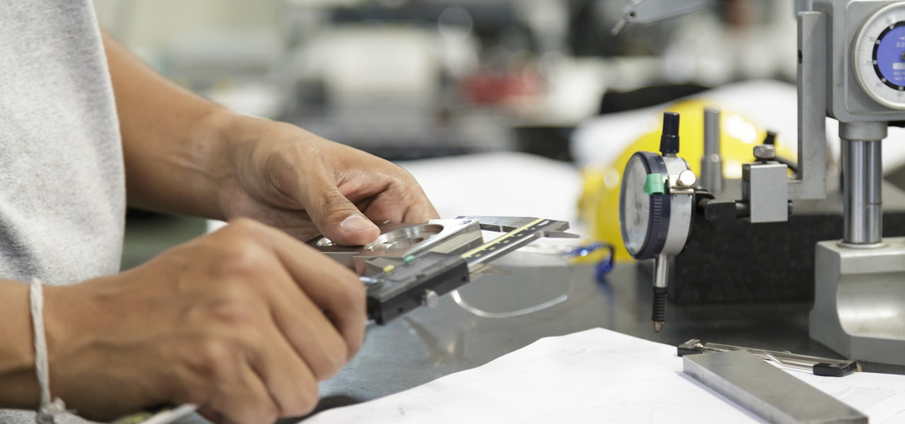

Figure 2

Overview of the Calibration Service
After identifying what adds value, the calibration service was reviewed to understand the actual processes to look for areas of waste. These processes are as follows:
- Equipment and gauges that are due for calibration in a given month are listed using records.
- This equipment is added to a digital notification form along with their locations.
- Notification form is sent to relevant customers.
- Customers place equipment in collection points located in various buildings across site.
- Calibration technician collects from collection points and returns it to calibration department.
- Equipment is taken to storeroom and booked into building.
- Equipment is moved to calibration laboratory.
- Equipment is calibrated. Results are recorded.
- Equipment is moved back to storeroom.
- Customer is notified that equipment is ready for collection.
- Customer arrives at storeroom. Equipment is collected and issued with a calibration label.
- Equipment is booked to relevant workplace.
- Customer leaves with equipment and returns to relevant workplace.
(Calibration Controller, Name Withheld, 2022)
Some of these processes, although non-value added, still need to take place for the service to function (such as a recall system to notify the customer that the calibration is due). However, there is a lot of waste present, even at this macro level, which will need to be further analysed.
To further understand the extent of the issues, the five previously discussed primary wastes relevant to this process will be analysed in more detail.

Waiting and Inventory
From the overview of the calibration service, it is immediately apparent that the equipment is likely to spend a large amount of time waiting with no processes taking place.
This is due to a few factors. The first of which is that there are multiple gauges being left in collection points across site every month that are awaiting pick up by calibration technicians. Due to the number of gauges being calibrated, these gauges then also spend an amount of time in the storeroom before making their way to the calibration laboratory.
To quantify this, some investigation was undertaken to understand the number of gauges calibrated each month, along with takt time to evaluate the waiting time in this period.
There are two technicians performing calibrations in the department. Half of their working week is scheduled for calibration activities. This accounts for 18.5 hours per person and 37 hours a week in total spent on these tasks (Calibration Controller, Name Withheld, 2022). Below is a table of the gauges returned per month so far in 2022:
Month | Gauges Returned
January | 124
February | 130
March | 112
April | 104
May | 107
June | 101
Average | 113
Table 1

Time spent on the calibration of each gauge is documented. The data for May was collected into a grouped frequency table:
Time Taken (Hours) | Midpoint (x) | Frequency (f) | fx
0.0 ≤ T < 0.5 | 0.25 | 2 | 0.5
0.5 ≤ T < 1.0 | 0.75 | 18 | 13.5
1.0 ≤ T < 1.5 | 1.25 | 33 | 41.25
1.5 ≤ T < 2.0 | 1.75 | 36 | 63
2.0 ≤ T < 2.5 | 2.25 | 14 | 31.5
2.5 ≤ T < 3.0 | 2.75 | 4 | 11
 |  | Total: 107 | Total: 160.75
Table 2

From the table, it is possible to calculate the mean calibration time for a single gauge:
$$Mean=\frac{\sum{fx}}{\sum{f}}$$
$$Mean=\frac{\left(160.75\right)}{(107)}=1.502 hours$$
Assuming this is representative of all the equipment, this means the mean time taken to calibrate the average amount of equipment returned each month is:
$$Mean Time Taken=Average Gauges Returned×Average Calibration Time$$
$$Mean Time Taken=\left(113\right)\left(1.502\right)=169.726 hours$$
It also highlights that some gauges, received at the beginning of the month, are waiting in storage for around 160 hours before being calibrated.
Once the equipment has been calibrated, it then sits waiting for a third time before collection by the customer.
All of this equates to a large amount of waste that could be greatly reduced.

Non-Value Added Processing
Due to this massive amount of inventory, a case study was undertaken to fully understand the procedure and what processes were necessary. The technicians were asked to demonstrate the full process of calibrating a single piece of equipment in more detail.
It was discovered that the recall system for gauges is a paper-based system that works alongside a digital computer program. It was found that, due to an aging workforce, the digital system was introduced but never fully replaced the paper-based version and the two have worked in tandem for the last few years (Calibration Technician, Name Withheld, 2022).
Effectively, the equipment records are duplicated, meaning the work done using the paper-based system is now an additional non-value-added process being applied to every gauge.
It was also found that the notification forms for customers were hand-typed using the paper-based system as the automated digital recall system had never been commissioned.
The time taken to write a notification form and email the necessary recipients was found to be around 92 minutes and it requires 2 people (Calibration Technician, Name Withheld, 2022). Due to the timescale this was the only time this was measured but it was stated by technicians to be representative of the average time.
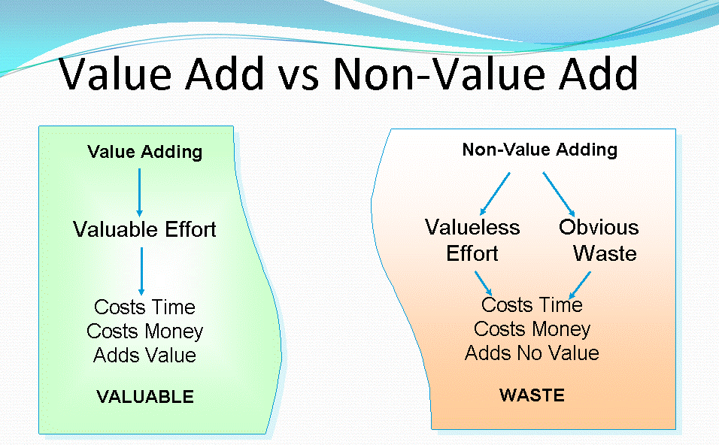
This is a significant loss of time that could be saved in its entirety if the automated system were to be commissioned.

Figure 3

Transportation
Another cause of waste in the process is transportation. It is important to understand that, although it is a non-value-added process, transportation is vital to complete the task. However, this should be limited to be as little as reasonably practicable.
In the case of the calibration department, the equipment is loaded into a vehicle by the customer and taken to their nearest collection point. It is then unloaded, ready for collection by the calibration technician, who then must load it into their vehicle before taking it to the calibration department where it is then unloaded for a second time (Process Leader (Customer), Name Withheld, 2022).
Once there, it is then taken to the stores room and booked in. Each piece of equipment is then individually (or in small quantities) taken to the calibration laboratory. It is then taken back to the stores and put on a shelf before being collected by the customer and taken back to the production facility (Calibration Controller, Name Withheld, 2022).
It was also made known that the calibration department’s vehicle was often found to be too small to visit each of the collection points in the same trip, further increasing transportation time (Calibration Technician, Name Withheld, 2022).
From this, it is clear that some of these movements could be eliminated through better organisation and more efficient utilisation or resources.


Figure 4

Motion
Waste of motion was a problem that became apparent with the case study that identified the paper-based system. There was found to be two sets of gauge cards – one to log calibrations and one to log location changes. These two sets of cards were also found to be in different rooms.
This means that for a technician to update the records for a single gauge, they need to search through the set for the relevant month to locate the desired gauge card before moving to another room to look through an alphanumerical list of cards to log a location change. They would then need to sit at a computer and log the same information a second time (Calibration Technician, Name Withheld, 2022).
To quantify this waste, ten gauges were selected at random, and the time taken to find and complete both cards was recorded from start to finish. The time taken to do this using the digital software was then also recorded as a comparison to see if it was more efficient.
The findings are below:
Item Number | Time Taken (Seconds)
Item Number | Paper System | Digital System
Item 1 | 256 | 48
Item 2 | 288 | 54
Item 3 | 262 | 50
Item 4 | 250 | 48
Item 5 | 280 | 58
Item 6 | 270 | 53
Item 7 | 272 | 49
Item 8 | 278 | 62
Item 9 | 266 | 51
Item 10 | 252 | 56
Average | 267.4 | 52.9
Table 3
From this it is obvious that the digital system is far more efficient, and the paper system is wasting a substantial amount of time. Using the 2022 value for average gauges returned per month so far, 113, and the average time of 267.4 seconds, the time spent completing the paper records equates to 8.39 hours a month and over 100 hours per year.

Takt Time
From the calculations conducted when finding the waste from waiting, it is obvious that the time spent calibrating gauges each month exceeds the available working time. To evaluate this, the takt time was calculated to understand the extent of the work time deficit.
Using 4.33 as the number of weeks per month (calculated from 52/12), the total number of hours available per person, per month for calibration work is:
$$Work Time Available=18.5×4.33=80.165 hours$$
Therefore, to find the takt time and minimum number of people required to complete this work:
$$Takt Time=\frac{Work Time Available}{Number of Units Requiring Calibration}$$
$$Takt Time=\frac{(80.165)}{(113)}=0.708 hours$$
$$Minimum Number of People=\frac{Cycle Time}{Takt Time}$$
$$Minimum Number of People=\frac{(1.502)}{(0.708)}=2.12=3 people$$
From this, it is clear that there are too few people to complete the work with the current arrangements. Multiplying the takt time by the number of people currently in the department to calculate the current deficit gives:
$$Takt Time Deficit=\left(Takt Time\right)-\frac{Mean Calibration Time}{Number of People}$$
$$Takt Time Deficit=\left(0.708\right)-\frac{\left(1.502\right)}{(2)}=-0.043 hours$$
This means the work overruns by 0.043 hours (2.58 minutes) on average for each piece of equipment. This is a monthly deficit of 4.86 hours which is evidence of overburdening (Muri). Currently, this has been covered by overtime at an additional cost to the business which equates to 58.31 hours per year paid at 1.6 times the normal rate for an effective annual cost of 93.29 hours at the standard rate.

Recommendations for Lean Improvements

Retirement of the Paper-Based Record System

Method of Improvement
According to the Ministry of Defence requirements, the calibration records must be kept for a period of 13 years. This means that the paper-based system would need to remain available for reference to past calibrations until the digital system has 13 years of records.
However, it does not state that the records need to be physical, and this has been confirmed by a representative.
It is therefore possible to now retire the paper-based system in favour of the sole use of the far more efficient digital system.
However, it will be imperative that the automated recall system is commissioned alongside this. From the data in section 2, this would save around 90 minutes per month for 2 people for the creation of notification forms alone. Over a 12-month period this equates to 1080 minutes which is 36 hours a year. This is almost a week’s work.
When considering the elimination of the time taken to complete both sets of handwritten gauge cards, this is over 136 hours of work saved per year. It is also worth noting that this is greater than the 58.31 hour deficit, showing that the cycle time will be reduced to less than twice the takt time, meaning that it would no longer by necessary for any overtime to be spent on calibration. There will also be a margin for error to account for defects or particularly busy periods.

Potential Problems
This will need to be adopted by the calibration technicians. It is possible that there will be resistance due to ‘the way the work has always been completed’ and a loss of overtime. However, once they have been persuaded and shown the time savings available this should be quite simple to implement, and overtime may be made available for other tasks.
The company will also need to accommodate this with some financial support to have the recall system commissioned. The provider has been contacted and has quoted the commissioning at £1920. With the current technician rate, this will be recuperated within 2 years (Calibration Controller, Name Withheld, 2022) and make additional savings every year afterwards.
These statistics will be used to justify the purchase to the finance department.

Abolition of Collection Points

Method of Improvement
The collection points act as a mid-point stores area that is unnecessary and adds surplus transport processes. Instead, it is proposed that customers will bring equipment directly to the calibration department. This will also eliminate the waste of the equipment waiting at the collection point.

Potential Problems
There is likely to be a reluctance from the customers to bring the equipment an additional distance. However, this, along with the other improvements, will combine to give the customer a better overall experience, a more efficient calibration process and processes will spend less time manually measuring components or using temporary replacements when certain gauges are unavailable.

Staggered Calibration Recalls

Method of Improvement
In order to combat the amount of time equipment is waiting to be processed, gauges should be recalled periodically throughout the month to minimise inventory. This will allow for a smooth flow of equipment in and out of the department.
The suggested method would be to send a notification to each customer successively throughout the month to separate the equipment into manageable amounts and reduce bottlenecking.
This means the customers would still only be required to transport one set of equipment per month, but not simultaneously.
Using working time of 18.5 hours and dividing by the takt time of 0.708 hours gives a maximum output of 26.13. Therefore, a maximum of 26 gauges will be recalled per week to ensure a steady flow of equipment.
Although this is still a form of batching, it is far closer to a Just In Time (JIT) model and will greatly reduce waiting times.

Potential Problems
This is reliant on the successful commissioning of the automated recall system. It will be difficult for the technicians to continually manually generate notifications separately for each customer.
This will need to be integrated into the computer program to make the process as simple as possible. Again, this will be used as justification for the finance department to ensure that the purchase order is promptly approved.
There should be little to no resistance from the customer as the only direct effect on them is the time at which the equipment is returned. This is unlikely not be a problem.

Conclusion
From the data collection and associated recommendations, it should be possible to facilitate a far leaner working environment in the calibration department.
In the future it may also be possible to introduce more complex systems involving barcodes to more quickly book equipment in and out, but this was not currently in the budget, so its feasibility was not investigated.
However, if the currently recommended improvements are implemented correctly, this will create a good baseline that allows the process to function successfully with two technicians. From this point, it will be possible to begin continuous improvement (Kaizen) in order to make small improvements over time.
This is likely to be a long process; ‘it took Eiji Toyoda and Ohno more than twenty years of relentless effort to fully implement this full set of ideas’ (Womack, et al., 1990) at Toyota, but this is the first step in the right direction towards a leaner workplace.


Figure 5

References
Calibration Controller, Name Withheld, 2022. Overview of Site Calibration [Interview] (June 2022).
Calibration Technician, Name Withheld, 2022. Gauge Calibration Discussion [Interview] (July 2022).
Process Leader (Customer), Name Withheld, 2022. Gauge Transportation Discussion [Interview] (July 2022).
Skhmot, N., 2017. The 8 Wastes of Lean. [Online]
Available at: https://theleanway.net/The-8-Wastes-of-Lean#:~:text=The%208%20Wastes%20of%20Lean%201%20Transport.%20Waste,reaching%2C%20bending%2C%20stretching%2C%20and%20moving.%20More%20items...%20
[Accessed July 2022].
The Lean Six Sigma Company, n.d. Lean Manufacturing. [Online]
Available at: https://www.theleansixsigmacompany.co.uk/lean-manufacturing/
[Accessed July 2022].
Womack, J. P., Jones, D. T. & Roos, D., 1990. In: The Machine That Changed The World. s.l.:Simon & Schuster, p. 62.

Tables and Figures
Figure 1 taken from https://theleanway.net/The-8-Wastes-of-Lean#:~:text=The%208%20Wastes%20of%20Lean%201%20Transport%20Waste,reaching%2C%20bending%2C%20stretching%2C%20and%20moving.%20More%20items...%20 3
Figure 2 taken from https://sicweb.com/blog/32-calibration-technicians-who-are-they-and-what-do-they-do 4
Figure 3 taken from http://leanmanufacturingtools.org/7-wastes/ 8
Figure 4 taken from https://webstockreview.net/explore/forklift-clipart-transparent/ 9
Figure 5 taken from https://www.feedough.com/lean-manufacturing-definition-principles-wastes-examples/ 14

Table 1 6
Table 2 6
Table 3 10

