Cian West 2004900
Changemakers Building Your Personal Brand for Sustainable Employment
Computer Animation

Mindmap

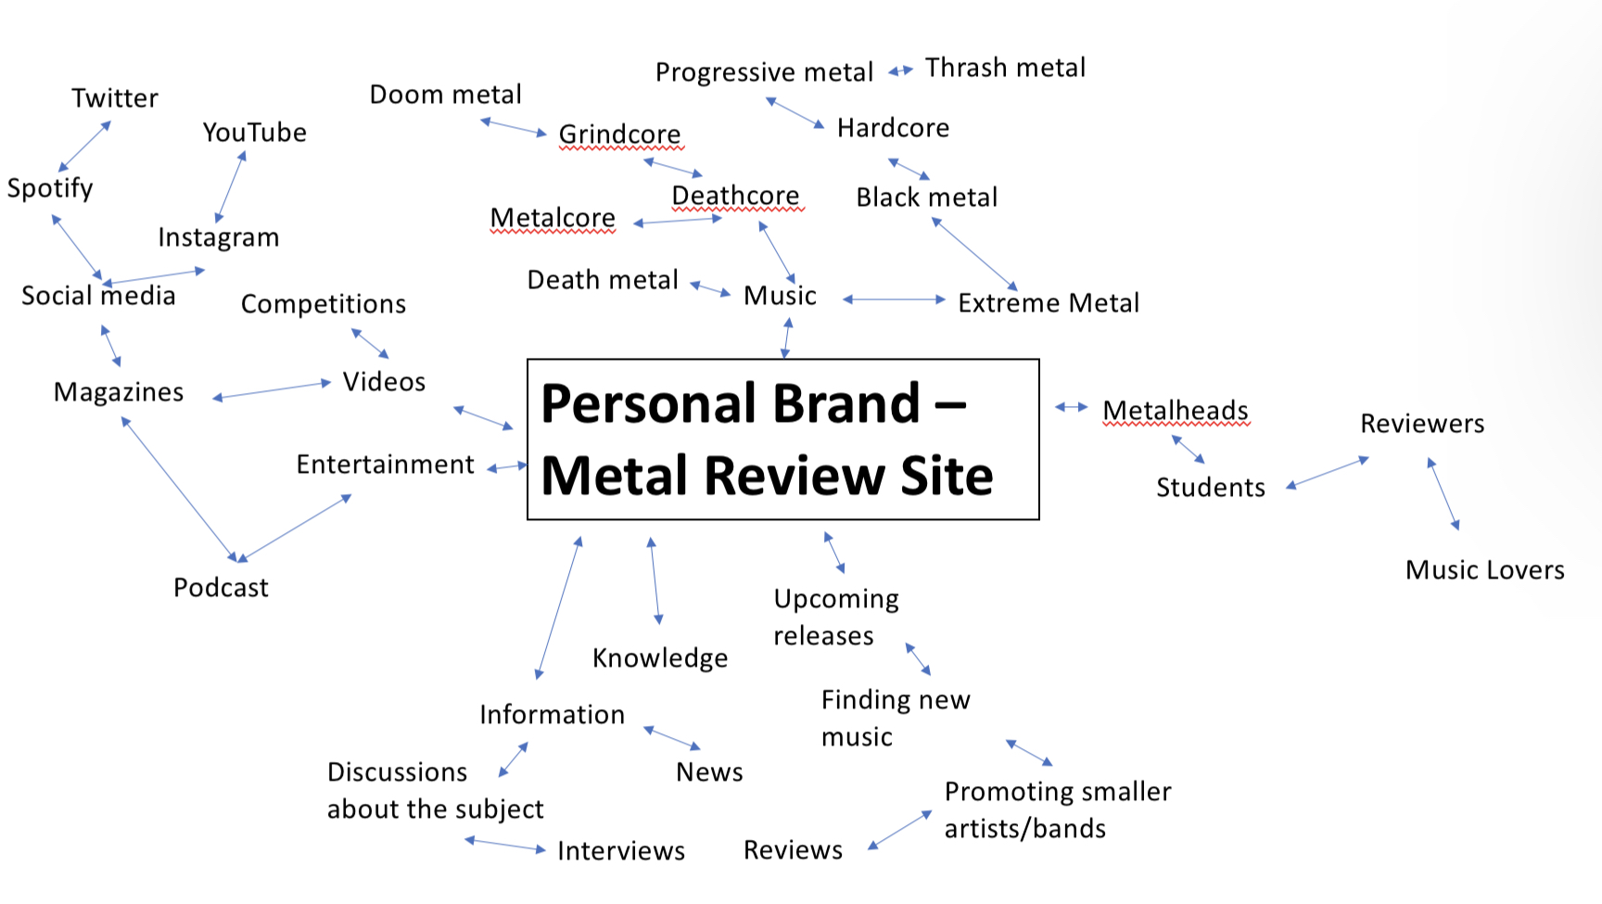
https://uowtsd-my.sharepoint.com/:p:/g/personal/2004900_student_uwtsd_ac_uk/EdHtmpM_NvVEjYqxnvEfWw8BFzTa24GhIpKNe5pJngMfWg?e=4BuKBD

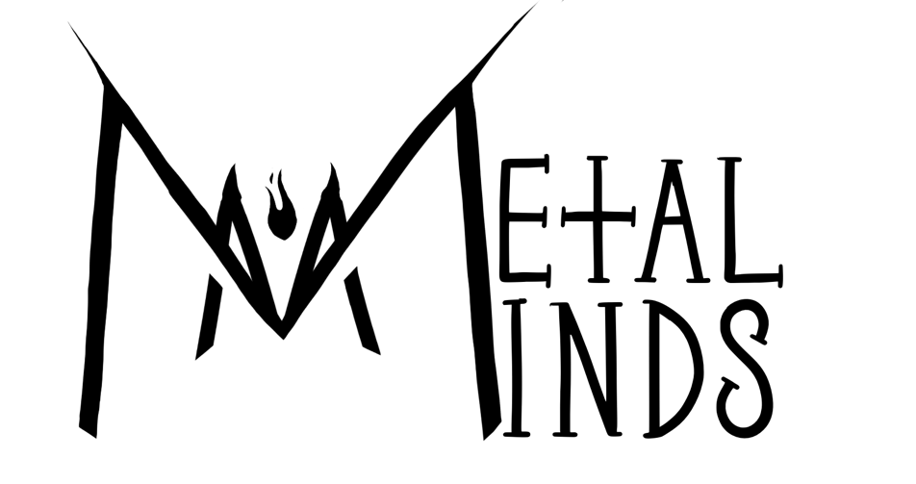
Logos
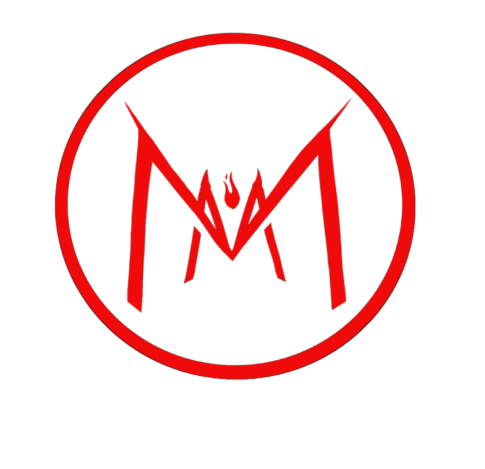
This is the design I’ve chosen for the logo.
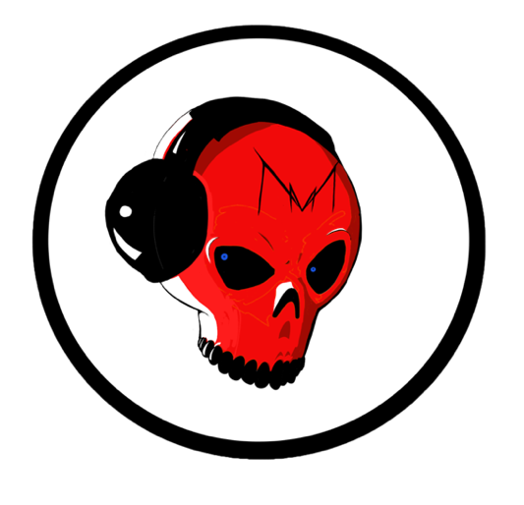
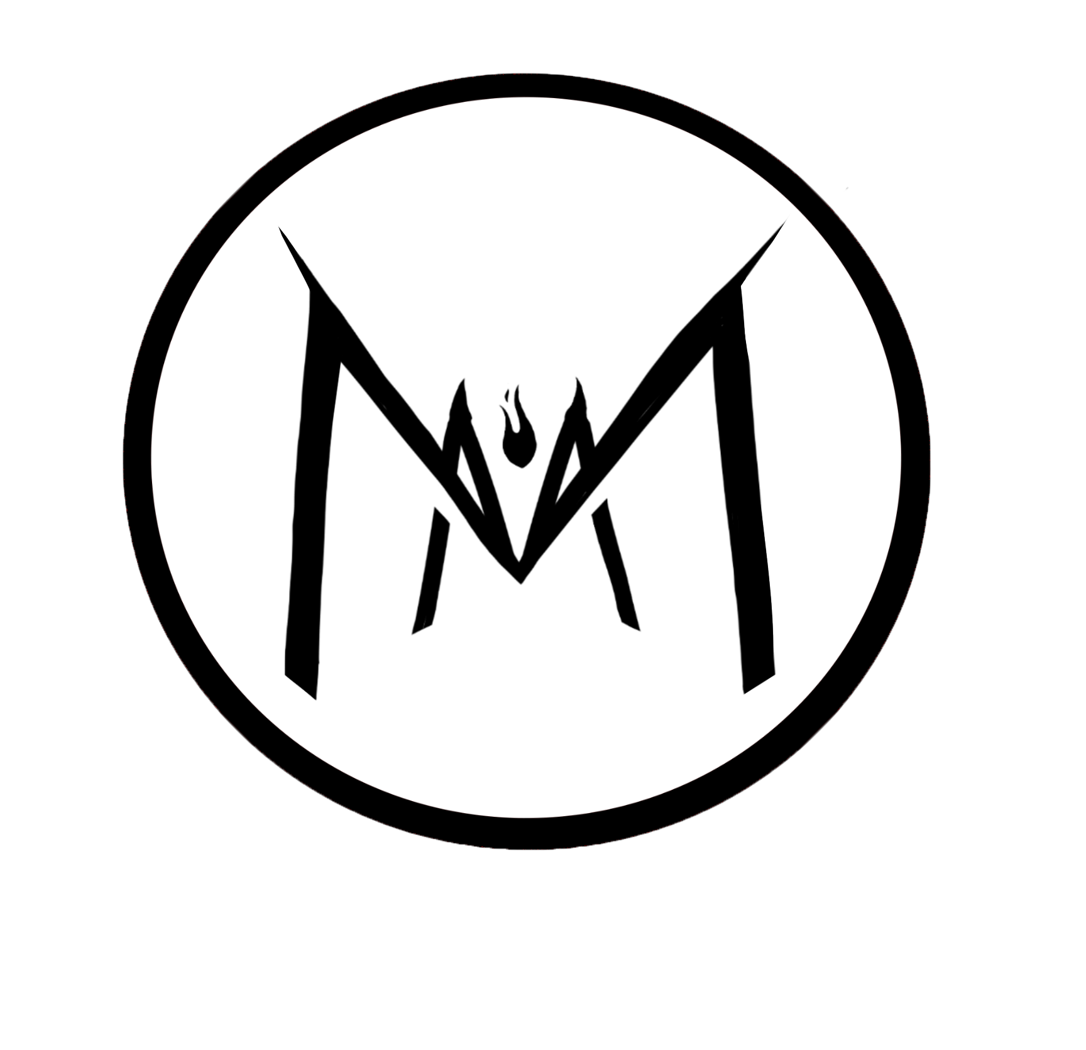
Font used: https://www.dafont.com/search.php?q=Metal
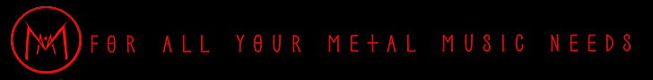

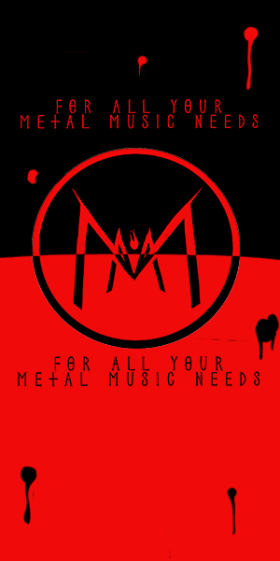
Banner Ads
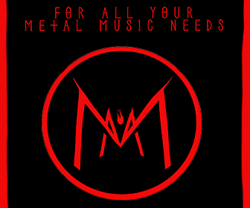
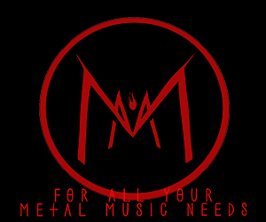

Intro Sequence

Original Intro Sequence

https://youtu.be/-ZggDHMCT24

This is the link to the original intro sequence on YouTube. I did not pick this intro sequence as I felt it did not explain what my brand is as it only had a logo present.

Chosen Intro Sequence

https://youtu.be/8J_e5u4Ftf0

This is the intro sequence I have chosen, it includes text to go with the logo.

