
Analysis and Simulation of a Centrifugal Clutch
Course Code: ACMA5010
Course Title: Stress Analysis & Dynamics
Submitted by:
Ieuan Wyn Morgan
ID: 2014408
Department of Engineering
Submitted to:
Rob Goodson
Submitted on:
17/10/2021

In this essay, I will research and discuss different types of clutches: the centrifugal shoe clutch and an electromagnetic clutch. Regarding the centrifugal clutch, I will discuss the following points: the clutch's development, choice of materials, typical applications, operating conditions, and advantages. I will finally talk about the current application of the electromagnetic clutch.
Engineers guide (2019) states that a centrifugal clutch Is a device used on driven rotary machinery. The centrifugal clutch is most commonly paired with a combustion engine and is used to automatically transmit the torque from the combustion engine into the driven equipment; no manual input is needed. Using a centrifugal clutch, the speed at which a mechanically driven shaft can be engaged is controlled. As the engine speeds up passed the set engagement speed of the clutch, the mechanical drive becomes engaged.
Engineers guide (2019) explains that a centrifugal clutch allows the operator to run an engine at a designated driving speed without driving the equipment, allowing the engine to reach its optimal torque before becoming engaged.
With regards to the early development of the centrifugal clutch, C.W.Trigell, (1969) writes that the shoe clutch is one of the earliest forms of the centrifugal clutch; a shoe clutch consists of two or more weights fitted with friction facings on their outsides and are driven by a combustion engine connected either directly or via a gearbox to a drive. The clutch will engage once the desired speed is met. As the engine’s speed increases, the shoes will move outwards due to centrifugal force until the shoes contact the drum, thus engaging the clutch. Clutches of this type are still commonly used due to their practical yet straightforward design. Trigell (1969) further explains that although the shoe clutch was initially used within the automotive industry, it was soon abandoned in favour of a swinging arrangement. A diagram of an early shoe type centrifugal clutch can be seen in Fig 1.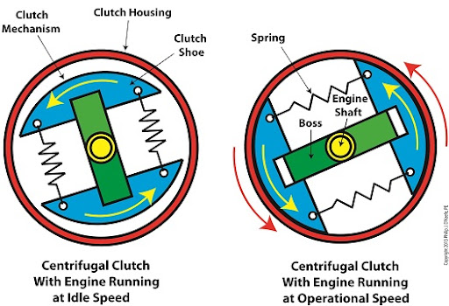
Fig.1 - Engineering expert, (2012) – Basic centrifugal clutch

Abdullah, O.I. et al. (2013) explains that a centrifugal clutch consists of four main parts. The shoe, driving member, control spring, and shoe pivot. An example of this is shown in Fig.2. Furthermore, Abdullah, O.I. et al. (2013) says that centrifugal clutches are not commonly used in automation but within industrial machinery. Eide international (2021) states that centrifugal clutches are most frequently used on machineries such as sweepers, mowers, chainsaws, generators, and motor pumps.
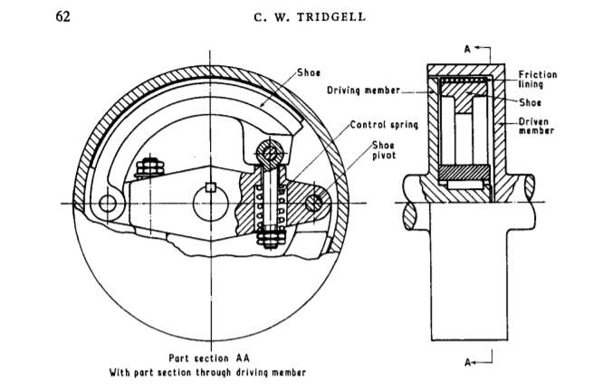
Fig.2 - C.W.Trigell, (1969) – Part section showing different parts of a centrifugal clutch
Furthermore, C.W.Trigell, (1969) notes that the swinging clutch is often favoured over the centrifugal shoe clutch due to the shoe clutch suffering from the disadvantage of unequal lining wear. Therefore, the centrifugal shoe clutch was further developed to a point where the internal links can be arranged to give positive and negative servo action. This is known as a multi-shoe trailing link clutch. A diagram of this is presented in Fig. 3. When used in automotive use, a negative servo is used to reduce the bite of the clutch. As a result, positive servo forces arise on overrun, which helps keep the shoe in contact with the drum when below the engagement speed, meaning the braking torque of the engine is transmitted for a more extended period than if a pivoted design was used.
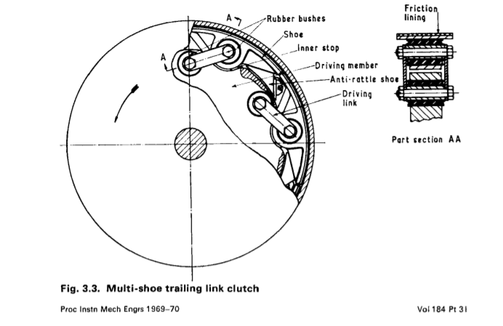
Fig. 3 - C.W. Trigell, (1969) – ‘multi-shoe’ centrifugal clutc
Phillip J. O’keefe (2012) discusses the materials used in a centrifugal clutch. They add that centrifugal clutches have linings inside the casings, which are commonly created from materials such as ceramic compounds. This meets with the shoe of the clutch, which is often metal lined with rubber. O’keefe (2012) explains that having a rubber coating on the metal drastically reduces the noise from the bare metal once the clutch has been engaged. Once the rubber materials of the shoe meet with the rough surface of the ceramic compound lining, the clutch is engaged. A diagram of this is shown in Fig. 4.
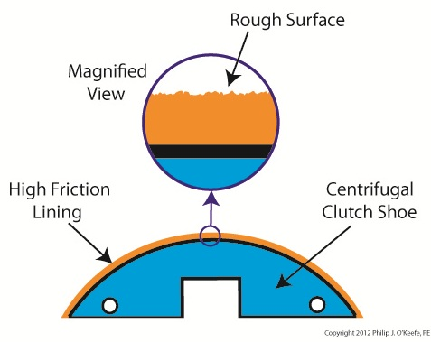

Fig. 4 - Phillip J., O’keefe, (2012) – Engagement of a centrifugal clutch,

In this section, I will talk about the advantages of centrifugal clutches. Nathan B. Crane (1999) writes about the advantages of the centrifugal friction clutch. Crane (1999, p.24) states, “the primary advantage of centrifugal devices is their simplicity.” This tells us that centrifugal clutches have a simple design that can be easily maintained. This simplicity of design makes centrifugal clutches more reliable and possess lower costs. Crane (1999, p.24) also says, “They do not require any external signal or power for actuation or control.” They do not require any external power or signal to work, only gravity and centrifugal force, meaning that centrifugal clutches can be applied to simple appliances.
Furthermore, Crane (1999) explains that a centrifugal clutch uses more minor components in its design compared to its fluid lever-activated counterpart. Therefore, having a simple design leads to lower manufacturing and maintenance costs and a higher level of reliability. Lastly, Crane (1999) talks about the centrifugal clutch’s sensitivity to small changes in speed. They explain that the sensitivity can be very advantageous when used as centrifugal switches and speed brakes. A slight increase in speed will result in a more significant increase in actuation force, meaning that an overspeed brake will have ease stopping a larger than expected load at a slightly higher speed.
Ogura (2021) explains that the electromagnetic clutch is electrically activated but transmits the torque mechanically. The Electromagnetic clutch utilises a single plate friction surface that engages the clutch's input and output sections. Orgua (2021) further talks about the use of electromagnetic clutches within automation. They explain that they are applied in applications such as packing machinery, food processing machinery, and factory automation. There are three central bodies of an Electromagnetic clutch, a coil in a shell, sometimes referred to as the ‘Field,’ the hub, and the armature. The clutch also bares a rotor which will connect the clutch mechanically.
With regards to the material used in electromagnetic clutches, Ogura (2021) tells us that the coil is comprised of carbon steel, this is used to strengthen the clutch, and its magnetic properties are needed. Furthermore, tightly wound copper is used as an electronic coil. Finally, a bobbin is used to hold the coil within the casing of the clutch. A diagram of this can be seen in Fig. 5.
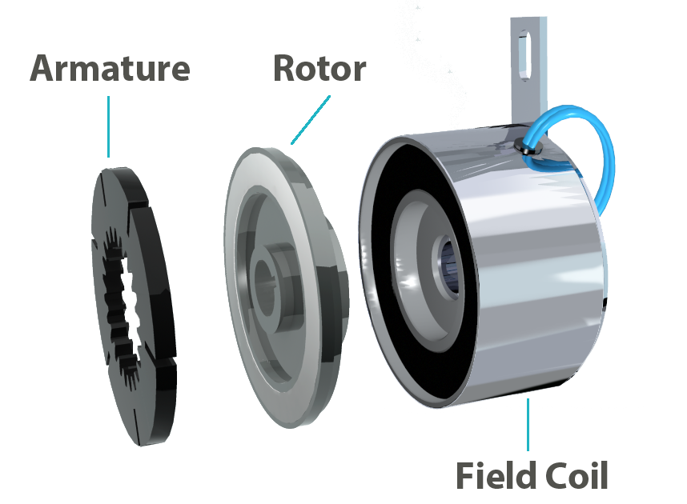

Fig. 5 – Ogura, (2021) – Parts of an electromagnetic clutch.

Yong li et al. (2010) discuss the advantages of an electromagnetic clutch. These include a unique advantage of non-contact and flexible transmission. Yong li et al. (2010) further explain that electromagnetic clutches benefit from a low noise design, are self-lubricating, and have inherent overload protection. Finally, they explain that no ‘clutch dust’ is produced, meaning that electromagnetic clutches are perfect for clean environments such as medical manufacturing or food manufacturing.
Ogura (2021) explains the different types of electromagnetic clutches. These include the electromagnetic tooth clutch, electromagnetic multiple disc clutch, Electromagnetic hysteresis clutch, electromagnetic particle clutch, and the most common is the electromagnetic single face clutch.
Kachanovskaya, L.T., Vinokurov, V.I., (1974) tells us how an electromagnetic clutch works; they explain that an electromagnetic clutch utilises the current of an electromagnetic field, creating friction between particles and transfer oil. However, an electromagnetic clutch doesn’t use a friction plate but uses two rotating discs. The space between both discs is filled with electromagnetically charged particles usually suspended in oil.
Furthermore, Kachanovskaya, L.T., Vinokurov, V.I., (1974) continues explaining that when a current passes, the charged particles suspended in the oil generate a magnetic field that binds the particles to form a sort of chain, creating a link between the two discs. The strength of the link is altered through the amount of current passed through the clutch. With increased voltage comes increased strength. The electrically charged particles are used to create friction within the clutch. When the charge is removed, the clutch is free to move with the drive shaft.
In conclusion, I have found that centrifugal clutches are often used in applications such as lawnmowers, go-karts, and other small engine appliances. Also, the centrifugal clutch is favoured for its reliability and simple design. On the other hand, electromagnetic clutches are used in applications such as machinery in the food industry due to their “no dust” design, low noise, and self-lubricating properties.

Task B

- Below are the given sums.

Radius – 95mm
Clearance – 9mm
Wall thickness - 4mm

These three sums added to together give us a radius of 108mm, times this sum by two to find the diameter – 108mm X 2 = 216mm, this is the diameter of the drum.

The sums given to us are listed below.
W – Unknown
FS – 7.5 KN/m
M - 1.1 Kg – 0.275 per shoe times be 4 (0.275 X 4 = 1.1 Kg).
X – 0.009 M (9mm)
R0 – 0.095m (95mm)

F = (FSx10ᶾ) X ( Xx10 ֿ ᶾ)
F = (7.5x10ᶾ) X (0.009)
F = 67.5 N
Using the force that I have found, I can calculate the radians per second.

W= $√\frac{F}{M (R0+X)}$
W= $√\frac{67.5}{1.1 (0.095+0.009)}$
W = 24.29 rad/s
To convert from rad/s to RPM we must use the following calculations
Rad/s – RPM =( Rad/s $÷$ $\frac{2π}{60}$ )
W= 24.29 $÷$ $\frac{2π}{60}$
W= 231.95 rounded to nearest 2 d.b = 232 RPM

Below are the sums that I have been given.
FR – Unknown
M - 1.1 Kg – 0.275 per shoe times be 4 (0.275 X 4 = 1.1 Kg).
R – 0.104m – 216/2 = 108 – 4(wall thickness) = 104x10 ֿ ᶾ = 0.104mm.

550 rpm X $\frac{2π}{60}$ = 57.6 rad/s
∑F = M X A
FR = M X $\frac{V²}{R}$
FR = M X $\frac{(W^{}X R)²}{R}$
FR = M X $\frac{(W^{2} X R^{2})}{R}$
FR = M X W² X R
FR = 1.1 X 57.6² X 0.104
FR = 379.551 N/m
FR = 379.551x10 ֿ ᶾ
FR = 0.38 KN/m

- Listed below are the sums I have been given.
T – Unknown
N – 4
μ – 0.35
FS – 7.5 K/NM
M – 0.275 Kg
R0 – 0.095 M
X - 0.009 M
F - 67.5 N
R – 0.104 M
W – 57.6 rad/s

F = (FSx10ᶾ) X ( X x10 ֿ ᶾ)
F = (7500) X (0.009)
F = 67.5 N
T = N X μ X (M X W² (R0 + X) – F) X R
T = 4 X 0.35 X (1.1 X 57.6² ( 0.095 + 0.009) – 67.5) X 0.104
T = 1.4 X 312.05 X 0.104
T = 45.43 N/m

- Below is the minimum RPM that had been calculated.
450 RPM X $\frac{2π}{60}$ = 47.123 rad/s
T = N X μ (M X W² (R0 + X) - F) X R
T = 4 x 0.35 (1.1 x 47.123² (0.095+0.009) – 67.5) 0.104
T 1.4 x 186.53 x 104
T =27.16 N/m

Below is the maximum RPM that had been calculated.
700RPM X $\frac{2π}{60}$ = 73.304rad/s
T = N X μ (M X W² (R0 + X) - F) X R
T = 4 x 0.35 (1.1 x 73.304² (0.095+0.009) – 67.5) 0.104
T 1.4 x 547.23 x 104
T =79.70 N/m

After calculating both the maximum and minimum I calculated the torque of each increasing level of RPM, each level increased by 25 RPM. Underneath is a table(fig.6) that I created on excel. I used each increment of 25 RPM to calculate the radians per second. Then using the equation above I calculated the torque by changing the radians per second for each increment. I then placed my results into a scatter graph. (fig.7)

RPM | rad/s | Torque
450 | 47.1 | 27.12326
475 | 49.71666667 | 31.343
500 | 52.33333333 | 35.79084
525 | 54.95 | 40.46677
550 | 57.56666667 | 45.37079
575 | 60.18333333 | 50.50291
600 | 62.8 | 55.86312
625 | 65.41666667 | 61.45143
650 | 68.03333333 | 67.26783
675 | 70.65 | 73.31233
700 | 73.26666667 | 79.58492
Question 5 table of results. (Fig. 6)

Question 5 scatter graph (Fig.7)

The graph shows that as the RPM increases, the torque follows suit and increases also.

- In question 6 I was asked to recreate my graphs but applying two new coefficients, 0.3 and 0.4. Below lie my results.
Coefficient 0.3
450 RPM X $\frac{2π}{60}$ = 47.123 rad/s
T = N X μ (M X W² (R0 + X) - F) X R
T = 4 x 0.30 (1.1 x 47.123² (0.095+0.009) – 67.5) 0.104
T 1.4 x -8.491 x 104
T = -1.059 N/m

Below is the maximum RPM that had been calculated.
700RPM X $\frac{2π}{60}$ = 73.304rad/s
T = N X μ (M X W² (R0 + X) - F) X R
T = 4 x 0.30 (1.1 x 73.304² (0.095+0.009) – 67.5) 0.104
T 1.4 x 81.681 x 104
T =10.194 N/m

Question 6 table of results coefficient 0.30 (Fig. 8)
RPM | rad/s | Torque
450 | 47.1 | 23.24851
475 | 49.71666667 | 26.86543
500 | 52.33333333 | 30.67786
525 | 54.95 | 34.6858
550 | 57.56666667 | 38.88925
575 | 60.18333333 | 43.28821
600 | 62.8 | 47.88268
625 | 65.41666667 | 52.67265
650 | 68.03333333 | 57.65814
675 | 70.65 | 62.83914
700 | 73.26666667 | 68.21564
Question 6 scatter graph coefficient 0.30 (Fig.9)
After viewing the scatter graph above (fig.9) it is apparent that as the coefficient decrease the torque follows suit. This is due to the friction plate having less friction meaning less torque can be delivered.

Coefficient 0.4
450 RPM X $\frac{2π}{60}$ = 47.123 rad/s
T = N X μ (M X W² (R0 + X) - F) X R
T = 4 x 0.40 (1.1 x 47.123² (0.095+0.009) – 67.5) 0.104
T 1.4 x -8.491 x 104
T = 31.05 N/m

Below is the maximum RPM that had been calculated.
700RPM X $\frac{2π}{60}$ = 73.304rad/s
T = N X μ (M X W² (R0 + X) - F) X R
T = 4 x 0.40 (1.1 x 73.304² (0.095+0.009) – 67.5) 0.104
T 1.4 x 81.681 x 104
T = 91.08 N/m

Question 6 table of results coefficient 0.40 (fig.10).
RPM | rad/s | Torque
450 | 47.1 | 31.00
475 | 49.71666667 | 35.82
500 | 52.33333333 | 40.90
525 | 54.95 | 46.25
550 | 57.56666667 | 51.85
575 | 60.18333333 | 57.72
600 | 62.8 | 63.84
625 | 65.41666667 | 70.23
650 | 68.03333333 | 76.88
675 | 70.65 | 83.79
700 | 73.26666667 | 90.95

Question 6 scatter graph coefficient 0.40 (fig. 11)

Similar to the graph from fig.9, the amount of torque produced changes with the coefficient. As the coefficient increases at 0.40, seen in fig.11, the number of torque increases. As the friction plate has more friction, the torque can be increased.
7)
Below are the sums given.
T – 79.70, this figure has been pulled from question 5.
M – 0.75 kg (750g)
R – 0.104m
F – Unknown
ɑ - Unknown
T = R X F
F = $\frac{T}{R}$
F = $\frac{79.70}{0.104 }$
F = 766.35 N/m
ɑ² = $\frac{F X R }{\frac{1}{2}XMXR²}$
ɑ$² =\frac{2 X 766.35}{0.75 X 0.104 }$
ɑ² = 19650 Rad/s²
ɑ = $\sqrt{19650}$
ɑ = 140.18 Rad/s
8)
Below are the sums given
A - 1M² (50mm X 20mm)
W – 700 RPM
FS – 7500 N/m
G – 9.81
σ – Direct Stress

700 x 2$\frac{2∏}{60}$ = 73.304 rad/s
σ = $\frac{73.3}{\left(0.02 X 0.05\right)}$ X 4
σ = 18325²
σ =$√18325$
σ= 135.37 N/m
Explanation on why this is not considered a complex stress.
When materials have more than one stress acting in two or more directions at the same time, this is considered complex stress. The stress acting upon the shoes is perpendicular to the shoes face, meaning there is only one form of direct stress, thus meaning no complex stress is delivered.

Acknowledgments

I would like to acknowledge both Aneurin Bamsey and Ben Shears. We have worked closely in both task A and B comparing each other’s answers and expressing our individual opinions on each topic.

References
C.W. Tridell, (1969), ‘Centrifugal clutches for automation use.’ British Leyland power jacks, 184(31), pps. 60 – 69. (Viewed 12th of September 2021).
Eide international, (2021), ‘What are the applications of a centrifugal clutch?’, Eide International, https://www.eide.net/en/faqs-eide/what-are-the-applications-of-a-centrifugal-clutch/. (Viewed 12th of September 2021).
Engineer’s Guide, (2019), ‘Centrifugal Clutch Explained’, Lancreal, https://www.lancereal.com/centrifugal-clutch-explained/ (Viewed 12th of September 2021).
Kachanovskaya, L.T., Vinokurov, V.I. (1974). ‘Manufacture and properties of a frictional material for electromagnetic clutches’. Powder Metall Met Ceram, 42(16), pps. 57–59. (Viewed 12th of September 2021)
Ogura, (2021), ‘Industrial clutches and brakes used in automation’, Ogura, https://ogura-clutch.com/electromagnetic_clutch.php (Viewed 12th of September 2021).
Phillip J. O’keefe, (2013), ‘centrifugal clutch’. Engineering Expert Witness Blog, http://www.engineeringexpert.net/Engineering-Expert-Witness-Blog/tag/centrifugal-clutch (viewed 12th of September 2021)

Bibliography

