Hotel Placement Research Project

Name: Nazmeen Akhtar
Student number: 2123059
Module name: Research Project
Code:BMIH6008
Project supervisor name: Ernest Wavei

Acknowledgement:
I acknowledge that I have not used any AI tools for completion of this assignment.
Staff Shortage in Hotel industry: A case study of Birmingham Holiday inn City Centre
Executive Summary
Recruitment and retention are two of the most important processes in the human resources department, and they help to identify the right kind of people for the right kind of job. Within the hospitality sector, hotels are facing higher staff shortages than other companies. IHG's Holiday Inn is located in the centre of Birmingham and has rooms, a smart central restaurant, and a meeting space. The key objective of the study was to address the challenges of staff shortage and to identify the level and consequences of the shortage of staff at Holiday Inn Birmingham City Centre.
The purpose of the research was to analyse the factors which contribute to staff shortage and the effect of a hotel's location on the recruitment and retention problem. In the current study, the use of specifically IHG's Holiday Inn Birmingham city centre was considered for analysing the challenge faced by hotels with respect to the recruitment and retention process. This indicates that the researcher explored the topic in a specified manner with the help of collecting relevant information from secondary sources. The secondary source involves all those documents which are originally presenting the information through primary sources only were used in the study. So, some of the sources from which information was gained in the current study were books, hotel websites, journal articles, magazine articles, reviews of customers, and data from competitors. The qualitative technique of data analysis means that critical interpretation and analysis of the finding based on the existing literature or data was done in the study. It interprets non-numerical data collected from existing sources only.
IHG Holiday Inn Birmingham City Centre faced the issue of staff shortage due to the requirement for advanced digital and technical expertise. Limited opportunities for career progression are identified as a reason behind the staff shortage within IHG Holiday Inn Birmingham City Centre. IHG’s Hotel Holiday Inn Birmingham City Centre offers comprehensive health insurance policies and employee discounts on hotels across IHG properties to foster employee retention. It was concluded that the main challenges hotels face are the technological changes and skill gap, recruitment and selection costs and less time to offer for training and development. It was recommended that the hotel integrate an efficient recruitment procedure, which is necessary to reduce staff shortage.

TABLE OF CONTENTS
1. Introduction 8
1.1 Background 8
1.2 Aims and objectives 8
1.3 Research question 8
1.4 Overview of the case study Error! Bookmark not defined.
1.5 Purpose of Research Activity Error! Bookmark not defined.
2. Literature Review 10
2.1 Challenges of staff shortage in the hotel industry of UK 10
2.2 Reasons behind the shortage of staff in the hotel industry of UK 11
2.3 Major factors that enhance the recruitment and retention of staff while improving operational efficiency hotel industry of UK 12
2.4 Link between recruitment and retention of staff and operational efficiency of hotel industry of UK 12
2.5 Literature gap 13
3. Methods 15
3.1 Case Study approach 15
3.2 Data Collection techniques 15
3.3 Data Analysis 16
4. Case Study Discussion 17
4.1 Brief History of Holiday Inn Birmingham City Centre 17
4.2 SWOT Analysis 18
4.2.1 Strengths: 18
4.2.2 Weaknesses: 18
4.2.3 Opportunities: 18
4.2.4 Threats: 19
4.3 PEST Analysis 19
4.3.1 Political Factors: 19
4.3.2 Economic Factors: 19
4.3.3 Social Factors: 20
4.3.4 Technological Factors: 21
4.4 Competitor Analysis 21
4.4.1 Hilton Birmingham Metropole 22
4.4.2 Novotel Birmingham Centre 22
4.5 Digital Ethnography 22
4.5.1 Operational Evaluation Analysis 22
4.5.2 Social Media Perceptions 23
4.6 Reflection 23
5. Discussion 24
5.1 Research findings 24
5.1.1 IHG Holiday Inn Birmingham City Centre faced the issue of staff shortage due to the requirement for advanced digital and technical expertise 24
5.1.2 Limited opportunities for career progression are identified as a reason behind the staff shortage within IHG Holiday Inn Birmingham City Centre. 25
5.1.3 IHG’s Hotel Holiday Inn Birmingham City Centre offers comprehensive health insurance policies and employee discounts on hotels across IHG properties to foster employee retention 26
5.1.4 IHG’s Hotel Holiday Inn Birmingham City Centre hire the right candidates and keeps them engaged in the work by appreciating and recognising them, resulting in a more stable workplace and culture 27
5.1.5 IHG’s Hotel Holiday Inn Birmingham City Centre fosters a truly inclusive workplace that allows its employees to thrive, regardless of their background 29
5.2 Exploring implications 29
5.3 Acknowledging limitations 30
5.4 Pointing out valuable areas 30
6. Conclusion and Recommendations 31
6.1 Conclusion 31
6.2 Recommendations 31
References 34

LIST OF FIGURES
Figure 1: Increased demand for staff in the UK hotel industry 10
Figure 2: Hotel industry forecast of the UK 11
Figure 3: 10 Effective Employee Retention Strategies for 2024 13
Figure 4: Holiday Inn Birmingham City Centre 17
Figure 5: Hospitality Industry in UK Size and Share Analysis - Growth Trends and Forecasts (2025 - 2030) 20
Figure 6: Hotel Industry Statistics 2023 21
Figure 7: UK hospitality staff shortage 24
Figure 8: Vacancies in hospitality sector of the UK 26
Figure 9: Employees working in the IHG hotels 28
Figure 10: Females in leadership positions in IHG 29

1. Introduction

1.1 Background
Recruitment and retention are two of the most important processes in the human resources department, and they help to identify the right kind of people for the right kind of job (Choy and Kamoche, 2021). The hiring process involves finding professionals and experienced personnel who can effectively contribute to the growth of the company. However, due to staff shortage, it is difficult to determine the effective contribution of professionals for the growth of the firm. Staff shortage could be due to several reasons like lack of flexibility, lack of skilled talent, poor compensation, and an ageing workforce.
Within the hospitality sector, hotels are facing higher staff shortages than other companies (Xue et.al 2022). For the hotel, it is important that the staff shortage problem is identified so that the required steps are taken in an effective manner. Recruiting new staff and retaining existing ones within the company are some of the strategies that have been identified as most helpful for hotels (Ndiuini and Baum, 2021). The central location of the hotel means that there is immense competition between the other players in the market.

1.2 Aims and objectives
Aim
To identify and investigate some of the contributory factors creating these staffing difficulties and examine the effects of the hotel’s central location on recruitment and retention problems
Objectives
- To address the challenges of staff shortage with the help of a well-outlined literature review in the hotel that is located in the city centre
- To identify the level and consequences of the shortage of staff at Holiday Inn Birmingham City Centre by using secondary information.
- To outline the major factors that enhances the recruitment and retention of staff while improving operational efficiency at Holiday Inn, Birmingham City.

1.3 Research question
Q1: What are the major factors contributing to the shortage of workers in the case of Holiday Inn Birmingham City Centre?
Q2: What are the major factors that impact recruitment and retention in a hotel located in Birmingham city centre?
Q3: What kind of measures can be implemented to better guarantee the recruitment, retention, and stability of a hotel workforce?

The purpose of the research is to analyse the factors which contribute to staff shortage and the effect of a hotel's location on the recruitment and retention problem. This means that this study includes a critical review of the topic in the form of themes, an analysis of the use of methods for collecting information and a discussion of the research findings according to objectives. The research also explains the major factors that enhance the recruitment and retention of staff of the IHG Holiday Inn Birmingham city centre.

2. Literature Review

2.1 Challenges of staff shortage in the hotel industry of UK
The hotel industry of the UK has faced diverse challenges that have adverse impacts on the overall performance and efficiency of the sector. As per the view of Ghani et.al (2022) one of the foremost challenges faced by the UK's hotel industry in the context of a shortage of staff is identified as technological changes and gaps in skills. Due to the evolution in the hotel industry, there is an increased leverage of advanced technologies within the work operations such as room automation, contactless check-inns and digital customer service (Putra, and Law, 2024). This requires highly skilled and expertise staff with proficient knowledge about technical and digital skills (King et.al 2021). For example: IHG Holiday Inn Birmingham City Centre faced the issue of staff shortage due to the requirement of advanced digital and technical expertise (The Standard.UK, 2024).
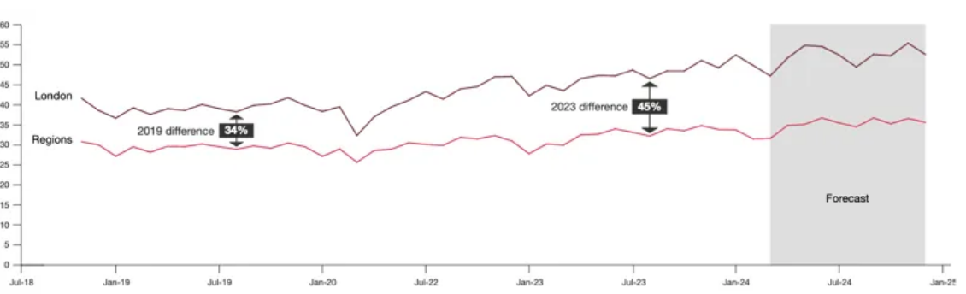
Figure 1: Increased demand for staff in the UK hotel industry
(Source: Hospitality Trends, 2024)
The above graph indicates about significant shortage of staff within the hotel industry in the UK. It has been identified that due to a shortage of staff, demand for skilled workers has been increased by 45% in the year 2023 in the UK (Hospitality Trends, 2024). As hotels struggle to fill the vacant positions, there is an increased expense of recruitment and training that leads to additional costs for the hotel (El-Ghoul et.al 2024). Adisa et.al (2023) mentioned that providing training to newly hired staff requires massive resources and time that puts extra strain on the hotel industry.
Along with that, with a shortage of staff, the management of the hotel industry has less time to offer development and training to new employees due to increased workload (Jones et.al 2023). Besides that, as hotels face complexities in retention and attracting new talents, they are not in a position to expand their service offerings and to fully capitalize on the development and growth opportunities. Ghani et.al (2022) stated that this emerged as a challenge for the hotel industry that has a negative impact on the growth of the business.

2.2 Reasons behind the shortage of staff in the hotel industry of UK
There are multiple reasons behind the issue of staff shortage within the UK hotel industry. As per the view of King et.al (2021) low wages and poor working environment emerged as the foremost reason that led to a shortage of staff. In addition, many hotels have poor working environments, such as strict holiday policies, long working hours, and toxic cultures that lead to attracting minimum employees (Budhwar et.al 2022). Along with that, these factors have a vital contribution to the increased rate of employee turnover (Adisa et.al 2023). For example Premier Inn, one of the leading hotels in the UK has faced complexities in the retention and recruitment of staff due to the reason of poor working conditions and low payment of wage in certain job roles (BBC News, 2024). Papadopoulos and Ioannou, (2023) acclaimed that multiple job roles are seen as basic entry-level and low-skilled that possesses limited opportunities for growth and career advancement. This leads to rising complexities for the hotel industry to retain skilled and talented workforce, results in a shortage of staff due to high turnover rates (King et.al 2021).
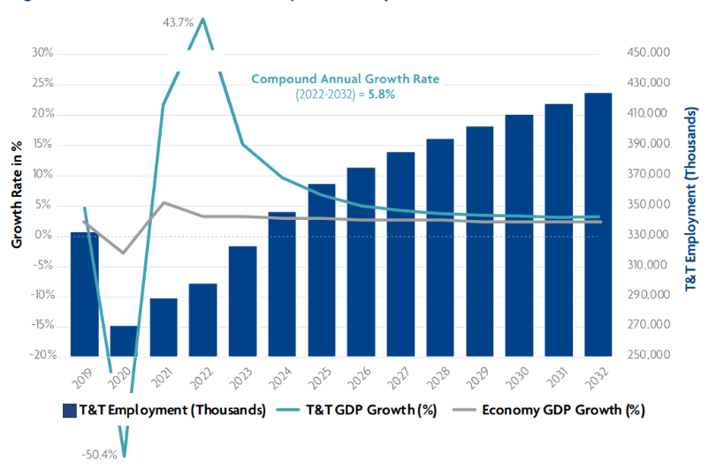
Figure 2: Hotel industry forecast of the UK
(Source: EHL Insights, 2024)
The above chart indicates that the growth rate of the hotel sector that was measured at $4,390.59 billion in 2022 to $4,699.57 billion in 2023 at a compound annual growth rate (CAGR) of 7.0% (EHL Insights, 2024).

2.3 Major factors that enhance the recruitment and retention of staff while improving operational efficiency hotel industry of UK
One of the factors is compensation and benefits, as offering competitive salaries helps hotels retain employees (Potočnik et.al 2021). Also, monetary and non-monetary benefits make a hotel job more attractive. Han, (2022) said that the benefits provided by the hotel ensure that employees are retained while improving the hotel's operational efficiency. For example, IHG’s Hotel Holiday Inn Birmingham City Centre offers comprehensive health insurance policies and employee discounts on hotels across IHG properties to foster employee retention (IHG, 2025). However, Hwang et.al (2021) argued that low wages and limited benefits decrease the morale of employees to work in a hotel. Another factor that enhances the recruitment and retention of staff while improving operational efficiency is employee recognition.
According to Karatepe et.al (2022), actively recognizing and appreciating employees’ hard work increases their morale and thus encourages them to stay longer and work in the same hotel. In addition to this, it also helps hotels improve and manage their operational services efficiently. It is eventually beneficial for hotels as it creates exceptional services by enhancing the interaction level of the guests and employees (Manoharan et.al 2021). For example, The Grand Hotel Birmingham provides inclusive interviewing and also offers work placements in order to enhance the recruitment process (The Grand Hotel Birmingham, 2024). Andersson et.al (2021) contended that unpredictable working hours sometimes decrease the morale of employees and thus result in increased employee turnover.

2.4 Link between recruitment and retention of staff and operational efficiency of hotel industry of UK
The link between recruitment and staff retention and operational efficiency is of two spectrums: positive and negative. Han, (2022) stated the positive link is that hiring the right candidates and keeping them engaged in the work by appreciating and recognizing them results in a more stable workplace and culture (Karatepe et.al 2022). Thus, this ultimately increases operational efficiency and results in the smooth streamlining of hotel activities. In contrast to this, Hwang et.al (2021) argued that there is also a negative link between poor recruitment practices and the retention and operational efficiency of the hotels. Also, poor practices disrupt the operations, result in decreased productivity and negatively influence the guest’s experience (Adeyefa et.al 2023).
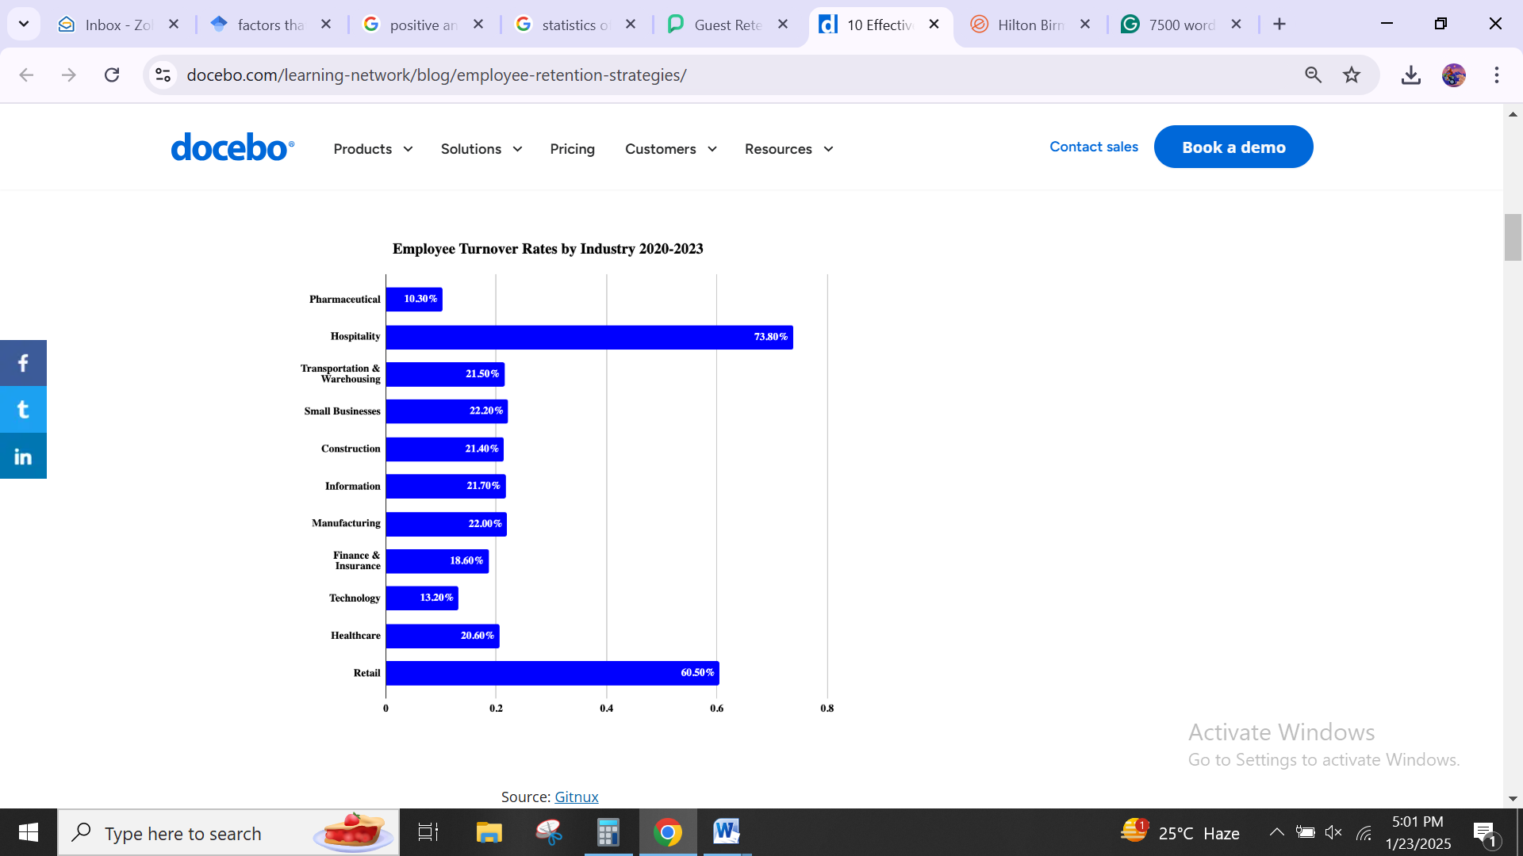
Figure 3: 10 Effective Employee Retention Strategies for 2024
(Source: Leskovar, 2024)
The above figure illustrates the rate of employee turnover in various industries. It can be observed that higher employee retention is in hospitality sector by 73.80% (Leskovar, 2024). For example, IHG’s Hotel Holiday Inn Birmingham City Centre offers robust career development opportunities to their employees in order to maintain the link between the retention and operation efficiency of the hotel (IHG, 2025). According to Manoharan et.al (2021), another factor is improved service quality. This is because consistent and trained staff with a deep understanding of the procedures provides exceptional services to their customers (Styvén et.al 2022). This ultimately helps the hotel increase and enhances guest satisfaction. For example, The Grand Hotel Birmingham fosters a truly inclusive workplace that allows its employees to thrive, regardless of their background (The Grand Hotel Birmingham, 2024).

2.5 Literature gap
The previous literature lacks in in-depth analysis about the factors that contribute towards staff shortage, and the factors that enhances the recruitment and retention of staff. Also, there is insufficient literature in the past in relation to the key challenges associated with staff shortage within the context of Holiday Inn in Birmingham. Thus, the present study bridges this literature
gap to clearly determine the challenges related to staff shortage, factors enhancing recruitment and selection and factors associated with staff shortage, particularly, in context of Holiday Inn, Birmingham.
3. Methods

3.1 Case Study approach
A case study is the kind of method where the study of a specified case, phenomenon, or organisation is done in an in-depth manner (Collis and Hussey, 2014). This methodology is used to gain a comprehensive understanding of the case and build the theoretical framework for it. In
the current study, the case used is related to IHG's Holiday Inn Birmingham city centre for analysing the challenge faced by hotels with respect to the recruitment and retention process. With the help of this hotel, the researcher tries to explore the relevant theories and concepts that might be helpful.
According to Saunders et.al (2012) one of the advantages of the case study method is that it is helpful in presenting the in-depth analysis of the specified phenomenon in the real-world context so that qualitative insights can be gained. This indicates that the researcher is exploring the topic in a specified manner with the help of collecting relevant information from secondary sources (Bryman 2008). However, it was argued that its limitation is that the collected data through the case study method will not be able to be generalised amongst the wider population due to its limited focus. This means that the researcher will not be able to use the data collected for other hotel brands or organisations that are facing similar issues.

3.2 Data Collection techniques
The data collection technique used in the case study approach is a secondary method (Cottrell, 2014). This means that for the purpose of collecting information, a secondary method is used so that critical analysis of the research findings can be done. The sources that offer already published information are referred to as the secondary source of data collection. These are often used to summarise and analyse the new data in a form that clearly states the aim and objectives (Cottrel, 2011).
So, some of the sources from which information is gained in the current study are books, hotel websites, journal articles, magazine articles, reviews of customers, and data from competitors. Through the help of secondary sources, the use of online data nethnography is also employed. With this online data netnography, it is helpful to identify the different digital platforms used by IHG's Holiday Inn Birmingham city centre in promotion and marketing. So, there is a comprehensive discussion of the relevance and application of data ethnography-related hotels.

3.3 Data Analysis
The analysis of the collected information is done in the qualitative form (Veal, 2006). Here, themes according to the topic and objective are created so that relevant data about the hotel can be provided. The qualitative technique of data analysis means that critical interpretation and analysis of the finding based on the existing literature or data is to be done. It interprets non-numerical data collected from existing sources only. The use of text and observation is very helpful for identifying the patterns from the data so that the objective is achieved (Diamantopoulos and Schlegelmilch, 2002). The advantage of this method is that it presents insights from complex phenomena and a rich understanding of the topic in an effective manner. This means that the researcher is able to explore the information in the proper manner according to the findings for the wider population.

4. Case Study Discussion

4.1 Brief History of Holiday Inn Birmingham City Centre
IHG’s Hotel Holiday Inn Birmingham City Centre is a modern and stylish hotel located at the heart of Birmingham (HI Birmingham, 2025). It has 261 bedrooms and offers comfortable services and convenient stays to their potential guests. The hotel is located right opposite the Grand Central shopping mall and Birmingham New Street Train Station. Moreover, it is only 9 minute train journey from Birmingham International Airport to the hotel’s location (HI Birmingham, 2025).
Thus, it is accessible for guests to explore the city by booking a room in this hotel. It offers rooms in three categories; premium rooms, suites and standard rooms. Currently, the hotel is renovating several floors, and it will be completed in the middle of January and February 2025. The starting price of the room offered by IHG’s Hotel Holiday Inn Birmingham City Centre is $92 per night (Booking.com, 2025).
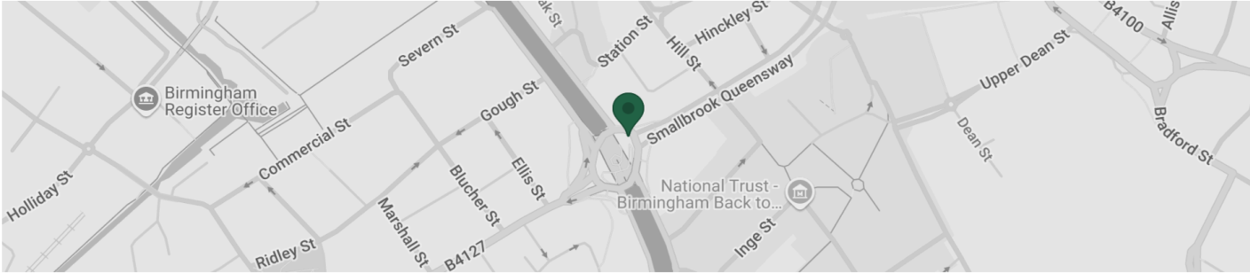
Figure 4: Holiday Inn Birmingham City Centre
(Source: IHG, 2025)
The above image is the location of the IHG's Hotel Holiday Inn Birmingham City Centre (IHG, 2025). Holiday Inn is a chain of hotels that was started in the United States and has slowly expanded to other countries. The chain was founded in 1952 by Kemmons Wilson by opening a motel named "Holiday Inn Hotel Courts" at Summer Avenue in Memphis. In 1972, there were 1400 Holiday Inn hotels across the globe (IHG, 2025).
However, the hotel chain lost its charm and market presence in the 1980s. From 1988 to 2000, Holiday Inn was owned by Bass Brewery. After that, from 2000 to 2003, it was owned by Six Continents. In 2002, Six Continents declared that it would split its brand into two companies, one for hotels and the other for restaurants and pubs. The split was accomplished in 2003, and thus, it created InterContinental Hotels Group as an independent hotel. After that, in 2003, the chain of Holiday Inn ultimately operated under InterContinental Hotels Group (IHG) (IHG, 2025).
It is a global hospitality brand that is also a parent hotel of so many other companies such as Six Senses and Crowne Plaza, Staybridge Suites, Hotel Indigo and Candlewood Suites. IHG's acquisition of Holiday Inn provided the hotel with additional resources, exposure to the market, expertise and a worldwide reach (IHG, 2025). This ultimately strengthened the position of the IHG's Hotel Holiday Inn in the entire hotel industry. In addition to this, IHG has also supported Holiday Inn in becoming one of the most trusted and iconic brands in the entire hotel sector.

4.2 SWOT Analysis

4.2.1 Strengths:
The strengths of IHG’s Hotel Holiday Inn Birmingham City Centre are its location, amenities, breakfast and recognition. Location is its strength as it is situated in the business centre of Birmingham, which is very close to New Street Train Station. The other strength is that it offers excellent services and amenities, with 261 air conditioning rooms, a lounge area, free newspapers, and rooms for non-smokers (HI Birmingham, 2025). In addition to this, it also prioritizes and recognizes IHG reward club members and provides them with special discounts and offers. The overall star rating of the hotel is 4.1, and the customer has given staff and service 4.3/5, room and comfort 4.1/5 and hygiene 4.4/5 (IHG, 2025).

4.2.2 Weaknesses:
The weakness of IHG’s Hotel Holiday Inn Birmingham City Centre is that it has some issues related to its room quality, water services and overall staff services. Some of the customers have stated that the hotel has rooms that are below the standard and expectations. In addition to this, the hotel rooms are noisy because of external noise as there are no soundproof walls in the rooms. Another weakness is the lack of staff attention, as the workers working at the property do not address the requirements and issues of the guests (HI Birmingham, 2025). This ultimately creates a poor experience for the customers.

4.2.3 Opportunities:
The opportunity for IHG’s Hotel Holiday Inn Birmingham City Centre will be implementing family-friendly policies. The hotel has chance to grab the attention of more potential guests due to their family-friendly policy. Under this policy, the hotel allows children between 6 and 17 to stay in the room free of charge (HI Birmingham, 2025). However, this policy applies only when the children are with their families. Moreover, this policy surely grabs the attention of the customers and thus ultimately increases the chance of higher revenue and sales of the hotel.

4.2.4 Threats:
The threat that IHG’s Hotel Holiday Inn Birmingham City Centre faces is competition from other hotels, such as Grand Hotel Birmingham. The hotel faces high competition as Grand Hotel Birmingham provides royal services to their customers. In addition to this, it is a hub for meetings and conferences that are held in Birmingham (The Grand Hotel Birmingham, 2024). This eventually draws the attention of potential guests who are searching for royal experiences. This ultimately becomes a major threat to IHG’s Hotel Holiday Inn Birmingham City Centre, which is related to the shift of consumer interest.

4.3 PEST Analysis
4.3.1 Political Factors:
The political factors of the UK that affect the operations and activities of IHG’s Hotel Holiday Inn Birmingham City Centre are: Brexit impact: The decision of the UK to exit the European Union influences the number of international tourists visiting. This eventually affects the booking rates and occupancy rates of Hotel Holiday Inn Birmingham City Centre. Fluctuations in the policies due to Brexit have also impacted the staffing levels of the hotel (Makos, 2024). This is because most of the hotel's staff is from EU countries, which makes it harder for the hotel to recruit and retain employees. Another factor is health and safety regulations imposed on the hospitality industry also affect the operations of the hotel (Rahman, 2025). This increases the operational cost of the hotel, and this cost is transferred to the prices charged to the guest, thus creating a poor guest experience.

4.3.2 Economic Factors:
One of the economic factors is raising inflation, as the UK is currently experiencing inflation, which ultimately increases the cost of food products, wages and energy. Thus, this forces IHG’s Hotel Holiday Inn Birmingham City Centre to adjust its menus or sourcing to eliminate price increases for customers. In addition to this, the market size of the hotel industry in the UK as of 2024 is 24.3 billion GBP (Statista, 2025). This underlines the growth and opportunities for Hotel Holiday Inn Birmingham City Centre to experience more customers.
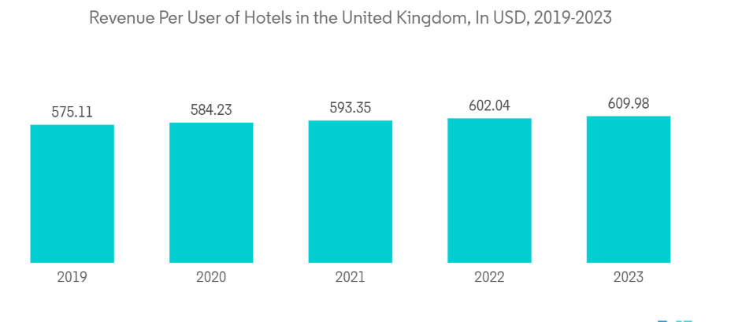
Figure 5: Hospitality Industry in UK Size and Share Analysis - Growth Trends and Forecasts (2025 - 2030)
(Source: Mordor Intelligence, 2025)
The above figure illustrates the revenue of hotels in the UK from 2109 to 2023. It can be observed that the revenue of hotel in 2023 was 609.98 USD (Mordor Intelligence, 2025).

4.3.3 Social Factors:
The key social factors that impact the operations and businesses of IHG’s Hotel Holiday Inn Birmingham City Centre are diversity, inclusions, and sustainability concerns. The hotel must actively promote and support a welcoming environment from different regions and diverse backgrounds across the globe because of the UK’s emphasis on diversity and inclusion (Rahman, 2025). Another social factor is increased health and safety concerns, as increased awareness of health issues obliges IHG’s Hotel Holiday Inn Birmingham City Centre to adopt various practices and initiatives that satisfy and improve guests’ experience. In addition to this, the UK attracts a wide range of international travellers, which creates a compulsion in hotels to provide a diverse range of services and amenities.
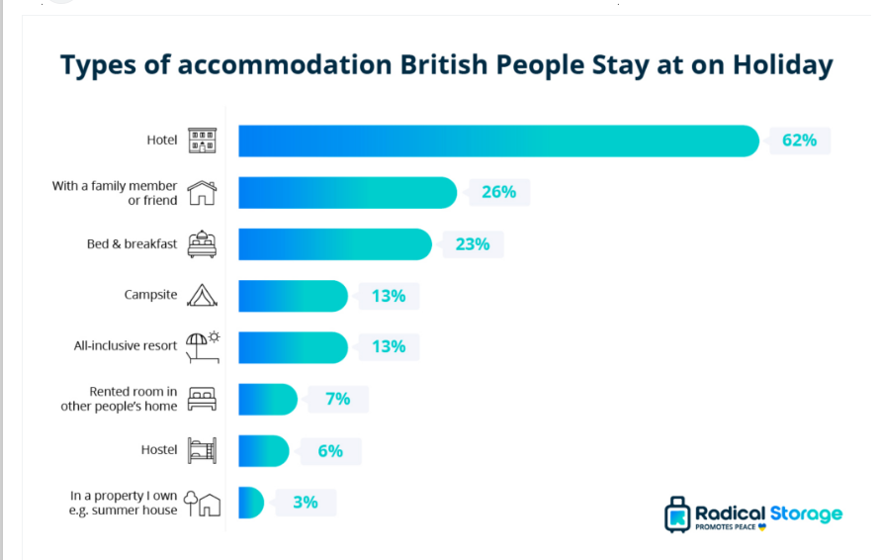
Figure 6: Hotel Industry Statistics 2023
(Source: Piva, 2024)
The above image demonstrates the accommodations that are considered by the people in the UK during booking a stay at the hotel (Piva, 2024).

4.3.4 Technological Factors:
The technological factors of the UK, such as the adoption of cloud technology and the Internet of things and the use of AI in operations to gain customer insights, affect the workings of IHG’s Hotel Holiday Inn Birmingham City Centre. One of the technological factors is AI-supported pricing algorithms, as these algorithms help hotels enhance their pricing strategies and also help in improving their customer experience (Makos, 2024). In addition to this, the adoption of cloud technology in the UK helps hotels improve their integration process, speed of operations, automation and ease of tasks.

4.4 Competitor Analysis
Competitor analysis is defined as the process of analysing and evaluating a competitor's products, prices, quality, marketing, and sales to understand how a business compares to them (Adisa et.al 2023). It also helps a business identify opportunities and threats and thus make appropriate decisions.

4.4.1 Hilton Birmingham Metropole
The Hilton Birmingham Metropole is the largest hotel in England outside London, and it has 790 rooms and suites. The average room rate of Hilton Birmingham Metropole starts from £93 per night (Booking.com, 2025). As compared to this, the average room rate at IHG’s Hotel Holiday Inn Birmingham City Centre is £109.34 (IHG, (2025). This showcases that the hotel Holiday Inn is more costly than the Hilton Birmingham Metropole. In addition to this, IHG’s Hotel Holiday Inn Birmingham City Centre service philosophy is to provide the best customer care and make guests brighter and more comfortable. Compared to this, Hilton Birmingham Metropole has a reputation for providing high-quality service; including friendly staff, great breakfast, and fast room service (Youneedtovisit, 2025).

4.4.2 Novotel Birmingham Centre
Novotel Birmingham Centre is a 4-star hotel located in Birmingham, amongst restaurants and bars. The Novotel Birmingham Centre’s room prices start from an average of £84 per night during the low season. But, around the weekend, its price goes up to around £97 per night (Kayak, 2025). In contrast to this, Holiday Inn Birmingham City Centre has the lowest prices during the low season, around £72 per night. However, during the weekend, the average price of Holiday Inn rooms goes up to £77 (Kayak, 2025). The quality of services in Novotel Birmingham Centre is that their staff is very friendly, accommodates special needs and has a helpful reception (Novotel, 2025). At the same time, Holiday Inn provides rooms and staff services that are above the expectations of the guests. Their main aim is to make their guests feel cared for, respected and welcomed uniquely.

4.5 Digital Ethnography
Digital ethnography is a method that studies how people interact in digital spaces. It is also known as virtual ethnography or netnography (Paoli and D’Auria, 2021). This method is used to analyse and determine the social media presence of a hotel and how it interacts with its customers. Digital ethnography and social media presence also help a hotel create brand awareness among the guests.

4.5.1 Operational Evaluation Analysis
Operational evaluation analysis in the hospitality industry is defined as the process of examining and evaluating a hotel’s operations and performance (Barendregt, 2021). IHG’s Hotel Holiday Inn Birmingham City Centre has made its own account on apps such as Instagram. This helps the hotel interact with its customers and understand their viewpoints about the property. In addition to this, the hotel utilizes this app to share their offers and discounts with the app users, thus attracting them (Amin et.al 2021). In addition to this, on TripAdvisor also, customers have posted reviews related to their staff, service, breakfast, housekeeping and food. These ultimately help the hotel in gaining customer insights and thus enhancing and providing exceptional services.

4.5.2 Social Media Perceptions
The IHG’s Hotel Holiday Inn Birmingham City Centre has a strong social media presence on platforms such as Instagram, Expedia and TripAdvisor. These platforms help the hotel interact with its guests and understand their perceptions. Social media also helps hotels spread information quickly and on a large basis, enabling them to interact with customers (Paoli and D’Auria, 2021). So many customers also write and post negative reviews on the platforms, which provide insight into the hotel's improvements. In addition to this, so many customers also post positive reviews and share their experiences on these platforms with other users. This ultimately creates a brand presence and positive reputation among the social media platforms and thus enables customers to revisit the hotel again.

4.6 Reflection
I did a placement in IHG’s Hotel Holiday Inn Birmingham City Centre, which helped me gain various insights into the hospitality industry. It also helped me learn about the skills that are needed in the efficient management of the hotel. I learned crucial skills such as problem-solving, communication, teamwork, customer service and adaptability. By doing the placement, the main skills that I inhibited within me were communication skills. Interacting with various customers in a day at IHG’s Hotel Holiday Inn Birmingham City Centre hel1 ped me enhance my skills. A hotel has to deal with various customers from different backgrounds and countries in a day (Shiu Pong Ng et.al 2023).
This ultimately builds adaptability and flexibility within me to deal with different guests from different backgrounds. However, I faced some challenges during the placement, such as staffing issues. This is because hotels often face high staff turnover at times of demanding schedules, which ultimately increases the workload of new employees to fill the gap (Ghani et.al 2022). I also gained some actionable insights during the placement. For example, I learned that Birmingham is a good tourist destination as it is widely known for its rich culture. Thus, this helped me provide rich, positive and memorable experiences for guests.

5. Discussion

5.1 Research findings

5.1.1 IHG Holiday Inn Birmingham City Centre faced the issue of staff shortage due to the requirement for advanced digital and technical expertise
Staff shortage is happening in the hotel industry, and one of the main reasons is advanced digital technology and lack of technical expertise (Michael and Fotiadis, 2022). This means that IHG Holiday Inn Birmingham City Centre is facing a staff shortage due to the need for technical expertise within the hotel. However, there is an existing gap between the required level of technical expertise and the level which is actually available in the market. It seems to be a very critical situation for the hotel, as it is not able to find the technical staff that will be able to present the digitally ready environment (Ladkin et.al 2023).
The hotel is facing the issue of staff shortage as most of them are not able to meet the requirements of learning and using advanced digital technologies (Miguez et.al 2023). In the city centre of Birmingham, there are different hotels operating; however, due to shift competition, there are challenges. Other brands like Grand Hotel Birmingham and Novotel Birmingham Centre also provide customers with better services. However, they witnessed the issue of staff shortage as well. On average, 48% of staff shortages are facing the issue of staff shortages, which is higher than in the pre-pandemic period.
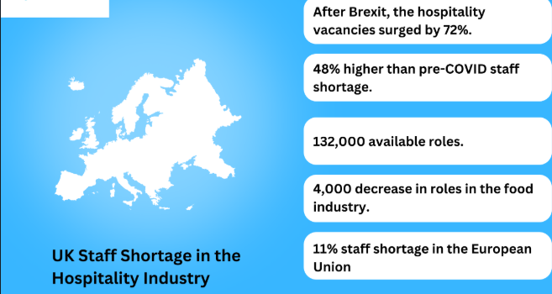
Figure 7: UK hospitality staff shortage

(Source: Roelen-Blasberg, 2025)
The above figure shows that after Brexit, the vacancies in UK hospitality increased to around 72%, where 132,000 jobs were available, and 11% of the shortage was within the EU (Roelen-Blasberg, 2025). Since the return of travellers in the post-pandemic era, the issue of staff shortage has been highlighted. According to the view of Kolodiziev et.al (2024) there is the evolution of technology in the hotel sector, like digital customer service and room automation, which is also creating the issue. This issue results in the appointment of professionals who have the required technical and digital skills (Nam et.al 2021). IHG Holiday Inn Birmingham City Centre is focusing on providing better services to customers, especially in relation to digital technology.

5.1.2 Limited opportunities for career progression are identified as a reason behind the staff shortage within IHG Holiday Inn Birmingham City Centre.
One of the reasons for the staff shortage in the IHG Holiday Inn Birmingham City Centre is the limited opportunities for career progression provided by the hotel. This means that people or staff is not provided with good opportunities for their future career progression, which is creating problems (Zhou et.al 2025). For the staff to progress and feel satisfied with the job, it is very important to provide them with better career progression. This can be done by identifying the training and development needs that will be required to progress further (Nanor et.al 2022).
The training and development provided by the hotel are very important, which indicates that professionals are looking forward to it. IHG Holiday Inn Birmingham City Centre is not able to identify the career progression that is required by the hotel in the long run. However, with this issue, there will always be a skill or knowledge gap that is required by the hotel to be fulfilled effectively (Azimi et.al 2024). This also means that the hospitality sector or the hotels are not able to fill the skill gap properly compared to the other sectors (Kuhn et.al 2021).
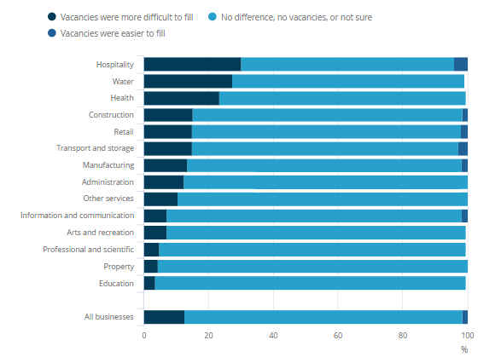
Figure 8: Vacancies in hospitality sector of the UK
(Source: ONS.GOV.UK, 2021)
From the chart, it could be determined that the hospitality sector of the UK is the one which is mainly facing the issue while filling the vacancies. 30.1% of the vacancies in the sector are difficult to fill as compared to 4.1% of those which are easy to fill (ONS.GOV.UK, 2021). However, Budhwar et.al (2022) argued that with better employee loyalty and a structured pathway, hotels will be able to retain their staff for a longer duration of time. This means that IHG is one of the few hospitality brands in the world that has actually tried to bring back its departed employees into the hotel after improvement (Sharam, 2025). The new HR strategy of the company confirms that the departed employees are coming back into the hotel by analysing the career progression scope.

5.1.3 IHG’s Hotel Holiday Inn Birmingham City Centre offers comprehensive health insurance policies and employee discounts on hotels across IHG properties to foster employee retention
By providing comprehensive health insurance policies and employee discounts, the hotel will be able to enhance the recruitment and retention of staff (Mujtaba, 2022). This is due to the fact that health insurance and employee discounts across different properties of hotel brands are among the most important retention strategies. It is due to the fact that staff are attracted or retained by these activities that their loyalty is also improved. These are some kinds of benefits which employee always likes to receive from the hotel where they are working so that their retention can be ensured. Health insurance policies are those where an employee's health is insured by the hotel itself so that their family will not be facing any kind of struggle after any sort of illness or disease to the employee (Urme, 2023).
This also means that in one of the industry reports, it was identified that 10% of the labour gap is present within the UK hospitality sector, especially including the Holiday Inn. In most of the locations of Holiday Inn, there is a lack of staff due to Brexit and the pandemic. The roles, including front office, chefs and kitchen staff, are mostly affected by the shortage within the IHG’s Hotel Holiday Inn Birmingham City Centre. Then, there is a 10% vacancy rate within the hotel sector, with 200,000 staff shortages (Race, 2021). It could also be stated by King et.al (2021) that working as a chef is one of the most challenging tasks or tough areas for the hotel due to the long working hours. With the help of health insurance policies, IHG’s Hotel Holiday Inn Birmingham City Centre is able to attract employees for a longer duration of time.
In addition to this, the hotel is able to provide employee discounts across the IHG properties, where employees can get discounts and special offers during their stay. Most of the staff members get special offers and discounts whenever they stay at any IHG property across the world. This means that hotels provide discounts to their staff as a means of fostering employee retention.

5.1.4 IHG’s Hotel Holiday Inn Birmingham City Centre hire the right candidates and keeps them engaged in the work by appreciating and recognising them, resulting in a more stable workplace and culture
IHG’s Hotel Holiday Inn Birmingham City has a culture of appointing the right candidates and keeping them engaged in the work so that they get appreciation. This means that the hotel is providing effective benefits to its staff members, including the front office, chefs and others (Jamil et.al 2023). A stable workplace and culture are provided to the employee of the hotel, which very much affects their performance on a larger level. This directly shows the link between recruitment and retention and the improved operational efficiency of the hotel. IHG’s Hotel Holiday Inn Birmingham City has a healthy culture and stable workplace where each employee is provided with engaged tasks or objectives. Based on the overall basis, IHG's motive is to provide gender balance by doubling the number of female staff in leadership positions.
The hotel is also looking after the commitment of 2030 which is for supporting the colleagues so that wellbeing could be prioritised (IHG, 2025). The follow of diversity, equality and inclusion (DEandI) is also done by IHG and into the Holiday Inn Birmingham City Centre as well. Under this approach, the hotel is committed to providing a culture of working together to achieve its performance objectives. Thus, this diversity in the culture of IHG's Hotel Holiday Inn Birmingham City is essential, where the best culture is provided to them. In the view of Mazlan and Jambulingam, (2023) hiring the right candidate, keeping them engaged and appreciating them at the workplace, stability in the culture could be provided to the employees. This indicates that employees are one of the most important parts of IHG's Hotel Holiday Inn Birmingham City, where each one is considered by management.
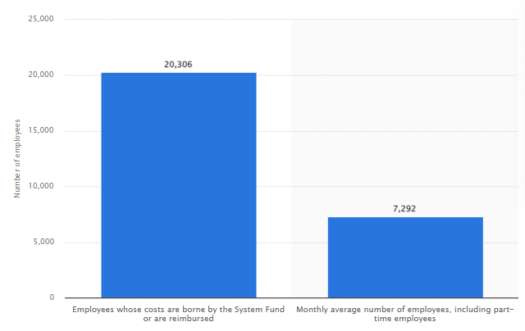
Figure 9: Employees working in the IHG hotels
(Source: Statista, 2024)
From the above figure, it could be identified that there are 7,292 employees working in the IHG hotels across the world in 2023, including part-time employees (Statista, 2024). So, for the hotel, providing a healthy and safer environment for each employee is very important.

5.1.5 IHG’s Hotel Holiday Inn Birmingham City Centre fosters a truly inclusive workplace that allows its employees to thrive, regardless of their background
Inclusivity is one of the most important parts of the IHG's Hotel Holiday Inn Birmingham City working culture. It means that the hotel is providing an inclusive environment for the employee where they are thriving irrespective of their background (Škerháková et.al 2022). According to the DEandI progress report, the hotel employees feel included, valued and respected in every possible manner. At a hotel, it is important to open doors for the employees effectively by breaking off the barriers so that there can only be meaningful differences presented within the workplace. The hotel is also committed to improving diversity in leadership with the aim of doubling the number of female leaders to a higher level by 2030.
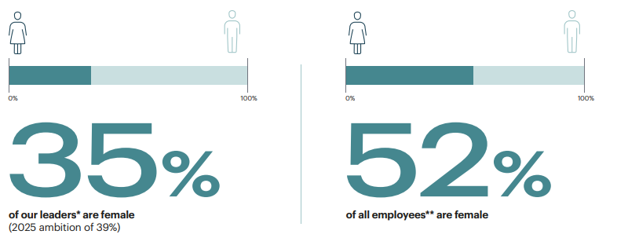
Figure 10: Females in leadership positions in IHG
(Source: IHG, 2025)
For example, in the above figure, it is identified that in 2023, there were 35% of females in leadership positions, which is aimed at having 39% by the end of 2025. Along with this, 52% of the hotel employees were female in 2023 (IHG, 2025). So, irrespective of the employee background, employee participation is fostered within IHG's Holiday Inn Birmingham city centre. This helps to provide an effective culture to the employees, which is helpful in delivering an inclusive workplace as well.

5.2 Exploring implications
The implication of this study will be that IHG's Holiday Inn Birmingham city centre will be able to explore the different reasons for staff shortage. The hotel will be able to determine the different factors or issues that the hotel is facing, especially those related to the prime location of the hotel. With the help of the above data, the hotel will be able to analyse the fact that it is very important to indicate the importance of qualified and well-trained staff for the hotel. The impact of trained staff on the quality of services provided by the hotel is shown in the study, so IHG's Holiday Inn Birmingham city centre can learn from it.

5.3 Acknowledging limitations
The limitation of this study is that there are chances of potential bias from the side of the researcher while collecting and interpreting the information. This means that the researcher is collecting data all by themselves, which means that only information that is relevant to the topic will be selected. The aim will only be drawing conclusions based on objectives rather than exploring the data in an in-depth manner. This also indicates that the limitation of the study is its outdated information that might be collected by the researcher. This means that the researcher might collect outdated data that does not adhere to the principle of ethical consideration.

5.4 Pointing out valuable areas
From the analysis, it could be stated that the valuable area that is critical to the placement hotel's operation is its customer services, which are related to the different amenities provided to them. This means that for IHG’s Hotel Holiday Inn Birmingham City Centre, it is very important to deliver basic amenities to guests, which helps to improve their satisfaction level. This is one of the valuable areas which placement hotels have for attracting more customers from around the world. Along with this, the front office is also an important operation which the hotel needs to focus on as it is valuable.

6. Conclusion and Recommendations

6.1 Conclusion
It is concluded that all the objectives have been achieved and that the research questions have been answered through this study. The first objective was to determine the challenges IHG's Holiday Inn Birmingham City Centre faces regarding staff shortage. It is found that the main challenges hotels face are the technological changes and skill gap, recruitment and selection costs and less time to offer for training and development. From the detailed analysis, it is determined that the hotel faces the challenge of advanced digital and technical expertise, which is the main challenge that leads to staff shortage. Due to new technological developments, the hotel cannot retain the staff as technical skills are required, which leads to a shortage. Thus, it can be said that the study's first objective is achieved.
The second objective was to identify the level and consequences of a staff shortage at the hotel. It is concluded that low wages, poor working environment and limited opportunities for career progression are the main factors that impact the shortage of staff and the consequence of poor organisational efficiency. It is found that limited opportunities for career progression are the main factor within IHG's Holiday Inn Birmingham City Centre, which leads to staff shortage and various consequences like poor idea creation, employee turnover and decreased productivity. From this conclusion, it is determined that a second objective is also achieved in this study.
Finally, the third objective was to know about various factors that enhance the recruitment and retention of staff while improving operational efficiency. It is summarised that monetary and non-monetary benefits, employee recognition and work stress are major factors leading to the recruitment and selection of staff. Within IHG's Holiday Inn Birmingham City Centre, health insurance and employee discounts on hotels are offered to lead to the recruitment and selection of staff. The hotel offers career development opportunities and an inclusive workplace to link retention with operational efficiency. Hence, this study also achieved a third objective.

6.2 Recommendations
The hotel's operational effectiveness and market performance are impacted by the difficulties and outcomes it faces. The hotel's staffing deficiency needs to be addressed; it was discovered. The following suggestions are put up to remedy these issues at IHG's Holiday Inn Birmingham City Centre:
Firstly, Improving Training and Recruiting Methods To draw in more competent applicants, IHG's Holiday Inn Birmingham City Centre should enhance its hiring procedure. This can be accomplished by utilising local employment fairs, online job boards, recruiting agencies, and collaborations with local colleges and universities for internships and placements (Ghani et al., 2022). The hotel should also spend money on a formal orientation program to aid in the rapid adjustment of new hires. Employee flexibility and efficiency will be increased through cross-training across departments in addition to recruitment (Owino, 2023). To ensure seamless operations even in the event of personnel shortages, front desk staff can be trained to help with housekeeping or food and beverage duties at busy times.
Secondly Using Technology to Increase Productivity The use of cutting-edge technology can decrease the need for manual effort while increasing worker productivity. To improve front desk operations, the hotel should use AI-powered mobile check-ins and self-check-in kiosks (Ruel & Njoku, 2021). Furthermore, computerised housekeeping scheduling systems can increase productivity by guaranteeing that rooms are cleaned on time without putting too much strain on employees. Robotics and AI-powered solutions for administrative and housekeeping duties will free up staff members to concentrate on providing excellent customer service, lowering stress levels at work, and increasing operational effectiveness.
Thirdly ⁠Enhancing Workplace Culture and Benefits to Increase Employee Retention IHG's
Holiday Inn Birmingham City Centre should foster a welcoming and inclusive workplace in order to retain employees and raise morale. Cross-cultural activities, frequent employee feedback channels (such as surveys, team meetings, and one-on-one conversations), and recognition initiatives like performance incentives and employee-of-the-month awards can all help achieve this (Royall et al., 2022). Additionally, providing competitive pay, flexible work arrangements, pay raises, wellness programs, and incentives for referrals will aid in luring and keeping top people (Yoopetch et al., 2021). Offering employees clear chances for job advancement will further motivate them to remain with the organisation over the long run.
Fourthly ⁠Operational Excellence through the Implementation of Quality Control Measures The hotel should use strong quality control measures, such as frequent audits and performance monitoring systems, to guarantee constant service quality (Styvén et al., 2022). Employees will be better equipped to handle quality-related issues proactively if clear quality standards are established and they receive extensive training. Establishing a culture of quality in every department will raise service standards, encourage safety, and eventually improve customer happiness and operational success.

By integrating these recommendations, IHG’s Holiday Inn Birmingham City Centre can effectively address staff shortages, improve operational efficiency, and enhance its overall market performance.

References
Adeyefa, A., Adedipe, A., Adebayo, I., and Adesuyan, A. (2023). Influence of green human resource management practices on employee retention in the hotel industry. African Journal of Hospitality, Tourism and Leisure, 12(1), 114-130.
Adisa, T.A., Ogbonnaya, C. and Adekoya, O.D., (2023). Remote working and employee engagement: a qualitative study of British workers during the pandemic. Information Technology and People, 36(5), pp.1835-1850.
Amin, M., Ryu, K., Cobanoglu, C. and Nizam, A., (2021). Determinants of online hotel booking intentions: website quality, social presence, affective commitment, and e-trust. Journal of Hospitality Marketing and Management, 30(7), pp.845-870.
Andersson, T., Stockhult, H., and Tengblad, S. (2021). Strategies for co-workership retention. Human Resource Development International, 24(4), 425-445.
Azimi, M., Sadeghvaziri, F., Ghaderi, Z., and Michael Hall, C. (2024). Corporate social responsibility and employer brand personality appeal: approaches for human resources challenges in the hospitality sector. Journal of Hospitality Marketing and Management, 33(4), 443-469.
Barendregt, B., (2021). Digital ethnography, or ‘deep hanging out’in the age of big data. In Audiovisual and Digital Ethnography (pp. 168-190).Routledge.
BBC News, (2024). Premier Inn owner Whitbread warns of staff shortages as demand recovers. [Online]. Available through: <https://www.bbc.com/news/business-59048014>. [Accessed On: 23rd January, 2025].
Booking.com, (2025).Hilton Birmingham Metropole Hotel.[Online]. Available through: <https://www.booking.com/hotel/gb/hilton-birmingham-metropole.en-gb.html>. [Accessed on: 23rd January 2025].
Booking.com, (2025).Holiday Inn Birmingham City, an IHG Hotel.[Online]. Available through: <https://www.booking.com/hotel/gb/birmingham-city.html>. [Accessed on: 23rd January 2025].
Bryman A. (2008). Social Research Methods, 2nd Ed, Oxford University Press.
Budhwar, P., Malik, A., De Silva, M. T., and Thevisuthan, P. (2022). Artificial intelligence–challenges and opportunities for international HRM: a review and research agenda. The InTernaTIonal Journal of human resource managemenT, 33(6), 1065-1097.
Choy, M. W., and Kamoche, K. (2021). Identifying stabilizing and destabilizing factors of job change: A qualitative study of employee retention in the Hong Kong travel agency industry. Current Issues in Tourism, 24(10), 1375-1388.
Collis, J. and Hussey, R., (2014). Business Research, A Practical Guide for Undergraduate and Post Graduate Students, Palgrave, London.
Cottrel, S. (2011). Critical Thinking Skills: Developing Effective Analysis and Argument, Palgrave Study. Guides, Palgrave Macmillan: Basingstoke.
Cottrell, S. (2014). Dissertations and project reports: a step by step guide. New York: Pallgrave.
Diamantopoulos, A. and Schlegelmilch, B. B., (2002). Taking the Fear Out of Data Analysis, Dryden, London.
EHL Insights, (2024). Hotel industry forecast of the UK. [Online]. Available through: <https://hospitalityinsights.ehl.edu/hospitality-industry>. [Accessed On: 23rd January, 2025].
El-Ghoul, M., Almassri, M. M., El-Habibi, M. F., Al-Qadi, M. H., Abou Eloun, A., Abu-Nasser, B. S., and Abu-Naser, S. S. (2024). AI in HRM: Revolutionizing Recruitment, Performance Management, and Employee Engagement.
Ghani, B., Zada, M., Memon, K. R., Ullah, R., Khattak, A., Han, H., and Araya-Castillo, L. (2022). Challenges and strategies for employee retention in the hospitality industry: A review. Sustainability, 14(5), 2885.
Han, J.W., (2022). A review of antecedents of employee turnover in the hospitality industry on individual, team and organizational levels. International Hospitality Review, 36(1), pp.156-173.
HI Birmingham, (2025). Welcome to the Holiday Inn Birmingham City Centre . [Online]. Available through: <https://www.hibirmingham.co.uk/>. [Accessed on: 23rd January 2025].
Hospitality trends, (2024). Increased demand for staff in the UK hotel industry. [Online]. Available through: <https://www.htrends.com/trends-detail-sid-130872.html>. [Accessed On: 23rd January, 2025].
Hwang, Y., Shi, X. and Wang, X., (2021). Hospitality employees’ emotions in the workplace: a systematic review of recent literature. International Journal of Contemporary Hospitality Management, 33(10), pp.3752-3796.
IHG, (2025). How we’re creating Room to Belong. [Online]. Available through: < https://careers.ihg.com/media/3agndvov/2023-progress-report-jan-11-final.pdf >. [Accessed on: 25th January 2025].
IHG, (2025). Our history. [Online]. Available through: < https://www.ihgplc.com/en/about-us/our-history. >. [Accessed on: 25th January 2025].
IHG, (2025). Our people. [Online]. Available through: < https://www.ihgplc.com/en/responsible-business/people >. [Accessed on: 25th January 2025].
IHG, (2025).Holiday Inn Birmingham City Centre.[Online]. Available through: <https://www.ihg.com/holidayinn/hotels/us/en/birmingham/bhxwm/hoteldetail>. [Accessed on: 23rd January 2025].
IHG, (2025).REVIEWS.[Online]. Available through: <https://www.ihg.com/holidayinn/hotels/gb/en/birmingham/bhxwm/hoteldetail/hotel-reviews>. [Accessed on: 23rd January 2025].
IHG, (2025).The brighter side of travel.[Online]. Available through: <https://www.ihgplc.com/en/our-brands/holiday-inn#:~:text=At%20Holiday%20Inn%20Hotels%20and%20Resorts,you're%20on%20the%20road>. [Accessed on: 23rd January 2025].
Jamil, S., Zaman, S. I., Kayikci, Y., and Khan, S. A. (2023). The role of green recruitment on organizational sustainability performance: A study within the context of green human resource management. Sustainability, 15(21), 15567.
Jones, K., Ksaifi, L., and Clark, C. (2023). ‘The biggest problem we are facing is the running away problem’: Recruitment and the paradox of facilitating the mobility of immobile workers. Work, Employment and Society, 37(4), 841-857.
Karatepe, T., Ozturen, A., Karatepe, O.M., Uner, M.M. and Kim, T.T., (2022).Management commitment to the ecological environment, green work engagement and their effects on hotel employees’ green work outcomes. International Journal of Contemporary Hospitality Management, 34(8), pp.3084-3112.
Kayak, (2025). Holiday Inn Birmingham City Centre.[Online]. Available through: <https://www.kayak.co.uk/Birmingham-Hotels-Holiday-Inn-Birmingham-City-Centre.21032.ksp>. [Accessed on: 23rd January 2025].
Kayak, (2025). Novotel Birmingham Centre. [Online]. Available through: <https://www.kayak.co.uk/Birmingham-Hotels-Novotel-Birmingham-Centre.54024.ksp>. [Accessed on: 23rd January 2025].
King, C., Madera, J. M., Lee, L., Murillo, E., Baum, T., and Solnet, D. (2021). Reimagining attraction and retention of hospitality management talent–A multilevel identity perspective. Journal of Business Research, 136, 251-262.
Kolodiziev, O., Dorokhov, O., Shcherbak, V., Dorokhova, L., Ismailov, A., and Figueiredo, R. (2024). Resilience Benchmarking: How Small Hotels Can Ensure Their Survival and Growth during Global Disruptions. Journal of Risk and Financial Management, 17(7), 281.
Kuhn, K. M., Meijerink, J., and Keegan, A. (2021). Human resource management and the gig economy: Challenges and opportunities at the intersection between organizational HR decision-makers and digital labour platforms. Research in personnel and human resources management, 39, 1-46.
Ladkin, A., Mooney, S., Solnet, D., Baum, T., Robinson, R., and Yan, H. (2023). A review of research into tourism work and employment: Launching the Annals of Tourism Research curated collection on tourism work and employment. Annals of Tourism Research, 100, 103554.
Leskovar, O., (2024). 10 Effective Employee Retention Strategies for 2024.[Online]. Available through: <https://www.docebo.com/learning-network/blog/employee-retention-strategies/>. [Accessed on: 23rd January 2025].
Makos, J., (2024).PESTLE Analysis for Hotel Industry (2024 Updated). [Online]. Available through: <https://pestleanalysis.com/pestle-analysis-for-hotel-industry/#:~:text=UK's%20decision%20to%20leave%20the,the%20meetings%20and%20events%20sector.>. [Accessed on: 23rd January 2025].
Manoharan, A., Jones, J., Jiang, Z. and Singal, M., (2021). Career optimism of culturally and linguistically diverse hotel workers in the pandemic age. International Journal of Hospitality Management, 93, p.102796.
Mazlan, M. R. M., and Jambulingam, M. (2023). Challenges of talent retention: a review of literature. Journal of Business and Management Review, 4(2), 078-091.
Michael, N., and Fotiadis, A. (2022). Employee turnover: The hotel industry perspective. Journal of Tourism, Heritage and Services Marketing, 8(1), 38-47.
Miguez, J. L., Rivo-Lopez, E., Porteiro, J., and Pérez-Orozco, R. (2023). Selection of non-financial sustainability indicators as key elements for multi-criteria analysis of hotel chains. Sustainable Production and Consumption, 35, 495-508.
Mordor Intelligence, (2025).Hospitality Industry in UK Size and Share Analysis - Growth Trends and Forecasts (2025 - 2030). [Online]. Available through: <https://www.mordorintelligence.com/industry-reports/hospitality-industry-in-the-united-kingdom>. [Accessed on: 23rd January 2025].
Mujtaba, B. G. (2022). Workplace management lessons on employee recruitment challenges, furloughs, and layoffs during the COVID-19 pandemic. Journal of Human Resource and Sustainability Studies, 10(1), 13-29.
Nam, K., Dutt, C. S., Chathoth, P., Daghfous, A., and Khan, M. S. (2021). The adoption of artificial intelligence and robotics in the hotel industry: prospects and challenges. Electronic Markets, 31, 553-574.
Nanor, A., Owusu, E., Senyah, M. M., Owusu, E. K. O., and Agyei, S. K. (2022). Recruitment and Selection Policies and Procedures and Their Effects on Organizational Performance: A Case Study. Technium Soc. Sci. J., 35, 405.
Ndiuini, A., and Baum, T. (2021). Underemployment and lived experiences of migrant workers in the hotel industry: policy and industry implications. Journal of Policy Research in Tourism, Leisure and Events, 13(1), 36-58.
Novotel, (2025). Novotel Hotels in Birmingham.[Online]. Available through: <https://novotel.accor.com/gb/city/hotels-birmingham-v0444.shtml.>. [Accessed on: 23rd January 2025].
ONS.GOV.UK, (2021). Hospitality businesses are most likely to be struggling to fill vacancies. [Online]. Available through: < https://www.ons.gov.uk/employmentandlabourmarket/peopleinwork/employmentandemployeetypes/articles/hospitalitybusinessesaremostlikelytobestrugglingtofillvacancies/2021-09-16 >. [Accessed on: 25th January 2025].
Owino, D. (2023). Employee cross-training as a tool for addressing employee loyalty and business environment uncertainties.
Paoli, A.D. and D’Auria, V., (2021). Digital ethnography: a systematic literature review. Italian Sociological Review, 11(4S), pp.243-243.
Papadopoulos, O., and Ioannou, G. (2023). Working in hospitality and catering in Greece and the UK: Do trade union membership and collective bargaining still matter? European Journal of Industrial Relations, 29(2), 105-122.
Piva, G., (2024). Hotel Industry Statistics 2023.[Online]. Available through: <https://radicalstorage.com/travel/hotel-industry-statistics/>. [Accessed on: 23rd January 2025].
Potočnik, K., Anderson, N. R., Born, M., Kleinmann, M., and Nikolaou, I. (2021). Paving the way for research in recruitment and selection: recent developments, challenges and future opportunities. European Journal of work and organizational psychology, 30(2), 159-174.
Putra, F. K. K., and Law, R. (2024). Critical success factors for virtual hotel operator partnership with small-and medium-sized hotels: perspectives of owners and operators. Journal of Hospitality and Tourism Insights, 7(3), 1391-1411.
Race, M., (2021). Is there a solution to the hospitality staff crisis?. [Online]. Available through: < https://www.bbc.com/news/business-57817775 >. [Accessed on: 25th January 2025].
Rahman, M., (2025). PESTEL analysis of the hospitality industry. [Online]. Available through: <https://www.howandwhat.net/pestel-analysis-hospitality-industry/>. [Accessed on: 23rd January 2025].
Roelen-Blasberg, T., (2025). Navigating the Staff Shortage Challenge in the Hospitality Industry. [Online]. Available through: < https://www.mara-solutions.com/post/staff-shortage-challenge-in-the-hospitality-industry#:~:text=The%20UK%20hospitality%20industry%20says,the%20food%20industry%20during%202023. >. [Accessed on: 25th January 2025].
Royall, S., McCarthy, V., and Miller, G. J. (2022). Creating an inclusive workplace: The effectiveness of diversity training. J. Glob. Econ. Trade Int. Bus, 3, 39-55.
Ruel, H., and Njoku, E. (2021). AI redefining the hospitality industry. Journal of Tourism Futures, 7(1), 53-66.
Saunders, M., Lewis, P. and Thornhill, A. (2012). Research Methods for Business Students, FT/Prentice Hall: Harlow.
Sharam, R., (2025). Why a quarter of IHG’s former employees are checking back in. [Online]. Available through: < https://www.hrkatha.com/features/why-a-quarter-of-ihgs-former-employees-are-checking-back-in/ >. [Accessed on: 25th January 2025].
Shiu Pong Ng, K., Rao, Y., Lai, I.K.W. and Zhou, Y.Q., (2023). How internship environmental factors affect students’ career intentions in the hotel industry through the reflective thinking processes.
Škerháková, V., Korba, P., Harničárová, M., and Taha, V. A. (2022). Talent retention: analysis of the antecedents of talented employees' intention to stay in the organizations. European Journal of Interdisciplinary Studies, 14(1), 56-67.
Statista, (2024). Number of employees of the InterContinental Hotel Group (IHG) in 2023. [Online]. Available through: < https://www.statista.com/statistics/223422/intercontinental-hotels-group-number-of-employees/ >. [Accessed on: 25th January 2025].
Statista, (2025).Market size of the hotel industry in the United Kingdom from 2013 to 2023, with a forecast for 2024.[Online]. Available through: <https://www.statista.com/statistics/1364712/hotel-industry-market-size-uk/>. [Accessed on: 23rd January 2025].
Styvén, M. E., Näppä, A., Mariani, M., and Nataraajan, R. (2022). Employee perceptions of employers’ creativity and innovation: Implications for employer attractiveness and branding in tourism and hospitality. Journal of Business Research, 141, 290-298.
The Grand Hotel Birmingham, (2024).Welcome to the Grand Hotel Birmingham. [Online]. Available through: <https://www.thegrandhotelbirmingham.co.uk/>. [Accessed on: 23rd January 2025].
The Standard.UK, (2024).IHG bemoans the recruitment crisis among hotel staff. [Online]. Available through: <https://www.standard.co.uk/business/ihg-recruitment-crisis-among-hotel-staff-holiday-inn-crowne-plaza-b1034332.html>. [Accessed On: 23rd January, 2025].
Urme, U. N. (2023). The impact of talent management strategies on employee retention. International Journal of Science and Business, 28(1), 127-146.
Veal, A J (2006). Research Methods for Leisure and Tourism, 3rd Ed, Financial Times/ Prentice Hall.
Xue, B. W., Lin, H. H., Chen, C. C., Lee, P. Y., and Hsu, C. H. (2022). How to improve the problem of hotel manpower shortage in the COVID-19 epidemic environment? Exploring the effectiveness of the hotel practice training system. Environmental Science and Pollution Research, 29(48), 72169-72184.
Yoopetch, C., Nimsai, S., and Kongarchapatara, B. (2021).The effects of employee learning, knowledge, benefits, and satisfaction on employee performance and career growth in the hospitality industry. Sustainability, 13(8), 4101.
Youneedtovisit, (2025). Hilton Birmingham Metropole – Hotel Review.[Online]. Available through: <https://www.youneedtovisit.co.uk/hilton-birmingham-metropole-review/#:~:text=Prices%20at%20the%20Hilton%20Birmingham%20Metropole%20start,room%20for%20a%20family%20room%20with%20breakfast.>. [Accessed on: 23rd January 2025].
Zhou, X., Chi, C. G. Q., and Wen, B. (2025). Retaining Generation Z employees in the hotel industry: a time-lag study. International Journal of Contemporary Hospitality Management, 37(1), 76-93.

