Course Title: Effective Teamwork and Communication

Student’s Name: HARRIET ERHERE AKPOJOTOR
Student’s Number:2020979
Lecturer’s Name: Anjali Ghosh
Module Code:BMSW4002

Table of Contents

Effective Teamwork & Communication……………………………………….2
Understanding Communication…………………………………………………..3
Models of Communication…………………………..................................4
Communication & Teamwork……………………………………………………..5
Improving Communication In the Workplace………………………………5
Team Dynamics & Development…………………………………………………6
References………………………………………………………………………………….8

Effective Teamwork and Communication Assessment 1
Introduction
In many different cases, different professions and vocations, communication and team work can be understood in a variety of ways, and can be defined using a variety of parameters and criteria. Human communication has always been a fundamental part of human evolution, and the larger socio-cultural development, of the larger human civilisation. Especially in a workplace where professional skills and technicalities are vital for success, and progress within that space and a wider society. Even in personal human relations, communication skills are part of an individual’s most significant, and unique personal attributes and/or abilities a human being can possess. In essence, on a larger scale, communication is also one of the most important contributors to the development of a society as a whole, hence it is one of the most vital elements to the progress, of the individual as well as the collective.
Considering a myriad of significant strides made in the science and technology of communication, there is such a huge number of machinery and/or gadgetry that are now available to deliver smooth, and steady conversation to people in the 21st century, a huge improvement from the dynamics of the same as just a few decades ago. At present, understanding communication, and its basic foundations and implicit dynamics of communication is crucial for a professional to understand, and succeed within their field.
It cannot be overemphasized the significant role that communication plays as one of the most essential and vital elements required for achieving and maintaining successful professional and personal relationships. One of those elements of successful professional life is learning to work or play in groups, and collections of fellow professionals and colleagues. Essentially working in teams is a highly desirable skill in every professional setting, and organisation environment. That is why communication and teamworking skills are some of the two most highly sought-after attributes employers are constantly seeking in their prospective employees, in order to maintain the effective running of their businesses and institutions.
As a consequence of the importance, and interdependence of communication and teamwork, it is impossible to competently understand one without the other (Deland et. al., 2015). To fully understand communication and teamwork, we must first gain an insight into the three main types of communication, and the mechanics of how they work.

Understanding Communication
There are three main types of communication. Speaking, writing, and signing (non-verbal communication) (Narula, U., 2006)
- Written communication is any forms of communication that is conveyed with symbols and codes in a literal form, printed on a hard medium. For instance, Letters, post-cards, e-mails, reports, memos along with other documents).
- Speaking/oral Communication is a form of communication that involves the sounds and audio-visual cues produced from a medium of communication. This is done usually between two entities present in each other’s company, face-to-face or over a telecommunication medium like a telephone or a video/visual call.
- Non-Verbal Communication, which as implied is a form of communication with no verbal cues r codes, no audio messages conveyed. It purely relies on visual cues, like signs and symbols, gestures, actions, expression or body movements, etc (Maund, A., 2017). This form of communication is relatively less popular, and infrequently utilised, as the other two formats, but it is an equally important method of human communication, especially in cases of verbal disability (Foronda et. al., 2016)
The figure below, is an infographic elaborating on the mechanics of communication, and the basic routes of communication between a sender and a receiver, including responses/feedback from each or both (Foronda et. al., 2016)
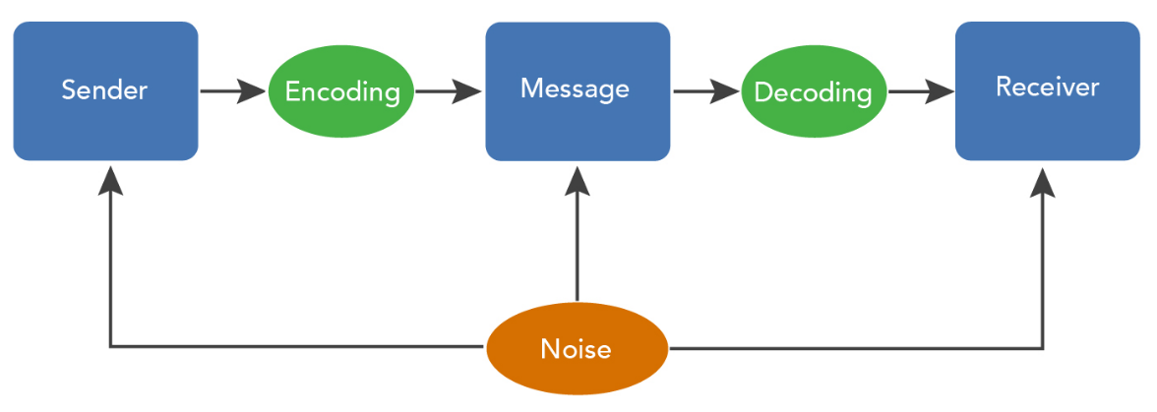
Figure 1: Shannon & Weaver’s Communication cycle
Successful organisations are constantly seeking experts with excellent and fluent communication skills, who are capable of efficiently running a complex organisational structure. The success of such individuals is in a large portion a consequence of their effective grasp of the models of communication, and their knowledge of the real-life methods of utilising their knowledge in building and operating effective team structures within their professional organisations. The more effective their understanding of these theories and models, the more effective they are at deploying their understanding and skill, the more successful their teamworking structures are likely to be (Griffith & Dunham, 2015).
The theories as discussed below, have become an ingredient, essential to understanding the basic models of communication to help the development of effective and progressive communication skills.
Models of Communication
Many academics have extensively studied the nature, and evolution of human communication, and over the last 50years, many theories have been developed to fully comprehend the nature of human communication. There are three main models of communication as listed below, and they cover various routes and dynamics of the process of communication (Narula, U., 2006)
- Shannon & Weaver’s Model of Communication
In the mid twentieth century, Claude Shannon presented one of the earliest models of communication which elaborates on how the dissemination of information takes place and also determines the possible hitches on the routes of communication and hinder the quality and effectiveness of communication.
Shannon and Weaver in this model, extensively describe human Communication as a mathematical theory of communication, arguing that the entire process can be broken down into six linear concepts: sender, encoder, channel, noise, decoder, and receiver
- Aristotle’s Model
This is one of the simplest models of communication that has yet been described, the Aristotle’s model of communication describes the sender/speaker as the author of the whole process which plays the most important role in the transmission of intended information. Literally the speaker is given the entire charge of communication, solely responsible for the clarity and impact of the message. He/she has to prepare clear and meaningful content from the message which can reach the listener easily and the listener will respond according to the influence of the message, which entirely depends on the speaker (Narula, U., 2006). Thus, to create a lasting impression, messages must be conveyed in a clear and loud voice avoiding stammering and/or instability or incoherence.
- Berlo’s Model of Communication
This is one of the most popular and widely accepted models of communication, and is described by Berlo, late lats century. This model lays the importance of thorough communication on both parties, the individual sending the message, and the one receiving the message. As per the model, ‘to properly decode and encode the message, the communication skills of both, sender and receiver, must be fluent. If both are skilled, the communication will be at its best’! The responsibility for the effectiveness of the message is laid on both the sender and receiver (Narula, U., 2006)
- Schramm’s Model
Of all Models described, Schramm’s model elaborates the significance of both sender and receiver, turn by turn, in the message, at different respective stages in the process. This model can be understood as a cycle of communication, where alternatively the sender and receiver are responsible respectively (Narula, U., 2006; Polis et. al., 2017).
Communication and Teamwork
Quality communication in the workplace is an indication of a high-performance, professional culture within a team or organisation, however, effective communication can only occur when the message is accurately sent, and promptly ad clearly received (Narula, U., 2006). In all walks of human endeavour, both professional and personal, effective communication is intrinsic to success and happiness. Effective communication in the workplace is central to all organisational and/or team targets.
The Advantages of Communication in a Team?
- Clear and accurate communication avoids confusion in objectives.
- Communication always conveys a sense of purpose
- Quality communication encourages a positive team culture
- Communication helps complete accountability of each teammate.
Improving communication in a workplace
Improving effective communication within a team always starts at the leader or manager, to meet the teams’ targets. Usually, internal communication is what separates a good team from a great one. Communication within a team, also ultimately defines every team’s goals, and helps teammates collaborate even more effectively, consequently encouraging greater productivity. This is why these skills are preferred by most employers and encouraged in most workplaces. A “team player” will always have an advantage over other attributes in a contemporary recruitment exercise. It’s absolutely crucial to measure communication so a leader or recruiter can develop an idea of “what works, what doesn’t, and tweak it accordingly” (Polis et. al., 2017). Workplace communication is important to a team’s development and success. It allows everyone to share their inputs and feel that their opinions are valued.
There are many communication strategies that a leader can employ as a means for building an effective team, and increasing productivity within any given group (Gordon et. al., 2015) some of these strategies are explored below:
- Always seeking and employing the right tools for the team or organisation. Employing cutting edge technology, with tools such as Skype, slack, and Zoom can help teams build team communication, and providing a total seamless communication process.
- Encourage two-way communication. Teams must endeavour to encourage teammates to keep raising questions and/or voice their opinions. Making sure the team feels more inclusive, aware, and empowered.
- Regular commendations and a reward system, by celebrating successes, telling what team is doing right. It is a good practice to positively reinforce the team, about its strengths on a daily basis.
- Concrete, specific and descriptive feedback. The team must be clearly directed and instructed on all occasions. Positive and constructive critiques must be encouraged at all times on what needs to be improved.
- Scheduled and regular team consultations, and check-ins among team-mates. Practice short, quick meetings and/or calls with a very specific agenda is an advantageous practice.
- Regular team building activities. It is well known that teams with more engaged players tend to do better, and be more productive for themselves and the team as a whole (Polis et. al., 2017). Team building activities always encourage engagement and productivity.
Within every team, organization, or workplace, it is critical to build a healthy, beneficial, and productive communication process. The effectiveness of every team/organisation’s communication is key to reaching long-term success, and ensuring it follows strategies like as above. Whatever stage of development the team is in, effective communication will always be essential to its success (Hills, L., 2014).
Team Dynamics & Development
Usually a Team’s dynamics are the unique psychological forces that influence the direction of a team's performance and success (Polis et. al., 2017) Those dynamics are created by team players involved, and how they all interact within the team, especially how they communicate. Understanding a team's dynamics can help predict the success of the long-term success of that team (Gordon et. al., 2015), and one of the most effective ways of understanding a team’s dynamics, are the communication processes employed within the team.
There are various theories about the development of team dynamics, but the two most prominent ones, are the Tuckman’s and Belbin’s theories of team development, and the communication strategies plays acritical role in both processes of team development and success (Griffith and Dunham, 2015)

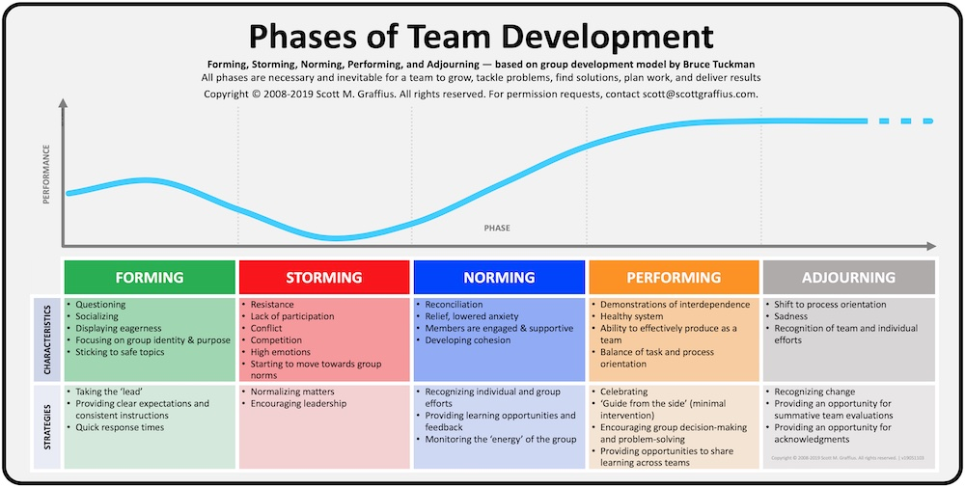
Figure 2: Tuckman’s Phases of team development.
Conclusion
As a consequence of the many studies over the past half century, and as discussed above, looking at the available evidence, it has become clear that effective communication is one of the most critical factors in the development of successful team work, and long term team success within any team, organisation, and/or society. Every successful means of individual or team/group development includes extensive evolution, and competent practice of excellent and effective communication. Hence the key attribute of the successful functionality of every team is equally excellent communication skills of the team players therein, and whatever organisational culture that encourages effective communication can be expected to enjoy long term success within its field of enterprise, especially within highly interpersonal fields like healthcare setting.

References
Deland, E., Gordon, J.E., Kelly, R.E. (2015). Let’s Talk About Improving Communication in Healthcare. Col Med Rev 1(1);23-27. May 2015.
Foronda, C., MacWilliams, B., McArthur, E. (2016). Interprofessional communication in healthcare: An integrative review. Nurse Education in Practice, Volume 19, 2016, Pages 36-40.
Gordon, J., Deland, E., Kelly, R. (2015). Let’s Talking About Improving Communication In healthcare. Columbia Medical Review, Vol.8. Academic commons.columbia.edu
Griffith, B.A., & Dunham, E.B.(2015). Working in teams. Sage Books.
Hills, L. (2014). Overcoming the Ten Most Common Barriers to Effective Team Communication. Podiatry Management, Vol.12: 2014
Leonard, M., Bonacum, G.S. (2004) The human factor: the critical importance of effective teamwork and communication in providing safe care. Qual Saf Health Care 2004;13(Suppl 1): 85–90.
Maund, Andrew, (2017) Certificate in higher education; skills for the workplace. Student yearbook SAGE Publications
Narula, U. (2006). Handbook of Communication Models, Perspectives, Strategies. Atlantic Publishers & Distributors, 2006.
Polis, S., Higgs, M., Manning, V., Netto, G., Fernandez, R. (2017). “Factors contributing to nursing team work in an acute care tertiary hospital” Collegian, Volume 24, Issue 1, 2017, Pages 19-25, ISSN 1322-7696,

