
Knowledge and information management Report for Amazon inc.
Knowledge and Information Management Skills for the Workplace: BMSW5106

April 6, 2023
Sabrina reid 1920873
LECTURER: DR SUJEEWA HEARTH

Table of Contents
Introduction 2
Amazon Inc 2
Fulfilment by Amazon 2
Amazon’s Competitive Edge 4
Amazon’s Knowledge Management System 5
Amazon’s Value Chain and Knowledge Management System 6
Amazon’s Management Information Systems and Customer Relationship Management 8
Amazon’s Web Service, Wide Area Network and Virtual Private Clouds 9
Recommendation 13
References 13

Introduction

Amazon Inc
An American e-commerce corporation known as Amazon is a business to consumer (B2C) organisation that conducts business throughout the globe in a number of host markets. It provides a variety of goods, along with an assortment of additional everyday items. The business produces and markets electronic gadgets like Kindle e-readers, Fire tablets, Fire TVs, and Echo. Additionally, it offers online services, order fulfilment, publishing, advertising, and services for co-branded credit cards (MarketLine, 2022).
Therefore, the goal of this study is to examine Amazon's offerings, business strategy, value chain, and expertise requirements. The analysis of Amazon's management information systems (MIS), supply chain systems, and systems for customer relationship management, in addition to an explanation of their functions and the significance of fulfilling knowledge requirements, show how their explicit and tacit knowledge helps them generate operational, tactical, in addition to strategic decisions.
The report is divided into seven sections: Fulfilment by Amazon, Amazon’s Competitive Edge, Amazon’s Knowledge Management System, Amazon’s Value Chain and Knowledge Management System, including Amazon’s Management Information Systems and Customer Relationship Management, Followed by Amazon’s Web Service, Wide Area Network and Virtual Private Clouds. Concluding with recommendations that could improve the e-commerce operational procedures throughout the future, potentially increasing the efficacy of the entire corporation.

Fulfilment by Amazon
There are no long-term agreements or contracts between Amazon and its merchants that would ensure the availability of goods, certain periods for payments, or an increase in credit limits. The core underpinning Amazon inbound logistics with privately held retail businesses is Fulfilment by Amazon (FBA). Additionally, for Amazon's inbound logistics, efficiency gains are quite a significant source of value generation. Through receiving and storing raw materials in order to generate goods and services, is referred to as inbound logistics in Amazon’s value chain analysis. The e-commerce maintains intricate yet effective inbound logistics operations due to the vast worldwide reach of its activities, their list of competitive advantages also includes this formidable logistical infrastructure (MarketLine, 2022).

Figure 1: Amazon FBA Management Software
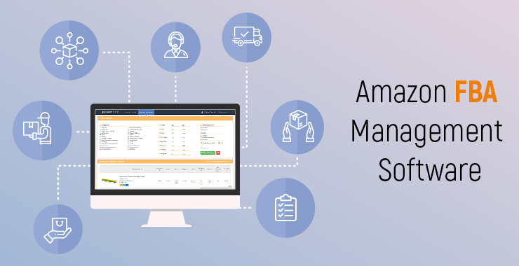
(Esellerhub, 2020)
Additionally, sellers may use FBA by storing their stock in Amazon fulfilment facilities. Shipping, customer support, and product returns are all handled entirely by Amazon in this B2C segment. Up to 1,400 jobs could be generated when a new Amazon storage facility opens in the Midlands, and that figure could increase over the coming years. A robotic fulfilment facility at Peddimore, Sutton Coldfield, is expected to be operational in the next three years, according to the corporation (BBC News, 2023). At Syracuse event on June 23rd, 2022, (McMahon, 2022) declared, "What we're speaking of has been around $400 million spent in this community by perhaps the finest logistics business worldwide in addition to one of the leading technology firms in the world". Furthermore, (McMahon, 2022) stated that Amazon contributed over $1.75 million to the downtown Syracuse STEAM school's robotics and computer science technology upgrades. Science, technology, engineering, art, and maths are collectively referred to as STEAM.
CLAY - The new robotic fulfilment centre for Amazon (NASDAQ: AMZN), located at 7211 Morgan Road in Clay, is the company's biggest New York facility. According to (Cruickshank 2022), director of public policy and community engagement for Amazon in New York for the e-commerce B2C behemoth based in Seattle, Washington. The more than 3-million-square-foot, five-story centre has been open since early May. With ambitions to hire more, the centre currently has 1,500 employees (Cruickshank, 2022). claims that there are numerous employment options available for members of this community. The most recent robotic technology is used by Amazon staff. According to (Ulatowski, 2022), the concept was conceived as a means of boosting the local economy and providing "an effective manner" for inhabitants of the Northeast to receive consumer items.
Amazon will concentrate on retaining multitudes of smaller things while they await to be sold. The organization disclosed that the second stage of its sales process involved a fulfilment centre, which acquired products from merchants shortly after they first delivered at one of the company's two sizable centres in Coventry or Doncaster. Once purchased and transferred to processing and distribution centres, the products are subsequently held in the fulfilment centres (BBC News, 2023). Boysen, de Koster, and Weidinger (2019) claim that due to their application performance (by incorporating robots and stations), high picking performance (of around 600 order-lines for every hour and picker), and the system's durability, robotic mobile fulfilment infrastructures are well suited for short deadlines, large assortments, and small order sizes in especially in the B2C field of e-commerce (Wurman et al., 2008).
A large increase in efficiency is achieved when a consumer orders both an FBA item along with an item from Amazon's own inventory. Merchants do have the option of using FBA, which qualifies their items for their free two-day shipping, free shipping, and other perks associated with Amazon Prime (BBC News, 2023). Moreover, a new generation of warehouses has emerged as a result of the e-commerce industry's steadily rising sales volumes over the recent decade (Statista, 2017). These warehouses are especially designed to meet the unique demands of online retailers who directly meet the demands of final customers throughout the business-to-consumer (B2C) sector ( Boysen et al., 2019).

Figure 2: Benefits of Amazons FBA
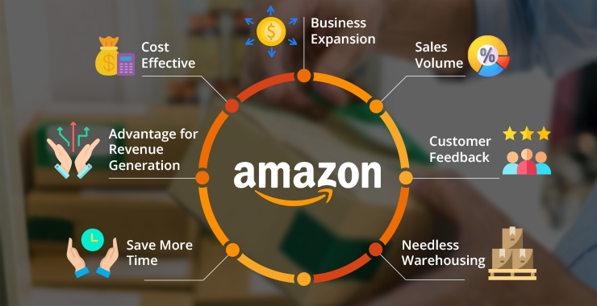
(Esellerhub, 2020)

Amazon’s Competitive Edge
Amazon sells its goods via the www.amazon.com website, and also has a presence on other foreign websites, services in retail, consumer electronics, digital and computer, digital media, and other regional markets. 200 million Prime members globally, with 310 million active users, for the fiscal year that concluded in December 2021 (FY2021), the firm generated revenues of US$469,822 million. Amazon presently holds the top spot in both the US and the worldwide e-commerce markets (MarketLine, 2022).
A strategy to attaining a competitive advantage generated from the exploitation of novel concepts and emerging technology is known as "openness to innovation," and it gauges a company's propensity for change (Harryson, 2008). The ability of businesses to innovate is strengthened by the adoption of technical solutions for the advancement of novel routines, practises, and products, allowing them to adapt to the requirements of a market that is constantly changing (Gil-Gomez, Guerola-Navarro, Oltra-Badenes and Lozano-Quilis, 2020).
Amazon competes in a very competitive market. The business contends with rivalry from several global industries. Selection, cost, and convenience, including prompt and dependable delivery, are its retail business's primary competitive advantages along with the company's services, tools, quality, responsiveness, and dependability, as well as its clients' capacity and openness to adopt new approaches to business are competitive considerations for its vendor and enterprise services also. A few of the company's main rivals are multichannel, online, and offline retailers, publishers, vendors, manufacturers, and producers, which include Dollar Tree, eBay, Best Buy, Target, and Wal-Mart (MarketLine, 2022).
As a consequence, innovation is also regarded as a governance matter that impacts the company model and compels business owners to establish intervention plans that can accommodate the demands of a market that is becoming more competitive and international (Ghezzi and Cavallo, 2020).
Some of Amazons top rivals have more resources, a more established history and client base, higher brand awareness, and more control over the inputs crucial to their diverse industries. These rivals have the ability to negotiate better terms with their suppliers, incorporate more aggressive pricing strategies, pursue distribution agreements that limit their access to supplies, steer customers toward their own products, bind potential customers with onerous terms, and invest more resources to advanced technologies, infrastructure, fulfilment, and marketing. The growth of Amazon's revenue and profitability may thus be impacted by greater competition (MarketLine, 2022).

Amazon’s Knowledge Management System
Approaches that enhance the importance of knowledge and knowledge management systems (KMS), promoting the development of shared and integrated systems capable of enhancing corporate performance, must find a place within the industry (Abubakar, Elrehail, Alatailat, and Elçi, 2019; Del Giudice and Della Peruta, 2016; Santoro and Ferraris and Bresciani, 2019). Since knowledge management systems are designed to optimise performance and enhance process management through the accumulation and exploitation of data, it provides the most efficient use of physical resources (Grant, 1996 and Bresciani, 2010).
Amazon launched its prime customer reward programme in 2007, additional services added to Prime which include streaming music, movies, and gaming. One of the advantages of Amazon Prime is that the majority of their products are eligible for free express delivery without a minimum order restriction. Due to these, consumers apparently purchase a far greater quantity of goods when using Amazon Prime than they would ordinarily, as a result of their habituation to free of charge coupled with the extra rapid shipments and operational speed from Prime (Amazon, 2018).
Utilizing big data facilitates knowledge acquisition and sharing between the organization as well as the external community (Schwertner, 2017), (Scuotto, Santoro, Bresciani and Del Giudice, 2017). Big Data, which is defined as huge data collections comprising a heterogeneity of information (Rialti et al., 2019a; 2019b), this enables businesses to accumulate, process, and protracted preserving rich digital content (Candela et al., 2007). Furthermore, identifying the condition of operations and assets via more complex analysis tools and identifying the degree of linkages between the data stored in the database gives the organisation a competitive edge (Ferraris, Mazzoleni, Devalle, and Couturier, 2019).

Amazon’s Value Chain and Knowledge Management System
Amazon’s annual Prime Day sale offers discounts on well-known brands and local companies, it is the company's largest bargain event of the year. As a gesture to honour Prime members on Amazon's 20th birthday, the event officially launched for consumers on 15th July 2015 (Amazon, 2022). Prime Day is classed as a customer shopping "holiday", which increases sales. The strategy was executed impeccably, as this event has increased profits yearly (Amazon, 2022). The typical Prime member is considered to spend more on Amazon, compared to non-Prime members, as a result of customers comfortability upon Prime’s free delivery, they will purchase products from Amazon, irrespective of whether it is of lower quality or could be obtained for less somewhere else (Amazon, 2022).

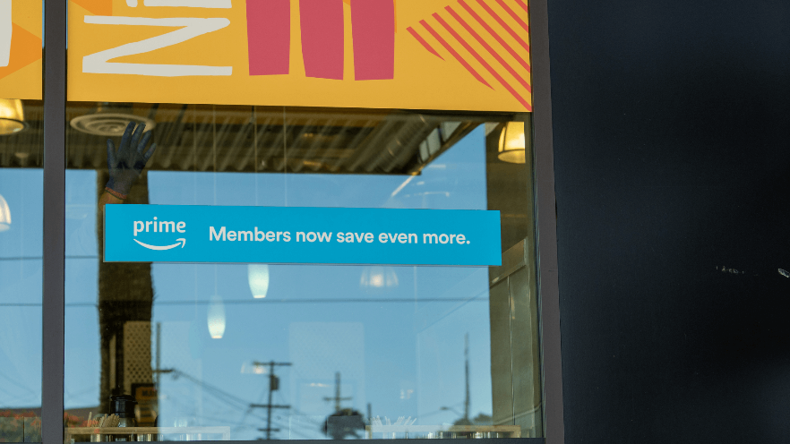
Figure 5: Prime
(Rubin, 2016).
As a result of this strategy in their value chain, this pushes the customer to make larger purchases in order to receive the free delivery, which also works ideally with increasing Amazon’s knowledge of market sales. An effect of creating individual profiles for each of their customers, Amazon are able to establish thorough records of each of their shopper's transactions and product searches, using item-to-item collaborative filtering, the recommendation algorithm will go over the visitor's most recent purchase history and draw up a list of similar things. All of the lists' choices for recommendations to the customer has items that appear often.
Customers can enter their required product in the search engine that appears as the website loads up, at which point they browse the database to locate the product along with additional goods a like. Once the relevant product has been identified, the customer has the choice to purchase the required product and make a payment with a bank card, gift certificate or utilising Paypal. Depending on the specified destination, the customer can expect to receive the product after it has been dispatched either next day, utilising prime delivery or within a matter of days to a few weeks.
This enables Amazon to provide product recommendations based on customer's prior purchases and preferences, all whilst customers are exploring Amazons website searching for the ideal/required product (Hardesty, 2019). As according to open innovation theory, a comprehensive cognitive strategy can enable the business to effectively utilise internal knowledge and take in outside knowledge about the changing environment (Alexy, Bascavusoglu-Moreau, and Salter, 2016; Del Giudice and Maggioni, 2014; Ferraris, Santoro, and Dezi, 2017; Santoro, Vrontis, Thrassou, and Dezi, 2018)
For instance, with this information Amazon strategy, should their customers purchase 678 thousand printers out of a million, is to establish recommendation offers for printers, ink, paper, cartridges, and all computer-based items such as laser printers, shredders, mice, keyboards, headsets, laptops, laptop bags and so forth. All whilst maintaining focus on the inventory database as this is also essential since it indicates the quantity of stock that is available, and continuously regulates to include the number of printers that remain on the database after sales. This also signifies the number of products require for restocking, along with the brands that have the highest number of sales (Hardesty, 2019). Amazon must gather data, information, and knowledge in any format, then evaluate it for a variety of purposes and in different methods for the company to maintain its relevance with its supply and demand, pricing structure, and current market trends.
The data amazon gathers are storage for use to monitor, which merchandise are high sellers and what products require restocking. It is also utilized to categorize the merchandise that customers are purchasing from the various venders and companies. Additionally, to secure a competitive advantage, they must monitor the sales forecast. Companies may progress and strengthen their businesses through digital transformation using big data information that assists them when spending money effectively and refrain from wasting money on restocking unnecessary products.

Amazon’s Management Information Systems and Customer Relationship Management
These frequently suggested additional items are also corresponding to previous customers that have similar profiles and purchased items. Amazon accomplishes this by comparing their customers purchases to that of other buyers who have similar purchases, through utilizing digital transformation and big data. A common model used for Amazon's shopping recommendations is a matrix completion problem. Imagine a sizable grid where the rows are Prime Video subscribers, and the columns are the movies available on Prime Video. The matching box in the grid includes a digit if a consumer has seen a certain movie, otherwise, it is blank. The grid must be filled with the odds that each consumer will view each movie as part of the matrix completion process (Hardesty, 2019).
A typical deep neural network has layers made up of hundreds or even millions of basic processing units. The output of the top layer indicates the outcome of some calculation. Data is supplied into the cells of the bottom layer, which analyse it and transfer their findings to the following layers, and so forth. Many inputs and outputs are provided. The network's parameters are continuously modified between the top and bottom outputs. Through the use of big data, these proposals, which also include societal pressures and targeting, is all a part of Amazon’s knowledge management strategy, as they are structured to be enticing, as customers are reluctant to pass up on what some other customers may have acquired (Hardesty, 2019).
Data storage is only advantageous if it can be put to efficient use. Both the tactical implementation of the strategy and the strategic planning process at forward-thinking businesses utilise this data. Companies can monitor sales statistics, costs, and productivity levels thanks to management information systems (MIS). The data can be utilised to improve the operational efficiency, analyse profitability over time, and pinpoint areas for development. Information technology (IT) is being used by businesses to enhance the way they plan and handle customer relations. CRM (customer relationship management) systems record every encounter a business has with a customer in order to provide a richer experience. When a consumer phones a contact centre with a problem, the customer service representative will have the ability to quickly resolve the issue by reviewing what the customer had ordered plus viewing their shipment details.
As an outcome, the development of a solid cognitive architecture that can ensure effective exploitation as well as conservation of information will support economic innovation processes utilizing intelligent infrastructures and collaborative methodologies that are interaction-based (Santoro et al., 2018). Knowledge management strategy, consequently, impacts the business performance since it encourages innovation, which subsequently strengthens competitive advantage (Martín-de Castro, Lopez-Saez, Delgado-Verde, Andreeva and Kianto, 2011; Costa and Monteiro, 2016; Zack, McKeen and Singh, 2009).
Based on the cards that the clientele owns and whether or not they are Prime members, customers who make purchases on Amazon credit cards can receive cash back. Prime members may very well receive a higher reward percentage on certain purchases also. Therefore, with these various money back prospective, Amazon may well be able to entice their consumers to make extra additional purchases, since utilising the knowledge acquired from previous product transactions, combined with increasing their product sales. This can be achieved through tailoring specific sales towards particular groups of customers. Amazon have ensured by choosing this method of payment their customers may also purchase an item instantly, with one tap of a button, utilising Amazon’s Buy Now function, and the transaction will be automatically transferred to a pre-approved payment method like their preferred credit card (Parker, 2022).
Online vendors may compare prices indefinitely using third-party cost tools and algorithms, basing their judgments on the most recent machine learning technology as well as market trends. Additionally, this gives their vendors the ability to gradually increase their income over time or to expand them seasonally or during the holidays (Melnychuk, 2022).

Amazon’s Web Service, Wide Area Network and Virtual Private Clouds
Amazons Web Services (AWS) "Security of the Cloud" mission include safeguarding the infrastructure that powers all of the services provided by the AWS Cloud. The facilities, networking, hardware, and software used to execute AWS Cloud services make up this infrastructure (MarketLine, 2022). AWS is familiar with and has direct knowledge of the daily struggles experienced by early-stage start-ups. Since 2006, when Amazon Web Services (AWS) introduced the world to cloud infrastructure, it has partnered with several hundred thousand entrepreneurs worldwide to assist them in establishing, growing, and expanding their companies (MarketLine, 2022). With pay-as-you-go pricing, cloud computing provides IT resources on demand through the Internet (Aws, 2021).
Therefore, a cloud provider may be used to access technological services including storage, databases, and computing power on an on-demand basis without than having to purchase, manage, and maintain physical data centres or servers (Aws, 2022).

Figure3: Amazon Shared Responsibility Model
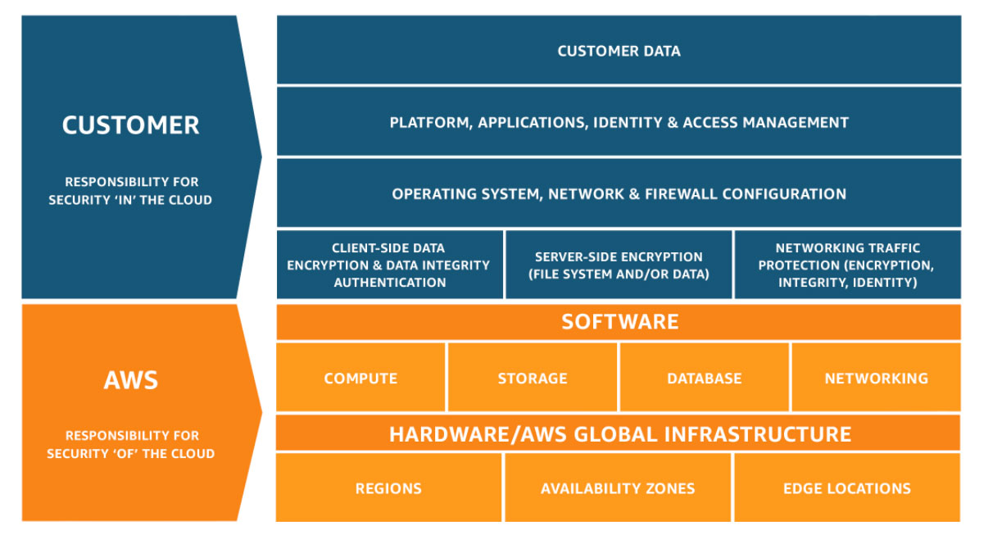
(Aws, 2022).
AWS is an extremely sophisticated and broadly used worldwide cloud platform, which provides a widely extensive and most in-depth range of services. AWS is trusted by millions of customers to power their apps and infrastructure (MarketLine, 2022). AWS services are being utilized by start-ups and companies of all sizes and sectors to experiment, innovate more efficiently, reduce expenses, and improve flexibility. Since Amazon handles the labour-intensive tasks, entrepreneurs may create and manage almost any kind of application (Aws, 2021).
For instance, the Kindle Direct Publishing, a web-based tool that enables independent writers and publishers to choose a royalty option and render their titles available in the Kindle Store, Amazon provides services to content producers like authors and independent publishers (MarketLine, 2022). Along with, social networks, smart cities, genetic research, gaming, streaming videos, online banking, and numerous other types (Aws, 2021).
There are no up-front payments or long-term commitments required to use these services, as the pay-as-you-go business model enables entrepreneurs and publishers to test out several technologies and royalty options until they choose the ones that best suit their requirements and reduce time to market (MarketLine, 2022). Start-ups may create their features and products more quickly and at a lower cost with this approach (MarketLine, 2022). AWS services exist in a variety of sizes, shapes, and forms, from core technologies like computation, storage, and databases, to cutting-edge ones like artificial intelligence and machine learning, data lakes, among many others (Aws, 2022).
While AWS controls all infrastructure and underlying resources, certain services allow users complete control (MarketLine, 2022). For all other applications, AWS is in charge of the overall stack's operation and security, all the user has to do is utilise it. This is what Amazon mean by the shared responsibility paradigm. However, a newly maintained Wide Area Network (WAN) service called AWS Cloud WAN was made available in July 2022 by Amazon Web Services, Inc (MarketLine, 2022). To make managing a worldwide network easier, the service links branch offices, cloud resources, and on-premises data centres (Amazon, 2022).
Customers can potentially examine the health condition of their global network, specify their network configuration, and automate routine security and configuration processes. By simply clicking a button, customers can link existing branch offices, data centres, as well as Amazon Virtual Private Clouds (Amazon VPCs) using the single dashboard provided by AWS Cloud WAN, creating a worldwide network (MarketLine, 2022). Network policies allow users to centrally automate network administration and security operations. To assist users in keeping track of the performance, security, and health of all on-premises and AWS networks, Cloud WAN creates a comprehensive picture of both networks (Amazon, 2022).

Figure 4: AWS Cloud WAN, Build, manage, and monitor global wide area networks.
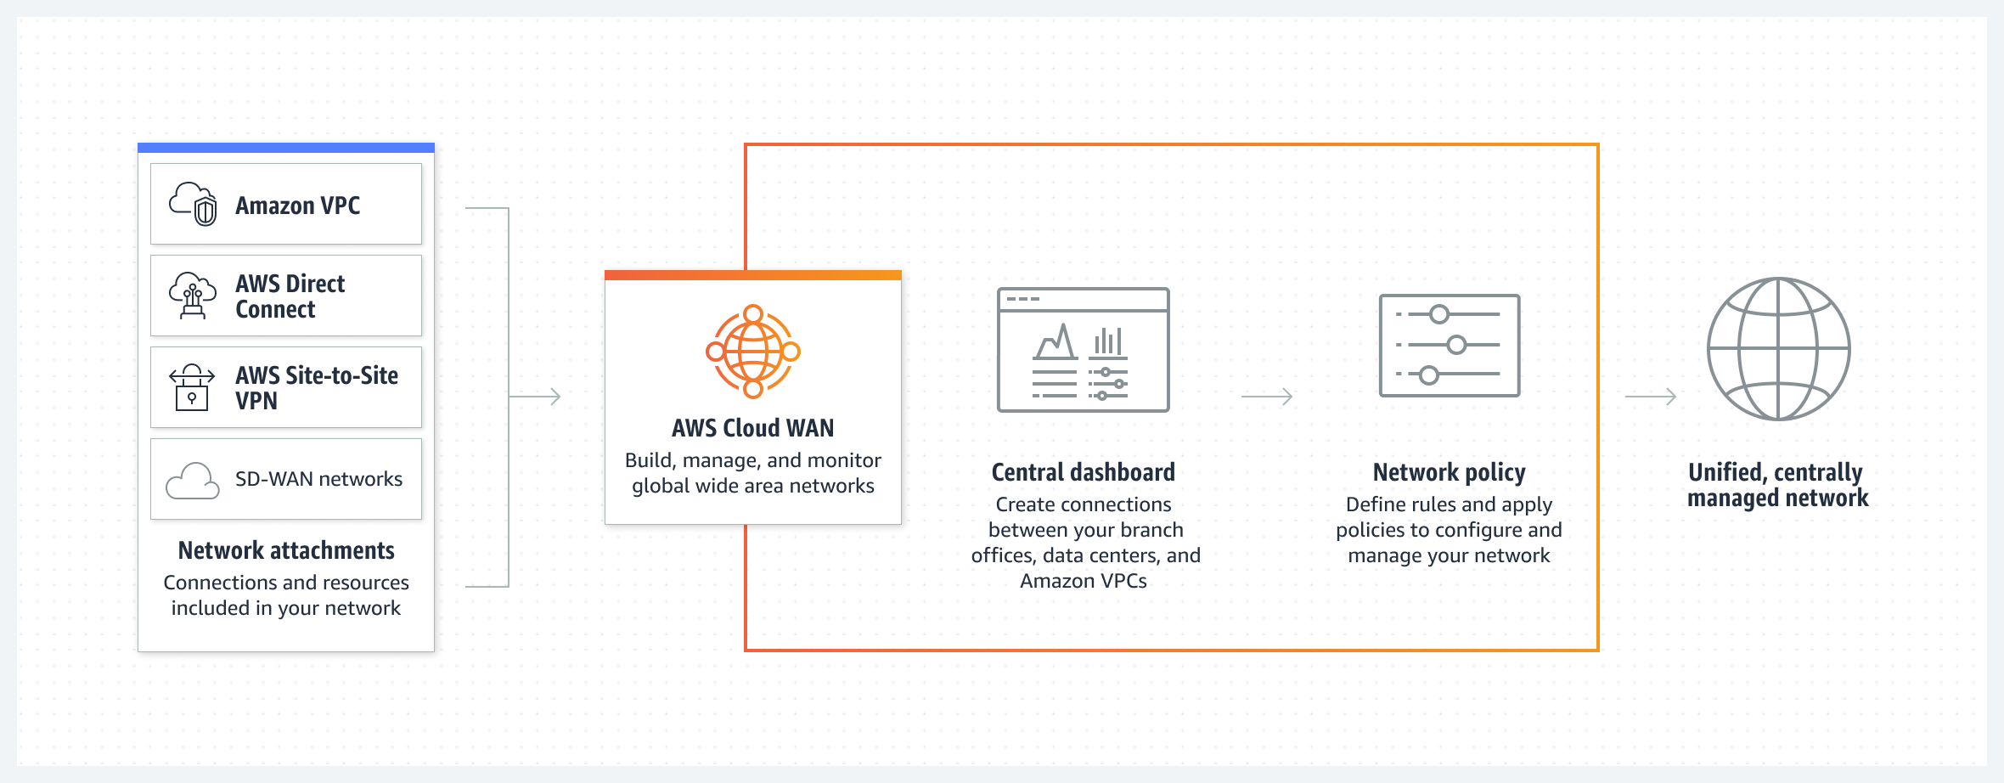 (Aws, 2022).
The US government's increasing involvement may harm the company's chances, as Amazon is governed by rules and regulations that apply to all businesses, as well as laws and regulations that are special to the Internet, e-commerce, electronic equipment, along with various other services (MarketLine, 2022). Any current or future law pertaining to taxes, data security, privacy, cost structure, content, distribution, copyrights, communications technology, electronic waste, energy usage, electronic contracts, environmental regulation, other communication services, competing, consumer safety, work opportunities, trading and protectionist initiatives, online services, the provision of digital payment services, information disclosure requirements, and other related topics. Every undesirable concern with rules and regulations may potentially reduce consumer demand for Amazon's goods and services along with raising their operating costs (MarketLine, 2022).
Moreover, the operations of Amazon's company might be impacted by changes in seasonality. Amazon maintains sufficient inventories of popular items to match client demand in order to lower risk. Changes in the seasons may have an impact on the company's finances and potential future growth. To decrease inventory, the company must overstock items, which results in commitment costs and may lower profitability. Due to free upgrades, divided shipments, and increased long-zone shipments required to guarantee on-time arrival for the Christmas season, the organisation may possibly see a net increase in shipping costs (MarketLine, 2022).
Due to increasing demand, Amazon may have system outages that prohibit its websites from being accessible or impede it from properly processing orders, in the case that a significant number of consumers utilize it within a short time frame. The pause can cause Amazon to sell fewer products and see a decline in demand for its goods and services. Additionally, the corporation wouldn't be able to staff its fulfilment network and customer support offices effectively during these busy times (MarketLine, 2022). More than 1,300 employments will be impacted by Amazon's plans to close three of its more than 30 UK fulfilment facilities and seven small delivery locations.
These adjustments occur as consumers cut their spending habits and the online company contends with unpredictability in the global economy. "We're continually analysing our network in order to be sure it suits our business goals and to enhance the experience for both customers and employees," an Amazon spokesman stated. “We will potentially close older locations as part of such an endeavour, upgrade current facilities, or build new locations. We have also started a discussion on the idea of closing three warehouses in 2023” (Butler, 2023).
Nearly every single company is impacted by economic developments. Consumers purchase more goods and services whenever the economy is flourishing as they possess extra money to spend. However, nearly every business experiences a slowdown when the economy falters as a result of consumers' reduced spending. In order to survive economically challenging times, many corporations dismiss or lay off workers. One of these unstable times is currently affecting the economy. When it comes to recruiting, expanding, and spending, most companies are all being vigilant and cautious. Business is still impacted by technology. On the one side, the expanding use of automation has reduced the need for laborers in certain areas, while on the other side, additional workers are required to procure, manage, and analyse robotic equipment.

Recommendation

The best course of action for Amazon is to investigate more in depth regarding other companies that manage efficient fulfilment centres and how these fulfilment facilities impact older employees, new employees along with the people residing within the local community. These new fulfilment centres will impact Amazons FBA, so it is imperative for them to identify exactly where they can be efficient in improvements, to be advantageous to Amazon in a productive manner. For instance, through providing their employees more flexible hours.

References

Abubakar, A. M., Elrehail, H., Alatailat, M. A., and Elçi, A. (2019). Knowledge management, decision-making style, and organizational performance. Journal of Innovation and Knowledge, 4(2), 104–114. https://doi.org/10.1016/j.jik.2017.07.003
Amazon. (2018). Amazon Prime. [Online]. [29 November 2022]. Available from: https://www.aboutamazon.co.uk/news/innovation/amazon-prime
Amazon. (2022). Everything you need to know about Prime Day. [Online]. [2 December 2022]. Available from: https://www.aboutamazon.com/news/retail/when-is-amazon-prime-day-2022
Amazon. (2022). Amazon Prime. [Online]. [2 December 2022]. Available from: https://www.amazon.com/gp/help/customer/display.html?nodeId=G6LDPN7YJHYKH2J6
Amazon. (2020). Lightning Deals. [Online]. [29 November 2022]. Available from: https://www.amazon.com/gp/help/customer/display.html?nodeId=GW3L8JX7Q9FH8ALB
Amazon. (2022). AWS Cloud WAN concepts. [Online]. [2 December 2022]. Available from: https://docs.aws.amazon.com/network-manager/latest/cloudwan/cloudwan-concepts.html
Aws. (2022). Shared Responsibility Model. [Online]. [2 December 2022]. Available from: https://aws.amazon.com/compliance/shared-responsibility-model/
Amazon. (2022). The Amazon Prime Membership Fee. [Online]. [2 December 2022]. Available from: https://www.amazon.co.uk/gp/help/customer/display.html?nodeId=G34EUPKVMYFW8N2U
Aws. (2021). Cloud computing with AWS. [Online]. [2 December 2022]. Available from: https://aws.amazon.com/what-is-aws/?nc1=f_cc
Aws. (2022). How AWS Works. [Online]. [25 November 2022]. Available from: https://aws.amazon.com/startups/start-building/how-aws-works/
Aws. (2022). AWS Cloud WAN Build, manage, and monitor global wide area networks. [Online]. [29 November 2022]. Available from: https://aws.amazon.com/cloud-wan/
BBC news. (2023). New Sutton Coldfield Amazon centre to create 1,400 jobs. [Online]. [28 February 2023]. Available from: https://www.bbc.co.uk/news/uk-england-birmingham-64250477
Boysen, De Koster and Weidinger. (2023). Stronger mixed-integer programming-formulations for order- and rack-sequencing in robotic mobile fulfilment systems. European Journal of Operational Research. [Online]. 305(13), 1063-1078. [7 March 2023]. Available from: https://www-sciencedirect-com.ezproxy.uwtsd.ac.uk/science/article/pii/S0377221722005264#bib0008
Boysen, N, De Koster, R and Weidinger, F. (2019). Warehousing in the e-commerce era: A survey. European Journal of Operational Research. [Online]. 227(2), 396-411. [7 March 2023]. Available from: https://www.sciencedirect.com/science/article/pii/S0377221718307185?via%3Dihub#bib0109
Business research methodology. (2016). EBay Value Chain Analysis. [Online]. [6 December 2022]. Available from: https://research-methodology.net/ebay-value-chain-analysis/
Butler, S. (2023). Amazon to shut three UK warehouses, putting 1,300 jobs at risk. [Online]. [2 March 2023]. Available from: https://www.theguardian.com/technology/2023/jan/10/amazon-shut-uk-warehouses-jobs-doncaster-hemel-hempstead-gourock
Candela, L., Castelli, D., Ferro, N., Ioannidis, Y., Koutrika, G., Meghini, C., and Schuldt, H. (2007). The DELOS digital library reference model. Foundations for Digital Libraries.
Cruickshank, J. (2022). Amazon's robotic-fulfilment centre in Clay formally opens. The Business Journal - Central New York; Syracuse. [Online]. 36(28), 3. [7 March 2023]. Available from: https://www.proquest.com/docview/2688129630?parentSessionId=f2nst%2BqpMDMDMh6M9gIQVQsC85UZtRxRMZrmOEPBRvc%3D&pq-origsite=primo&accountid=130472
Di vaio et al... (2021). The role of digital innovation in knowledge management systems: A systematic literature review. Journal of Business Research. [Online]. 123(2), 220-231. [28 February 2023]. Available from: https://reader.elsevier.com/reader/sd/pii/S0148296320306238?token=996488DA6E87142967575F8F42475C6D3C759607471C8C8E27EC2E9DDA83DBEB055E902C9665AB84EA78AD2437FF897A&originRegion=eu-west-1&originCreation=20230228202218
Esellerhub. (2020). Amazon FBA management Software. [Online]. [29 November 2022]. Available from: https://www.esellerhub.com/amazon-fba-management-software.html
Ferraris, A., Mazzoleni, A., Devalle, A., and Couturier, J. (2019). Big data analytics capabilities and knowledge management: Impact on firm performance. Management Decision, 57(8), 1923–1936. https://doi.org/10.1108/MD-07-2018-0825
Ghezzi, A., and Cavallo, A. (2020). Agile business model innovation in digital entrepreneurship: Lean startup approaches. Journal of Business Research, 519–537. https://doi.org/10.1016/j.jbusres.2018.06.013
Gil-Gomez, H., Guerola-Navarro, V., Oltra-Badenes, R., and Lozano-Quilis, J. A. (2020). Customer relationship management: Digital transformation and sustainable business model innovation. Economic Research-Ekonomska Istraˇzivanja, 1–18. https://doi.org/ 10.1080/1331677X.2019.1676283
Hardesty, L. (2019). Amazon Science, The history of Amazon's recommendation algorithm. [Online]. [2 December 2022]. Available from: https://www.amazon.science/the-history-of-amazons-recommendation-algorithm
Harryson, S. J. (2008). Entrepreneurship through relationships–navigating from creativity to commercialisation. R and D Management, 38(3), 290–310. https://doi.org/ 10.1111/j.1467-9310.2008.00516.x
MarketLine, I.C. 18 Nov (2022). MarketLine Intelligence Centre, Amazon.com Inc Overview. [Online]. [21 November 2022]. Available from: https://advantage-marketline-com.ezproxy.uwtsd.ac.uk/Company/Summary/amazoncom_inc
McMahon, R. (2022). Amazon's robotic-fulfilment centre in Clay formally opens. The Business Journal - Central New York; Syracuse. [Online]. 36(28), 3. [7 March 2023]. Available from: https://www.proquest.com/docview/2688129630?parentSessionId=f2nst%2BqpMDMDMh6M9gIQVQsC85UZtRxRMZrmOEPBRvc%3D&pq-origsite=primo&accountid=130472
Melnychuk , V. (2022). Profit Whales, Choose the Best Amazon Pricing Strategy for Your Business. [Online]. [2 December 2022]. Available from: https://profitwhales.com/archives/articles/amazon-pricing-strategy#link7
Parker, T. (2022). Investopedia, How Does the Amazon Prime Rewards Signature Visa Credit Card Work: Benefits and Rewards. [Online]. [2 December 2022]. Available from: https://www.investopedia.com/articles/personal-finance/012815/how-amazoncom-credit-card-works.asp#:~:text=Rewards%20and%20Benefits,-This%20card%20offers&text=5%25%20(or%203%25%20for,on%20all%20other%20purchases1
Reinhardt, E. (2022). Amazon's robotic-fulfilment centre in Clay formally opens. The Business Journal - Central New York; Syracuse. [Online]. 36(28), 3. [7 March 2023]. Available from: https://www.proquest.com/docview/2688129630?parentSessionId=f2nst%2BqpMDMDMh6M9gIQVQsC85UZtRxRMZrmOEPBRvc%3D&pq-origsite=primo&accountid=130472
Rialti, R., Marzi, G., Ciappei, C., and Busso, D. (2019a). Big data and dynamic capabilities: A bibliometric analysis and systematic literature review. Management Decision. https://doi.org/10.1108/MD-07-2018-0821
Rialti, R., Zollo, L., Ferraris, A., and Alon, I. (2019b). Big data analytics capabilities and performance: Evidence from a moderated multi-mediation model. Technological Forecasting and Social Change, 149, 119781. https://doi.org/10.1016/j. techfore.2019.119781
Rubin, C. (2016). The History of Amazon Prime and Their Followed Success. [Online]. [29 November 2022]. Available from: https://www.skubana.com/blog/evolution-of-amazon-prime
Schwertner, K. (2017). Digital transformation of business. Trakia Journal of Sciences, 15 (1), 388–393. https://doi.org/10.15547/tjs.2017.s.01.065
Scuotto, V., Santoro, G., Bresciani, S., and Del Giudice, M. (2017). Shifting intra-and interorganizational innovation processes towards digital business: An empirical analysis of SMEs. Creativity and Innovation Management, 26(3), 247–255. https://doi.org/ 10.1111/caim.12221
Statista (2017). Annual retail e-commerce sales growth worldwide from 2014 to 2020. https://www.statista.com/statistics/288487/forecast-of-global-b2c-e-commerce-growt/
Wurman et al. (2023). Stronger mixed-integer programming-formulations for order- and rack-sequencing in robotic mobile fulfilment systems. European Journal of Operational Research. [Online]. 305(13), 1063-1078. [7 March 2023]. Available from: https://www-sciencedirect-com.ezproxy.uwtsd.ac.uk/science/article/pii/S0377221722005264#bib0008

