

PROGRAMME NAME: MASTER OF BUSINESS ADMINISTRATION

MODULE NAME: FINANCIAL MANAGEMENT

MODULE CODE: LCMB7002

Assessment Title: Individual Report on Tesla

Lecturer: Isaiah oino

STUDENT NAME: sundavadra hinaben rajshibhai
STUDENT ID: 2521861

Table of Contents
1. Introduction 6
2. Financial Health Analysis 6
2.1 Profitability Analysis 6
2.2 Liquidity Analysis 7
2.3 Efficiency Analysis 7
2.4 Leverage Analysis 8
2.5 Investment Ratios 8
2.6 Cash Flow Ratios 9
3. Working Capital Management Analysis 9
3.1 Cash Operating Cycle (COC) 9
3.2 Recommendation on improving liquidity through working capital 10
3.3 Financing Options 11
3.3.1 Short-term Financing 11
3.3.2 Long-term Financing 11
4. Strategic Financial Restructuring Plan 12
4.1 Suggestion on Financial Restructuring Options 12
4.2 Evaluation of Impact 14
4.2.1 Shareholder Value 14
4.2.2 Debt Structure 14
4.2.3 Operational Flexibility 14
4.3 International and Ethical Considerations 15
4.3.1 Currency Risk 15
4.3.2 Inflation Impact 15
4.3.3 Corporate Social Responsibility (CSR) 16
5. Investment Appraisal and Capital Budgeting 17
5.1 Project Recommendation 17
5.1.1 Justification on financial performance 17
5.1.2 Justification based on non-financial risks 18
5.2 Suggestion based on capital rationing 20
6. Conclusion 21
References 23
Appendices 29
Appendix 1: Profitability Ratios 29
Appendix 2: Liquidity Ratios 31
Appendix 3: Efficiency Ratios 32
Appendix 4: Leverage Ratio 33
Appendix 5: Investment Ratio 34
Appendix 6: Cash Flow Ratios 36
Appendix 7: Working Capital Ratios 38
Appendix 8: Investment Appraisal 40
Appendix 9: Capital Rationing 43
Appendix 10: Annual Report Extracts 44

List of Figures
Figure 1: Working Capital Management Theory 10
Figure 2: Synergy Theory of Merger 13
Figure 3: Competitive EV markets 15
Figure 4: Principles of CSR 16
Figure 5: Real Options Theory 19
Figure 6: Shareholder Theory 20
Figure 7: Profitability Ratios 29
Figure 8: Liquidity Ratios 31
Figure 9: Efficiency Ratios 32
Figure 10: Leverage Ratio 33
Figure 11: Investment Ratio 34
Figure 12: Cash Flow Ratios 36
Figure 13: Working Capital Ratios 38

List of Tables
Table 1: Profitability Ratios 30
Table 2: Liquidity Ratios 31
Table 3: Efficiency Ratios 32
Table 4: Leverage Ratio 33
Table 5: Investment Ratio 35
Table 6: Cash Flow Ratios 37
Table 7: Working Capital Ratios 38
Table 8: Project A 40
Table 9: Project B 41
Table 10: Project C 42
Table 11: Investment choice based on Capital Rationing 43
Table 12: Balance Sheet 2025-2024 44
Table 13: Income Statement 2025-2024 45
Table 14: Cash Flow Statement 2025-2024 46
Table 15: Balance Sheet 2023-2022 47
Table 16: Income Statement 2023-2022 48
Table 17: Cash Flow Statement 2023-2022 49
Table 18: Balance Sheet 2021 50
Table 19: Income Statement 2021 51
Table 20: Cash Flow Statement 2021 52

Executive Summary
Tesla is one of the leading businesses in the EV industry of the world, giving innovative technologies to the world population. This report aims to identify the financial performance of Tesla and identify the investment strategy. The financial performance of Tesla is noted to have low profitability and high stability positions. The low financial leverage risk was noted, which was affected due to the financial performance of the business. The COC analysis and the working capital management show that there is an increase in the liquidity efficiency due to the high cash generation and control of the inventory. However, The increasing current liabilities and operational expansion pressure indicate the need to closely observe the short-term cash conversion to maintain its efficiency. The investment appraisal result depicted that compared to Project A and Project B, the profitability aspects of Project C has been better, depicting higher IRR, ARR, and lower negative NPV. Aligning with the weak profitability, Project C is beneficial, showcasing the strength to create better profits than other projects. This project can also enable Tesla to address the regulatory, technology and environmental challenges. The combination of Project B and C reflects to be effective as per capital rationing, assisting Tesla to enjoy better profits and offer better return to its shareholders. Hence, the currency risk inflation exposure, and CSR are also classified as international and Ethical considerations that influence the worldwide profitability, cost structure, and ethical supply chain management choices of Tesla. However, these aspects drive the sustainability of Tesla and need to be monitored on a strategic level over time to ensure that it remains competitive in the global market.

1. Introduction
Tesla is one of the leading Electric Vehicle (EV) businesses in the world, which is also involved in creating clean energy that focuses on accelerating the transition to sustainable energy. The business is involved in creating energy storage systems and different solar powers, combined with the development of AI and the inclusion of robotics. Tesla is known to be the leader in electric vehicles and solar generative panels with battery solutions for both Business to Business (B2B) and Business to Client (B2C) clients. This strategy led to a decrease in their operational cost and led the business to gain net income. This report investigates the growth of the business by implementing the ratio analysis to gain an idea about its performance and the industry positioning. The future investment strategy was also being noted through the implementation of investment appraisal techniques and capital rationing. Thus, the report gives an overview of the financial performance for the last 5 years, which includes the period between 2021 and 2025.

2. Financial Health Analysis

2.1 Profitability Analysis
The profitability positioning of Tesla was determined through the investigation of the last 5 years of financial statements (2021 - 2025). In the context of the investigation, it was revealed that the operating efficiency had decreased along with the returns, despite the stable sales (Refer to Appendix 1). A similar decrease was observed in gross profit margin, which indicates the effect of the increasing production cost. In the last few years, the leaders of Tesla decided to make investments in the physical-AI, which is regarded as a massive shift from hardware-centric manufacturing (Tesla, 2026). This led to an effect on its pricing strategy, which affects its competitive position in the EV market. This is the reason that the operating margin of Tesla shows contraction between the years 2022 and 2025. The effect of the increasing global inflation also influenced the production and operating costs of Tesla. In the last two years, global inflation increased by 0.35%, which directly affected the international car brands in the world market (World Bank, 2023). The effect directly reflected on the net profit margin of the business, highlighting the reduction in the bottom-line efficiency. Furthermore, in the context of the utilisation of resources being reduced in Tesla in the year 2025, due to the strategic shifts in the business. Thus, the profitability trends decreased in the current year, but show promising future growth.

2.2 Liquidity Analysis
Short-term stability positions of Tesla between the years 2021 and 2025 are estimated to strengthen the structural growth. These investments were made to support long-term solvency, which delivers future sustainability (Refer to Appendix 2). In this context, the current ratio of Tesla has significantly increased, which indicates the deliberate accumulation of cash that meets the short-term obligations. This accumulation reflected the efficient working capital management, which influenced the operational scalability. A similar increase was observed during the evaluation of the quick ratio, which shows that the current assets meet the short-term obligations, despite removing the inventory buffer from the current assets. In order to deal with the future operational issues, Tesla stacks up their cash reserves, resulting in inflating their current assets. This was revealed from the evaluation of the cash ratio, which indicates growth in the cash reserves, but it remained low in proportion to the current liabilities of the business. This also showcases the strategic deployment of cash in the business, which influences the operating profits of the business. Thus, Tesla has increased the current assets, which meet the short-term obligations and strengthen the long-term solvency.

2.3 Efficiency Analysis
The efficiency ratio showed the flaws in the strategy of Tesla, which is related to asset utilisation, despite the increase in the scale of the business (Refer to Appendix 3). This was noted from the asset utilisation ratio, which showed that the assets of Tesla are generating low sales, as it decreased from 0.99 to 0.69 between the years 2022 and 2025. In recent years, Tesla invested in its Gigafactories for the development of EV batteries, but the full utilisation of these factories remained low, which affected its performance (Reuters, 2025). The investments outpaced the sales growth, which is also noted from the fixed asset turnover ratio. It is estimated that investments like Nevada, of $6.2 billion, led to the estimate for future return that increases the financial performance of the business (Tesla, 2023b). In the case of inventory turnover, the fluctuations were observed, showing the slower inventory movement due to the variability in demand. Moreover, Tesla faces direct pressure in countries like China and Europe due to the increasing competition in the EV market (Carey and Roy, 2025). The effect was observed in the inventory turnover ratio, indicating that the requirement for innovation is needed to influence its financial growth. Thus, it was noted that Tesla is facing short-term efficiency, which pressures its investment through the long-term gains.

2.4 Leverage Analysis
The leverage ratios of Tesla revealed the declining dependence on debt, showcasing the conservative capital structure, but the increasing effect from interest servicing was noted from the evaluation (Refer to Appendix 4). The leverage ratios depict the capital structuring positions, which influence the financial solvency of businesses (Park, 2025). In order to understand the leverage position of Tesla, the debt-to-equity ratio between the years 2021 and 2025 was determined, indicating low dependence on debt and high dependence on equity. This decreased the financial leverage risk, but it affects the operational control over the business performance. However, the decline in the interest coverage ratio was noted in 2025, indicating weakening retained earnings in relation to interest obligations. The decrease in the interest coverage was noted due to the decrease in the EBIT, which led to the decrease from 71.50 in 2022 to 12.88 in 2025. The high competition from the EV market led to a decrease in the volumes of sales in the year 2025, deepening the EBIT of Tesla (Jolly, 2025b). This shows that the operational profitability has direct pressures on the strategy of the business, but creates financing inefficiency for the business. Thus, despite maintaining the low-risk leverage structure, the effect of the interest coverage creates business concerns.

2.5 Investment Ratios
The shareholders of Tesla were affected in the year 2025, which was revealed from the investment ratios, despite the establishment of new factories in the market. Investment ratios were estimated to identify the returns that the investors can gain from their investments, which meets the confidence of the investors (Malhotra, Singh and Ramani, 2024). In this context, it was revealed that there was a decrease in the Return on Equity (ROE), reflecting the reduction in profitability, further affecting the returns of the shareholders (Refer to Appendix 5). This indicates that the equity growth driven by the retained earnings with share issuance outpaced the net income, reducing the returns of the shareholders. A similar decrease was noted in Return on Asset (ROA), which reduced from 15.25% to 4.69% between the years 2022 and 2025. The inefficiency in utilisations of assets has a direct influence on the ROA, which is also reflected in the decline of the profitability (Arwani, Masrur and Muhammad, 2024). This was noted in the case of ROA, which aligns with the returns on the total invested capital, signalling the inefficiencies for capital deployment. Return on Invested Capital (ROIC) indicates that there is a huge drop in the investment's return from 39.70% to 3.96% between 2022 and 2025, which indicates that the effect on the fluctuations of the fluctuations in profitability have a direct influence on the confidence of the investors. Furthermore, the EPS was also found to be decreased in the current year, signalling the substantial increase in the shares outstanding. Thus, Tesla is getting affected by the profitability that reduces its investor return, declining their confidence in the equity holdings.

2.6 Cash Flow Ratios
In order to maintain its long-term solvency, Tesla maintains its operating cash flow, but gets affected by the increasing pressures from its capital expenditure. Improvement in the operating cash flow was noted, which increased from 0.35 to 0.46 between the years 2021 and 2025, indicating that the short-term solvency is low in contrast to the current liabilities. Though the cash generation reflects the strong operating cash flow of the business. In contrast to cash flow operations, the cash flow to debt ratio decreased from 4.75 to 1.76 between 2022 and 2025, showcasing the reduction in the cash to cover the debt balance through the utilisations of cash flows (Refer to Appendix 6). The effect of the increasing global inflation, with the doubtful cash flows, affected the cash flow of businesses (Fang, 2022). Thus, it was noted that Tesla has high cash flow, which maintains the strong cash generation despite the constraint on free cash flow.

3. Working Capital Management Analysis

3.1 Cash Operating Cycle (COC)
The COC of Tesla, raised between 2021 and 2025 due to an increase in operating cash flow between 6,912m to 14,747m and an increase in inventory stability as the company expanded (Refer to Appendix 7). The vertically integrated and direct-to-consumer sales strategy generally enables the company to turnover its inventories at a faster rate and convert cash faster than the conventional automakers. For example, digital inventory and global supply chain stabilisation enhance working capital cycles by minimising disruptions, increasing logistics speed, improving real-time tracking, and converting cash faster throughout manufacturing processes (Khedr and Sheeja, 2024). This aligns with the fact that Tesla has been investing in optimisation of the production process, its logistics, and inventory management that assist in compressing the operating cycle. However, the increasing current liabilities and variable demand patterns, particularly in later years, indicate that there was some strain on short-term liquidity efficiency (Kaya, 2024). Thus, the trend of Tesla COC shows that the company is leaving the phase of high expansion in 2021 and moving to a more efficient operational organisation in 2025. However, it has been getting more efficient in its cash operating efficiency, but this requires maintaining a balance between growth and stricter working capital management.

3.2 Recommendation on improving liquidity through working capital
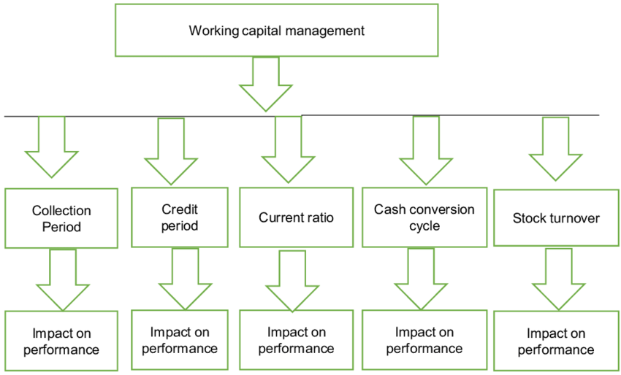

Figure 1: Working Capital Management Theory
(Source: Olaoye, Adekanbi and Oluwadare, 2019)
In the case of Tesla, liquidity needs to be enhanced by raising the management of working capital by being more rigorous in the management of short-term assets and short-term liabilities as the company moves into operational maturity. The Working Capital Management Theory which argues that any company can optimise its liquidity and profitability by maximising the relationship between current assets and current liabilities, by reducing the COC (Olaoye, Adekanbi and Oluwadare, 2019) (Refer to Figure 1). Tesla needs to focus on a more stringent inventory management by planning production based on demand and using sophisticated forecasting technologies to minimise excess holding costs and release cash. However, cash inflows can be expedited by enhancing receivables management, including decreasing the collection cycle and imposing credit restrictions in non-automotive lines of business (Barbosa, Anderson and Simões, 2024). On the liability side, the company has the ability to plan its payment terms with suppliers by extending them without damaging connections, hence, conserving cash in the short-term. Moreover, a more selective reallocation of capital expenditure and the holding of a buffer of liquid assets contributes to financial flexibility. Thus, by integrating such strategies with effective working capital practices, Tesla can enhance its liquidity status and maintain growth and operational sustainability in a market that is becoming more competitive.

3.3 Financing Options

3.3.1 Short-term Financing
The short-term funding needs to be aimed at ensuring liquidity flexibility and sustaining daily basis operations. Trade credit can through which companies negotiate longer payment terms with its suppliers, and in this way the company can save cash without any direct interest expense (Abdulai, Dary and Domanban, 2024). Moreover, short-term bank loans and revolving credit facilities may be used to supply urgent liquidity to cope with the movement of working capital, particularly in times of demand variability. Another alternative that can be adopted by Tesla is commercial paper issuance as the company has a good reputation within the market and therefore it can access cheap funds in the short-run. Additionally, cash inflows may be expedited by inventory financing and factoring of receivables in its services part (Choi et al., 2023). However, overdependence on short-term financing can heighten the refinancing risk and liquidity constraints in periods of decline. Hence, Tesla is advised to strike a balance between these sources to make sure the liquidity is adequate yet cost-effective and financially stable in the short-run.

3.3.2 Long-term Financing
The long-term funding is necessary to fund capital-intensive projects, including new gigafactories, battery technology and expansion of energy storage. Equity financing allows the company to increase the capital base and decrease financial risk but it can also dilute current shareholders. Long-term debt, like corporate bonds, is also a good option especially in cases where interest rates are favourable that enables stable financing on big-scale projects (Khan and Vismara, 2025). Additionally, green bonds may be a nice alternative, more with sustainability concerns of Tesla and which attracts the attention of environmentally aware investors. Joint ventures and strategic alliances can also be used to provide long-term capital without causing a massive rise in leverage (Gao and Huang, 2025). However, long-term financing boosts growth capacity and needs to be carefully controlled to prevent excessive debt burden. Thus, such a balanced capital structure allows Tesla to remain innovative and remain financially stable.

4. Strategic Financial Restructuring Plan

4.1 Suggestion on Financial Restructuring Options
Tesla is involved in the inclusion of the capital structure optimisation strategy, which was noted from the low debt-to-equity ratio. This suggests that there is a decrease in the financial leverage risk through the reduction of the debt capital. This was noted from the decrease in declining investments, which suggests inefficient utilisation of capital. From a strategic point, it is important to note that Tesla can implement the merger strategy through the utilisations of both horizontal and vertical mergers, which suggests the value creation through cost efficiencies and sales increment. Implementation of vertical integration of merger, which was guided by the Synergy Theory of merger and acquisition. This theory indicates that the merger of two businesses creates more value, increasing operational efficiencies (Fiorentino and Garzella, 2015). The influence of this vertical integration of merger stabilises the cost with the regular dependence risk identified through internationalising supply chains, which reduces the uncertainty and opportunism. Thus, the integration of vertical merger improves the transaction cost economics, which internalises the supply chains of the business.
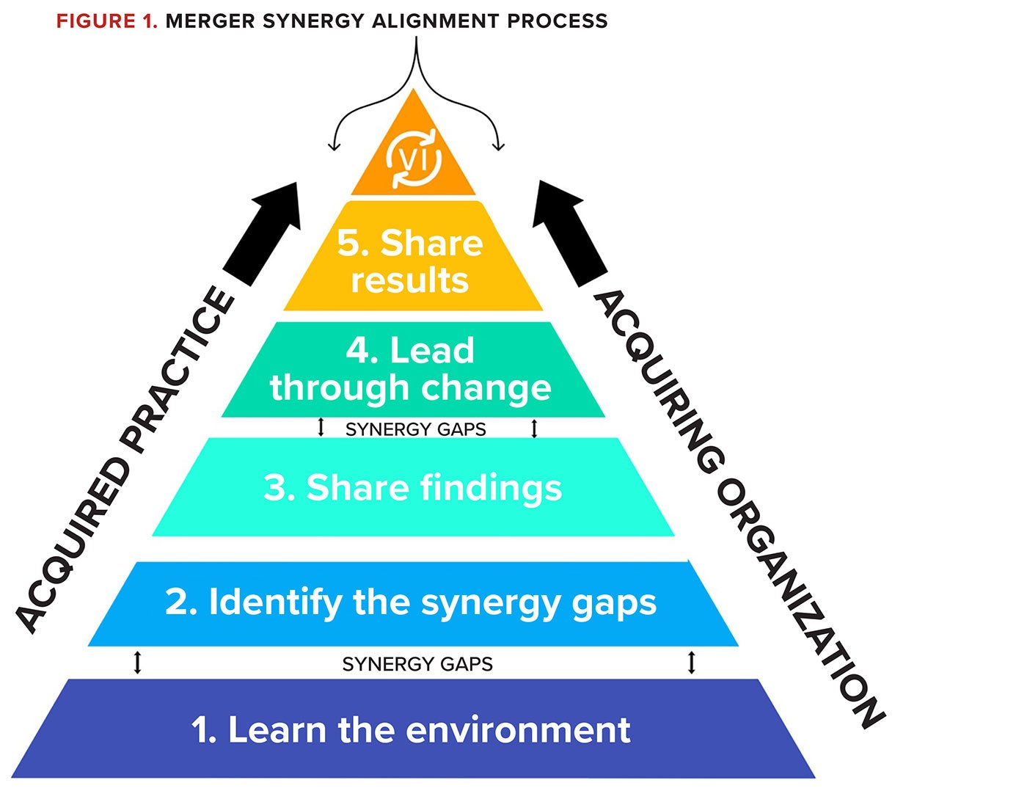

Figure 2: Synergy Theory of Merger
(Source: Fiorentino and Garzella, 2015)
In view of horizontal mergers involved in conducting strategic alliances with regional EV businesses, particularly in China or Europe. This strategy gives influence in countering the competitive pressures in the market (Lin, Huang and Lin, 2024) (Refer to Figure 2). Integrating the market penetration gives the local distribution networks through the AI-driven mobility solutions, which increases the competitive advantage. Additionally, Tesla can consider the joint venture in developing nations like India, which assists in reducing the competition in the market and maintaining the leverage of the local expertise in the business. Implications of both horizontal and vertical mergers in the competitive market can influence the business growth in the stringent markets like China and Europe. In developing nations like India, joint ventures influence business growth, which can influence their financial performance, creating value. Thus, it is recommended that these strategies influence the financial growth of Tesla guided by the local markets.

4.2 Evaluation of Impact

4.2.1 Shareholder Value
In the case of Tesla, the suggested financial restructuring measures are likely to raise shareholder value through the betterment of long-term profitability and market positioning. In the short-run, the use of equity financing or merging strategies can dilute EPS and ROE. However, profitability and cash flows are likely to increase in the long-run due to better operational efficiency, cost synergies, and market presence (Setyopurnomo et al., 2024). Thus, this would enhance shareholder returns in terms of capital appreciation and sustainable growth, which helps to boost overall firm valuation in the end.

4.2.2 Debt Structure
The restructuring plan is likely to streamline the debt-structure by balancing the low leverage that the Tesla has and discriminatory long-term borrowing. Replacing excessive debt financing with moderate debt financing like bond or green financing instruments can reduce the total cost of capital by providing tax benefits without compromising financial stability (Li et al., 2025). However, high dependence on debt can result in a rise in interest payments and deteriorate coverage ratios especially, with the recent pressure on operating profits. Thus, Tesla ought to embrace a balanced capital structure that is a mix of equity and debt that helps to increase its financial flexibility at the lowest risk and help to sustain long-term growth.

4.2.3 Operational Flexibility
In the case of Tesla, the recommended reorganisation has a strongly beneficial impact on the flexibility of operations as it enhances the control of supply chains and manufacturing processes. This can decrease reliance on external suppliers, decrease disruptions and increase cost-efficiency through vertical integration and strategic partnerships (Li, Wang, et al., 2025). Moreover, horizontal growth into new markets can lead to scalability and enable the organization to react swiftly to the evolving demand conditions. Additionally, the operations can be initially complicated due to the increased investments and integration efforts. Thus, the enhancement of operational flexibility helps Tesla adjust to market dynamics better, facilitate innovation, and maintain a competitive edge in the changing EV market.

4.3 International and Ethical Considerations

4.3.1 Currency Risk
In the case of Tesla, its currency risk is a major concern because of its international business. The revenue generation takes place in various regions, exposing earnings to exchange rate risks. Unstable currencies have the potential of lowering profit margins upon conversion into the US Dollars (Bagsic et al., 2025). Short-term exposure can be minimised by forward contracts, a form of hedging, as hedging complicates and increases the financial cost of treasury operations. Purchasing power and demand may also be lowered due to currency devaluation in major markets. Hence, it is necessary to monitor the fluctuations of foreign exchange to maintain stable international money flows and guarantee the security of the financial performance in the long-run for Tesla.

4.3.2 Inflation Impact
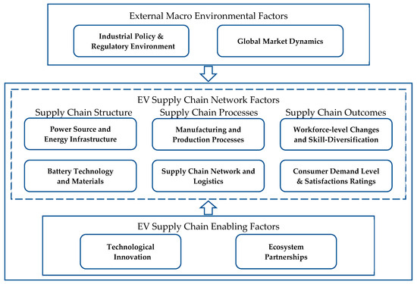

Figure 3: Competitive EV markets
(Source: Jagani, Marsillac and Hong, 2024)
Inflation has an impact on the cost structure of Tesla in terms of increased cost of raw materials, labour and logistics. Han et al., (2024) highlights that Gross margins may be lowered by increased input costs which are not completely transferred to consumers. In contrast, Jagani, Marsillac and Hong (2024) states that the competitive EV markets limit pricing flexibility, and inflation-related increases in interest rates increase the cost of financing expansion projects (Refer to Figure 3). This can slow down the process of investment in new gigafactories and research and development. However, here the size of this company and technological efficiency partially counter the inflationary pressure. However, better supply chain integration has led to better cost control whereas inflation has caused short-term problems that can be addressed with operational efficiency and strategic pricing changes.

4.3.3 Corporate Social Responsibility (CSR)
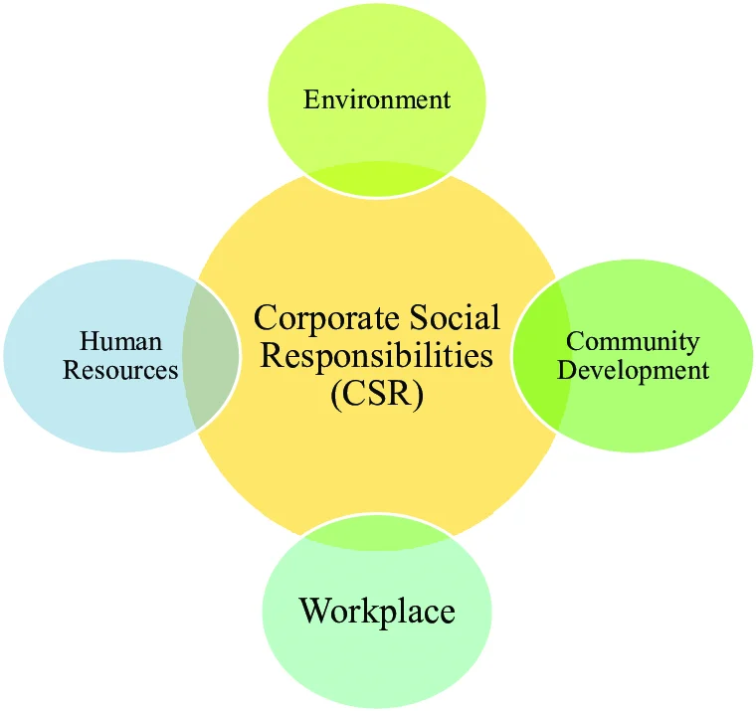

Figure 4: Principles of CSR
(Source: Jermsittiparsert et al., 2019)
Tesla is a sustainable energy company with its better global positioning that revolves around CSR. Ethical issues involve responsible sourcing of lithium and cobalt which are used in manufacturing batteries (Jermsittiparsert et al., 2019) (Refer to Figure 4). This company should make sure that the supply chain is transparent to prevent human rights abuses. Sustainability of the environment is also of great importance in manufacturing and energy consumption of Tesla. Hence, this company encourages the use of clean energy in the form of electric cars and solar products.

5. Investment Appraisal and Capital Budgeting

5.1 Project Recommendation

5.1.1 Justification on financial performance
The analysis of the investment proposals has been conducted with the help of key investment appraisal methods. It incorporates Payback Period (PBP), Net Present Value (NPV), Accounting Rate of Return (ARR), Profitability Index (PI), and Internal Rate of Return (IRR). In the words of Khan et al. (2025), investment decisions benefit organisations in selecting a project that aligns with the financial and strategic goals related to capital. The investment analysis benefits in assessing the ability of the projects to justify the capital and offer returns to businesses, which adds value to the financial and strategic goals. In this regard, the selection of different methods have benefited in evaluating the effectiveness of the project to support Tesla in making efficient capital investment. NPV considers the present values of the future cash flows with the help of a discounting rate, and analyses of the profitability of the project in dollar value (Lin, Dong and Zheng, 2025). A positive NPV-based project is usually recommended for selection compared to a negative NPV-based project, showcasing a better profit generating ability of the former. However, other methods are also crucial for making the final decision as it helps in reducing the risk level, while measuring other prospects. Thus, PBP, ARR, PI and IRR are considered to evaluate the effectiveness of Project A, B and C.
Based on the NPV, all the projects generate a negative NPV at the discounting rate of 10%, which indicates that none of the projects align with the cost of capital of Tesla. In comparison, Project C demonstrates a lower negative NPV of (1.98), implying the strength of the project to provide positive return in future (Refer to Appendix 8). According to Mioduchowska-Jaroszewicz (2023), consolidated financial statements provide reliable information regarding the financial performance of a business, which helps in attracting investors to support the funding for new investment propositions. Following the financial performance of Tesla, it depicts declining profit margins and reduced returns, indicating the need for making investment in profitable projects. In addition, it also reflects that the investment requires additional funding support, which can help in reducing the capital investment burden and benefit Tesla in generating returns. As calculated, Project C reflects a better ARR of 6% compared to 2% of Project B and 1.60% of Project A. Thus, based on NPV and ARR, Project C is considered to be the best for investment purposes of Tesla.
In contrast, from the liquidity perspective, Tesla demonstrates a stable liquidity position, depicting the financial effectiveness in managing short-term liabilities. In this context, the cash flows of Project B reflects to be strong compared to Project A and C, however, the PBP is the highest depicting 4.55 (Refer to Appendix 8). In this respect, concerning the IRR, the return rate of Project C is higher, whereas the return of Project A is the lowest, depicting 0.7%. As stated by Zhang (2022), IRR measures the future rate of return, considering the discounting rate, determining the percentage-driven profitability of investments. In this regard, a lower IRR of Project B depicts the ineffectiveness of the project to support return generation, despite higher cashflows. The PI also depicted that the choice of Project C is more beneficial, showcasing 0.96, compared to 0.83 for Project A and B, respectively. Thus, based on the financial performance and the investment results, Tesla can be suggested to invest in Project C.

5.1.2 Justification based on non-financial risks
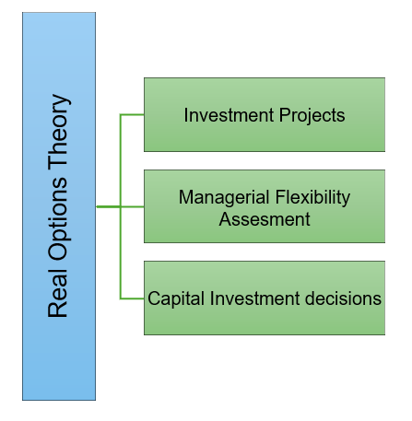

Figure 5: Real Options Theory
(Source: Self-Developed)
Investment techniques strongly guide businesses in making the effective investment decisions, however, it fails to consider the non-financial risks, which reduces the ability of firms to align with strategic goals. As per Alshehadeh, Nahleh and AlZyoud (2025) , investment decisions relying on financial information often fail to provide appropriate decisions due to the non consideration of management items (Refer to Figure 5). It fails to focus on the strategic information, reducing the accuracy of the investment decision in assisting businesses to achieve organisational goals. The selection of an investment project based on non-financial risks improves acceptance, especially in technology-driven industries like the EVs. In the case of Tesla, one of the major risks that the firm faces is the technological risk, depicting the reliance on battery-driven innovative cars. Real Options Theory explains that choices of investment projects need to be done by assessing the managerial flexibility, reflecting the management of uncertain risks (Carozzani and D’Alpaos, 2025). In the case of Tesla, the company needs to consider the technological risks for assessing the investment projects and select one, evaluating the managerial efficiency to control such risks. Project C generates a strong cashflow, which is likely to benefit Tesla in generating better returns, which can help in improving the technological infrastructure.
The consideration of regulatory risks are also crucial while making final investment decisions. As found, the new tax rules related to the EVs reduced the demand in the UK market, thereby negatively hitting the battery car sales (Jolly, 2025a). This has also impacted Tesla as companies are forced to sell EVs at a lower profit, which increases financial stress. Project C depicts a better return and profitability, which is likely to enable Tesla in addressing the regulatory challenges, enabling it to overcome the reduced profit challenges. In addition to this, the environmental risks also impact the selection of investment projects, based on their ability to provide sustainable returns to address the risks. For instance, in the UK, the Zero-emission Vehicle (ZEV) mandate compelled the organisations to sell EVs more, however, this mandate was found to be unsustainable (Partridge, 2025). The selection of Project C can enable Tesla in addressing this mandate by investing more in the production of EVs, thereby increasing economic sustainability. Moreover, with a lower payback time, Tesla can benefit from reduced cost pressure, which can further help in accelerating innovative operations for developing EVs. Therefore, based on the non-financial risks, Tesla can be advised to invest in Project C, as it has the ability to support long-term strategic growth, maintaining sustainability.

5.2 Suggestion based on capital rationing
The investment choice is to be made assuming that Tesla has £100 million only, reflecting a limited funding option. As viewed by Darmansyah, Ali and Parveen (2025), capital rationing helps in avoiding risks while making capital budgeting decisions, influencing selection of projects that provide best returns based on limited budgets. Aligned with the given scenario, the best combination choice concerning the investment projects is to be made that offers better return to Tesla with an investment of £100 million. In this case, considering the NPV, Project A demonstrated an NPV of (8.68), whereas Project B depicted (8.30), and Project C showcased (1.98) (Refer to Appendix 9). This apparently implies that Project C is the best choice, followed by Project B, reflecting an investment of £50 million each. However, to make the final decision, the combined profitability assessment is crucial, reflecting the usefulness of capital rationing.
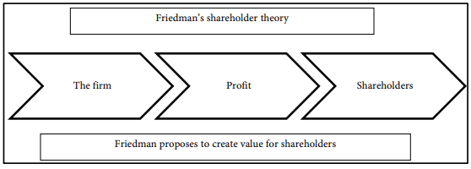

Figure 6: Shareholder Theory
(Source: Narbel and Muff, 2017)
The three projects have been combined to analyse the maximum profitability of the combinations, which can help Tesla make an informed decision. As found, the combined profitability of Project A and B is (16.98), Project B and C is (10.29), and (A+C) is (10.66) (Refer to Appendix 9). This indicates that Project A+C, and B+C are comparatively better than Project A+C, as it showcases a higher negative profitability (Refer to Figure 6). The analysis of investment profitability based on NPV allows organisations to assess the economic efficiency of the project to generate returns, and benefit organisations with better profitability (Dobrowolski and Drozdowski, 2022). Concerning the alternatives, the combination of Project B and C is found to be the best, as it depicts a lower negative NPV compared to the other combination of projects. The Shareholder Theory demonstrates that investment decisions are the commitment that businesses make aiming to generate more profits to offer better returns to shareholders (Narbel and Muff, 2017). In this regard, Tesla needs to consider Projects that generate least negative NPV, showcasing a better potential to generate better profits compared to other projects.
The combination of Project B and C can be beneficial for Tesla as Project B has a better cash flow, which can help in maintaining the liquidity position, thereby reducing the challenges of insolvency. In addition, with better PBP and PI, Project C can help Tesla overcome the challenges of rising costs, thereby recovering the initial project cost within 3.6 years. On the other hand, the IRR of 8.39% depicts that the project is able to generate more returns, depicting a better financial flexibility. Concerning the capital rationing concept, the allocation of £100 million in this combination of projects can benefit the company in improving the operational efficiency. It can positively impact production, and technological developments, enabling Tesla to address the strategic goals of innovation and sustainability. However, it can further help in the long-term financial growth and success, thereby increasing competitiveness of the firm. Therefore, Tesla can be recommended to invest in Project B and C combinedly to achieve better financial stability through higher returns.

6. Conclusion
The study has assessed the financial performance and strategic direction of Tesla relying on ratio analysis, cash flow analysis, working capital analysis and investment appraisal methodologies. The analysis demonstrated that Tesla has continued to generate strong revenue and cash flows but that its profitability and efficiency ratios have suffered due to increases in cost, capital outlay and competition. Cash holdings are high with adequate liquidity but working capital pressures and an increase in the cash operating cycle suggesting short-term cash efficiency issues. Hence, Leverage ratio is low which decreases risk but also tax savings, while ROE, ROA and ROIC have fallen, suggesting diminished capital efficiency and shareholders value. However, strong operating cash flows continue to ensure short-term financial stability and operational resilience of Tesla. Additionally, the financial position of Tesla can be viewed as a transitional period in which the company is undertaking high-risk investments in expansion and innovation that is impacting its short-term profitability. Hence, the efficiency in future is likely to be increased through strategic restructuring and better working capital management. Sustainable technologies and internal market penetration keep the company in a good position of long-term expansion. Thus, ongoing emphasis on cost control and asset utilisation is very necessary in the future.

References
Abdulai, M. G., Dary, S. K. and Domanban, P. B. (2024) ‘Adoption of digital payment platforms and trade credit activities among informal firms in Ghana’, Heliyon, 10(11), pp. e32302–e32302. doi: https://doi.org/10.1016/j.heliyon.2024.e32302 (Accessed: 03 April 2026).
Alshehadeh, A. R., Nahleh, I. T. A. and AlZyoud, I. A. (2025) ‘The Impact of Financial and Non-Financial Information on Investment Decision-Making in the Jordanian Business Environment’, Al-Zaytoonah Journal of Business, 1(1), pp. 1–8. Available at: https://www.researchgate.net/publication/390668678_The_Impact_of_Financial_and_Non-Financial_Information_on_Investment_Decision-Making_in_the_Jordanian_Business_Environment (Accessed: 17 April 2026).
Arwani, A., Masrur, M. and Muhammad, R. (2024) ‘Profit Growth: Redefining Success with an Advanced ROA Model’, Owner, 8(4), pp. 4507–4523. doi: https://doi.org/10.33395/owner.v8i4.2489 (Accessed: 07 April 2026).
Bagsic, C. et al. (2025) ‘The impact of currency depreciation and foreign exchange positions on bank lending: Evidence from an emerging market’, Emerging Markets Review, 66, p. 101279. doi: https://doi.org/10.1016/j.ememar.2025.101279 (Accessed: 07 April 2026).
Barbosa, A., Anderson, F. and Simões, P. (2024) ‘Governance and Efficiency in Brazilian Water Utilities: An Analysis Based on Revenue Collection Efficiency’, Water, 16(17), pp. 2483–2483. doi: https://doi.org/10.3390/w16172483 (Accessed: 05 April 2026).
Carey, N. and Roy, A. (2025) ‘Focus: Tesla struggles to course correct from sales skid’, Reuters, January. Available at: https://www.reuters.com/business/autos-transportation/tesla-struggles-course-correct-sales-skid-2025-11-26/ (Accessed: 20 April 2026).
Carozzani, A. and D’Alpaos, C. (2025) ‘The Real Option Approach to Investment Decisions in Hybrid Renewable Energy Systems: A Systematic Literature Review’, Energies, 18(20), pp. 1–35. doi: https://doi.org/10.3390/en18205535 (Accessed: 08 April 2026).
Choi, T. Y. et al. (2023) ‘The supply chain financing ecosystem: Early responses during the COVID-19 crisis’, Journal of Purchasing and Supply Management, 29(4), p. 100836. doi: https://doi.org/10.1016/j.pursup.2023.100836 (Accessed: 03 April 2026).
Darmansyah, A., Ali, Q. and Parveen, S. (2025) ‘Sophisticated Capital Budgeting Decisions for Financial Performance and Risk Management—A Tale of Two Business Entities’, Journal of Risk and Financial Management, 18(6), pp. 1–22. doi: https://doi.org/10.3390/jrfm18060297 (Accessed: 08 April 2026).
Dobrowolski, Z. and Drozdowski, G. (2022) ‘Does the Net Present Value as a Financial Metric Fit Investment in Green Energy Security?’, Energies, 15(1), pp. 1–16. doi: https://doi.org/10.3390/en15010353 (Accessed: 10 April 2026).
Fang, J. (2022) An Overall Financial Analysis of Tesla. atlantis-press. Available at: https://www.atlantis-press.com/article/125975330.pdf (Accessed: 20 April 2026).
Fiorentino, R. and Garzella, S. (2015) ‘Synergy management pitfalls in mergers and acquisitions’, Management Decision, 53(7), pp. 1469–1503. doi: https://doi.org/10.1108/md-12-2014-0692 (Accessed: 08 April 2026).
Gao, K. and Huang, X. (2025) ‘The impact of strategic alliances on corporate real investment and its mechanisms from the perspective of organizational learning theory: An empirical analysis based on Chinese listed companies’, PLoS ONE, 20(9), pp. e0332364–e0332364. doi: https://doi.org/10.1371/journal.pone.0332364 (Accessed: 10 April 2026).
Han, F. et al. (2024) ‘Research on Dynamic Pricing and Long-Term Profit of Companies under Influence of Word of Mouth’, Journal of theoretical and applied electronic commerce research, 19(3), pp. 2157–2179. doi: https://doi.org/10.3390/jtaer19030105 (Accessed: 05 April 2026).
Jagani, S., Marsillac, E. and Hong, P. (2024) ‘The Electric Vehicle Supply Chain Ecosystem: Changing Roles of Automotive Suppliers’, Sustainability, 16(4), p. 1570. doi: https://doi.org/10.3390/su16041570 (Accessed: 10 April 2026).
Jermsittiparsert, K. et al. (2019) ‘Do consumers expect companies to be socially responsible? The impact of corporate social responsibility on buying behavior’, Uncertain Supply Chain Management, 7(4), pp. 741–752. doi: https://doi.org/10.5267/j.uscm.2019.1.005 (Accessed: 05 April 2026).
Jolly, J. (2025a) Tesla privately warned UK that weakening EV rules would hit sales, The Guardian. www.theguardian.com. Available at: https://www.theguardian.com/technology/2025/dec/03/tesla-uk-ev-rules-sales-elon-musk-electric-car (Accessed: 18 April 2026).
Jolly, J. (2025b) Tesla publishes analyst forecasts suggesting sales set to fall, the Guardian. www.theguardian.com. Available at: https://www.theguardian.com/technology/2025/dec/31/tesla-surprise-announcement-lower-sales-2025 (Accessed: 12 April 2026).
Kaya, O. (2024) ‘The impact of late payments on SMEs’ access to finance: Evidence from credit rationing and loan terms’, Economic Modelling, 141, pp. 106896–106896. doi: https://doi.org/10.1016/j.econmod.2024.106896 (Accessed: 12 April 2026).
Khan, M. A. and Vismara, S. (2025) ‘Green bond issuance and corporate environmental and financial performance: A meta-analysis’, International Review of Economics & Finance, 102, p. 104313. doi: https://doi.org/10.1016/j.iref.2025.104313 (Accessed: 13 April 2026).
Khan, S. J. I. et al. (2025) ‘Techniques for Investment Decision Making: An Analysis of Firms in Pakistan’, Human Nature Journal of Social Sciences, 6(1), pp. 218–228. doi: https://doi.org/10.71016/hnjss/csfq9f66 (Accessed: 13 April 2026).
Khedr, A. M. and Sheeja , R. S. (2024) ‘Enhancing Supply Chain Management with Deep Learning and Machine Learning Techniques: A Review’, Journal of Open Innovation Technology Market and Complexity, 10(4), pp. 100379–100379. doi: https://doi.org/10.1016/j.joitmc.2024.100379 (Accessed: 13 April 2026).
Li, S. et al. (2025) ‘The impact of green finance on debt financing costs from the perspective of strategic corporate signaling behavior—Evidence from China’, International Review of Financial Analysis, 102, p. 104024. doi: https://doi.org/10.1016/j.irfa.2025.104024 (Accessed: 14 April 2026).
Li, Y. et al. (2025) ‘Vertical integration, supply chain disruptions, and corporate yield spreads’, The British Accounting Review, pp. 101639–101639. doi: https://doi.org/10.1016/j.bar.2025.101639 (Accessed: 14 April 2026).
Lin, J., Dong, J. and Zheng, Y. (2025) ‘Net Present Value As a Decision Tool During Investment: Evaluating the Effectiveness of Net Present Value (NPV) Against Traditional Investment Appraisal Techniques in Predicting the Financial Success of Technology Startups’, Advances in Economics, Management and Political Sciences, 217(1), pp. 41–60. doi: https://doi.org/10.54254/2754-1169/2024.26903 (Accessed: 18 April 2026).
Lin, X., Huang, H. and Lin, Q. (2024) ‘Horizontal mergers between public and private firms in vertically-differentiated markets’, Journal of the Operational Research Society, 76(5), pp. 881–903. doi: https://doi.org/10.1080/01605682.2024.2398763 (Accessed: 18 April 2026).
Malhotra, D., Singh, R. and Ramani, L. (2024) ‘Navigating market volatility: risk and return insights from Indian mutual funds’, Cogent Economics & Finance, 12(1). doi: https://doi.org/10.1080/23322039.2024.2431535 (Accessed: 12 April 2026).
Mioduchowska-Jaroszewicz, E. (2023) ‘Investment decisions based on the financial performance of related parties’, Procedia Computer Science, 225, pp. 3313–3321. doi: https://doi.org/10.1016/j.procs.2023.10.325 (Accessed: 11 April 2026).
Narbel, F. and Muff, K. (2017) ‘Should the Evolution of Stakeholder Theory Be Discontinued Given Its Limitations?’, Theoretical Economics Letters, 07(05), pp. 1357–1381. doi: https://doi.org/10.4236/tel.2017.75092 (Accessed: 18 April 2026).
Olaoye, F. O., Adekanbi, J. A. and Oluwadare, O. E. (2019) ‘Working Capital Management and Firms’ Profitability: Evidence from Quoted Firms on the Nigerian Stock Exchange’, Intelligent Information Management, 11(03), pp. 43–60. doi: https://doi.org/10.4236/iim.2019.113005 (Accessed: 10 April 2026).
Park, H. W. (2025) ‘Leverage–led growth in the circuit of capital model with a banking sector’, Economic Modelling. doi: https://doi.org/10.1016/j.econmod.2025.107275 (Accessed: 20 April 2026).
Partridge, J. (2025) UK government plays down reports of plan to bring EV sales target review forward, The Guardian. www.theguardian.com. Available at: https://www.theguardian.com/business/2025/dec/17/uk-to-bring-forward-review-of-ev-sales-targets-from-2027-to-next-year (Accessed: 20 April 2026).
Reuters (2025) ‘Tesla ramps up battery cell investments at German gigafactory’, Reuters. Available at: https://www.reuters.com/business/autos-transportation/tesla-ramps-up-battery-cell-investments-german-gigafactory-2025-12-16/ (Accessed: 23 April 2026).
Setyopurnomo, R. et al. (2024) ‘Enhancing operation effectiveness by maximizing daily EBITDA as a turnaround strategy execution system to enhance operation performance and profitability’, Journal of Open Innovation: Technology, Market, and Complexity, 11(1), p. 100431. doi: https://doi.org/10.1016/j.joitmc.2024.100431 (Accessed: 08 April 2026).
Tesla (2021) UNITED STATES SECURITIES AND EXCHANGE COMMISSION. Available at: https://ir.tesla.com/_flysystem/s3/sec/000095017021002253/tsla-20210930-gen.pdf (Accessed: 04 April 2026).
Tesla (2023a) Annual Report. Available at: https://ir.tesla.com/_flysystem/s3/sec/000162828024002390/tsla-20231231-gen.pdf (Accessed: 04 April 2026).
Tesla (2023b) Continuing Our Investment in Nevada, Tesla. www.tesla.com. Available at: https://www.tesla.com/blog/continuing-our-investment-nevada (Accessed: 16 April 2026).
Tesla (2025) UNITED STATES SECURITIES AND EXCHANGE COMMISSION. Available at: https://ir.tesla.com/_flysystem/s3/sec/000162828026003952/tsla-20251231-gen.pdf (Accessed: 04 April 2026).
Tesla (2026) Q4 and FY 2025 of Tesla. assets-ir.tesla.com. Available at: https://assets-ir.tesla.com/tesla-contents/IR/TSLA-Q4-2025-Update.pdf (Accessed: 18 April 2026).
World Bank (2023) What Explains Global Inflation, World Bank. www.worldbank.org. Available at: https://www.worldbank.org/en/research/brief/global-inflation (Accessed: 13 April 2026).
Zhang, Y. (2022) ‘The Effectiveness of NPV and IRR Used in Fundamental Financial Markets’, Advances in Economics, Business and Management Research, 648, pp. 1208–1212. doi: https://doi.org/10.2991/aebmr.k.220307.200 (Accessed: 05 April 2026).

Appendices

Appendix 1: Profitability Ratios
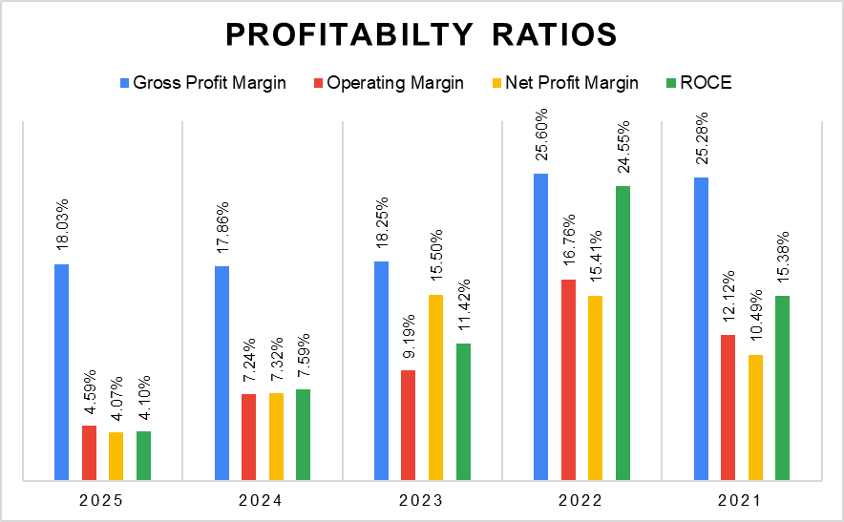

Figure 7: Profitability Ratios
(Source: Tesla, 2025, 2023a, 2021)
Profitability Ratios | 2025 ($m) | 2024 ($m) | 2023 ($m) | 2022 ($m) | 2021 ($m)
Gross Profit | 17,094 | 17,450 | 17,660 | 20,853 | 13,606
Sales | 94,827 | 97,690 | 96,773 | 81,462 | 53,823
Gross Profit Margin | 18.03% | 17.86% | 18.25% | 25.60% | 25.28%
Formula: Gross Profit​ / Sales
EBIT | 4,355 | 7,076 | 8,891 | 13,656 | 6,523
Sales | 94,827 | 97,690 | 96,773 | 81,462 | 53,823
Operating Margin | 4.59% | 7.24% | 9.19% | 16.76% | 12.12%
Formula: EBIT / Sales
Net Income | 3,855 | 7,153 | 14,997 | 12,556 | 5,644
Sales | 94,827 | 97,690 | 96,773 | 81,462 | 53,823
Net Profit Margin | 4.07% | 7.32% | 15.50% | 15.41% | 10.49%
Formula: Net Income / Sales
EBIT | 4,355 | 7,076 | 8,891 | 13,656 | 6,523
Total Assets | 137,806 | 122,070 | 106,618 | 82,338 | 62,131
Current Liabilities | 31,714 | 28,821 | 28,748 | 26,709 | 19,705
ROCE | 4.10% | 7.59% | 11.42% | 24.55% | 15.38%
Formula = EBIT / (Total Assets - Current Liabilities)

Table 1: Profitability Ratios
(Source: Tesla, 2025, 2023a, 2021)

Appendix 2: Liquidity Ratios
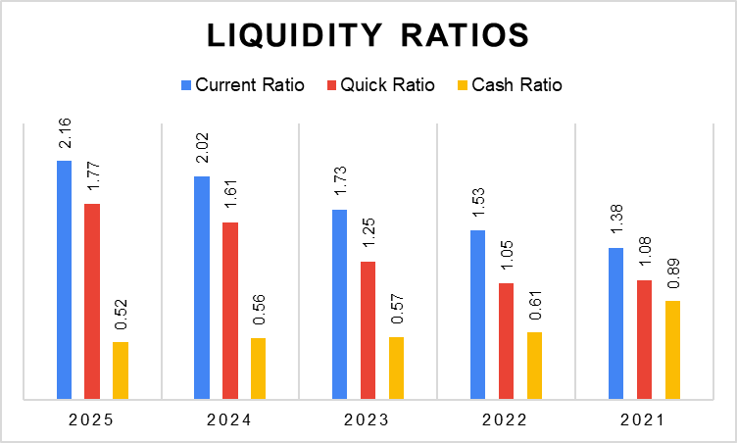

Figure 8: Liquidity Ratios
(Source: Tesla, 2025, 2023a, 2021)
Liquidity Ratios | 2025 ($m) | 2024 ($m) | 2023 ($m) | 2022 ($m) | 2021 ($m)
Current Assets | 68,642 | 58,360 | 49,616 | 40,917 | 27,100
Current Liabilities | 31,714 | 28,821 | 28,748 | 26,709 | 19,705
Current Ratio | 2.16 | 2.02 | 1.73 | 1.53 | 1.38
Formula: Current Assets / Current Liabilities
Current Assets | 68,642 | 58,360 | 49,616 | 40,917 | 27,100
Inventory | 12,392 | 12,017 | 13,626 | 12,839 | 5,757
Current Liabilities | 31,714 | 28,821 | 28,748 | 26,709 | 19,705
Quick Ratio | 1.77 | 1.61 | 1.25 | 1.05 | 1.08
Formula: (Current Assets - Inventory) / Current Liabilities
Cash | 16,513 | 16,139 | 16,398 | 16,253 | 17,576
Current Liabilities | 31,714 | 28,821 | 28,748 | 26,709 | 19,705
Cash Ratio | 0.52 | 0.56 | 0.57 | 0.61 | 0.89
Formula: Cash / Current Liabilities

Table 2: Liquidity Ratios
(Source: Tesla, 2025, 2023a, 2021)

Appendix 3: Efficiency Ratios
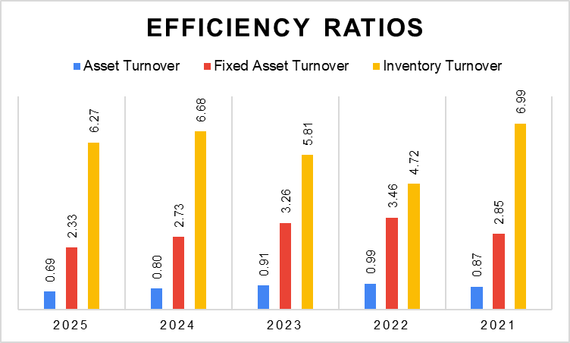

Figure 9: Efficiency Ratios
(Source: Tesla, 2025, 2023a, 2021)
Efficiency Ratios | 2025 ($m) | 2024 ($m) | 2023 ($m) | 2022 ($m) | 2021 ($m)
Sales | 94,827 | 97,690 | 96,773 | 81,462 | 53,823
Total Assets | 137,806 | 122,070 | 106,618 | 82,338 | 62,131
Asset Turnover | 0.69 | 0.80 | 0.91 | 0.99 | 0.87
Formula: Sales / Total Assets
Sales | 94,827 | 97,690 | 96,773 | 81,462 | 53,823
Fixed Assets | 40,643 | 35,836 | 29,725 | 23,548 | 18,884
Fixed Asset Turnover | 2.33 | 2.73 | 3.26 | 3.46 | 2.85
Formula: Fixed Assets / Fixed Asset Turnover
Cost of Goods Sales | 77,733 | 80,240 | 79,113 | 60,609 | 40,217
Inventory | 12,392 | 12,017 | 13,626 | 12,839 | 5,757
Inventory Turnover | 6.27 | 6.68 | 5.81 | 4.72 | 6.99
Formula: Cost of Goods Sales / Inventory

Table 3: Efficiency Ratios
(Source: Tesla, 2025, 2023a, 2021)

Appendix 4: Leverage Ratio
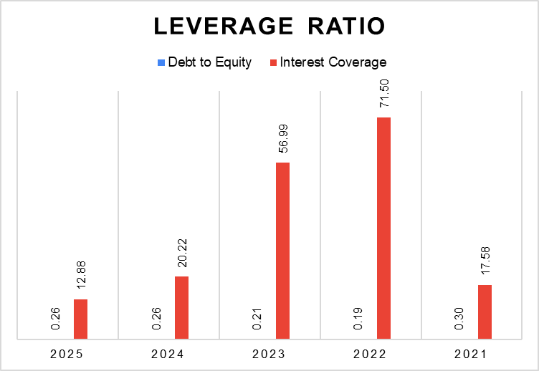

Figure 10: Leverage Ratio
(Source: Tesla, 2025, 2023, 2021)
Leverage Ratio | 2025 ($m) | 2024 ($m) | 2023 ($m) | 2022 ($m) | 2021 ($m)
Debt | 21,236 | 18,708 | 13383 | 8429 | 8,199
Equity | 82,137 | 72,913 | 62,634 | 44,704 | 27,053
Debt to Equity | 0.26 | 0.26 | 0.21 | 0.19 | 0.30
Formula: Total Debt / Total Equity
EBIT | 4,355 | 7,076 | 8,891 | 13,656 | 6,523
Interest Expense | 338 | 350 | 156 | 191 | 371
Interest Coverage | 12.88 | 20.22 | 56.99 | 71.50 | 17.58
Formula: EBIT / Interest Expense

Table 4: Leverage Ratio
(Source: Tesla, 2025, 2023, 2021)

Appendix 5: Investment Ratio
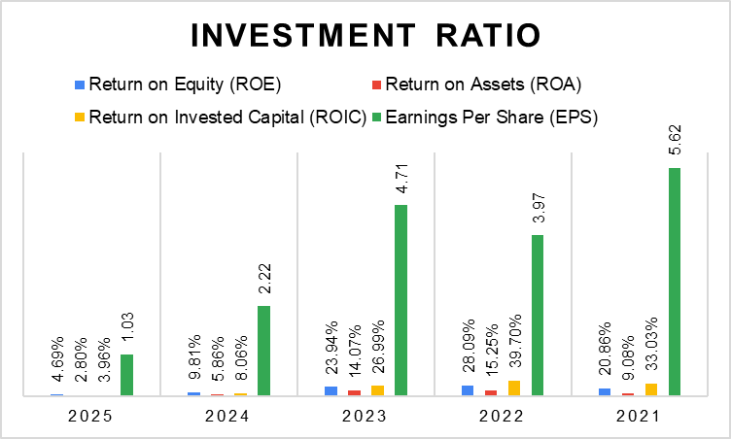

Figure 11: Investment Ratio
(Source: Tesla, 2025, 2023a, 2021)
Investment Ratio | 2025 ($m) | 2024 ($m) | 2023 ($m) | 2022 ($m) | 2021 ($m)
Net Income | 3,855 | 7,153 | 14,997 | 12,556 | 5,644
Equity | 82,137 | 72,913 | 62,634 | 44,704 | 27,053
Return on Equity (ROE) | 4.69% | 9.81% | 23.94% | 28.09% | 20.86%
Formula: Net Income / Equity
Net Income | 3,855 | 7,153 | 14,997 | 12,556 | 5,644
Total Assets | 137,806 | 122,070 | 106,618 | 82,338 | 62,131
Return on Assets (ROA) | 2.80% | 5.86% | 14.07% | 15.25% | 9.08%
Formula: Net Income / Total Assets
EBIT | 4,355 | 7,076 | 8,891 | 13,656 | 6,523
Equity | 82,137 | 72,913 | 62,634 | 44,704 | 27,053
Tax | 1,423 | 1,837 | -5,001 | 1,132 | 699
Total Debt | 8376 | 8213 | 5230 | 3099 | 8154
Cash | 16,513 | 16,139 | 16,398 | 16,253 | 17,576
Net Debt | -8,137 | -7,926 | -11,168 | -13,154 | -9,422
Return on Invested Capital (ROIC) | 3.96% | 8.06% | 26.99% | 39.70% | 33.03%
Formula: (EBIT-Taxation) / (Total Equity+Net Debt)
Net Income | 3,855 | 7,153 | 14,997 | 12,556 | 5,644
Shares outstanding | 3,751 | 3,216 | 3,185 | 3,164 | 1,004
Earnings Per Share (EPS) | 1.03 | 2.22 | 4.71 | 3.97 | 5.62
Formula: Net Income / Shares outstanding

Table 5: Investment Ratio
(Source: Tesla, 2025, 2023a, 2021)

Appendix 6: Cash Flow Ratios
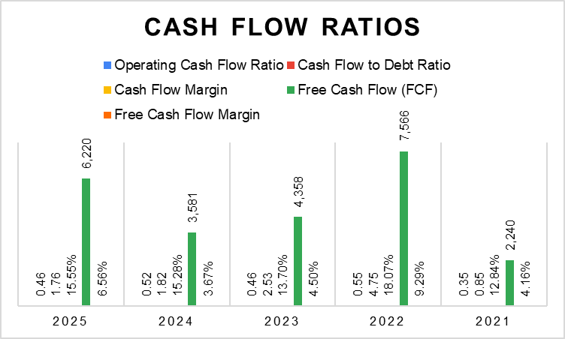

Figure 12: Cash Flow Ratios
(Source: Tesla, 2025, 2023a, 2021)
Cash Flow Ratios | 2025 ($m) | 2024 ($m) | 2023 ($m) | 2022 ($m) | 2021 ($m)
Operating Cash Flow​ | 14,747 | 14,923 | 13,256 | 14,724 | 6,912
Current Liabilities | 31,714 | 28,821 | 28,748 | 26,709 | 19,705
Operating Cash Flow Ratio | 0.46 | 0.52 | 0.46 | 0.55 | 0.35
Formula: Operating Cash Flow​ / Current Liabilities
Operating Cash Flow​ | 14,747 | 14,923 | 13,256 | 14,724 | 6,912
Total Debt | 8376 | 8213 | 5230 | 3099 | 8154
Cash Flow to Debt Ratio | 1.76 | 1.82 | 2.53 | 4.75 | 0.85
Formula: Operating Cash Flow​ / Total Debt
Operating Cash Flow​ | 14,747 | 14,923 | 13,256 | 14,724 | 6,912
Sales | 94,827 | 97,690 | 96,773 | 81,462 | 53,823
Cash Flow Margin | 15.55% | 15.28% | 13.70% | 18.07% | 12.84%
Formula: Operating Cash Flow​ / Sales
Operating Cash Flow​ | 14,747 | 14,923 | 13,256 | 14,724 | 6,912
Capital Expenditure | 8,527 | 11,342 | 8,898 | 7,158 | 4,672
Free Cash Flow (FCF) | 6,220 | 3,581 | 4,358 | 7,566 | 2,240
Formula: Operating Cash Flow - Capital Expenditure
Free Cash Flow (FCF) | 6,220 | 3,581 | 4,358 | 7,566 | 2,240
Sales | 94,827 | 97,690 | 96,773 | 81,462 | 53,823
Free Cash Flow Margin | 6.56% | 3.67% | 4.50% | 9.29% | 4.16%
Formula: Free Cash Flow (FCF) / Sales

Table 6: Cash Flow Ratios
(Source: Tesla, 2025, 2023a, 2021)

Appendix 7: Working Capital Ratios
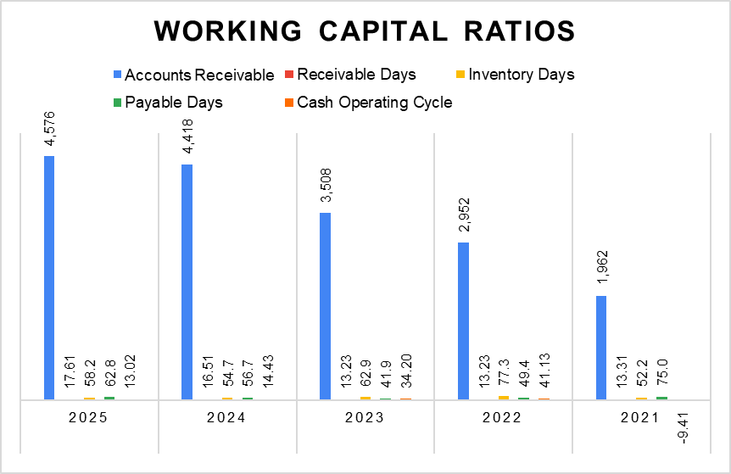

Figure 13: Working Capital Ratios
(Source: Tesla, 2025, 2023a, 2021)
Working Capital Ratios | 2025 ($m) | 2024 ($m) | 2023 ($m) | 2022 ($m) | 2021 ($m)
Accounts Receivable​ | 4,576 | 4,418 | 3,508 | 2,952 | 1,962
Sales | 94,827 | 97,690 | 96,773 | 81,462 | 53,823
Receivable Days | 17.61 | 16.51 | 13.23 | 13.23 | 13.31
Formula: (Accounts Receivable​ / Sales) *365
Inventory | 12,392 | 12,017 | 13,626 | 12,839 | 5,757
Cost of Goods Sales | 77,733 | 80,240 | 79,113 | 60,609 | 40,217
Inventory Days | 58.2 | 54.7 | 62.9 | 77.3 | 52.2
Formula: (Inventory / Cost of Goods Sales) *365
Accounts Payable​ | 13,371 | 12,474 | 9,080 | 8,205 | 8,260
Cost of Goods Sales | 77,733 | 80,240 | 79,113 | 60,609 | 40,217
Payable Days | 62.8 | 56.7 | 41.9 | 49.4 | 75.0
Formula: (Accounts Payable​ / Cost of Goods Sales) *365
Cash Operating Cycle | 13.02 | 14.43 | 34.20 | 41.13 | -9.41
Formula: Receivable Days + Inventory Days - Payable Days

Table 7: Working Capital Ratios
(Source: Tesla, 2025, 2023a, 2021)

Appendix 8: Investment Appraisal
Project A (£m)
Year | Cash Flows | Depreciation | Profit | Cumulative Cash Flow | PV Factor (10%) | PV of Cash Flows | PV Factor (15%) | PV of Cash Flows
0 | -50 |  |  | -50 | 1 | -50 | 1 | -50
1 | 10 | 10 | 0 | -40 | 0.909 | 9 | 0.870 | 9
2 | 12 | 10 | 2 | -28 | 0.826 | 10 | 0.756 | 9
3 | 14 | 10 | 4 | -14 | 0.751 | 11 | 0.658 | 9
4 | 10 | 10 | 0 | -4 | 0.683 | 7 | 0.572 | 6
5 | 8 | 10 | -2 | 4 | 0.621 | 5 | 0.497 | 4
Total | 54 |  | 0.8 |  | 4.79 | 41.32 | 4.35 | 36.67
Payback Period | 4.50
Accounting Rate of Return (ARR) | 1.60%
Net Present Value (NPV)_1 | -8.68
Profitability Index (PI) | 0.83
NPV_2 | -13.33
Discount Rate_1 | 10%
Discount Rate_2 | 15%
Internal Rate of Return | 0.7%

Table 8: Project A
Project B (£m)
Year | Cash Flows | Depreciation | Profit | Cumulative Cash Flow | PV Factor (10%) | PV of Cash Flows | PV Factor (15%) | PV of Cash Flows
0 | -50 |  |  | -50 | 1 | -50 | 1 | -50
1 | 11 | 10 | 1 | -39 | 0.909 | 10 | 0.870 | 10
2 | 11 | 10 | 1 | -28 | 0.826 | 9 | 0.756 | 8
3 | 11 | 10 | 1 | -17 | 0.751 | 8 | 0.658 | 7
4 | 11 | 10 | 1 | -6 | 0.683 | 8 | 0.572 | 6
5 | 11 | 10 | 1 | 5 | 0.621 | 7 | 0.497 | 5
Total | 55 |  | 1 |  | 4.79 | 41.70 | 4.35 | 36.87
Payback Period | 4.55
Accounting Rate of Return (ARR) | 2.00%
Net Present Value (NPV)_1 | -8.30
Profitability Index (PI) | 0.83
NPV_2 | -13.13
Discount Rate_1 | 10%
Discount Rate_2 | 15%
Internal Rate of Return | 1.40%

Table 9: Project B
Project C (£m)
Year | Cash Flows | Depreciation | Profit | Cumulative Cash Flow | PV Factor (10%) | PV of Cash Flows | PV Factor (15%) | PV of Cash Flows
0 | -50 |  |  | -50 | 1 | -50 | 1 | -50
1 | 5 | 10 | -5 | -45 | 0.909 | 5 | 0.870 | 4
2 | 10 | 10 | 0 | -35 | 0.826 | 8 | 0.756 | 8
3 | 20 | 10 | 10 | -15 | 0.751 | 15 | 0.658 | 13
4 | 25 | 10 | 15 | 10 | 0.683 | 17 | 0.572 | 14
5 | 5 | 10 | -5 | 15 | 0.621 | 3 | 0.497 | 2
Total | 65 |  | 3 |  | 4.79 | 48.02 | 4.35 | 41.84
Payback Period | 3.60
Accounting Rate of Return (ARR) | 6.00%
Net Present Value (NPV)_1 | -1.98
Profitability Index (PI) | 0.96
NPV_2 | -8.16
Discount Rate_1 | 10%
Discount Rate_2 | 15%
Internal Rate of Return | 8.39%

Table 10: Project C

Appendix 9: Capital Rationing
Capital Rationing (£m)
Project | Investment Capital | NPV
A | 50 | -8.68
B | 50 | -8.30
C | 50 | -1.98
Project | Profitability
A+B | -16.98
B+C | -10.29
A+C | -10.66

Table 11: Investment choice based on Capital Rationing

Appendix 10: Annual Report Extracts
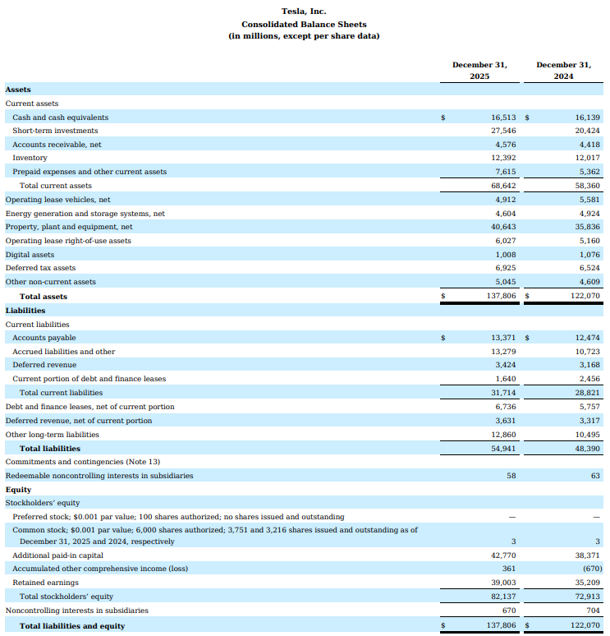

Table 12: Balance Sheet 2025-2024
(Source: Tesla, 2025)

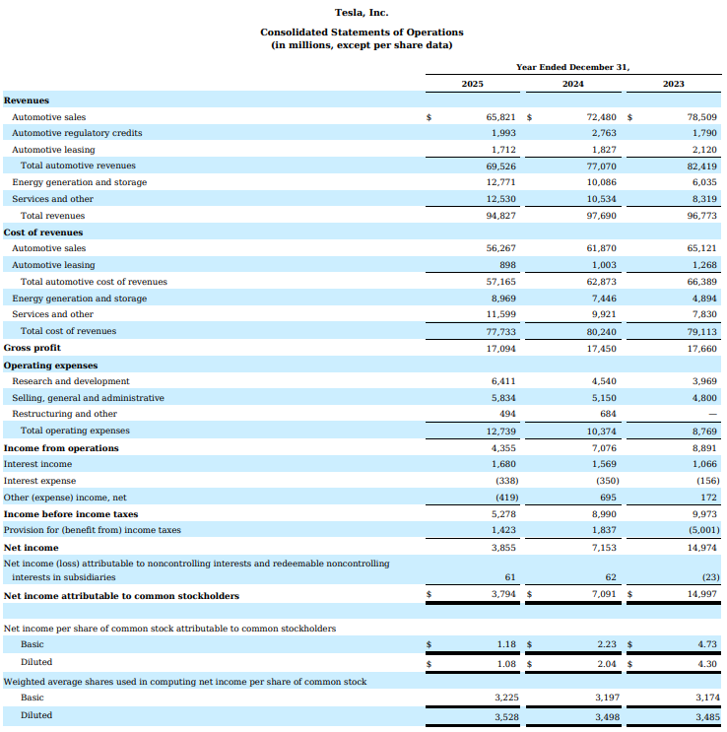

Table 13: Income Statement 2025-2024
(Source: Tesla, 2025)

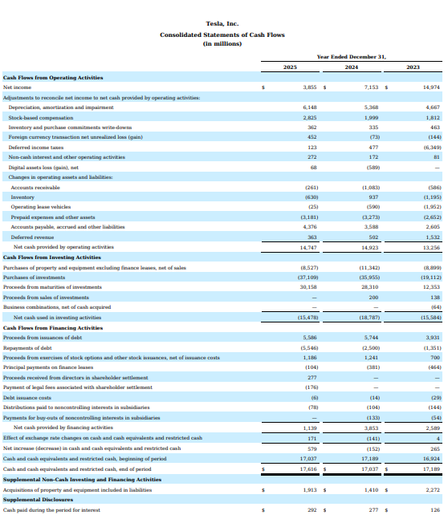

Table 14: Cash Flow Statement 2025-2024
(Source: Tesla, 2025)
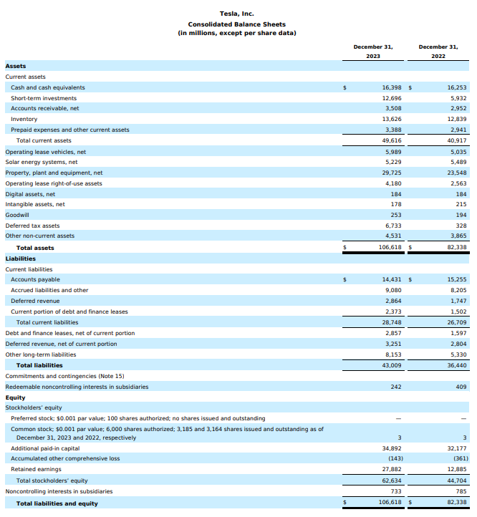

Table 15: Balance Sheet 2023-2022
(Source: Tesla, 2023a)
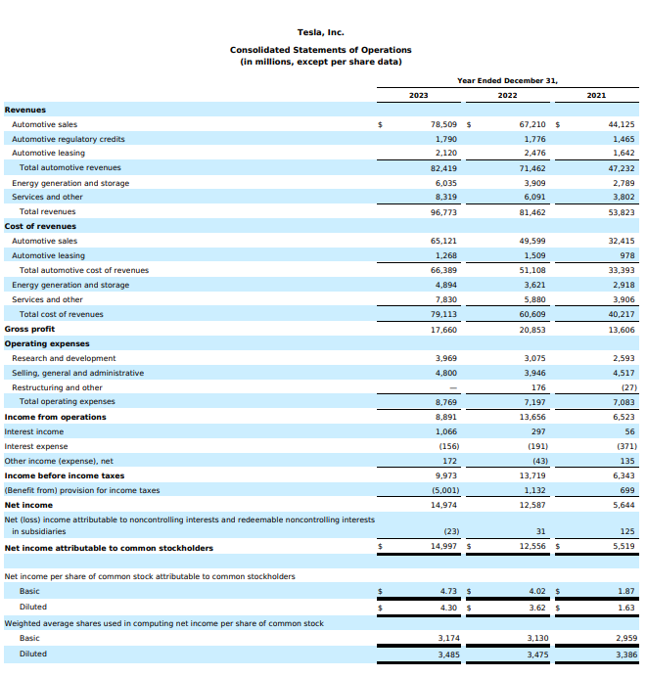

Table 16: Income Statement 2023-2022
(Source: Tesla, 2023a)
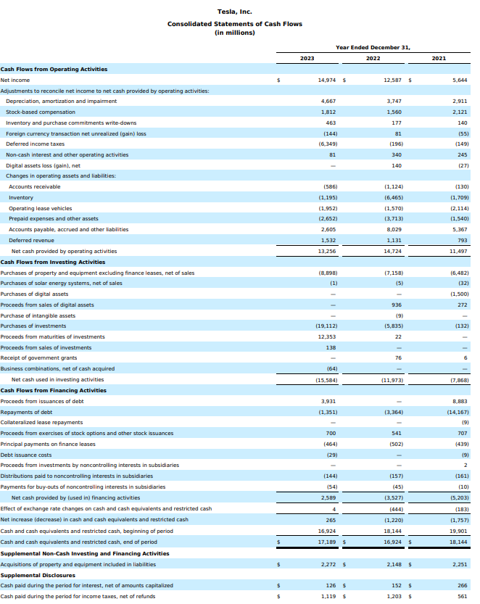

Table 17: Cash Flow Statement 2023-2022
(Source: Tesla, 2023a)
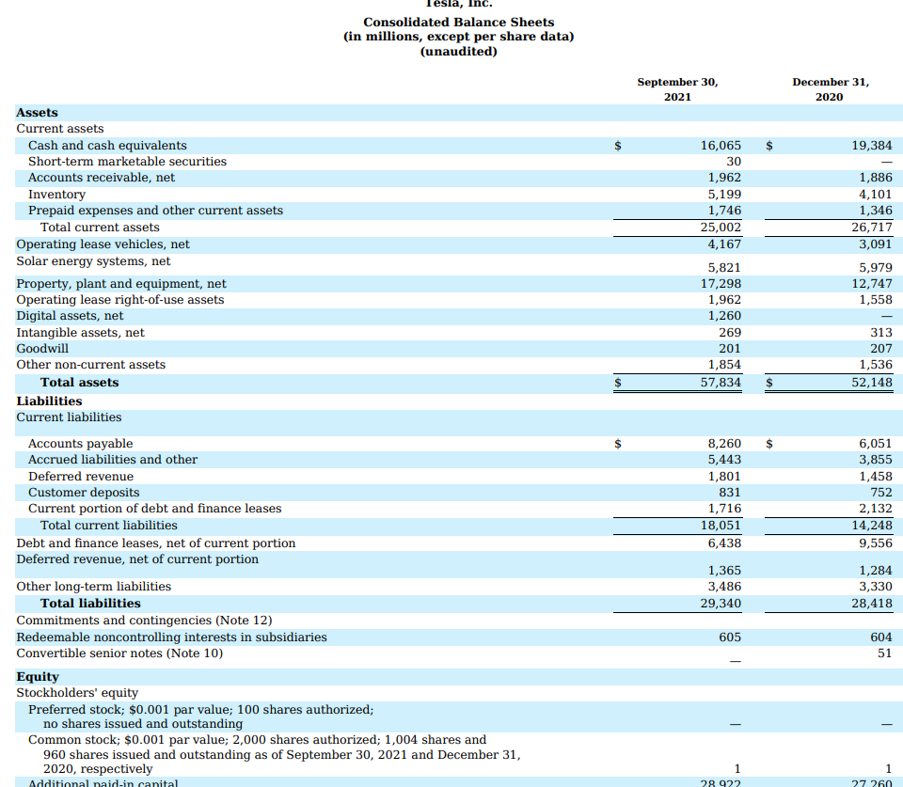

Table 18: Balance Sheet 2021
(Source: Tesla, 2021)
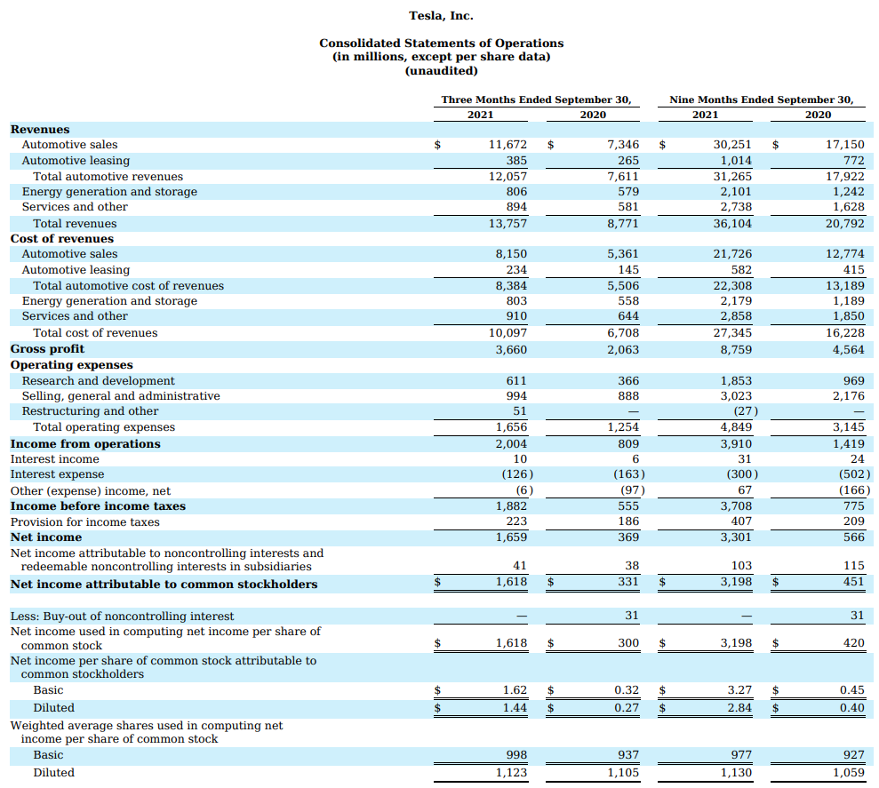

Table 19: Income Statement 2021
(Source: Tesla, 2021)
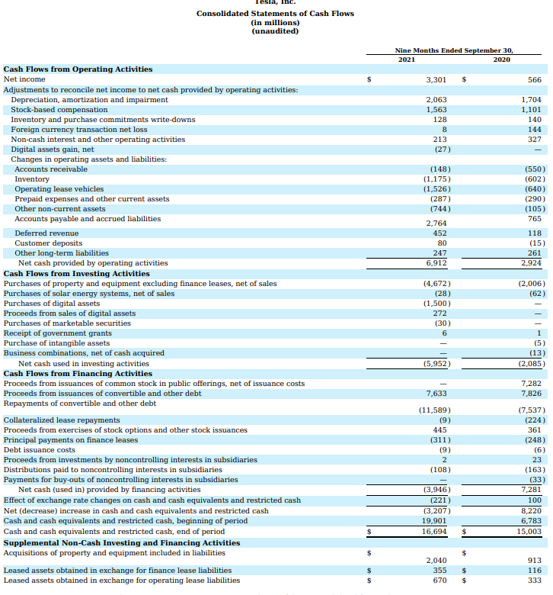

Table 20: Cash Flow Statement 2021
(Source: Tesla, 2021)

