jQuery Selecting Page Elements

CSS Reminder

In CSS, if we wanted style all <h1> tags on a page, we would do something like this:

h1{color:#FF0000}



If we want to style just a certain id, we might write something like:
#myid { color:#00FF00 }



CSS also has contextual selectors:

To style all <p> tags contained within <div> tags
div p { font-family:sans-serif; }

To style all <p> tags contained within tag with id myid
myid p { font-family:sans-serif; }

jQuery

jQuery allows us to select in a similar way to CSS, but instead of applying CSS, we apply Javascript code.

First, let’s set up a HTML page we can work with. Don’t forget to link to your jQuery library file and your myscripts.js file:

<html>
<head>
<style>

</style>
</head>
<body>
<h1>Hello, welcome to my page</h1>
<div class="normalstyle">
<p>Some text</p>
</div>

<h1>Today's news</h1>
<div id="myid">
<p>Some more text</p>
</div>

<h1>Today's weather report</h1>
<div class="normalstyle">
Even more text
</div>
</body>
link to scripts
<script src="jquery-3.6.0.js"></script>
<script src="myscripts.js"></script>

</html>

Selecting a tag in jQuery

In jQuery, we select all the h1 tags on the page by using

$("h1")

This would work for any tag, for example

$("p")
$("h2")
$("div")

We can then append some behaviour. For example:

$(pageready);

function pageready()
{
$("h1").css("background-color","red");
}

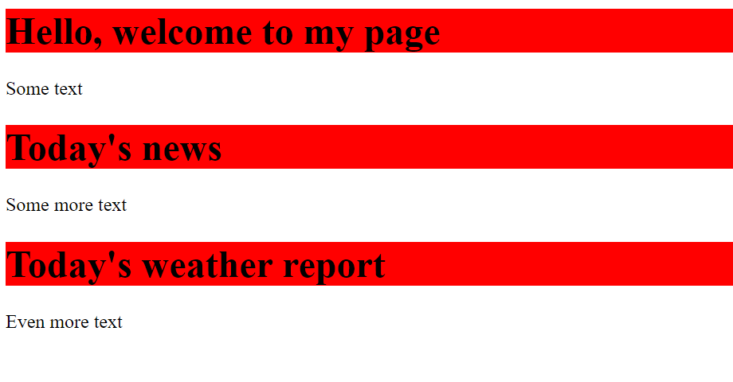

Let's add a few more:

$(pageready)

function pageready()
{
$("h1").css("background-color","red");
$("h1").css("color","blue");
$("div").css("background-color","green");
}



Selecting a class

In our example, two of our <div> tags have an attribute of class="normalstyle"

We can select these using jQuery too:

$(pageready)

function pageready()
{
$("div.normalstyle").css("color","red");
$("div.normalstyle").css("font-style","italic");
}



Note: we could also have written:

$(pageready)

function pageready()
{
$("div.normalstyle").css("color","red").css("font-style","italic");
}

or

$(pageready)

function pageready()
{
$("div.normalstyle").css({"color":"red","font-style":"italic"})
}

Selecting an id

In our example, there is also a <div> tag that has a specific id

<div id="myid">

This can also be selected using jQuery:

$(pageready)

function pageready()
{
$("#myid").css("font-family","sans-serif")
$("#myid").css("color","green")
}



Selecting contextual tags

We can also select (for example) all <p> tags within a <div> tag:

$(pageready)

function pageready()
{
$("div p").css("font-size","20pt")
$("div p").css("color","orange")
}



Selecting HTML elements with different forms (eg input)

Let's set up a HTML page we can experiment with:

<html>
<head>

</head>
<body>
<h1>Forms </h1>

<form>
<label for="fname">First name:</label>
<input type="text" id="fname" name="fname"><br>
<label for="lname">Surname:</label>
<input type="text" id="lname" name="lname"><br>
<label for="pword">Password:</label>
<input type="password" id="pword" name="pword"><br><br>

<input type="submit" name="Submit">
</form>

</body>
<script src="jquery-3.6.0.js"></script>
<script src="myscripts.js"></script>
</html>

We can use input in our jQuery to affect all the form elements:

$(pageready)

function pageready()
{
$("input").css("background-color", "yellow");
}

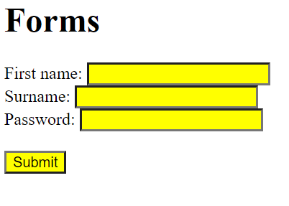

Or we can select just the text input:

$(pageready)

function pageready()
{
$("input:text").css("background-color", "yellow");
}

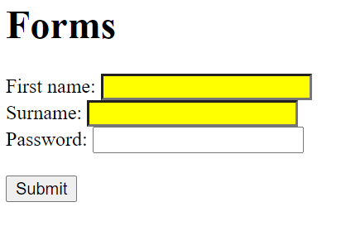

Or just the submit:

$(pageready)

function pageready()
{
$("input:submit").css("background-color", "yellow");
}

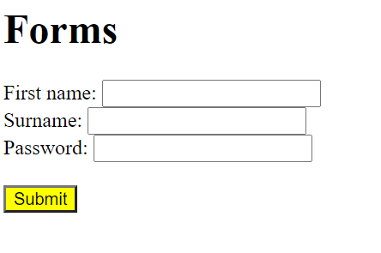

Or, you can select two at once:

$(pageready)

function pageready()
{
$("input:text,input:password").css("background-color", "yellow");
}



