Opportunities for Industry 4.0 applications in ‘Ready Meal’ production

Thomas Abbott
2221273@student.uwtsd.ac.uk

University of Wales Trinity Saint David (UWTSD)
Swansea Waterfront
IQ Campus
Swansea SA1 8EW

Supervisor: Mahesh Kannath
Date: 25.11.2022

Abstract:
This paper examines opportunities to enhance ‘ready meal’ manufacture utilising industry 4.0. With pressures labour availability and consumer demand for high quality, safe, legal food production the need for solutions becomes ever more prevalent. The paper investigates an example of labour reduction however the opportunities to improve quality and safety are also discussed - identifying that there are many opportunities for application in food production.
Introduction:
The agri-food industry plays a major part of the UK economy. One of the largest sectors contributing ‘£116.2 billion or 6% national Gross Value Added (GVA)’, of which £28.8bn is attributed to Food and Drink Manufacturing (GOV.UK, 2022).
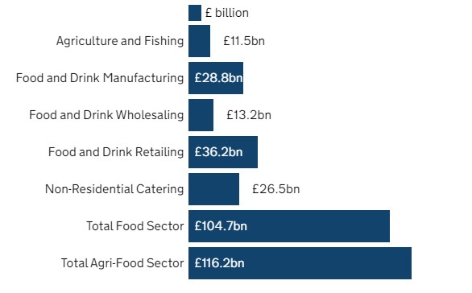
Fig.1 – Gross Value Added of the UK agri-food sector 2020 (GOV.UK, 2022).
The need to introduce industry 4.0 applications is becoming ever more prevalent with new and emerging challenges around labour shortages driven by Brexit and the covid-19 pandemic. Parliament.uk state that ‘in August 2021, the number of vacancies was estimated to be 500,000 out of 4.1 million roles in the sector’. (Labour shortages in the food and farming sector Fourth Report of Session 2021-22 Report, together with formal minutes relating to the report by authority of the House of Commons, 2022a). This coupled with the need to reduce costs and improve product quality, industry 4.0 could play an important role in advanced manufacturing. As a nation we are behind the curve of industry 4.0 application. For example, when comparing to other countries; automation in the UK is limited Fig.2 illustrates the UK ranked at 15th for annual installations in 2020 (IFR, 2021) a staggering 166,200 units behind the leader China.
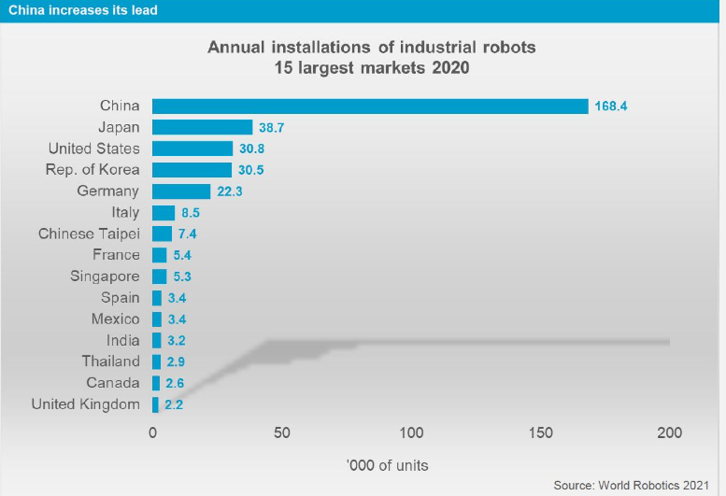
Fig.2: Annual installations of industrial robots 15 largest markets 2020 (IFR, 2021)
Aims & Objectives:
The purpose of this paper is to explore and identify how introducing industry 4.0 applications to a repetitive process within the food industry could lead to labour savings, quality improvement and reduced production errors which could have consumer safety implications, customer complaints and impact brand reputation.
Implementation Methodology:
In order to assess the opportunities to improve ‘ready meal’ production utilising industry 4.0 practices the following steps will be undertaken:
- Define the situation
- Assessment of the current process – focus on product packing
- Mitigations and potential opportunities of utilising industry 4.0 Background Research: -
The Situation:
Ready Meal manufacturing is often complex due to multiple processes and component ingredients used within recipes. These products often have short shelf life and in turn relatively short production runs. Historically this has made the introduction of technology a low priority as tasks could be completed with a manual process enabling flexibility with short production runs and different products. Fig. 3 illustrates an example factory layout and different processes.
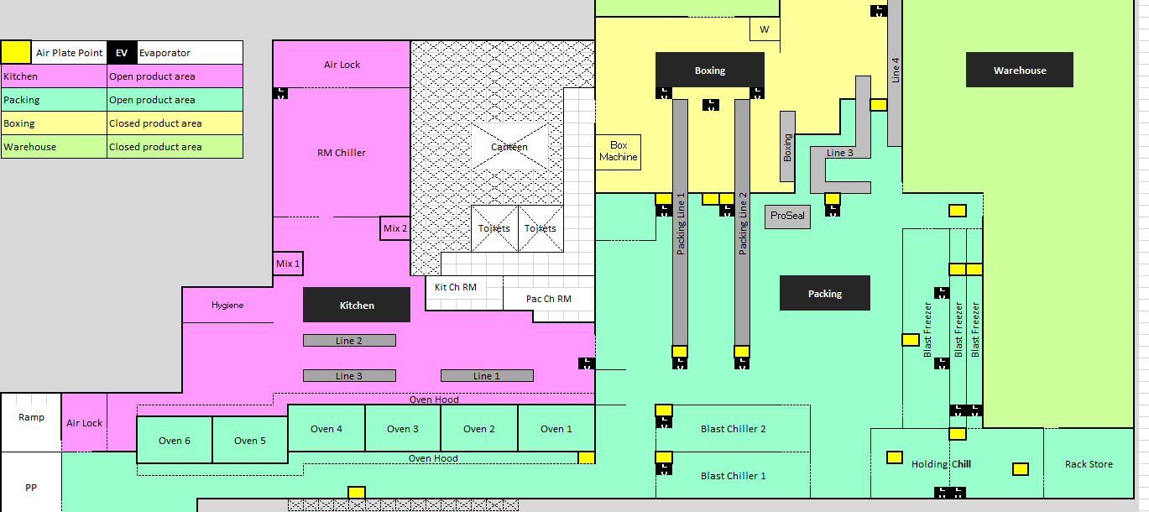
Fig.3 – Example manufacturing floor plan
The emergence of new technology that is commercially viable presents a great opportunity for applications.
Common challenges:
- Access to labour
- Operator safety (repetitive actions)
- Human error – reliance on human quality checks
- Poor data collection and review of data
- Reactive to issues rather than proactive
- Aging infrastructure
Assessment of the current process – focus on product packing:
The current processing method of packing a ‘ready meal’ is highly manual fig.4 illustrates the requirement of 20 heads (in yellow) across a production line.
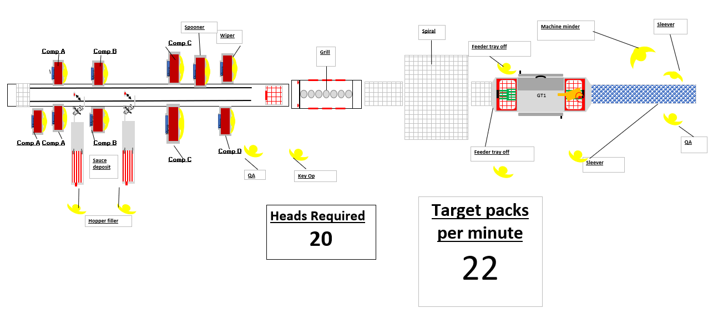
Fig. 4 - ‘Ready Meal’ line mapping
Pre-processed components and packaging are bought to the production line to construct the ‘Ready Meal’. In terms of efficiency the current process as previous mention is highly manual and reliant on human labour – 20 operators are required. Fig. 5 illustrates each manual task, operators require, units per min and time required.
 | Function | Task Summary | Ops Required | Unit per min | Speed (secs)
1 | Comp A | Pick and place component | 3 | 15 | 45
2 | Comp B | Pick and place component | 2 | 20 | 40
3 | Comp C | Pick and place component | 2 | 20 | 40
4 | Comp D | Pick and place component | 1 | 30 | 30
5 | Feeder | Tray transfer | 2 | 60 | 120
6 | QA | Quality checks – weights, MD, visual | 2 | 60 | 120
7 | Machine Minder | Settings amends | 1 | 30 | 30
8 | Hopper Filler | Fill hoppers with ingredients | 2 | 60 | 120
9 | Key Operator | Oversee operation | 1 | 60 | 60
10 | Spooner | Spreading sauce evenly on top | 1 | 30 | 30
11 | Wiper | Removing debris from packaging | 1 | 30 | 30
12 | Sleever | Sleeve application | 2 | 20 | 40
Machinery & Equipment
1 | GT1 |  |  | 45 | 45
2 | Checkweigher |  |  | 60 | 60
3 | Metal Detection |  |  | 60 | 60
 | Total Labour Summary |  | 20
Fig. 5 – Summary of tasks and labour requirements
The tasks undertaken manually are repetitive and, in some areas, relatively simple. Some however involve handling delicate components with irregular shapes. Quality steps such as the wiper and visual inspection currently rely on the operative in reality a 100% check is not possible.
Mitigations and potential opportunities of utilising industry 4.0 –
According to Erboz (2017, pp.761–767) there are nine key pillars in industry 4.0 defined as:
- Big Data and Analytics
- Autonomous Robots
- Simulation
- Horizontal and vertical systems integration
- The Industrial Internet of Things
- The Cloud
- Additive Manufacturing
- Augmented Reality (AR)
- Cyber Security

Fig. 6 summaries potential industry 4.0 mitigations to improve efficiency and product quality control.
Process | Current operation | Requirements: | Potential Mitigations
Pick and place components | Manual | - Correct component bought to line  - Use of correct component  - Correct positioning in pack  - No debris on sealing edge | - IoT – inventory management  - Vision systems  - Industrial robotics & Vision systems  - Vision systems
Hopper fill and ingredient replenishment | Manual | - Correct component bought to line  - Replenish hopper  - Replenish pick and place components | - IoT – inventory management
Sauce deposit | Automated | - Use of correct component  - Even deposit  - No debris on sealing edge | - IoT – inventory management  - Vision systems  - Vision systems
Spooner | Manual | - Even coverage of sauce  - No debris on sealing edge | - Industrial robotics  - Vision systems
Wiping | Manual | - Remove debris from seal edge | - Void with improved up stream controls
Grill | Automated | - Core temp - 72C 2mins  - Quality - Gratination | - Vision systems
Spiral chill | Automated | - Core temp >5C in 4 hours
Feeder tray off | Manual | - Transfer into GT1 | - Industrial robotics
GT1 – Tray Sealer | Automated | - Heat seal tray  - No debris in seal | - Vision systems
Sleeving | Manual | - Correct sleeve used  - Correct use by date | - 2D barcode verification in place, vision systems could further reduce risk
Quality Checks | Manual | - Visual quality inspection  - Component weight checks  - Metal detection verification  - Seal integrity checks  - Completion of due diligence paperwork | - Vision systems – 100% inspection  - 100% check in place - Systems integration could further improve  - Vision systems (heat mapping)  - IoT and systems integration
Fig. 6 – Summary of process, requirements and possible mitigations
Industrial Robotics:
According to Britannica automation is ‘a technology concerned with performing a process by means of programmed commands combined with automatic feedback control to ensure proper execution of the instructions. The resulting system is capable of operating without human intervention.’ (Groover, 2019, Para 3).
Utilising industrial robotics for the component pick and place operation in this process could reduce the operators required by 8 (from 20). Kuka market the fact they can pack up to ‘2,000 parts per minute by multiple robots in a line’. (KUKA AG, n.d.)
If the process is optimised to achieve 60 packs per minute and precision placement to avoid debris on the sealing edge the labour could be repurposed into more complex operations where the efficiency bottle neck lies (i.e. sleeving). Couple this with the vision systems to identify debris on the sealing edge further reducing the requirement of the ‘wiper’.
Steps for industrial robotics application:
- Agree industry partners – suppliers and integrators
- Establish operating parameters utilise simulation software such as RoboDK to get the most out the robot (robodk.com, n.d.)
- Robot selection – articulated for best versatility which mimics the human arm (HowToRobot, 2022)

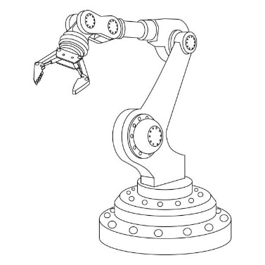
Fig. 7 – example articulated robot arm (www.istockphoto.com, n.d.)
- Programming – must account for bin pick of food components
- End effectors – careful selection to ensure no damage to inconsistent size and shape as well as being delicate. Grippers or vacuum.
- Trial – test and learn
- Internet of things – quality control, potential for vision systems to identify out of specification materials
- Optimisation
- Considerations –
  - Human safety
  - Factory space constraints
  - Hygiene
  - Maintenance / operating
  - Human impact – Schwab (Schwab, 2016) states that we must ensure that the fourth industrial revolution is ‘empowering and human-centred, rather than divisive and dehumanising’.
  - Future programming – accounting for recipe changes, factory layout etc.
  - Commercial return on investment (ROI)
Conclusion:
There are many opportunities for the application of Industry 4.0 technology and this paper illustrates the use of automation with industrial robotics could have a significant impact. In the example significant labour reductions can be achieved. In the complex production of ‘Ready Meals’ there are multiple other opportunities to be further explored.
Recommendations:
- Assess each mitigation in detail and review improvement opportunity versus return on investment – factoring in easy of setup. Consider future risks i.e., changes to labour market
- A detail assessment of the pick and place process utilising industry experts (robotics manufacturers, systems integrators)
- Further exploration into other Industry 4.0 opportunities summarised in Fig.6 and potential benefits

References:
GOV.UK. (2022). Food statistics in your pocket. [online] Available at: https://www.gov.uk/government/statistics/food-statistics-pocketbook/food-statistics-in-your-pocket.
Labour shortages in the food and farming sector Fourth Report of Session 2021-22 Report, together with formal minutes relating to the report by authority of the House of Commons. (2022a).
IFR (2021). IFR presents World Robotics 2021 reports. [online] IFR International Federation of Robotics. Available at: https://ifr.org/ifr-press-releases/news/robot-sales-rise-again.
Erboz, G. (2017). MANAGERIAL TRENDS IN THE DEVELOPMENT OF ENTERPRISES IN GLOBALIZATION ERA. Slovak University of Agriculture in Nitra, pp.761–767.
Groover, M.P. (2019). Automation. In: Encyclopædia Britannica. [online] Available at: https://www.britannica.com/technology/automation.
KUKA AG. (n.d.). Pick-and-place robots set the pace. [online] Available at: https://www.kuka.com/en-us/products/process-technologies/pick-and-place-robots.
robodk.com. (n.d.). Simulator for industrial robots and offline programming - RoboDK. [online] Available at: https://robodk.com/.
#HowToRobot. (2022). Articulated Robots: A Guide to the Most Familiar Industrial Robot. [online] Available at: https://howtorobot.com/expert-insight/articulated-robots.
www.istockphoto.com. (n.d.). Robot Arm Stock Photos, Pictures & Royalty-Free Images - iStock. [online] Available at: https://www.istockphoto.com/photos/robot-arm.
Schwab, K. (2016). The Fourth Industrial Revolution. [online] London: Penguin Random House. Available at: https://law.unimelb.edu.au/__data/assets/pdf_file/0005/3385454/Schwab-The_Fourth_Industrial_Revolution_Klaus_S.pdf. p. 4

