

Malhar Parbhubhai Patel
Student Number: 2240598
May 2023

Module:
Practice Based Research
(LCHS7001)

Lecturer’s Name:
Dr Aishat T. Bakre

Assignment Title:
Written Report

Table of Contents
Introduction 3
Rationale 4
Research Question 4
Research Aims 5
Research Objectives 5
Research Methodology 5
Research Design 6
Recruitment, Sampling & Study Participants 6
Data Collection Procedure: 8
Data Analysis Technique: 8
Ethical Considerations 9
Results 9
Theme 1: Challenges and Enablers in Postgraduate Students' Eating Behaviour 10
Sub-theme 1-Time 11
Sub-theme 2- Hunger and Peer Influence 11
Theme 2: Cost as a Barrier in Postgraduate Students' Eating Behaviour 11
Sub-theme 1- Difficulty in Adapting to new costs 12
Sub-theme 2- Lack of Availability 12
Discussion 12
Conclusion 13
References 14
Appendix 16
Appendix 1 16
Appendix 2 18

Introduction
The complex dance of eating behaviours becomes a worldwide concern in the ever-expanding global landscape where lives are influenced by an interplay of cultural, societal, and educational forces (Story et al., 2002). Understanding the nutritional benefits of a good diet is not only important for maintaining one's own health but also for the larger global conversation on wellbeing, because it helps us navigate through the complexity of dietary options (Bernstein et al., 2012).
With the demands of academic pursuits, postgraduate students frequently have to manage busy schedules, high stress levels, and vibrant social settings (Hadjioannou et al., 2007). The significance of eating a balanced diet and the knowledge of nutritional values might occasionally be neglected in the midst of these difficulties (Temple et al., 2006).
As people advance through the educational system, their settings, responsibilities, and lives change significantly (Elder et al., 1988). Postgraduate studies are a crucial time when academic endeavours become more intense, and they are frequently accompanied by elevated stress levels, more time limits, and changed social dynamics (Schaufeli et al., 2020). These elements can then have a substantial effect on eating habits, influencing people's decisions about their diet, nutrition, and general well-being (Falk et al., 1996).
The university environment, with its distinct fusion of disciplines, cultures, and socioeconomic origins, functions as a tiny world where personal experiences and broader trends intersect (Rhodes, 2001). With all of the nutritional knowledge at their disposal, university students may unintentionally overlook incorporating dietary habits into their daily lives due to their intense academic schedules (Temple et al., 2006).
The goal of this research is to add to the global conversation on health and wellbeing as well as the local understanding of eating behaviours. Through identifying the complex relationships between global trends and the food preferences of postgraduate students, the objective is to provide cross-border insights that inform interventions and support systems that may be adapted to the many academic contexts around the globe. In order to do this, it is crucial to promote a thorough worldwide understanding of the variables influencing postgraduate student's food preferences. This will eventually open the door for more knowledgeable and culturally aware methods of encouraging healthy eating practices globally.

Rational

It's important to know about the elements that affect postgraduate student’s eating habits at public universities for a number of reasons. Although a significant quantity of research has been done on eating habits in a variety of settings, it has not fully examined the unique difficulties experienced by postgraduate students in academic settings.
Previous research has done a thorough analysis of the variables affecting eating habits in a variety of populations, such as adults, adolescents, and particular professional groups (Mizia et al., 2021). On the other hand, postgraduate student’s experiences—especially those in academic settings—have not gotten enough attention. The majority of studies conducted on college students concentrate on undergraduate populations, with little attention paid to the unique difficulties experienced by postgraduate students (Terenzini et al., 1998).
Research on eating habits have brought attention to the significance of variables such as time restrictions, stress, cultural influences, and socioeconomic position (Feinstein et al., 1993). The complex interactions between these elements in the particular setting of graduate school, however, are still little understood. Postgraduate students frequently deal with increased pressure to perform academically, hectic schedules, and a change in social dynamics—all of which have a big impact on how they eat (Horta et al., 2023). It is imperative to examine these variables in the context of a public university in order to create treatments that suit the particular requirements of this population.

Research Question
- "What factors influence the eating habits of postgraduate students in a public university setting?"
- To what extent do environmental factors, such as the availability of healthy food options on campus, influence the eating behaviour of postgraduate students?

Research Aims
"To comprehensively explore and understand the various factors influencing the eating behaviour of postgraduate students in a public university, with the aim of identifying key determinants and potential intervention points for promoting healthier dietary habits within this academic demographic."

Research Objectives
- To identify and analyse the various factors that influence the eating behaviour of postgraduate students in a public university.
- To assess the influence of environmental factors, including the availability of healthy food options on campus, on the eating behaviour of postgraduate students.

Research Methodology
In this research, a qualitative research approach was employed to investigate the factors that influenced the eating behaviour of postgraduate students in a public university. Qualitative research is well-suited for investigating subjective experiences, perceptions, and social contexts influencing behaviour, particularly in the realm of studying eating behaviour (Bisogni et al., 2012). This approach facilitates an in-depth understanding by collecting rich and detailed data through open-ended questions, allowing participants to freely express their thoughts and experiences (Austin et al., 2014). Qualitative methods, known for their flexibility and adaptability, are crucial when exploring complex phenomena like eating behaviour, enabling the examination of unforeseen factors (Nan, 2011). The emphasis on contextualization in qualitative research provides a holistic view of the subject by exploring social, cultural, and environmental factors that shape individuals' food choices (Roudsari et al., 2017). However, qualitative research has limitations, including limited generalizability due to small sample sizes and specific study contexts, potential for subjectivity and bias, time-consuming data collection, transcription, and analysis processes, and the risk of social desirability bias, necessitating the establishment of rapport and a safe environment for participants (Queiros et al., 2017).

Research Design
Qualitative research serves as the ideal methodology for exploring the myriad factors influencing the eating behaviour of postgraduate students in a public university. Its suitability stems from the capacity for in-depth exploration, allowing researchers to delve into the lived experiences, perspectives, and behaviours of postgraduate students (Callary et al., 2015). By employing open-ended questions and discussions, qualitative methods go beyond numerical data, revealing rich, context-specific information (Locks et al., 2015). This approach is particularly relevant given the intricate and multifaceted nature of the study, aiming to unravel the complexities shaping eating behaviours among postgraduate students (Zina, 2005).
Within the qualitative research paradigm, focus group discussions (FGDs) are chosen as the primary method for several compelling reasons. FGDs leverage the dynamics of group interactions, facilitating engagement and uncovering shared experiences, diverse perspectives, and group norms that influence eating behaviours (Hennink, 2013). However, limitations include the potential for certain voices to dominate, the risk of social desirability bias influencing responses, difficulty in generalizing findings to a larger population, and the possibility of groupthink suppressing dissenting views within the group (Smithson, 2000). The time efficiency of FGDs, with an average allocation of 20 minutes per group, is crucial for accommodating the busy schedules of postgraduate students (Boateng, 2012). Additionally, FGDs are instrumental in uncovering societal and cultural influences on eating behaviours, aligning with the diverse cultural backgrounds represented among postgraduate students (Raymond et al., 2014). In summary, the combination of qualitative research methods, particularly FGDs, is chosen to comprehensively capture the depth, complexity, and diversity of factors shaping the eating behaviour of postgraduate students in the unique context of a public university.

Recruitment, Sampling & Study Participants
Recruitment for this qualitative study on the factors influencing the eating behaviour of postgraduate students in the University of Wales was executed through a systematic process. Convenience sampling was employed in this research study. This sampling method was chosen due to its practicality and efficiency in recruiting participants who were readily accessible within the study environment (Robinson, 2014). Given the specific focus on understanding the experiences of postgraduate students within the University of Wales, convenience sampling streamlined the recruitment process, acknowledging the constraints of the study setting (Chandler et al., 2016).
The inclusion criteria specified that participants needed to be currently enrolled postgraduate students at the University of Wales, irrespective of their academic discipline. To ensure a diverse representation, no specific restrictions were imposed based on gender, age, or cultural background. However, participants were required to be willing to engage openly in focus group discussions about their eating behaviours, challenges, and perceptions.
Exclusion criteria were minimal, with the primary emphasis on excluding individuals who did not meet the inclusion criteria of being current postgraduate students at the University of Wales. Participants were informed about the voluntary nature of their participation and their right to withdraw from the study at any point without consequences.
Recruitment channels included university communication platforms, such as email lists and notice boards, to disseminate information about the study. The recruitment process involved providing a brief overview of the research, emphasizing its voluntary nature, and detailing the criteria for participation. Interested individuals were encouraged to express their willingness to participate, and from the pool of volunteers, participants were chosen based on their availability or proximity to the research setting.
A total of 13 participants (Age≥24) were selected for the study. the study using a convenient sampling method, whereby individuals were chosen based on their accessibility and willingness to participate. But, among them 2 participants couldn’t attend the discussion because of personal reason and the second focus group was reduced to 5. Dividing participants into two distinct groups, each consisting of 5 individuals. This setup allowed for a comprehensive exploration of individual perspectives within the dynamic of a group setting. Each FGD was allocated an average of 20 minutes, striking a balance between a detailed examination of themes and maintaining participant engagement. The focus group sessions were conducted with different members for each session, ensuring varied perspectives and experiences were captured
Table 1: Demographic Characteristics of Focus Group Participants (n=10)
 | Characteristics | Total n (%)
Age | 20-25 | 9(90%)
 | 25-30 | 1(10%)
sex | female | 9(90%)
 | male | 1(10%)
educational Back Ground | university Degree | 10(100%)
Body Mass Index (Kg/m2) | normal | 8(80%)
 | Over Weight | 2(20%)
Ethnic Background | Asian | 10(100%)
Residency | Off Campus | 10(100%)

Data Collection Procedure
The focus group discussion took place in a class room within the Birmingham City campus Building at the University of Wales, designed to accommodate 13-15 participants. This venue was deemed convenient and secure by the participants due to its proximity to their usual place of worship and easy accessibility by walking or various transportation services, complemented by available car parking spaces. Prior to commencing the focus group sessions, a brief questionnaire (see Appendix 1) collected basic socio-demographic information from the participants. Each participant had previously signed and returned a consent form. Each the focus group discussions lasting approximately 20 mins. The researcher facilitated the sessions and briefly introduced and welcomed participants. The researcher leads the discussions independently. To ensure a comprehensive record, participant’s responses were audio-recorded, capturing the depth of their narratives. Data were recorded using a mobile phone (Xiomi, Redmi note 7 pro). Simultaneously, moderators took detailed notes, complementing the recordings by capturing nuances, non-verbal cues, and group dynamics. This dual approach emerged as valuable resources, effectively capturing the diversity of participant perspectives on the intricate factors shaping their eating behaviour during their postgraduate studies at the University of Wales.
A discussion guide featuring semi-structured open-ended questions (see Appendix 2) guided participants in addressing the research questions. Throughout the discussions, additional questions were posed to clarify responses or ensure participants remained focused on the primary topic of consideration.

Data Analysis Technique
SPSS Statistics 20 was used to analyse data obtained from the questionnaire and to calculate descriptive statistics of the focus group sample. The research embraced an inductive approach, enabling themes and patterns to organically emerge from the data rather than imposing predetermined concepts (Glaser et al., 2014). This approach was well-suited for the exploratory nature of the study, fostering a nuanced understanding of the diverse factors influencing eating behaviours among postgraduate students (Azungah, 2018).
The primary method of data collection was through semi-structured focus group discussions. This format facilitated open dialogue, ensuring that key themes related to eating behaviours, challenges faced by university students, and perceptions were thoroughly explored (Raymond et al., 2014). To further analyse the gathered data, participants' responses were recorded and transcribed for a comprehensive examination.
Thematic analysis was then applied to identify patterns, trends, and recurring themes within the transcribed data. These emergent themes formed the foundation of the analytical framework, providing a structured lens through which to interpret the complexities of postgraduate student’s eating habits. These includes getting acquainted with the data, producing the initial codes, identifying themes, reviewing themes, defining and naming themes and generating the report of the analysis.

Ethical Considerations
Throughout the qualitative study on the factors influencing the eating behaviour of postgraduate students at the University of Wales, ethical considerations played a central role. The study adhered to key ethical principles, including obtaining informed consent from participants, ensuring confidentiality and anonymity of responses, respecting the dignity and autonomy of participants, and prioritizing beneficence and non-maleficence. Transparent research practices, including clear communication of the study's design and objectives, were maintained, and the research protocol received approval from the ethical review board at the University of Wales. The voluntary nature of participation was emphasized, allowing participants the freedom to withdraw without consequences. After the focus group discussions, participants were debriefed, providing an overview of key findings and offering an opportunity for questions. Participants were assured that their responses would be treated with the utmost confidentiality. Identifying information was kept confidential, and pseudonyms were used in any reporting or publication to maintain anonymity. Overall, these ethical considerations were integral to conducting a rigorous and respectful exploration of the factors influencing the eating behaviour of postgraduate students, ensuring their well-being and rights were prioritized throughout the research process.

Results
In exploring the transcribed data, participants articulated their views on a healthy person, emphasizing the significance of nutritious eating. Additionally, challenges faced by university students, including time constraints, limited access to proper meals, and weight fluctuations linked to irregular eating habits, were elucidated. Factors influencing eating behaviour, such as travel, social media distractions, and difficulties adapting to a new place for international student, were also highlighted.
The data further uncovered barriers and enablers of healthy eating, ranging from convenience and societal trends to cost perceptions and a lack of awareness about nutritional content. Weight consciousness and dietary preferences were explored, with concerns about weight gain influencing food choices and cultural backgrounds shaping dietary preferences. Finally, participants provided suggestions for promoting healthy eating, advocating for skeet, encouraging breakfast consumption, and creating affordable, diverse food outlets on campus.
Several key themes emerged, covering aspects such as the definition of a healthy person, challenges faced by university students, factors influencing eating behaviour, and suggestions for promoting healthy eating.

Theme 1: Challenges and Enablers in Postgraduate Students' Eating Behaviour
This theme reflects the participants common challenges and enablers in post-graduate student’s eating behaviour. These include two subthemes
- Time Constraints as a Barrier
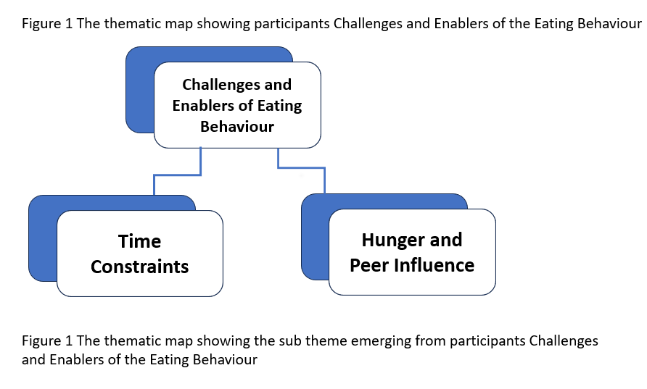
- Hunger and Peer Influence as Enablers

Sub-theme 1-Time
The participants perceived time as a barrier, Participants consistently expressed the struggle to allocate sufficient time for regular and balanced meals amidst the demands of academic commitments and deadlines. One of them commented:
“Sometimes you miss the morning breakfast yeah may be sometimes the lunch so we don’t have time to make the breakfast and lunch especially when yeah is difficult.” P1 FG1
Another participant reiterated that:
“When we came to universe, we get tired from morning to the evening we miss the proper meal
…” P5 FG1

Sub-theme 2- Hunger and Peer Influence
The participants perceived Hunger and Peer Influence as Enablers. One of them commented:
“Like, I’m hungry so I have to eat.” P2 FG1
Another participant reiterated that:
“At the university as we see the surrounding people eating fruits and all it influences that we can bring food tomorrow for…” P1 FG2

Theme 2: Cost as a Barrier in Postgraduate Students' Eating Behaviour
This theme reflects the cost of the available food as an influencing factor in eating behaviour of the post graduate student in university of wales. These include two subthemes
- Difficulty adapting to new food costs
- Lack of availability of familiar foods

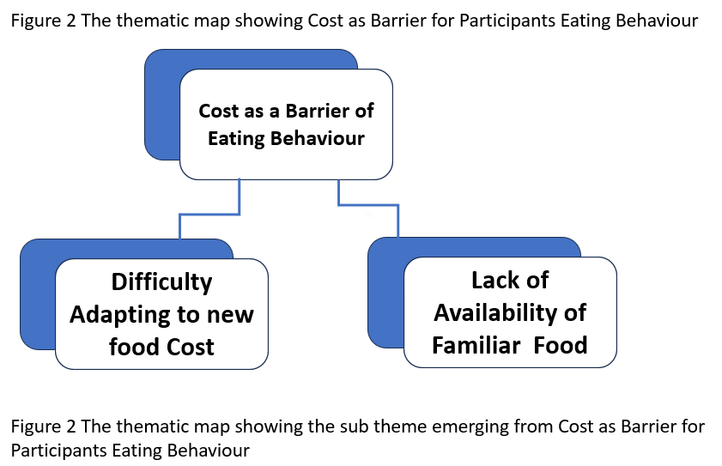

Sub-theme 1- Difficulty in Adapting to new costs
Specifically international student faces difficulty in adapting in newer food costs. This struggle is the major factor which influence the eating behaviour of the post graduate students. One of them commented:
“Cost is the major influencing factor” P1 FG2
Another participant reiterated that:
“Price of the food” P4 FG2

Sub-theme 2- Lack of Availability
Participants feels that lack of availability of the native foods also affects the eating behaviour of the participants. One of them commented:
“Access of native foods is our preference sometime we do not get in the foreign land our native foods” P5 FG1
Another participant reiterated that:
“Uuniversity have to provide some foods like International Foods so students can easily get it”

Discussion
The primary goal of this investigative research was to uncover the factors influencing eating behaviours among university students. Additionally, our objective was to gather insights and suggestions to support the creation of targeted intervention programs designed to enhance healthy eating habits among this demographic. The study identified four major levels of determinants: individual (intrapersonal), social environment (interpersonal), physical environment (community settings), and macro environment (societal). Moreover, specific characteristics unique to the university setting were identified as influencers on students' eating behaviours.
The present study aimed to explore the factors influencing eating behaviour in university students. The current study's findings demonstrated that the main factor impacting university students' eating habits is time constraints. These results are in line with Murray et al. (2016)'s literature.
The result of this study also shows that hunger and peer influence are also the influencer of the eating behaviour among the university students. which bears similarities to the Kabir et al., 2018 study.
The study on factors influencing eating behaviour among postgraduate students in a public university acknowledges limitations, including concerns about generalizability due to its focus on a specific institution, potential sample size constraints, and the risk of social desirability bias affecting self-reported eating behaviours. Understanding these factors, however, holds significant implications for both academic and well-being programs. The findings could inform targeted health initiatives, nutritional education, and counselling services tailored to postgraduate students' specific needs. Additionally, the research outcomes may contribute to the development of university policies promoting healthier food options and creating an environment conducive to positive eating habits. Recommendations include the need for longitudinal studies, replication in diverse university settings, a mixed-methods approach for a comprehensive understanding, collaboration with health professionals, and the incorporation of technology for ongoing support. These suggestions aim to enhance the study's robustness and applicability while addressing its limitations, ultimately promoting healthier lifestyles among postgraduate students in public universities.

Conclusion
There are various factors that influencing the eating behaviour of postgraduate students in a public university. challenges faced by university students, including time constraints, limited access to proper meals, and weight fluctuations linked to irregular eating habits, were elucidated. Factors influencing eating behaviour, such as travel, social media distractions, and difficulties adapting to a new place for international student, were also highlighted.
Results from the study revealed time constraints as a significant barrier to healthy eating among postgraduate students. Hunger and peer influence emerged as enablers, shedding light on the intricate interplay of social dynamics on dietary choices. The thematic analysis highlighted challenges and enablers, emphasizing the impact of time constraints on regular and balanced meals and the influence of hunger and peer behaviours.
The discussion placed the study's findings in the broader context of determinants affecting university students' eating behaviours, acknowledging the uniqueness of the university setting. The research identified individual, social, physical, and macro-environmental factors shaping students' dietary choices. Recommendations stemming from the study included the necessity for longitudinal research, replication in diverse settings, a mixed-methods approach for a more comprehensive understanding, collaboration with health professionals for targeted interventions, and the incorporation of technology for ongoing support.
The recommendations provided a roadmap for future research endeavours, encouraging a holistic and culturally sensitive approach to promoting healthier eating habits among postgraduate students in public universities globally. Overall, this research contributes to the ongoing conversation about the complex factors influencing eating behaviour and the importance of tailored interventions for diverse academic populations.

References
Austin, Z. and Sutton, J. (2014). Qualitative research: Getting started. The Canadian journal of hospital pharmacy, 67(6), p.436.
Azungah, T. (2018). Qualitative research: deductive and inductive approaches to data analysis. Qualitative research journal, 18(4), pp.383-400.
Bernstein, M. and Munoz, N. (2012). Position of the Academy of Nutrition and Dietetics: food and nutrition for older adults: promoting health and wellness. Journal of the Academy of Nutrition and Dietetics, 112(8), pp.1255-1277.
Bisogni, C.A., Jastran, M., Seligson, M. and Thompson, A. (2012). How people interpret healthy eating: contributions of qualitative research. Journal of nutrition education and behavior, 44(4), pp.282-301.
Boateng, W., 2012. Evaluating the efficacy of focus group discussion (FGD) in qualitative social research. International Journal of Business and Social Science, 3(7).
Callary, B., Rathwell, S. and Young, B.W. (2015). Insights on the Process of Using Interpretive Phenomenological Analysis in a Sport Coaching Research Project. Qualitative Report, 20(2).
Chandler, J. and Shapiro, D. (2016). Conducting clinical research using crowdsourced convenience samples. Annual review of clinical psychology, 12, pp.53-81.
Elder Jr, G.H. and Caspi, A. (1988). Human development and social change: An emerging perspective on the life course. Persons in context: Developmental processes, 69(1), pp.77-113.
Falk, L.W., Bisogni, C.A. and Sobal, J. (1996). Food choice processes of older adults: a qualitative investigation. Journal of nutrition Education, 28(5), pp.257-265.
Feinstein, J.S. (1993). The relationship between socioeconomic status and health: a review of the literature. The Milbank Quarterly, pp.279-322.
Glaser, B.G. and Holton, J., 2004, May. Remodeling grounded theory. In Forum qualitative sozialforschung/forum: qualitative social research (Vol. 5, No. 2).
Hadjioannou, X., Shelton, N.R., Fu, D. and Dhanarattigannon, J. (2007). The road to a doctoral degree: Co-travelers through a perilous passage. College Student Journal, 41(1).
Hennink, M.M. (2013). Focus group discussions. Oxford University Press.
Horta, H. and Li, H. (2023). Nothing but publishing: The overriding goal of PhD students in mainland China, Hong Kong, and Macau. Studies in Higher Education, 48(2), pp.263-282.
Kabir, A., Miah, S. and Islam, A. (2018). Factors influencing eating behavior and dietary intake among resident students in a public university in Bangladesh: A qualitative study. PloS one, 13(6), p.e0198801.
Locks, L.M., Pandey, P.R., Osei, A.K., Spiro, D.S., Adhikari, D.P., Haselow, N.J., Quinn, V.J. and Nielsen, J.N. (2015). Using formative research to design a context‐specific behaviour change strategy to improve infant and young child feeding practices and nutrition in N epal. Maternal & Child Nutrition, 11(4), pp.882-896.
Mizia, Sylwia, Anna Felińczak, Dariusz Włodarek, and Magdalena Syrkiewicz-Świtała. (2021). "Evaluation of eating habits and their impact on health among adolescents and young adults: A cross-sectional study." International journal of environmental research and public health 18, no. 8 (2021): 3996.
Murray, D.W., Mahadevan, M., Gatto, K., O’Connor, K., Fissinger, A., Bailey, D. and Cassara, E., 2016. Culinary efficacy: an exploratory study of skills, confidence, and healthy cooking competencies among university students. Perspectives in Public Health, 136(3), pp.143-151.
Nan, N., 2011. Capturing bottom-up information technology use processes: A complex adaptive systems model. MIS quarterly, pp.505-532.
Raymond, C.M., Kenter, J.O., Plieninger, T., Turner, N.J. and Alexander, K.A., 2014. Comparing instrumental and deliberative paradigms underpinning the assessment of social values for cultural ecosystem services. Ecological economics, 107, pp.145-156.
Rhodes, F.H.T., 2001. The creation of the future: The role of the American university. Cornell University Press.
Robinson, O.C., 2014. Sampling in interview-based qualitative research: A theoretical and practical guide. Qualitative research in psychology, 11(1), pp.25-41.
Roudsari, A.H., Vedadhir, A., Amiri, P., Kalantari, N., Omidvar, N., Eini-Zinab, H. and Sadati, S.M.H., 2017. Psycho-socio-cultural determinants of food choice: A qualitative study on adults in social and cultural context of Iran. Iranian journal of psychiatry, 12(4), p.241.
Schaufeli, W. and Enzmann, D., 2020. The burnout companion to study and practice: A critical analysis. CRC press.
Smithson, J., 2000. Using and analysing focus groups: limitations and possibilities. International journal of social research methodology, 3(2), pp.103-119.
Story, M., Neumark-Sztainer, D. and French, S., 2002. Individual and environmental influences on adolescent eating behaviors. Journal of the American Dietetic association, 102(3), pp.S40-S51.
Temple, N.J., Steyn, N.P., Myburgh, N.G. and Nel, J.H., 2006. Food items consumed by students attending schools in different socioeconomic areas in Cape Town, South Africa. Nutrition, 22(3), pp.252-258.
Terenzini, P.T. and Pascarella, E.T., 1998. Studying college students in the 21st century: Meeting new challenges. The review of higher education, 21(2), pp.151-165.
Zina, O., 2005. Researching real-world problems: A guide to methods of inquiry. Sage.

Appendix

Appendix 1

A Brief Questionnaire

Age (years)
c
15-20

20-25

25-30

30-35

35-40

Sex

Male

Female

Educational background

Primary School

Secondary School

University Degree

Graduate Degree
Other
Please specify:
…………………………………………

Body Mass Index (BMI) (kg/m2)
Height ………………………..
Weight ………………………..
BMI ………………………..

Ethnic background

White British

Black British

Black African

Black Caribbean

Indian

Pakistani
Bangladeshi

Chinese
Asian Other

Please specify:
…………………………………………….

Any other Ethnic group

Please specify:
………………………………………….....

Residency
On-campus

Off/campus

Programme of Study
Please specify:

………………………………………………………………………….

Appendix 2
Exploring the factors that influence eating behaviour among postgraduate students in a public university: a focus group discussion.
Opening
1. Where are you from and what's your name? Introduction
2. Describe a healthy person.
Transition
3. What comes to your mind when you think of the health of a university students"?
4. Since you became a university student has your body weight and/or body composition changed?
Key
5. Since you entered university has your eating behaviour changed?
6. What factors do you think are influencing your healthy eating habits at the university What barriers and enablers of healthy eating behaviour can you identify?
7. Which of the previously mentioned factors have had the greatest influence on your healthy eating behaviour?
Ending
8. Do you have any suggestions, additions?
9. Can you give us some advice on how to promote healthy eating behaviours in students?
10. What can university do to promote healthy eating habits among students?
Probe: Please explain in detail.

