DS 1 Assignment

My Screenshots/Photos

Screenshot/Photo 1

I use Word for letters, my CV and portfolio documents, while Excel helps me organise figures, track work and reach clear results.

Screenshot/Photo 2

I use Gmail and Outlook regularly to manage my messages and keep track of important information, including university emails.

Screenshot/Photo 3

I use Telegram to transfer large files and keep useful documents in Saved Messages, so I can access them later on my phone or computer.

Screenshot/Photo 4

WhatsApp helps me stay connected and communicate with people in different ways.

Screenshot/Photo 5
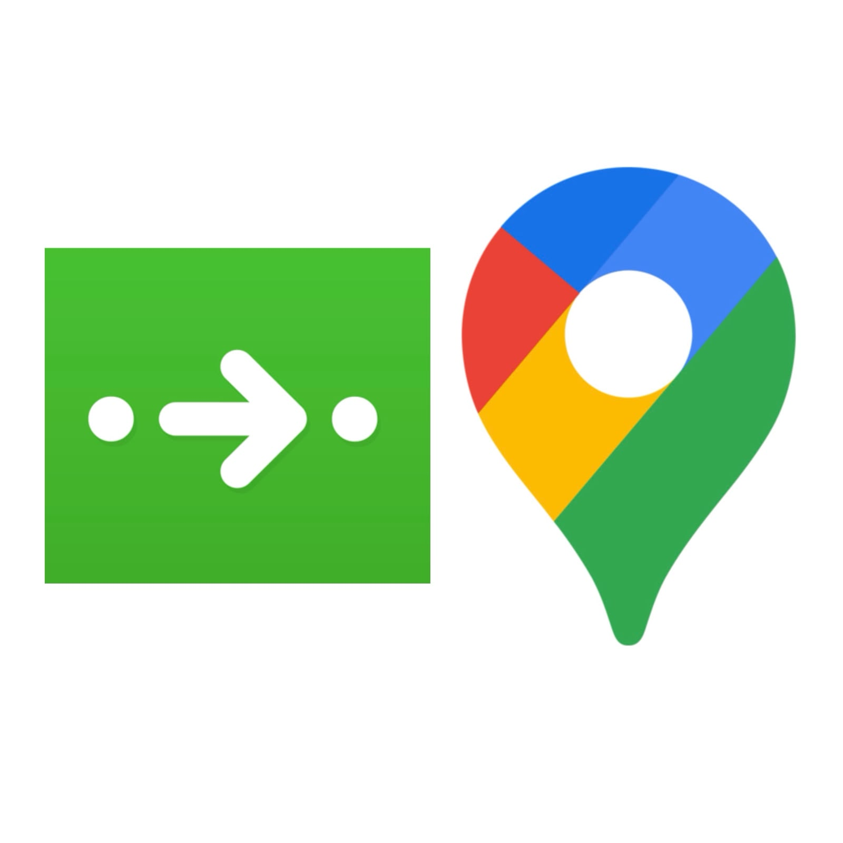
Navigation apps such as Google Maps and City Mapper help me find directions and plan journeys, especially since moving to the UK.

Screenshot/Photo 6

Picsart shows the creative side of my digital life. I have often used it on my phone to make quick designs with images, text and stickers instead of opening Photoshop.

My Short Reflection
- Write 5–8 simple sentences about your digital life.
- You can use the sentence starters below if helpful.
Digital tools help me manage my daily life more efficiently and save time. I use Microsoft Word to prepare letters, my CV and other documents, including my portfolio. Excel is one of my favourite tools because it helps me organise information, track progress and reach clear results. I use Gmail and Outlook regularly to keep up with personal and university emails. WhatsApp and Instagram help me stay connected with people, while Telegram is useful for sharing and saving large files. Since moving to the UK, Google Maps and Citymapper have helped me plan journeys and find my way around. Finally, Picsart lets me make quick designs on my phone using images, text and stickers without opening Photoshop.

