Name: Gurpreet Kaur Cheema

Student number: 2026299

Module code: BMSW4005

Lecturer’s Name: Sujeewa Herat

Table of Contents
Introduction 2
Part 1 2
Part 2 4
SWOT Analysis 4
Personal Development Plan 5
Personality Test 6
Part 3 7
Gibbs Reflective Cycle 7
Mock interview 8
Reference: 9

Introduction
This assessment will include in the first part, the information about mine skills and competences using three tools which are SWOT Analysis, Personal Development Plan and Personality Test.
In the second part, all these tool will be explained with more details and how these can help and be used in certain scenarios.
In the last part, is about assess and reflect on mine learning about previous tasks such as open boos assessment, mock interview and UK employment legislation.

Part 1
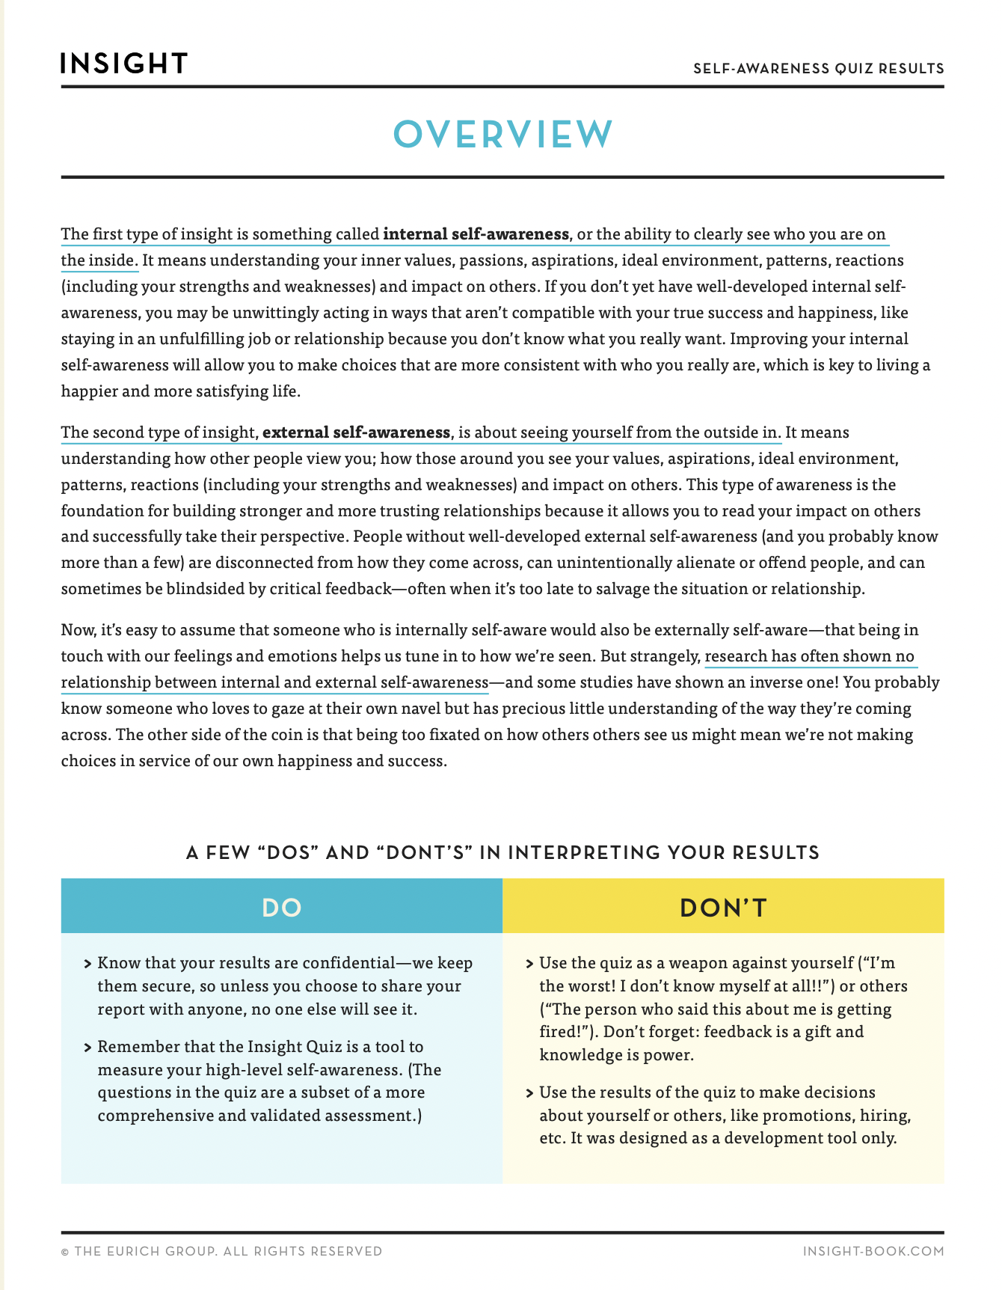
“self-awareness represents how clearly we see our own values, passions, aspiration, fit with our environment, reactions and impacts on others.” Self-awareness is when you have a clear picture of yourself and your personality that include the strength, weaknesses, thoughts, beliefs, motivation and emotions.
Self awareness is really important because it helps you to reflect on yourself, recognise your strengths and weaknesses, helps to control your emotions and take criticism. The 95% of the people thinks that they are self-aware but the actual figure is only 10-15%.
In our lesson we have a self-awareness quiz to find out about ourselves with the help of one of the person that knows us well.
As you can see the outcome has been sent by email, it include a detailed description of myself based on the quiz that I have done and right below there is another description of myself again but this time is based on my friend’s answers to the quiz.
Based on the result I am a pleaser that cares more how others sees me rather then how I see myself.
Added to this I have done the SWOT analysis where I have find out what are my strength are, such as time management skills and organisation skills. It highlights my weaknesses such as easily distractive and impatient. In the end I have to find what opportunities that I have and what threats I might face.
Last but not least the personality test with several questions that at the end tells you what kind of a personality you have, I am an virtuoso.

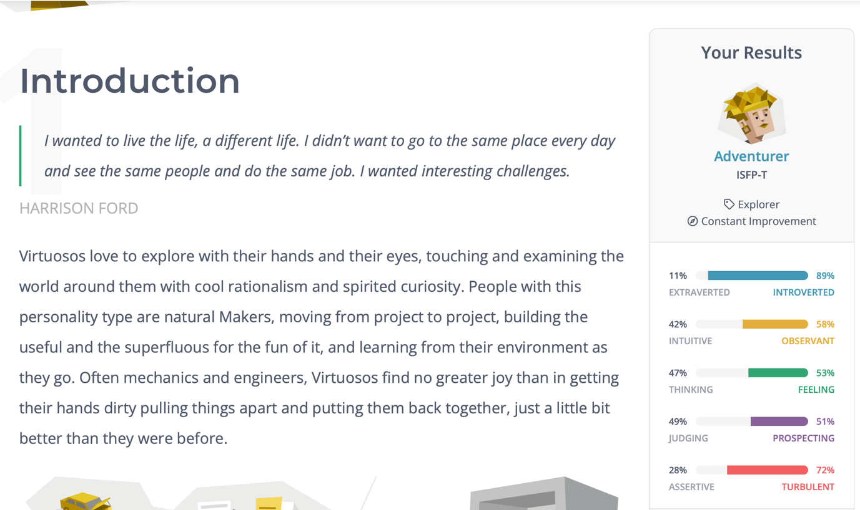

Part 2

In the second part of the assignment, I am being appointed as manager in my organisation, regarding my responsibility I will be determining the learning and the development in the training that my staff has had.
The methods that I will be using are the same as mentioned before.
Training is process that every employee goes through to learn new skills and how a job should be done. Also, training is used to improve current or special knowledge, an attitude toward a job to make sure is performed accurately and to make sure that the quality of the work improves.
Development is a long-term concept that requires a lot of time and experience, it may lead to an employee to liking the organisation’s strategy and their learning plans.
To learn more about the staff members the method that are going to be used are: SWOT analysis, personal development plan and personality test.

SWOT Analysis

“SWOT Analysis is a popular 4-box strategy analysis and strategy development framework.”
SWOT each letter has a significant and it stand for strengths, weaknesses, opportunities, threats; it highlights the micro part of a company but its also used to by people to know more about their selves, to know what they are good at and where they need to improve, what can they to do so and what kind of tasks of difficulties they might have to go through.
Is best if this tool is used before an organisation’s decides to launch a new strategy, its also helps you with the research and to record the idea.
The advantage of this tool is that is very simple to create and it has not mathematics, its also very straight forward if you to communicate it to other stakeholders.
The disadvantage is that all the information used in this tool is very generalised and is based on perception, belief, personality and preference.

Strength  -work experience  -education  -technical expertise  -transferable skills | Weaknesses  -lack of work experience  -limited education  -Limited technical knowledge  -lack of job knowledge
Opportunities  -positive trend  -enhancing education  -fields in need of your skills  -geography: ability to move | Threats  -negative trends  -competition  -limited ability do develop  -limited position in your area

Personal Development Plan

“Confronted with the speed of technological advancements and increasing global competition, organizations have come to realize that their employees' continuous learning drives business success. A popular tool to support and enhance continuous learning is the personal development plan (PDP).”
To succeed and to be happier about your education, career and life, its suggested to continue to improve your knowledge, learn new skills and gain more experience. This is called personal development plan, which is a lifelong process.
PDP is very favourable for you as an individual and for company’s’ itself, you will be able to have a positive impact on yourself and people surrounding you.
PDP is an action plan that can be identified because it include the goals set by the person and the achievement that he wants to make, strength and weakness, which part you need improvement and development to reach your goal, what should be done to get to the goal and for last anything else that could stop you from progression.
The benefit of this plan is that it highlights the goals, it identifies where are you good at and where you need to improve, it also improves the chances of your employment and performance, you feel more motivated.
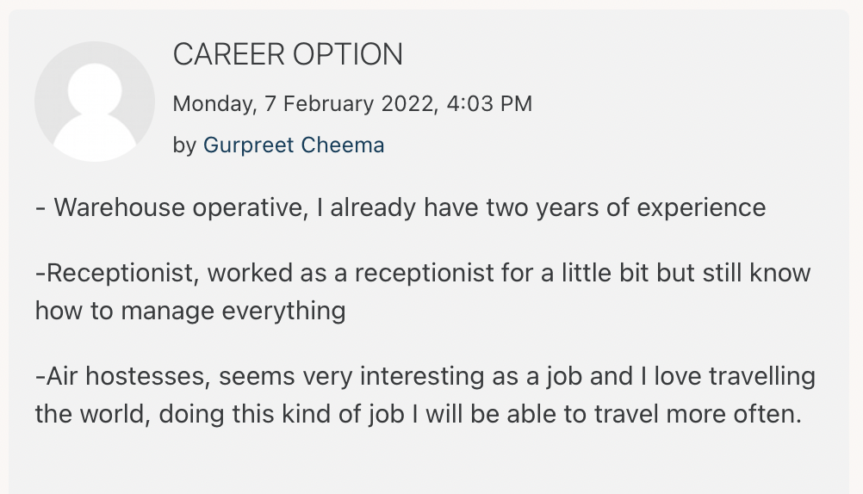

Personality Test

“if there is to be a speciality called personality, its unique and therefore defining characteristic is traits’.” People react to some kind of situations in certain ways.
The personality test measures peoples actions and their behaviour.

There are two type of personality test:
- Myers-Briggs Type Indicator: is an online test where you have to answer to 221 question related some specific topics, these questions have to be answered in 25 minutes maximum. C.G.Jung describes this tool as a understandable and something that be very useful to people.
- Insights discovery: this a particular one because is psychometric tool that comes from Jungian phycology, the main point are personalities and behaviours divided in 4 colour model. The for colours are cool blue that means cautious, precise, deliberate, questioning and formal. The fiery red means competitive, demanding, determined, strong willed and purposeful. Earth green means caring, encouraging, sharing, patient and relaxed. And last one is sunshine yellow that means sociable, dynamic, demonstrative, enthusiastic and persuasive.
There is also a quiz to complete for this tool which is a 25 round of 4 multiple choice question, the result is compiled in a personal profile for the workshop. It also exists a 72 type available based on different colour mixes.

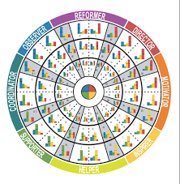
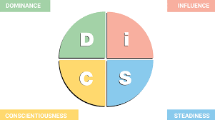

Part 3
For this last part of the assignment I will be using a reflective model to assess and reflect on my learning regarding some of the previous assignment, which are open book assessment, mock interview and UK employment.

Gibbs Reflective Cycle

“The findings of the study revealed that Gibbs’ reflective cycle is a good framework to be used by the students in writing reflections upon literary works they are working on.”
Graham Gibbs is the person that in 1988 has developed the Gibbs’ Reflective Cycle, the purpose is to give structure to learn from the past experience. It covers 6 stages: description, feelings, evaluation, analysis, conclusion, action plan.
The first assignment it was an open book assignment of 500 word on a case study based on creative thinking, active learning and digital literature.
We had 2 hours to complete this, we received two questions and we had to choose one of them. I choose the first one about core employability skills. My overall grade from assignment Is 7 out 10.

- Description: First assignment of the module
- Feelings: anxious/nervous
- Evaluation:Felt very nervous at the start but when I started writing and started writing something I was more relaxed and optimism about myself
- Analysis: it was pretty normal to feel that way, because even if you studied a lot you will always think you might fail
- Conclusion: I could have studied more and know more about the topic
- Action plan: in the future I will try to be more calm and be more prepared for the task.

Mock interview

“Smiling was negatively related to hiring, and smiling mediated the relation between applicants’ motivation to make a good impression and hiring.”
The second task was a job interview, we have selected a job related to our personality test outcome. The job that I found related to the test its cabin crew.
Before the interview I felt a little bit nervous but I have been able to control my emotion as soon as the interview started. After I finished I was pretty sure I passed it because I followed all the requirements.
Few days later I received the result and the points earned are 70 out of 100, which means I passed my test and I have also been hired but I could have done better than this if I had improved few little things, such as the answer to the question where I had to spoke about myself it was too brief and with only few details.

- Description: job interview as an assignment
- Feeling: nervous
- Evaluation: felt nervous at the beginning but have been able to control it
- Analysis: the interview it was quite easy and the question asked were pretty much easier to answer.
- Conclusion: could have done better in few things but overall it is still a good achievement
- Action Plan: I will prepare myself better on answering questions.

UK Employment

“Employers buy labour rather than like other commodities.” In one of the last lessons, we have learnt about an important law, The Employment Law. This law keeps a good relationship between employers and employees, the law it could be seen in the recruitment process, in the employment contract, data protection, employees wages and holiday entitlement, working hours, health and safety at the workplace, any kind of discrimination, discipline and grievance, dismissal of an employer and the redundancies.
“Workers are people, not things. As such they deserved to be treated with respect.”
- Recruitment: equality act 2010, against discrimination.
- Employment contract: employment rights act 1996, is about Sundays and time off, detriment and detriment.
- Data Protection: act 2018, safeguarding important information and to make sure is only used legally and properly.
- Pay and holiday entitlement: working time regulation 1998, the employer must provide every employee the minimum od annual leave of 28 days a year.
- Working Time: act 1998 the time limit per week is 48 hours.
- Health and safety at work: act 1974, publishing health and safety policy and make sure safety information and suitable training is provided.
- Discrimination: equality act 2010
- Discipline and grievance: act 2008, employers and employees can solve grievance and disciplinary issue by themselves.
- Dismissal and redundancies: employment rights 1996, end of the contract told with a notice or not, the employee leaves if a fixed term contract has been ended.

Reference:

Tasha Eurich (2018) Harvard Business Review PP.4 https://membership.amavic.com.au/files/What%20self-awareness%20is%20and%20how%20to%20cultivate%20it_HBR_2018.pdf

Alan Sarsby (2016) SWOT Analysis PP. 3
https://books.google.co.uk/books?hl=en&lr=&id=Yrp3DQAAQBAJ&oi=fnd&pg=PA1&dq=swot+analysis&ots=ODnj0yv23F&sig=5KrFVgVy-aUeoOIgZPhSZFUqdHQ&redir_esc=y#v=onepage&q&f=false

International journal of training and development (2011)
https://onlinelibrary.wiley.com/doi/abs/10.1111/j.1468-2419.2011.00375.x

Gerald Matthews (2003) Personality traits PP.4
https://books.google.co.uk/books?hl=en&lr=&id=BqFH_XIq0yYC&oi=fnd&pg=PR10&dq=personality&ots=emJ7iD_Ssw&sig=Fps7BQXRIk0b1efamfgslXR1jHo&redir_esc=y#v=onepage&q=personality&f=false

Adeani (2020) Vol 6, No 2
https://journal.uniku.ac.id/index.php/IEFLJ/article/view/3382

Mollie A. Ruben (2015) Smiling in a job interview: When less is more
https://www.tandfonline.com/doi/abs/10.1080/00224545.2014.972312

Hugh Collins () Employment Law PP.3
https://books.google.co.uk/books?hl=en&lr=&id=t2YVDAAAQBAJ&oi=fnd&pg=PR7&dq=employment+law&ots=L-WwIgJsZl&sig=T70pv02wh92VRzqZ33ZqW9xkYYA&redir_esc=y#v=onepage&q=employment%20law&f=false

