University of Wales Trinity Saint David
School of Engineering

CAD Report- Dry Sump Design Project

Engineering Design- ACMA4008

Charlie Morgan
2219665
01/02/2023

Contents
1 Introduction 1
2 Problem identification 2
3 Design specification 5
3.1 Marketing requirements 5
3.2 Life in service requirements 5
3.3 Product requirements 5
3.4 Packaging 5
3.5 Environment 6
3.6 Maintaining the dry sump system 6
3.7 Materials 6
3.8 Documentation 6
3.9 Conclusion 6
4 Design isolation 8
5 Final product design 10
6 Evaluation framework 12
7 References 14

Introduction
The aim of this paper is to design a dry sump system that will comply with customer expectations and use a range of tools to help the product exceed these expectations. Also, thorough research will be carried out in the market to have a good idea of competitions products, and how this product can be made to excel. Using tools such as a QFD and the kano model help walk in the customers shoes and will critically analyse methods to create the optimum product. SolidWorks will be used to design a dry sump system and then it will be converted into a technical drawing giving the products dimensions. A design isolation will also be used evaluating designs against each other on a set of customer constraints, allowing the best product for the customer to be chosen. Also, evaluation methods have been provided and an insight into how the market have also tested their systems have been referenced. “If I have 60 minutes to solve a problem, I will spend 59 minutes defining the problem and 1 minute to resolve it” (Einstein). This quote is an exaggerated example compared to process design but does relate to it. Lots of time and research must be put into understanding the customer needs to create the optimum product for success- and that’s what this paper shows.

Problem identification
A QFD (quality function deployment) has been used to understand the customer requirements and assess the difficulty of keeping these prioritised when designing the dry sump model. This means that the product can be created in a way which will increase customer satisfaction as their requirements will have been met.
Table 1- Quality function deployment created for the dry slump design

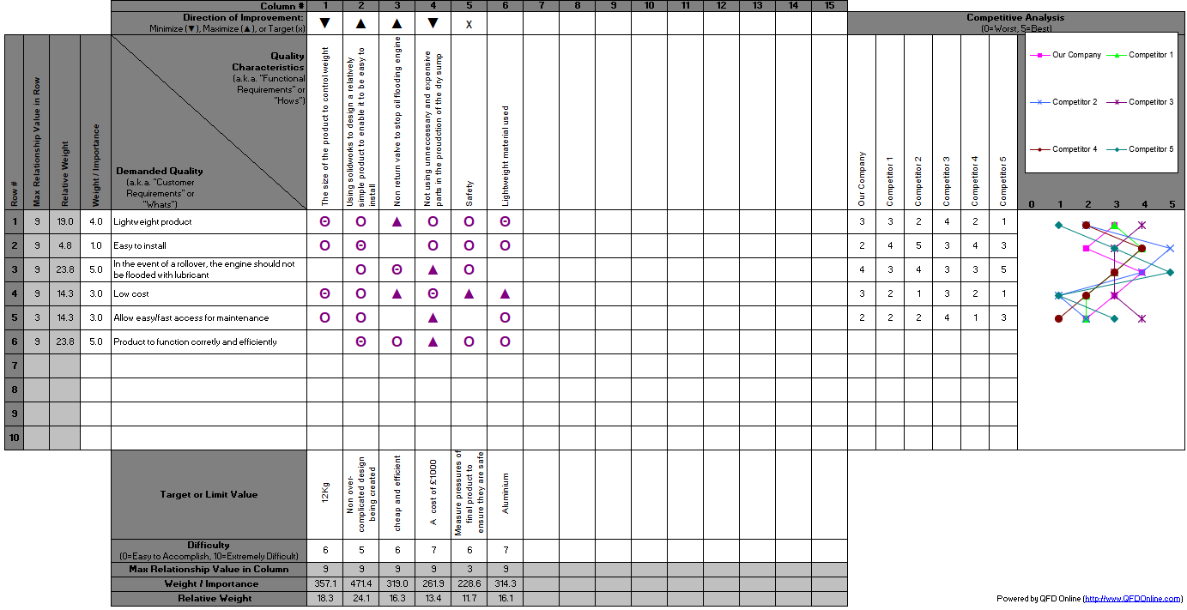
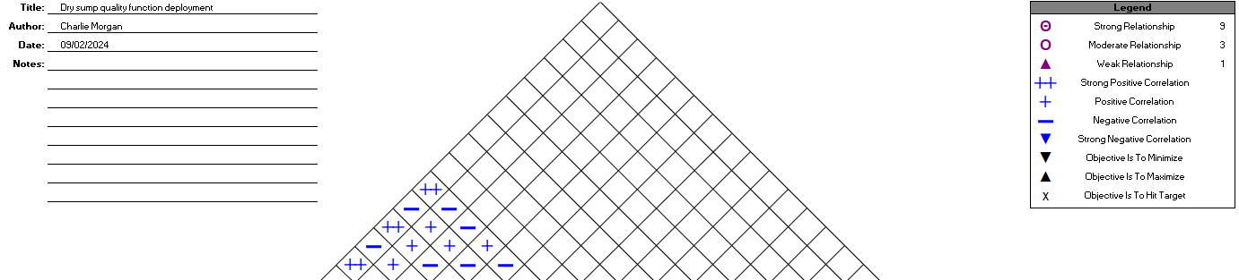

As shown in table 1, the customer demands have been highlighted in the “what” section. They have then been given a weight which allows enables the ability to identify which demands have higher priority. Then, the “how’s” have been entered, which explains how each customer goal will be achieved for the final product. The middle squares then show the relationship between each what and how, showing which of the corrective actions to keep customer focus in mind really affect the customer needs. The target value corresponds to the target for the how’s, an example being a lightweight dry sump being 12kg as they vary from 9kg to 22kg on the market. This has been chosen as 9kg will either be too basic or require expensive part that are lightweight, so 12kg is the compromise made. In the top section of the house of quality, the corrective actions have been compared. This is so the actions that don’t have a positive correlation together can be identified and then a possible compromise can then be made based off this. I have also researched other company’s dry sump designs such as ford and Subaru and then have scored them in the other company’s sector. For example, Subaru was scored 1 for price with just the scavenge dry sump kit alone costing £3,300 (AVIAD, 2020). This has allowed me to analyse my product against other companies and identify weak points in my design. Weak points are identified and methods to improve these scores are then created to make the product more competitive.
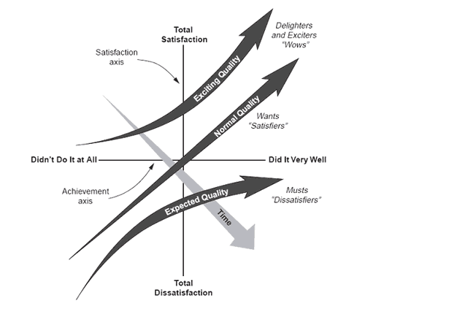
Figure 1- Kano model (ASQ, 2024)
Figure 1 shows the kano model which applies to the design process of the dry sump. This is a tool which allows product requirements to be better understood and can be optimally combined with a QFD. The kano model is used to highlight the individual features for customer satisfaction allowing the design and production to be more successful (Sauerwein, et al., 1996). By using this model, it highlights that giving the customer more than expected will maximise customer satisfaction and make the product more successful. The kano model also identifies exciting features in which the customer may not have expected, increasing satisfaction. Over time these exciting features may turn into fundamental features. For example, the design of electric car windows was first a luxury or exciting feature, but now in modern times is a fundamental expected feature of a car.

Design specification
The design specification will help identify possible failures in the product and allows targets to be set which can be referred to when designing the product. It will also set targets and allow an analysis of the targets set to test the feasibility of them.

Marketing requirements
From researching the dry sump system, it was found typically the price ranges from £500-£4000. By using the QFD, the target sale price has been set as £1500, this is because keep keeping the product lightweight is difficult without using more expensive parts. A combination of making the dry sump system smaller and using reasonable priced parts keeps the weight of the product light. Also, the product needs to function correctly with a tank outside of the engine rather than keeping the oil stored at the bottom in an oil pan. To do this the product will be designed so that any oil going into the bottom of the pan will enter the tank and use CAD software to design this.

Life in service requirements
Another customer demand highlighted in the QDF was to allow easy access for maintenance. This combined with keeping the product light weight was a quick win as making the product smaller benefits both options. Making the product smaller leaves more room for easier access for maintenance and will also keep the weight lower. Instructions will be provided with the product which will clearly state oil levels must be regularly checked and controlled, as running low on oil will damage the engine. With these regular checks and a cars service and MOT being complete, the life expectancy of this product is 80,000 miles. From research it has been found on average a dry sump system can lost from 50,000 to 100,000 miles. Product quality has been kept in mind while designing this product, as creating a product better than the customer expectations will result in greater customer satisfaction demonstrated in the kano model.

Product requirements
The target costs of manufacture is £600. This is a reasonable price as it allows relatively good components at a low-price meaning quality hasn’t been sacrificed to create the product. Also, the product is aimed to be 12kg or slightly under keeping the weight low compared to other dry sump systems on the market. This also makes this an ideal system for cars that are trying to keep weight to a minimum.

Packaging
Packaging must be kept to a minimum. It must protect the product, but excess packing will not be required as this is not fragile.

Environment
The dry sump system must be designed to function in demanding conditions due to the engine. This include:
- Dust
- Vibration and shocks due to bumps or potholes
- High temperatures when the engine is hot
- Low temperatures during cold conditions

Maintaining the dry sump system
The customer demand highlighted it is important to be easily accessible to allow easy servicing. The product will have a relatively simple design, so unneeded features will not be in the way.

Materials
Lightweight and high-quality materials must be used for the dry sump system. Aluminium has been identified as the ideal material to ensure durability under extreme conditions.

Documentation
Instructions will come with the product to ensure customers have no difficulty in fitting the dry sump system. Clear instructions for servicing have been provided to ensure the product will reach or exceed the shelf life provided.

Conclusion
The dry sump system must keep the customer demands as a priority. This will allow the product to be competitive and excel in the market. Despite these customer priorities being kept in mind, these will not affect the performance of the dry sump system and the materials used will not sacrifice the quality of the product.

Table 2-Design specifications
Performance requirement | Design requirement | Design specification
Easy access/maintenance | Lightweight | <12kg
Allow oil flow to engine whenever required | Oil tank outside engine | pipe from 2 gallon oil tank to engine
Must be a reasonable price | Must be low cost | £600 manufacture price
long life expectancy | Made so the engine never runs dry | 80,000 miles

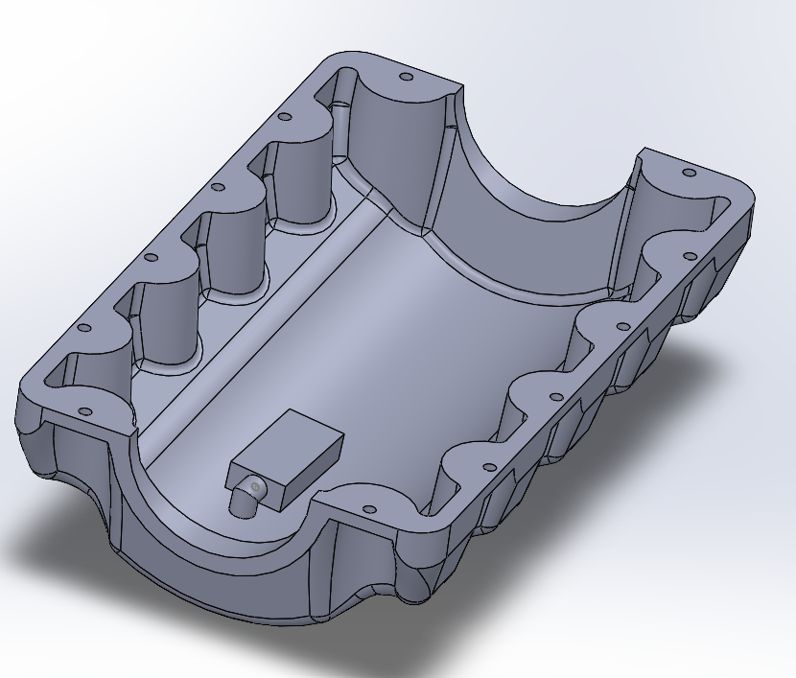
Figure 2- Dry sump design A
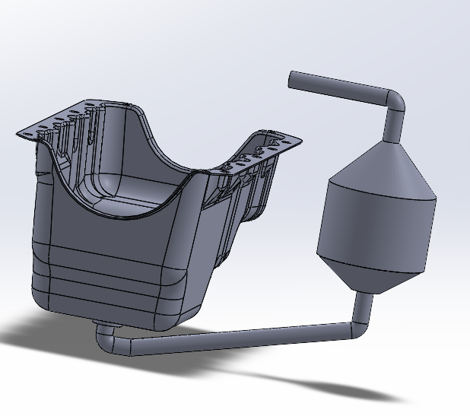
Figure 3- Dry sump design B
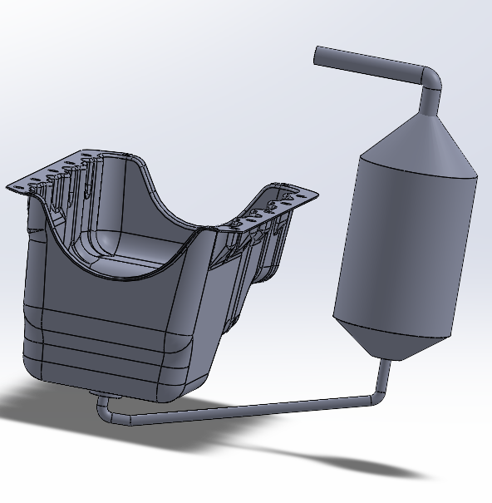
Figure 4- Dry sump design C

Design isolation
A design isolation has also been created to obtain the preferable solution for the product. A weighting has also been used so that the more important requirements are rewarded better in a designs score, keeping customer focus in mind. Dry sump design B had pipe’s too thick in diameter and didn’t have an effective oil pickup system. The sump pan was also too deep. Design C cut material costs and weight of the product by decreasing the size of the pipe picking up oil from the bottom of the pump to carry to the reservoir. This was also too small for purpose and would not pickup the oil as efficiently as required causing too much oil to build up over time. Design C also had a sump pan that was too deep and did not have a functioning pump to pickup oil to deliver to the reservoir.
Table 3- Design isolation scoring
Feature | Design A | Design B | Design C
Function correctly | 10 | 9 | 8
Reliability | 8 | 9 | 7
Cost | 7 | 3 | 5
Ease of access | 6 | 4 | 4
Life | 8 | 9 | 8
Once the scoring had been done, a new column was added which gave a weighting to each feature. Once the weighting had been multiplied with the scores, the total for each design was compared. Design A was ranked the best as it has the best balance between performance and cost, where as design B sacrifices cost to be high performing. Design C was poorly made and would not compete with other products on the market. Design A also features an effective oil pickup adapter with a shallower pan making it the best designed dry sump design.
Table 4- Final design isolation scoring
Feature | Weighting | Design A | Design B | Design C
Function correctly | 3 | 30 | 27 | 24
Reliability | 3 | 24 | 27 | 21
Cost | 2 | 14 | 6 | 10
Ease of access | 2 | 12 | 8 | 8
Life | 2 | 8 | 9 | 8
Total |  | 88 | 77 | 71

Final product design
The final product chosen was design A. The combination of the previous tools lead the final design being chosen. It has a slightly deeper sump pan compared to other dry sump systems on the market, but this is because in the event of a rollover there is more storage for the oil in the reservoir and sump pan, meaning the engine will not be flooded with oil making this a competitive product. It is also relatively small allowing the 12kg weight target to be met keeping customer satisfaction high as it will be easily accessed.
A technical drawing has also been created showing different views of the product as well as the dimensions used.

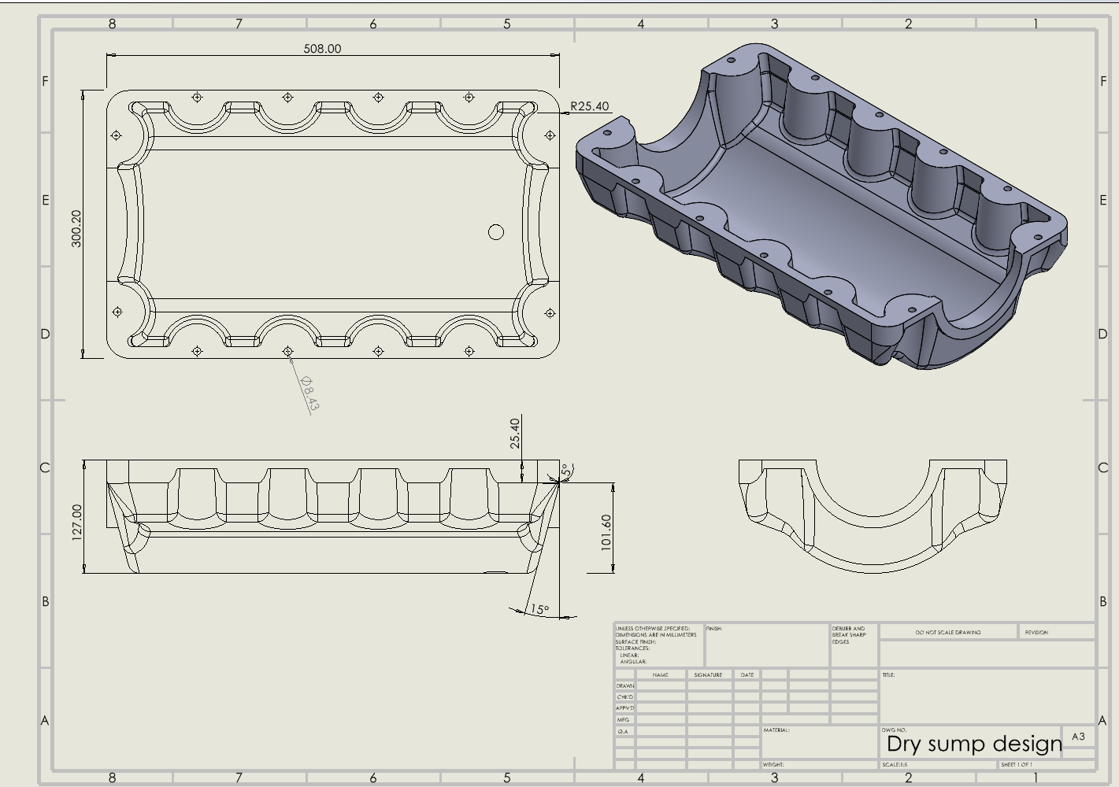
Figure 5- Technical drawing of dry sump pan
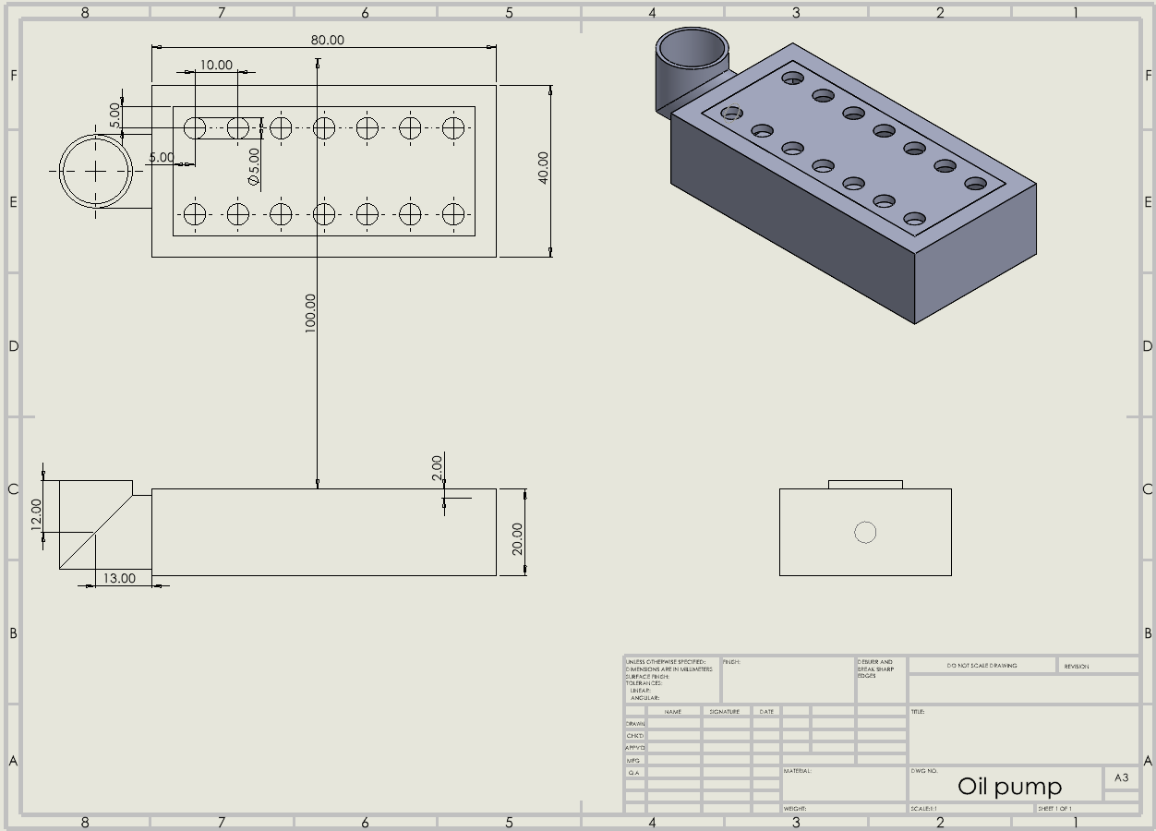
Figure 6- Oil pickup adapter
The design for the dry sump pan and oil pickup adapter are displayed in figures 5 and 6. The dry sump pan is shallower than a wet sump pan, as the oil pickup adapter will take the oil from the pan to an external reservoir. The adapter is also slightly raised from the surface of the pan to effectively control the pressure within the system. The pump will scavenge any oil in the bottom of the pan and deliver this to an external reservoir effectively.

Evaluation framework
During a design process, validation is fundamental to a well performing product. This means the product needs to be tested and analyses to ensure it can fulfil its expectations. A dry sump system should contribute to an increase in performance of an engine due to the system never running dry, especially when cornering. One methodology of testing is by using a dyno. An engine can be placed on a dyno with a wet sump system and the engines output can then be logged. As shown in figure 4, the dry sump performance can then be plotted against the wet sump system. The red is a dry sump system and blue is a wet sump system. The dry sump system performs better in every area, and there is not a single point where the wet sump system is creating a better power output. This is a great way to test a dry sump system as it will show whether the dry sump is functioning correctly and test if it is increasing the engines output (Acosta, 2019).
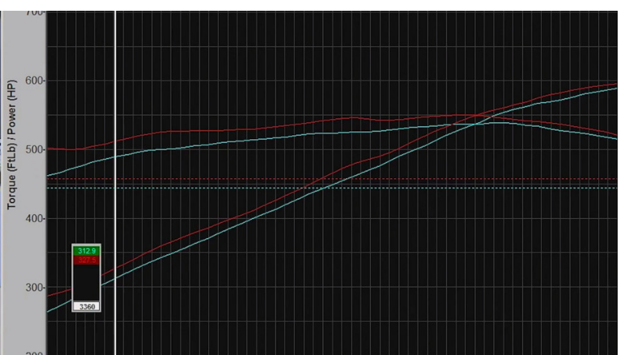
Figure 7- Dyno displaying wet sump against dry sumps engine performance (Acosta, 2019)
Another method of testing the dry sump system is to record the oil pressure. Once again this can be compared with a wet sump system. If the recorded results come out similar and there isn’t too much pressure being created, it means the oil and pump system is working correctly. (Khanna & Kumar, 2019) used this method to test a designed dry sump system and then plotted the results in a bar graph. Figure 5 shows this comparison with a max difference in pressures being 5psi, showing a healthy running system.

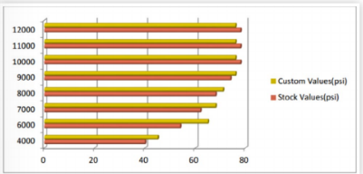
Figure 8- Dry sump (custom) and wet sump (stock) pressure values (Khanna & Kumar, 2019)
Another way a product can be evaluated is by using software’s such as Simulink. The product can be designed, and Simulink will simulate a real-life situation, and the event of a rollover in a dry sump system can be tested to see whether the oil will then flood the engine. The product can be placed in different scenarios and will allow a true analysis of the design and any flaws will be exposed and then can be improved on. Finally, once a design had been produced an analysis should be done. This means the product should be tested and the products ability to carry out its function is assessed. Any flaws in the design found can then be used to improve the design, rather than mass producing a product to find a flaw through a dissatisfied customer. This will hurt the company reputation and affect future sales.

References
Acosta, G., 2019. EFI University Finds Out How Much Power A Dry-Sump System Is Worth. [Online]
Available at: https://www.enginelabs.com/news/efi-university-finds-out-how-much-power-a-dry-sump-system-is-worth/
[Accessed 10 February 2024].
ASQ, 2024. What is the kano model?. [Online]
Available at: https://asq.org/quality-resources/articles/a-quick-refresher-on-the-kano-model?id=c9e7eea9082f401da1ed829c5801fe59
AVIAD, 2020. Subaru dry sump systems. [Online]
Available at: https://aviaid.com/shopsite_sc/store/html/Subaru-Dry-Sump-Systems.htm
[Accessed 7 February 2024].
Khanna, R. & Kumar, A., 2019. Design and Development of a Dry Sump Lubrication System for a Formula SAE Race Car. Research Gate.
Sauerwein, E., Bailom, F., Matzler, K. & Hinterhuber, H. H., 1996. THE KANO MODEL: HOW TO DELIGHT YOUR CUSTOMERS. InternationalWorking Seminar on Pruduction Economics, 1(1), pp. 313-327.

