

‘Prototype design’

User Experience Design
M6X01111

Shannon Cranfield
P149078
Dr Nik Whitehead

Table of contents

1. Introduction 1
2. Personas 1
2.1. Persona 1 – First year student 2
2.2. PERSONA 2 – THIRD YEAR STUDENT 4
2.3. PERSONA 3 – INTERNATIONAL STUDENT 5
2.4. PERSONA 4 –STUDENT WITH PHYSICAL DISABILITIES 7
3. User requirements 8
4. Information Architecture 9
5. Wireframe Storyboards 11
6. Feedback 13
7. Conclusion 14
8. References 14
Appendix A – User Requirements 15
Appendix B – Wireframes 16

Introduction

A mobile application has been assigned to be created for students in the faculty of architecture, computing and engineering who go to the University of Wales Trinity Saint David, this app will ensure that users will have stress-free access to the system that they use from day to day. In this report user personas, have been drawn together. Additionally, an architecture of the application will be explored. The design of the app will be explained initially by a set of wireframe storyboards. The report concludes with the process of how feedback was collected on the storyboards, analysing the good and bad responses attained.

Personas

Personas, also known as user profiles is a representation of a type of user. Personas answer the question as to who creators are designing for. They are based on user research that encompass user goals, roles, interests and pain. Personas stipulates an influential means for understanding the different needs for different users [1]. Personas are used to support designers to design for real people and to apprehend their needs and requirements [2]. It enables designers and developers to visualize through the eyes of the users the system or project, this can aid with recognizing and outlining the target audience. Additionally, there is a construction of sympathy that is built between users and designers to see how things will turn out from the perspective of the user. Personas are a great benefit to creating effectiveness in decision making in the early stages of designing [3].

Personas are not made up but drawn from user research. Before the four personas were created below user research took place. This was in a form of casual interview/focus group, this lead to the creating of some requirements and the creation of the personas.

  - Persona 1 – First year student

Persona Name:
Lincoln Blackburn

Demographic:
25-35, single, no children

Description:
Lincoln is a first-year student studying his BSc in Architecture. He wants to ensure that he becomes more organised in keeping track of all his commitments both for his education and is personal curricular.

Goals:
Lincoln wants to ensure they he completes his degree to the best of his ability by walking away with a 1st. He also wants to be more confident in asking questions in class. Know where his lecturers are. He wants to access his academic stuff on the go.

Pain:
Not being able to reach staff or getting a response from them. Using a user interfaces that is not straightforward.

Media & Device Preference
Lincoln mainly uses his IPhone to stay connected with friends and family. Laptop to do his assignments and personal work. Lincoln makes use of university electronic facilities while at university.

Role & Responbility
Works part time in his family business.

Tasks:
He wants to be able to check course material. Looking for resources/material for assignments. Ask questions to lectures in class secretively

Scenario
Lincoln had an assignment due at the end of his fist semester but due to be being unorganised an unaware he missed it. Unless he uses the app and receives an alert.

  - PERSONA 2 – THIRD YEAR STUDENT

Persona Name
Jared Lee

Demographic:
30-40, married, 1 child

Description:
Jared is 32 years old and is in his third year studying Energy and Environmental Engineering.

Goals:
Booking rooms to practise presentation and group work. Keep up to date with emails and student ambassador events. Soon to finish his degree, Jared has accumulated lots of books wants to get rid of them.

Pain:
Room clashes

Media & Device Preference
He uses mobile daily to make sure child is okay with picking up and dropping and babysitting arrangements and uses pc at home to complete personal and university work

Role & Responbility
Working with other students and staff at open days and events representing uwtsd as a student ambassador

Tasks:
Booking a room on campus to do collaborative work. Additionally, checking emails and timetables/events.

Scenario
Jared arrived at Uni with his group to prepare for an oral presentation. He checked all computer labs only to find out they are all busy. Unless jarred uses the app to help secure a room by booking a room.
  - PERSONA 3 – INTERNATIONAL STUDENT

Persona Name:
Nadia Magnu

Demographic:
18-25, single, no children

Description:
Nadia is a first-year international student studying games development

Goals:
As Nadia is new to Swansea she wants to find out about her local area and city. She also wants to ensure that she is in the loop with her student finances and loans and money that goes to the university. Also, being that English is not her first language she wants to ensure that there is an option for her language to be present.

Pain:
Language barrier

Media & Device Preference
Primary device is her mobile to stay in connect with friends and family back home. Also, has access to ipad, laptop and pc at home.

Role & Responbility
Unemployed and searching for a job

Tasks:
Wants to be able to check course material. Looking for resources/material for assignments. Ask questions to lectures in class secretively

Scenario
Nadia has arrived to the UK for her first time. She does not know the city well. She has an
induction day coming up, but has no clue where the university is or how to get there. Unless she uses the app, which has the map integrated and is student friendly and has the option to changing the language which is one of Nadia’s requirements.

  - PERSONA 4 –STUDENT WITH PHYSICAL DISABILITIES

Persona Name:
Aliyah Mayer
Demographic:
35-40, married, 2 children
Description:
Aliyah is a second-year student studying Logistics and Supply Chain Management, she has physical disabilities which revolves in her using a wheelchair 24/7. Aliyah is mother who is balancing work life, parenthood and university.

Goals:
She does not want her physical disabilities affect her learning. She wants know where her classes are.

Pain:
Routes from building to building not being disability friendly. Waiting in long ques to get food. Attending university and her classes have been changed or cancelled.

Media & Device Preference
Aliyah has a family pc at home which she shares with her family to do her work. She is also constantly on her phone.

Role & Responbility
Mother to her two children.

Tasks:
Checks map so that she can get to correct lecture room and classes.

Scenario
Aliyah leaves for University Monday morning and prepares for a 10:00 lecture, she arrives to find out that it’s been delayed till 13:00, this is an inconvenience for her she has three hours of waiting Unless there was an appropriate and useful way of alerting her of the changes.

User requirements

From the four personas, a summary of the requirements is shown in appendix A. Interviews helped with the discovery of some features of the app. This is the main requests of the users:
- Library
- Food service
- Booking service
- Knowing when lectures are available to talk to

Information Architecture

Information architecture is the organising of content of a software, website, or mobile application. Content is structured by grouping information and designing sortable navigation as well as the layout [4]. The image below shows a card sorting of the organising and grouping of content for the app. Card sorting is one method to help design an information architecture. Additionally, card sorting is used by different means in information architecture, one being learning what goes well together and what does not, another is brainstorming a wide range of categories [5].
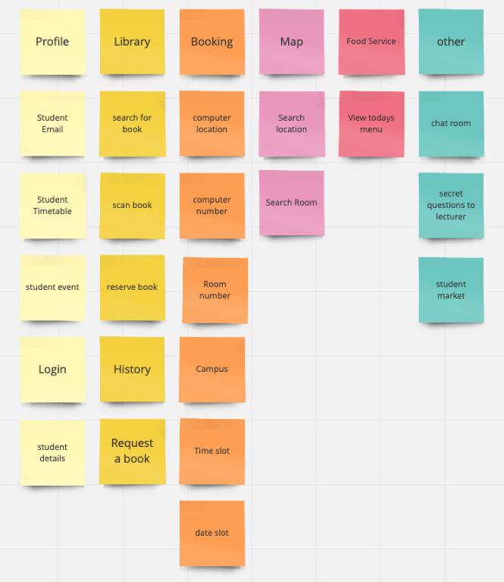

Card sorting is used as a contribution to information architecture. When organising there are a few factors to take into consideration as there are always more than one way to arrange information. Individuals minds differ when it comes to how information needs to be organized. There are lots of different classifications: alphabetical order, audience, task, topic, and chronological order [5].

This app needs to hold information about students and their details along with their academic information. A map is used to help student locate locations within the university and around. The app will recognise what campus you are on and change atomically for example the food services if you are in campus 1 and then change to campus 2 the food menu will change accordingly.

Wireframe Storyboards

Wireframes are a low-fidelity models of a user interface, meaning its design is at its basic showing just enough information linked to the features of the interface. Wireframes are identified as skeletons, created to give customers/users an ideal presentation of how the system will look. The use of wireframes can still provide users with an experience on how the system will work without any development of prototypes [6]. Several wireframe storyboards have been created for the UWTSD app have been shown below.

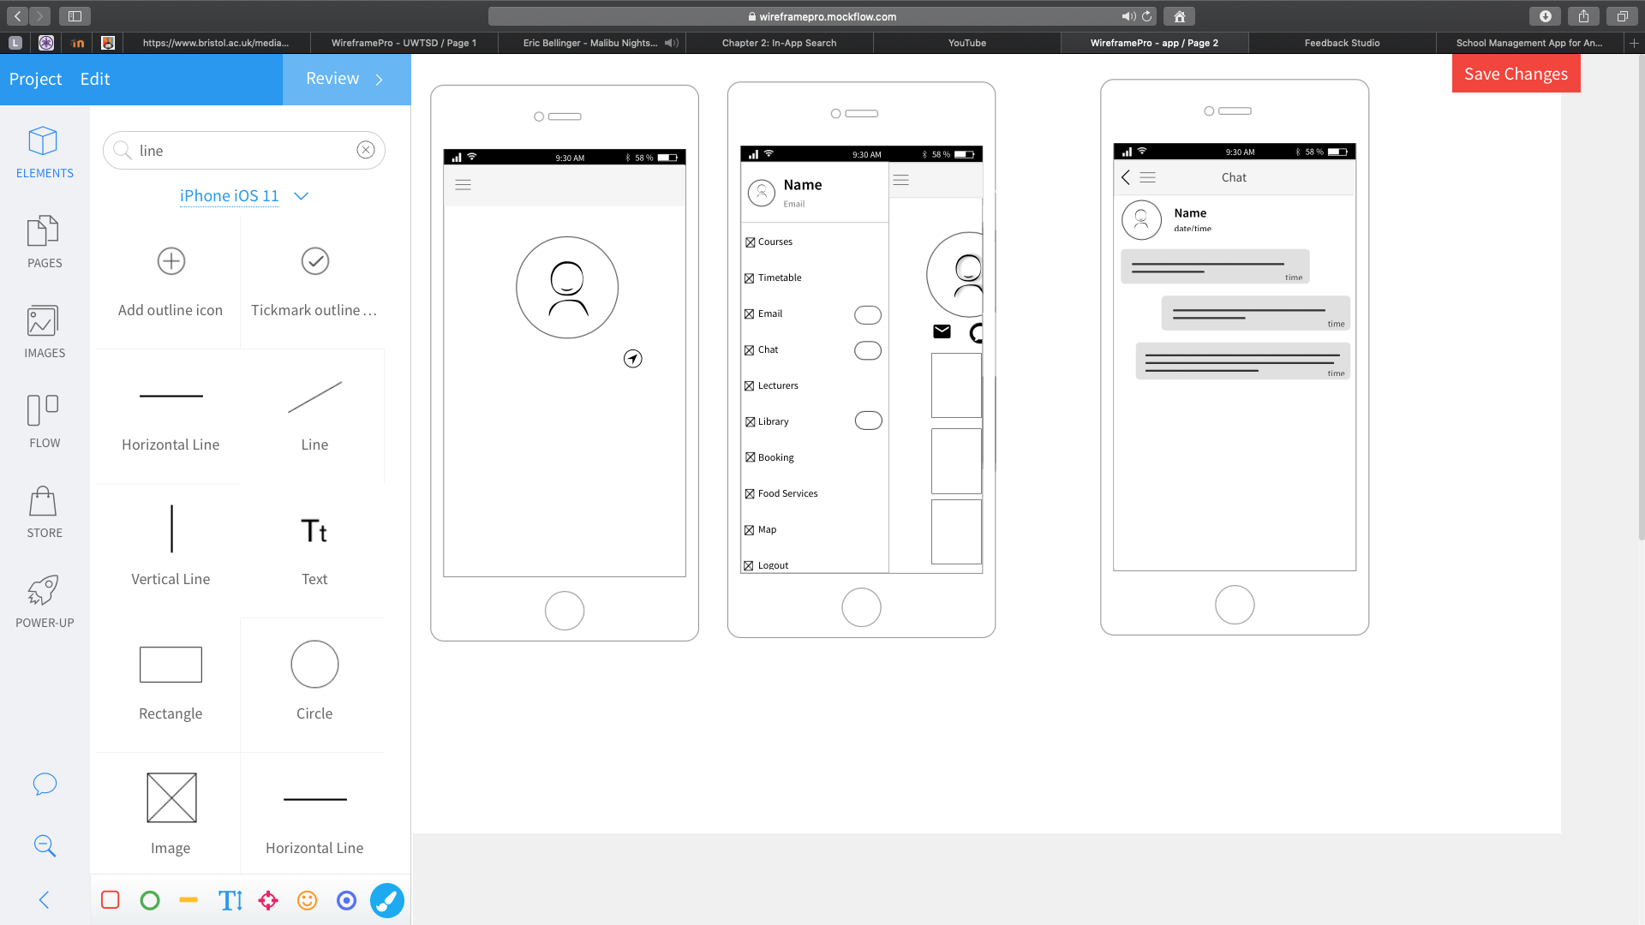
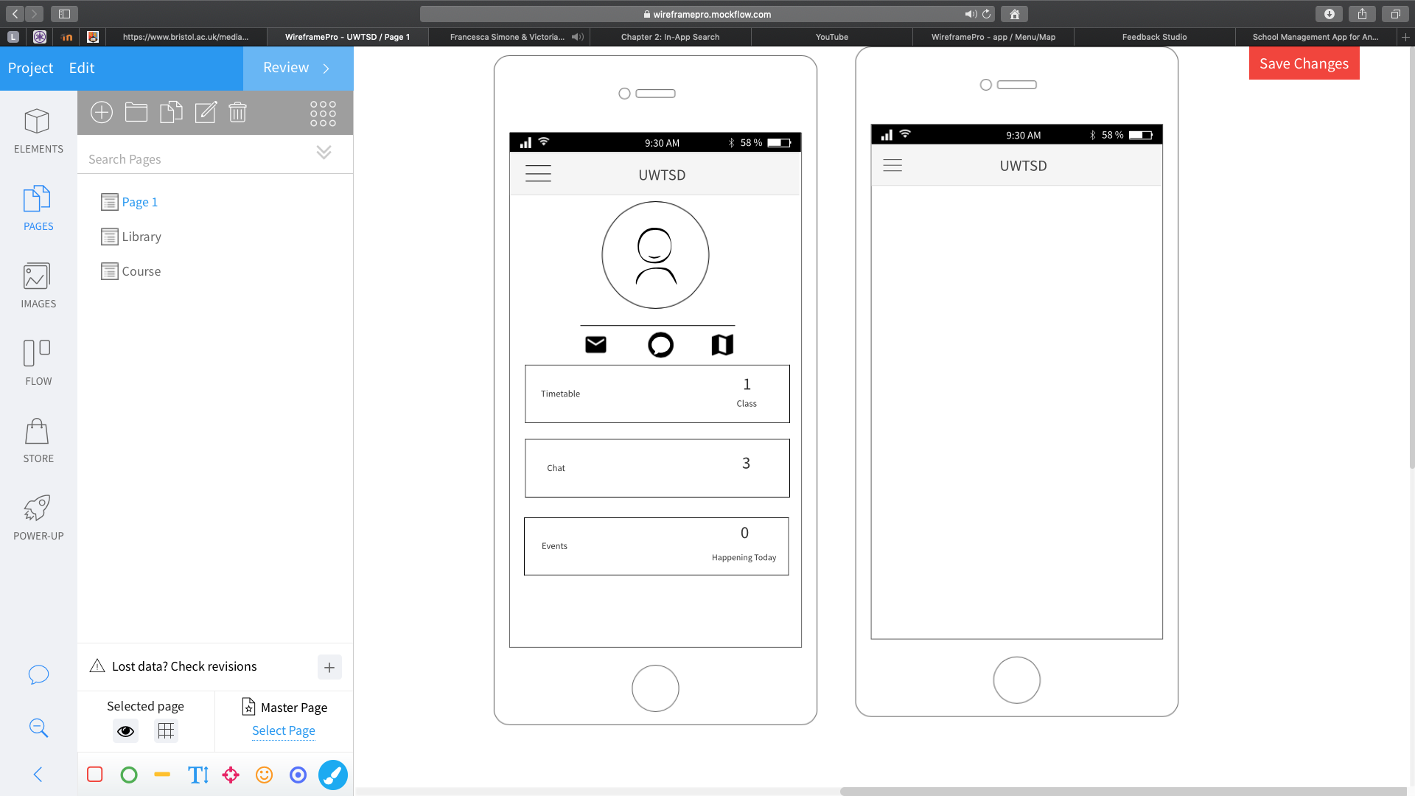
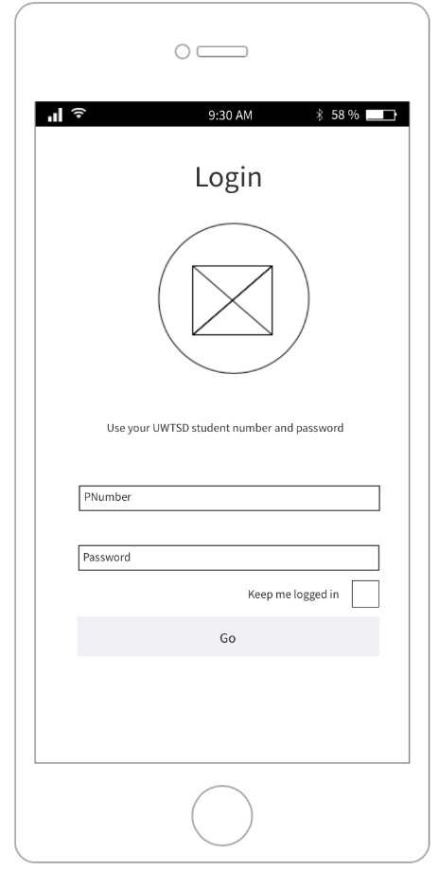
The first image shown below is the login screen, where students log in with their p number and password, once they have entered their details users will be directed to the next page acting like a home screen shown on the second wireframe, informing them of the days’ timetable, chat and events. This page also allows users to directly send messages, emails and search maps. Additionally, users are also given the opportunity to explore more by selecting the hamburger menu, once the menu is open options become available to the users such as viewing their courses, checking their email, starting a chat with either the lecture or other students in the class. Users can browse the university’s library catalogue, booking a room or computer, viewing the day’s meu and locating different locations within the university and outside.
When designing the wireframes some design principles that where considered was ensuring that users can determine what they should do and what is going on with the interface. Furthermore, ensuring that features are clearly visible of the users as well as simplifying task structure [7]. The navigation side menu is used mostly when there are greater than five section counts. The top navigation bar remains consistent throughout the app to ensure that users are aware of the location that they are at within the app. The right-hand side of the top navigation bar is known to be the least accessible angle of the app, therefore mostly throughout the app the right-hand side is empty [8].

The below wireframes show the library feature of the app, one user requirement that was discussed and occurred from the user personas and interviews was to integrate the University library into the same app. Users will use the search function to browse and look up a book, studies has shown that search boxes should be disabled at the top of the page clearly presented [9]

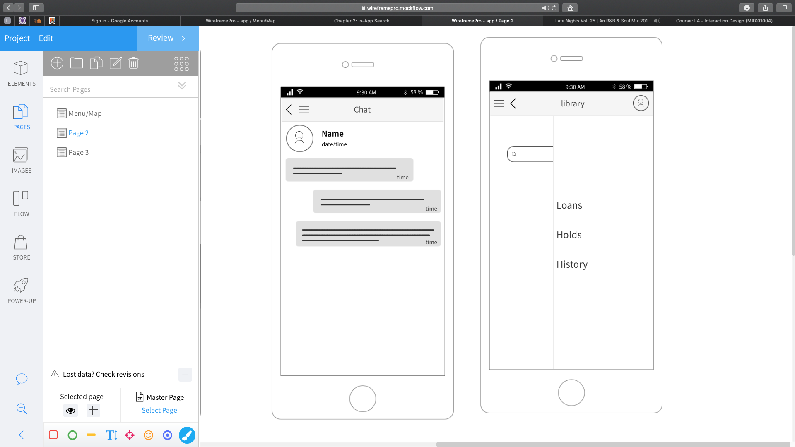
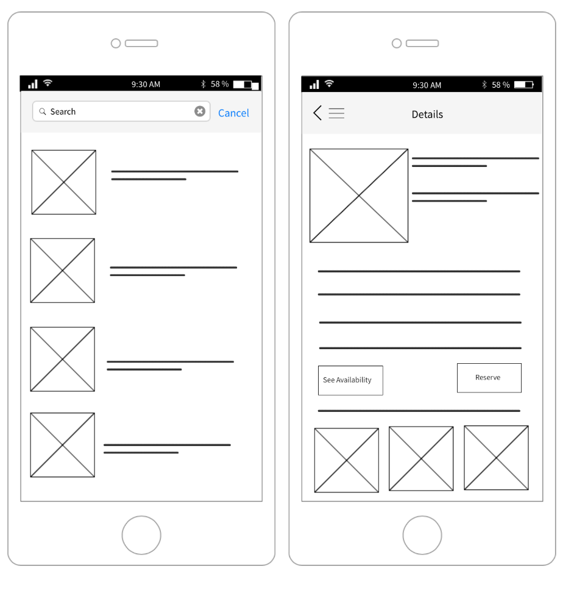
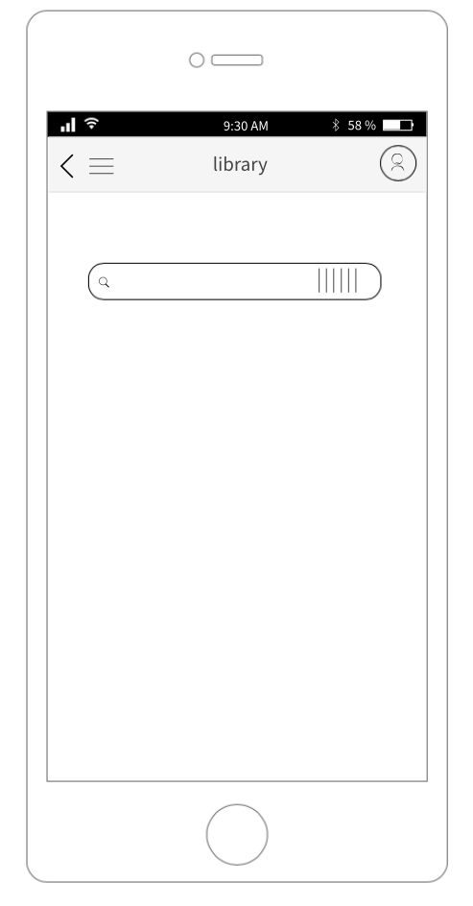

Wireframes of the following features are displayed in Appendix B

- Courses
- Timetable
- Food services
- Email
- Messages
- Asking questions privately
- Map
- Booking

Feedback

A small focus group was formed again to test the wireframe designs, this was carried out to give user feedback. Receiving early feedback can be a huge advantage in the long run as it can save time in the development stage. It is recommended that no more than five users partake in user testing, anything more becomes time consuming. Nielson Norman learnt that small is preferable as one user can share a lot about the usability [10]. Wireframe testing will give a sound understanding of the application early in the development stages as errors can be picked up. Also, getting feedback on the wireframes will help the design progress in a more efficient way.

Taking on the recommendation of Norman, the focus group consisted of 5 users. Feedback received most where mostly positive with a few negatives and suggestions. The wireframes were detailed and clean enough for the user to know what is going on. Another positive that surfaced was that everything was integrated in one app and there was no moving in and out of the app. One negative was that there are too many different screens, it was brought up that a novice user may find it difficult to manoeuvre around the app. A few suggestions were made, one being on the timetable, adding an attendance button to electronically confirm presence. Additionally, a small suggestion was made to include a queuing tracker on the food services feature, so that students don’t waste too much time queuing. The participants were thrilled to have a few features integrated in to the app to enhance their university academic experience.

Conclusion
In this report a discussion of a university app was explored. It included four personas explaining their main user requirements. Also, an information architecture was briefly brought together using card sorting. A set of wireframes storyboards were also presented and explored looking at some features of the app such as timetable, booking system and course content. Feedback was collected on the wireframes via focus groups.

References
[1] M. Barlow, “Using Personas To Develop Awesome Products Experiences.”
[2] N. Turner, “An introduction to personas for technical authors,” 2010.
[3] T. India, “Personas,” p. 17, 2016.
[4] “Victorian Government Website Management Framework Developing and managing an information architecture.”
[5] D. Spencer, Card Sorting: Designing Usable Categories. New York: Louis Rosenfeld, 2009.
[6] V. Paradigm, “Wireframe,” pp. 1–8, 2016.
[7] D. Norman, The Design of Everyday Things. DoubleDay.
[8] J. Kaufman and A. U. Design, “Principles of Mobile App Design.”
[9] Google, “Principles of mobile site design: Delight users and drive conversions,” Think with Google, p. 42, 2016.
[10] J. Nielsen and T. K. Landauer, “A mathematical model of the finding of usability problems,” p. 213, 1993.

Appendix A – User Requirements

Feature | MoSCoW | Description
Courses | Should have | App should allow for students to access their courses and the courses material
Library | Should have | Browse catalogue and reserve a book  Use of barcode to scan in shops to see if Uni has the book
Questions | Should have | App should allow students to ask questions to lecturer
Timetable | should have | The user should be able to find their timetable. Displaying name of class, room number, campus and time
Events | should have | The user should be able to find their events for the day as well as adding events and deleting events.
Book a Room | could have | Users should be allowed to book a room
Book a Computer | could have | Users should be allowed to book a computer
Student market | could have | Users may sell educational items to other students who may find them useful
Emails | should have | Users should be able to send and receive. Keeping up with emails
Chats | should have | Users should be allowed to talk to other students in their class to discuss work
Student finances | should have | Users should be allowed to see their finance records going to the Uni and their maintenance loans.
Language | could have | Students may want to view the app in a language that is more comfortable to them
Map | Should have | App should allow users to not only find their way around the campus but also find any destination from the university address
Food services | could have | App should display the day’s menu for students

Appendix B – Wireframes

Splash screen Login
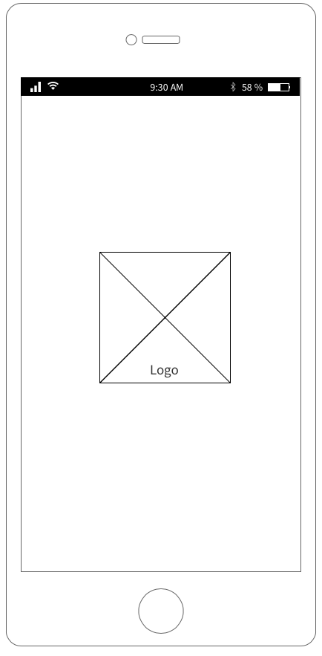

Home screen/dashboard

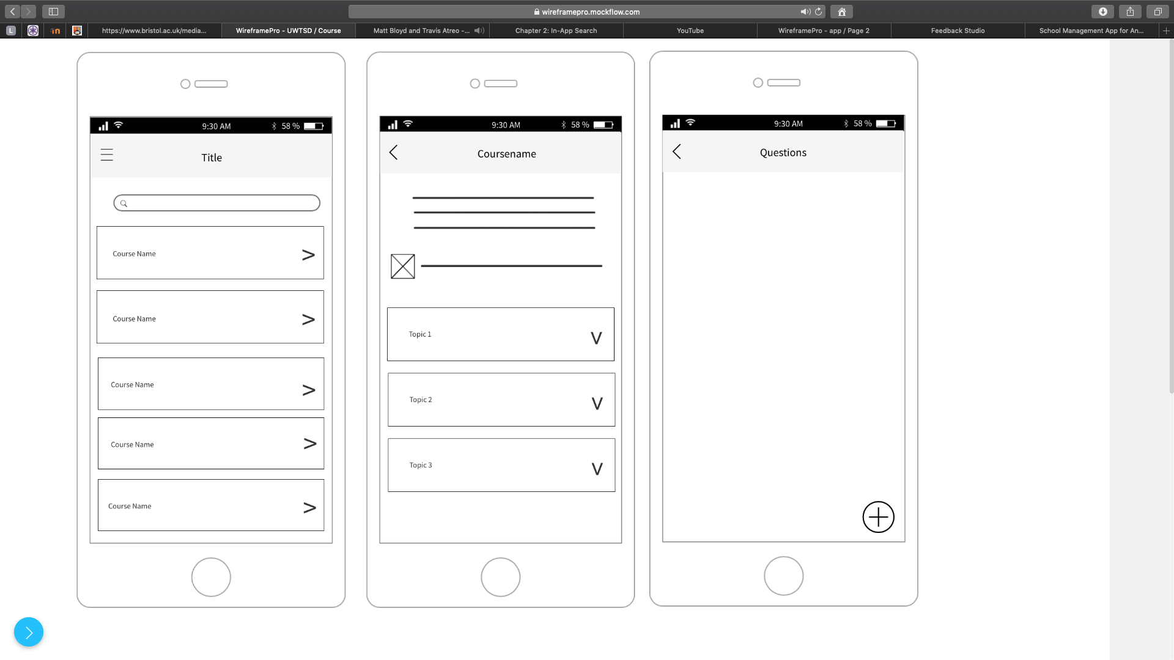
Side menu Course Overview Course content

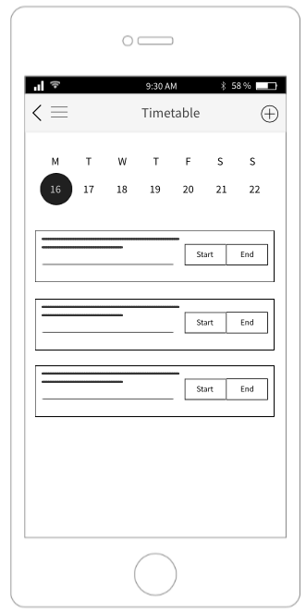
Timetable Chat Map
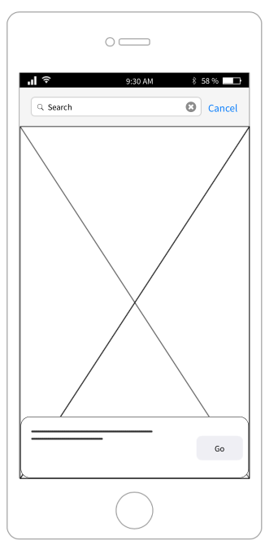
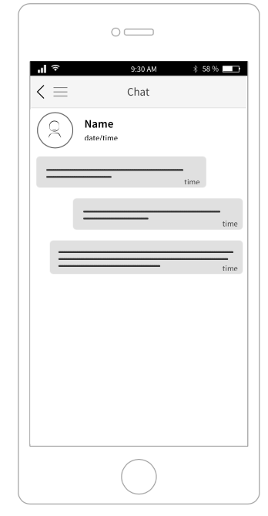

Booking
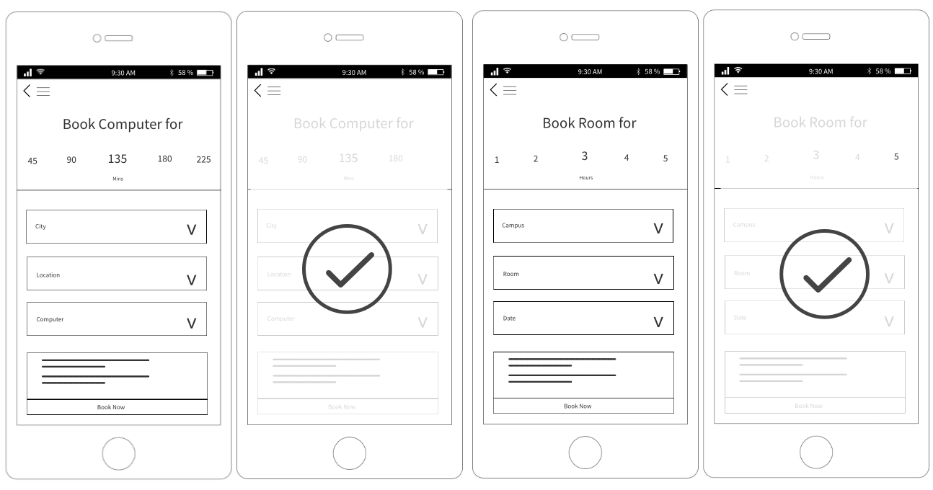

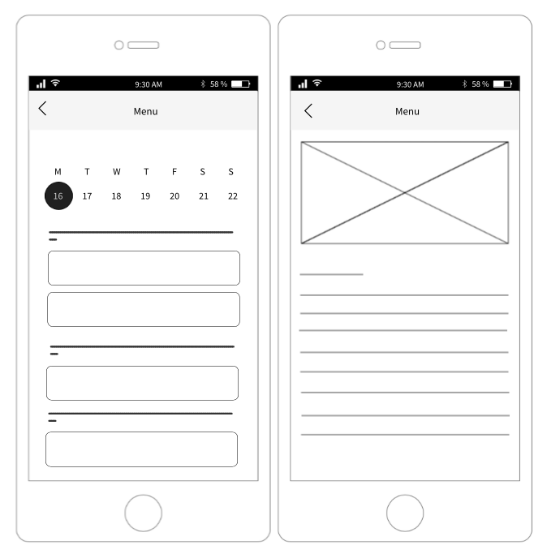
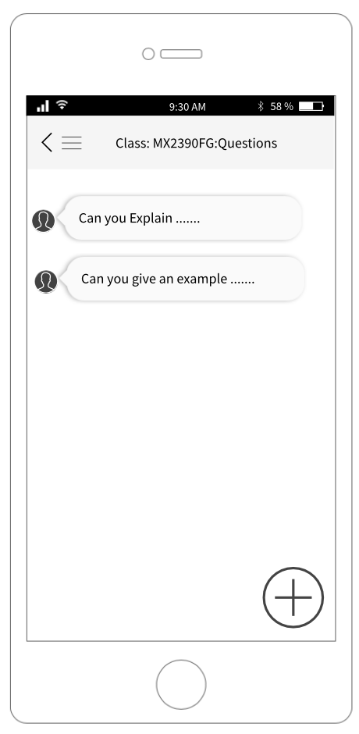
Questions for lecturer food overview food details

