Qualification: CIPD Diploma in Applied Human Resources.
Module name: Resourcing and Talent Planning
Word Count: 3043

Student name: Melissa Regimbal
Student Number: 1920894
CIPD membership Number: 56645910

By signing below, I confirm that the work/evidence presented is my own, unaided work. I understand the regulations pertaining to candidate malpractice and the action that may be take as a result.

Signed: M.Regimbal
Date: 08/06/2020

1. An employee is emigrating and asks you if the labour market trends of their destination country are the same as in the UK. Describe the key contemporary trends in both the UK labour market and in the labour market of any other country.
For this part of the task, I have chosen to compare the labour market trends of the UK and Spain. The United Kingdom has a population of around 67 million (Worldometer, 2020) compared to Spain with a population of around 46 million. This date was collated in May 2020. It is noted that in relation to the population, the UK’s population size is approximately 31% larger than Spain’s population. Subsequently, this would have to be considered when comparing statistics as straightforward statistical comparisons may be a misguided representation when providing such information to the person wishing to compare the trends.
The key labour market trends report on the following:
- Employment rate;
- Unemployment rate;
- Part time workers rates ;
- Age and
- Industry/sector rates.
Employment rate
Statistics compiled Trading Economics (2020), evidenced that the UK has a 75.4% working age population in comparison to Spain who currently sit at 63.2%. This would suggest that in relation to the number of people in employment; the UK has a higher number of jobs available to the population and consequently more opportunities given the UK an additional 12.2% of the population more than Spain). It is noted that the statistics reported by OECD (2020) outlined the working age to be 15-64 years. Should the retirement ages be different in the two countries, this may change the statistical outcomes.
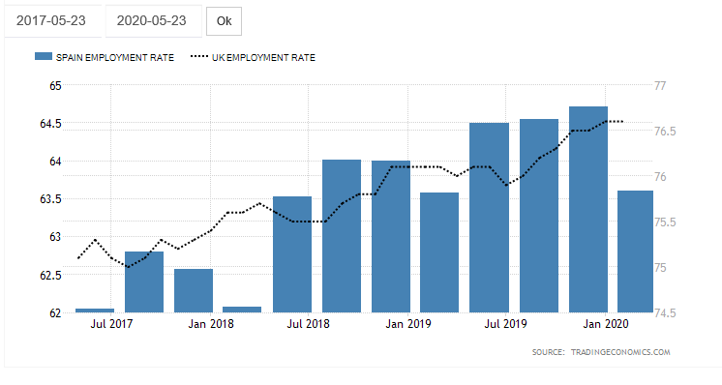As shown in the table above (Trading Economics, 2020), between July 2017 and January 2020, the UK employment rate has continued to steadily increase, with only a few small reductions and recoveries. Spain on the other hand appears to have also had a steady increase in employment rates over the period noted however, they also appear to have had momentary reductions in employment of approximately 0.5%. One interesting statistic is that of the most recent month recorded in the chart, January 2020. UK employment rates appear to have been maintained at over 76.5% whereas Spain experienced a reduction of approximately 1%. That means that of the approximate 29 million employed in Spain, roughly 460,000 become unemployed in January 2020. Interestingly, these figures were recorded prior to the Covid-19 pandemic so they should provide an unhindered account of the employment rates.
Unemployment rate
Trading Economics (2020) outline in the below graph that both the UK and Spain has had a somewhat steady decline in the number of unemployed people between 2016 and 2020 with occasional increases in unemployment. Remarkably, whilst differing in population size, both countries have experienced the same increments and reductions over the last 10 months or so. This is a positive indication of more jobs being available whether through being employed or being self-employed. It is noted that whilst this steady decline in both countries appears to be positive, figures are not taking into account the nature of pay and working hours so whilst appearing positive, one country may have more low paid job opportunities and/or a percentage of the working population may be on part time working rates meaning financial pressures may differ between countries.
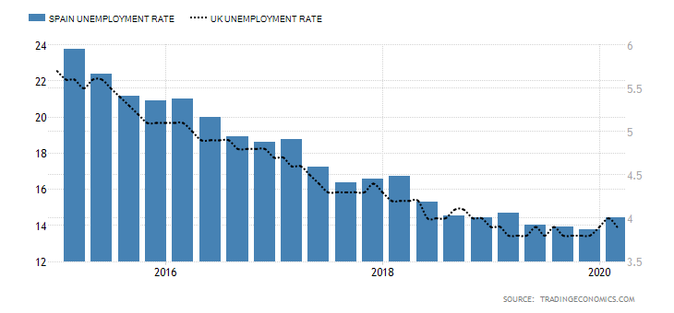
Part time workers rates
Trading Economics (2020) report that both Spain and the UK experienced record lows in relation to part time worker rates in the early 1990’s. This may suggest that across Europe or the Globe, many affluent countries were experiencing similar trends due to economic matters. Over this 30 year time span, the UK’s part time employment has increased by 44% and Spain’s part time employment has increased by 415%. Interestingly, both countries also recorded record highs in the second quarter of 2020.

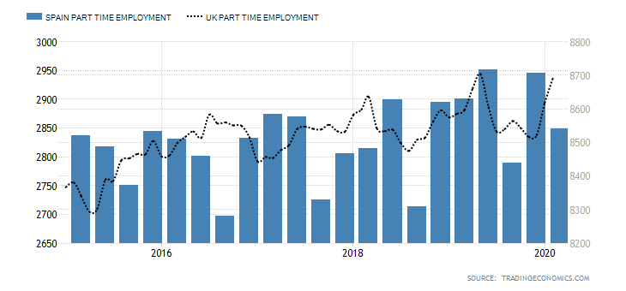
Age
OECD (2020) reports their figures in three separate categories; 15-24, 25,54 and 55-64. Within the age category 15-24; the figures show that the UK has 50.4% of people employed which is 28.1% more than Spain who has 22.3%. The 25-54 age category shows the UK has 9.7% more people employed and within the 55-64 age category the UK have 11.3% more people employed. This evidences that the UK has a higher employment rate across the board than Spain, and the largest contributing category for both countries is aged between 25-54.
Industry/sector rates
From compiling the figures in the below table from the OECD (2020), in relation to the different industry/sector rates, these figures suggest that the agriculture industry in Spain is over double the size of that of the UK. In relation to Services within each country; the Spanish total is only 56% of the UK total employed within this industry. Interestingly, the UK construction industry is almost double the size of the Spanish construction industry, showing considerably more money is being spent on development.
Industry | UK | Spain
Agriculture | 336 | 760
Construction | 2294 | 1295
Industry inc Construction | 5847 | 4093
Manufacturing | 3026 | 2530
Services | 26638 | 15054

2. A new HR Assistant asks you to explain the following aspects of workforce planning:
- key principles of workforce planning
- tools used in workforce planning
- how to develop a basic people plan, including succession planning

CIPD (2020) states that Workforce planning is a process of analysing the current workforce, determining future workforce needs, identifying the gap between the present and the future and implementing solutions so that an organisation can accomplish its mission, goals and strategic plan. There are two types of workforce planning:
- strategic (soft) workforce planning
- operational (hard) workforce planning
Strategic workforce planning, or otherwise known as ‘soft’ workforce planning gives the managers the opportunity to consider a range of possibilities before reaching a decision. This is outlined by developing a strategy or strategic framework within which information can be considered (HR Portal 2020).
Operational workforce planning, or otherwise known as ‘hard’ workforce planning is the consideration of the skills needed to undertake a role and how many people would be needed for this. This type of planning is a numerical approach to workforce planning.
The planning process must be considered throughout the whole organisation and communication between HR and the rest of the business is valuable in making the decisions (HR Portal 2020).
Specific tools are required to help identify and address gaps in skills and demand, as detailed in the diagram below (CIPD 2020):
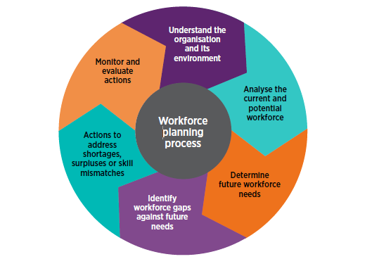
This shows that a good understanding of the business is needed, along with the ability to analyse and evaluate data collected. Problem solving, communication and advisory skills will also be helpful in this process. The ability to build relations with leaders and colleagues in HR will also play a key role in successful workforce planning (CIPD 2020)
According to Taylor (2016) there are 4 stages that should be followed when developing a people plan:
- Forecasting the demand for the organisations future skills – this involves asking what tasks will need doing, how can these be divided into individual roles and what skills are needed for each role. In order to answer these; the following types of approach could be taken:
  - Systematic, which includes looking at past trends to predict future needs;
  - Managerial judgement, which is knowledge and experience taken from senior staff
  - Working back from costs, which starts with the future budget and determines how many st aff the organisation can afford to employ.
- Forecasting supply – this is considering the make up of the current workforce, the skills of the workforce and the proportion of the workforce that is likely to still be in employment at the time we are forecasting for. Identifying the total number of people employed, the total wage cost, the workforce make up and the level of sickness absence will give a better understanding of the current workforce. After looking at the people you currently have, you must assess the skills they have. Lastly, forecasting supply involves estimating the number of employees that are likely to be employed in the future. Look at general trends in employee turnover; including how many people tend to resign each year and how many people are approaching retirement age.
- Identifying gaps between supply and demand - Taylor (2016) states there are 3 steps to identifying gaps;
  - Creating a competency framework for each common role.
  - Assess each current employee using an audit form; this should be based on personal judgement, observation and a discussion with the individual.
  - Summarise the results for the whole workforce, identifying the total skills available and to what extent this matches the skills needed for the future.
- Addressing the gaps – this can be split into 2 areas
  - Determining how the organisation can best use its existing resources. This could involve extra training, moving people around roles, encourage knowledge sharing, work on retaining the valued employees.
  - Identifying what external sources of skills can be utilised. This can include assessing the local labour market , recruiting from further afield, and consideration of contract basis employees from other organisations i.e. work experience
Succession planning, according to Taylor (2016) refers to a group of activities that aim to ensure that at any time an organisation has sufficient numbers or people with the right ability, knowledge, qualities and experience necessary to step into roles at the next level should they become available. The original emphasis of succession planning was related to the higher level of the organisation, to ensure a smooth transition should a director or someone of that standard depart. This would help to avoid asking someone to ‘act up’, to promote someone who is not prepared or to recruit someone from outside who does not know the organisation or how it works. This has since been changed to cover the whole workforce, rather than targeting specific individuals for specific roles, the aim is to develop ‘pools of talent’ from which a replacement can be found when the vacancy arises.
3. Your director asks for your thoughts on how the organisation can attract the talented people it requires and ensure that these people stay with the organisation. Explain different approaches an organisation can take to both attracting and retaining talent, and the strengths and weaknesses of each approach.
CIPD (2020) states there are many ways to generate potential candidates for a role such as the following:
- Employee referral scheme - offering incentives to existing employees to draw attention from family, friends or acquaintances. The positive to this statement is it will attract new employees to the business. The negative to this statement is it could attract too many of the wrong type of employee i.e. wrong skill set to match the position.
- Internal recruitment – providing opportunities for internal candidates to develop their career progression can help with retaining staff and support succession planning. The positive to this statement is it will alleviate any recruitment costs. The negative to this statement is it could attract someone who although shows great potential; may not have the skill or mind set to start a more challenging role at this time.
- Employer branding – CIPD (2020) states employer branding involves applying a similar approach to people management and describes how an organisation markets what it has to offer to potential and existing employees. A strong employer brand should connect an organisations values, people strategy and HR policies and be linked to the company brand. One positive is this can help an organisation to compete effectively in the labour market and drive employee loyalty through effective recruitment, engagement and retention practices. A negative to Employer branding is if there is no regularity between the brand you’re showing your employees and the one you show customers.
Employee retention involves strategising to ensure that employees do not leave the organisation. This can be solved within the reason of why the employee wishes to leave. Some reasons are as follows (Wisestep 2020):
- Less pay – often employees feel the salary they are paid is too low compared to other firms or co-workers. It has been found that the higher paid members of staff have more work experience within the company or are higher performers. This could be solved by offering a bonus, a pay increase after meeting certain targets or an additional perk that might be a concern to the employee. The downside to this could potentially result in a negative impact on the company’s finances.
- Enticement from other firms – there are times when employees will be tempted by other companies to leave their jobs and join them. High performing or experienced members of staff are usually the most targeted as they have played a part in the company’s growth and performance. These are the employees that would need retaining the most. Should they leave the company, they take with them all of their expertise and training held within the organisation. This could be solved by offering counselling, keeping employees engaged in their work and offering opportunities to grow in the company.
- Recruitment errors – this could be from both sides; sometimes an organisation is unclear of their full expectations and this can leave employees feeling that their full potential is not utilised. Alternatively, from the employees perspective, they could make false promises of skills and attributes that they are later unable to deliver. As money has already been spent on these employees; training them up when they first joined the company, the employer should utilise them within the organisation and teach them new skills that are needed for the job.

4. In preparation for input at a managers meeting, summarise the following
- key aspects of good practice in relation to developing job descriptions, person specifications and competency frameworks
- Different methods of recruitment and selection and the strengths and weaknesses of each
- Good practice in relation to dismissal, redundancy and retirement.
Wilkinson and Taylor (2016) states that recruitment is a required activity for 2 different circumstances; when a new job role is created within a business, or when an existing employee moves on. Careful consideration should be given to any recruitment process to ensure that a vacancy has definitely arisen and what skills and experience are needed to fulfil this role. A job analysis should be undertaken to collate information to include job roles and responsibilities, controls over work, interactions with others, performance expectations and the working environment. Information can be taken from current role holders, line managers for that specific role, appraisal results and external experts in the field.
The next step would be to create a job description and person specification. Wilkinson and Taylor (2016) states that a job description is one of the key documents in the recruitment and selection process. It will summarise the tasks that make up the job role, the areas of responsibility and performance criteria. A job description typically focuses on the nature of the role, whereas the person specification focuses on the human characteristics that are deemed an essential part of a person fulfilling the particular role. It is also advised to create a competency framework, which includes highlighting the desirable characteristics that are required for the role, and a suggestion of the level of skill required. The most commonly noted competencies in the UK; as found by Taylor (2020) include communication, customer focus, teamwork, flexibility and problem solving.
There are different types of recruitment and selection methods;
- Internal – using promotions, job transfers and employees. This would be a good way to save on costs of recruiting externally but may also draw up costs should you need to then advertise for another post.
- Online – according to Randstad (2020) this could help speed up the recruitment process and streamline administration. The downside to could be seen to be discriminatory to candidates who are not computer literate.
- Recruitment agencies – the positive to this would be minimal admin work for the organisation as the agency will oversee many of the recruitment tasks. The downside could be that candidates may prefer to deal directly with the potential employer.
- Social media – the benefits of this would be access to a wide network of contacts. The downside to this would be if employers discourage staff from discussing the company on social media.
CIPD (2020) states that selecting candidates involves two main process; shortlisting and assessing applicants to decide who should be made a job offer. After the shortlisting process has taken place, interviews are the main source of the selection process. An interview is an opportunity for the employer to gauge a candidates experience and ability to perform in a role. This also gives the candidate a positive impression of the organisation and a better understanding of the job role and its responsibilities. The downside to the interview process can be interviewers may make decisions on the basis of whether they personally like the candidate or not. The interviewer may also give preference to a candidate they recognise as having a similar background or career history as themselves.
There are three types of employee departure; retirement, dismissal and redundancy.
- Retirement – Taylor (2016) states retirement is referred to as a ‘scheduled departure’ of an employee because they have reached the set age for departure from the workforce. As it is now not legal for a company to retire someone once they reach the compulsory age, many individuals choose to take flexible retirement options, rather than leaving altogether. Good practice in managing retirement requires ongoing discussions with all employees about future intentions and offering a range of options when retirement starts to be a consideration. This could include reducing full time hours to part time or stepping down to a role with less responsibility.
- Dismissal – Taylor (2016) states dismissal refers to involuntary employee turnover, where a contract is terminated by the employer. This usually occurs when an employee has failed to meet the requirements of the job role. There must be a fair and proper procedure followed to ensure there is a valid reason for the dismissal. A valid reason usually falls into two categories; conduct or capability. Conduct issues refer to a break in company rules either a minor or major way. Capability issues can be linked to an inability to do the job; i.e. ill health or competence. ACAS (11/03/2015) states that fairness and transparency should be promoted by developing and using rules and procedures for handling dismissals. These should be set down in writing, be specific and clear. Employees and where appropriate, their representatives should be involved in the development of rules and procedures. It is also important to ensure that employees and managers understand what the rules and procedures are, where they can be found and how they are to be used.
- Redundancy - Another form of involuntary turnover according to Taylor (2016) is redundancy. This happens when a job role that an individual is doing is no longer practical. It is good practice for the employee to attempt to find alternatives to compulsory redundancy. This can benefit the company by boosting staff morale and reputation. The other alternatives to redundancy could be a recruitment freeze and redeployment of existing staff. There will obviously need to be training involved. Pay cuts or overtime freeze would also be an option. The final options could be voluntary redundancy or voluntary early retirement. If redundancy was the only option, the company would need to be as communicative and transparent as possible with employees and remain engaged with current and those employees who will be dismissed.

References:
https://www.worldometers.info/world-population/population-by-country/ (accessed on 23/05/2020)
https://tradingeconomics.com/spain/employment-rate (accessed on 23/05/2020)
https://tradingeconomics.com/spain/unemployment-rate (accessed on 23/05/2020)
https://tradingeconomics.com/spain/part-time-employment (accessed on 23/05/2020)
https://tradingeconomics.com/united-kingdom/part-time-employment (accessed on 23/05/2020)
OECD (2020), Employment rate by age group (indicator). doi: 10.1787/084f32c7-en (Accessed on 25 May 2020)
https://www.cipd.co.uk/Images/workforce-planning-guide_tcm18-42735.pdf
https://www.hrportal.sg/hr-functions/workforce-planning/ (accessed on 29/05/2020)
https://www.cipd.co.uk/Images/workforce-planning-guide_tcm18-42735.pdf (accessed on 31/05/2020)
Human Resources Management: People and Organisatons (2nd Edition 2016) Taylor and Woodham, Chapter 3, pages 57-59
https://www.cipd.co.uk/knowledge/strategy/resourcing/succession-planning-factsheet (accessed on 31/05/2020)
https://moodle.uwtsd.ac.uk/pluginfile.php/351618/mod_resource/content/0/Recruitment%20factsheet%20-%20recommended.pdf (accessed on 01/06/2020)
https://www.cipd.co.uk/knowledge/fundamentals/people/recruitment/brand-factsheet (accessed on 07/06/2020)
https://content.wisestep.com/advantages-disadvantages-employee-retention/ (accessed on 01/06/2020)
Human Resource Management: People and Organisations (2nd edition 2016) Taylor and Woodham Chapter 3, page 62-65
https://www.randstad.co.uk/market-insights/attracting-recruiting-talent/different-recruitment-methods-advantages-disadvantages/ (accessed on 02/06/2020)
https://www.cipd.co.uk/knowledge/fundamentals/people/recruitment/selection-factsheet (accessed on 02/06/2020)
Human Resource Management: People and Organisations (2nd edition 2016) Taylor and Woodham Chapter 3, pages 74-75
https://moodle.uwtsd.ac.uk/pluginfile.php/351412/mod_resource/content/0/ACAS%20code-of-practice-on-disciplinary-and-grievance-procedures%20%20-%20mandatory%20reading.pdf (accessed on 07/06/2020)

