Module – Cultural Awareness

Module Code – BMIH5003

Lecturer – Rodrigo F Aguilera

Assignment Title – Hotel Handbook for Intercultural Handbook

Contents Page

Executive Summary ……………………………………………………………...Pg 3
What is Cultural Intelligence? …………………………………………………..Pg 3
What are Cultural Models?...........................................................................Pg 4
Why is Cultural Intelligence Important in the Workplace …………………… Pg 4
Hofstede Theory ………………………………………………………………….Pg 4
What are The Cultural Dimensions in the UK? ……………………………….Pg 5
What are The Cultural Dimensions in Spain? …………………………………Pg 6
Differences in Britain and Spain Cutural Dimension ………………………….Pg 7
How Can A Hotel in Britain Cater to Spanish Guests …………………………Pg 8
Conclusion …………………………………………………………………………Pg 9

Executive Summary
This report will look cross cultural theories and models and why cultural intelligence and sensitivity is important for hotel personnel. The report will focus on guest service effects for guests from one international country.
What is Cultural Intelligence
Cultural intelligence can help create a wider understanding of operating in other cultures. Culturally intelligent staff will show a good understanding of global customers. It contributes to better communications and effective leadership through understanding and sensitivity (R Walker, 2022)
Reasons Why Cultural Intelligence is Important to Leadership in an Organization: -
- Better communication
- Stronger interpersonal relations
- Culturally sensitive managers make better leaders
- Global Success

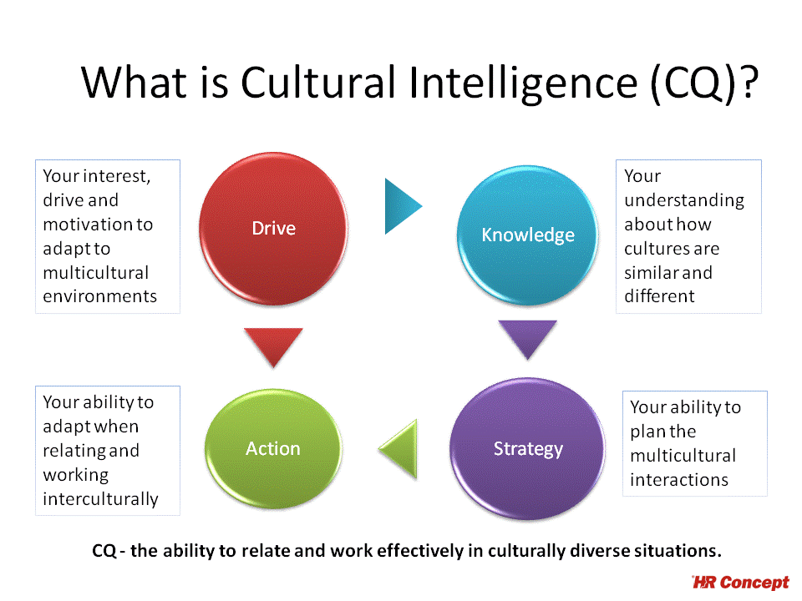

What are Cultural Models?
Cultural models are mental representations shared by member of a culture, they are mental structures and examples of behaviour that differentiate one culture from another. Cultural models are used to read attitudes and emotions. (Bernardo G, De Munck, V, 2013)

Why is Cultural Intelligence Important in the Workplace
It Creates Harmony – When Co-Workers are adaptive and can understand each other’s cultures, they are able to develop a culture of harmony and this way they can be more productive at.
Better Communication – If a team is culturally intelligent then they can easily understand each other and can work together more successfully which results in less miscommunication. (Indeed Editorial Team, 2023)

Hofstede Theory
Professor Geert Hofstede carried out a study of how values in the workplace are influenced by culture. He quoted ‘the collective programming of the mind distinguishing the members of one group or category of people from others’ – (Hofstede G)

What are The Cultural Dimensions in the UK
The UK is believed to be a masculine country under Hofstede’s study. UK have a tendency to value competition, achievement and success and they place less value on things like getting on well with other people – Hofstede.
Britain culture is influenced by the combined nations history, its historically Christian religious life, its interaction with the cultures of Europe. Britain is made up of England, Scotland, Wales and Northern Ireland. Britain is multi-nation, multi ethnic land of diversity (Boyd C, 2019)
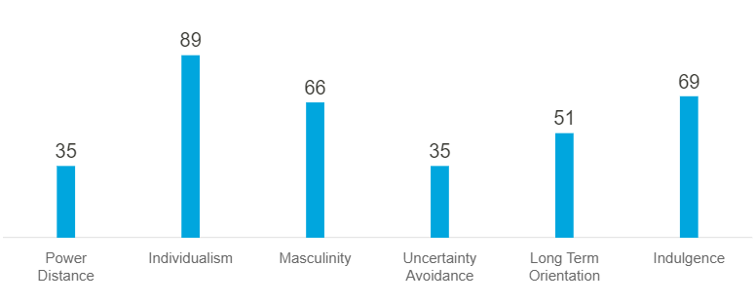
(Hofstede Insights)
Power Distance, Britain scored 35, which is low. They believe that differences between people should be minimal.
Individualism, UK is among the highest of the Individualist results, they are a highly Individualist and are said to be private individuals.
Masculinity A high score (Masculine) on this suggests that the society will be motivated by competition, achievement, and victory. Britain is a masculine culture which is highly focused on success.
Uncertainty Avoidance, UK has a low score of 35 on uncertainty avoidance this means that they are quite happy to wake up not knowing what the day will bring.
Long Term Orientation with a score of 51, a dominant inclination in British culture can’t be determined.
Indulgence, with a score of 69, this means that Britain is seen to be an indulgent society.
What are The Cultural Dimensions in Spain
Spain is famous around the world for flamenco music and dance, bull fights and fantastic beaches. Spain is the second largest country in the EU, it is the home of the world second most widely spoken language. It has the fifth largest popularity in Europe, and it is one of the worlds most popular tourist destination. (Godoy S, 2021)
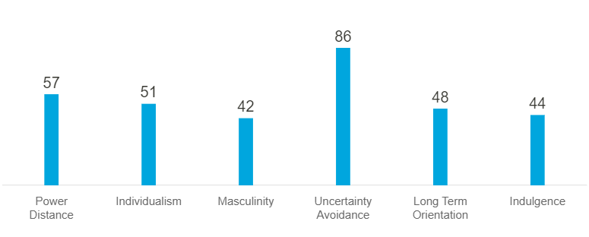
Power Distance, with a high score of 57, this means that the Spanish believe a hierarchical order is needed in which everyone has a place.
Individualism, teamwork is natural, and employees work in this way without the need for strong motivation from managers
Masculinity, Spain is a nation where the key word is harmony, so polarization is not well deemed, or excessive competitiveness welcomed.
Uncertainty Avoidance, Spain is said to be the second noisiest nation in the world. People like to have rules but also, they are compelled to steer clear of rules that make life more difficult.
Long Term Orientation Spanish people like to live in the moment without great worry for what the future will bring, they look for speedy results without delay.
Indulgence, Spain is not an indulgent country, they don’t believe in spoiling themselves.

Differences in Britain and Spain Cutural Dimension

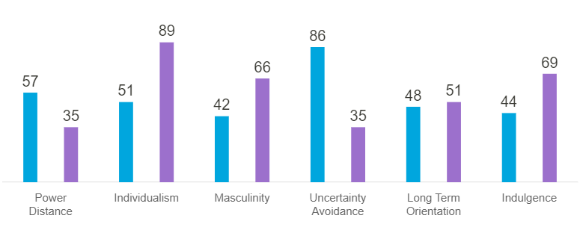

The table shows the difference between the 2 countries. There are big differences between the two countries for each category.
The biggest difference is ‘uncertainty avoidance’ category. There is not much difference with the two countries when it comes to ‘long term orientation.

How Can A Hotel in Britain Cater to Spanish Guests
Front of House / Reception is a very important department as this where all guests will need to check in. This department is the direct delegate to link the work and report consequence to other departments. (Set up My Hotel, 2023) The reception team will need to welcome the Spanish guests in a polite manner. It would be an advantage if there was a staff member who could speak Spanish. The reception team should also be knowledgeable, for example if the Spanish guests would like to have visit different places the reception team should be able to have any information ready for them. If this is not possible then there should be leaflets/ booklets near front desk where the guests can find all the information needed.

Restaurant/ Catering - The Spanish like to have light breakfast so the hotel will need to arrange a continental breakfast. They also like toast with jam or cheese, they enjoy strong coffee with hot milk. They love to have French madeleine as a treat.
Lunch is the largest meal of the day for them and they enjoy their meal with wine. They enjoy things like fish, roast chicken and soup, things are a hotel restaurant would normally cook for all guests. For dinner they enjoy seafood or just something simple like omelette. (Sierra L, Sierra T, 2020)

Housekeeping - Everyone likes to have a clean room when they visit a hotel. It is very important the rooms are set to high standards, especially for foreign guests as you would not want the Spanish thinking the British are filthy.

Conclusion
Cultural awareness is very important to any organisation, especially to the hotel industry. A cultural intelligent team can lead to success. Hotel staff should understand the importance of cultural awareness as they will cater for guests from all over world. They should know how to treat all guests regardless of culture, beliefs, and faith and should be trained to cater to all. Training in cultural awareness should be mandatory to achieve overall success

References

Bennardo, Giovanni, and Victor C. de Munck, 'Introduction', Cultural Models: Genesis, Methods, and Experiences (New York, 2013; online edn, Oxford Academic, 2014), https://doi.org/10.1093/acprof:oso/9780199908042.003.0001, accessed Mar. 2023.
Brainz Magazine, Walker R, Jan 2022, Available at https://www.brainzmagazine.com/post/the-importance-of-cultural-intelligence-and-sensitivity-in-leadership (Accessed March 2023)
Hofstede Insights, National Culture, Hofstede G, Available at https://hi.hofstedeinsights.com/national-culture (Accessed March 2023)
British Traditions and Culture, Boyd C, 2019 Available at https://www.britishcouncil.pt/en/blog/british-traditions-and-culture (Accessed March 2023)
A Brief Introduction to Spanish Culture, traditions and beliefs, Godiy S, 2021. Available at https://www.spanish.academy/blog/a-brief-introduction-to-spanish-culture-traditions-and-beliefs/ (Accessed March 2023)
Meal time and Culinary Customs of Spain, Sierra L, Sierra T, 2020, Available at https://www.thespruceeats.com/meals-and-the-culture-of-spain-3083066 (Accessed March 2023)
Set Up my Hotel, March 2023, Available at https://setupmyhotel.com/homepage/hotel-management-glossary/front-office-department.html (Accessed March 2023)

