BA (Hons) Leadership and Management Skills in the Workplace
Module: Managing project in the Organisation
Module code: BMSW5104
Lecturer: Paul Ranson
Student: Miss Manjit Kaur Gharu
Student no: 1814769

Table of contents
Introduction………. p.3- p.5
The Project Cycle……….p.6- P.7
The Iron Triangle……….p.8- p.9
The Scope……….p.10- p.11
Time……….p.12- p.13
Cost……….p.14
The Gantt Chart……….p.15
Conclusion……….p.16
References……….p.17

Introduction
Vintner’s family have come to the decision where they are moving their business from Shirley to Sparkhill. The Vintner’s family are investing in a plan to proceed with online sales in their unused warehouse in Sparkhill rather than offer an in-store service. As the warehouse needs work doing to it to proceed with this move the Vintner’s have asked for further guidance on how to make the move go as smoothly as possible. The shop in Shirley is well established for 30 years. As the shop in Shirley was in-store based, where customers could visit the store and see the items, the Vintner’s family want minimum disruption to the sales. Due to the Covid-19 pandemic customers would understand this move in the business as lockdown restrictions have impacted in-store sales drastically. Customers would appreciate the online sales more rather than closing all together due to the restrictions.
This report has been created to advise the project sponsor. The report would help with the delivery of the project. There are various techniques in this report which are helpful. As the plan has been developed by using the waterfall approach which is commercially known as Prince 2. This approach shows the plan and how other techniques are attached to the plan to get this completed.
Currently the roles in the Vintner’s Antiques are in a diagram below.

As the project manager I suggest that the relevant stakeholders are to be nominated in these roles to complete the project.
Dennis is nominated to be the Project Sponsor. Dennis has knowledge and locates antiques from everywhere. Dennis has a passion for old antiques and will manage this project well with his experience.
Doreen is nominated to be the Finance Specialist. As Doreen has the expertise as an accountant and competes the task to control budget well, she would be perfect in the role. She is very sincere in job role.
Suha is nominated as the Customer Service Specialist. Suha has a very good rapport with our customers. In the last 3 years since she joined the business, she has shown passion in what she does on a day-to-day basis. Suha is passionate in her position.
Omar is nominated to be the Technical Specialist. As Omar has key skills for repairing antiques and any carpenter tasks, he would be perfect for this role.

I have provided these recommendations as this gives everyone involved responsibility. The impact of a project with no structure could be very immense to the result. As there would be no responsibility should anything go wrong, everyone would do tasks at their own accord, or no one would understand what has been completed and when. The 7 Red Lines is an example of this. The 7 Red Lines is where a team give instructions to complete a task. There is no plan, no one has the right material, no one knows has the task is going to be completed, no set guidance is given yet a result is expected. (Beinerts, 2014)

The Project Cycle

The project cycle is used as a guidance to follow as phases throughout the project.
The plan phase would be when the tasks are agreed to go ahead using techniques like User stories on Trello. Both the customer and supplier would agree on the plan, which would preferably be an agreement and signed off by both parties. The plan would include the critical path of the project.
The delegate phase is when the relevant team are allocated the task. The team have previously been liaised with the project where quote estimates have been agreed.
The monitor phase is where you would check on how the task is being carried out to make sure everyone is following the plan.
The report phase would be reliant on the monitor phase. Should there be an obstacle which has been detected in the monitor phase, the results would need to be recorded in the report phase. For example, if there was a delay on the office furniture due to the pandemic, this was delaying the office being completed. The report phase would be documented, and the project time frame would need to be adjusted according to the delivery of the furniture. In the long run, this could affect the completion date of the project.
The control phase is where the report phase is vital. The report phase would be documented, and the project time frame would need to be adjusted according to delivery of the furniture. Control is vital as long-term this could affect the completion date of the project.
The project cycle is repeated until completion. This would keep everyone involved motivated to complete the task allocated and on target as agreed in the plan. (Roberts, 2009)

Iron Triangle

The Iron Triangle is a framework used in project management. This presents the quality of the project. The use of triple constraints shows how everything involved is reliant on the other to be balanced to get the quality. If one is changed the others will be compromised, as everything within the triangle is interconnected. Should any change be made to either scope, cost, or time then as a project sponsor everything must be reassessed as the Iron Triangle becomes imbalanced. An example is if the customer decides they want a personalised solid oak frame mirror, both the customer and the supplier agree on the time and cost of the order placed according to the customer’s personalised needs. Similar to a contract that has been agreed, the customer knows what they want (scope), the customer has agreed with the time and cost, like a contract, for the result and quality of the mirror. Should the customer come back and change the order to a black metal modern mirror as the solid oak doesn’t match the furniture, the supplier would then go back to the plan (Iron Triangle) and reassess the cost and time. The customer could not expect the cost and time to remain the same as cost could be more/ less. The Iron Triangle framework is to be balanced out again and a new order would be confirmed for both the customer and supplier to agree on. Each time the customer makes any changes to the order, such as size or colour, the supplier would go back to the Iron Triangle and each change would affect the cost and time. Should the customer disagree with the cost, the quality of the result would be compromised, e.g., cheaper material, smaller product, etc.
The waterfall approach is where the scope is the target. Regardless on change to the cost or the time the result would no be compromised. The example below shows a waterfall approach diagram to the grand opening of the store. The scope would not change, the grand opening would go ahead. But the time and cost may change due to any obstacles.

The agile approach is where the cost and time is the target. The scope is variable in this. Below shows the same diagram where the scope can be compromised. As the cost and time is crucial in this approach, this can’t be changed, but the scope can, so if the grand opening was on the 1st of March, there store can still open, but quality is not as planned in the original scope. For example, if the painters are still in the store to complete unfinished work or the signage is up but no electricity connected to it.
Time
Cost

Scope
The scope is the result of the completed project. As a project sponsor they should get everyone involved in the project to establish what the scope is. Having everyone, from the management team, the warehouse team, the technical team, the staff, anyone who is a stakeholder involved helps to get everyone’s views in the project. This could be used as an opportunity for everyone to have their say in the scope which is the completed result. As a project sponsor this gives you the advantage if anyone says at the end that they wanted an office to themselves, yet it wasn’t expressed in the planning of the project, you are able to go back to the Iron Triangle and confirm this was not in the plan. This involves everyone’s invested time, should anything change, become a success, or go wrong in the project, everyone is accountable.
The computer software used to get everyone’s views and needs for the completed project would be Trello which is available online. This is software which can be used anywhere on the website, where everyone involved will need an email and password to access Trello. All individuals involved can access Trello as their own accord, from anywhere. This software is helpful if people can’t get together, like in the pandemic. There is no need for hiring a board room to get everyone to voice their opinions. The project sponsor would invite every team member to a board using an email address, such as Vintners Sparkhill Warehouse board. Once everyone has access to the board, they can add user stories. To do this add a card, write in the card ‘What you want’, Why you want it and How you will benefit from this. For example, ‘I want a professional camera so I can take photos of the antiques. I want this because I will be uploading the photos to advertise the items online.’
Once everyone has added their needs in the user stories, the stories need to be prioritised. The Chevron technique is used to do this. This is where the swim lines are used for ‘must have’, ‘want to have’ and ‘nice to have’. The user stories would be moved to the relevant swim line according to how important the request is. This would present the issues that need resolving.
This is a modern version of the traditional white board and post it note exercise where everyone involved would attend a meeting together. Also known as the Kanban technique in Japanese. The team would all brainstorm and write on the post it notes what they want, why they need this and how this would help the organisation, like the user stories. All the post it notes are collected and prioritised in the correct columns on a white board. This is like the swim lines, chevron technique. (Heagney, 2008)
Below is an example of what the Trello board would look like. This technique is also known as the Moscow technique.

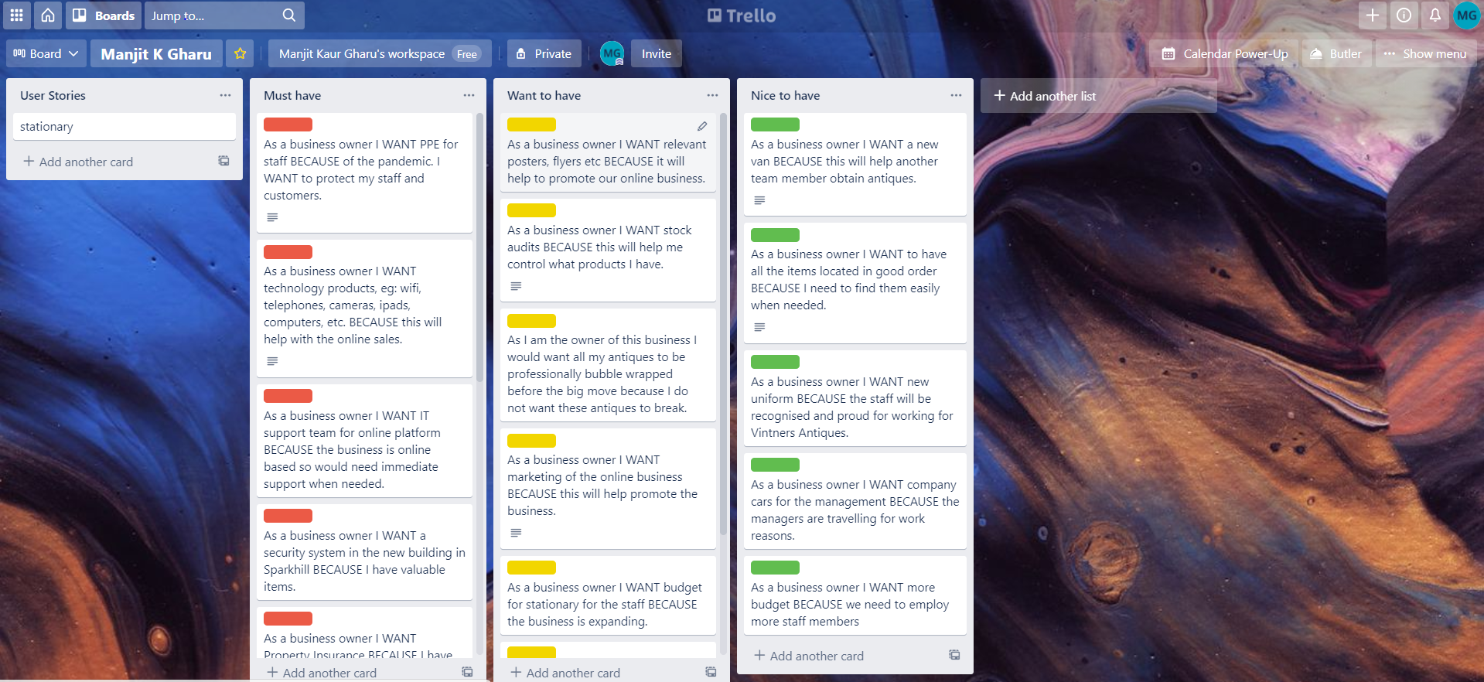
Time
Time is precious to all stakeholders involved. Time in any project is even more crucial as mentioned before in the iron Triangle. The quality of the scope is dependent on time. If time is gambled it can lead to altering the scope and cost of the project. Time would be estimated amongst the individuals involved and collaborating an estimate time on each task. Using the Roberts Product Project Technique as follows. The tool used would be Planning poker, this is available online. Traditionally when everyone can be together to make the plan to estimate time, this would be a whiteboard and post it note exercise. This will help everyone give their time estimate using the user stories. Some individuals may think installing internet in the new warehouse is a 1-day task whereas others may think this would be a 3-day task. Again, everyone gets to have their say on this decision. The time scale would be dependent on how complicated (easy, medium, or hard) and how big, (small, medium, or large) the task is. This would then be entered into the 3 x 3 matrix tools for project management where everyone can agree on what the majority estimate the time to complete the task. Each user story would be discussed, and a time can be added to the task once everyone has an input. (Clayton, 2018)
Below is an example of a 3 x 3 matrix. As an average figure of days is collected from using the Roberts product project technique which is the column and the row meet. This information can be recorded on each card/ task in the Trello software.
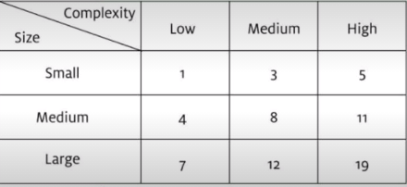
(Roberts, 2011)

Cost
The same Roberts Product Project Technique would be used to estimate the cost in the project. Wisdom of the crowd is the best way to calculate the cost. This would have everyone involved to give the cost of each task, then the average would be taken. As this is just an average, there may be changes. The obvious things such as labour, cost of materials, etc would need to be considered. Using the user stories which were created in the Trello software, each task can be selected then the estimate can be attached. (Dalton, 2011)
Once all this data is collected there would be more meaning to using the Trello software as the crowd would be responsible to select what tasks need to be done, prioritised the task and estimate the time and cost of this task.
Below is an example of the Trello card once opened. This shows the task, which shows the fact that stakeholders have selected this a ‘must have’, shows the estimated days for this to be completed and the cost to complete the task.
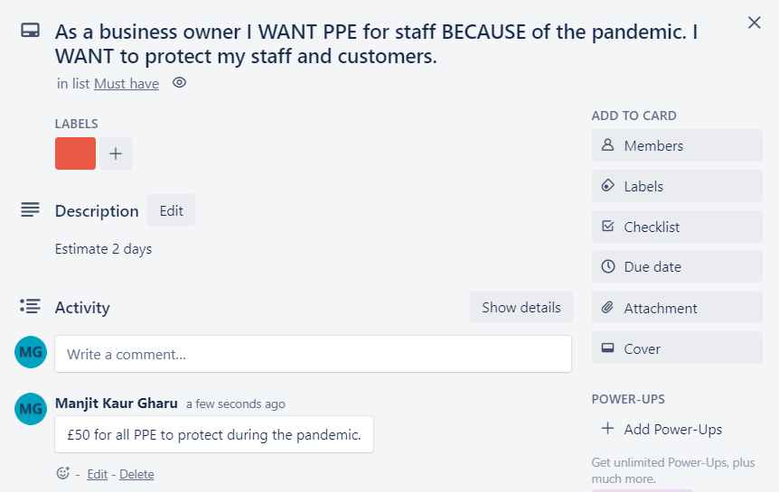

The Gantt Chart
The Gantt Chart is a technique used to plan the project. This tool presents everything agreed in the plan and the schedule of the plan. All tasks that need to be completed are noted in the chart which can be created using Microsoft Excel. Each task has already been allocated a certain amount of time as previously described.
Below is an example of the Gantt chart. This chart shows how reliant each task is to another task. For example, the roof will start once the electric is complete. Should the electrician get delayed in completed the task in 6 days, the roof can’t start until the electrics are complete. This would affect the time of the project. (Gharani, 2019)

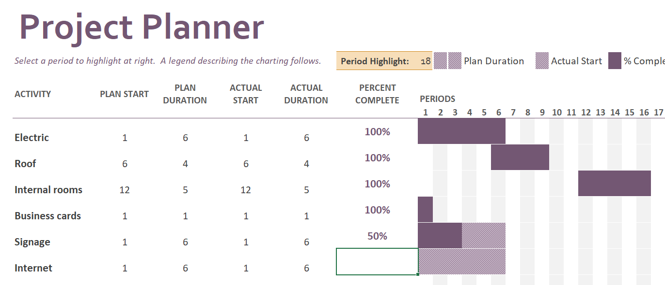
Conclusion
The Vintner’s needed assisting in the project of the move from Shirley to Sparkhill. The project manager has no authority to enforce this project on the organisation. As a project manager I’ve been hired to advice the project sponsor on how to organise the project with the least number of difficulties. If difficulties do develop then the project sponsor would detect these as soon as possible and the guidance and actions to be taken are suggested. The recommended techniques are helpful if followed correctly. The solution is not guaranteed but is reliant on the stakeholders. Having reduced the risk of issues, the project would be completed on time.

References
Beinerts, L (2014) The Expert (Short Comedy Sketch) https://m.youtube.com/watch?v=BKorP55Aqvg (Accessed on 14th March 2021)
Clayton, M (2018) What is Planning Poker? Project Management in Under 5 Available at: https://m.youtube.com/watch?v=cm3DbFo5bxY (Accessed on 16th March 2021)
Dalton, F (2011) BBC – The Code – The Wisdom of the Crowd Available at: https://m.youtube.com/watch?v=iOucwX7Z1HU (Accessed on 16th March 2021)
Gharani, L (2019) Project Plan in Excel with Gantt Chart (Plan, Action & Progress in ONE VIEW) Available at https://m.youtube.com/watch?v=HfAOkXt5V_8 (Accessed on 20th March 2021)
Heagney, J (2008) Making things happen; mastering project management Available at: VLeBooks (Accessed on 20th March 2021)
Roberts, P (2011) Effective project management, p.112 – p.116 Philadelphia, London Available at: VLeBooks (Accessed on 23rd March 2021)

