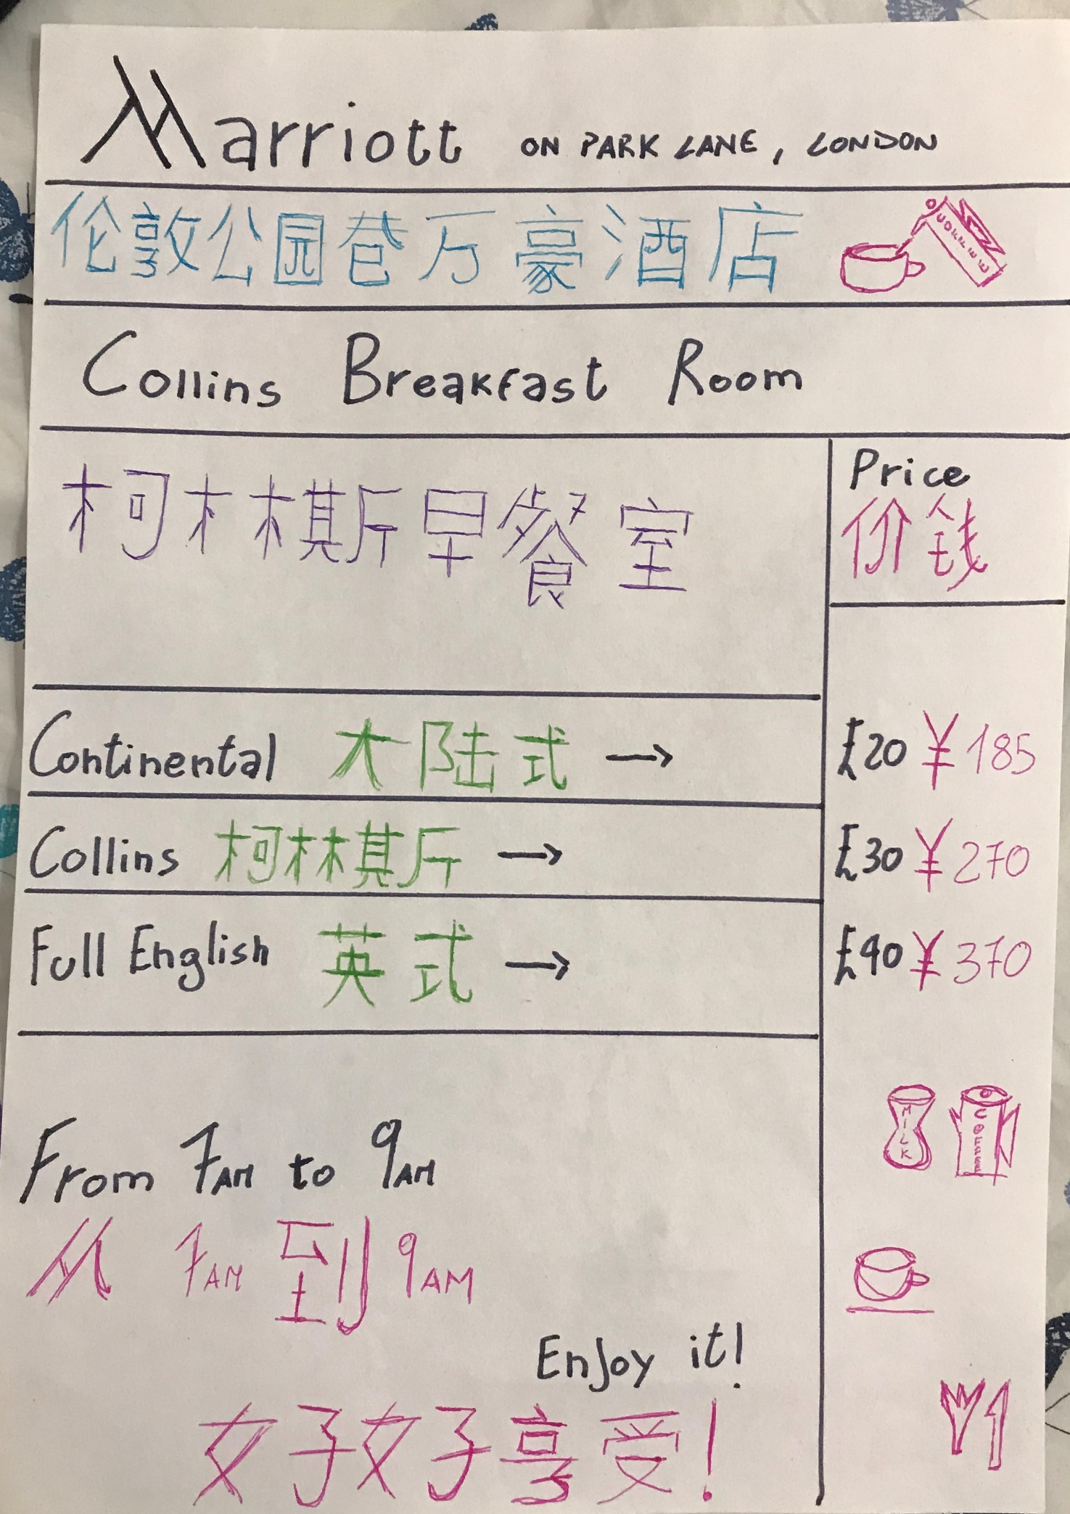

Student Name: Riccardo Russo
Student Number:1815101
Breakfast Board 4th assignment of Chinese
University of Wales Trinity and Saint David
Thank you

