

ACBA5001

Built Environment Programmes

Level 5. BSc (Hons) Construction Management; BSc (Hons) Civil Engineering and HND pathways.

Project Planning for Construction

2000 +/- 10% words

Steffan Dancey

Table of Contents
Introduction 2
Procedure 3
Findings 3
What is Quality? 3
Quality Management 4
Quality Assurance and Quality Control 5
Total Quality Management 8
Management concept 9
Conclusion 10
References 11
Appendices 12
Appendix 1 12
Appendix 2 12
Appendix 3 13
Appendix 4 13

Introduction

In this assignment I will provide a written report to a client discussing Quality Assurance and Quality Control for Project Effectiveness, and Total Quality Management in Construction. In this report I will assess the principles and assess effective methods of project management.

Procedure

The information within this written report will be gathered from sources such as books, articles, lecture notes, and online websites, all information sourced in this document will be referenced to display its original source. Please see reference list on page 11.

Findings

What is Quality?

Quality is an interpretation of how something may be perceived, this may be evaluated differently by an individual based on their judgement or view on a certain product, Quality is described as not being static, since customer expectations can change (Lochner)

“Quality involves developing product or service specifications and standards to meet customer needs (quality of design) and then manufacturing products or providing services which satisfy those specifications and standards (quality of conformance)” (Lochner)

Effectively managing quality can enhance a company’s reputation, profits, efficiency, and its ability to develop. A crucial component of construction project management, quality management frequently makes the difference between success and failure. The ambition to produce high-quality work on schedule and within budget ties all parties involved in construction projects, which cover a variety of functions and specialist parties and trades.

Quality Management

In the construction industry, Quality Management refers to the policies, practises, and guidelines established to enhance an organization's capacity to deliver quality to its customers, whether they are clients, owners, contractors, or subcontractors, on a regular and improving basis.

The main objective of quality management is to prevent defects from occurring during delivery or handover and to find and resolve snags before customers do, protecting a company’s reputation. One of the more evident advantages of achieving these objectives is maintaining a good image, subsequently creating more work with a favourable reputation. Correcting issues on site is a lot less time and cost effective than preventing the mistakes happening in the first place. An effective Quality Management plan will provide an effective way to improve quality and reduce the likelihood of mistakes occurring on site in the first instance. (Hodgson, n.d.)

A comprehensive quality plan will include elements such as Legal requirements, Requirement Standards, Quality Policies, and Quality Objectives.

Please see Appendix 4 – for company Quality Policy.

This Quality policy also refers to requirement standards, for example BS EN ISO 9000. These are a series of international standards that provide a description of the principles and concepts involved in quality management. The family includes standards such as ISO 9001, ISO9000, and ISO9004. (ISO, 2015)

ISO 9001 is defined as the internationally recognised standard for Quality Management Systems. It is the Quality Management System Standard that is the most widely used in the world. (NQA, 2015)

To manage a company with good judgement and consistently meet customer expectations as well as other parties, the standard ISO 9001 establishes a structure and set of principles. Essentially said, ISO 9001 quality management system provides the basis for effective systems to consistently deliver effective goods and services. (ISO, 2015)

In construction projects there derives a balance of three primary components, Quality, Time, and Cost, as shown in the Project Management Triangle illustration below:

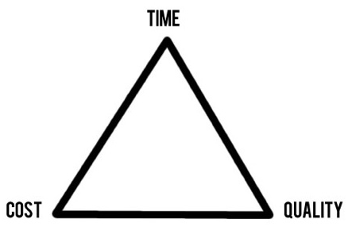 (Khinda, 2016)

Using the Project Management triangle, we can establish the following:
- Projects that are completed quickly at High quality will result in high cost.
- Projects that are completed quickly at low Cost will sacrifice quality.
- High Quality Projects delivered at a low Cost will be low priority.

Quality Assurance and Quality Control

Both Quality Assurance and Quality Control contribute to the final delivery of the project ensuring it meets the required specifications and expectations, however they both achieve the same objective but in two very different ways.

“Quality assurance is the practice of managing the way goods are produced or services are provided to make sure they are kept to a high standard” ​ (Dictionaries, n.d.)

Applying proactive techniques with the goal of preventing faults is recognised as quality assurance (QA). Essentially, quality control (QC) is the process of examining the product to detect and correct possible faults. Quality Control may be seen as a correction tool that is often used by a particular team of workers on a construction project, such as inspectors and engineers who highlight areas that require attention. Through organised and regular operations that seek to stop faults before they happen. (Rogers, 2018)

Although Quality Control (QC) and Quality Assurance (QA) sound very similar, they refer to two different stages in the quality management process. QA and QC are carried out within the construction sector by various parties, at various time periods, and with multiple objectives. Yet, these principles are frequently confused and misinterpreted.

Quality Management systems standard ISO9000 defines both Quality Assurance & Quality Control as:
- A component of quality management, quality assurance works to create faith in the ability to meet standards of quality.
- In contrast, quality control is an element of quality management that focuses on achieving quality criteria.
- While QC verifies that the high-quality standards have now fact been maintained, QA aims at giving confidence that these quality standards will be met.
(ISO, 2015)
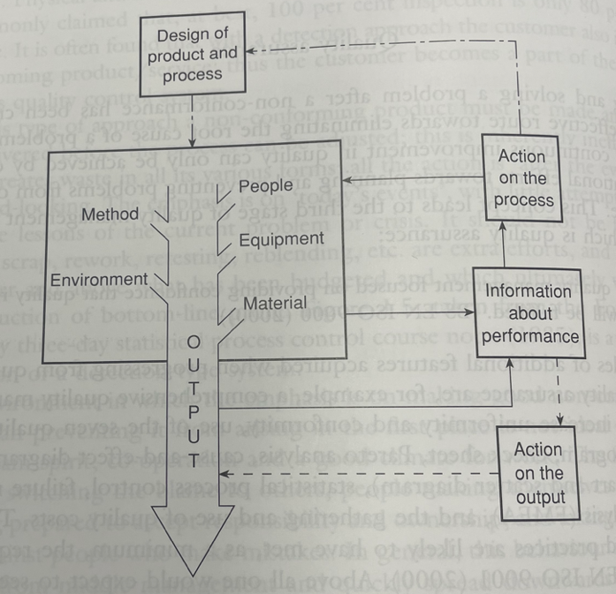
By putting a focus on product, service, and process design, Quality Assurance is a prevention-based approach that raises productivity and enhances the quality of products and services. It prevents the production of non-conforming products and the provision of non-conforming services by focusing on source activities and including quality into the planning and design stages; even when flaws do arise, they are found early in the process. In contrast to detection, which is reactive, this strategy is proactive. As seen in figure diagram below, the emphasis has clearly shifted from downstream to upstream processes and from product to process; from "product out" to "customer in". The Plan, Do, Check, Act (PDCA) cycle may also be used to explain this shift in emphasis. In the detection approach, the act portion of the cycle is constrained, resulting in an incomplete cycle. In contrast, the prevention approach emphasises the importance of act as an integral component of individuals and teams' efforts to pursue continuous improvement as part of their regular work activities.

Appendix 2

(Ford Motor Company , 1985)

The majority of quality-related issues are brought on by inadequate or inappropriate product and process designs. Quality is established during the design stage, not the later control stage. The process as characterised by its input of people, machines, materials, technique, management, and environment is acknowledged in the preventative approach. Along with eliminating the source of waste and non-value-adding activities, it also increases and deepens the sense of accountability for quality among people who produce and provide the service. (Barrie G. Dale)

To transition from detection to prevention, there must be development a new operational concept and method which calls for a transition in style of management and way of thinking, particularly addition to the use of a set of tools and approaches.

When senior management starts incorporating the improvement efforts of multiple departments, it starts to emphasise prevention before detection in its policies and objectives. This continues to the next stage, total quality management (TQM).

Examples of good Quality Assurance would be as indicated below:

- Measuring quality – adhering to standards and specifications.
- Material – Correct size? Correct material?
- Project Management – Budgets, timeframes etc.
- Skills – Qualifications, workforce experience.
(Plan Radar, 2018)

Total Quality Management

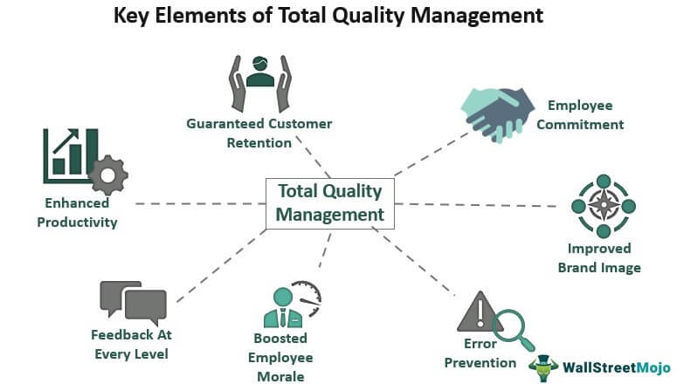
The goal of the management theory known as total quality management (TQM) is to increase an ability of the organization to provide consistent high-quality services to the clients.

Appendix 3

(Vaidya, n.d.)

A traditional Quality management system and TQM differ in various ways. TQM prioritises quality, flexibility, and services over price and technological efficiency and employs a process-oriented rather than a result-oriented approach. Rather than the conventional management structure, TQM utilises a more organisational structure. Although TQM is a concept that would be more commonly linked with the manufacturing and service sectors, yet it's also been introduced to the construction industry as clients require increasingly higher delivery standards for large and complex structures.

The application of TQM requires a change in the employee's mindset from one of just monitoring to continually looking for opportunities to improve. Regardless of disruptions and flaws that can arise in construction that are unavoidable, significantly more than in a more controlled manufacturing environment. With an emphasis on new technology and innovation Total Quality Management may be used in the construction industry as a method of approaching the concept, visualisation, and execution of goals to assure efficient quality and productivity.

Total Quality Management is subject to several definitions and interpretations. But essentially. TQM is the cooperative effort of every individual in a company and its associated processes to create goods and services that are economical and that, ideally, meet or exceed the demands and expectations of consumers. TQM is a management concept and a set of principles for running a business in a way that is beneficial to everyone involved. (Barrie G. Dale)

Total Quality Management can be implemented in a variety of ways, but there are a few requirements:
- Employees who are doing well should be recognized and rewarded.
- Customer feedback should be evaluated and implemented as necessary.
- Regular training should be given to staff to enhance their abilities.
- The consumer wishes a good product at a fair price.
- Disagreements should be avoided, and groups should collaborate to accomplish a shared objective.
- Senior management must be committed and proactive in their leadership.
(Wood, 2021)

Management concept

Douglas McGregor’s X and Y theory developed two conflicting concepts, based on a manager’s motivators and/or views and how this affects their management style. Theory X managers typically assume that staff are not interested in the work, are not responsible, need constant supervision and need to be motivated by rewards.
However, Theory Y managers tend to hold trust in their employees, find their work satisfying and take responsibility for their work. (Tutor2U, 2021)

Conclusion

After conducting the research into Quality Assurance, Quality Control and Total Quality Management I have gained an improved understanding of the stages of Quality management. The findings from the conducted research assisted me in establishing that Total Quality Management TQM is the solution to improved project effectiveness.

Although all Quality Management methods can lead to improved outcomes, I believe Total Quality Management is superior as it’s a comprehensive combination of Quality Assurance and Quality Control and has the ability to improve productivity, reduce costs and enhance customer satisfaction. On the other hand, this does depend on the extent of the construction project, and the size of the company, as smaller sized projects or smaller sized construction companies may not benefit from the advantages from employing this method of Quality Management.

Ultimately, irrespective of any management system that can be put in place, the effectiveness of quality management predominantly rests with the staff in the company, if a positive attitude is applied towards Quality Management, then there will subsequently be a greater chance of a good-quality product. Providing staff with trustworthy training partnered with the positive mindset will furthermore support a construction project’s target for achieving a higher quality product.

To ensure the positive attitude is maintained by employees, an effective management style must be provided. Using the X and Y theory above, I believe Theory Y managers provide will provide a better suited style of management, as they provide employees with their own accountability and independence, allowing them to perform much more effectively. It also encourages teamwork, to develop ideas and problem solve. Unfortunately, some employees may mistreat the trust and freedom provided, and not perform up to standard as measuring success with this theory can be difficult.

References

Barrie G. Dale, T. v. (n.d.). Fifth Edition Managing Quality .
Dictionaries, O. L. (n.d.). Dictionaries, Oxford Learner's. Retrieved from https://www.oxfordlearnersdictionaries.com/definition/english/quality-assurance?q=quality+assurance
Ford Motor Company . (1985).
Hodgson, L. (n.d.). Sitemate. Retrieved from https://sitemate.com/uk/resources/articles/quality/quality-management-construction/
ISO. (2015). 9001:2015.
Jones, M. (2022). Quality Policy. J Randall Roofing Contractors .
Khinda, B. (2016). Safety, the Fourth Project Management Criterion.
Lochner, R. H. (n.d.). Designing For Quality - An introduction to the best of Taguchi and Western Methods of statistical experimental design.
NQA. (2015). Quality Management - ISO9001.
Plan Radar. (2018, January 2018). Retrieved from Plan Radar: https://www.planradar.com/gb/quality-assurance-in-construction-5-golden-rules-saving-money/
Rogers, J. (2018). QA and QC in Construction .
Tutor2U. (2021, March 22). Retrieved from Tutor2U: https://www.tutor2u.net/business/reference/motivation-mcgregor-theory-x-theory-y
Vaidya, D. (n.d.). Total Quality Management. Retrieved from WallStreetMojo: https://www.wallstreetmojo.com/total-quality-management/
Wood, S. L. (2021). The ASQ Certified Manager of Quality/Organisational Excellence. ASQ.

Appendices

Appendix 1
Project Management Triangle
(Khinda, 2016)

Appendix 2
Ford Motor Company
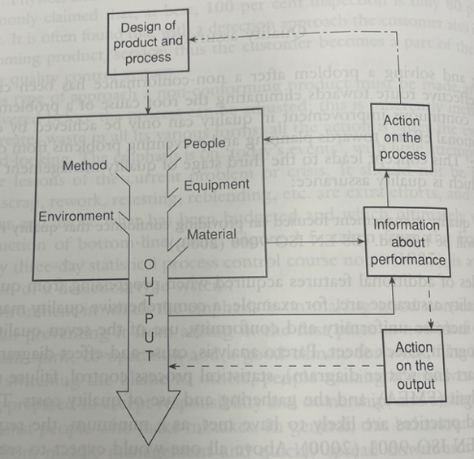

Original source
Ford Motor Company 1985

Appendix 3

(Vaidya, n.d.)

Appendix 4
company Quality Policy
(Jones, 2022)

