BA International Hotel Management
Cultural Awareness
BMIH5003
Student Id : 2008820
Module lecturer : Mike Davies
Assessment
“ Hotel Handbook for Intercultural Competence “

Executive Summary
This is depicting the international culture with the context of the hotel management services. There is the comparison of the two countries that is making the difference how Indian culture is making the different from the UK. The Indian culture is believing on the teamworking ability that is very important factors for delivering the services in hotel trinity. However, from the different culture, the staffs not the hotel can decide what can be important or what can be avoided and this is making the operational efficiency of the organization.

Table of Contents
Executive Summary 2
Introduction 4
Country Analysis 4
Hotel handbook do’s and don’ts 6
Conclusion 7
Reference List 8

Introduction
The purpose of the study is to demonstrate the cultural awareness among the staff of the Hotel trinity in the international market. Through the concept of the cross-cultural dimension differences of the two countries are established and this will help the staff members of the Hotel Trinity in India.
Country A – UK
Country B – India

Country Analysis
Culture refers to the collective mental programming of the human mind that can be distinguished from one group to another group. The Trinity can face the cultural differences in the market of India compared to the UK market (Moran, 2018).
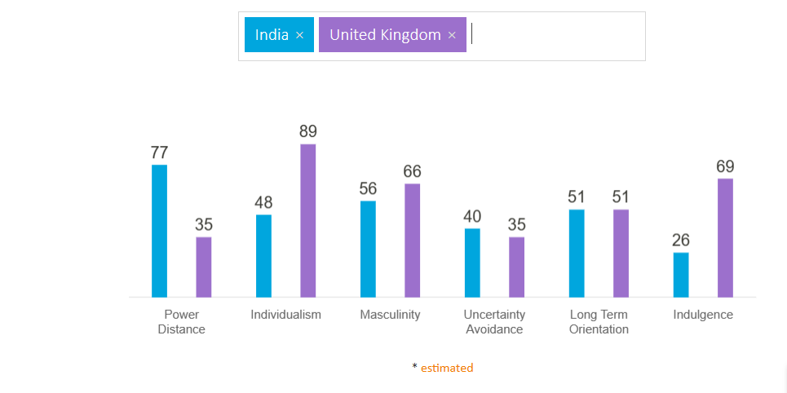
Figure 1: Culture comparison of UK and India
Source: (Hofstede Insights, 2021)
Power Distance - In this dimension, the UK has the low rank they scored just 35. This is the society that believes in the inequalities among the people that needs to be minimized (Mone et al. 2016). On the other hand, India scored 67 in this dimension. From the comparison it has been understood that the guest is expecting the ultimate loyalty ftom the staff and in this area the company should trained properly their staff to change their attitude and the staff has to be humble towards the guests. Employees of the hotel in India can expecting that they can get the clever and proper direction that will make the effectiveness in delivering the services to the guests (Methan, 2001).
Individualism - In this dimension, the UK scored high. The British people are highly taught from a young age to take their own responsibility (Minkov et al. 2017). So, the people in this country believe in self-dependency. India scored only 48 in this dimension. India is a society that believes in both individualism as well as collectivism. So, the guests are preferring that the employees are working with following the social concern. When the guests are coming with a group, all people from the group should be treated equally in the hotel. In India, there is the value of the relationship. So, the guests should ve obliged with the proper relationship with the staff that is important to make happiness among the visitors. The collectivist suggests that there is the high preference of belonging in the large social framework in which the individuals expect to act in accordance with the group. In this situation, The individual’s action is influenced by the different types of the opinion of extended family, neighbors as well as the other ones. The employee relationship is made on the basis of the expectations (Bukowski and Rudnicki, 2019).
Masculinity - The UK is a masculine society. People in the UK are working with a clear ambition for life, whereas India is also considered as the masculine society but the score is less than the UK (Gaygısız et al. 2017). Both of the countries are focusing on the success as well as the achievements. India is also visualized with masculinity. The indication of masculinity has been seen in the brand level and the other areas. But the country is involved with spiritual power as well as different types of the philosophies and millions of the deities. However, the masculine country is referring to the society that is involved with the achievement, success as well as the competition (Timm, 2011). So, the staffs have to understand what their competitors are producing to make effectiveness and the hotel should allow the guests regarding the religious perspectives and the guests can expect the success stories from the hotel trinity that can be helpful for the hotel.
Uncertainty avoidance - This dimension is referring to the fact that society can deal with situations that cannot be known before (Bozer and Delegach, 2019). UK scored 35 and India scored 40 in this dimension. It refers that India has more acceptance of the uncertainty as well as the unexpected thing. One statement that India follows is “nothing is impossible’' in India (Samovar, 2009). So, this very beneficial for Hotel Trinity and the staff of the hotel can convince the guests with their services.
Long term Orientation - This is the dimension that describes how the society is maintaining some links with their past when they are dealing with the challenges (Jandt, 2016). Though there is same types of the perspectives if with countries in this area, the Indian are believing in philosophical and religious thoughts. So, the guests can expects the Indian authenticity and styles in the food and accommodation of the hotel Trinity.
Indulgence - There is the high score of UK 69 refers to the fact that British culture is classified as indulgent. People in the UK are having fun as well as enjoying their lifestyle whereas India has low scores in this dimension and the people in this region are pessimistic as well as believe in cynicism (Heydari et al. 2021). The Indians are spending less percentage of the money as compared to the UK. Indian people don't spend huge amounts of money and they care about their money. So, the department of the hotel should not create high amount of the money for the guests that can create conflict.

Hotel handbook do’s and don’ts
Following the culture comparison of the both countries are important for the staff to understand their duty in the India -

Do’s | Don’ts’
Housekeeping department should work with the direction of the manager of the organization. | The department should not take the decision individually because India doesn't believe only in individualism.
Front office department has to maintain a proper cost for every money as well as the Accounts department should be flexible in the money transaction. | Indian people don't spend huge amounts of money and they care about their money. So, the department should not create conflict in this area.
Maintenance and engineering department can prepare the rooms of the hotel traditionally because the Indian people believe in religious thought. The department should keep the place clean always. | The department should not use too much western culture in designing and maintaining the room.
Kitchen and food production department can provide the food with the authentic Indian flavor that will meet the Indian culture. | The department doesn't need any special flavor or western flavor with the food dishes.
Table 1: Summarization of the data for staff in India
Source: (self-developed)
Through these documents the staff of the Hotel trinity can provide the effective service in India and they can avoid the conflicts in the organization.

Conclusion
The report has made the cultural differences of the UK and India through Hofstede's cross-cultural dimension. The staff of hotel trinity have to care about the difference when they are providing the service in the Indian market. A summary regarding the duty of the staff has been demonstrated through the report that is important for providing in the Hotel trinity in India.

Reference List
Bozer, G. and Delegach, M., 2019. Bringing context to workplace coaching: A theoretical framework based on uncertainty avoidance and regulatory focus. Human Resource Development Review, 18(3), pp.376-402.
Bukowski, A. and Rudnicki, S., 2019. Not only individualism: The effects of long-term orientation and other cultural variables on national innovation success. Cross-Cultural Research, 53(2), pp.119-162.
Gaygısız, Ü., Lajunen, T. and Gaygısız, E., 2017. Socio-economic factors, cultural values, national personality and antibiotics use: a cross-cultural study among European countries. Journal of infection and public health, 10(6), pp.755-760.
Heydari, A., Laroche, M., Paulin, M. and Richard, M.O., 2021. Hofstede's individual-level indulgence dimension: Scale development and validation. Journal of Retailing and Consumer Services, 62, p.102640.
Hofstede Insights. 2021. Compare countries - Hofstede Insights. [online] Available at: <https://www.hofstede-insights.com/product/compare-countries/> [Accessed 22 October 2021].
Jandt, F. 2016. An Introduction to Intercultural Communication, 8th edition, Sage: San Bernadino
Methan, K. 2001. Tourism in a Global Society: Place, Culture, Consumption. London: Macmillan.
Minkov, M., Dutt, P., Schachner, M., Morales, O., Sanchez, C., Jandosova, J., Khassenbekov, Y. and Mudd, B., 2017. A revision of Hofstede’s individualism-collectivism dimension: A new national index from a 56-country study. Cross Cultural & Strategic Management.
Mone, I.S., Benga, O. and Opre, A., 2016. CROSS-CULTURAL DIFFERENCES IN SOCIALIZATION GOALS AS A FUNCTION OF POWER DISTANCE, INDIVIDUALISM-COLLECTIVISM AND EDUCATION. Romanian Journal of Experimental Applied Psychology, 7.
Moran, R. 2018. Managing Cultural Differences, 10th edition, Routledge:Abingdon
Samovar, L. 2009. Communication Between Cultures, Wadsworth, London
Timm, A. 2011. Intercultural Problems in the Tourism Industry, GRIN Verlag

