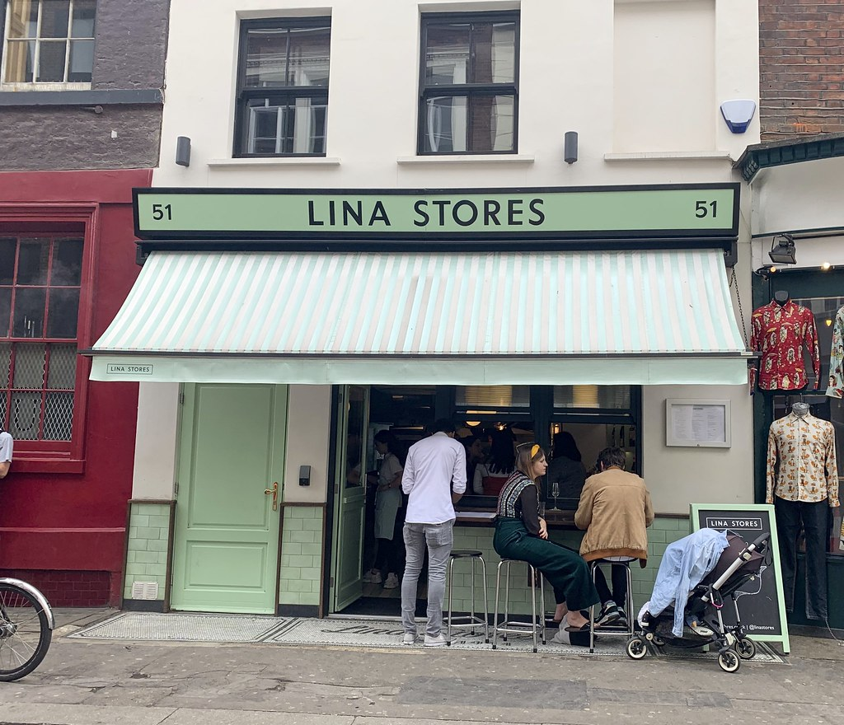
APRIL 2022

Ezequiel Pena
2029864
Module Leader: Yajesh Kumar
Problem Solving and Decision Making
BMSW4004

PROBLEM REPORT

Table of Contents
INTRODUCTION 3
Problems 4
Causes 6
Decision-Making 7

INTRODUCTION
About 8 months ago when I started working at the Lina Stores restaurant everything was going quite well, it gave me the feeling of being a great company and above all a great human group and this was what I liked about the job and that is why I accepted the job. But due to circumstances that we cannot control, we have lost very important members of our team, both as managers and as part of the staff, which has led to an organizational problem, a problem of lack of power and, above all, the culture of company, the creation of a group feeling, and this has led us to have a problem of attitude and commitment with new employees since they do not feel part of a group.

Problems
In this section we are going to develop the problems that have arisen in the company during the last few months, the impact they have on the company and how each one of them are directly connected.

Unsupportive boss: To begin with, I would like to start with the problem that I think is the origin of other problems. In my opinion this is the main problem and the bigger problem that we have. Unfortunately, we lost a really important members of our team, both as part of the staff and managers and this situation led us to other problems like lack power or poor organization.

Fortunately, we have a great manager, a very hard-working and organized person who is in charge of almost all the responsibilities of the company, such as making schedules, placing orders, organizing people and even training new team members. Despite the quality of our manager, I believe that this is where the biggest problem lies, because there is no separation of tasks in the area of stakeholders, everything falls on the same person and this can lead to the overwhelming of said person which can lead to them underperforming. Despite this problem, I believe that the biggest problems come from being a single person who does not have enough time to focus on some extremely important aspects such as the organization of the group, the personal well-being of each member, and staff training. and this has led us to different problems such as the following.

Company culture: Due to the overload of work of our manager, this has created certain problems that did not exist before, such as the lack of company culture, in the past we used to hold small meetings before each shift to discuss how the work was developing, such as organize ourselves and we even took advantage of the moment to give advice and even train new people in the company. Unfortunately, the person who was in charge of doing these small meetings has passed away and we have not been able to find a substitute of the same quality, and this has created many problems.

The lack of culture in the company is a big problem because it affects the old employees and especially the new employees, because the staff does not feel part of the company, or part of something bigger, which generates a lack of commitment in the new ones team members and this affects the entire company because we tend to have many absences, new staff do not usually stay in the company for long and this means that our staff is not very qualified and this is reflected in the service offered.

Work/life balance: Due to the problems already described above, the following problem arises. Thanks to the small number of staff and the low quality of new employees, employees with seniority in the company are sometimes forced to do more hours than desired, which leads to staff not being entirely happy with the balance between work life and personal life which can lead to the loss of important staff. Here we can see how all the problems are connected to each other and open the doors to find solutions.

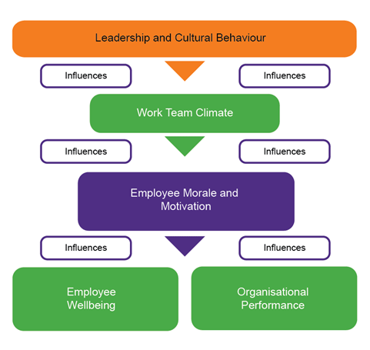

Causes

As I have already mentioned before, I believe that the origin of the problem and therefore the cause is the loss of important members in the organization, which has led to a multifaceted problem that affects all levels in our restaurant. Consequently, we can find different causes to the different problems for example:

Little separation of tasks in the organization: We already know that we do not have a lot of staff, but I think that in the organization the tasks could be better separated so that in this way all the important aspects of the company can be covered and like this maximize the results.

Untrained staff: The staff we have is quite young, inexperienced and many of them they are part-time, so we don't have much time to train them.

A lot of loss of staff: I think the staff we have do not feel part of the company or are not involved with the company and this leads to the loss of a lot of staff, and this makes it more difficult for us to have qualified staff because right now it is one of the more difficult moments to find workers.

Effects

Thanks to everyone's work, the quality of our product and location, because it certainly helps to be in Soho, the impact of the problems has not been seen in an exaggerated way, but we can see some impacts in different areas, that if it is not paid attention soon it could be much more serious.

Economic: In this aspect, the effects of the problems are beginning to be noticed, fortunately in the restaurant we always have many reserves, but there is a drop in the money generated, which is a great concern.

A few months ago, Greek St was the best restaurant in the company according to sales and the objectives set by the company, but due to the problems it has been reduced. This is reflected in weekly sales and the amount spent per person.

This drop in sales has resulted in lowering the weekly targets in order to be able to reach them, before the target was 32k per week, now it has dropped to 30k per week.

Environmental: Due to the few staff we have, the environment in the work area has dropped a bit. Although there is a great relationship between all the workers, some of them complain about working long hours and that influences the work environment.

This is an aspect of the company of vital importance because for the development and growth of a company its employees must be happy to be available to provide the best possible service.

Decision-Making

To make the best decision we have several tools or models that we can use that will be of great help to make a decision for example A General Rational Decision-Making Model

This model clearly explains the 7 steps we must follow to find the solution.

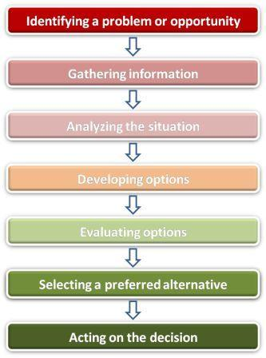

Source: https://moodle.uwtsd.ac.uk/course/view.php?id=7090

Once the problem has been found, the information analyzed, we will develop different solutions to the problem to choose the most appropriate one.

Once the solutions are developed, we will use different decision-making tools, for example PMI or SWOT, to ensure that we choose the most appropriate to the problem.

Unsupportive boss: As we already know, this problem is very important because it gives rise to other problems.

The most appropriate solution is to guarantee the separation of responsibilities between the managers, in order to have more control in the organization I believe it is the next one. In our restaurant we have 3 managers, with which we must distribute the tasks more evenly and that each one has a marked function. For example:

manager 1: This manager would oversee the functions most related to the company such as accounting, orders and the organization of the company.

Manager 2: He would oversee the aspect most related to the staff, such as the schedules, training for the new ones and the creation of the company's culture.

Manager 3: This would be the one in charge of the most physical functions, as it would be make sure that everything is clean, that each person does their job properly and that the service offered is the best.

Before moving on to the tools used to evaluate these decisions, I would like to briefly explain what each one of them is.

PMI is a good tool for evaluating the pros and cons of a decision. In which we elaborate a table and score the aspects of a decision such as Plus, Minus or Interesting.

SWOT analysis: It is a tool both for companies, as personal and decision making. In it we can find aspects for example: Strength, Weakness, Opportunities, Threats.

 | PMI
Plus + | Minus - | Interesting ?
Better organization +3 | Problem to separate -1 | Could be a challenge
More time to be develop different aspects of the organization +2 | We will have a expect staff in different areas but not in all of them -2
Less stress for them +2
Total= 7 | Total= - 3 | Total= 1

Here we can see how it would be of great help to divide the organization tasks thanks to the fact that it has more pros in favor of the company than cons

Company culture: I believe that this problem has an easy solution, it is just to give more time to the facet of communication between employers and employees.

I propose to organize several types of meetings; a meeting with the entire staff once a week where they will discuss the objectives set for that week, sales, provide information about the menu and wines and provide some training to new employees.

The other would be every day with the staff that is working, to talk about the functions of each one during that shift, things that can be improved and, above all, motivate the team.

I also propose to have a more fluid communication through the WhatsApp group where you can review the different feedbacks and comment on the negative ones.

Here we can how to make small talks with the staff could be of great help to create more company culture. We can find several strengths such as improving communication between managers and employees, having a better organization and keeping the team motivated, and yet we find few weaknesses such as paying those minutes to employees, but I think that money is more of an investment in quality.

Work/life balance: For this problem I think the solution is a bit obvious. We have to hire more staff to be able to distribute the hours more easily. It would be important to hire staff with experience and if it can be full time, since most of the current staff are part-time and that makes it difficult to make the schedule. If the staff does not have experience, it is very important to dedicate them to training them, this would help us to have a much stronger team and at the same time create more company culture and this would help new people stay in the company for longer.

From my point of view, this is a very accepted solution to find a good balance between the work life and the personal life of our staff.

Speak with the stakeholders and appropriate monitoring solution.

This information will be sent to my superior so that he can analyze it and make the decision that he deems appropriate or more educated.

Once the plan to solve the problem is implemented, we will wait a few weeks and then we will see how it is working by carrying out certain surveys to the staff to see if they are happy, we can also verify if the solution was correct by looking at the reviews of our clients and comparing them with which the previous weeks.

