University of Wales Trinity Saint David
Wales Institute of Science & Art

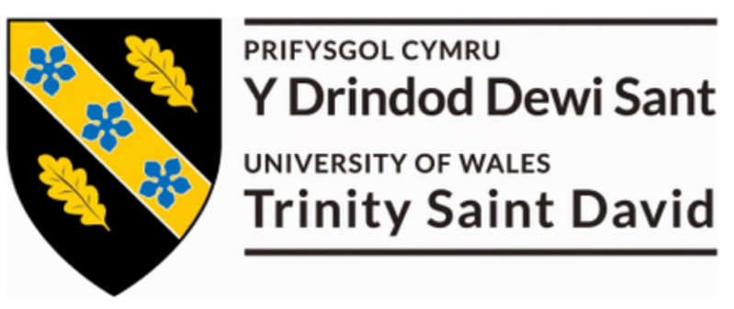

Coursework Title: Discrete Event Simulation
Module Name & Code: Manufacturing Systems & Simulation - ACMA 6002

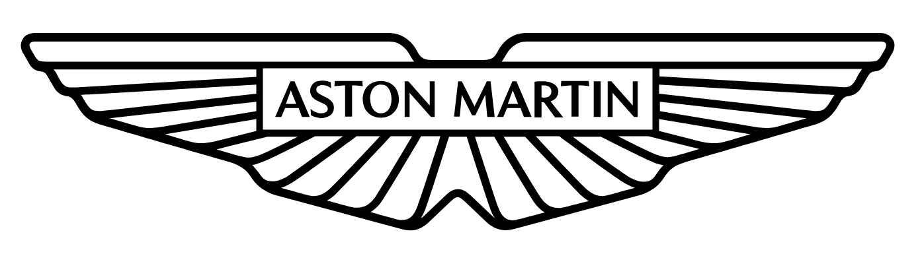
Name: Luke Huzzey-Evans (2205835)
Date: 01/10/2026

Executive Summary
This report develops a current-state discrete event simulation of the FESTO I4.0 CP Laboratory using Arena. The model represents the full production sequence from component arrival through optical inspection, drilling, cap dispensing, pressing, label printing and final output. Product mix, variable process times, fixed transfer times and the shared production operative were included so that the model reflected the supplied case-study conditions rather than a simple deterministic line.
The model was run for ten replications of an eight-hour production period. Average output was 1,164.8 completed assemblies per replication, equivalent to approximately 145.6 assemblies per hour. The main issue identified was drilling. Drill utilisation reached 99.96%, the average Drill Hold queue was approximately 198 parts and the average wait before drilling was approximately 59.4 minutes. The production operative also showed high utilisation at 98.23%, but the queue evidence shows that drilling is the main throughput constraint. The recommended improvement priority is therefore to reduce drilling demand or increase drilling capacity, followed by reducing manual refill/output activity and unnecessary movement.

Contents
1 Executive Summary ii
2 Introduction 1
2.1 Aims 1
2.2 Objectives 1
3 Current State 2
4 Arena Model Development 4
5 Model Verification & Validation 6
6 Simulation Results & Analysis 8
7 Waste & Value Analysis 10
8 Lean Improvement Opportunities 11
9 Conclusion 12
10 References 13

Table 1 - Current-State Process Data and Arena Inputs 2
Table 2 - Verification of key case-study requirements 6
Table 3 - Main current-state Arena results 8

Figure 1 - Completed FESTO current-state model in Arena 5

Introduction
Discrete Event Simulation (DES) can be used to model a manufacturing system and understand how parts, processes and resources interact over time. In this study, Arena simulation software is used to model the FESTO I4.0 CP Laboratory and evaluate its current-state performance.
The model represents the movement of components through automated optical inspection, drilling, top-cap dispensing, hydraulic pressing, label printing and the output station. The supplied process times, movement times, product mix and manual activities are incorporated into the model.
The purpose of the study is to use the completed simulation to identify restrictions within the current process and evaluate opportunities to improve flow. Particular attention is given to throughput, waiting time, queue length and resource utilisation, together with the identification of waste and value-adding activity.

Aims
The aim is to develop and analyse a current-state DES model of the FESTO CP Laboratory and use quantitative evidence to identify opportunities to improve flow and reduce waste.

Objectives
The objectives are to:
- Develop the supplied FESTO production sequence in Arena using the stated process data.
- Represent the 60:40 drilling mix, process variability, refill logic and shared production operative.
- Verify the model against the case-study requirements and check that the model behaves as intended.
- Analyse throughput, cycle time, waiting, queues and resource utilisation.
- Identify value-adding and non-value-adding activity.
- Use the simulation evidence to recommend lean improvement opportunities

Current State
Components enter the line from robot assembly using a triangular inter-arrival distribution (TRIA) of 15, 18 and 21 seconds. The first operation is automated optical inspection, followed by a fixed 8.2 second movement to drilling. At drilling, 60% of components require two holes and 40% require four holes. The two-hole process uses TRIA(16,18,20) seconds, while the four-hole process uses TRIA(30,33,36) seconds. This difference is important because the product mix changes the average load placed on the drill.
After drilling, components move to top-cap dispensing. The dispenser operates at TRIA(2.7,3.0,3.5) seconds and requires replenishment after every ten components. Refill takes TRIA(110,120,135) seconds. Components then move to the hydraulic press, label printer and output station. The output station can hold four assemblies before the completed parts are removed. One production operative performs both dispenser refill and output removal, so these manual activities compete for the same resource.
Table 1 - Current-State Process Data and Arena Inputs
Process | Arena input | Routing / trigger | Purpose
Parts in | TRIA(15,18,21) s | All parts | Entity arrival
Optical inspection | TRIA(2,2.4,3.4) s | All parts | Quality inspection
Move to drill | 8.2 s fixed | All parts | Transport
Drill – 2 holes | TRIA(16,18,20) s | 60% | Component transformation
Drill – 4 holes | TRIA(30,33,36) s | 40% | Component transformation
Move to dispenser | 7.3 s fixed | All parts | Transport
Cap dispensing | TRIA(2.7,3,3.5) s | All parts | Assembly
Dispenser refill | TRIA(110,120,135) s | Every 10 cycles | Manual support
Move to press | 7.3 s fixed | All parts | Transport
Hydraulic press | TRIA(11.7,12.3,12.9) s | All parts | Assembly
Move to label | 8.2 s fixed | All parts | Transport
Label printing | TRIA(6.2,7,8.7) s | All parts | Product identification
Move to output | 8.2 s fixed | All parts | Transport
Output station | TRIA(3.6,4.1,5.1) s | All parts | Final handling
Remove parts | TRIA(20,26,32) s | Every 4 cycles | Manual support

Triangular distributions were used because the case study provides minimum, central and maximum values and permits these values to be modelled as triangular distributions. This gives variation between entities while keeping the model within the supplied data. Fixed movement times were retained as stated. No additional breakdown, scrap or rework assumptions were added because these are not provided in the case study.

Arena Model Development
The Arena model was developed around the physical process sequence. Each component is represented as an entity. A Create module generates arrivals, after which the entity moves through the camera, drilling, dispensing, press, label and output stages. Process modules seize the relevant resource, apply the process delay and release the resource when the operation is complete. This approach keeps the model logic close to the real production sequence and makes the results easier to interpret.
The drilling stage required additional logic because there are two product variants. A Decide module was used to send 60% of parts to the two-hole route and 40% to the four-hole route. Both routes use the same drilling resource, but the four-hole route has a much longer process time. Using the stated mix, the expected drilling demand is approximately 24 seconds per component. This is already higher than the 18 second most-likely arrival interval, which suggests that drilling may become capacity constrained. The simulation was used to test whether this theoretical imbalance resulted in a real queue when all other process interactions were included. Counter and hold logic was used for the periodic activities. The dispenser is replenished after ten components, and the output is cleared after four completed assemblies. The same production operative was assigned to the refill and removal activities because the case study states that one operative performs both tasks. This is important because modelling separate operators would overstate the available labour capacity.
The final model retained the specified 60:40 drilling split and the periodic refill and output-removal logic. The completed model was run for ten replications, with each replication representing an eight-hour production period. Multiple replications were used because the process contains random triangular times and probabilistic routing, so a single run could be influenced by one random sequence.
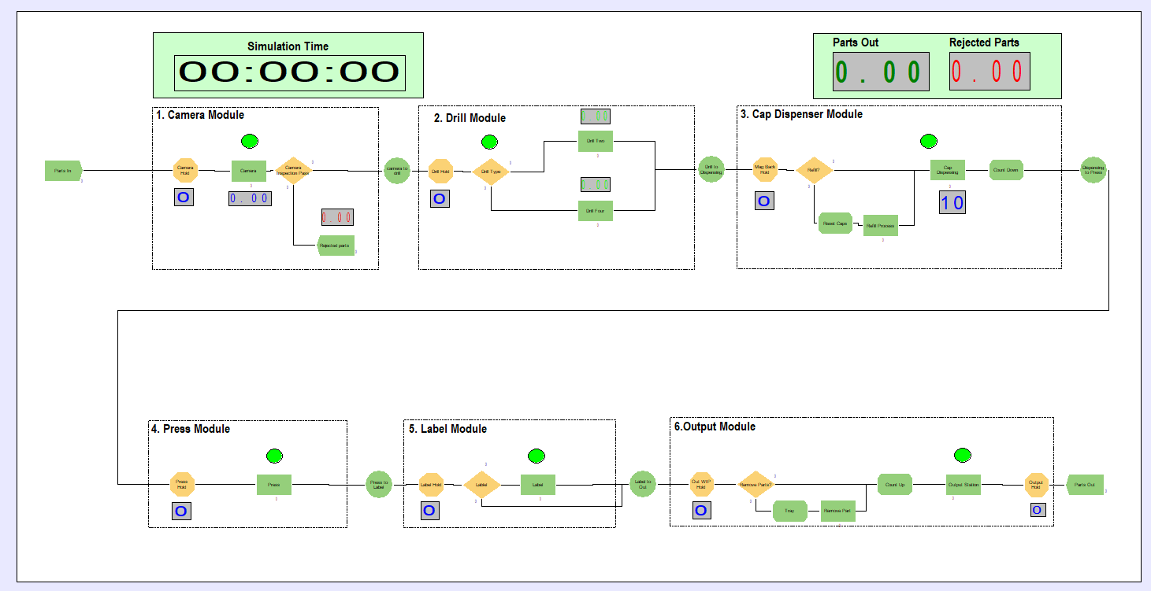
Figure 1 - Completed FESTO current-state model in Arena

Model Verification & Validation
Verification focused on whether the Arena model had been built correctly. Each process time was checked against the case-study data, followed by the routing percentages, fixed movement times, refill frequency and output-removal frequency. The model was then run while the animation and counters were observed. Entities followed the expected sequence and the model completed without deadlocks or unsupported external-file dependencies. This type of step-by-step logic checking is consistent with established simulation verification practice, where entity sequence, resource behaviour and event triggering are checked before results are used for decisions (Law, 2015).
Table 2 - Verification of key case-study requirements
Case-study requirement | Arena implementation | Verification evidence
60% two-hole / 40% four-hole mix | Decide module routes entities to two drilling branches | Simulation entries ≈60.2% / 39.8%
Variable process times | TRIA(min, most-likely, max) used for stated variable times | Module inputs checked against supplied data
Refill after every 10 components | Counter/hold logic triggers refill activity | ≈129.5 refills for ≈1,171 dispenser completions
Output cleared every 4 assemblies | Counter/hold logic triggers removal activity | ≈290.4 removals for ≈1,165 output entries
One operative for refill and output emptying | Shared production-operative resource | Operative utilisation reported as 98.23%
Label printing required | Label Process using Resource_Printer_1, TRIA(6.2,7,8.7) s | Module input checked against supplied case-study data

The output provides a useful check on the routing and periodic logic. Across the ten replications, the two drilling branches received approximately 60.2% and 39.8% of drilling entries, close to the required 60:40 product mix. The cap refill and output-removal counts were also consistent with their intended triggers.
Validation is more limited because the assignment provides a case study rather than measured output from a live production line. The model can therefore be validated against the supplied process description, but there is no independent physical throughput data for a full statistical comparison. This is an important limitation. The results should be treated as the expected performance of the stated FESTO scenario rather than a fully calibrated digital twin. If the model were used for an industrial investment decision, measured cycle times, downtime, operator walking time, failure data and actual product mix would need to be collected and compared with the model output.

Simulation Results & Analysis
The model produced an average of 1,164.8 completed assemblies during each eight-hour replication, equivalent to approximately 145.6 assemblies per hour. Average input was 1,599.8 entities, or approximately 200 parts per hour. The difference of about 435 entities per replication is not scrap; it is work-in-process remaining in the system when the run ends. This shows that the line cannot keep pace with the imposed arrival rate. Arena reports the base time unit as Days, with each model day representing the eight-hour production period. Time-based outputs have therefore been converted using 480 minutes per model day.
Table 3 - Main current-state Arena results
Measure | Average result | Interpretation
Completed output | 1,164.8 per 8 h | ≈145.6 assemblies/hour
Input | 1,599.8 per 8 h | Input exceeds system output
Drill utilisation | 99.961% | Effectively fully loaded
Production operative utilisation | 98.230% | Very little labour capacity margin
Press utilisation | 49.948% | Downstream spare capacity
Camera utilisation | 14.444% | Not a system constraint
Dispenser utilisation | 12.475% | Not a system constraint
Drill Hold average queue | ≈198 entities | Largest WIP accumulation
Drill Hold average wait | ≈59.4 min | Dominant queue delay
Average total time in system | ≈67.4 min | Lead time dominated by waiting

The drilling process is the main bottleneck in the model. Drill utilisation reached 99.961%, while an average of approximately 198 parts accumulated in the Drill Hold queue. The average Drill Hold waiting time was 0.123731 model days, equivalent to approximately 59.4 minutes on the eight-hour model day. These results show that components arrive at the drill faster than they can be processed, restricting flow through the rest of the system. This is consistent with the input data: the expected mix-weighted drilling demand is approximately 24 seconds per component, while the mean inter-arrival time is 18 seconds. A single drill therefore has a nominal capacity of about 150 parts per hour against an arrival rate of about 200 parts per hour.
The size of the drill queue is more important than utilisation alone. A resource can show high utilisation and still be acceptable if it processes demand without creating excessive waiting. In this case, high utilisation is accompanied by the largest queue and longest waiting time, so the evidence points to a genuine throughput constraint. This agrees with recent DES research where bottlenecks are identified using a combination of resource loading and system response rather than one KPI in isolation (Lidberg & Amos, 2024; Javadi, et al., 2023).
The production operative also reached 98.23% utilisation. At first sight this could suggest that labour is an equally important bottleneck. However, the queue pattern does not support that conclusion. The main WIP accumulation occurs before drilling, while the downstream Output Hold queue remains small. The operative is therefore a capacity and resilience risk, but not the first constraint controlling system throughput. Adding another operator before addressing drilling could increase cost while leaving the main queue unchanged. This distinction is important because improvement activity should target the constraint that limits overall flow, not simply the resource with the next-highest utilisation.
The press operated at approximately 49.95% utilisation, while the camera and dispenser were much lower at 14.44% and 12.48%. These resources have available capacity under the current scenario. Increasing their speed would therefore have little effect on completed output because parts are already being restricted upstream. Al-zqebah, Guertler and Clemon (2025) show that manufacturing constraints can move depending on the balance between equipment and labour. The same principle applies here: if drilling capacity is improved, the production operative or another downstream stage may become the next constraint and should be reassessed rather than assumed.
Average entity time in the system was 0.140479 model days, equivalent to approximately 67.4 minutes. Recorded waiting time averaged 0.136824 model days, or approximately 65.7 minutes. This means that almost all elapsed time is waiting rather than processing. The result gives a clear link between the simulation and lean analysis because the main performance loss is queueing and excess WIP rather than a small difference in one automated process cycle.

Waste & Value Analysis
Lean analysis considers whether an activity changes the product in a way that the customer requires. In this process, drilling, cap dispensing and hydraulic pressing clearly transform the assembly. Label printing is also treated as value adding because it forms part of the required finished product identification. Optical inspection is necessary for quality control but does not transform the product, while transport, queueing, refill and output removal are non-value-adding or necessary support activities.
For value analysis, the case-study process contains approximately 46.7 seconds of expected direct transformation time per component: 24.0 seconds for mix-weighted drilling, 3.07 seconds for cap dispensing, 12.3 seconds for pressing and 7.3 seconds for label printing. This is small compared with the overall time that components spend within the system, showing that the main opportunity is the reduction of waiting and work-in-process rather than small reductions in individual process times.
The much larger loss is waiting. Arena reports approximately 65.7 minutes of average waiting within an average total system time of approximately 67.4 minutes. The Drill Hold queue is responsible for the largest individual delay, averaging approximately 59.4 minutes. Vilela et al. (2022) show how DES can be used alongside lean production to quantify waste rather than identifying it only through observation. The FESTO model gives the same practical advantage: the simulation measures the size and time impact of the queue across repeated runs.
Arena's value-added and non-value-added categories should be interpreted carefully because the module allocation settings do not consistently match the customer-value classification used in this report. For that reason, the value analysis above is calculated directly from the same process-time distributions used in the model rather than relying on Arena's aggregate value-added statistic. This provides a consistent basis for comparing processing activity with the much larger amount of waiting identified by the simulation.

Lean Improvement Opportunities
The first improvement should focus on drilling. The current mixed drilling demand is approximately 24 seconds per component, while the most-likely arrival interval is 18 seconds. The model therefore contains a structural capacity gap. Reducing a few seconds from another station would not solve this problem. The practical options are to reduce drilling cycle time, provide parallel drilling capacity or reduce the demand placed on the existing drill.
Cycle-time reduction should be investigated before automatically purchasing another machine. The four-hole variant is the main opportunity because it represents 40% of production but has a most-likely drilling time of 33 seconds compared with 18 seconds for the two-hole part. The drilling cycle should be broken down into loading, positioning, drilling and unloading to identify where time can be removed. Fixture improvements, tool-path optimisation, simultaneous drilling or changes to the drilling method could then be evaluated. If these changes cannot bring effective capacity close to the arrival rate, a second drilling resource would be justified for simulation as a future-state scenario.
The second opportunity is the shared production operative. Although labour is not the primary throughput constraint, 98.23% utilisation leaves very little capacity for normal variation. Increasing the dispenser magazine capacity would reduce the frequency of the long refill activity. Similarly, changing the output container or removal method could reduce the frequency or duration of output clearance. These changes would release operator capacity without immediately adding another person. The benefit should be tested after drilling is improved because the labour constraint may become more significant once additional parts reach the downstream process.
Transport is a third improvement area. The fixed movement times total 39.2 seconds for every completed assembly. Layout changes, shorter transfer distances or combining adjacent operations could reduce this non-value-adding time. Unlike drilling improvements, this may not increase maximum throughput while the drill remains constrained, but it would reduce lead time and improve flow. Recent work combining lean methods with simulation has shown the value of testing process and layout changes before implementation, particularly where reducing one form of waste can move the constraint elsewhere (Harish, et al., 2024; Velazques-Serrano, et al., 2025).
The improvement sequence is therefore important. Drilling should be addressed first because it controls throughput. Manual support and transport should then be reviewed to improve resilience and lead time. After each major change, the model should be rerun because the bottleneck may move. This prevents local optimisation, where one station is improved without increasing overall system performance.

Conclusion
A current-state DES model of the FESTO I4.0 CP Laboratory was developed in Arena using the supplied process sequence, triangular process times, 60:40 drilling mix, movement times and shared production operative. Ten eight-hour replications produced an average output of 1,164.8 completed assemblies, equivalent to approximately 145.6 assemblies per hour.
The simulation identified drilling as the main system bottleneck. Drill utilisation reached 99.961%, the average Drill Hold queue was approximately 198 parts and the average wait before drilling was approximately 59.4 minutes. Average total time in system was approximately 67.4 minutes, of which around 65.7 minutes was recorded as waiting. The production operative also showed high utilisation at 98.23%, but the queue evidence indicates that labour is a secondary capacity risk rather than the current throughput constraint.
The recommended priority is to reduce drilling demand or increase drilling capacity, with particular attention to the four-hole variant. Dispenser refill, output handling and transport should then be improved to release labour capacity and reduce non-value-adding time. The model should be rerun after each major change because improving the drill may move the constraint elsewhere. Overall, the simulation provides a clear evidence base for deciding where lean improvement effort should be focused.

References
ACMA6002 Discrete Event Simulation – FESTO CP Laboratory. Module case-study material. (2026) University of Wales Trinity Saint David.
Al-zqebah, R., Guertler, M. & Clemon, L., 2025. Powder bed fusion factory productivity increases using discrete event simulation and genetic algorithm. Production Engineering, Volume 19, pp. 29-45.
Harish, D. et al., 2024. Productivity improvement by application of simulation and lean approaches in an multimodel assembly line. Proceedings of the Institution of Mechanical Engineers, Volume 238, pp. 6-7.
Javadi, S., Sadjadi, S. & Makui, A., 2023. Identification and fixing bottlenecks of a food manufacturing system using a simulation approach. Scientific Reports, 13(11786 ).
Law, A., 2015. Simulation Modeling and Analysis. 5th ed. New York: McGraw-Hill Education.
Lidberg, S. & Amos, C., 2024. A System Architecture for Continuous Manufacturing Decision Support Using Knowledge Generated from Multi-Level Simulation-Based Optimization. s.l., Swedish Production Symposium.
Velazques-Serrano, J. et al., 2025. Enhancing production efficiency through value stream mapping and simulation in the automotive industry. International Journal of Industrial Engineering and Management, 16(3), pp. 239-252.
Vilela, F. et al., 2022. Discrete event simulation and lean production: quantification of waste in a pharmaceutical industry. Journal of Lean Systems, 7(2).

