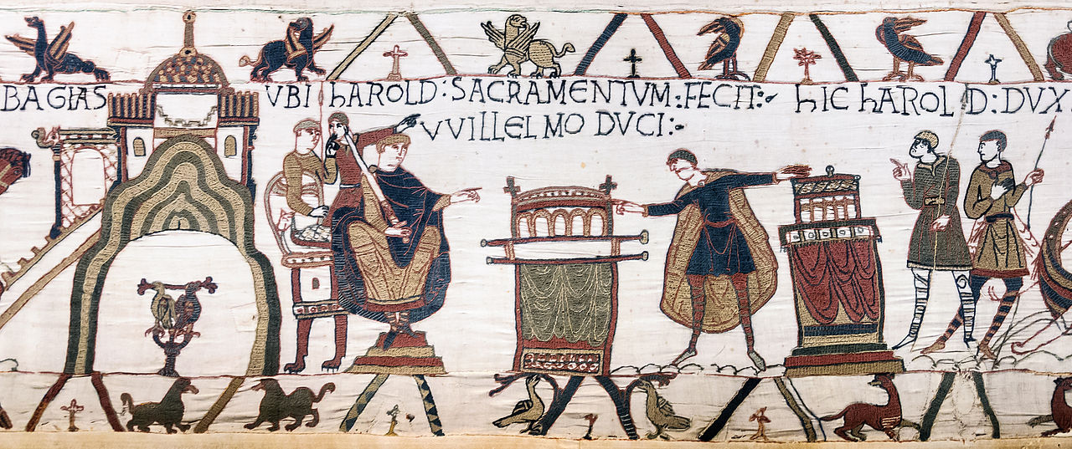
Commentary on a Scene from the Bayeux Tapestry, ‘Harold swears an oath to William’
One of the most iconic of Norman artworks, the Bayeux Tapestry is—despite what the name suggests—not actually a tapestry at all, but an embroidery that depicts the events of the Norman Conquest and the preceding years from the perspective of the Normans and is accordingly in keeping with the Norman’s party line of justifying the conquest through the notorious oath that then Earl Harold took to concede the throne to the Norman ruler, Duke William, later King of England. It is this oath that is the focus of the scene above, the oath itself being taken in Rouen upon holy relics before Duke William. This commentary will examine the history of the Tapestry and some of the wider debate that it features in.
The Bayeux Tapestry has a long history, much of which is unknown. Historians have suggested that the most likely place the Tapestry was made is in Canterbury, Kent, c. 1070s, having been commissioned by Bishop Odo of Bayeux, to celebrate his half-brother, William the Conqueror’s, victory at the Battle of Hastings in 1066, although the Tapestry itself does give credibility to a claim for Normandy as the place of manufacture, specifically in the grammatical forms of words employed; ‘The use of the word “Bagias”, a Norman dialect term for Bayeux has been used as evidence […].’ There are also the use of the term ‘Wilgelm’—also a Norman dialectic—to refer to William himself. It is known that William appointed Odo to the office of Earl of Kent and that he was already Bishop of Bayeux, the cathedral of which was completed at the same time, which leaves it exceptionally likely that the Tapestry was as much to celebrate the completion of Odo’s own cathedral as to commemorate the Norman Conquest. The Tapestry itself, however, does not enter documentation prior to 1476 when an inventory of Bayeux Cathedral, ‘[…] noted that a “very long and very narrow strip of linen, embroidered with figures and inscriptions representing the Conquest of England, which is hung round the nave of the church on the Feast of relics and throughout the Octave,”’ was part of the collection, although there is a reference by the Bishop of Dol from 1100 that Adela, daughter of William the Conqueror, owned a tapestry which may or may not be the same one. During the French Revolution the Tapestry nearly ended up seeing service as a cannon’s rain cover, but was saved by Lambert Leonard-Leforestier, a member of the city council. Throughout the course of World War 2 it occupied an air raid shelter, before receiving its own exhibition centre in 1949. In the Victorian Era, Elizabeth Wardle of the Leek Embroidery Society, Staffordshire, spearheaded the Society’s efforts to make a replica and visited Bayeux throughout 1885 as part of her research. The Reconstruction is currently on display in Reading Museum.
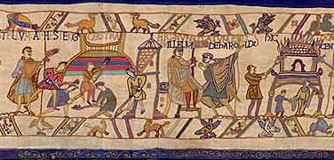
Many details documented in the Tapestry are corroborated by other accounts from the era, such as William of Poitiers’ account in his history of Duke William’s life, the Gesta Willelmi, where he wrote, ‘At a gathering at Bonneville, Harold took an oath of faithfulness to him according to the sacred rite of the Christians. And, as highly respected men of the utmost sincerity have related, who were witnesses to the event, in the last item in the oath that was drawn up, he pronounced, clearly and of his own free will, these words: that he would be the agent of duke William at the court of king Edward for as long as the king lived […]’ The number of witnesses to these events makes it unlikely that the account of the oath is a Norman conspiracy; it seems likely William was simply deceived and trusted in a false oath Harold never meant to keep. Given the intended audience and purpose of the Tapestry to advertise King William as supreme ruler of the conquered Kingdom of England, it is to be expected that the events may be somewhat bleached from reality in the finished Tapestry, but they have not been so completely; ‘Beachhead—Scene 3’ of the Reading Museum reconstruction of the Bayeux Tapestry depicts a woman and child fleeing a burning building, while the Normans construct their castle at Hastings. At a previous point in the Tapestry, Harold is depicted saving Norman knights from quicksand as they approached Dol.
Figure 1 A section from Beachhead--Scene 3, depicting a castle being built (left) and a woman and child fleeing a burning building (right). (Britain’s Bayeux Tapestry, Beachhead—Scene 3, http://www.bayeuxtapestry.org.uk/bayeux22.htm [Accessed: 16/11/18])
Another point of interest in the Tapestry is that the lower border depicts after the lifting of the siege of Rivallon, ‘[…] two conjoined fish [which] may depict Pisces and therefore indicate the season of the year is early spring.’ Earlier, during Harold’s captivity at the hands of Count Guy of Brittany, farmers are depicted sowing their crops and protecting them from birds, events that took place in late spring. If accurate, Harold could have been imprisoned for the better part of a year. Further evidence of the passing of time is that in the oath scene above, Harold and his companions are shown to be clean shaven, a characteristic common to Normans, not the traditionally long-haired and moustached Anglo-Saxons.
One of the most recognizable artefacts of Norman England, the Bayeux Tapestry is still—and unless more documentation becomes available, will continue to be—a holder of secrets from its own time and personal history. A likely place of manufacture for it is Kent and the most probable patron for it would be Bishop Odo, Earl of Kent, the regional lord of the people who embroidered it and who placed himself in a prominent position on the Tapestry and then hanged within the Cathedral he presided over as Bishop. This mixed heritage of a Norman lord commissioning a work that commemorated his own half-brother’s conquest of England, reserved in English embroidery have combined to form a piece that is both propagandist in how it presents events and yet is not dishonest in some of the character of Earl Harold and of the brutality of the Norman Conquest. Tantalizing glimpses are offered into one of England’s most renowned historical fulcra, albeit from a biased perspective which historians and laymen alike will be fascinated by for ages to come.

Word Count: 1,145

Bibliography
(n.d.). Retrieved 11 16, 2018, from The Bayeux Tapestry: A Guide: http://www.bayeux-tapestry.org.uk/
Beachhead--Scene 3. (n.d.). Retrieved 11 16, 2018, from Britain's Bayeux Tapestry: http://www.bayeuxtapestry.org.uk/bayeux22.htm
History of the Tapestry. (n.d.). Retrieved 11 16, 2018, from Britain's Bayeux Tapestry: http://www.bayeuxtapestry.org.uk/BayeuxInfo.htm
Kempen, A. F. (2009). The Mercian Connection, Harold Godwineson's Ambitions, Diplomacy and Channel-crossing, 1056-1066. The Historical Association.
Poitiers, W. o. (n.d.). Gesta Willelmi. as provided in source reader.
The Anglo-Saxon Chronicle. (1823, 1993 reprint). (R. J. Ingram, Trans.) London: Studio Editions Ltd.
The Bayeux Tapestry. (n.d.). Retrieved 11 16, 2018, from BBC A History of the World: http://www.bbc.co.uk/blogs/ahistoryoftheworld/2010/08/the-bayeux-tapestry.shtml
The Bayeux Tapestry. (n.d.). Retrieved 11 16, 2018, from The History Learning Site: https://www.historylearningsite.co.uk/medieval-england/the-bayeux-tapestry/
The Bayeux Tapestry. (n.d.). Retrieved 11 16, 2018, from Bayeux Museum: http://www.bayeuxmuseum.com/en/la_tapisserie_de_bayeux_en.html
THE BAYEUX TAPESTRY. (1833, 3 9). The Saturday magazine, 92. Retrieved 11 15, 18
The Oath--Scene 1. (n.d.). Retrieved 11 16, 18, from Britain's Bayeux Tapestry: http://www.bayeuxtapestry.org.uk/Bayeux11.htm

The Bayeux Tapestry: A Guide, http://www.bayeux-tapestry.org.uk/ (Accessed: 16/11/18)
The Bayeux Tapestry: A Guide, http://www.bayeux-tapestry.org.uk/ (Accessed: 16/11/18)
The History Learning Site, The Bayeux Tapestry, https://www.historylearningsite.co.uk/medieval-england/the-bayeux-tapestry/ (Accessed: 16/11/18) Britain’s Bayeux Tapestry, History of the Tapestry, http://www.bayeuxtapestry.org.uk/BayeuxInfo.htm (Accessed: 16/11/2018)
Britain’s Bayeux Tapestry, History of the Tapestry, http://www.bayeuxtapestry.org.uk/BayeuxInfo.htm (Accessed: 16/11/2018)
William of Poitiers, Gesta Willelmi, as provided in source reader.
Ad F. J. Van Kempen, ‘The Mercian Connection, Harold Godwineson’s Ambitions, Diplomacy and Channel-crossing, 1056–1066’, in The Historical Association (Tilburg, The Netherlands: 2009) p. 13
The Bayeux Tapestry: A Guide, http://www.bayeux-tapestry.org.uk/ (Accessed: 16/11/18)

