

Feasibility plan for an International Meeting

Student Name: Adina Irimia
Student ID: 2125046
Jemma Smith


Introduction

- The hospitality industry is a leading metropolis of traditions and innovations, evolving over time to meet consumer needs (Dutt, Harvey & Shaw, 2023).
- In today's rapidly changing landscape, technology and innovation are imperative for enhancing guest
experience and maintaining competitiveness (Ekhsan et al., 2020).
- The proposed event aims to bring together industry professionals, vendors, and thought leaders to drive development and transformation within the sector, with a focus on evaluating viability through market dynamics, operational factors, and financial aspects.
- This presentation will critically analyze various factors to determine the feasibility and strategic pre−
planning research necessary for the successful execution of the proposed event.


Market Factors
- The event targets hospitality industry professionals and stakeholders, reflecting the sector's need for digital transformation (Jan et al., 2023).
- Extensive market research identifies a niche audience interested in
the intersection of technology and hospitality, providing a platform for engagement with key industry players (Le Tan et al., 2021).


Operational Factors
- Venue selection, logistical management, and
staffing
are
crucial operational
considerations (Nuseir, 2022).
- Competent event staff are essential for ensuring a seamless experience, while amenities like catering and seating arrangements contribute to guest
satisfaction (Pandya & Al Janahi, 2021).



Financial Factors
- Financial analysis includes cost and income projections, covering expenses such as venue rental, equipment purchase, and marketing (Sever & Malbašić, 2019).
- Revenue−generating strategies and cost management are vital for ensuring a positive net income and event sustainability (Sudibjo & Prameswari, 2021).


Understanding of the Topic
- Feasibility study indicates thorough understanding of event planning functions and pre−planning considerations for organizing a Technology and Innovation event in the hospitality industry (Wijnen−Meijer et al., 2022).
- Theme of Technology and Innovation underscores the industry's necessity for ongoing innovation to stay competitive and meet changing customer expectations.
- Event planning intricacies such as site selection, staffing needs, and resource allocation are taken into account.
- Strategic planning and risk management are recognized as crucial for overcoming challenges and maximizing growth opportunities (Wilson Dutt, 2022).
- Knowledge of industry trends and target audience needs informs the creation of an event idea tailored to meet these demands.
The financial analysis of the Technology and Innovation event within the hospitality sector has been done in a detailed and accurate way including cost and income projection schemes. Regarding financial factors, they include venue rental, purchase of equipment, staff costs, marketing expenses, and miscellaneous expenses (Sever and Malbašić, 2019). The accounting work has been of high quality so the conclusions should be correct and complete. In addition to the planning, the revenue-generating
strategies instinct to the optimization of income streams and the sustainability of the event design in the next stage. Promoting these income sources and controlling costs through cost management well
projects that the event will generate a positive net income (Sudibjo and Prameswari, 2021).
Furthermore, careful financial planning makes sure that the event does not end up with a loss, thus preserving the financial well−being of the organizers and other parties that are directly or indirectly involved in the project. Through sound financial management and strategic revenue optimization, the proposed event is likely to be successful and will create value for the attendees and sponsors.



Analysis
- Market demand, operational logistics, and financial performance are analyzed to ensure a successful event (Dutt, Harvey & Shaw, 2023).
- Cash flow forecasting and revenue optimization strategies are essential for managing financial risks (Ekhsan et al., 2020).

Practical Application and Deployment
- Theoretical concepts are translated into practical scenarios through effective event management and stakeholder engagement (Jan et al., 2023).
- Collaboration with vendors and sponsors leverages resources and expertise to enhance event impact and participant engagement.


- Demonstrating initiative, effective communication, and attention to detail is essential for professional practice (Sever & Malbašić, 2019).
- Proper referencing reflects academic
integrity and competency in scholarly
conventions.
Skills for ProfessionaI Practice

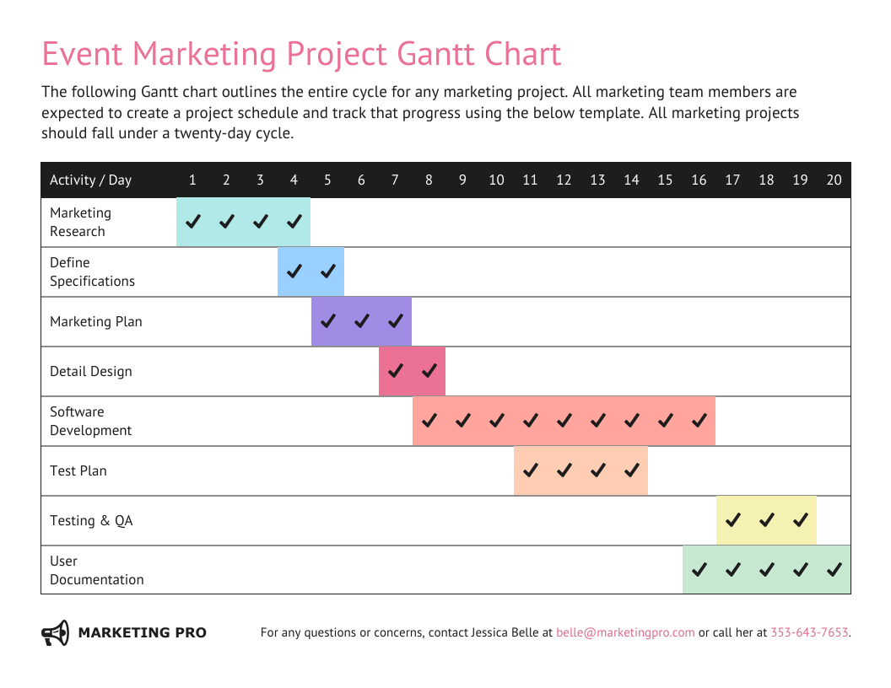


Conclusion
- The feasibility study underscores the complexity of organizing a Technology and Innovation event within
the hospitality sector.
- Market opportunities, operational adequacy, and financial viability suggest a promising outlook for the
event.
- Professionalism, clarity, and attention to detail are pivotal for successful event execution and industry influence.
Conclusion
The feasibility study of organizing a Technology and Innovation event within the hospitality sector is very complex and it involves market, operations, and financial examination. Based on a thorough research study and analysis, we have established the feasibility of the event, specifying the key opportunities that will help it to succeed and the challenges to be overcome. By targeting the market of professional and key players in the hotel industry and offering them new ideas and solutions, we will receive the reaction that we expect at the event. From venue selection to staffing and resource allocation, all operational aspects are firm and adequate to guarantee a seamless and fun−filled experience for the participants.
The financial projections are good as the event is economically feasible with the strategies related to revenue generation in place to cover costs and make a profit as a result. The feasibility study highlights that to be able to implement theoretical knowledge into practice we should have a good knowledge of core event planning functions and pre−planning considerations. Our professionalism, clarity of communication, and close attention to detail are what we trust will make us able to conduct the event that was proposed. Perhaps, the feasibility study is the starting point of the event planning process, which will ultimately lead to a successful and widely influential Technology and Innovation event in the hospitality industry.

References

Dutt, C. S., Harvey, W. S., and Shaw, G. (2023). Exploring the relevance of Social Exchange Theory in the Middle East: A case study of tourism in Dubai, UAE. International Journal of Tourism Research, 25(2), 198 −220.
Ekhsan, M., Badrianto, Y., Fahlevi, M., and Rabiah, A. S. (2020, February). Analysis of the effect of learning orientation, role of leaders and competence to employee performance front office the Sultan Hotel Jakarta. In 4th International Conference on Management, Econ omics and Business (ICMEB 2019) (pp. 239 −244). Atlantis Press.
Jan, A., Khan, M., Ajmal, M. M., and Patwary, A. K. (2023). From traditional advertising to digital marketing: exploring electronic word of mouth
through a theoretical lens in the hospitality and tourism industry. Global Knowledge, Memory and Communication.
Le Tan, T., Anh, P. V. T., Nhu, P. N. P., Thu, T. T. A., Tuan, V. D. A.,and Hung, H. N. (2021). Research Factors Affecting the Working Motivation of Employees at Accommodation Facilities in Danang. International Journal of Marketing & Human Resource Research, 2(4), 236 −264.
Nuseir, M. T. (2022). Assessing the impact of brand equity and demographic characteristics on brand loyalty: The mediating role pla yed by customer experience in United Arab Emirates’ Hotel Industry. Journal of Hospitality & Tourism Research, 46(5), 905 −922.
Pandya, B., and Al Janahi, M. M. (2021). The intervention of artificial intelligence in the recruitment function in UAE’s hospitality industry. Transnational Marketing Journal, 9(1), 89 −105.
Sever, S., and Malbašić, I. (2019, November). Managing employee motivation with the job characteristics model. In DIEM: Dubrovnik International
Economic Meeting (Vol. 4, No. 1, pp. 55 −63). Sveučilište u Dubrovniku.
Sudibjo, N., and Prameswari, R. K. (2021). The effects of knowledge sharing and person −organization fit on the relationship between transformational leadership on innovative work behavior. Heliyon, 7(6).
Wijnen−Meijer, M., Brandhuber, T., Schneider, A., and Berberat, P. O. (2022). Implementing Kolb s experiential learning cycle by linking real experience, case −based discussion and simulation. Journal of medical education and curricular development, 9, 23821205221091511.
Wilson, M., and Dutt, C. S. (2022). Expatriate adjustment in hotels in Dubai, UAE. Journal of Human Resources in Hospitality & Tourism, 21(3) , 463−
481.

References
Dutt, C. S., Harvey, W. S., and Shaw, G. (2023). Exploring the relevance of Social Exchange Theory in the Middle East: A case study of tourism in Dubai, UAE. International Journal of Tourism Research, 25(2), 198−220.
Ekhsan, M., Badrianto, Y., Fahlevi, M., and Rabiah, A. S. (2020, February). Analysis of the effect of learning orientation, role of leaders and competence to employee performance front office of the Sultan Hotel Jakarta. In 4th International Conference on Management, Economics and Business (ICMEB 2019) (pp. 239−244). Atlantis Press.
Jan, A., Khan, M., Ajmal, M. M., and Patwary, A. K. (2023). From traditional advertising to digital
marketing: exploring electronic word of mouth through a theoretical lens in the hospitality and tourism industry. Global Knowledge, Memory and Communication.
Le Tan, T., Anh, P. V. T., Nhu, P. N. P., Thu, T. T. A., Tuan, V. D. A., and Hung, H. N. (2021). Research Factors Affecting the Working Motivation of Employees at Accommodation Facilities in Danang. International Journal of Marketing & Human Resource Research, 2(4), 236−264.
Nuseir, M. T. (2022). Assessing the impact of brand equity and demographic characteristics on brand loyalty: The mediating role played by customer experience in United Arab Emirates Hotel Industry. Journal of Hospitality & Tourism Research, 46(5), 905−922.
Pandya, B., and Al Janahi, M. M. (2021). The intervention of artificial intelligence in the recruitment function in UAE’s hospitality industry. Transnational Marketing Journal, 9(1), 89−105.
Sever, S., and Malbašić, I. (2019, November). Managing employee motivation with the job characteristics model. In DIEM: Dubrovnik International Economic Meeting (Vol. 4, No. 1, pp. 55−63). Sveučilište u Dubrovniku.

Sudibjo, N., and Prameswari, R. K. (2021). The effects of knowledge sharing and person-organization fit on the relationship between transformational leadership on innovative work behavior. Heliyon, 7(6).
Wijnen−Meijer, M., Brandhuber, T., Schneider, A., and Berberat, P. O. (2022). Implementing Kolb's experiential learning cycle by linking real experience, case−based discussion and simulation. Journal of medical education and curricular development, 9, 23821205221091511.
Wilson, M., and Dutt, C. S. (2022). Expatriate adjustment in hotels in Dubai, UAE. Journal of Human Resources in Hospitality & Tourism, 21(3), 463−481.

