Student name : Cosmina–Andreea Babuta
Student number: 1907090
Programme: Certificate of Higher Education in Skills for the Workplace
Assignment title: Academic and Employability Skills
Lecturer name : Anita Nan
Module name : Academic and Employability Skills
Module code : BMSW4001

Contents
Introduction 3
Content 4
Referencing and paraphrasing skills 5
Note taking and summarising 5
Effective communication 5
Problem solving 6
Resource and time management 7
Analytical and critical thinking 8
Conclusion 10
Reference list 11
Appendix 12

Introduction

The aim of this academic report is to reflect on this academic year learning and the impact in my student and employee experience.
The content of this module was shared between twenty weeks of in class and self learning and online library reading guided by my lecturer.
Learning was accompanied by constructive feedback given by my lecturer as part of my academic progression.
,, Academic and employability skills’’ is a module that was helping me to improve my student and employee skills in order to achieve great performances at University and at work.
The most interesting part about this module is that going through every week of learning I was able to identify my skills but also to recognise the gaps in my abilities and the areas where I can improve.
As a first year student was really helpful to improve referencing and paraphrasing skills, note taking and summarising skills and also being a student while full time working, through this module, helped by the lecturer I was able to identify my skills as an employee and to develop abilities to help improving my performance.

Content
,, Academic and employability skills ‘’ learning module was structured in two terms with ten weeks of in class and self learning each.
During twenty weeks I was alternating between academic skills and employability skills enlargement.
First term was really captivating and all information received during the courses were beneficial for my academic progress and also at work I was able to use skills learned in class like problem solving, effective communication, resource and time management.
To have a better understanding and to see the relation between what I have studied during my first academic year I was using Kolb’s reflective model.

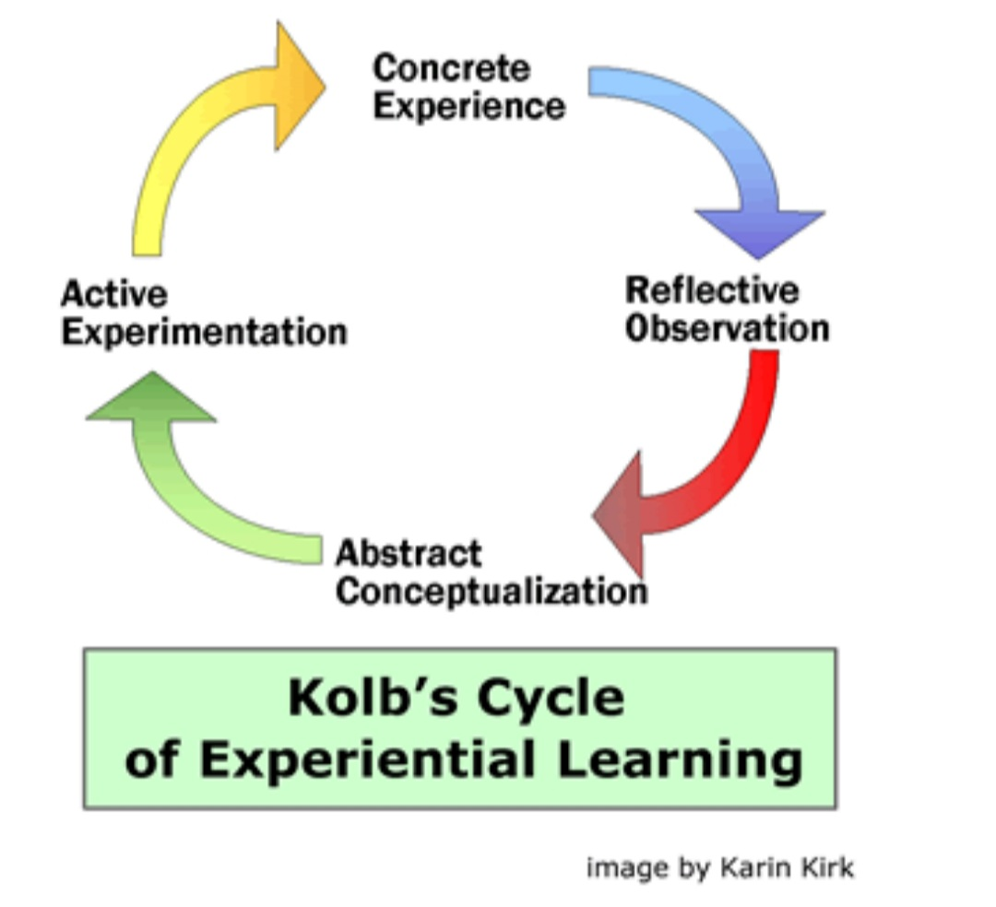

Referencing and paraphrasing skills
During first term I have learned how to paraphrase someone else’s ideas while reading published literature. The most useful were the practice I have done in class through exercises and feedback received from the lecturer.
I have a better understanding about the importance of paraphrasing and that is impossible to assume another person idea like being yours.
Being able to paraphrase a text I was demonstrating that I can acknowledge the meaning of it and express the idea in my own words using synonyms, changing the structure of the phrase, break the information into separate sentences.
Learning this skill was helping me as a student to express ideas and information from different sources.
Developing paraphrasing ability I was able at work to share communication, hold meetings and send reports using my own words to express different communication from my manager to other employees.
Referencing according to Harvard style was something new for me and through practice I am now capable to give the right reference for my assignments.

Note taking and summarising
This skill that I have developed during first term helped me at University to keep useful information in a notebook and go back to them while writing my assignments. Note taking and summarising helped me at work as well because I could easily write information during important meetings and summarise the conversations and cascade information to other employees.
This skill involved active listening and effective communication.

Effective communication
I have realised that I have this skill but I could improve by using different techniques, involving body language, controlling voice tone and also the right personal appearance in accordance to my audience.
I have used this skill at work while in important meetings I was able to talk in front of a large number of people and made myself understood.
First term I have also learned that communication style has to be adapted to my audience and in accordance with what I want to achieve by communicating that. Sending informal emails communication style was different than my daily brief with associates regarding sales and plans, however both informal styles were clear and the shared information was effectively received by audience.
Working in an environment with different types of people with different abilities I have to make sure that I was transmitting the right information and the other person received it and acknowledge. Many times I found myself in situation where I had to adapt my communication style to specific group of people ensuring it was effective and the results will be efficient.

Problem solving
When referring at problem solving skills I am thinking about the ability of dealing with difficult or unexpected situations at work.
Problem solving ability it could be defined as an independent skill, however there are some other skills that could have an impact on this ability.
- Active listening
- Analysis
- Research
- Creativity
- Communication
- Decision making
Within my organisation my role is Assistant Manager and before my senior manager is getting involved I have to use problem solving ability to sort different issues and unplanned situation at work.
To be able to sort the problem I have to find the source of it, to look for different solutions by doing research, communicate with my colleagues if necessary and take a decision by choosing the right solution and review results for efficiency.
This skill is important in all types of careers and will be used for different scenarios according to the environment.

Resource and time management
I had this ability from before joining this course but going through this module and helped by the lecturer I understood the importance of this skill and where I can use it to achieve great performances.
At University is good to have this skill to prepare for exams and have a good balance between my student life and my career. As a student I was given a huge amount of learning resources as in class and self learning through library reading. The part that I have developed was time management and I understood how important it is to plan my activities and follow the organiser to be able to finish my learning in time for exams preparation.
At work I have to use this ability to manage myself and other employees that I am responsible for.
I am working in fashion retail industry and this is a very fast moving business and I have to keep up with all changes and in the same time to manage my resources and time.
During the year there are periods which we use to call ‘’peak time’’ and they are usually summer time and Christmas period when I have to use my resource and time management skills to hold the business at high performance standards.
Resource management skill is used when I have to plan the schedule for my employees according with the activities we have to execute. As a manager I have to take in consideration my employees capacities and their availability also the workload planned.
There are few steps I have to follow to achieve great results with my team:
- Planning and organising
- Manage resources
- Communicate effectively
- Motivate the team
- Review and validate results
By managing the resources and the time is a very efficient cost control technique. As a member of management team within organisation I have to ensure that the employees are delivering tasks in a time frame at the best standards.
A very good tool to keep my work load well organised is keeping a list with the things I have to achieve and organise them by the importance and the urgency of achieving. Following this way will help me to prioritise my goals and achieve great performances step by step.

Analytical and critical thinking
Some people will wrongly believe that is good to have developed only one of them two, but is great to develop both analytical and critical thinking and to learn when you have to use one of them. There will be certain situation when I have to use analytical thinking and some scenarios when my critical thinking will take decision.
I use analytical thinking to break down a series of information, take things by steps and look for a solution from different points of view with the objective to create a solution and to visualise an effect.
On the other side is critical thinking which is more an opinion based way of thinking. Once received the information I make a conclusion regarding my perception of the given information. This process combine the information received with my current knowledge and lead to a personal feeling conclusion.
At work frequently I have to use my analytical thinking when facing complex problems. Using step by step approach, gather information, delegate tasks and imagine a result and the effect of it will help me to sort different complex situations effectively.
Also at work there are situations where I have to use critical thinking method and this will involve observation, analysis, interpretation, reflection, evaluation, problem solving and decision making.
Building those skills will help me to complete tasks effectively in a short time frame.
I have to continue to develop my analytical thinking by consistent practice. Reading books will help me to have a wider vision around facts. Also going to different courses and seminaries will enlarge my knowledge and I will share opinions and information with other people.
Critical thinking skill will be growing along with experience .As many situations I will face will make me able to find solution based on my knowledge.

Conclusion

The purpose of this report is to reflect on my learning in this module.
During first year of learning,, Academic and employability skills ‘’ I have developed different abilities that helped me at University and at work.
Through this module I have discovered that I have some skills but they need to grow and also I have learned new skills that helped me as a student and improve the way I was working as an employee.
The purpose of all those skills is to make my life easier, to achieve great results, to keep up with this century way of learning and working.
I understood that even if I have some abilities they need to be nourished by continue learning and practice.

Reference list

Cottrell, S. (2011) Critical thinking skills: Developing effective analysis and argument (Palgrave study skills). 2nd edn. Basingstoke: Palgrave Macmillan.

McMillan, K. and Weyers, J. (2006) The smarter student: Skills and strategies for success at university, London: Prentice Hall.

OpenLearn. (2016) Skills for study [online] available at http://www.open.edu/openlearn/skills-for-study

Pears, R. and Shields, G. (2010) Cite them right: The essential referencing guide. 8th edn. Basingstoke: Palgrave Macmillan

Van Emden, J. and Becker, L. (2010) Presentation skills for students. 2nd edn. United Kingdom: Palgrave Macmillan

Williams, K. (2014) Getting critical. United Kingdom: Palgrave Macmillan.

Wilson, E A and Bedford, D (2009) Study Skills for Part-time Students Harlow: Pearson

Wilson, J. (2013) Essentials of Business Research: A Guide to Doing Your Research Project, Sage: London

Appendix

In class exercise and feedback received


