Student Name: Aziz Ahmad Tahir Bhatti
Student ID: 2424161
Module Title: Learning in the Digital Era
Module Code: ACCA4025
Table of Contents
1.Task 1 – Academic & Employment Skills 3
1.1 Essential Academic and Career Skills for Success 3
References 4

1.Task 1 – Academic & Employment Skills

1.1 Essential Academic and Career Skills for Success
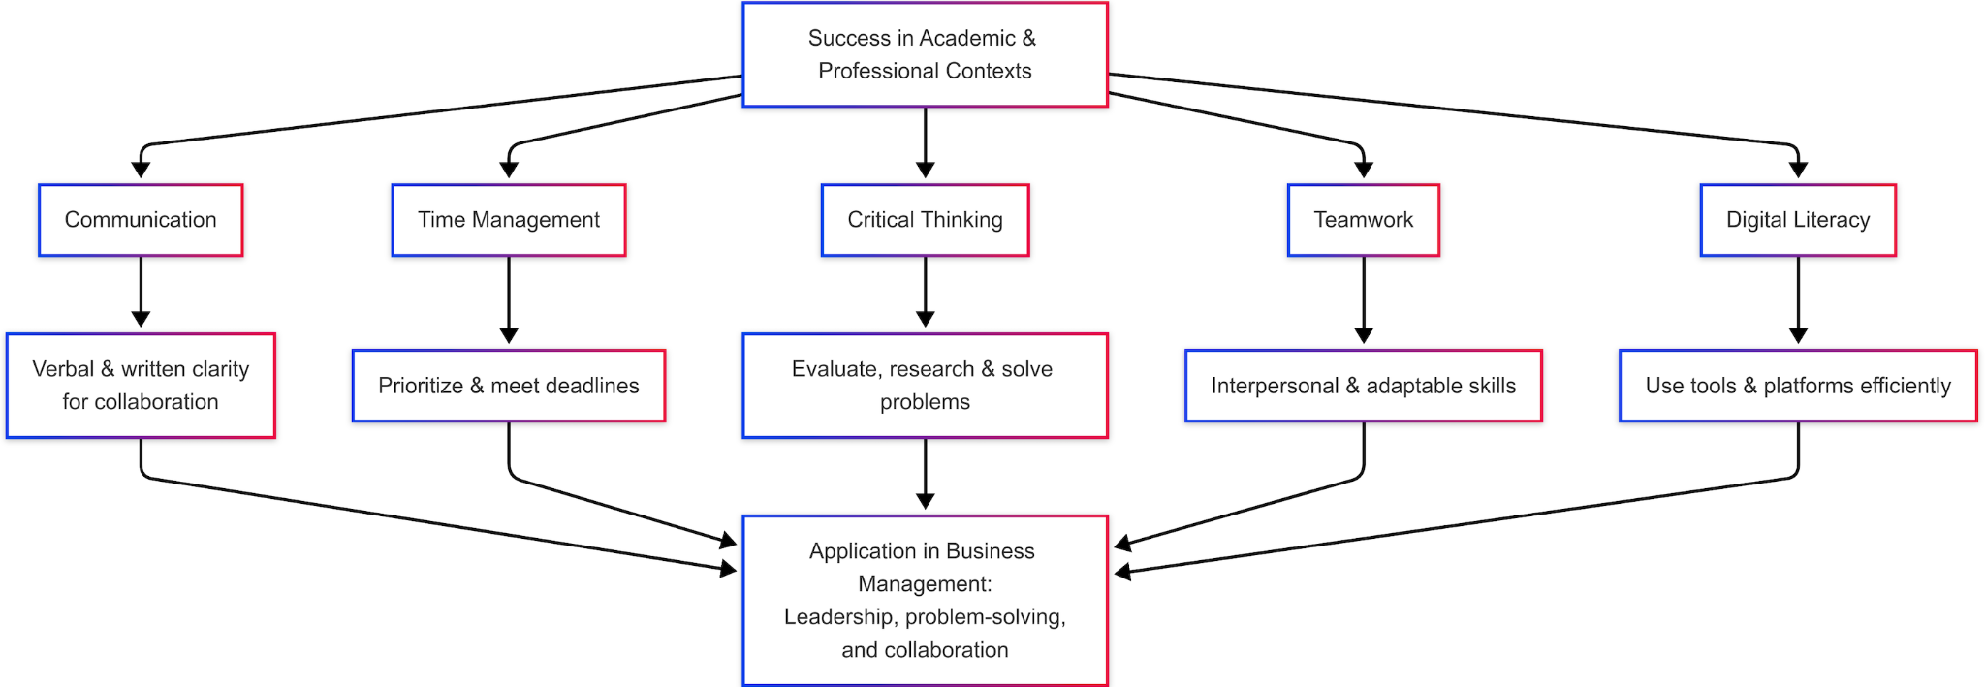
Achieving success in academic as well as professional contexts is heavily dependent on a wide range of essential abilities. The most important include communication, time management and critical thinking. They also require collaborative work and digital literacy.
Communication, both verbal and written, is essential. It facilitates clear exchange of ideas, is a way to reduce misunderstandings and is essential for collaboration within academic and professional settings [1]. It improves efficiency as it helps individuals prioritize assignments and adhere to deadlines, an essential skill when students are juggling multiple projects or professional professionals who are juggling multiple requirements [2].
Critical thinking involves the evaluation of facts and coming to a rational conclusion. It is a key component of research in the academic field, problem-solving and efficient decision-making in ever-changing workplaces [3]. Teamwork, another key skill, promotes collaboration, adaptability, and the development of interpersonal relationships--qualities increasingly demanded by employers in globalized, project-based settings [4].
In the end digital literacy is now essential. It is essential to be able to navigate online platforms, make use of digital tools, and assess internet content is vital to studies in academia, remote work as well as communication in the digital age [5].
They are all interconnected and directly aid my career goals within"Insert Your Chosen Field, e.g., "Business Management.In this field, excellent communication, collaboration as well as technological skills are vital to be a leader and are essential for problem-solving.

References
[1] M. Duck and S. McMahan, Communication in Organizations, London: Routledge, 2020.
[2] S. Covey, The 7 Habits of Highly Effective People, New York: Free Press, 2013.
[3] P. Facione, “Critical thinking: What it is and why it counts,” Insight Assessment, 2020. [Online]. Available: https://www.insightassessment.com
[4] D. W. Johnson and R. T. Johnson, “An educational psychology success story: Social interdependence theory and cooperative learning,” Educational Researcher, vol. 38, no. 5, pp. 365–379, 2009.
[5] The Open University, “Digital Literacy: An introduction,” 2023. [Online]. Available: https://www.open.edu/openlearn/skills-for-study/digital-literacy

