FINAL REPORT

‘APARATUS’

Name: Andrew T. Gardner

No: 2118383

MA pathway: FINE ART

Module: Confirmative Praxis (ADAA7002)

MA Contemporary Dialogues (Fine Art)

University of Wales Trinity Saint David, Swansea, 07th May 2026

WORD COUNT 5209/5810

TABLE OF CONTENTS

Abstract…………………………………………………………………………….…………..3
Introduction…………………………………………………………………………….………3
Painting……………………………………………………………………….………….……..5
Mediation……………………………………………………………………………….……..11
Apparatus………………………………………………………………..……………….……15
Conclusion……………………………………………………………………………….……20
List of illustrations…………………………………………………………………………….22
Bibliography…………………………………………………………………………………..22

ABSTRACT

This praxis research investigates the relationship between painting, mediation, and apparatus, examining how images are produced, transformed, and experienced. Beginning with a focus on controlled, greyscale painting derived from degraded photographic and video sources, the work shifts toward an exploration of mediation as both method and subject. Through the use of analogue video technologies, numerous associations are embedded within the image. The final installation ‘apparatus’ conceals the paintings, presenting them only through a live video feed, positioning the viewer as an active participant. The project simultaneously questions perception, authorship, and reality, proposing that images (objects) are conditional, unstable, and inaccessible.

INTRODUCTION

This report looks into three distinct areas examining how each operates within my work and how their complex relationships can be restructured and reinterpreted. At its core, the project begins with painting as both a technical discipline and a conceptual starting point. My aim is to explore how the painted surface can move beyond representation, becoming an active site of meaning in itself. While my work draws on photographic and video-based imagery, I seek to minimise expressive gesture through controlled, automated techniques, producing surfaces that appear detached and uniform. Working predominantly in greyscale, I aim to emphasise subtle nuance and neutrality, positioning painting as a space where illusion and materiality remain in flux.
Alongside this, the project investigates mediation as a generative process rather than a secondary condition. I aim to produce source imagery using low-resolution analogue video, deliberately incorporating degradation, noise, and visual instability. These sources will then be translated into painting, embedding the qualities of technological decay within the work itself. Through this process, I seek to challenge distinctions between original and copy, exploring how images are constructed, transformed, and reinterpreted across different stages. Mediation, in this sense, becomes both the subject and the method, allowing the work to reflect on its own conditions of production.
The final component of this investigation focuses on the ‘apparatus’ as the primary means through which the work is encountered. Rather than presenting paintings directly, I intend to conceal them and make them accessible only through a mediated system of cameras and monitors. This approach aims to shift emphasis away from the painting as an object and toward the conditions of its visibility. By restricting direct access, I seek to introduce ambiguity around the status of the image, what is seen is partial, unstable, and technologically conditioned. The apparatus will not simply display the work but actively shape its perception, distributing authorship across artist, system, and viewer. Ultimately, this project aims to question how reality, representation, and experience are constructed, proposing a practice in which meaning is not fixed but mediated, deferred, and reconfigured.

1. PAINTING
Everything (Art) has a beginning; mine starts with painting. In 1990, whilst studying at the Academie van Beeldende Kunsten in Rotterdam, I was taught a painting technique which has inspired me for over 30 years. For most of my painting life I have always sought to find a balance between form and content yet I now find myself in a place where the painted surface (and technique) is ostensibly more important than subject matter. One might regard “...paint itself as subject matter”. (Enright, R. and Walsh, M., 2003, pp.20-35), as understood by the artist Veja Celmins known for producing paintings based on natural phenomena amongst other things (Fig. 4). The notion of paint asserting itself as meaning (content) is not anything new. Abstract art, in all its complexity, constantly evades the notion of content (not entirely) and often resists the stability of fixed meaning, unfolding instead as a field of shifting relations where interpretation remains perpetually in motion. “...the pure form once masked by an extraneous content was liberated and could now be directly perceived” (Shapiro, M., 1937, p.77).
Yet my paintings are not trying to be abstract art in a traditional sense - subject matter still exists, originating from partly made up imagery, degraded black and white imagery or primitive video signals. With no obvious signs of self expression, flat brushless surfaces are carefully executed using subtle nuance and purposeful technique. I have drawn parallels with Gerhard Richter in conscientiously rendering the painted surface as flat and formless as possible, “The flowing transitions, the smooth, equalizing surface, clarify the content and make representation credible (an alla prima impasto would be too reminiscent of painting, and would destroy the illusion)”. (Richter, et al., 1995, pp. 35-37). Like Richter, especially during his ‘grey painting or photo painting period’, a distinction is made between what is expected of a painting and what is not expected. Richter also states, in an interview with Robert Storr in 2001:
“I take even more focus out of the painted image, which is already a bit out of focus, and make the picture even smoother. I also subtract the materiality, the surface of the painting, and it becomes something different.”
(Richter, G., Storr, R., 2002, p. 291).

In this statement, Gerhard Richter describes a tension between materiality and illusionistic qualities in the painted surface. He alludes to the idea that minimising visible brushwork allows the image to assert itself as a convincing or authentic representation rather than as an object of painterly construction. Celmins makes a similar claim regarding the painting surface:
“One of the things that irritated me,” she says, “was that in painting I had a flat surface and I was sticking an object, like the lamp, in there. One of the ways I tried to minimize this was by keeping a totally even surface without any brushmarks.”
(Adams, H., 2023, p.100).

Celmins, like Richter, has a very clear objective regarding the painted surface, an aspect as central to the painting’s aesthetic as to its subject matter. In my own paintings I place huge importance on creating a brushless, almost non-human, surface in order to create a unified image which becomes a pure visual field devoid of material and ultimately the artist’s hand. Even the canvas preparation is fundamental to the finished painting - between 6-10 layers of primer, sanded in between to create a smooth surface, without the canvas texture, again reducing the material effects of the surface. The aim, perhaps, is to take a photographic image and reproduce it in oil paint—not just copying it, but somehow altering the reality of the image. “You might say it's copying, but it's really not, it's reimagining this thing in another medium” (Enright, R., and Walsh, M., 2003, pp. 20-35). In this statement, Celmins is concerned with not just copying the photograph but ‘reimagining’ or changing the whole dynamic. Celmins and Richter weren’t the only artists producing greyscale images during the sixties and seventies; the grey image was popular with artists such as Andy Warhol and Chuck Close. What makes Celmins and Richter different is that they both work from photographic sources with intent to change and interrogate the fundamental conditions of representation.
Currently my paintings have gradually shifted toward a largely monochrome, mostly greyscale palette - driven by aesthetic choices, as well as my sources and my painting process. This can mostly be attributed to the use of a grisaille - a grisaille, which has its origins as far back as Giotto’s frescos, is a mostly greyscale understudy which can be use as a tonal under painting before glazing. It is common practise for me to paint this way, every painting I produce evolves from a grisaille, and sometimes I feel the painting is resolved at the grisaille stage. (Fig 1,2)
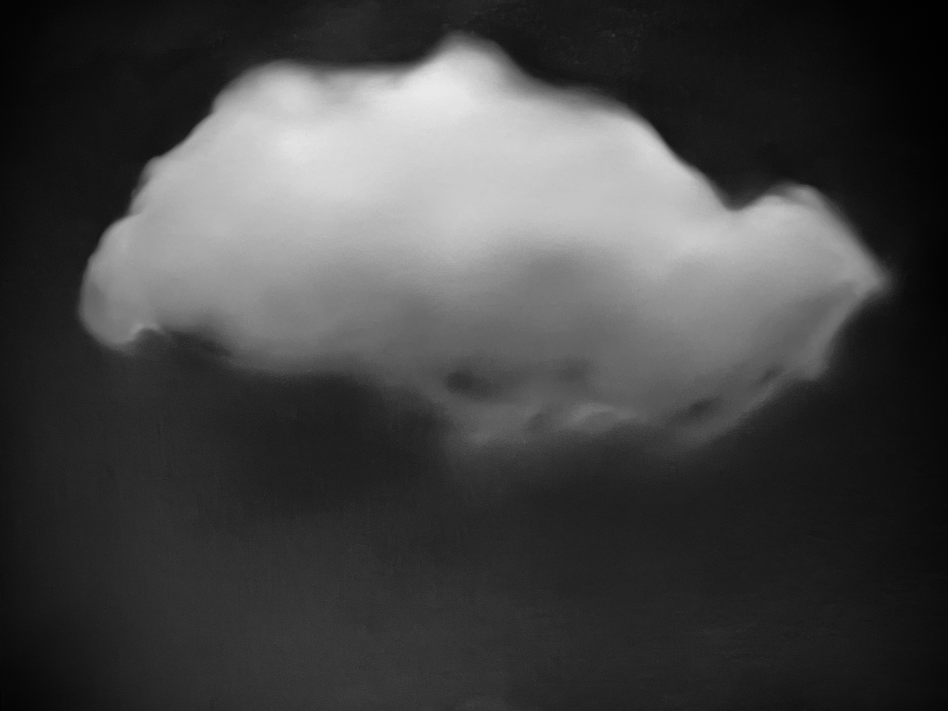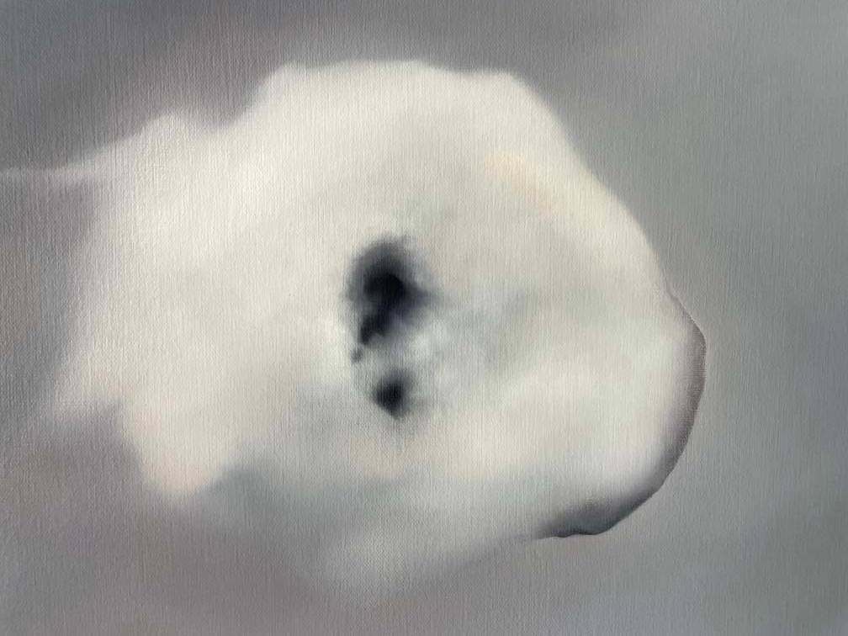

Fig 1: Andrew T. Gardner 2025 The cloud of unknowing, Fig 2: Andrew T. Gardner 2025 The cloud of knowing,
Oil on canvas Oil on canvas

For Veja Celmins the use of greyscale was to do with her sources, “It came naturally out of the photographs, which were black and white, from the pencil, which is graphite, and the paper, which is light, and it had a sombreness I felt was right.” (Enright, R., and Walsh, M., 2003, pp.20-35). Whereas Gerhard Richter took a more reductionist viewpoint, in a letter to Edy de Wilde in 1975, he states,
“Grey. It makes no statement whatever; it evokes neither feelings nor associations; it is really neither visible or invisible. Its inconspicuousness gives it the capacity to mediate, to make visible, in a positively illusionistic way, like a photograph. It has the capacity that no other colour has, to make ‘nothing’ visible.
(Richter, et al., 1995, p. 82).
He goes on to say how through the colour grey can only be real as an idea and pursues validity as well as universality, a kind of neutralisation.
My own use of greyscale has evolved from grisaille, however, my reasons for using this method has similarities to Richter and Celmins. Some of my first ‘serious’ paintings in the early nineties were mediations of film noir stills, so like Celmins’ greyscale came naturally through black and white sources. However, the paintings I have developed for my Confirmative Praxis are more in line with Richter’s methods of reinventing the image with one main difference which I will discuss in the next chapter.
Another major attribute of Richter’s paintings (not just the grey paintings), is the illusion of blur (Fig.3). Richter describes this aspect of his paintings countless times. The ‘blur’ has become a key feature in his earlier work and something for what he is known for. According to Richter, the superficial blurring has something to do with his own perception of reality, which he regards as limited, flawed and impossible to comprehend: “I don’t mistrust reality, of what I know next to nothing. I mistrust the picture of reality conveyed to us by our senses, which is imperfect and circumscribed.” (Richter, et al., 1995, p.73). He goes on to say, regarding pictures (paintings):
“This superficial blurring has something to do with the incapacity I have just mentioned. I can make no statement about reality clearer than my own relationship to reality…Pictures are something different, you see; for instance, they are never blurred. What we regard as blurring is imprecision, and that means that they are different from the object represented. But, since pictures are not made for purposes of comparison with reality, they cannot be blurred, or imprecise, or different (different from what?) How can, say, paint on canvas be blurred?”
(Richter, et al, 1995, p.74).

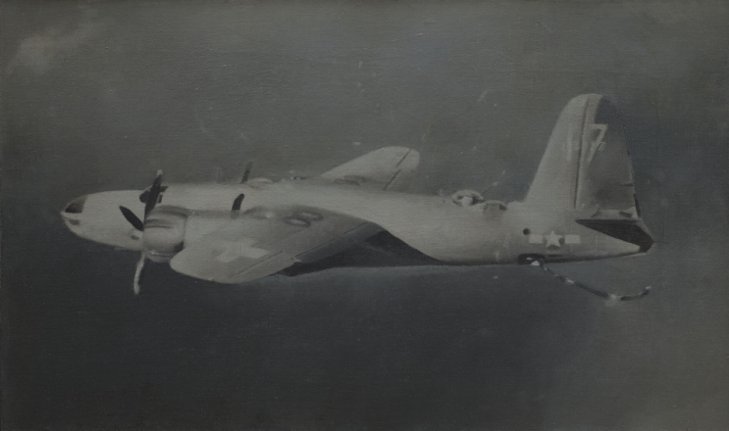
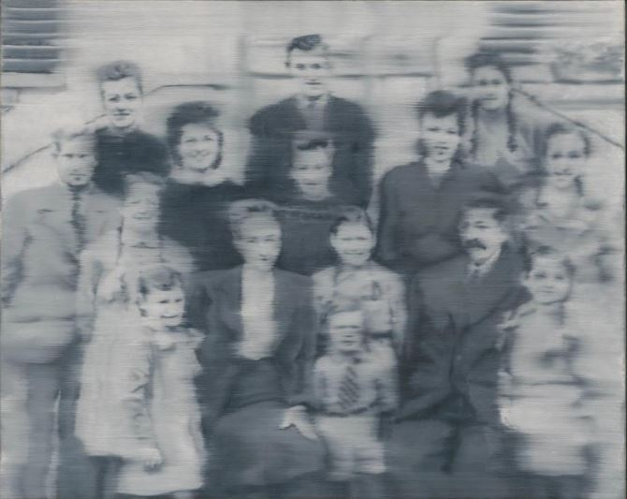
Fig 3: Gerhard Richter - Familie Liechti (The Liechti Fig 4: Vija Celmins - Suspended Plane, 1966 Oil on canvas
Family), 1966, Oil on canvas/www.davidzwirner.com www.sfmoma.org

It seems Richter is making a clear distinction between our inadequacy to perceive reality and the difference between reality (whatever it may be) and its representation (in this case a painting). He questions the instability of representation and the impossibility of directly accessing or reproducing ‘reality’. Richter questions the very idea of blur or imprecision in images, suggesting that what we call ‘blurred’ is not a failure to match reality but a misunderstanding of images as things that should correspond to reality at all—since images exist on their own terms, not in direct comparison with reality.
This resonates with Jacques Derrida’s concept of différance, where meaning is never a pure origin but always emerges through repetition, displacement, and difference across time and space.
“… that meaning is relayed only through the passage of différance, each empirical instantiation of an origin has to differ from it spatially and temporally, and hence become altered in its reinscription as repetition with a difference.”
(Chin-Yi, C., 2010, p.70)
Derrida argues that every repetition alters what it repeats, whilst Richter implies that representation (like painting) is never a version of reality but something fundamentally separate from it. In both cases, the idea of a stable, original ‘real’ that can be clearly or authentically reproduced is undermined; instead, meaning and representation are always mediated, transformed, and constituted through difference rather than resemblance.
These opinions, which align with post-structural and post modern theory, would have been instrumental in shifting the understanding of painting away from ‘representation as a search for truth’, toward a more critical analysis of how images defer and destabilise meaning. Richter’s response to painting, at that time, would have had a similar outlook and subversion.
My practice to date involves a gradual shift away from the primacy of subject matter toward more engagement with surface, process, and the conditions under which images are produced and understood. Influenced in part by artists such as Gerhard Richter and Vija Celmins, I have increasingly prioritised a controlled, brushless surface that opposes overt gestures of expression, instead drawing attention to the means of construction, nuance and rendering.
Working in greyscale, and often using photographic source material, the paintings operate in a space between illusion and materiality. This approach allows the image to never fully resolve as either depiction or object - inviting a slower, more attentive mode of viewing. Rather than attempting to reproduce reality, the work seeks to question how reality is mediated and represented. In this way, the paintings remain intentionally open-ended, resisting fixed meaning and instead continually changing through perception, difference, and reinterpretation.

2. MEDIATION
At the start of the confirmative praxis in October 2025, I was producing and completing paintings that presented illusionistic qualities based on representation and ambiguity. The paintings were technique driven and usually showed the illusion of blur by softly blending the whole painting or selected areas (similar to Richter) “...in which depth is produced by different degrees of blurring” (Gelshorn, J., 2006, p.31). This can be compared to a narrow ‘depth of field’ found in photography and film. This illusion of blur is common in classical portraiture, where the edges are softened (blurred) on one side of the head to create the illusion of depth.
Although the paintings were interesting to look at, I was concerned with how I would present them in an exhibition; did I want just paintings on walls? I had already toyed with the idea of filming my paintings as a final outcome and since I had experimented extensively with very early video tube cameras during my explorative this seemed like an interesting option. The question now was, why? And what would I paint?
The first paintings I worked on around the end of 2025, were either from old anonymous photographs, similar to Richter’s sources, or images of CRT television static (when no signal is received), which due to their meticulous detail align more with Celmins’. After sometime, I made the decision to produce the sources for my final paintings using old video cameras (my own recordings) - I wanted to produce still images using old 200 line video cameras (inferior quality by today’s standards) and then paint the same images as exact as possible - painting with the same degraded visual quality as the surveillance footage would cause the work to pre-emptively absorbs its own mediation thus challenging traditional distinctions between original artwork, reproduction, and perception (discussed in next chapter). Finally, the paintings would be observed through the same video quality (as they were created) via an old surveillance monitor.
Three distinct phases of mediation:
1. Create the source (Video mediation)
2. Paint the source (Mediation/Artefact)
3. Observe the painting (mediation via the device that created the source).
Moving away from ‘hanging a painting on a wall’, I wanted to resist the objectification of a painting (as a thing) which can only be (using this method of presentation) a piece of cloth with paint on it. Although I cannot escape materiality completely, I wasn’t interested in presenting painting in a direct materialistic way (a trope of Modern Art) - I was no Frank Stella:
“He came up with the idea of conveying the painting as nothing more than an object, which made him think about the relationship between of all the materials used to make a painting”.
(De Corte, H. and De Winter, S. 2024, p.2).
Instead I wanted to achieve a type of mediation of a mediation of a mediation, or even ‘remediation’, a term coined by Bolter and Grusin in their book of the same name in 1999. Their book, serves as an updated version for the digital age of Marshall McLuhan’s earlier ‘Understanding Media: The Extensions of Man’ where McLuhan stated “the 'content' of any medium is always another medium” (McLuhan, M., 1964, p. 15). Bolter and Grusin found this statement to be problematic and suggest McLuhan was “not thinking of simple repurposing, but perhaps of a more complex kind of borrowing in which one medium is itself incorporated or represented in another medium.” (Bolter, J.D., and Grusin, R.A., 1999 p.45) Bolter and Grusin state:
“...outline the process of remediation by which older media are refashioned and reused by newer media. The “double logic” of remediation addresses the contradiction between hypermediacy and immediacy in popular culture.”
(Derosa, R., 2013, p.127).

Immediacy aims for total immersion by concealing the presence of the medium, whereas hypermediacy highlights the diverse, layered nature of mediated space by drawing attention to the medium itself. In contrast, Jean Baudrillard maintains that simulation has come to replace reality and, although he collapses the distinction between the two - “all distinctions between the real and the fictional, between a copy and the original, disappear” (Kvas, K., 2020, p.13), he nevertheless continues to acknowledge their conceptual presence.
“The double logic of remediation exposes Baudrillard’s assumption that an already established reality exists apart from the processes of mediation, just like he assumes some essential humanity exists apart from the machine”
(Derosa, R., 2013, p.127).

Remediation, according to Bolter and Grusin, is inseparable from reality, “Although Baudrillard's notion of simulation and simulacra might suggest otherwise, all mediations are themselves real. They are real as artefacts (but not as autonomous agents) in our mediated culture”, (Bolter, J.D., and Grusin, R.A., 1999 p.55-56).

The artist Nam June Paik is a key figure and pioneer in 60s video art and consequently video mediation - it would be difficult to broach the subject of early video art without mentioning Paik. One of Paik’s most compelling works, TV Buddha (first produced in 1974), (Fig. 5), is simple yet complex. It shows a Buddha statue watching its own live video feed, blending meditation, technology, and self-observation in a quiet loop of contemplation. The meaning of TV Buddha has been vaguely interpreted as the relationship between ancient spirituality and modern technology, according to W. Smith, W. 2000, p.361) its link to Eastern philosophy is often overlooked by art critics:

“the meditating Buddha image itself represents nirvana, or enlightenment. This transcendent, indefinable state is to be identified with the Buddha himself. And so, the Buddha contemplating himself is contemplating, or absorbed within, his own nirvana”. (Smith, W., 2000)

It is not so much the interpretation of TV Buddha that I am interested in, it is the form of mediation which I find fascinating, from the low quality image produced by the video tube camera and the stillness between it and the referent. Of course, low resolution video at the time of Paik was common place - my intentions in using similar low quality in the present day have huge implications and raises questions around my doing so. This will be made clearer in the next chapter.
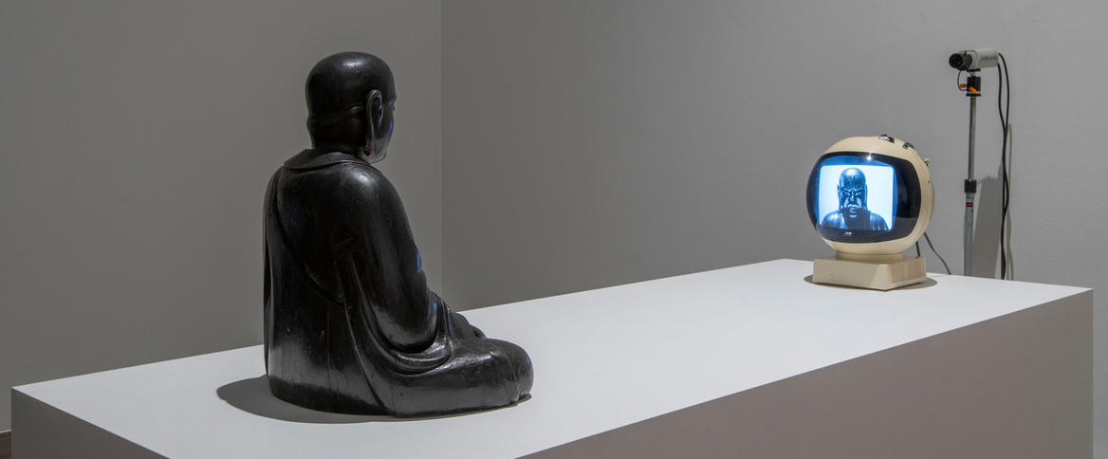

Fig 5: Nam June Paik - TV Buddha, 1974 - Stedelijk Museum, Amsterdam © The Estate of Nam June Paik - www.sartle.com

3. APARATUS

“Video depends - in order for anything to be experienced at all - on a set of physical mechanisms” (Krauss, R., 1976, p. 52).

The development of this work has led to consideration of the apparatus – not simply as a neutral vehicle for representation, but as the primary format through which the work is to be experienced and constituted. If video depends on physical mechanisms, as Rosalind Krauss suggests, then the object is only ever encountered through the means of a system. I had already decided that my paintings would be mediated through old cameras and video monitors and by doing so the work shifts away from the painting as object and toward the apparatus as a site of experience. This prompts a critical question: If access to the paintings is displaced through technological mediation then what is the role of the artefact?
In response, the paintings are hidden behind a curtain, with no access to the viewer, and only experienced through video mediation. This concealment generates a sense of ambiguity: what the viewer sees is no longer an artefact or an object but degraded and partial image whose origin is vague. The grey low-resolution image emphasises this condition, introducing ghostly light trails, noise, low contrast and a visual unsteadiness which opposes any clear definition. This mediation does not illuminate or enhance, but withdraws - thus producing a technological occlusion in which the artefact recedes and what is left is its unstable facade. The video material - the signal, resolution, interference, mechanical limitations are not hidden, but play an explicit part of the work itself.
This technological withdrawal extends beyond the artefact and starts to implicate authorship. As Hito Steyerl states, “Resolution was fetishized as if its lack amounted to castration of the author.” (Steyerl, H., 2021). The degraded quality of the remediation does not just signal loss, but displaces authorship across the system. The work is no longer solely dependent on the painted surface, but in the whole apparatus that mediates it and the conditions in which it is experienced. Authorship is now distributed between artist, system and viewer – not predetermined. In addition to this redistribution, the imagery of my paintings is already produced through the same camera that mediates it to the viewer. This raises a further critical question: why is painting presumed to be the original, rather than just mediation? The obvious counter would be something to do with its human-made qualities, according to Maurice Merleau-Ponty, the painter “takes his body with him” (Merleau-Ponty, M., 1964, p.16) suggesting that the artefact embodies an imprint of the artist’s being. For Giles Deleuze, painting embodies a sensory encounter, “As a spectator, I experience the sensation only by entering the painting, by reaching the unity of the sensing and the sensed.” (Deleuze,G., 2003, p.35). The artwork is not simply view from the outside but experience through an immersive exchange between spectator and object. However, the apparatus obscures the idea of the original - the artefact is not to be seen with human eyes –only mediated, which renders it partially unknowable in the in the terms suggested by Merleau-Ponty and Deleuze. Like Richter’s neutral grey photo-paintings, the artefact is constructed and estranged—mechanically detached and unstable in its claim to originality—replaced by a temporal, mediated system that neither records nor reproduces, but only creates experience.
This displacement aligns with Walter Benjamin’s claim “that which withers in the age of mechanical reproduction is the aura of the work of art” (Benjamin, W., 2008, p.8), yet this loss need not be reductive. As Steyerl argues:
“By losing its visual substance it recovers some of its political punch and creates a new aura around it. This aura is no longer based on the permanence of the “original,” but on the transience of the copy”, she continues… “The poor image is no longer about the real thing—the originary original. Instead, it is about its own real conditions of existence”
(Steyerl, H., 2021)
The screen image no longer points back to an origin but affirms itself as an artefact independently, a position echoed by Bolter and Grusin, where mediation is not secondary, but real.
The video signal produces a similar outcome irrespective of content, the introduction of a further element behind the curtain became of interest and complicates the notion of the real even further, a direct mediation or a staged performance (something three dimensional) - a tableau seen through a cut out frame, mimicking a painting. Referencing Marcel Duchamp’s ‘Étant Donnés (1946–1966)’, where the viewer looks voyeuristically through a hole in a door at a haunting tableau, this work repositions that encounter through video. More elements behind the curtain would signify more cameras, however, I decided to use one camera attached to a rotational motor which could be controlled by the viewer via a remote control. The viewer becomes an operator, able to navigate the field of vision. However, this agency is limited. The viewer operates within a preconfigured system - framed by resolution limits, fixed positioning, and constraint. Vilém Flusser, referring to the photographer, states, “But the choice is limited to the categories of the camera, and the freedom of the photographer remains a programmed freedom”. (Flusser, V., 2000, p. 35). While this apparatus resembles surveillance systems, particularly in relation to Michel Foucault’s panopticism, it does not operate primarily through control, but through limitation and withdrawal.
What materialises in not power, but ambiguity. The viewer only experiences a partial view, conveyed to them gradually as the camera slowly pans. They are aware of the hidden zone and the conditions of its inaccessibility. This aligns with John Berger’s statement “The relationship between what we see and what we know is never settled” (Berger, J., 2009, p.7). The mediated image complete with its imperfections, destabilises any fixed relation between appearance and understanding. The screen functions dualistically as access and limitation, a surface which can be seen but never fully grasped.
A philosophical parallel can be drawn with Immanuel Kant’s distinction between phenomena and noumena. Kant saw the world as it appears or experienced by our senses (phenomena) and the world independent (noumena) of our senses, the ‘thing in itself’: “we can therefore have no knowledge of any object as thing in itself, but only in so far as it is an object of sensible intuition, that is, an appearance,…” (Kant, I., 1929, p.92). The concealed space behind the curtain operates as a noumenal domain—existing but inaccessible—while the mediated image functions as its phenomenal counterpart. However, this distinction is later complicated by Merleau-Ponty, who insists that “...it exists only in so far as someone can perceive it. I cannot even for an instant imagine an object in itself” (Merleau-Ponty, M., 1964, p.16). Yet he simultaneously identifies a tension within perception itself:
“Thus there is a paradox of immanence and transcendence in perception. Immanence, because the perceived object cannot be foreign to him who perceives; transcendence, because it always contains something more than what is actually given...”
(Merleau-Ponty, M., 1964, p.16).
Within this framework, what lies beyond the veil is not ‘foreign to him that perceives it’, it is still visible as mediation - the occlusion does not simply denote an inaccessible beyond but manifests as an excess within perception—a “something more” that remains unresolved.
This ‘something more’ can be extended into contemporary thought, particularly in Speculative Realism and its ‘object-oriented ontology’ framework. A significant influence on these theories is the work of Bruno Latour, “Nothing can be reduced to anything else, nothing can be deduced from anything else, everything may be allied to everything else” (Latour, B.,1988, p.163). From this perspective, a non-hierarchic, or equilibrium, is formed between all objects, which rejects modes of reduction and the limitations of mind and language. The apparatus acts in a similar way, the screen, grey and flat, levels the observation field. A similar observation is expressed by Graham Harman, ““Objects exist as autonomous units, but they also exist in conjunction with their qualities, accidents, relations and moments without being reduced to these”, (Harman, G., 2009, p.156). The concealed paintings – and any staged elements – exist independently of whether they are seen - their withdrawal is not lack, but a condition of their autonomy.
Speculative realism challenges the Post-Kantian continental philosophy – often characterised as Correlationism, which maintains, “that things-in- themselves are beyond the bounds of knowledge and reason” (Birks, C., 2018). G. W. F. Hegel illustrates this epistemological constraint perfectly: “consciousness seems unable, as it were, to get behind the scenes to see the object not as it is for consciousness, but as it is in itself” (Inwood, M., 2018, p.40). Despite this constraint, speculative realism redirects philosophy away from questions of access and back toward reality itself. “…all the speculative realists are committed to reality itself rather than to representations or mediations of it” (Birks, C., 2018 p.7). Speculative realism, insists that reality exceeds, and exists independently of our access to it - “Object-oriented philosophy is a proud defence of the ‘something more”, (Harman, G., 2009 p.155).
The apparatus operates and coexists between correlationist traditions, particularly phenomenological limits of access, and speculative realist accounts of object withdrawal. The mediated screen image aligns with correlationist limitation, presenting only what is accessible to perception, and the concealed ‘something more’ beyond human access – echoes Speculative realist claims of the withdrawn reality of objects.

CONCLUSION

This project has explored the interrelated roles of painting, mediation, and ‘the apparatus’, reconfiguring how an artwork is produced, encountered, and understood. What began as an investigation grounded in painting has expanded into a broader enquiry into the conditions that shape visual experience. While painting remains central, its role has shifted from a self-contained object toward a component within a wider system of production and perception. Through the development of a controlled, nuanced technique and the sustained use of greyscale, the paintings move away from overt expression and toward a neutral, constructed surface. This approach prioritises accuracy and subtle variation, allowing images to exist in a state of ambiguity between representation and abstraction. Rather than depicting reality, the paintings function as reinterpretations - reworked from mediated sources and shaped by the limitations of their process. In doing so, they foreground the instability of images and resist fixed meaning. Mediation has been integral to this shift. By generating source material through low-resolution analogue video and reintroducing this same degraded visual language in the final presentation, the work embeds layers of transformation. The stages of recording, painting, and re-mediation disrupt the notion of an original image, replacing it with a succession of reinterpretations - new realities. The image is therefore not a stable entity, but something dependent - formed through the systems that produce and display it.
The ‘apparatus’ becomes the primary site through which these concerns are realised. Operating between correlationist traditions and speculative realist thought, it simultaneously limits and extends perception establishing a dialogue between the two. The mediated screen image aligns with phenomenological constraints, presenting only what is accessible to human perception, while the inaccessible “something more” that exists beyond view echoes speculative realist ideas of object autonomy, where the object persists independently of its observation. Importantly, by occluding the physical paintings behind a veil and presenting them only through a live camera feed, the viewer is repositioned as an active operator within a system of controlled visibility. The screen image no longer acts as a secondary representation but as an ontological extension of the object itself, creating a condition in which distortion, signal, and mediation complicate any clear distinction between origin and representation.
Ultimately, this project examines how perception is structured and constrained by technological systems and human finitude. By displacing direct access and foregrounding mediation, the work proposes that meaning is not inherent or stable, but continually deferred. The installation invites viewers to navigate this uncertainty, finding understanding through interfaces that simultaneously reveal and obscure implicating both the system and the viewer within the production of the real.

LIST OF ILLUSTRATIONS:
Fig 1: Andrew T. Gardner - The cloud of unknowing, 2025, Oil on canvas.

Fig 2: Andrew T. Gardner - The cloud of knowing, 2025, Oil on canvas.

Fig 3: Gerhard Richter - Familie Liechti (The Liechti Family),1966, Oil on canvas - www.davidzwirner.com
Fig 4: Vija Celmins- Suspended Plane, 1966 Oil on canvas - www.sfmoma.org
Fig 5: Nam June Paik - TV Buddha, 1974 - Stedelijk Museum, Amsterdam - www.sartle.com

BIBLIOGRAPHY
Adams, H. (2023) “Vija Celmins: The Art of Enervation,” Zeitschrift für Kunstgeschichte, 86(1), (p. 100).
Benjamin, W. (2008) The work of art in the age of mechanical reproduction. London: Penguin. (p.8).
Berger, J. (2009) Ways of seeing. London: Penguin. (p.7).
Birks, C. (2018) “Objectivity, Speculative Realism, and the Cinematic Apparatus,” Cinema journal, 57(4).
Bolter, J.D. and Grusin, R.A. (1999) Remediation : understanding new media. Cambridge, Mass. ; MIT Press.
Chin-Yi, C. (2010) “Metaphysics and Representation: Derrida’s Views on the Truth in Painting,” Rupkatha journal on interdisciplinary studies in humanities, 2(1), (p 70).

De Corte, H. and De Winter, S. (2024) “The Painting in Front of Itself: Frank Stella’s Atypical ‘Projective’ Spaces through Canvas, Paint and Colour,” Art & perception (Leyden, Netherlands), 12(3), (p.2).

Deleuze,G. (2003). Francis Bacon : the logic of sensation. London ; New York: Continuum, (p.35).
Derosa, R. (2013). Simulation in media and culture: believing the hype. Lanham: Lexington Books.(p.127).
Enright, R. and Walsh, M. (2003) “Tender touches: an interview with Vija Celmins,” Border crossings, 1 August, (pp. 20–35).
Flusser, V. (2000) Towards a philosophy of photography. London: Reaktion Books. (p.35)
Gelshorn, J. (2006) “From Flatness to Space and Back Again: Concepts of Representation in the Work of Gerhard Richter and Sigmar Polke,” RACAR, 31(1–2), (p.31).
Harman, G. (2009). Prince of Networks. Melbourne, Australia: re.press, pp.155–156.
Inwood, M. (2018). Hegel: The Phenomenology of Spirit. Oxford University Press, p.40.
Kant, I. (1929). Immanuel Kant’s Critique of Pure Reason. Translated by Norman Kemp Smith. London: Macmillan And Company Limited. (A50/B74 - p.92).
Krauss, R. (1976) “Video: The Aesthetics of Narcissism,” October, 1, (p. 52).
Kvas, Kornelije (2020). The Boundaries of Realism in World Literature. Lanham, Boulder, New York, London: Lexington Books. (p. 13)
Latour, B. (1988). The Pasteurization of France. Cambridge, Massachusetts and London : Harvard University Press, (p.163).
McLuhan, Marshall. (1964) Understanding Media. New York : McGraw-Hill, (p. 15).

Merleau-Ponty, M. (1964) The primacy of perception : and other essays on phenomenological psychology, the philosophy of art, history, and politics. Evanston, Ill: Northwestern University Press. (p.16).

Richter, G. Storr, R. and Art (2002). Gerhard Richter - forty years of painting : [The Museum of Modern Art, New York, February 14 - May 21, 2002 ; The Art Institute of Chicago, June 22 - September 15, 2002 ; San Francisco Museum of Modern Art, October 11, 2002 - January 14, 2003 ; Hirshhorn Museum and Sculpture Garden, Washington D.C., February 20 - March 18, 2003]. New York: The Museum Of Modern Art (p.291).
Richter, G., Hans Ulrich Obrist and Britt, D. (1995). The daily practice of painting : writings and interviews, 1962-1993. Cambridge, Mass.: Mit Press ; London.

Shapiro, M. (1937) “Nature of Abstract Art” Marxist Quarterly, Vol. 1, 1937 (Greenwood Reprint Corporation, 1968, p.77).

Smith, W. (2000) “NAM JUNE PAIK’S TV BUDDHA AS BUDDHIST ART,” Religion and the arts (Chestnut Hill, Mass.), 4(3), (p.361).

Steyerl, H. (2021). In Defense of the Poor Image - Journal #10. [online] E-flux.com. Available at: https://www.e-flux.com/journal/10/61362/in-defense-of-the-poor-image

