Name: Ruvi Miah
Marketing Management
Lecturer: Tushara Balendran
Student ID: 1805642
Moodle Code:LCMB7001

Table of Contents
1 Environmental Marketing Analysis of Nike 1
1.1 Introduction 1
1.2 PESTLE Factors 1
1.2.1 Political Factors (Favorable) 1
1.2.2 Economic Factors (Unfavorable) 1
1.2.3 Social Factors (Favorable) 2
1.2.4 Technological Factors (Favorable) 2
1.2.5 Environmental Factors (Unfavorable) 3
1.2.6 Legal Factors (Unfavorable) 4
1.3 Porter’s Five Forces Model 4
1.3.1 Competitive Rivalry (High) 4
1.3.2 Bargaining Power of Suppliers (Low) 4
1.3.3 Bargaining Power of Buyers (Medium) 5
1.3.4 Threats of New Entrants (Low) 5
1.3.5 Threat of Substitutes (Medium) 5
1.4 SWOT Analysis 5
1.4.1 Strengths 5
1.4.2 Weaknesses 6
1.4.3 Opportunities 6
1.4.4 Threats 6
1.5 Nike’s Segmentation 6
1.6 Targeting of Nike 7
1.7 Positioning of Nike 7
1.8 Marketing Mix Strategy of Nike 8
1.8.1 Products 8
1.8.2 Price 8
1.8.3 Place 8
1.8.4 Promotion 8
1.9 Conclusion 100 9
2 Recommendations 9
3 Works Cited 10

Environmental Marketing Analysis of Nike

Introduction
This report is about the environmental marketing analysis of Nike Inc. Marketing analysis helps to recognize the internal and external factors of the environment which influence the operations and decision making of an organization. In this analysis, we observe micro-economic and macro-economic factors affecting organizational operations (Charles, 2020). The chosen organization for this assignment is Nike Inc. which is an American multinational corporation deal with the designing and manufacturing of footwear, clothing, and other accessories. In this study various macro-economic and micro-economic factors have been discussed that affect the decision-making and business operations of Nike.

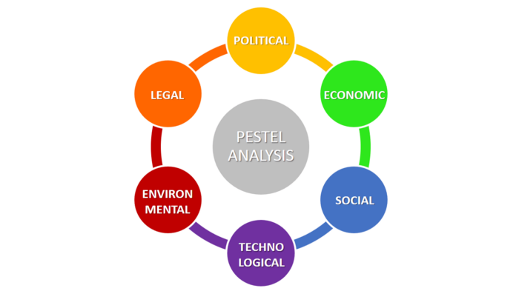
PESTLE Factors
PESTLE analysis shows the influence of the industry’s macro-economic factors on the brand’s business (Perera, 2017). It helps to understand the impact of macro factors on the business operations of Nike.

Political Factors (Favorable)
Political factors exposed to Nike are favorable for the brand because the core market for Nike is the US and the political condition of the country is stable. The favorable international tax agreements of the brand provide ample scope for worldwide growth and success. Manufacturing laws and tax regulations of countries where Nike has manufacturing facilities are favorable for it.

Economic Factors (Unfavorable)
Due to the recent pandemic, the economy of different countries was severely affected and forced store closures in the US, Asia, and Europe decrease the revenue of Nike. The prevailing economic conditions worldwide do not permit the management of Nike to open any new factory or store. During the pandemic, the worldwide bad economic condition was the biggest threat for Nike.
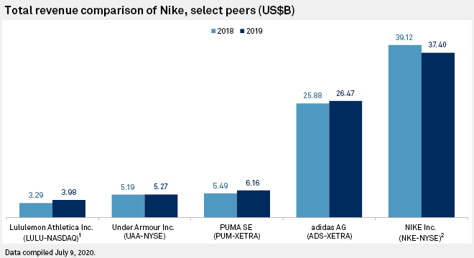
Figure 1: Total Revenue Comparison of Nike

Social Factors (Favorable)
The General public has become more health-conscious and they are joining fitness clubs that impose a favorable impact on Nike’s business. When individual joins a fitness club or exercise regularly, he/she uses footwear, apparel, and other fitness accessories and Nike Inc. is the number one choice for long in the sports and fitness industry. Besides this, in different countries of Asia, Nike failed to improve poor workplace conditions for workers and low rates of wages that impose negative effects on the reputation of the brand (Jordan B. Peterson, 2021).

Technological Factors (Favorable)
Technological factors have positive effects on sales, marketing, community engagement of Nike. During the pandemic, when stores were closed due to lockdown, Nike plans to increase its online business. Technological factors helped a lot to increase online sales of Nike and despite a 37% decrease in total sales during the 4th quarter of 2020, its online sales grew 75% (Arcieri, 2020).
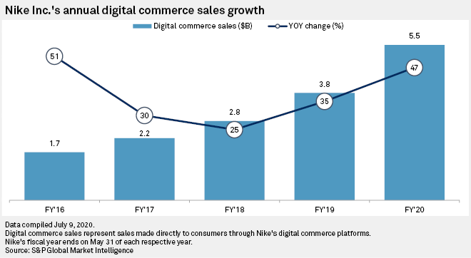
Figure 2: Annual Digital Commerce Sales Growth of Nike

Environmental Factors (Unfavorable)
The General public has become more conscious about environmental sustainability than ever before but the mass production facilities of Nike are producing pollution that affects the environment badly. Nike has eradicated the use of plastic bags in all stores in 2021 (Jordan B. Peterson, 2021). At the end of 2020, the total waste produced by Nike was 2142 metric tons (Statista , 2021). Environmental factors imposed various restrictions on the production and services operations of Nike.
Figure 3: Volume of waste generated at Nike, Inc. headquarters worldwide in FY 2020, by disposal method

Legal Factors (Unfavorable)
Over the years Nike Inc. has been involved in several legal clashes. It has faced various legal penalties due to poor working conditions and disobedience of the minimum wage law (Rowland, 2017). Besides this, Nike also has a prolonged history of patent violations with Adidas. It recently filed litigation against the Skechers for imitating the design patents.

Porter’s Five Forces Model
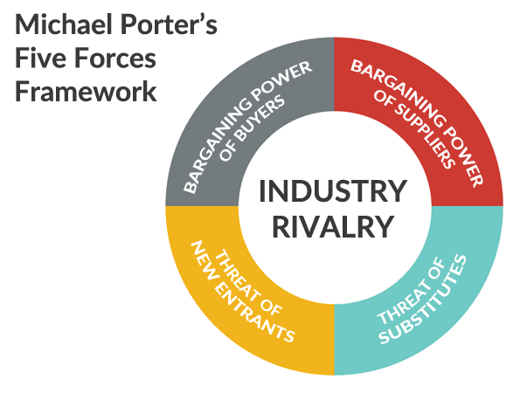
Figure 4: Michael Porter's Five Forces Analysis

Competitive Rivalry (High)
Nike is facing intense market competition because various other brands are providing the same high-quality products with unique designs. A low market growth rate and a moderate number of firms with the same products and services impose challenge to increase the market share of Nike. So, this factor has a high impact on Nike’s decision-making.

Bargaining Power of Suppliers (Low)
This force has low impacts on Nike because various suppliers provide the same raw materials and services in the industry. The availability of a large number of suppliers decreases the influence of individual suppliers on Nike’s business operations (Adamkasi, 2019).

Bargaining Power of Buyers (Medium)
The effect of customers on Nike’s decision-making and operations is moderate because substitutes are available and customers have moderate switching options. Customers directly affect the Nike business because low switching costs make it easy for them to shift to other brands.

Threats of New Entrants (Low)
The threat of new entrants is low because the high cost of brand development is a hurdle for new entrants. So, Nike’s business is not highly affected by the threat of new entrants in the market of sports shoes, apparel, and other sports accessories.

Threat of Substitutes (Medium)
The threat of substitutes on Nike’s operations is moderate because it is a leading player in the global sporty products market. Moderate availability of substitutes and low switching cost shows the threat of substitutes is medium on Nike’s business (Rowland, 2017).

SWOT Analysis
Like other companies, Nike has a number of weaknesses, strengths, opportunities, and threats that have been given below:
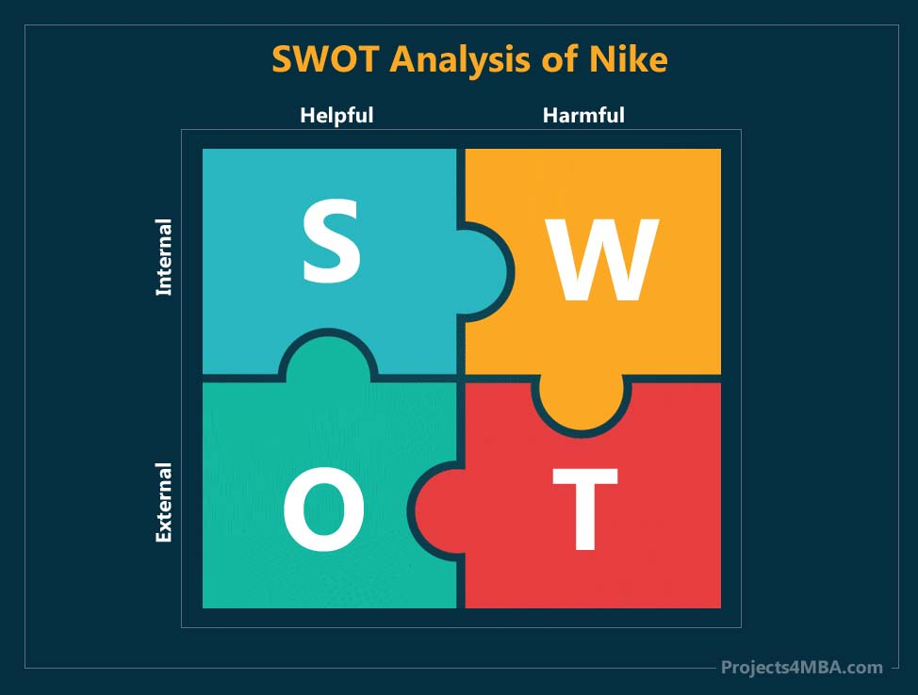
Figure 5: SWOT Analysis of Nike

Strengths
The most significant strengths of Nike are its powerful brand image and low production cost. The strongest brand in the sportswear industry is Nike. Nike has a diverse brand portfolio and various sub-brands including NikeID, Nike Grind, Nike Shox, and Nike Tiempo, etc. Nike also has strong control over both retail and online business. Association with celebrated athletes and an amazing customer base around the world is another strength of Nike.

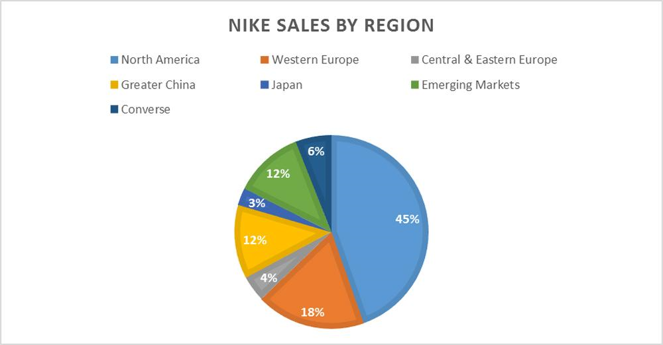
Weaknesses
The main weakness of Nike is poor workplace conditions in various countries due to which it faces lawsuits for a long time. Nike is highly dependent on the US market and more than 45% of total income came from America. Retailers get upper-margin cuts that increase the operating cost of Nike.

Opportunities
Although Nike is providing services in various countries, there is still an opportunity to offer services in emerging markets like India, Brazil, China, etc. It also has the opportunity to broaden its horizon in other fashion lines. It can improve business operations by reducing controversies associated with upper management (Bush, 2019).

Threats
The increasing market competition is a threat for Nike and it needs to be more innovative and cost-effective to maintain its position. Counterfeiting of Nike products is rapidly increasing which is a big threat for the company. Besides this, due to poor economic conditions, Nike is facing budget pressure.

Nike’s Segmentation
The segmentation strategy of Nike is contained on different classifications which include, demographic, geographical, socioeconomic, behavioral, benefits, and psychographic market segmentation. For demographic segmentation, it has involved different age groups (mainly between1-5year, 5-10years, 11-18years, 18-45 years) and gender according (including men, women, and kids) to their financial status.
For geographical segmentation, it has various outlets worldwide and provides services according to the cultural and lifestyle habits of that country (Panagiotopoulou, 2017). The generally targeted segment of Nike is “all athletes” and other segments are given below in detail:
Demographic | Geographic | Psychographic
Age | World region | Lifestyle
Gender | Country | Personality
Ethnic Background | Country region | Opinions
Family life cycle | City | Activities
Socioeconomic | Physical climate | Personality
Income | Benefits | Behavioral
Education | Desired product design | Frequency of purchase
Occupation | Consumer needs | Loyalty of consumers

Targeting of Nike
The next step after segmentation is targeting where the firm systematically selects the groups to achieve its goals most effectively and efficiently (Camilleri, 2017). Nike chooses its target audience according to size, accessibility, behavior, and measurability variables. However, Nike has a niche market to serve and that is professional athletes and fitness and sport lover individuals. It provides unique and high-quality products to all kind of athletes. It has outlets across the world and also provides online services to make sure all products are reachable for targeted customers. it also offers choices to customers to create their own custom-designed shoes which differentiate Nike from other footwear brands. It also targets customers through psychological tactics by sponsoring prominent athletes with marvelous achievements (Panagiotopoulou, 2017). Severe competition and sustainable innovation are the trigger for modernizing Nike’s business operations and services.

Positioning of Nike
Nike has positioned itself as the market leader of footwear, clothing, and sports equipment in the world. Positioning statement of Nike is: “shoe for every serious athlete”. It provides high quality sports products and innovative technology (Panagiotopoulou, 2017). It has also influenced its customers that Nike is an aspiring and champion brand through the swish together with the slogan “Just Do It” and through different marketing activities (including discount vouchers, cuts the prices, sale offers etc.) that connect its brand with brilliant accomplishments of prominent sportspersons. Nike is expanding the position of its products in terms of competition by using different marketing research techniques. Nike speaks in the hearts of athletes due to its unique products, which make it different from the competitors. Besides this, it has established its name in fashion where its products define lifestyle of people of a certain group.

Marketing Mix Strategy of Nike
Marketing mix strategy of Nike decides the growth and profitability of its business. Nike use this to strengthen its capabilities against the rivals.

Products
Nike deals with a range of sports products. It provides outwear (boots for strikers, mid fielders, defenders, sneakers), apparel (headwear, shorts, shocks, jackets, jersey, tops), equipment (ball, sports glasses, bags, watches), national team gear, and club gear.
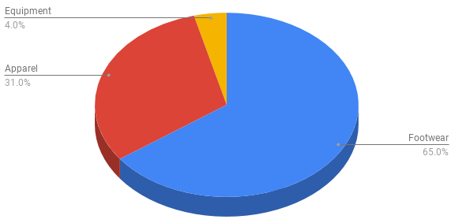
Figure 6: Nike's revenue share by product category

Price
Nike Inc. applies a rapid price skimming strategy. When it introduces limited edition products, it keeps their price very high. It invests a lot in promoting new designs that increase the cost of products.

Place
Nike has its stores in more than 170 countries where it sells sports shoes, apparel, and other equipment worldwide. Besides this, Nike also provide online services to its customers. The worldwide appearance of its outlets ensures the accessibility to the targeted markets. Its distribution strategy can be dividing into three portions: retail stores (large firms like Walmart), Nike online stores, and company-owned retail outlets of Nike.

Promotion
Nike follows an effective marketing mix to maintain a strong brand image. Advertising, discount vouchers, personal selling, public relations, sales promotions, direct marketing are some significant promotional activities of Nike. It follows a direct marketing strategy to increase loyalty with potential customers (Sadnan Bin Sattar, 2021).

Conclusion
This part of the report explains the environmental marketing analysis of Nike Inc. It narrates the favorable and unfavorable PESTLE factors influencing the business operations of Nike. The different industrial forces also affect the Nike’s business that has been explained with the help of Porter’s five forces analysis. Besides this, it narrates the SWOT analysis, marketing mix, positioning, segmentation, and targeting strategies of Nike.

Recommendations
In this rapidly changing business world, it has become essential for Nike to adopt change and enhance its innovation process in order to stay competitive. Nike should focus on available opportunities of expanding product lines and enhancing market share by entering emerging markets. It is an era of innovation and creativity that makes it necessary for companies to bring innovation in products and customers services to increase loyalty with potential consumers. besides this, it should focus on design patents protection by collaborating with the government so that it can prevent itself from lawsuit problems.

Works Cited
Adamkasi, 2019. Porter's Five Forces Analysis of Nike. [Online]
Available at: https://www.porteranalysis.com/porters-five-forces-analysis-of-nike/
[Accessed 04 December 2021].
Arcieri, K., 2020. Nike levels up digital game in wake of coronavirus hit. [Online]
Available at: https://www.spglobal.com/marketintelligence/en/news-insights/latest-news-headlines/nike-levels-up-digital-game-in-wake-of-coronavirus-hit-59265634
[Accessed 01 December 2021].
Bush, T., 2019. SWOT Analysis of Nike. [Online]
Available at: https://pestleanalysis.com/swot-analysis-of-nike/
[Accessed 03 December 2021].
Camilleri, M. A., 2017. Market Segmentation, Targeting and Positioning. In: Travel Marketing, Tourism Economics and the Airline Product: An Introduction to THeory and Practice. Switzerland: Springer, pp. 69-73.
Charles, 2020. What is marketing environmental analysis?. [Online]
Available at: https://digitalschoolofmarketing.co.za/blog/what-is-marketing-environmental-analysis/
[Accessed 02 December 2021].
Fortune, 2021. Nike. [Online]
Available at: https://fortune.com/company/nike/
[Accessed 02 December 2021].
Jordan B. Peterson, G. V., 2021. Nike — a PESTEL analysis (2021). [Online]
Available at: https://brand-minds.medium.com/nike-a-pestel-analysis-a213cbc18ad9
[Accessed 02 December 2021].
Panagiotopoulou, V., 2017. SEGMENTATION, TARGETING AND POSITIONING STRATEGY OF NIKE & BUYING DECISION ANALYSIS, Cyprus : researchgate.
Perera, R., 2017. The PESTLE Analysis. 1st ed. s.l.:Nerdynaut.
Rowland, C., 2017. Nike Inc. Five Forces Analysis (Porter’s Model). [Online]
Available at: http://panmore.com/nike-inc-five-forces-analysis-porters-model
[Accessed 03 December 2021].
Rowland, C., 2017. Nike Inc. PESTEL/PESTLE Analysis & Recommendations. [Online]
Available at: http://panmore.com/nike-inc-pestel-pestle-analysis-recommendations
[Accessed 02 December 2021].
Sadnan Bin Sattar, 2021. Promotional Strategy of Nike. [Online]
Available at: https://www.thestrategywatch.com/promotional-strategy-nike/
[Accessed 03 December 2021].
Statista , 2021. Volume of waste generated at Nike, Inc. headquarters worldwide in FY 2020, by disposal method. [Online]
Available at: https://www.statista.com/statistics/551660/nike-inc-world-headquarters-volume-of-waste-by-facility/
[Accessed 02 December 2021].

