1. Introduction
Cloud computing has revolutionized the way organizations develop, deploy and manage applications by providing computing resources through the online platform accessed on demand. The approach is cost-effective compared to the traditional method hence different organizations are adopting them to host their applications over the internet. Some of the fields that have benefited from the paradigm shift include healthcare, finance, educational, and e-commerce industries, among others. Furthermore, the need for more powerful machines and storage has led to the creation of virtualization and containerization technologies.
Organizations have started developing applications using Virtualization Technology because it allows multiple virtual machines to run on the same server without interfering with each other while saving the hardware costs associated with using multiple physical computers. Similarly, other cloud providers utilize the concept of containers to allow applications to run smoothly when migrating from one computer system to another. However, docker has been the best containerization software after virtualization due to its ease in developing cloud-based applications. Additionally, some cloud suppliers have been providing their clients with advanced cloud technologies such as load balancing, automatic scaling, and application gateways to enhance the performance of cloud-based applications.
Serverless technology is the latest cloud computing paradigm where it enables developers to build and run applications without considering the underlying infrastructure that serves the applications. Therefore, the paper discusses the concept of virtualization and containerization while comparing the containerization vs serverless concepts. In addition, the paper demonstrates the creation of docker image, uses of Docker file, volume, and networking of the containers and publishing the image to the docker hub. Finally, the paper looks at the aspects of load balance, scaling, and application gateway in cloud computing to look at the benefits they provide in cloud-based applications.

2. Principles and Benefits of Containerization
2.1. Introduction to Containerization
Containerization is a relatively new software technology that allows for packaging an application with the files, libraries, and dependencies and settings for the application to run. The main advantage with this technology is that it allows an application to behave the same, regardless of the environment. In the last few years containerization technology has become very popular and widely used technology while developing software and in cloud computing and DevOps.

2.2 How does the Containerization Work?
Applications today have been containerized. They can now be delivered along with all of their dependencies as a single, unified file, named Image. A Single Image can consist of source code, run-time, binaries, configuration file, system tools etc.
Container Images are run on a Docker Engine to give you an instance of a deployed application. A Docker Engine can be told to run numerous Images (and Containers) on many different Docker Engines working on a single Host Operating System.
The Docker Engine is in charge of the creation and running of the isolated Container Environments. When an application is being deployed with the help of Docker, developers of the application can be relaxed about additional and external software dependencies. This is because the application is completely self-contained in the Image file that enables it to run.
Docker technology uses the deployment of lightweight processes on the Host Operating System. This lightweight nature makes the processes easier to deploy and better utilizes the available processing and memory resources of the Host OS on which the deployment is taking place.

2.3 Docker Architecture
Docker client and Docker Engine make the client-server architecture in Docker. The commands sent by the Docker client are received by Docker Engine.
The Docker daemon referred to as the Docker engine performs the primary function of constructing and operating containers.
The Docker images contain all the information needed to operate the containers. The images are constructed using Dockerfiles that provide the instructions for constructing images.
Docker allows developers to operate containers created from Docker images.
Finally, the Docker registry stores Docker images for easy access and distribution.
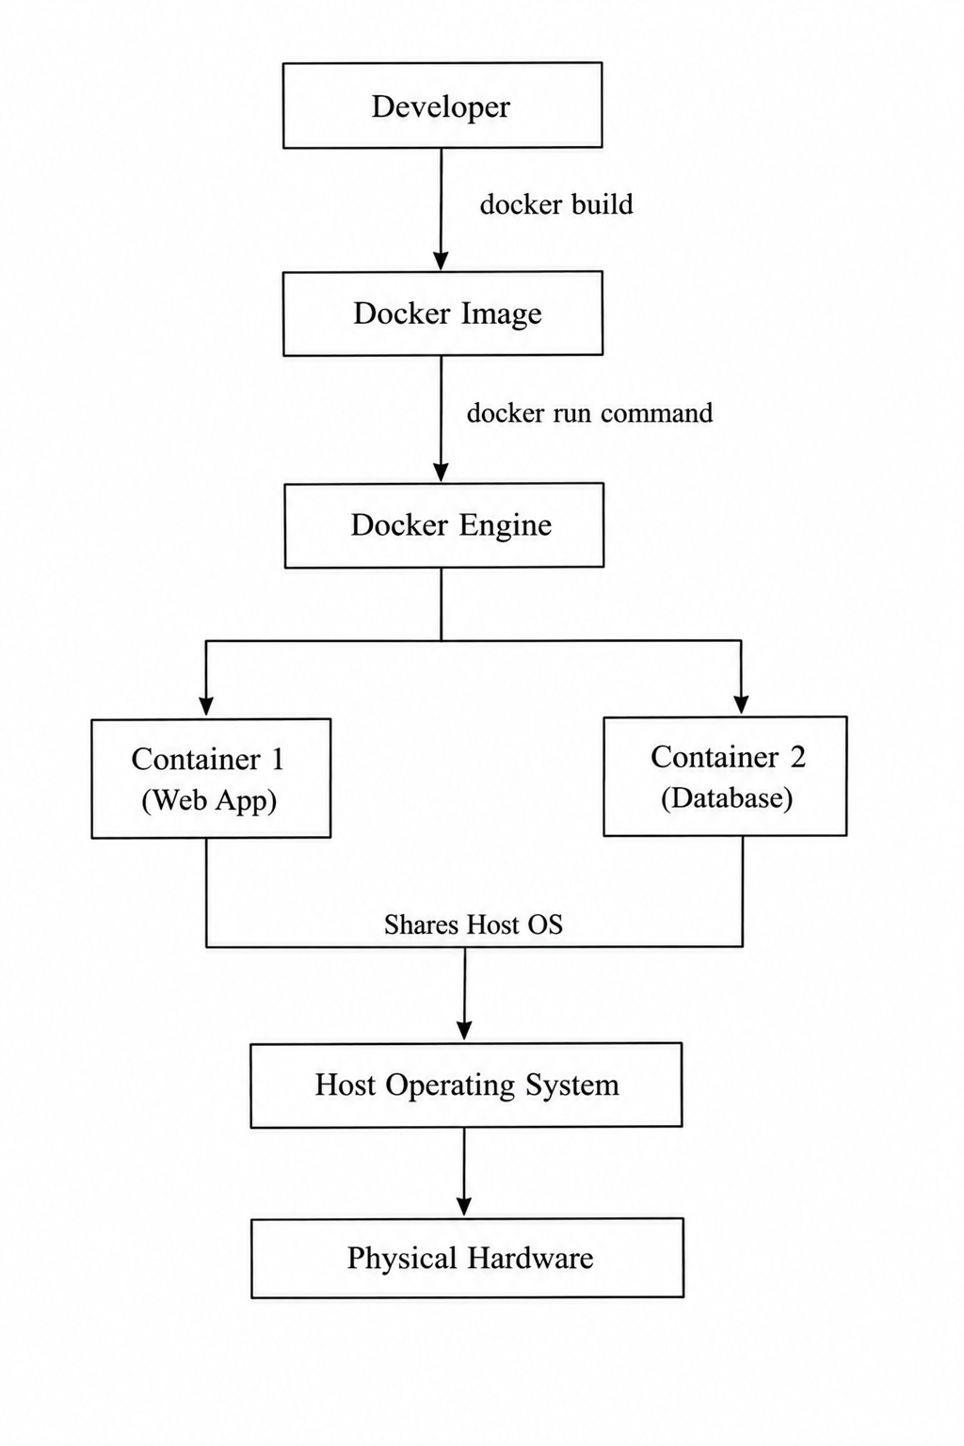
Figure 2.1: Docker Containerization Architecture

The figure above shows the basic architecture of the Docker platform. The Docker architecture can be further explained using the following components:
Docker Client | This component executes commands to operate Docker applications.
Docker Engine | This component serves as the Docker daemon that operates the Docker images and containers.
Docker Images | This component contains the information needed to operate Docker images.
Docker Registry | This component stores and distributes Docker images. The registry makes the images accessible for installation.

2.4 Benefits of Using ContainerizationTechnology
Lightweight Deployment: Containers take up system resources like CPU, memory and storage which makes it quicker to put applications into use.
Portability: Applications work the way in different places whether it is a developers computer, a test server, a private data center or a cloud service.
Rapid Deployment: It works well with integration and deployment which makes the process of building and releasing software much faster.
Cost Efficiency: Using resources means the cost of the infrastructure and cloud hosting is lower.
Application Isolation: Every container works on its own so if one application has a problem it does not cause issues for applications.
Scalability: Containers can be increased quickly which makes them perfect, for cloud-based applications that need to manage growing amounts of work.

2.5 Virtualisation vs Containerisation
Virtualisation | Containerisation
Runs virtual machines | Runs containers
Every virtual machine requires an operating system | All containers run on the same operating system
Requires much more processing power and memory | Fewer system resources
Virtual machines take a relatively long time to start up | Containers start within a few seconds
Better operating isolation | Limited isolation
Slower portability and deployment | Better portability and deployment
Ideal for running multiple operating systems | Ideal for cloud-native applications
Table 2.1 Virtualization vs. Containerizatio

3. Images and Publishing Images
3.1 Introduction to Docker Images
Source Code and Dependencies in Docker Images Because Docker images provide the foundation where Docker containers operate and they can run consistently regardless of the runtime environments that contain the necessary software applications, they can contain everything. Basically, the Docker images include binary format that is read only, and the complete information application must have. This includes system libraries, configuration files, runtime environments, software tools, source code, and dependent packages.
It is worth noting that images lie at the heart of the cloud computing platform because they allow developing applications to be bundled and distributed once and then installed multiple times on different platforms without any alterations. Moreover, installing such applications is also simplified since nothing needs to be restructured or redeployed.

3.2 Difference between Docker Image and Container
A Docker image is a template only in the read-only category with a set of necessary files or codes required for running a software. Docker image has contain in it everything from the code, required Libraries, dependencies, and run-time required to run the application or software. We can consider the Docker Image to be the “blueprint of a container” which holds all the code, dependency, and software with it required for the successful running of software.
A Docker container is a “run time instance of the image“. Once the image is being executed from the Docker command line interface (CLI), Docker generates and creates an individual container for running that application code and all its components that have previously been packaged within that image. Similar to the images, we cannot directly change the container from outside but as compared to image, containers run on their own individual space so they will not interact with each other’s.
This individual environment gives a system stability as no single running software can affect other software or system.
We can spin multiple instances of containers from a single Docker image simultaneously.

3.3 Creating Docker Images
How the image is created Using the provided Dockerfile the image is built. The instructions will be read from top to bottom of the dockerfile and Docker will process each one in sequence. Within the instruction everything needed by the application, including base operating system, the application code, any application libraries, dependencies, environment variables, configuration values, and command which to execute when run will be defined.
The processing the dockerfile will result in the creation of a self-contained and reusable image with the applications configured and running to the specified settings that will produce the identical running application from that image wherever the image is ran.
Once the dockerfile has been read by Docker, Docker will go ahead and process the rest of the instructions within the dockerfile, resulting in a new image within the local image registry or cloud.
Moreover, it is worth noting that the use of Dockerfile is not mandatory, but rather optional as developers can create images without using it, although, in practice, the utilization of this concept facilitates the process of image creation.

3.4 Docker Image Layers
When you construct a Docker image, it’s comprised of several “layers.” Each layer is just a component that will add or do something on the top of one layer and they combine to create a whole new Docker image.
So, basically Docker executes your Dockerfile one instruction at a time.
So everytime it’s being run through your Dockerfile, it executes each instruction and gives back a layer, which either adds to or changes what was in the previous layer. Having said that, what this brings with itself is that layers are also cacheable by Docker. Which means that the next time when you are rebuilding an image, and say for some instructions nothing has changed, they wouldn’t be run through again.
Instead they will pick from the cache, saving a lot of time!
In addition to it, layers can also be reused across multiple docker images. For example, say you build multiple applications based on the same OS, say a particular Ubuntu version. The same OS layers will be shared between all these images, thereby saving on space!

3.5 Docker Registries and Docker Hub
A Docker registry refers to a system for storing and distributing Docker images.
In particular, it allows uploading images into the system for subsequent downloading from the system whenever needed.
There are two types of Docker registries:
- Public registries, which are open for everyone.
- Private registries, which require authentication before being accessed.
A Docker registry stores and distributes Docker images which are images of applications built by developers and are portable to any host and different project. It will make easier to developers or companies that need to distribute their applications to various devices or multiple projects. One of the well-known and widely used registry is Docker Hub where you can find numerous official and publicly available images such as Ubuntu, Nginx, MySQL, Redis, Python, Node.js, and so forth. Developers could leverage these available images without having to rebuild them all and only customize needed image for each application.
On the other hand, certain organizations may host private registries containing their application images for better security reasons.
Docker registries help in simplifying the application distribution process since they serve as a central place where images can be stored, viewed, searched, and distributed to other platforms securely.
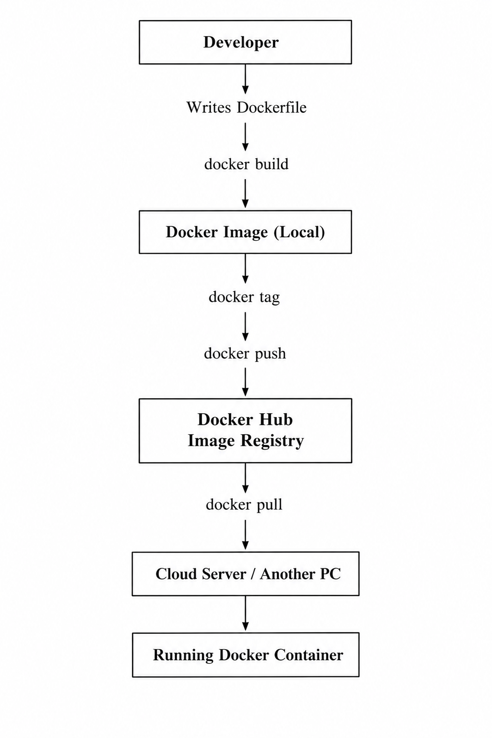
Figure 3.1: Docker Image Publishing Workflow Using Docker Hub
As displayed in figure 3.1, a Docker image is constructed from a Dockerfile and can be downloaded to the computer of the programmer, or pushed to a Docker registry, which we'll refer to as Docker Hub for convenience. From this Docker Hub, an image can be retrieved from any computer or server to implement and share the same applications on other environments.

3.6 Publishing Images to Docker Hub
Publishing Docker Images This is yet another most important step in deploying your software application on cloud instances by using Docker. Therefore, publishing basically boils down to creating an image locally under a particular name and pushing it to the Docker Hub in the first step, followed by the other systems pulling your named image and running it. Publishing a Docker image to the Docker Hub is definitely the simplest and fastest way of deploying an application. No need to ship your code with your application, install your softwares and dependancies onto the machine of your choice one after the other, instead you have an image you could simply share it with the others!
4. Container Volumes
4.1 Introduction to Container Volumes
Docker containers are epemeral by default. That means that any data is contained inside the container and it's destroyed when the container is destroyed. Most applications however require that some of the data on a container be persistent. This is especially true for databases and the storage of files since the data contained within them must be retained even when the container is deleted.
This is done by using Docker volumes which provide an alternate storage location for applications to use in addition to or instead of the writable layer of the container. A Docker volume is a persistent and self-contained storage area that can be mounted on a running container.
The volumes are widely used in cloud computing to store data vital to the applications while also providing the flexibility of managing storage.

4.2 Why Persistent Storage is Required
As explained in section 2, most containers are created and run on a short-term basis and are therefore deleted soon after. However, this is not compatible with most applications that use databases, files, and other persistent data.
It is the nature of Docker volumes to provide an alternate storage location for containers that are short-term or being run on a large scale.
For instance if a dockerized application that requires databases is deployed on a Docker container, then on deletion of that container the database information within the container will also be deleted, this is a major hurdle for most applications requiring use of databases. Fortunately, by using the volumes in Docker we will be able to persist the data in some other place in the computer to be able to retrieve and use when necessary. We must point out at this point that using Docker volumes is also beneficial to application developers as they can program their applications such that their applications have some storage space that they can attach to from out of the container store space, and when the container gets deleted the volumes remain intact.

4.3 How Docker Volumes Work
Most of the Docker volumes in their nature exist outside the scope of the writable layer of a specific Docker container.
It shows that the volume provided by that Docker volume can be directly accessed by the container that provides Docker volume mount point to the container, from within the Docker container. This will give you the freedom to read/write information on the Docker container.
Since the volume exists outside the container, its data can also be accessed and modified even when the Docker container is deleted.
It is also possible to share volumes among different Docker containers so as to share information when necessary.

4.4 Types of Docker Storage
There are different types of Docker storage that can be used for different purposes.
The recommended type of storage to use in Docker is the Docker Volumes that have been discussed throughout this paper.
The other types of storage that can be used include:
- Bind Mounts. : This type of mount allows users to bind files and/or folders on the Docker host and mount them on the Docker container.

- Tmpfs Mounts : The main difference is their performance, though they're extremely quick as compared to others, tmpfs mount would all data gone, if the Docker container gets terminated. Here, you can store some temporary files into the Docker host’s Random Access Memory (RAM).
4.5 Advantages of Docker Volumes
Docker Volumes offer several advantages to the users over the other types of Docker storage.
Some benefits of using Docker volumes to store the data needed by your applications are:
- Data persistence: Any data written into Docker volumes remains persistently on your machine even if you remove the Docker container or the Docker image.

- Backup and restore: Data written into a Docker volumes is easy to back up and restore since the data resides separately from the application requiring it.

- Data sharing: Volumes can be used to share data among different applications since they can be mounted on different Docker containers at the same time.

- Performance: Volumes are optimized for performance since they provide the best storage performance possible for Docker containers.

- Portability: Using Docker volumes increases the portability of applications since it is possible to move applications from one environment to another while also maintaining the data that is required for it to run.

4.6 Applications of Container Volumes
Container volumes are really useful because they let you store data for a time even if you get rid of the container. Databases like MySQL and PostgreSQL use container volumes a lot. So do web servers when people upload things or when they need to keep logs. Big companies also use container volumes to share files between containers. When you are working with native environments container volumes work well with tools like Kubernetes. This makes it easy to have storage that's reliable can handle a lot of work and is not too hard to manage. Container volumes are really important, for this.
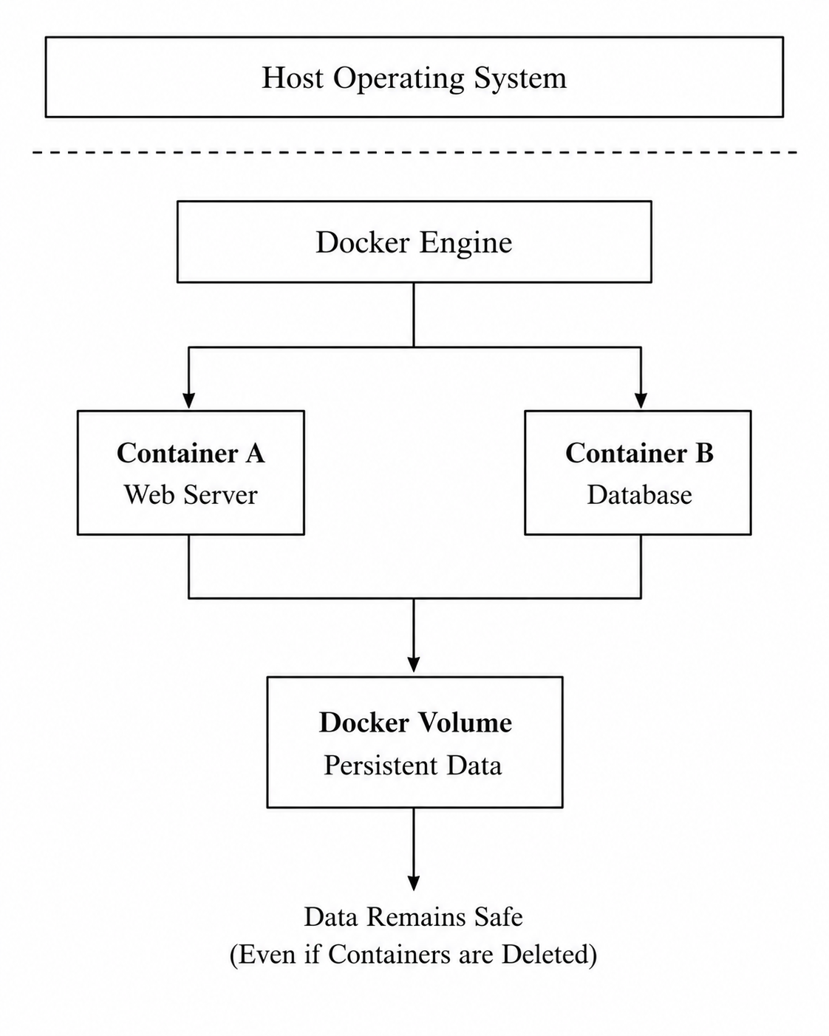
Figure 4.1: Docker Volume Architecture
It is also quite clear from Figure 4.1 that the data is stored in the Docker volume and not in the Docker container. This is because when you remove the Docker container you will still be able to retrieve the data. The data can also be mounted on other Docker containers as explained in this paper.

5. Container Networking
5.1 Introduction of Container Networking
One of Docker’s key features is the ability to allow the communication of its containers, between the host, and to the outside world. The idea behind containers is that a single application can be split into several interconnected microservices.
So an application can run in, besides just web and database servers, a file server or a message server. These Docker containers need to be able to talk to each other for your application to function as expected. Using Docker networking you can share information between them in a way that they're completely isolated from other applications running on the same machine.
By assigning virtual networks to the containers, Docker allows their communication while isolating other services.
Container networking is beneficial for cloud computing and the organization of microservices.

5.2 The Workings of Docker Networking
By default, Docker containers communicate via a built virtual network, which is why upon the creation of a new container, it gains an IP address.
With Docker networking, the containers can directly communicate with each other by sending data through virtual network interfaces.
Such interfaces are connected to the host machine and resemble real computer networks, however they are entirely virtual.
Through the usage of these networks Docker has the capability to separate your containers that are running to other process taking place on the host and also permit them to communicate with one another. It is additionally attainable to set up digital systems all on your own that will let you give containers with private IP tackle that enable to communicate solely with particular services.
This is useful for the isolation of different applications.

5.3 Different Types of Docker Networks
- Bridge Networks: When we use Docker it makes a bridge network by default. This network lets containers on the computer talk to each other. It also keeps them separate from containers on networks so they can communicate in a safe and organized way.
- Host Networks: A host network lets a container use the network of the computer it is running on. This makes the network work faster. It is not as safe because the container and the computer are not as separate.
- Overlay Networks: An overlay network connects containers that are running on computers with Docker. It lets them talk to each other like they are on the network. We often use Docker Networks like this when we have applications that are spread across computers like with Docker Swarm and Kubernetes.
- None Networks: A none network means a container has no network all. The Docker container cannot access the internet. Talk to other containers unless we set up the network ourselves. Docker Networks, like this are very basic. Do not let Docker containers communicate with anything.
5.4 Advantages of Container Networking
- Provides secure communication by isolating container networks.
- Separates applications to prevent unwanted interactions.
- Supports multiple networks for development, testing, and production.
- Makes microservice-based applications easier to manage and scale.
- Improves scalability by allowing new containers to join the network easily.
5.5 The Use Cases and Applications of Container Networking
Docker networking connects services, like web servers, databases and application servers running in separate containers. It is widely used in cloud and microservice-based applications to enable communication, isolation and easy management across multiple servers.
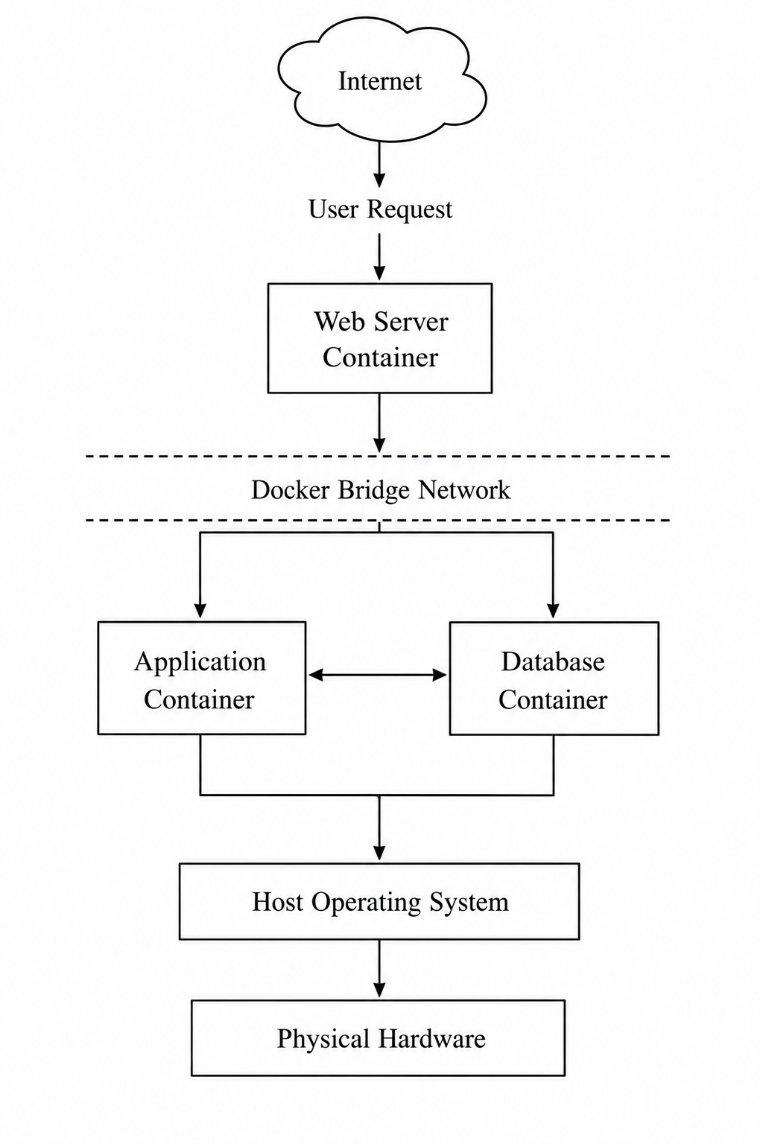
Figure 5.1: Docker Container Networking Architecture
As seen in Figure 5.1, Docker’s virtual network allows multiple containers to communicate with each other across the host machine. Thus, the web server, app server, and database server are connected with a network while being isolated from other services.

6. Complete Docker Practical Demonstration
6.1 Introduction
The main idea of this practical demonstration was to learn the concept of complete process of containerising the web application using Docker.
The following activities were performed in the practical:
- Create an HTML page for the website to be hosted in the Docker Container.
- Build Docker Image with the help of Dockerfile.
- Run the created image in the Docker Container.
- Create a Docker Volume to maintain persistent storage.
- Establish communication between the web application container and other containers with the help of Docker Network.
- Push image to Docker Hub.

6.2 Tools and Materials
The below-mentioned materials were used to perform the activities of the practical:
- Ubuntu Linux Operating System
- Docker Engine
- Docker CLI (Command Line Interface)
- Nano Text Editor
- Docker Hub Account (Used to Push image to Docker Hub)
- Web Browser (To view the website)

6.3 Create HTML Web Page
The initial activity involved creating an HTML web page which would be later hosted in the Docker Container.
Initially a folder was created named ‘DockerAssignment’, the terminal command was used to ‘ cd’ inside that folder. In that ‘DockerAssignment’ folder, by using Nano text editor the following html code was written and saved as ‘index.html’.
The content of the HTML page consisted of some text and other elements to test if the webpage was accessible from the browser. This HTML page would be deployed as the application inside the Docker Container.
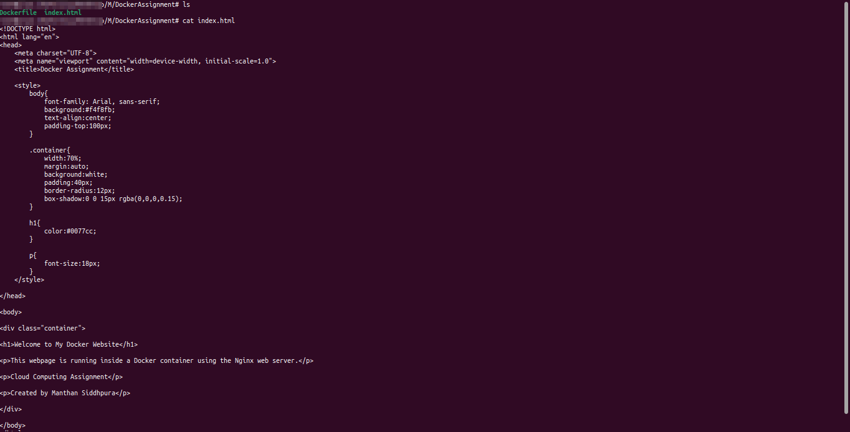Figure 6.1: Project Directory with HTML Code

6.4 Create Dockerfile
The next step was to create a Dockerfile with the help of which Docker image would be built. The Dockerfile consisted of some instructions that Docker would follow during the image creation process.The created Dockerfile is shown below.
The Dockerfile used the official Nginx image as a base image and set the application code (HTML page) as the default webserver document root.
Moreover, the Dockerfile exposed port 80 to make the webserver accessible.The Docker image would be built with the help of this file.
Figure 6.2: Dockerfile to Create Docker Image

6.5 Create Docker Image
The next step involved building the Docker image.
To do that, the build command was used.
After executing this command, Docker read and processed all the instructions mentioned in the Dockerfile and successfully built the image with tag mywebsite:v1.
This image consisted of the Nginx webserver and the HTML page deployed in the Nginx webserver.
To check if the image was successfully built, the images command was used.
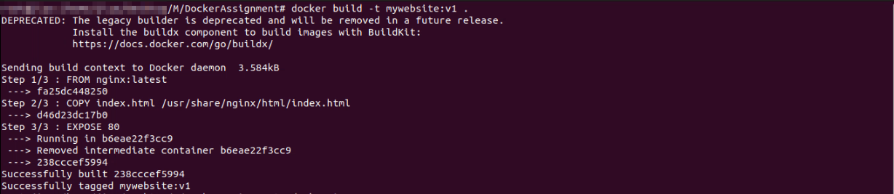Figure 6.3: Output of Successful Image Creation

6.6 Run Docker Container
The next step was to run the Docker container.
So at this point, we basically just took the docker container which we had created in the previous step and we just expose that container’s port 80 to port 8080 on our local host, and the idea was that when we just access it from localhost colon 8080 in our local browser, where we run the commands locally, we should get an html file sent back to us from a web server.
To just verify if the container got created properly we simply use the ps command.
Figure 6.4: Successfully Run Docker Container

6.7 View Website in Browser
To check if the webserver inside the Docker container was accessible or not, a browser was used.The URL mentioned below was typed in the address bar of the browser.
As seen in the below-attached image, the HTML page was successfully retrieved.
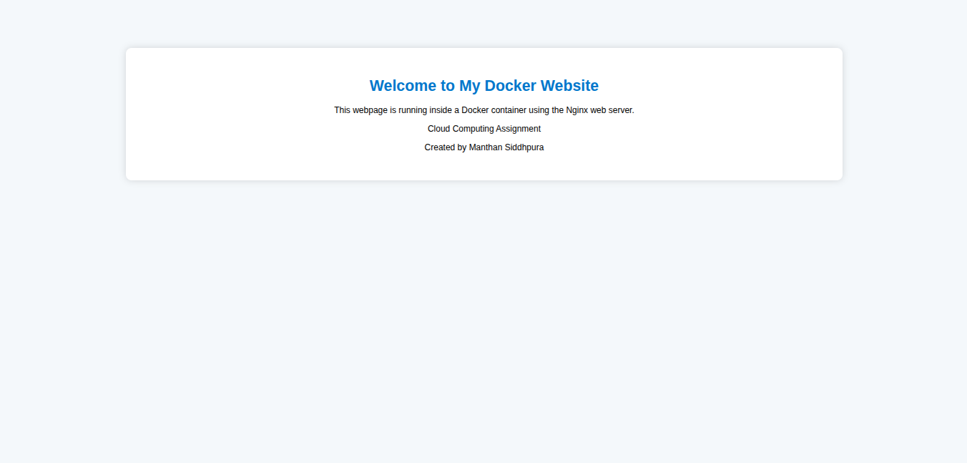Figure 6.5: Output of HTML Page Hosted in the Docker Container
This step checks if the Docker image got built successfully and whether the Docker container started up and is running. If this step succeed, it indicates that the service had successfully been deployed inside the Docker container.

6.8 Create Docker Volume
The next step involved creating a Docker volume.First, a volume named myvolume was created.The created volume was mounted to the default webserver directory while running the Docker container.
The purpose of using Docker volume was to maintain persistent storage.Data stored in the Docker volume remained persistent even after the removal of the Docker container.
To check the created volumes, the below-attached command was used.
Figure 6.6: Creation of Docker Volume

6.9 Create Docker Network
The next step involved creating a Docker network.First, a network named mynetwork was created.The created network was attached to the webserver container. An Ubuntu container named ubuntu-client was also attached to the created network.
This helped in establishing communication between the webserver container and the Ubuntu container.To establish communication, first, the Ubuntu container was opened using the below-attached command.
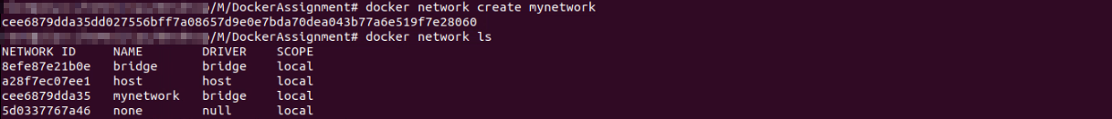Figure 6.7: Create Docker Network
Then, the client was able to communicate with the webserver container as seen in the below-attached output.
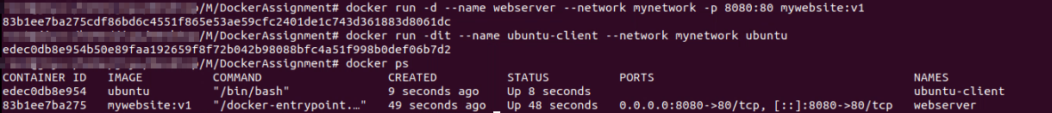Figure 6.8: Multiple Containers Attached to Docker Network

6.10 Publish Docker Image
The last step involved publishing the Docker image to Docker Hub.To do that, first, the login credentials were entered using the login command as seen below.After logging in, the tag command was used to tag the Docker image.The tagged image was pushed to Docker Hub using the push command.

Figure 6.9: Login to Docker Hub
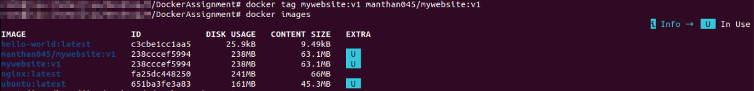Figure 6.10: Tag Image
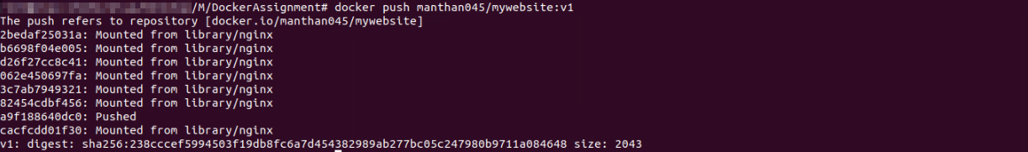Figure 6.11: Publish Image

6.11 Outcome
The entire activity was a great learning experience as it involved working with Docker tools and performing various operations.
It started with the creation of an HTML webpage which would be later deployed in the Docker container.
Then, a Docker image was built which was later run in the Docker container.
Moreover, a Docker volume was created which helped in maintaining persistent storage.
A Docker network was created which enabled communication among the different containers. Lastly, the Docker image was pushed to Docker Hub so that it can be utilized to run the application on other machines too.

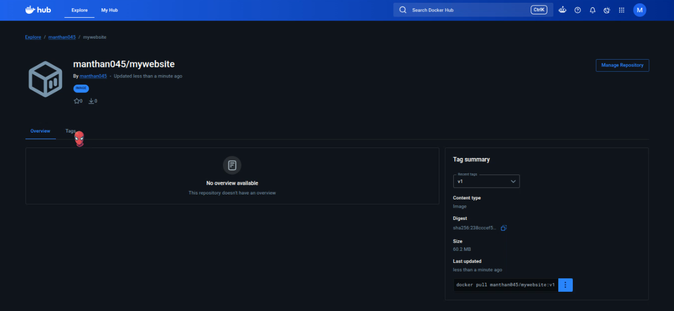Figure 6.12: Docker Hub repository page

7. Driving Forces Behind Cloud Computing and Serverless Computing
7.1 Introduction
Cloud computing has allowed organisations to develop applications in a different manner.
Organisations do not have to invest in hardware and spend on maintaining servers since they can use cloud computing services to host applications whenever they want to deploy them.
It is a more affordable and flexible approach to developing applications because it reduces expenditure and enables faster deployment to meet the needs of the business.
Further, cloud computing has created new methods for deploying applications, and these methods allow developers to build applications in a more efficient way.
An example is Serverless Computing or Function as a Service, which enables developers to leverage FaaS for the purpose of deploying applications without the burden of servers to maintain. Containerisation and serverless computing share many similarities but are generally different in their usage for developing cloud-native application

7.2 Driving Forces Behind the Growth of Cloud Computing
Cloud computing has witnessed a meteoric rise and become a norm in industries for quite some time now due to a number of factors:
- Cost : Cloud computing reduces the need to buy and maintain expensive hardware. Organizations only pay for the resources they use, making it a cost-effective solution.

- Flexibility : Cloud services allow users to access applications and data from anywhere with an internet connection. This makes it easy to adapt to changing business needs.

- Scalability : Cloud platforms can quickly increase or decrease resources based on demand. This helps applications handle more users without additional hardware.

- Reliability : Cloud providers use multiple data centers to ensure high availability. If one server fails, another takes over, reducing downtime.
- Fast Deployment : Cloud computing enables faster application deployment by removing the need to set up physical servers. Developers can launch applications more quickly and efficiently.

7.3 Serverless Computing (Function as a Service)
Serverless computing Serverless computing is a model in cloud computing in which developers are freed of any responsibility to manage the underlying hardware or the operating system but are only responsible for writing and executing their code. The responsibility for managing everything else, including the provisioning of resources for execution, is shouldered by the cloud provider.
Developers only have to write the codes for their applications and let the cloud provider handle the execution whenever there is a request.
Advantages of Serverless Computing for Developers As Serverless Developers: Not worry about host or manages server. No need to maintain and do updates. Don't worry about the application scale, as the cloud provider manages servers for them.
AWS Lambda and Microsoft Azure Functions are popular cloud providers of Serverless.
Serverless cloud provider service options may include functions, which are used to perform a piece of code when an event triggers – for instance, a change to data stored in a data store, a new file uploaded to storage, an incoming request, or even scheduled triggers.
The functions are only active for the duration that they take to execute, and this eliminates idle resources for applications that have sporadic traffic.
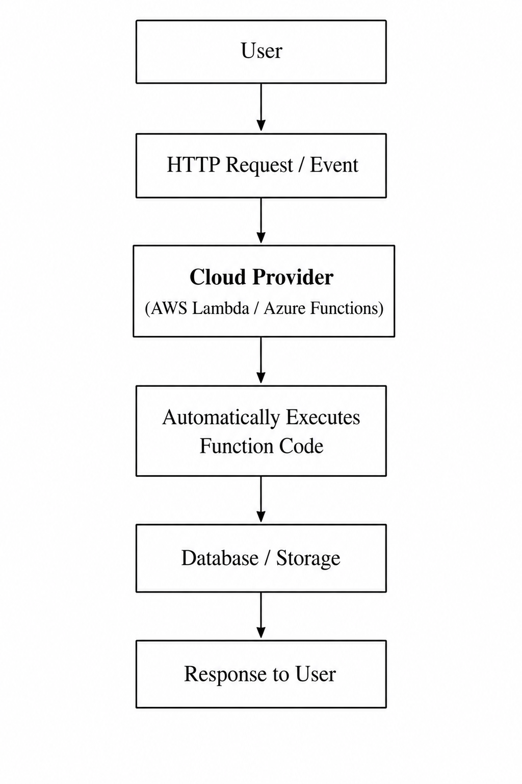
Figure 8.1: Model of Execution for Serverless Compute
From Figure 8.1, one can see that when there is a request for an action the execution of the task triggers a cloud function controlled by the provider.
The cloud provider handles the allocation of resources, execution of the required function, responding to end-users, and releasing the resource after execution.

7.4 Comparison Between Serverless Computing and Containerisation
Serverless Computing and Containerizationare cloud-native application development methods used to deploy applications in the cloud.
While both technologies serve a similar purpose of enabling organisations to take their applications in the cloud without having to host their own infrastructure. There are differences that could see you choose one over the other. Some of the more common differences between Containerizationand ServerlessComputing can be seen below.
Feature | Containerisation | Serverless Computing
InfrastructureManagement | Developers are responsible for managing containers. | The cloud provider manages the infrastructure.
Deployment Unit | Complete application is deployed as a container. | Individual functions are executed in response to a request.
Resource Allocation | Resources are allocated when a container is launched. | Resources are only allocated when functions are executed.
Cost | Containers are billed depending on their size and usage duration. | The cost is incurred when functions are executed and depends on their duration.
Startup Time | The startup time is usually a few seconds. | The startup time is often measured in milliseconds.
Best For | Long-running applications such as microservices. | Applications with events such as automation, scripts, and functions.
Table 8.1: Comparison Between Serverless Computing and Containerisation
Containerizationis best for deploying complete applications because it allows developers to manage the hosting infrastructure.

7.5 Benefits of Serverless Computing
Serverless computing has several advantages over other cloud computing service models.
Among the many advantages of using serverless computing, the most significant ones include autoscaling, cost, reduced infrastructure management, and faster development.
Autoscaling : Serverless computing automatically scales resources based on application demand. This ensures smooth performance without manual intervention.
Cost : With a pay-as-you-go model, users only pay for the actual execution time of their applications. This reduces infrastructure and operating costs.
Reduced Infrastructure Management : Developers do not need to manage servers or system maintenance. The cloud provider handles the underlying infrastructure.
Faster Development : Serverless computing speeds up application development by removing server configuration tasks. Developers can focus on writing and deploying code quickly.

Conclusion
This report explored the fundamental concepts of Docker and demonstrated its importance in cloud computing through both theoretical explanations and practical implementation. The key topics covered included virtualisation, containerisation, Docker images, image publishing, container volumes, and container networking. A complete Docker workflow was demonstrated by creating a Docker image from a Dockerfile, deploying a web application inside a container, implementing persistent storage using Docker volumes, configuring communication between containers through a custom network, and publishing the image to Docker Hub. The report also discussed cloud computing concepts such as load balancing, scalability, application gateways, and serverless computing. Overall, the practical activities and research highlighted how Docker enables consistent application deployment, improves resource utilisation, simplifies application management, and supports the development of scalable and reliable cloud-based solutions.

References
[1] D. Merkel, “Docker: Lightweight Linux Containers for Consistent Development and Deployment,” Linux Journal, vol. 2014, no. 239, pp. 2–6, Mar. 2014.
[2] N. Turnbull, The Docker Book: Containerization is the New Virtualization. James Turnbull, 2014.
[3] K. Matthias and S. Kane, Docker: Up & Running, 3rd ed. Sebastopol, CA, USA: O'Reilly Media, 2023.
[4] A. Mouat, Using Docker: Developing and Deploying Software with Containers, 2nd ed. Sebastopol, CA, USA: O'Reilly Media, 2023.
[5] Docker Documentation
[6] Docker Hub Documentation
[7] Amazon Web Services (AWS) Documentation – AWS Lambda
[8] Microsoft Learn – Azure Functions Documentation
[9] Microsoft Learn – Azure Load Balancer Documentation
[10] NGINX Documentation
[11] R. Buyya, C. Vecchiola, and S. T. Selvi, Mastering Cloud Computing: Foundations and Applications Programming. New Delhi, India: McGraw-Hill Education, 2013.
[12] T. Erl, R. Puttini, and Z. Mahmood, Cloud Computing: Concepts, Technology & Architecture. Upper Saddle River, NJ, USA: Prentice Hall, 2013.

