

Module Title: Financial Management for the Hotel Industry
Module Code: BMIH5007
Student Name: Persima Barreto
Student ID:2243324
Lecturer:Tristan Hawkins
Word count: 2166



Executive Summary
This paper gives a report on the financial management practices of two leading hospitality companies, namely Shangri-La Hotels and Premier Inn Hotels. These areas include total revenue, market position, growth opportunity, and CSR analysis. The case analysis for Shangri-La Hotels finds that its operational revenues originate from luxurious services, exquisite dining, and secure events. A focused differentiation strategy is used to maintain a favourable position in the market where the company targets successful customers who desire unique products. The further recommendation for Shangri-La is to extend this differentiation with more intensive investments in the individualised guest services that would satisfy the increasing consumer needs for more unique, luxurious sensations. Premier Inn Hotel, which competes in the budget hotel segment, mainly depends on accommodation and combined food and beverage services. Chotiwathana’s low-price strategy is further backed up by the promotion of cost-effectiveness as well as standardisation of operations. The prospects for Premier Inn involve keeping up high sustainability initiatives seen as attracting consumers with environmentally friendly products at the same time retaining the company’s affordable pricing strategy. This strategy fits appropriately with what the market now expects from organisations with regard to ethics and could lead to patronage. Altogether, the authors of the report conclude that both of the considered hotels, which belong to different market segments, have potential for expansion with the help of their strategies considered. Shangri-La should continue the focus on the luxury segment, as Premier Inn can enhance the concept of sustainable development to consolidate its positions in the budget segment.

Table of Contents
1. Introduction 5
2. Total Revenue Analysis 5
2.1. Shangri-La Hotels 5
2.2. Premier Inn 6
3. Bowman’s Strategy Clock Analysis 7
3.1. Shangri-La Hotels: Focused Differentiation 7
3.2. Premier Inn Hotels: Low Price 7
4. Market Positioning and Demand Curve 8
4.1. Shangri-La Hotels 8
4.2. Premier Inn Hotels 8
5. Growth Potential 9
5.1. Growth Strategies and Challenges for Shangri-La Hotels 9
5.2. Growth Strategies and Challenges for Premier Inn Hotels 10
6. Financial Commitment to CSR 10
6.1. CSR Initiatives of Shangri-La Hotels and Their Financial Implications 10
6.2. CSR Initiatives of Premier Inn Hotels and Their Financial Implications 10
7. Conclusion 11
8. Recommendations 11
8.1. Shangri-La Hotels: The Focus Differentiation Strategy 11
8.2. Premier Inn Hotels: Price-Positioning Strategy 11
Reference List 13

1. Introduction
The report is an all-inclusive analysis of the two leaders in hospitality, which are Shangri-La Hotels and Premier Inn Hotels. The purpose of this report is to try to get an understanding of their financial management strategies and practices in areas such as total revenue, market position, growth potential and CSR commitment. The report uses Bowman's Strategy Clock to analyse the strategic positioning of each of the hotel groups and analyses the consequences for their demand curves and elasticity. It is structured so that sections deal with these analyses, summing up well-reasoned recommendations for each organisation.

2. Total Revenue Analysis

2.1. Shangri-La Hotels
- Revenue Streams: Shangri-La Hotels generates its revenues from various sources, while the major portion of these revenues is generated from hotel operations, primarily as a result of room occupancy (Sinha and Fukey, 2020). The company operates hotels to cater both to leisure and business travel markets, and it handles a vast array of hotels in several regions. Its dining services, through its restaurants and bars, are also substantial income generators for the company. Apart from that, Shangri-La earns events and conference revenues by hosting corporate meetings, weddings and other events at facilities. Projects of this type, combined with management contracts of third-party hotels, add to its revenue streams.
- Revenue Trends: Shangri-La Hotels experienced tremendous revenue growth in 2023. Consolidated revenue achieved the USD 2.14 billion mark, up 46.5% from the 2022 figures. The effective share of revenue from subsidiaries and associates was at USD 2.77 billion, or up by 44.6% year over year. EBITDA also reflected strong growth with a USD 873.6 million figure in 2023, having increased by 97.8% year on year, marking the improving operational efficiency (Shangri-la Group, 2024a).
- The Key Drivers of Revenue Changes: Major contributors to Shangri-La's revenues have been post-Covid recovery, primarily in Mainland China and Hong Kong, which has witnessed a considerable rise in travel requirements after the pandemic (Su and Zabilski, 2022). The efficiency in the execution of operations, coupled with cost-cutting measures, added impetus to profitability. Global market dynamics have also helped push hotel bookings and restaurant income, mainly in urban business areas.

2.2. Premier Inn
On the other hand, factors associated with the total revenue analysis of Premier Inn are as follows:
- Revenue Sources: The company earns most of its revenues from room bookings in more than 85,000 rooms in its 850 hotels in the UK and its growing operations in Germany (Reid, 2024). Revenues also come from foods and beverages sold through integrated or adjacent restaurants, such as for breakfast and other meals. Premier Inn earns revenues through the events and conferences it hosts especially in city-based locations that focus on business-related traveling.
- Revenue Trends: In the financial year 2023/24, Premier Inn saw statutory revenue at £2.96 billion, up from £2.63 billion in the financial year 2022/23. This indicates that the company's revenues are on the course towards steady upward momentum, with a substantial rise in profitability. The statutory profit before tax increased to £452 million compared to the prior fiscal year when it was £375 million. As for adjusted profit before tax, it reached £561 million, having strong operational performance (Whitbread Plc, 2024).
- The Key Drivers of Revenue Changes: These factors significantly contribute to the revenue growth of Premier Inn as domestic tourism across the nation has bounced back from the pandemic, leading to increased occupancy and room nights (George, 2021c). The new revenue streams have been earned by Premier Inn in Germany for the first time. The vertically integrated business model has enhanced operational efficiencies and continued investment in guest services and food offers has catalysed an increase in customers' spending money.

3. Bowman’s Strategy Clock Analysis
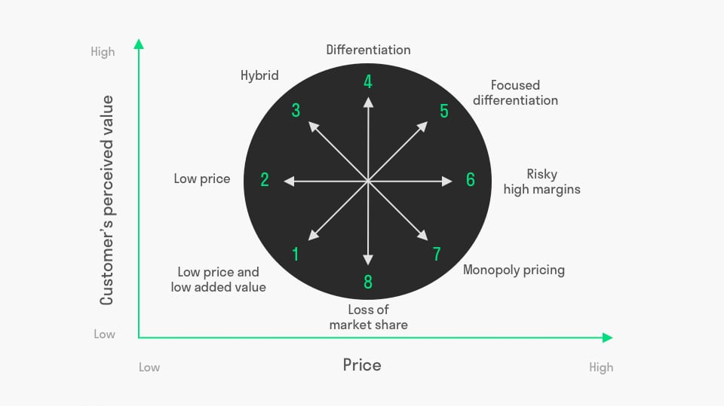
Figure 1: Bowman Strategy Clock model
(Source: nepedup.com, 2024)

3.1. Shangri-La Hotels: Focused Differentiation
Shangri-La Hotels aligns with Focused Differentiation on Bowman’s Strategy Clock. The brand positions itself as a luxury hotel chain, offering high-quality services and exclusive experiences (Bohne, 2021). With its focus on personalised guest services, premium facilities and unique cultural touchpoints in each property, Shangri-La targets a niche segment of affluent leisure and business travellers who prioritise quality and exclusivity over price. The company’s revenue streams from high-end dining, luxury events and premium room offerings reflect this differentiation strategy (Mishra and Kukreti, 2022). Shangri-La’s pricing strategy is premium, catering to customers willing to pay higher prices for superior service and distinctive experiences, enhancing its competitive advantage.

3.2. Premier Inn Hotels: Low Price
In contrast, Premier Inn operates under a Low-Price strategy, positioning itself as an affordable, budget-friendly hotel chain while maintaining good-quality services. Premier Inn appeals to cost-conscious travellers who seek value for money by focusing on cost efficiency, standardisation, and scale (George, 2021d). Its vertically integrated business model, with cost-effective room pricing and integrated dining services, supports the low-price strategy. Premier Inn’s commitment to delivering consistent quality at affordable rates has solidified its position as a leading player in the budget hotel segment.

4. Market Positioning and Demand Curve
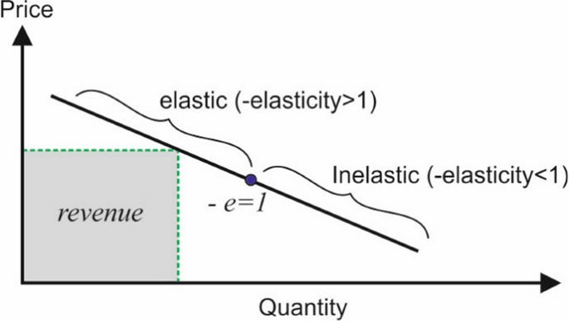
Figure 2: Revenue and Demand Curve
(Source: springer.com, 2024)

4.1. Shangri-La Hotels
Market Share, Customer Demographics and Brand Perception
Shangri-La Hotels is one of the leaders in the hospitality sector in the luxury segment, with over 100 hotels in more than 78 locations worldwide (Shangri-La Group, 2024b). Its strong foothold in Asia serves as a basis for its targeted customers, affluent business executives, and high-net-worth leisure travellers. The target age group is between 30 to 60 years, who opt for quality service and quality amenities. Brand perception is strong as Shangri-La is synonymous with luxury and Asian hospitality, often recognised for its commitment to exceptional service and cultural authenticity.
Impact of Market Positioning on Demand Curve and Elasticity
Since Shangri-La is a luxury brand, its demand is less elastic. This reflects that the changes in prices will have a relatively small effect on the quantity demanded (Chen, 2021). The price premium strategy of Shangri-La can be sustained since its clientele, with relatively higher disposable income, is less responsive to the price surcharges. The brand loyalty and luxury experience value proposition encapsulates this inelastic demand curve for the brand. Economic depressions would decrease the overall demand but would not deter the brand's loyalists from visiting the property even in the worst times (Drury, 2021).

4.2. Premier Inn Hotels
Market Share, Customer Demographics and Brand Perception
On the other hand, Premier Inn is the UK's largest budget-friendly hotel chain. It serves budget-conscious travellers ranging from families to business travellers looking for a relatively less expensive place to stay. The target customers range across various middle income-aged 25 to 55 with an interest in remaining cost-effective without sacrificing too much comfort. The brand is reportedly consistent and perceived as a good value.
Demand Curve and Elasticity Based on Affordability
The budget positioning of Premier Inn leads to a more elastic demand environment. Customer sensibility to price is relatively higher. Thus, small price changes can very drastically influence demand (George, 2021b). For instance, customers would easily look elsewhere for alternatives or consider switching brands, especially when they feel that its current pricing strategies are disadvantageous when the economy is not doing well or during increased competition. With elasticity in the demand environment, Premier Inn prices dynamically and attracts price-sensitive travellers without significantly being affected by lower occupancy rates.

5. Growth Potential

5.1. Growth Strategies and Challenges for Shangri-La Hotels
Shangri-La Hotels falls into this category, so it also has enormous growth potential. It would be able to utilise its Focused Differentiation strategy to access new international markets and expand the business in more in-demand regions. In today's more prosperous economies, especially Asia and the Middle East, Shangri-La's luxury brand can capitalise on the surging demand for premium travel experiences. Thus, the brand can attract affluent travellers in those markets by maintaining its premium service and luxury positioning (Walker, 2021). Furthermore, strategic partnerships and management contracts with third-party hotels facilitate Shangri-La to expand its global footprint without the full capital investment that the ownership requires.
Bowman's focused differentiation strategy will help the company obtain a competitive advantage in growth by focusing on a niche market segment wherein exclusivity and high-quality experiences are significant aspects of interest (Shieni, 2023). The ability to sustain premium pricing and deliver high-quality customer services ensures that Shangri-La continues to be the preferred choice for high net worth.

5.2. Growth Strategies and Challenges for Premier Inn Hotels
On the other hand, Premier Inn Hotels’ expansion strategy is based on a low-price approach, whereby the brand creates a lead in the budget hotel sector. Recent expansion in Germany, where the group is establishing a stronger presence, indicates the scope to capture new markets (Page and Connell, 2020). Premier Inn can further continue growing by finding underdeveloped markets where there is demand for budget accommodation, especially in Europe. The value-for-money model, paired with operational efficiency, makes the company a potential player in these regions.
Moreover, intense competition and saturated markets in the UK restrict the scope of potential growth opportunities. Premier Inn needs to seize customer loyalty and enhance its value proposition to compete with its peers. It must also keep controlling its cost of operations well through low prices, as the market is price-sensitive. Premier Inn can further expand through budget hotels by focusing on low-cost strategies and searching for market gaps.

6. Financial Commitment to CSR

6.1. CSR Initiatives of Shangri-La Hotels and Their Financial Implications
Shangri-La Hotels engages in several CSR programs, such as sustainable sourcing, community engagement and environmental stewardship. Such a mechanism likely incurs operational costs for the company, but sustainable sourcing escalates brand loyalty and customer satisfaction rates. It has been proven that participation of the company in charitable functions enhances the reputation of the company and increases customer goodwill towards the company (Sinha and Fukey, 2020). Investments in energy-saving technologies and waste reduction programs would incur one-time costs but should save money in the long run while delivering operational efficiencies. Such CSR activities will appeal to a subset of consumers who are willing to pay a premium for luxury experiences, with any resulting uptick in operational costs translating into improvements in brand value and market share.

6.2. CSR Initiatives of Premier Inn Hotels and Their Financial Implications
On the other hand, Premier Inn is a brand of Whitbread PLC, which has been significantly contributing to CSR, including carbon reduction and sustainable building practices. It aims to achieve carbon emissions intensity reduction by 50% by 2030 and will reach net-zero carbon emissions by 2040 while committing to 100% renewable electricity in all its hotels (Berry, 2022). New hotels are powered directly by renewable energy, thus decreasing energy costs over time. CSR activities of Premier Inn thus increase the brand value by attracting price-sensitive consumers who still care about sustainability. This can be pretty useful in establishing customer loyalty while distancing a brand in this competitive budget hotel sector.

7. Conclusion
Shangri-La Hotels and Premier Inn best represent how differences in financial management are naturally shaped out from each position along Bowman's strategy clock. Shangri-La's Focused Differentiation will attract affluent travellers such that demand inelasticity and premium prices add enormous value to its revenue growth. On the other hand, Premier Inn makes a use of Low-Price strategy wherein customers are very worried about the price, therefore leading the demand curve to be influenced more heavily than not by the conditions of the marketplace. Both hotels offer differentiated positioning and operational efficiencies to optimise financial performance.

8. Recommendations

8.1. Shangri-La Hotels: The Focus Differentiation Strategy
Shangri-La Hotels should further enhance its Focused Differentiation strategy by focusing on upgrading the guest services in personalisation which is going to expand as demand for individualised luxury experiences continues with the economy (Loureiro, 2022). Luxury customers want quality and exclusivity. Price is inelastic for unique offerings and customers would be a boon for Shangri-La if upgraded guest services were going to be built on customer data.

8.2. Premier Inn Hotels: Price-Positioning Strategy
For Premier Inn, sustainability practices will be essential in attracting price-sensitive customers who also care about environmental issues. Therefore, coupled with increased investment in renewable energy and carbon reduction goals, Premier Inn can continue to attract environmentally conscious visitors but make it at an affordable price (George, 2021a). Customer behaviour studies evidence portrays that consumers are more likely to opt for budget hotels because they align with the values of the consumers. This increases brand loyalty. Thus, by this dual approach, the market share is increased, and Premier Inn becomes a responsible leader in budget hospitality to meet the growing demand for sustainable accommodation (Seal, 2019).

Reference List
Berry, C.T.P., (2022). Equity Research-Whitbread PLC (Master's thesis, Universidade de Lisboa (Portugal)).
Bohne, H., (2021). Recruiting for luxury: Case studies of luxury hotel brands and their co-operative activities for recruiting. Research in Hospitality Management, 11(1), pp.45-52.
Chen, Y., (2021). Economics of tourism and hospitality: a micro approach. Routledge.
Drury, C., (2021) (11th Ed) Management and Cost Accounting,London, Prentice Hall
George, R., (2021a). Characteristics of Tourism and Hospitality Marketing. In Marketing Tourism and Hospitality: Concepts and Cases (pp. 33-61). Cham: Springer International Publishing.
George, R., (2021b). Market Segmentation, Targeting, and Positioning. In Marketing Tourism and Hospitality: Concepts and Cases (pp. 221-246). Cham: Springer International Publishing.
George, R., (2021c). Tourism and Hospitality Marketing Principles. In Marketing Tourism and Hospitality: Concepts and Cases (pp. 3-31). Cham: Springer International Publishing.
George, R., (2021d). Tourism and Hospitality Products, Branding, and Pricing. In Marketing Tourism and Hospitality: Concepts and Cases (pp. 249-283). Cham: Springer International Publishing.
Loureiro, S.M.C., (2022). Technology and luxury in tourism and hospitality. In The Emerald Handbook of Luxury Management for Hospitality and Tourism (pp. 273-284). Emerald Publishing Limited.
Mishra, A. and Kukreti, M., (2022). Challenges and prospects for Oman in the making of luxury tourism destination. The Emerald Handbook of Luxury Management for Hospitality and Tourism, pp.101-121.
Page, S.J. and Connell, J., (2020). Tourism accommodation and hospitality services. In Tourism (pp. 216-241). Routledge.
Reid, S. (2024). What makes Premier Inn Britain’s most successful hotel brand? [online] The Scotsman. Available at: https://www.scotsman.com/business/what-makes-premier-inn-britains-most-successful-hotel-brand-4670202 [Accessed 12 Oct. 2024].
Seal, W., (2019) (6th Ed) Management Accounting, London,McGraw Hill
Shangri-la Group (2024a). ANNUAL REPORT (2023). [online] Available at: https://sitecore-cd.shangri-la.com/-/media/Project/Shangri-La-Group/Investor/Files/Public-Disclosures/Latest-Top-Publications/2023_Annual_Report_E.pdf [Accessed 12 Oct. 2024].
Shangri-la Group (2024b). Welcome: Shangri-La Group. [online] Shangri-la.com. Available at: https://www.shangri-la.com/group/our-businesses/hotels-and-resorts [Accessed 12 Oct. 2024].
Shieni, J.S., (2023). EFFECT OF COMPETITIVE STRATEGIES ON FINANCIAL PERFORMANCE OF SACCOs IN KENYA: A CASE OF NAROK TOWN (Doctoral dissertation).
Sinha, M. and Fukey, L.N., (2020). Circular Economy: Assessing a Progress of Resources Efficient Practices in Hotel Industry. In Circular Economy for the Management of Operations (pp. 89-117). CRC Press.
Su, Z. and Zabilski, A., (2022). What is the relationship between quality of working life, work–life balance and quality of life?. Worldwide Hospitality and Tourism Themes, 14(3), pp.247-260.
Walker, J., (2021) Introduction to Hospitality, Harlow, Pearson
Whitbread Plc (2024). Building Building advantage on our. [online] Available at: https://cdn.whitbread.co.uk/media/2024/05/Whitbread-PLC-Annual-Report-and-Accounts-2023_Single_pages-1.pdf [Accessed 12 Oct. 2024].

