Parallelising Collision Detection
Student Name: Mathew Taylor

P Number: 149885

Module Title: High Performance Computing for Games & Visualisation

Assignment Title: HPC for Games Assignment

Module Lecturer’s Name: Gordon Dickers

Abstract
This report covers the research done pertaining to two different collision detection methods that could be implemented as well as methods for implementing a CUDA version of the collision detection. After the research section, the algorithm chosen as well as the implementation of that algorithm is discussed and the method for parallelising said algorithm is also discussed. At the end of the report, the results found during the development will be discussed and evaluated as well any conclusions made and future work discussed.

Table of Contents
Abstract 2
Table of Figures 4
Introduction and Review 5
Collision Detection Methods 5
Sort and Sweep 5
Uniform Grid Collision Detection 6
CUDA – Uniform Grid Collision Detection 7
Algorithm and Implementation 8
Loading Objects 8
Creating the Grid and Cells 8
Assigning Objects to Cells 8
Collision Detection 8
Rendering the Scene 8
Parallelization of Algorithm and Implementation 11
Setting Up the Passes 11
Collision Detection 11
CUDA Implementation Issues 12
Results and Evaluation 13
Conclusions 14
Future Work 14
References 15
Abstract 16

Table of Figures
Figure 1 - Example of the Sort and Sweep method in 2D[3] 5
Figure 2 - A 2D representation of uniform grid collision detection[3] 6
Figure 3 - An 2D example of the uniform grid with assigned ids to each cell[3] 7
Figure 4 - CPU Implementation with all the objects and grid toggled on, on the right and the data for the grid and collisions on the left 9
Figure 5 - CPU Implementation with the grid toggled off 9
Figure 6 - CPU Implementation with only the green objects toggled on 9
Figure 7 - CPU Implementation with only the red objects toggled on 10
Figure 8 - Cells showing the pass they belong to 11
Figure 9 - CUDA Uniform Grid Collision Detection Result 11

Introduction and Review
The aim of this report is to discuss the comparisons made between the efficiency of running the collision detection of one thousand objects on the CPU and the GPU.
This report will discuss the research done that relates to collision detection methods and a CUDA implementation of collision detection. Once the research is completed the collision detection method was chosen, this will be discussed in detail as well as how it was implemented on the CPU. Finally, the report will discuss the implementation of the chosen collision detection method on the GPU using CUDA and the results found from both implementations will be compared through a timing method.

Collision Detection Methods
Collision detection methods are widely used as just about every game requires some form of collision detection.[1] As a result, there have been many different methods created to handle both 2D and 3D collision detection, in this case it will be 3D collision detection being researched.[2]

Sort and Sweep
The sort and sweep method, also known as the sweep and prune method implements bounding boxes. Each object will have a bounding box that surrounds them. Each object will view other object’s start and end points to determine if those points are between its own start and end points, if they are then a collision detection will be done.[3][1][4] Figure 1 - Example of the Sort and Sweep method in 2D demonstrates a 2D use of this method.
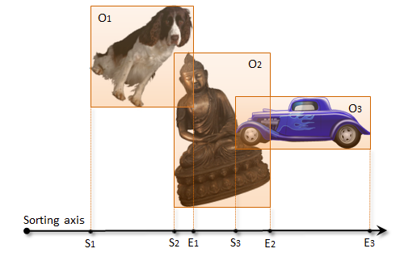
Figure 1 - Example of the Sort and Sweep method in 2D[3]
An advantage of this method is that it isn’t nearly as computationally expensive as performing a collision detection between all the object in the scene. On the other hand, it’s not the least computationally expensive option either as there’s a chance that a large number of object may be clustered together causing a great amount of collision detections to be needed.[5][4]

Uniform Grid Collision Detection
The uniform grid collision detection is a simple and nominal approach to spatial partitioning. With this method, the scene or area that contains all the objects is divided into grid cells, all equal size. The size of the cells created are set to be at least as large as the largest object in the scene.[1][6]
Once the grid has been generated with all the cells of a reasonable size, the objects will have to be added to the cell their centroids reside in. After all the objects are in the corresponding cells, the collision detection calculation phase is next. To perform a collision detection for an object using the uniform grid method, the object being checked will have the distance between it and all the other objects in the same cell and all adjacent cells calculated using Pythagoras. Using the calculated value, it can be seen whether or not a collision has occurred with that object.[7][6][8][3][9]
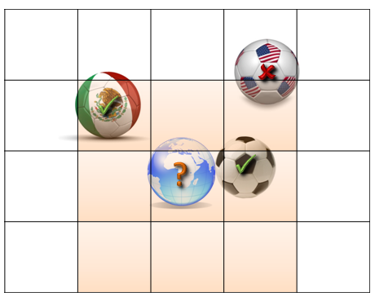
Figure 2 - A 2D representation of uniform grid collision detection[3]
The benefit of using uniform grid collision detection is that it’s generally a lot less computationally expensive than other methods of collision detection. Generally, the developer wants to perform less collision detection calculations due to their complexity. As the uniform grid collision detection method only looks at the objects in adjacent cells, it will only perform the calculations that are necessary and won’t check objects that are on opposites sides of the scene.[6]
The disadvantages of using this form of collision detection are, one that if the correct cell size isn’t chosen then it will cause issues. Cells that are too small may need an unnecessary amount of memory to be stored, and large objects covering several cells will ruin the performance. On the other hand, if the cells are too large, it will cause unnecessary computation as there will be a lot of objects in each cell, causing a lot of collision detection calculations to be done. A solution to this was found to be the hierarchical grids method.[1][7]
The hierarchical grids method involves having multiple overlapping grids with different cell sizes in each grid, this method is however much complicated with regard to tracking the locations of objects.[1]

CUDA – Uniform Grid Collision Detection
CUDA is a programming model created by NVidia for programming on their GPUs. CUDA enables developers to improve the efficiency of computationally expensive applications due to it being a parallel computing platform.[10] When it comes to performing collision detection calculations, games do an immense amount of them. For example, in an FPS (First-Person Shooter), when a bullet is fired, collision detection must be carried out as the bullet travels to determine if it has hit an object. If the player fires many bullets then a great deal of calculations will have to be performed, this is where CUDA comes in. CUDA will run all the calculations simultaneously, making it much faster.[3][9]
In the case of uniform grid collision detection due to memory access violations, not all the cells can be calculated at the same time. This means that multiple passes are required to complete the uniform grid collision detection. Each cell in the grid should be assigned a number, that number represents which pass it will be in as shown in Figure 3 - An 2D example of the uniform grid with assigned ids to each cell. This ensures that the same calculation won’t be performed at the same time and cause memory access violations as mentioned previously.[3]
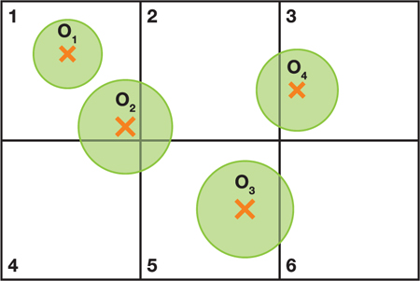
Figure 3 - An 2D example of the uniform grid with assigned ids to each cell[3]
In the book ‘GPU Gems 3’, they discuss the idea of implementing a CUDA variation of uniform grid collision detection. In the book an idea of processing all the generated cells in parallel rather than the objects was shown.[3]

Algorithm and Implementation
The chosen collision detection method to be implemented was uniform grid collision detection as this method isn’t very computationally expensive and will allow the CPU to complete it quicker than other methods. [6]

Loading Objects
The first step of implementing this method is to read the one-thousand generated objects being used in from a file, this file contains the positions of the objects and their radiuses. This information is stored in an array of a structure called objects. A separate short script was made to generate the one-thousand objects as it would be far too time consuming to make them all and many objects were needed for the comparison to be necessary.

Creating the Grid and Cells
The size of the cells is determined by finding the largest radius of the objects loaded in and multiplying it by two to get the diameter, this ensures that all the cells are greater than or equal in size to the largest object. This ensures that the performance will not be ruined by objects that cover multiple cells. Next the number of cells to be made is calculated by using the pre-set screen sizes in all three dimensions divided by the size of the cell. Finally, the minimum and maximums of each cell is found on the x, y, and z axis and stored in an array of structures called grid.

Assigning Objects to Cells
All the objects are assigned to cells based on their positions, there was one issue with doing it this way, there was a chance an object may be positioned on the edge of one cell and the edge of another cell. Due to an object being able to be in multiple cells, it was set so once and object has been added to a cell, it can’t be added to another one. The added objects are stored in that cells grid structure to be used later. Next a separate structure is made to store which cells have objects in them so the cells with objects can easily be accessed.

Collision Detection
This is the stage where the collision detection occurs. Every cell that has an object in it will be looked at, when looking at a cell if there are more than one objects in the cell, a collision detection will be done between all the objects within the cell. Next all the adjacent cells to the cell being looked at will be checked and a collision detection will be done between all the objects in the cell being looked at and all the objects in the adjacent cells. The total amount of collisions found will be totalled and output to the user.

Rendering the Scene
This part may not be implemented in CUDA depending on time constraints as it’s not a requirement. At this stage all the objects will be rendered for the user to view, objects will be green if they haven’t collided and objects will be red if they have. The grid will also be displayed, these can all be toggled on and off. The ‘r’, ‘g’, and ‘f’ keys are used to toggle the objects and cells on and Figure 4, Figure 5, Figure 6, and Figure 7 demonstrate the output after all the calculations have been performed.
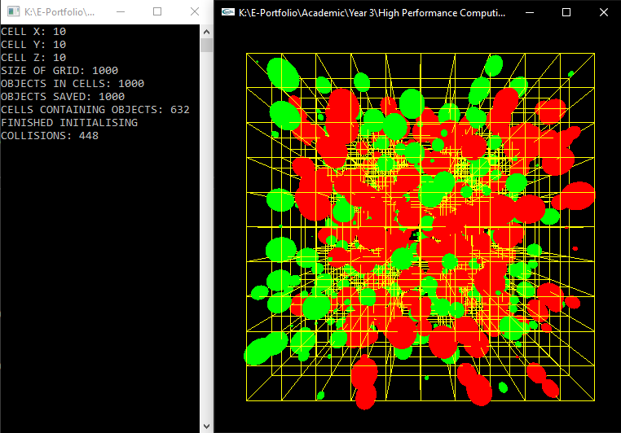
Figure 4 - CPU Implementation with all the objects and grid toggled on, on the right and the data for the grid and collisions on the left
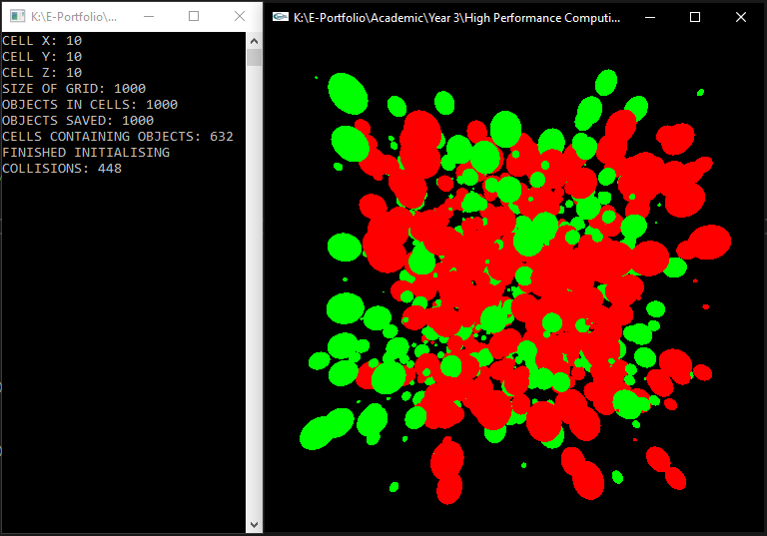
Figure 5 - CPU Implementation with the grid toggled off
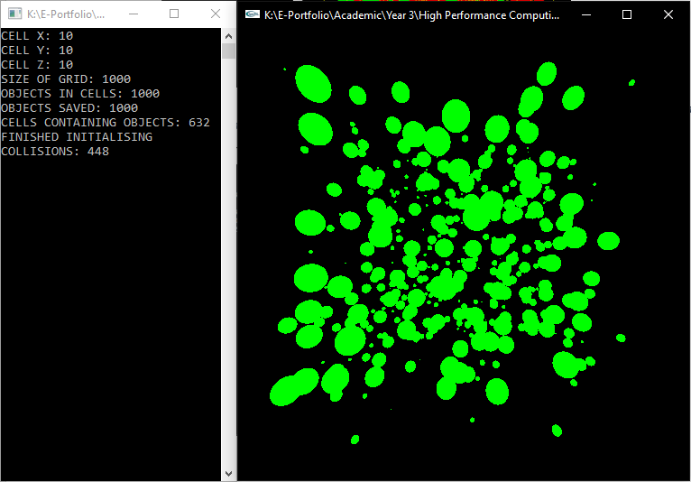
Figure 6 - CPU Implementation with only the green objects toggled on
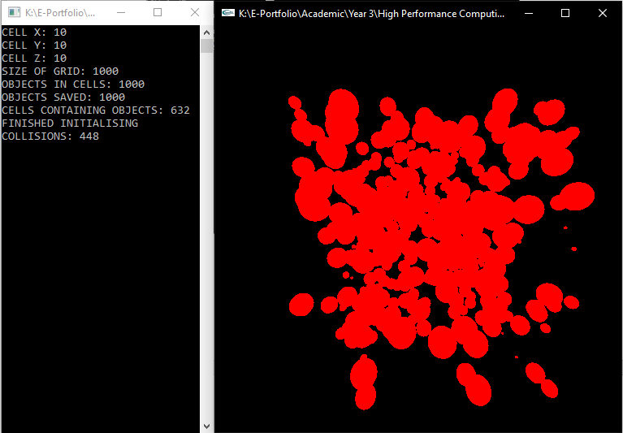
Figure 7 - CPU Implementation with only the red objects toggled on

Parallelization of Algorithm and Implementation
The chosen method for parallelising uniform grid collision detection, is to parallelise the cells in the grid. What this entails, is each cell will look at all their adjacent cells at the same time and perform any necessary collision detections. However, it was found that should all the cells’ collision detections be done at once, it would cause serious issues as the cells and could attempt to use the same data at the same time, to solve this, multiple passes will be done. As the collision detection requires each cell to look at all the adjacent cells in 3D space, that means there’s twenty-six cells that each cell must look at, which means that none of these cells can be running at the same time. This leads to the conclusion that a total of twenty-seven passes are required.
When it comes to parallelising the CPU, implementation developed in the algorithm section, all the initialisation steps are almost identical. The first three steps are the same.

Setting Up the Passes
After the grid is fully set up and the objects have been assigned to the cells, it must be determined which cells are in which pass. This is done based on the positions of the cells, if the cell is on the front, bottom of the grid then it will be set to one, two, three from left to right and then repeat again, until it’s reached the end of the grid. Figure 8 demonstrates how the passes are assigned.
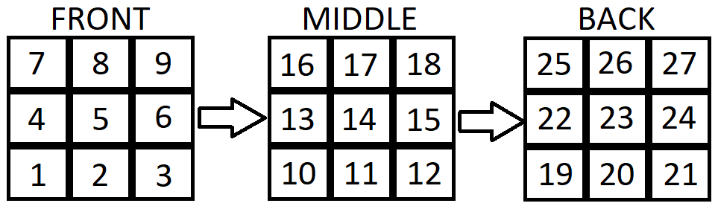
Figure 8 - Cells showing the pass they belong to

Collision Detection
CUDA will be run twenty-seven times to account for all the passes. Each pass, all the necessary information will be passed through, this is the same information used on the CPU’s collision detection. The pass and the number of cells for that pass are also passed into the kernel. The number of cells for that pass determines the number of threads to be used for that pass. In the kernel the only cells that will be looked at are the cells that are in the current pass, the collision detections will occur the same way as the CPU implementation at this point. Once the first pass has been completed, the second pass will start, this will continue until all the passes have been completed.
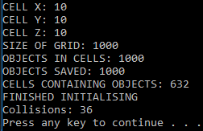
Figure 9 - CUDA Uniform Grid Collision Detection Result

CUDA Implementation Issues
During the implementation of collision detection into CUDA, it was found that CUDA doesn’t support multi-dimensional arrays or at least a way to implement them wasn’t found. Due to this, the 3D array being used to store the cell information had to be converted to a 1D array.
After the implementation of collision detection in CUDA was complete, it was found that unfortunately it returns and incorrect number of collisions. This is believed to be caused by an issue with how the values for the objects are being copied from the host to the device.

Results and Evaluation
Room 204 University Computer Speed Test
Execution Number | CPU Time (Seconds) | GPU Time (Seconds)
Execution 1: | 18.1 | 25.7
Execution 2: | 17.5 | 25.9
Execution 3: | 20.2 | 26.8
Execution 4: | 18.3 | 25.7
Execution 5: | 17.5 | 26
Average: | 18.32 | 26.02
During the testing of the CPU and GPU implementations, the GPU was returning an incorrect number of collisions. The CPU returned 448 collisions, while the GPU returned 36, this means that the GPU implementation should be quicker, however due to the time it requires to set up the kernel it takes roughly 7.3 seconds longer. These results were done using 1000 cells, as the number of cells increase the CPU would in all likelihood slow down while the GPU will begin to require less time than the CPU due to more cells being parallelised.

Conclusions
The results achieved in this assignment weren’t quite what was expected. The expected result would be that both the GPU and CPU implementations would return the same number of collisions and the GPU would be faster. However, the CPU ended up being quicker than the GPU in this case and the GPU was found to be performing less collisions than the CPU.

Future Work
The future work that needs to be completed would be the fixing of the CUDA implementation, as it doesn’t return the correct number of collisions currently.
Implement OpenGL into the CUDA implementation to display the collisions to the user.
Make the CPU and GPU use a large number of cells to demonstrate how the times are affected with a larger number of cells.

References
[1] R. R. Kroiss, “Collision Detection Using Hierarchical Grid Spatial Partitioning on the GPU,” 2013.
[2] R. Weller, “A Brief Overview of Collision Detection,” Springer, Heidelberg, 2013, pp. 9–46.
[3] “Thinking Parallel, Part I: Collision Detection on the GPU | NVIDIA Developer Blog.” [Online]. Available: https://devblogs.nvidia.com/thinking-parallel-part-i-collision-detection-gpu/#disqus_thread. [Accessed: 12-Feb-2019].
[4] D. R. Caldwell, “Coordinates Series A, No. 2 Unlocking the Mysteries of the Bounding Box.”
[5] B. V. Mirtich, “Impulse-Based Dynamic Simulation of Rigid Body Systems,” Kuffner.Org, pp. 1–259, 1996.
[6] “GPU Gems | NVIDIA Developer.” [Online]. Available: https://developer.nvidia.com/gpugems/GPUGems3/gpugems3_ch32.html. [Accessed: 12-Feb-2019].
[7] G. E. Blelloch, “‘Prefix sums and their applications’ by Guy E. Blelloch,” 1990.
[8] teschner, “Collision Detection based on Spatial Partitioning.”
[9] D. Barbieri, V. Cardellini, and S. Filippone, “Fast Uniform Grid Construction on GPGPUs Using Atomic Operations.”
[10] M. Heller, “What is CUDA? Parallel programming for GPUs,” 2018. [Online]. Available: https://www.infoworld.com/article/3299703/what-is-cuda-parallel-programming-for-gpus.html. [Accessed: 02-May-2019].

Abstract

