My Digital life. (DS1 assignment)

Screenshot/Photo 1
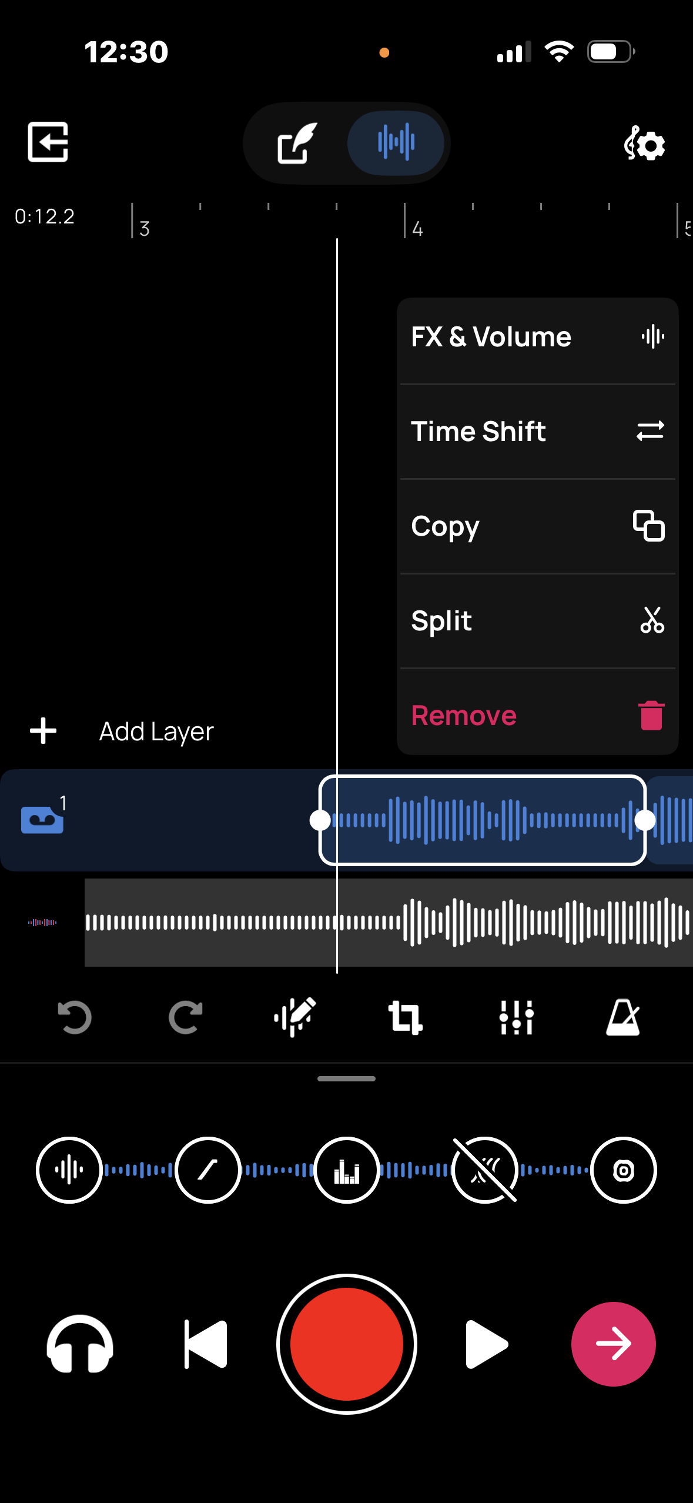

This is a screenshot of me editing one of my songs.

Screenshot/Photo 2
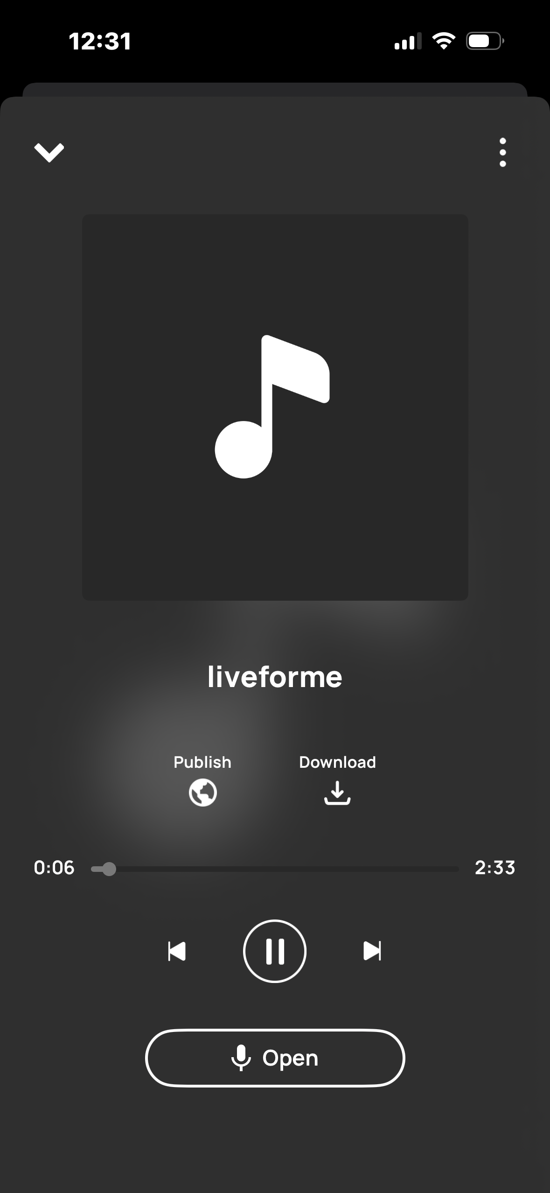
This is a screenshot of me using the playback function to listen to my song.

Screenshot/Photo 3
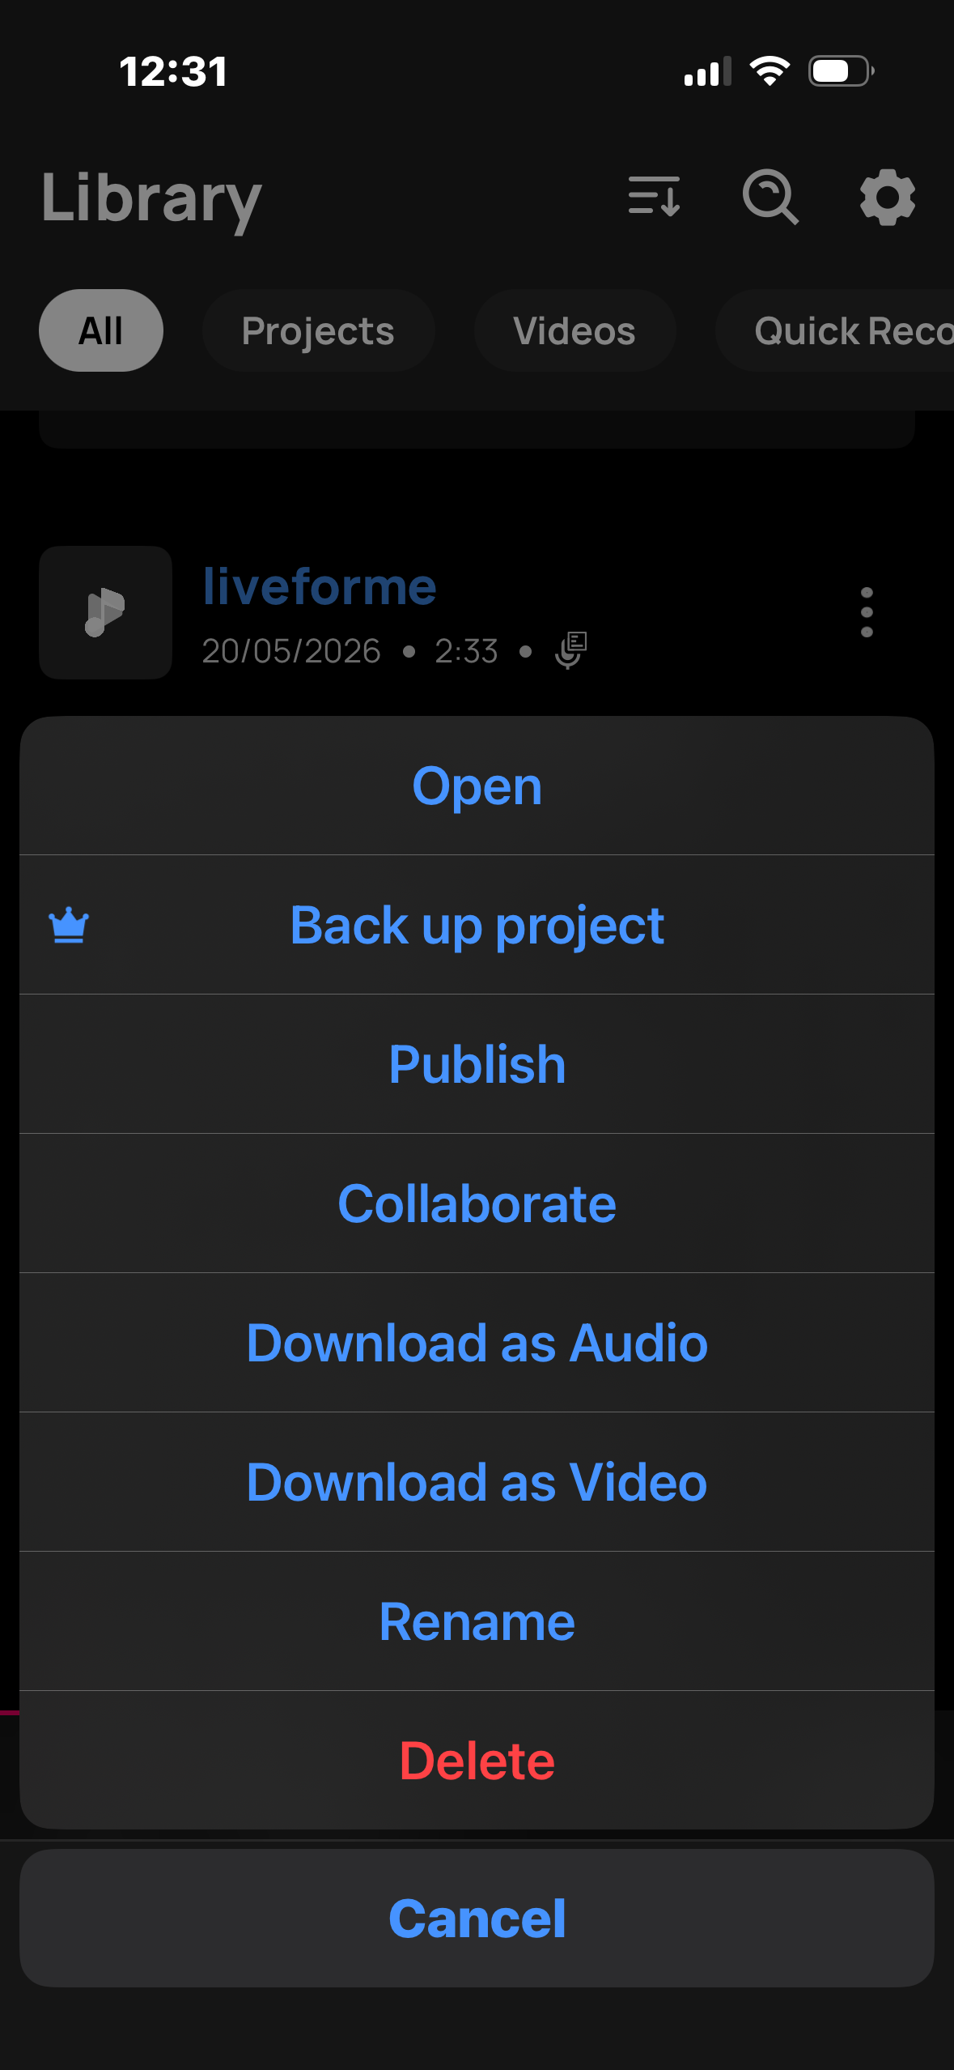
This is a screenshot of me using the ‘more options’ tab to download my song on to my phone.

Screenshot/Photo 4
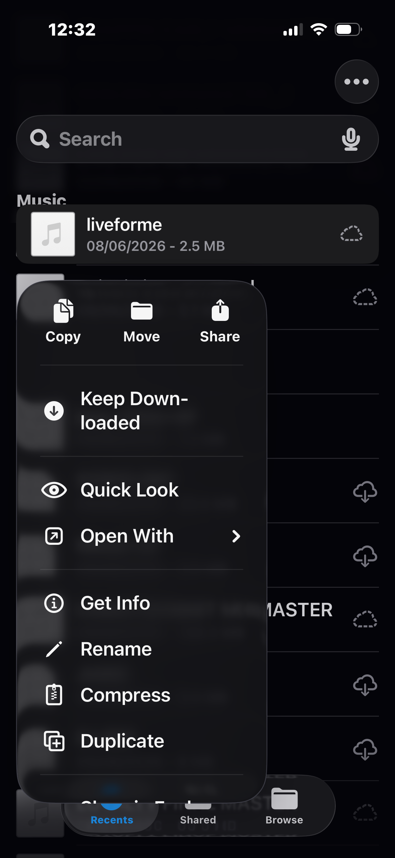
This is a screenshot of me managing my files.

Screenshot/Photo 5
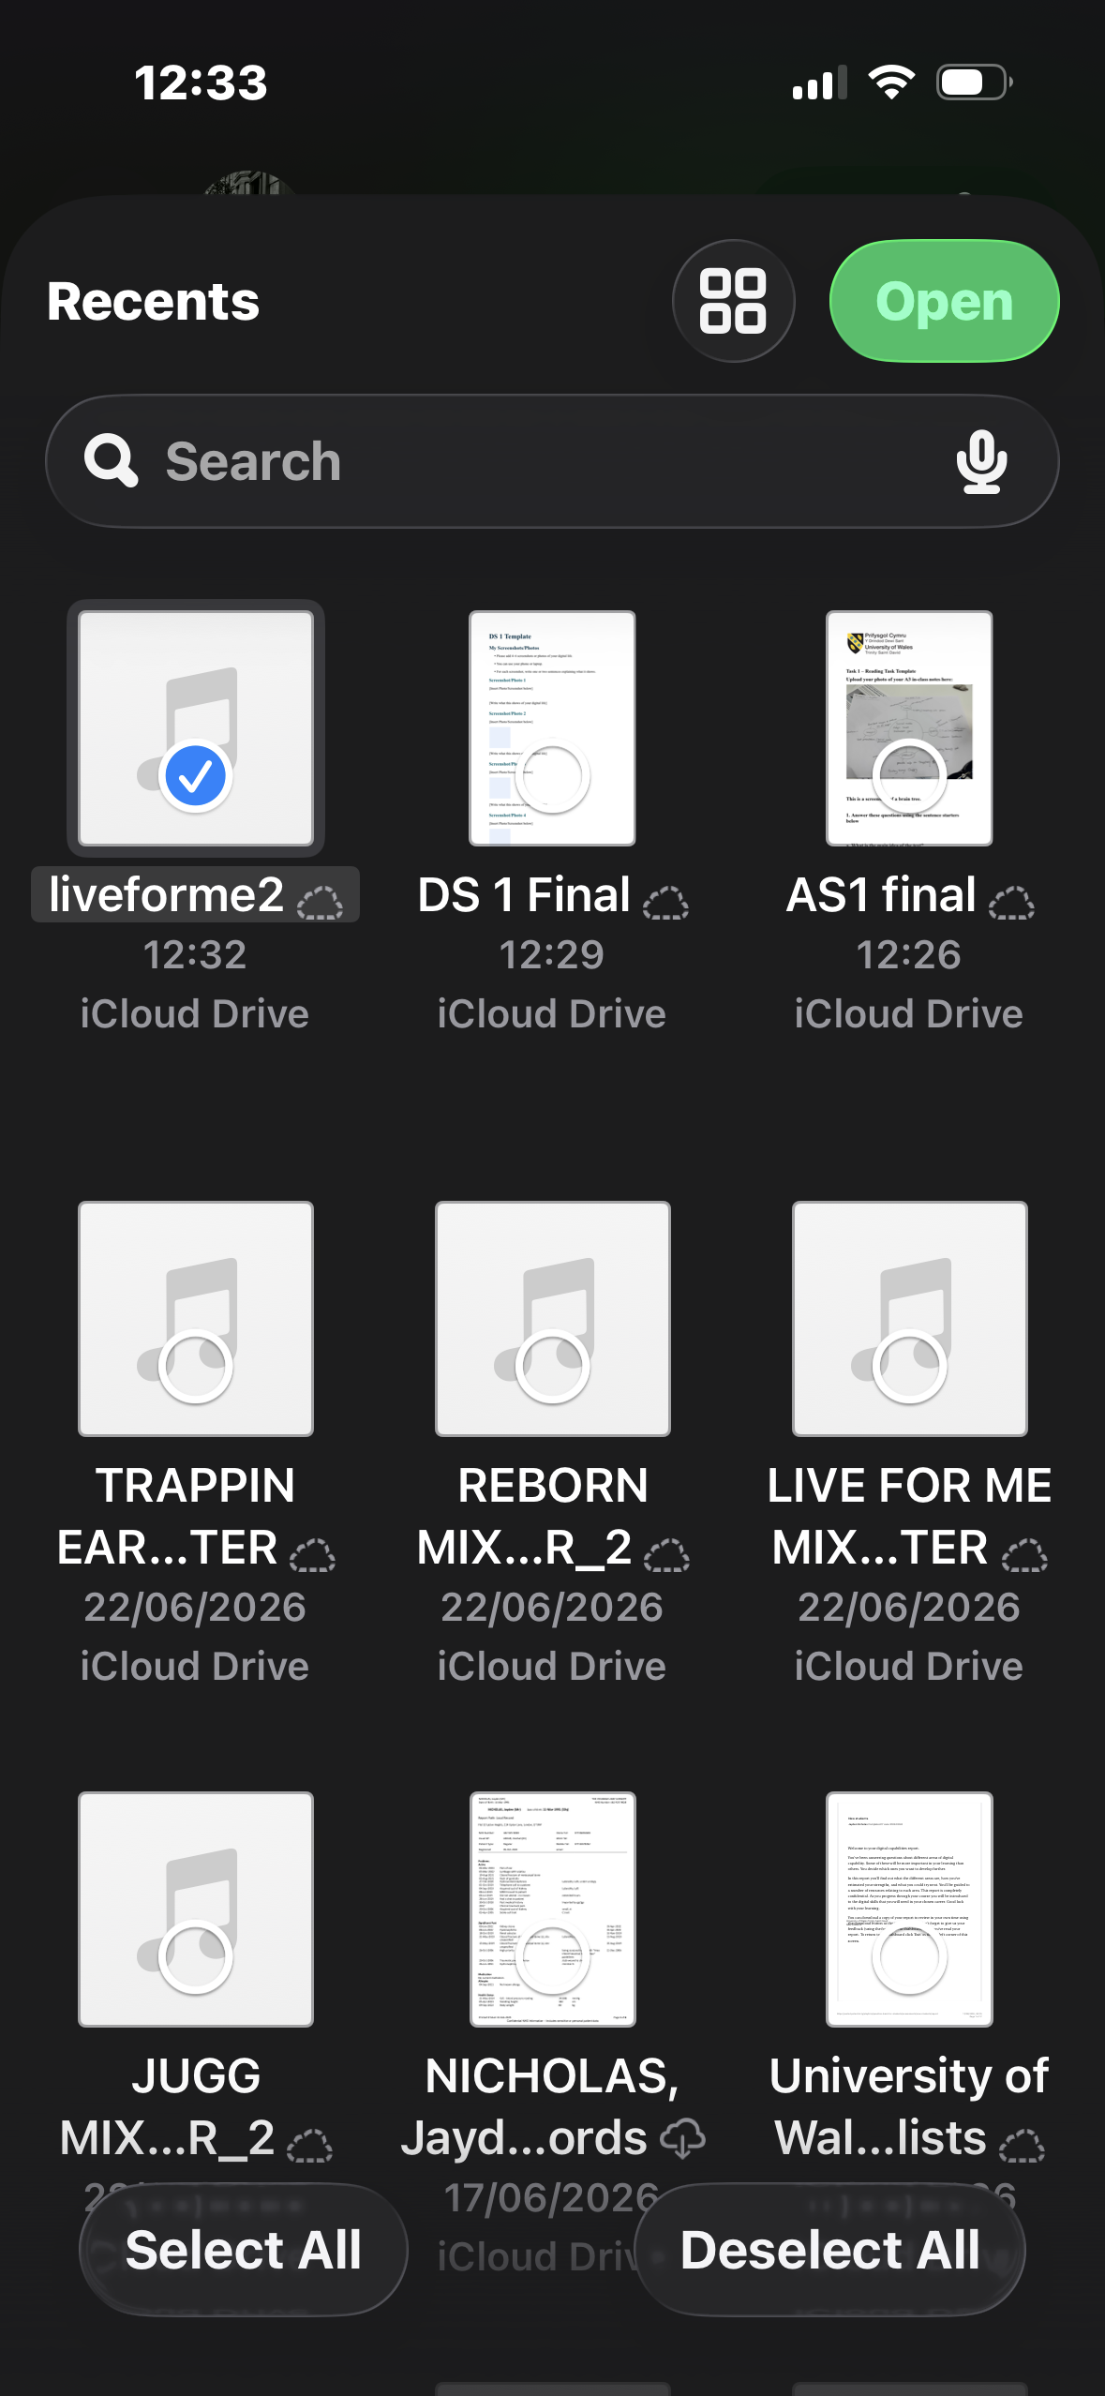
This is a screenshot of me sending my song to a friend on WhatsApp.

Screenshot/Photo 6
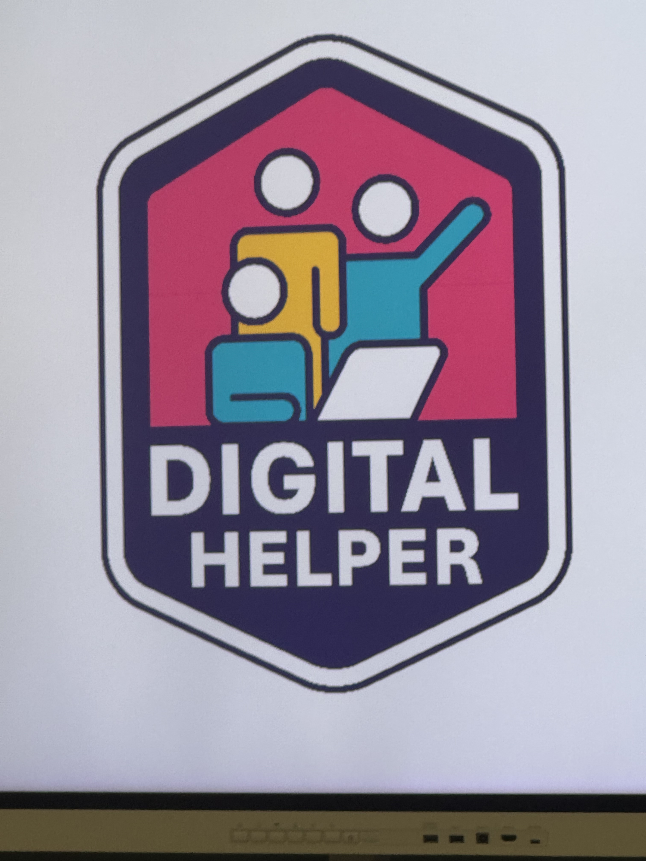
This is a screenshot of my digital helper badge. This badge was given to me by my lecturer for helping my peers in class.

My Short Reflection

I use digital tools to help with my creativity. I also use digital skills in my day to day life by using Gmail.
I feel very accomplished when I have made a song from scratch that people like. I would like to improve my music engineering skills as I often use these tools on my phone and would like to be confident while doing so on a laptop.
Digital skills are important because they are used in business. From making reports on excel to communicating through email to a supplier or customer. All different types of digital skills are relevant.

