Appendices

Appendix A

Lesson Study 1 Lesson Plan

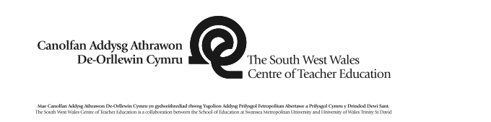 |  |  |  |  |  |  |  |  |  |  | 1B

Session Plan – Key Stage 2
Name of trainee: |  | Harriet Thomas |  |  |  | Session ref: |  |  | E046
Personal target(s) in relation to QTS: |  |  |  | S3.2.1  They make appropriate use of a range of monitoring and assessment strategies to evaluate learners’ progress towards planned learning objectives, and use this information to improve their own planning and teaching.
Year group: | 6 |  | No. of learners: |  | 23 |  | ALN: JTW  RR
Additional Adults: |  |  | Mrs Maggs
Learning objective(s):  - To redraft our stories. |  |  |  |  |  |  | Success criteria:  - Nelly’s Nag List- Proof read work, always use capital letters and full stops.  - Punctuation  - Similes and Metaphors  - Verbs, Adjectives and Adverbs  - Paragraphs  - Sentence Connectives
Links to previous learning:
- Previous learning on similes, metaphors, alliteration and onomatopoeia.
- Previous knowledge on book genres and how the characters, setting and plot indicates the genre of the story.
- Ability to re-draft a story.

Curriculum coverage (range, skills)
- Choose and use a wide range of adventurous and imaginative vocabulary with precision.
- Craft their writing by using the standard forms of English, e.g. nouns, pronouns, adjectives, adverbs, prepositions, connectives and verb tenses.
- Proofread their own work and that of others, assess and evaluate it and make clear recommendations for improvement; edit/redraft work to show progression.
- Speak and listen individually, in pairs, in groups and as members of a class.

Literacy (LNF)  - Use varied and appropriate vocabulary, including subject-specific words and phrases  - Reflect on, edit and redraft to improve their writing.  - Use paragraphs making links between them. |  |  |  |  |  | Numeracy (LNF)  /
DCF  - Type up final draft. |  |  | Thinking  - Activate prior skills, knowledge and understanding on story writing.  - Determine the success criteria before main activity begins. |  |  | ESDGC  / |  |  |  | YCC  /
Key vocabulary (English/Welsh):
- Detective/ Mystery
- Myths and Legends
- Science Fiction
- Traditional Fairy Tales
- Story Map
- Characters
- Setting
- Beginning

- Build up
- Problem, Resolution
- Ending
- Verbs, Adverbs, Adjectives
- Similes
- Metaphors
- Alliteration, Onomatopoeia
- Story Writing
- Dydd Gwener Chewfror 15
- Brashem’s Tortoise
- Story
- Genres
- Horror
- Adventure
- Historical
- Fantasy

Time | Session activities, organisation and management | Key questions & Assessment for Learning opportunities
9:00-9:20am | Introduction:
9:00-9:20am | - Recap on their first drafts and have a few children to discuss theirs. Considering their chosen genre, settings, characters, problem and solution. Have the children to read a few sentences from the beginning of their story and the ending of their story.  - As a class discuss ideas of the stories that have been read and share as a class. Can you pick out any powerful words or sentences? Can you guess the genre? Why?  - Reflect on Nelly’s Nag list and generate a Success Criteria as a class before the lesson starts. |  | - Activate children’s prior skils, knowledge and understanding on story writing.  - Reflection  Reflect on previous learning- drafting a story, similes and metaphors, adjectives, verbs and adverbs.  - Questioning  Assess understanding within the introduction through questioning and answers.
9:00-9:20am |  |  | - AFL- Nelly’s Nag List
9:00-9:20am |  |  | This is an extension of success criteria. It consists of criteria which the teacher expects for almost all of the work undertaken in class.
9:20-10:20am | Main activities:  - Redraft their stories, looking back and reflecting on their first draft to check and improve any errors within their writing and how they can improve their story in this draft. |  | - AFL- Success Criteria  On the board list the success criteria for the lesson, generate these as a class with both pupil and teacher input. E.g. for this lesson- paragraphs, punctuation, similes and metaphors, adjectives, verbs and adverbs etc.
9:20-10:20am | Mid-way Plenary: 9:45-9:55am  - Recap on success criteria  - Verbally peer assess- ask children to share parts of their story and as a class we will point out what’s good and how it could be improved.  - Question the children’s work and ideas.
10:20-10:30am | Plenary:  - Discussion and sharing of stories.  - Peer and Self-Assessment- 2 stars and a wish.  - Those who finish first can type up their story redraft on the computer, adding images to their story to print and stick in their book. |  | - Plenary Discussion  Allows an assesment of understanding after the main activities have been completed.  - AFL- Peer and Self-Assessment  Peer assessment is uniquely valuable because learners may accept feedback from one another which they might not take seriously from a teacher. Meaningful self-assessment is often a direct by-product of effective peer assessment: learners need to be ‘coached’ in self-evaluation through modelling questions and thinking with others initially.  - AFL- Two Stars and a Wish  This is a tool to make sure that positive comments (the stars) and a target (wish) are given for work. It works well in peer, teacher and self-assessment.

Lesson Study 2 Lesson Plan

 |  |  |  |  |  |  |  |  |  |  | 1B

Session Plan – Key Stage 2
Name of trainee: |  | Kelly Price |  |  |  | Session ref: |  |  | 210219ENG01
Personal target(s) in relation to QTS:
Year group: |  |  | No. of learners: |  | 31 |  | ALN: | 11
Additional Adults: |  |  | 1 - support children. Mainly the ALN children
Learning objective(s):  Skill: Adapt what is written for purpose and reader, choosing words appropriately.  Context: Script writing |  |  |  |  |  |  | Success criteria:  Must: identify suitable vocabulary for the news report.  Should: write a simple script for their new report.  Could: deliver the news report to camera.
Links to previous learning: Children have completed a lesson using hot seating where they worked in groups to talk to a survivor of a natural disaster. This will continue on from that, using the same groups and scenario.
Curriculum coverage (range, skills)
Oracy. Developing and presenting information and ideas – speaking, listening.
Writing. Write for a variety of purposes. Organising ideas and information – meaning, purpose, readers. Structure and organisation.
Writing accurately – language, grammar punctuation spelling handwriting.

Literacy (LNF)  Yr 3 - Explain information and ideas using relevant vocabulary. Organise what they say so that listeners can understand. Speak clearly varying expression to help listeners. Keep in role and support others in role play. Contribute to group discussion, sharing ideas and information. Note down ideas to use in writing. Review and improve sections of their work. Use basic structure for writing. Present processes, event or reports in a clear sequence.  Yr 4 – Organise talk so that different audience can follow what is being said. Adapt talk, showing understanding of the differences between informal talk and more extended talk with a wider group. Explore different situations through role play. Contribute to group discussion and help everyone take part. Adapt what they write to the purpose and reader. Gather ideas to plan writing. Improve writing, checking for clarity and organisation.  Yr 3 & 4 – write for a variety of purposes including narrate, discuss/analyse, explain, inform, recount and empathise. Write in a range of continuous and non-continuous texts in a variety of forms (including scripts). Write for a range of authentic audiences, real or imagined. Use language appropriate to writing including standard forms of English. Use vocabulary related to the topic. |  |  |  |  |  | Numeracy (LNF)
DCF  Some children will type up and print the script they have drafted with their groups. |  |  | Thinking |  |  | ESDGC  Natural disasters – children may talk about the effect on the environment. |  |  |  | YCC  Some natural disasters may take place in the local area/Wales.
Key vocabulary (English/Welsh): Script, actor/actress. News report, reporter, witness.

Time | Session activities, organisation and management | Key questions & Assessment for Learning opportunities
 | Introduction
Explain today’s lesson – children to plan for a news report linking to natural disasters.
Remind children of last week – natural disaster hot seat.

Explain that we are going to be reporting on the Avalanche that hit the hotel in Switzerland – linking to newspaper report.
Read must should could.

Watch video and then discuss what was included – pause if need to so that can add this to the board under must should could as extended success criteria
https://www.bbc.co.uk/newsround/news/watch_newsround

Show scriptwriter masterclass – recap after video/pause at intervals to talk about what has been said.
http://www.bbc.co.uk/schoolreport/28309703

 | Main activities
Give them information about the story they will be reporting on – show video of avalanche aftermath and print the report.
Video of hotel after the avalanche
https://www.bbc.co.uk/news/av/world-europe-46843893/swiss-alps-avalanche-workers-clear-snow-from-inside-the-hotel

Give children the sheets relating to who is who
2 x studio reporters
2 x reporters at the destination
2 x witnesses (these can be people helping to sort the hotel out after the avalanche/a survivor or someone who saw it but wasn’t in the hotel)

Once sheets are completed give the template for the script – Group 1 write on this sheet – write your part but help each other

All other groups can use this sheet but expand on it if they need to.

Stop lesson halfway through and remind of success criteria and things discussed as being required for a news report.

Ask some children to read what they have on their information sheet and/or any parts of the script they have completed – peer assess these as a class. Redirect children to check their work against success criteria.

 | Plenary
Ask children to read their script – give some information.

Practice for the recording in front of the class.

Appendix B

Focus Group Interview Questions

- Tape record interview
- Write down seating arrangement
- State date and time
- State to the 3 children that no names will be shared, only we will know about your feedback and the tape recording will be deleted after myself and Miss Price/Thomas have completed our work.

- Was there anything you enjoyed about today’s lesson?

- Was there anything in today’s lesson that you felt was useful in keeping you involved with your work?

- Remember when we stopped and discussed ________ & ________ work and looked at the lesson success criteria?

- How do you feel about doing this in the lesson?

- Did stopping you to do this help you stay involved in the lesson?

- Why do you think/ feel this way?
Changed this question for the second focus group interview.

5. Did this effect your involvement?

We felt it lead the children to answer just to please us as teachers.

- How would feel about doing this again in other lessons?

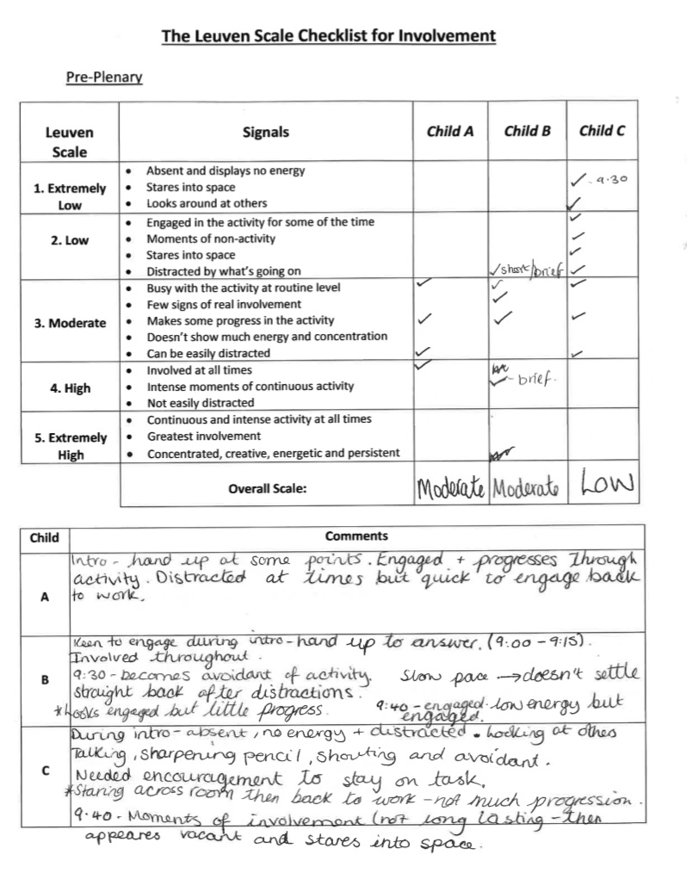
Appendix C
Lesson Study 1 Observation

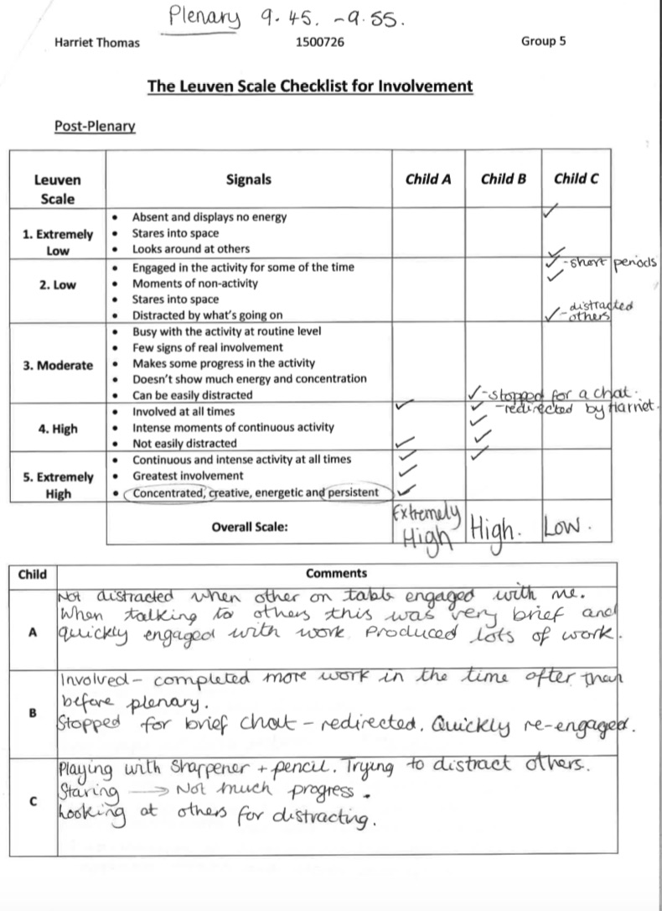

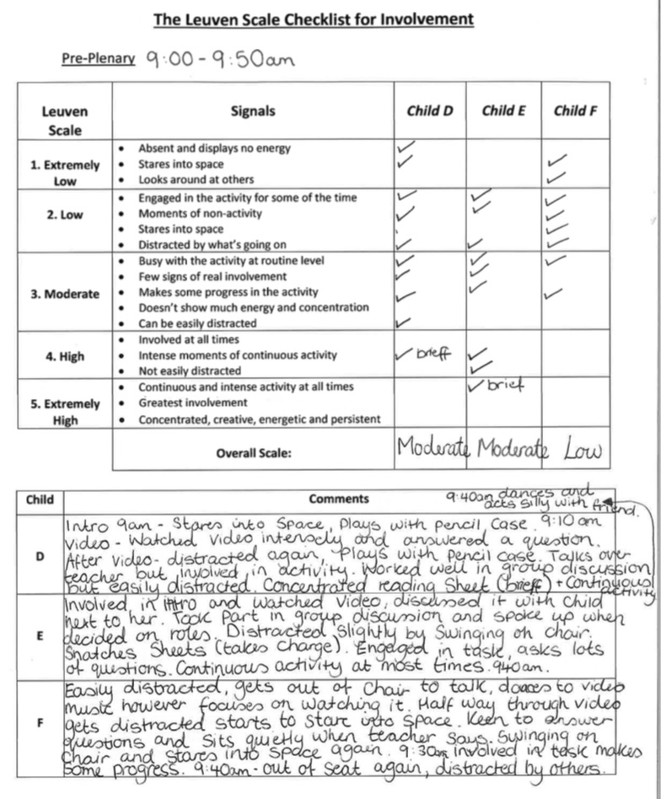
Lesson Study 2 Observation

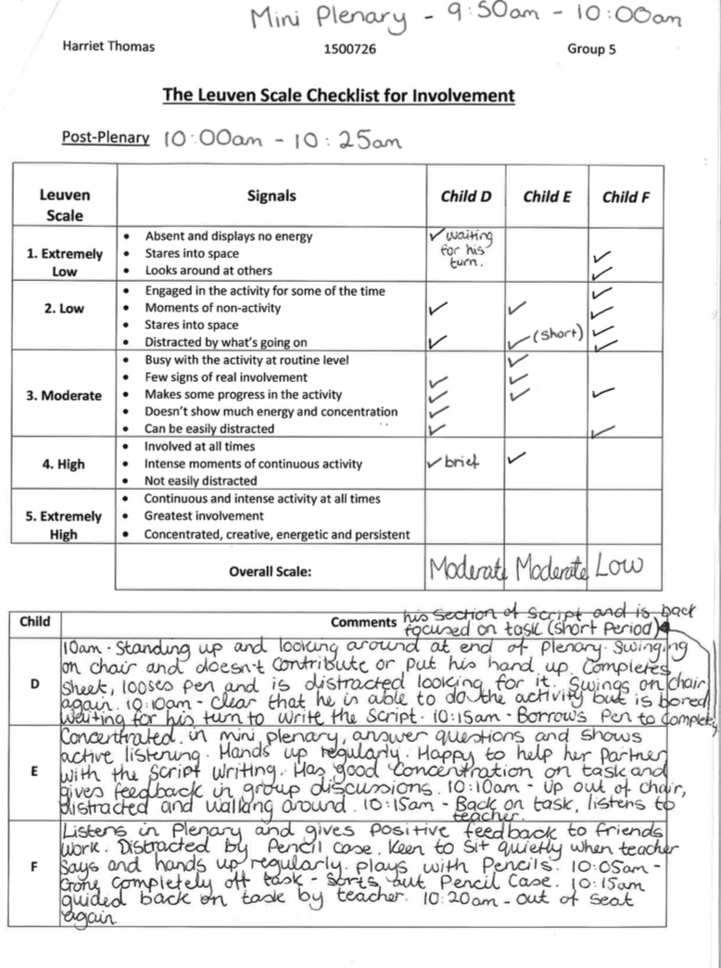

\\

Appendix D
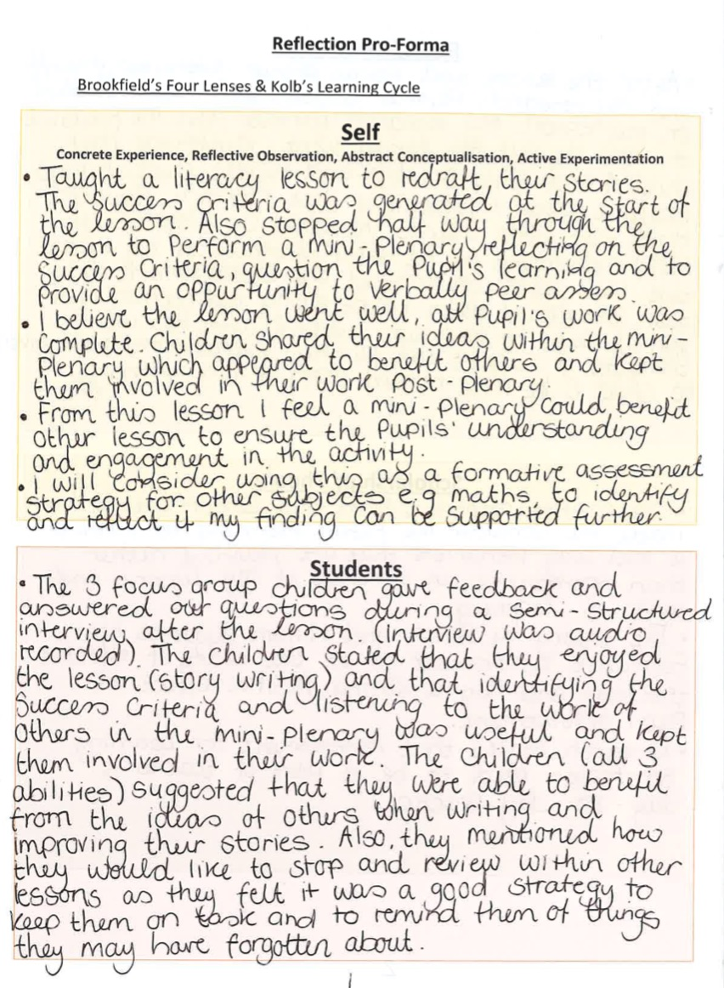
My Reflection Pro-Forma (Lesson Study 1)

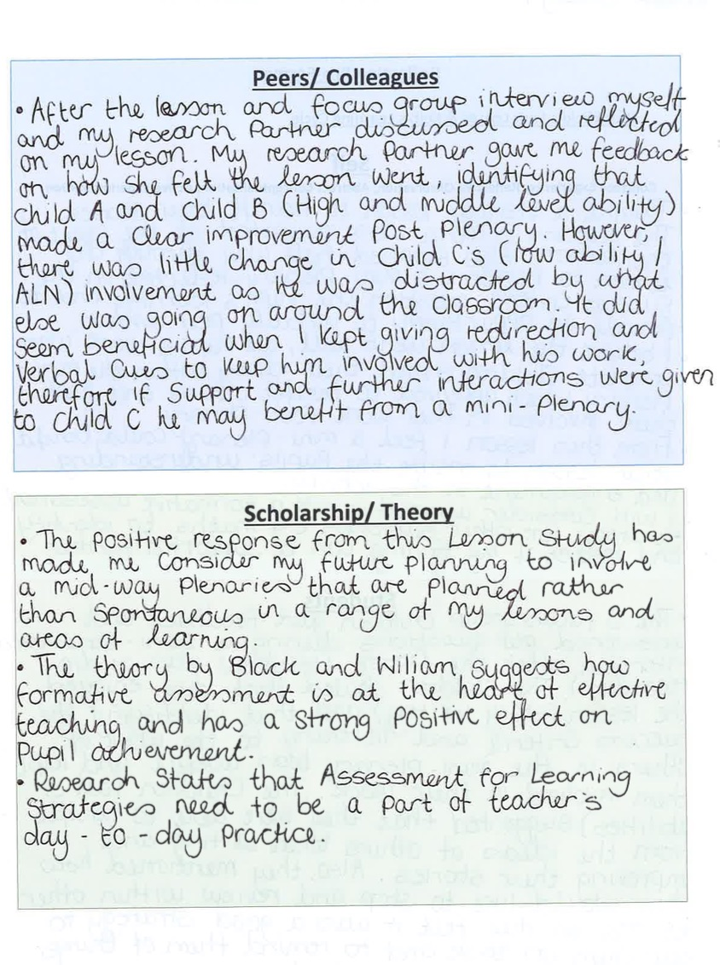

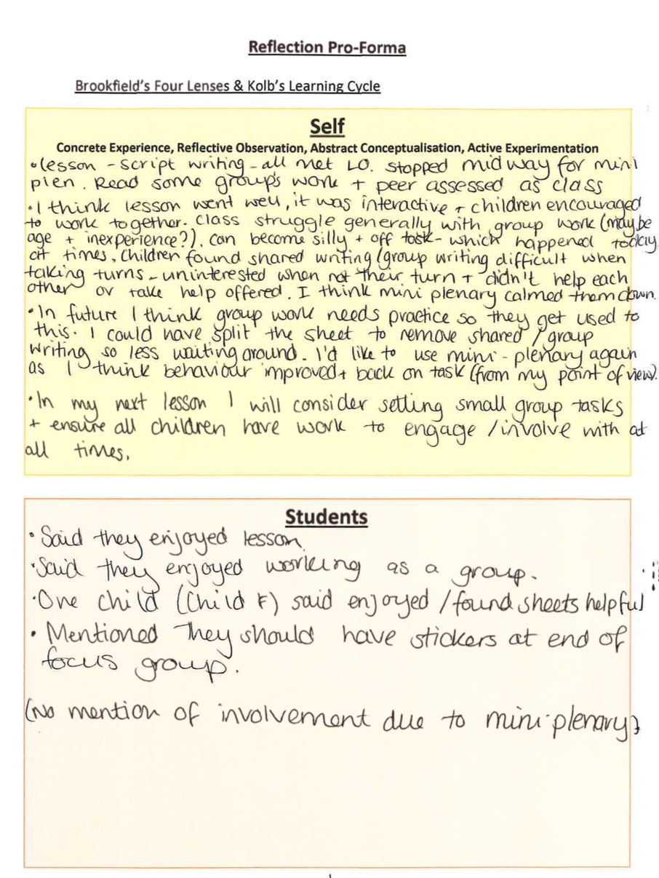
My Research Partner’s Reflection Pro-Forma

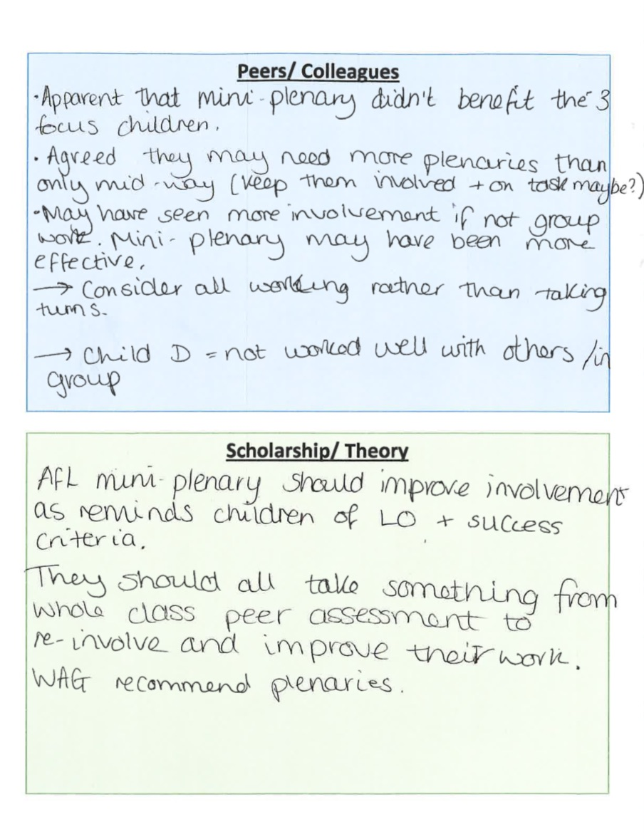

Appendix E

Assent Process

To acquire assent from the pupils I will verbally inform the class as a whole stating exactly what will be happening.

- Inform the children that the purpose of the research is to find out whether stopping during the middle of the lesson to reflect on their work, recap on the learning objective and to discuss the aims of the lesson is beneficial to them and keeps them involved in their work.

- State that a friend who is another trainee teacher will be coming in to observe the lesson to identify whether the teaching and learning is working well and what happens when we stop during the middle of the lesson. Miss Price/Thomas will be sitting in our class writing some notes and watching how we work.

- Encourage the children to be themselves and to show Miss Price/Thomas how great our class is!

- Identify that 3 children will be asked to talk to myself and Miss Price/Thomas at the end of the lesson to reflect on it and to discuss how they felt it went.

- Say that the feedback given by the 3 children will help myself and Miss Price/Thomas with our research for University, to look at how the lesson went and to consider the views of children from our class.
(Before focus group interview highlight that no names will be shared, only we will know about your feedback and the tape recording will be deleted after myself and Miss Price/Thomas have completed our work.)

- State that if any of the children do not what to be a part of the research, such as notes being made about them or questions being asked to them, they can withdraw at any time they just have to let one of us know.

- Identify that this research will help us as trainee teachers to know how to improve future lessons and to see what ways of teaching work best within the classroom. Say that the information collected will help us to write our essay for university and to become better teachers.

