Marketing Fundamentals

MADE BY MIHAELA PLACINTA
ID 2028614

Contents
Introduction 3
Company Overview 3
Process and steps of marketing 4
Internal analysis of Burberry 6
SWOT analysis of Burberry 6
VRIO analysis 9
External analysis of Burberry 11
PESTLE analysis 11
Market Segmentation 14
Burberry's target market and positioning 15
Marketing Mix of Burberry 15
Impact of Covid-19 on Burberry 16
Conclusion 17
Reference 18

Introduction
Marketing is the practice of actively stimulating demand for an organization's goods and services (Lancaster and Withey, 2006). Marketing aids a company in enhancing its brand value as well as the pace at which goods or services are sold. The marketing department's main responsibilities include market research, segmentation, target market selection, and business promotion. An organization's efficiency and long-term viability can be boosted by properly implementing marketing processes and strategies (Russell 2009). Investigative marketing, cause marketing, connection marketing, and constraint marketing are examples of marketing tactics used by a variety of companies to increase brand value, sales rate, productivity, sustainability, and wealth, among other things. In the following report, as a marketing manager, I will undertake an internal and external study of Burberry from the standpoint of marketing process, taking into account the likely influence of Covid-19 on Burberry's performance and financial performance. With a view to accomplishing the study, this report encompasses marketing process, segmentation, targeting, positioning, marketing mix, PESTLE analysis, SWOT analysis, and Porter's Five Forces analysis of Burberry.

Company Overview
Burberry is a dominating luxury brand of the fashion industry of UK. It is an age-old fashion brand which has been providing luxurious offerings since its birth. It was originated by Thomas Burberry in 1856. Burberry is headquartered in Horseferry Road, Westminster, London, UK. At present Burberry is one of the giant luxury brand which occupies around 420 shops in 59 countries and almost 9800 employee in now working in this company. With such an enormous market, it was ranked 73rd in Inter-brands Best Global Brands report. This brand is very much popular for leather goods, fashion accessories, perfumes, cosmetics, eyewear etc.


Process and steps of marketing

Figure 1: 5steps of marketing process.
- Understanding the Marketplace and the need and wants of customer: with the purpose of developing a value laden relationship with clients and providing a satisfactory market offering while recognizing the requirement, The customer's wants and demands are significant and critical, and they aid an organization in building long-term customer equity (Joshi 2005). There are many rivals that do business in the same marketplace, although it is critical to evaluate the market to acquire a comprehensive image of the competitors, their marketing methods, and the market trend. The better a firm understands the industry and its clients, the better it will be able to develop great marketing tactics that will assist the company to get competitive advantages. Consumers would accept items and services given by a business on an ad hoc basis, based on their needs and demands.
- Creating a Customer-Centered Marketing Plan: The major goal of the marketing process is to satisfy consumers so that a firm can retain a loyal connection with them, which is why marketers create a customer-driven marketing plan that puts the customer first (Verhage and Visser, 2007). To do so, an organization's marketers must first identify the target consumers they wish to serve, and then determine the best approach to service those customers in order to satisfy them. It is possible to pick a target market by segmenting the market into different segments. Marketers should create a compelling value proposition in order to provide the finest benefits to customers. There are five options for building a customer-driven strategy: product idea, production concept, selling concept, marketing concept, and societal concept. Of these five concepts, marketing concept is the most suited for assuring consumer primacy.
- Creating a comprehensive marketing strategy that provides exceptional results: It's time for marketers to design an integrated marketing plan that will give additional value to customers after they've identified their target customers and chosen the best ways to serve them. The 4Ps (marketing mix) and the collaboration of marketing tools used by the firm to accomplish the marketing strategy are the core components of an integrated marketing plan. Marketing programs turn marketing strategy into action in order to build consumer relationships (Stone, 2007). To achieve this, all marketing techniques must be combined into an integrated and complete marketing campaign that will work together to give the promised value to customers.
- Establishing Profitable Partnerships: The ultimate method of customer relationship management is to establish client happiness by providing better customer value in order to sustain a lucrative and trustworthy customer connection. Customer relationship management prioritizes generating high customer equity and ensuring a customer's lifetime value. The key to developing a long-term customer connection is ensuring customer happiness and delivering customer value. Organizations nowadays are increasingly concerned with developing a long-term and beneficial connection with customers in order to boost sales and profits.
- Getting the Most out of Customers: When a consumer has a high level of loyalty to a company, the customer's equity is also high. When a consumer is happy, he or she becomes loyal to the company and will continue to buy or use the services supplied by that company. Creating Consumers' worth may be measured in terms of sales, profit, market share, and other metrics. The more consumers acquire or utilize services, the more value a business may extract from them. The ultimate goal of completing marketing operations is to get value from clients in return.

Internal analysis of Burberry
Internal analysis refers to the process of analyzing all the factors that affect the organization from inside (Moore and Pareek, 2006). Internal environment encompasses resources allocation, asset management, production process, marketing process, competitors, abilities and weaknesses etc. Every management board of modern organizations always remain up-to-date with the changes of the factors of internal environment. Because all of this contributes to the decision-making process by determining the scope of development and modification in order to formulate a suitable company plan. SWOT analysis, resource capability analysis, VRIO analysis, value chain analysis, core competencies analysis, GAP analysis, strategy review, and McKinsey 7S Framework analysis are all examples of internal analysis. A handful of these will be examined in the following sections from the standpoint of Burberry.

SWOT analysis of Burberry
SWOT Analysis is a method to examine the internal environmental factors (Smith, and Albaum, 2005). This method is used by the managers to find out the strengths and weaknesses associated with the organization. with the help of this method, mangers can be acknowledged with the opportunities and threat existed in the market. I will discuss in details about SWOT analysis of Burberry:
Strengths:
Iconic | 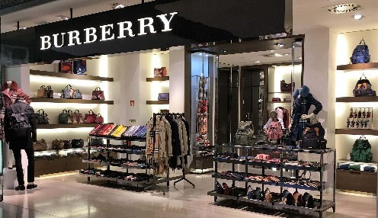  Burberry is an ancient brand which is renowned for its classy offerings.
Immediately recognizable | Since it is an international brand, it brings variety and class even in the wrapping, and the brand logo which give it an undersigned identity to the customers.
Powerful customer loyalty | Because of having reputation for offering enriched quality products, customers trust Burberry only by its name.
Presence on a global scale | Having almost 410 shops in 59 countries, gives it a upper rank as a luxury brand.
Weaknesses:
Huge Price Range | As it provides premium products, the price of the products are so high. Which prohibits mediocre people to buy such costly products at such a higher rate.
Product range is limited. | The main offerings of Burberry are perfume, cloths, cosmetics, and other useable products. But other brands in the industry nowadays are producing many other goods either, which gives Burberry a disadvantage of having limited range of products.
Asian Markets |   By population, Asian market is the largest market in the world (RM, et al, 2018). And this large population encompasses a variety of people with various taste. Because of the lacking of variation in products, Burberry faces obstacles to attain a good position in the market.

Opportunities:
Changing the Way of Life: | Because of developed economies are saturated, a shift in taste and preferences and the demand for premium products and services has risen dramatically as a result of education and changing lifestyles in developing nations.
Expansion in product line | Expanding the company's product range will provide new prospects while also allowing it to stand out from the competition.
Premium product demand is on the rise | If we just look at the Asian market, we can see that demand for premium items is growing at a tremendous rate. This growing demand makes it clear that, Burberry has a very good opportunity to grab the Asian market with its classy products by a demographic analysis.

Threats:
The other competitors: | 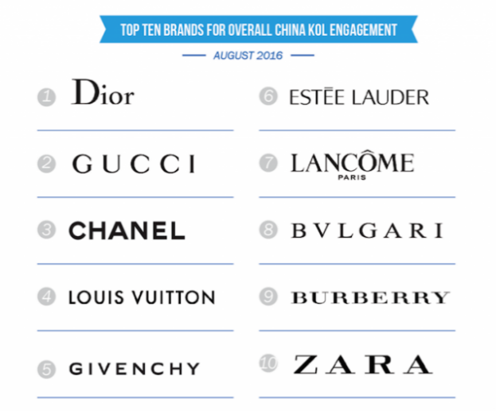  Along with the dynamic globalization, many new brands have been emerged in recent years. They are bringing new variations continuously which produces risk for Burberry regarding its market position.
Customer behavior is changing | Globalization also affects the customer preferences. Nowadays, culture of one society is being mixed with other society’s culture very easily which has make the demographic analysis too much critical (Wilmshurst and Mackay, 2002).
Phony goods | Piracy of products has been a tempting issue for all brand. So it is for Burberry. Customers with a little know of authentic products often get affected with fake products which threatened the goodwill of the brand.

VRIO analysis
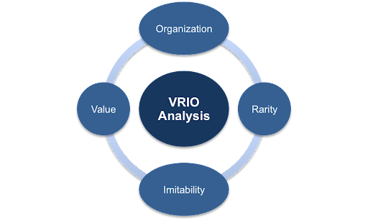
Figure 3: VIRO Analysis
Value | - Brand image: To enrich the Brand recognition, Burberry gets itself involved with social activities either. It has already accomplished many social well-being, and going to undertake many others also which are used to be published through company websites, financial papers, magazines etc.  - Raising capital ability: Because of having certified investors and a good amount of retained earnings, Burberry is capable enough to generate funds by itself solely.
Rarity | - International presence: Burberry is an international brand occupying a strong position in the economies of 59 countries. This vast operating area gives it both financial abundance and a world-wide recognition.  - Problem solving skills: Giving impromptu solutions to the problems is a crying need for every organization (Lancaster and Withey, 2007). Inasmuch, problems hinders the smooth growth of company, Burberry has assigned a specialized team within the company with a prior objective to identify problems and giving solutions as early as possible.  - Adaptability: Since Burberry is an international brand, it has to face variety of situations in its operating countries. To strengthen sustainability, Burberry has created such business strategy which is able to cope up with changing situations at no time.
Imitability | - Quality product offering: Burberry offers classy products only. Even though there are variety of brands available in the market, very few of them are capable of providing such premium quality products like Burberry offers.  - Public relations and marketing: The authority of Burberry is using marketing channel and other necessary promotional campaigns so that I can carry a good relation with the customers.  - Competitive pricing: By analyzing competitors thoroughly, any organization can attain some competitive advantages. Analyzing competitors helps organizations mostly by finding out the price levels of any specific type of product.
Organization | - Financial strength: Money is one of the biggest factors within a company. Financial health impacts the growth of the company a lot. With the help of financial abundance and proper budgetary plans Burberry can enjoy a sustainable financial health.  - Staff education: Employees’ efficiency is a tempting issue for companies like Burberry. So it conducts various training processes to develop the workability of the human resources.  - Distribution channels: Burberry has a trusted chain of distributors. It also uses of a variety of distribution methods which help it to reach and penetrate new markets, as well as improve the number of sales and consumption of its products.

External analysis of Burberry
External analysis, also associated with environmental analysis, is the process of evaluating changes in an organization brought about by the marketplace or the outside world, which can have both a good and negative influence on the company's profitability (Viswanathan and Dickson, 2007). Organizations attempt to examine changes through external analysis in order to determine if they will be able to adapt to the changes or not. It assists a company in assessing the larger business environment. External analysis promotes corporate expansion into new sectors, assists in anticipating and adjusting to changes, and provides possibilities to outperform competitors. From Burberry point of view, the external analysis is as follows.

PESTLE analysis

Figure 4: PESTLE.
Political: It is the most concerning issue for companies like Burberry. As it is an international organization and operates business in 59 countries, it has to deal with the political issues of every operating country. Issues like political instability, irregular changes in the political matters, strikes, economic relation between the operating country and the originated country etc. are the main issues of this environment. These factors affect Burberry a lot, and always require Burberry to remain aware of both national and international political situations
Economic: Economic crashes have an impact on how people spend their money (Baines, et al, 2021). When the economy is in a slump, consumers choose to buy a low-cost item to address fundamental necessities rather than a luxury item that many people can do without. Employee expectations of increased compensation, on the other hand, have been a source of concern for Burberry since it employs over 111,900 people. If the corporation needs to raise the employee's compensation, the cost of the final product will rise.
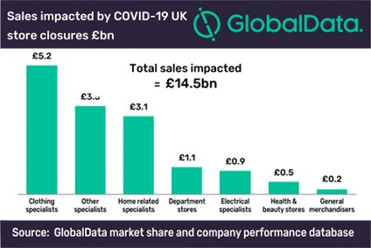
Social: Burberry is a high-end brand popular among the wealthy. It offers premium quality products to the rich with a high price. But to grab more market shares, it has been generating quality products at a cheaper rate so that mediocre people can also enjoy the premium quality products at a reasonable price.
Technological: The use of AI (artificial intelligence) and big data is boosting the benefits of technology, allowing Burberry to analyze customers more deeply and intensely. It also aids the business in optimizing profits and avoiding waste. Technologies are now being use in production, distribution, marketing, selling etc. of Burberry. It has a created certified website and other marketing channels through which it promotes and sells its products on online.
Environmental: Environment is the broadest factor of a company. Every single element of a company is influenced by environment to some extends. As the demand for organic products are being increased day by day, Burberry is now offering organic products including cotton wool products, alcohol free perfumes etc. Burberry is also tensed regarding the calamities occurred by both human and nature, like, terrorism, flood etc.
Legal: This is the factors which shapes an organization. Since, Burberry operates business in many countries, it has to deal with the legal issues of all the operating countries. Factors such as, Tax rate, consumption rate, national income etc. facts a lot. As Burberry offers brand products, it offers basically to the rich as ordinary people can’t afford to buy such products. So, changes in national per head income impacts the selling unit as well as profitability deeply. Moreover, being an international brand, it has to pay a big amount of tax in the foreign locations.

Porter’s Five Forces
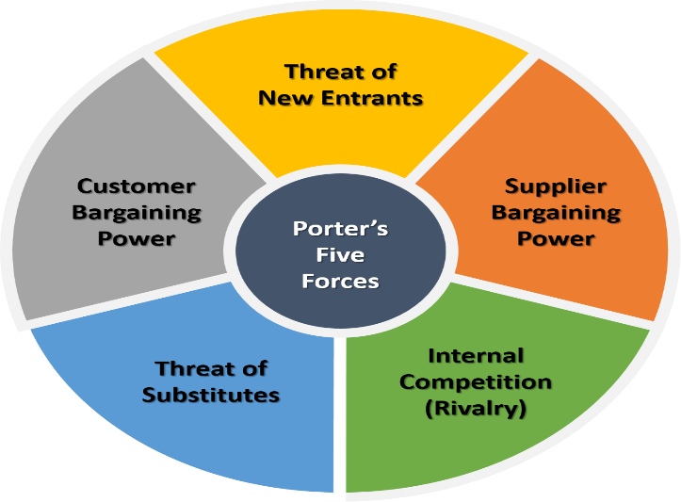
Figure 5: Porter’s five forces
- Threats of New Entrants: Fresh entrants bring new innovation, new ideas, and new tactics to the market, which can cause incumbent retailers like Burberry, Tesco, Asda, Aldi, and others to react by providing their new value proposition, lower cost, and lower price approach to customers.
- Supplier Bargaining Power: Because there are so many retailers in the retail business, suppliers have a stronger bargaining position. Furthermore, dominating market suppliers might harm Burberry by refusing to supply raw materials or demanding higher costs, making it difficult for the corporation to maintain higher quality items at cheaper pricing.
- Internal Competition: Due to competition among current industry participants, there may be a down price strategy, decreased profitability, and heated competition. Barberry is also up against a lot of competition from the retail industry's established competitors.
- Threat of substitutes: Most shops in the fashion business create comparable items, which might pose a danger to a company (Forsyth, 2009). When the substitute product's value proposition fits a different set of requirements than the existing product, it has a different impact. Burberry's alternative items are also produced by Gucci, Adidas, and Puma, which is why the rivalry is fierce.
- Customer Bargaining Power: The availability of shops in almost every location encourages buyers to be more obstinate. They do not want to pay higher costs for things when competing companies are selling the same product at a lower price, giving them more negotiating leverage. Burberry shoppers, for example, might be great bargainers due to Gucci, Adidas, or Puma influence.

Market Segmentation
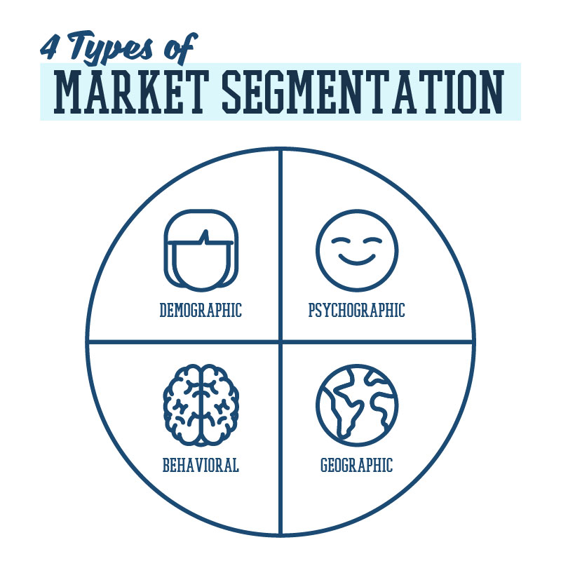
Figure 6: Market Segmentation
- Demographic segmentation: The demographic segmentation is the most popular and widely utilized sort of market segmentation, which separates the whole market based on age, gender, income, geography, family status, yearly income, education, ethnicity, and other factors.

- Geographic segmentation: Geographic segmentation separates the market based on geographic borders, which is the most basic sort of segmentation. Such segmentation might be based on ZIP code, nation, city, county, climate, urban, rural, and so on.
- Psychographic segmentation: Customers are classified based on criteria like as values, attitude, interest, priorities, motivation, and other aspects of their lifestyle, attributes, and personality (Russell, 2009). Psychographic segmentation separates a market's clients.
- Behavioral segmentation: Customers' behaviors, such as spending patterns, purchase habits, brand interaction, user status, and so on, are used to segment the market.

Burberry's target market and positioning
Examining the total market via the lens of four different segmentation kinds Burberry focuses on the family, particularly the mother. The firm also wishes to target a more quality-focused market. It aims to give a high-quality product at a reasonable cost to the target client. "Assisting everyone to eat well" is one of Burberry's phrases that encourages clients to buy their products and to stay loyal for a longer length of time. Burberry was able to establish itself as the second biggest grocery chain thanks to the devotion of its consumers, and the firm will continue to thrive and expand its business in the future.
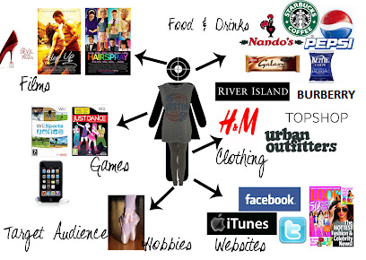

Marketing Mix of Burberry
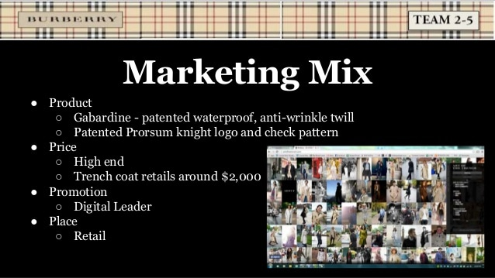
Figure 7: Marketing Mix 4P
- Products: Burberry has become one of the world's most prestigious premium fashion houses. Burberry's main goods include clothing, cosmetics, fragrances, eyewear, and accessory for men, women, and children. Every single product carries a brand value which attracts the customers more.
- Price: To ensure sustainable profitability, Burberry intends to create the correct balance of low-cost and high-end luxury items (Visser 2007). Burberry, being a premium brand, does not compete directly on price with its competitors in its marketing mix.
- Place: Burberry is represented in more than 50 countries through hundreds of boutiques. For ensuring stable flow of profit, it has located it’s shops in populated areas so that it can easily attracts more and more customers. This motto has helped Burberry to build a strong and loyal customer base.
- Promotion: As Burberry offers luxurious fashion products, it has to maintain the premium quality even when making advertisement. As its products are usually so costly, if it wants to attract middle class stylish people, it has to design promotional strategies by both upholding the premium quality and the low price.


Impact of Covid-19 on Burberry
Burberry's last financial quarter saw sales growth stall as the effect of Covid-19 restrictions lingered, despite sales being just above pre-pandemic levels. The premium clothes company reported overall revenues of £1.2 billion for the 26 weeks ending September 25, up 38% year on year. In the second half of that time, however, like-for-like shop sales only increased by 6% year over year. The stock dropped 5% on Thursday, making it one of the largest losers on the FTSE 100. Across-store sales in Europe, the Middle East, India, and Africa also struggled in the most recent financial quarter, falling by 25%.
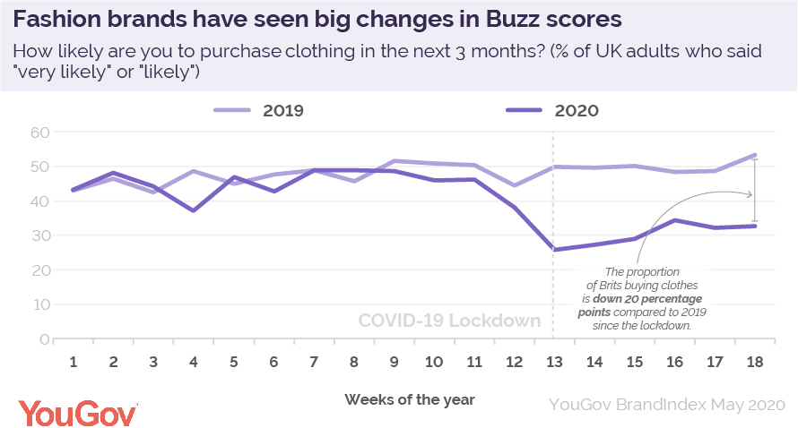

Conclusion
An effective marketing plan may convert a potential consumer into a regular and loyal customer, which is why marketing operations must be carried out precisely and effectively by businesses (Deepak and Jeyakumar, 2019). A well-executed marketing plan promises increased productivity and profitability. Marketers use their extensive talents and expertise to conduct internal and external analysis in order to assist a firm in coping with market trends and changes. In order to provide a clear perspective, I undertook a complete examination of Burberry marketing methods, including a variety of internal and external analysis tools, marketing mix, segmentation, positioning, and the influence of the Covid-19 on the firm.

Reference
Lancaster, G. and Withey, F., 2006. Marketing fundamentals. Routledge.
Verhage, B. and Visser, M., 2007. Marketing fundamentals. Wolters-Noordhoff.
Stone, M., 2007. Fundamentals of marketing. Routledge.
Moore, K. and Pareek, N., 2006. Marketing: the basics. Routledge.
Smith, S.M. and Albaum, G.S., 2005. Fundamentals of marketing research. Sage.
RM, M.V. and Berry, M., 2018. Digital marketing fundamentals.
Wilmshurst, J. and Mackay, A., 2002. The fundamentals and practice of marketing. Routledge.
Lancaster, G. and Withey, F., 2007. Marketing Fundamentals 2007-2008. Routledge.
Viswanathan, N.K. and Dickson, P.R., 2007. The fundamentals of standardizing global marketing strategy. International marketing review.
Russell, E., 2009. The fundamentals of marketing. Bloomsbury Publishing.
Joshi, R.M., 2005. International marketing. New Delhi: oxford university press.
Baines, P., Whitehouse, S., Antonetti, P. and Rosengren, S., 2021. Fundamentals of Marketing 2e. Oxford University Press, USA.
Deepak, R.K.A. and Jeyakumar, S., 2019. Marketing management. Educreation Publishing.
Forsyth, P., 2009. Marketing: A guide to the fundamentals (Vol. 19). John Wiley & Sons.

