Student name: Emily Westwood-Atkins
Student number: 2204666
Programme of Study: Illustration (BA)
Module: Research in Practice (ADAD5004/C)
Word count: 2319
Tutors name: Delyth Lloyd-Evans
Three keywords: Feminism, representation, sexualisation

Statement of intent

This proposal will explore my chosen key words; feminism, representation, and transformation, mainly focusing on the portrayal of woman during ancient, modern, and present times. I will explore what women had to do to be respected as well as taking on masculine roles regarding features and attitudes. I will also research how women have taken back their femininity from the male gaze within history, tv and video games. From researching into these key words and expanding my knowledge, I hope to a conclude question for my independent project.

Feminism
Feminism, “the advocacy of woman’s rights on the basis of the equality of the sexes”. This has become a major topic of conversation during the 21st century with women wanting equal rights, however, it has not only just become a topic as of now, but rather been brought more into the light with hints of this topic as far back as ancient Greece within their stories of Gods. During ancient times, women were seen as lesser to men and not as respected (wordpress.com). In mythology, woman was commonly portrayed as manipulative, devious, deceitful, and hazardous to men. The way that women were portrayed in stories highlighted the fears that men had in ancient Greece: that the women would become uncontrollable, promiscuous, and disloyal. Researching into Greek mythology and the feminism surrounding it, a couple women who stood out to me were: Medusa, Athena, and Aphrodite.
To give a brief explanation of Aphrodite, she is the goddess of love, sex, beauty, and fertility, she was a woman other woman looked up to. She has large breasts, a pear-shaped body and round face, she then became the ideal beauty for woman (eternalgoddess.co.uk).
Looking into the origin of the Greek gods, I found the poem Theogony by Hesiod and found that a man had created the ideal look for a woman. He had then also created another goddess who, even though was a woman, had masculine traits to which she was also respected due to her abilities and strength. This links back to my point of woman having to be more masculine to be seen as useful and respected. Athena, in classic mythology shows Athena to be a vain, hot-headed, right-hand woman of the patriarchy. She is seen as strongly male-identified, assisting in male heroes, and generally not concerned with woman or mistreating them (Cosettepaneque.com). Athena is a Greek goddess of warfare, wisdom, and handicraft. She is also the daughter of Zeus and is known for her strategic skills in warfare.
The main woman I investigated for feminism was Medusa. I investigated in her mainly because women have now seen Medusa as a symbol of reclaiming agency from a male-dominated society and female empowerment (elon.edu). The myth surrounding Medusa is a warning to mortals. “Don’t believe yourself to be equal to the gods.” Mortals should never reject anything from the gods, so why did Medusa think she was allowed to reject Poseidon? (educationispowerful.net). She was turned into a monster by Athena for violating her temple with Poseidon. Woman have now taken Medusa’s story and have claimed her a victim and her story represent the issues surrounding the treatment of woman, sexual assault and the suppression of female sexuality compared to male sexuality over time.

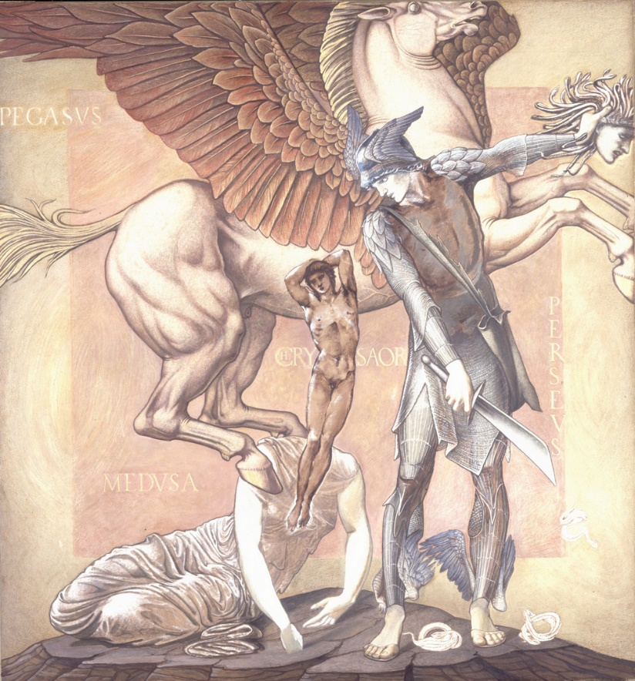
Also researching into art pieces that have been created to symbolise her death, as this is a main part of her story. This art piece depicted Hesiod’s story.
The Death of Medusa I, Edward Burne-Jones (1888-1892)

This artwork depicts that Medusa was carrying the children of Poseidon, and when Perseus took her head, she released Pegasus and her human son, Chrysaor. It was made during the Pre-Raphaelite Brotherhood period using oil paints. I chose this piece because this depicts the beauty she has inside her with the Pegasus and her mortality is represented by her human son (southhamptoncityartgallery, 2018)

Representation
Representation, “the description or portrayal of someone or something in a particular way”. The representation of women has changed a lot over the course of history. Women have always been seen as second classed citizens, were usually excluded, and portrayed in sex stereotype roles which included mothers, wives, mistresses, and daughters.
Society has changed how they see women and how they should look and what they should do. Evidence of this is shown within statues, movies, art pieces and video games. Investigating into the differences between men and women statues to find what features are used and what they mean. Reading an interview by Professor Wright, a historian of Latrobe University states that “it is about asserting dominance and authority over a place” and explains how it is a declaration of 19th century colonialism. Due to this, when we see statues of men in more modern times, they’re seen as strong with a tall stance with weaponry to show power and books to show knowledge.

Researching famous men, this statue of Alexander the Great was rather interesting. While investigating, the features such as his abs and how he is riding a horse so majestically is a public reminder of how he wanted to be seen, strong and a warrior. Researching into the horse and his stance, it appears that when a horse is placed on his back legs, which is shown in the image, means that the rider has died in battle.
Statue of Alexander the Great (1973)
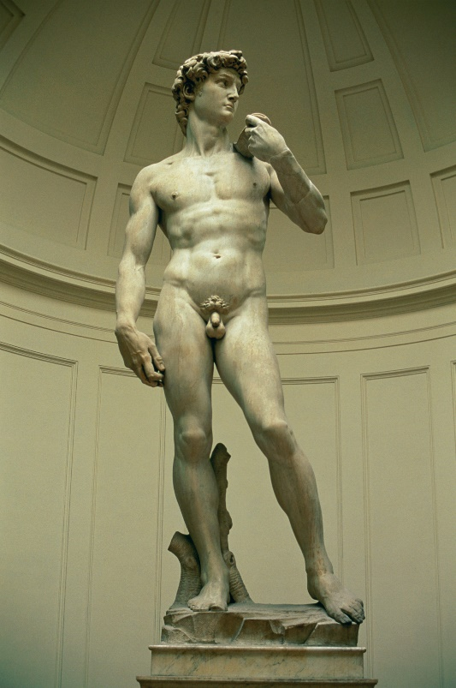
This sculpture is another example of showing the viewers how great men were. It has been made so that the abs are on full display, as well as accentuating their biceps. Another point is the small penis. In Kenneth Dover’s book ‘Greek Homosexuality’, he argued that during that era it was seen as desirable to have a smaller penis because men who has a larger penis, were seen as “less attractive and more sexually promiscuous.”
Michelangelo’s ‘David’, 1501-1504
It is stated by Hunter Murray that men have been given more permission to talk openly about their sexual desires while young women have been told not to express it (webmd, n/a). This links back to men having the upper hand and being able to openly talk about topics, which women have been shunned away from and just having to follow. In statues created about men, the features show is to present how powerful they are while in statues about women, it is about showing what appeals to them as most statues were created by men, therefore it is made in the male gaze.
Venus de Milo, 2nd century BC

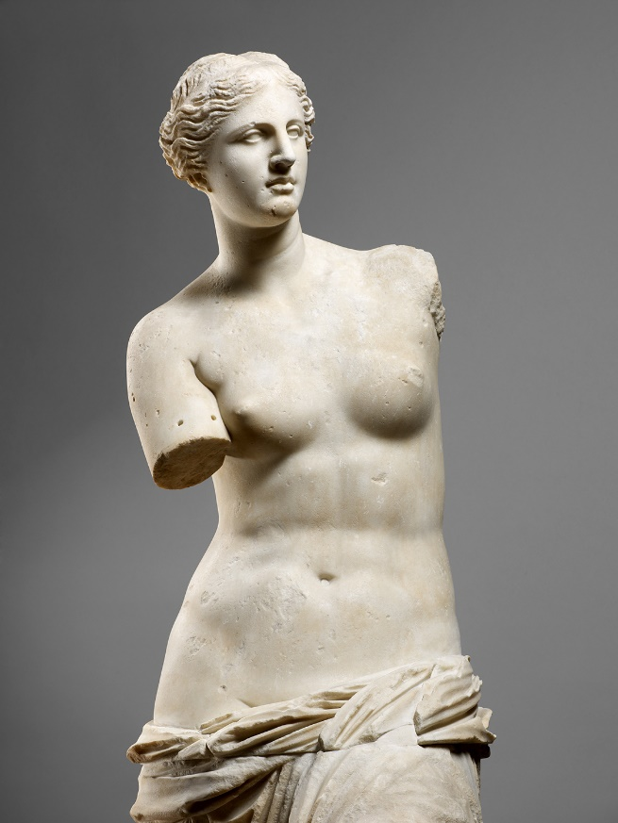
This statue of Aphrodite by Alexandros of Antioch is another example of how men view women. At first glace of this statue, the first thing you look at is her breasts, and then her face. Her breasts being the centre point while her clothes seeming to have fallen around her waist is the viewpoint of a man, coincidentally, the creator. While the story of Aphrodite was created by a man, this has been visually represented in this sculpture to show the appealing features that men had sexualised in their favour. Her breasts being perfect and on show, her hips being curvy and her hair being neat, is the preferred women for a man. While her arms were not able to be in the found, it can also be interpreted as women being cut of from reaching for the same opportunity’s men had, regarding their careers or hobbies, or women were only as good as certain aspect. As their main roles were giving birth to children, they needed to be attractive to entice a mate so the aspects that were appealing to men had to be the best. This is why some women sexualise themselves and believe that these features need to be a certain way, which has been depicted in history, rather than being happy with how they are, because stories and history has drilled into young, impressionable girls that they need to look a certain way to be desirable.
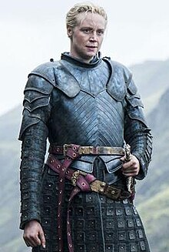
Wikipedia, 2024
In contrast, while investigating more modern depictions of a strong women, Brienne of Tarth from Game of Thrones was a perfect depiction. Researching into the description of Brienne, it is stated that she is classed as unattractive by the standards of that era and unfeminine in appearance. She is described as muscular, tall, and flat-chested. She is broad and crooked teeth with a nose which has been broken multiple times (awoiaf.westeros.org, n/a). From this depiction of a strong women during 298 AC, when this was set, it shows that one of the few women that has been represented as straying away from normality, has been given masculine features. Her curves and appealing features have been stripped away and replaced with masculine features to fit the role of men being more dominate in affairs that were more violent. She is a protector, fights with a word and often gets bloody and that is the opposite of what a women should be with long hair, dresses, and cleanliness.

Sexualisation

Sexualisation, “the emphasis of the sexual nature of a behaviour or person” (Wikipedia, 2024). This has remained the same for women for generations. During ancient times they were emphasising on women’s features such as their breasts or curves. Even more so in more present times with impressionable media such as video games, companies are still creating sexualised version of female characters in the view of the male gaze. In video game, female role models are rare, but if they are, they are highly sexualised. The objectification theory suggests that ‘exposure to sexualised media characters increase self-objectification and decrease body satisfaction in female users’ (sciencedirect.com, January 2021). To continue with this, while male users are gaining satisfaction while playing with female characters that appeal to them, female users are experiencing the opposite with body and self-image issues. This seems to be a reoccurring theme with stories or images created by men about women, as they will create their fantasy about them and disregard how the other sex will interpret it.
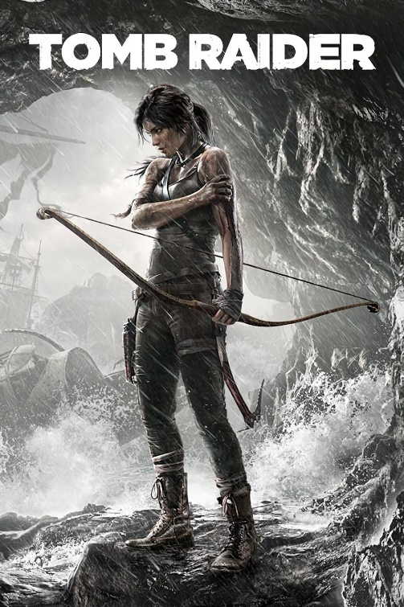
An example of sexualisation of females are Lara Croft in the Tomb Raider games. Investigating into the cover for Tomb Raider (2013), there are some noticeable details within it. Firstly, there is obvious detail of her being hurt. It is not known yet what has hurt her, but it may be taken as she is seen as weaker as this is on the front cover, and that she will have trouble down the road and needs to run and hide in a cave. Secondly, is her chest. Tomb Raider is about Lara, who is adventuring on an expedition so she should have appropriate clothing, but it seems that Yoshitaka Amano, creator of the cover, has made a point of having her chest on display.

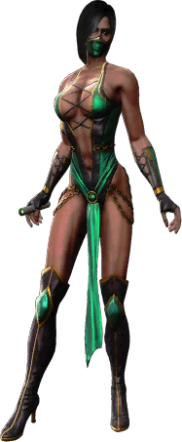
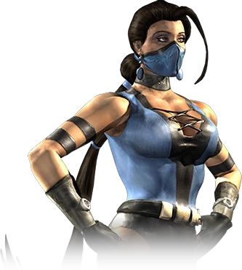
Another game is the Mortal Komat franchise, but more specifically Kitana, Mileena, and Jade. Investigating into Jade in Mortal Kombat Armageddon, she wears a skin-tight green outfit, with most of her torso and stomach exposed, along with green thigh high boots. She also has a staff which she is used in a similar fashion to a stripper’s pole. Secondly, investigating into Kitana there were some similarities with the clothing. Her chest was on display and accentuated, she has barely anything covering her arms and legs while only short shorts curving around the tops of her thighs. Her weapon of choice is a fan with blades, which is a way to keep her feminine side. Thirdly was Mileena. Mileena’s outfit consist of her having the bottom of her breasts on display, even though she has her arms covered, she only has a small piece of clothing covers her bottom half, and two daggers that she uses.
MortalKombatWarehouse, n/a
MortalKombatWarehouse, n/a
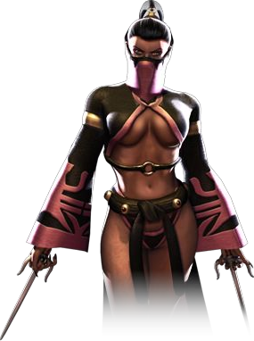
After investigating the clothes, weapons and moves within the game, these characters were made for the male gaze as this was also a male user dominated during 2006. An example is with jade’s outfit, it is meant to be portrayed as seductive, which links into her staff which can indicate the seduction within the exotic business, which is a female dominated profession to perform for a male dominated audience. Another example is that of one of Kitana’s attack moves, to which she crushes the opponent with bottom. This is quite an unusual move as she clearly has weapons that she can use, but again, the creators used an asset of her in a way that would accentuate it.
MortalKombatWarehouse, n/a

While researching throughout this topic and exploring the key words, this has led me to the possibility of an overall question. My proposed question is “Are Women Trying To Be Men?” I found that this is an appropriate question for my topic as a reoccurring theme within stories and more present, video games and tv shows, for a women to be seen as equal to a man she must be more muscular and more violent, if she is more dainty and curvy then she is seen for her looks rather than what she is capable of, so the point of the question is the reality of women are needing to become more like men in order to be respected and seen as equal, rather than being sexualised by them.

To conclude, my proposed practice based-project will consist of multiple concept art drawings of women during different time periods ranging from ancient times to a more present era to show in my own style. These pieces will include links to their respected periods either in the background of the characters, or on the framing of the images itself to create depth. My idea for doing this is to show the progression of the view on women and to show how they have been represented, compared to more present times to which women have been able to grow more of a voice and be able to project it, but to also show the similarities of how women are still being whittled down to certain features, just like a statue would be.

Bibliography

Brienne Tarth (no date) A Wiki of Ice and Fire. Available at: https://awoiaf.westeros.org/index.php/Brienne_Tarth#:~:text=She%20is%20tall%2C%20muscular%2C%20flat,been%20broken%20more%20than%20once. (Accessed: 26 May 2024).

Mortal Kombat Warehouse (no date a) MKWarehouse: Mortal Kombat: Jade. Available at: https://www.mortalkombatwarehouse.com/mk/jade/ (Accessed: 21 April 2024).

Mortal Kombat Warehouse (no date a) MKWarehouse: Mortal Kombat: Armageddon: Mileena. Available at: https://www.mortalkombatwarehouse.com/mka/mileena/ (Accessed: 21 April 2024).

Mortal Kombat Warehouse (no date) MKWarehouse: Mortal Kombat: Armageddon: Kitana. Available at: https://www.mortalkombatwarehouse.com/mka/kitana/#cutout (Accessed: 21 April 2024).

RadioTimes (no date) Tomb Raider Games in order: Story and release chronology: Radio Times, Tomb Raider games in order | Story and release chronology | Radio Times. Available at: https://www.radiotimes.com/technology/gaming/tomb-raider-games-in-order/ (Accessed: 22 April 2024).

Roberts, S. (2016) This is the bizarre reason male statues always have such a small penis, The Sun. Available at: https://www.thesun.co.uk/living/1413449/this-is-the-bizarre-reason-male-statues-always-have-such-a-small-penis/ (Accessed: 25 May 2024).

Sex drive: How do men and women compare? (2024) WebMD. Available at: https://www.webmd.com/sex/features/sex-drive-how-do-men-women-compare (Accessed: 25 May 2024).

Vénus de Milo (2024) Musée du Louvre. Available at: https://collections.louvre.fr/ark:/53355/cl010277627 (Accessed: 25 May 2024).

Wiki, C. to L.C. (no date a) Tomb Raider (2013 game), Lara Croft Wiki. Available at: https://tombraider.fandom.com/wiki/Tomb_Raider_(2013_Game)#Story (Accessed: 22 April 2024).

Wiki, C. to L.C. (no date) Tomb Raider (2013 game), Lara Croft Wiki. Available at: https://tombraider.fandom.com/wiki/Tomb_Raider_(2013_Game)#Characters (Accessed: 22 April 2024).

Wiki, C. to M.K. (no date a) Jade, Mortal Kombat Wiki. Available at: https://mortalkombat.fandom.com/wiki/Jade#Appearance (Accessed: 21 April 2024).

Wiki, C. to M.K. (no date b) Kitana, Mortal Kombat Wiki. Available at: https://mortalkombat.fandom.com/wiki/Kitana (Accessed: 21 April 2024).

