

INTERNATIONAL MARKETING
MODULE CODE: LCMB7006
STUDENT ID: 2220279
STUDENT NAME: CHARANJEET KAUR
ASSIGNMENT TITLE: ASSESSMENT 1
NAME OF LECTURER: DR. TUSHARA BALENDRAN

Table of contents
1. Introduction and Background 4
1.1. Introduction 4
1.2. Background 4
2. Market analysis 6
2.1 PESTEL Analysis (India Vs UK) 6
Political factor 6
2.2 Critical comparison: marketing context of tata steel in UK vs India 10
2.2.1 Cultural Communities with Human Aspects 11
2.2.2 Economic Fundamentals with Marketing Strategies 11
2.2.3 Political and Legal Views 13
2.2.4 Socio-Demographic Factors 13
2.2.5 Practical and Ethical Reach 13
3. International marketing strategy crafting 16
3.1 Porter's five forces 16
3.2 SWOT Analysis 16
3.3 STP Analysis of India vs UK 17
3.3.1 STP of India 17
3.3.2 STP of UK 18
3.4 Perceptual map 21
Figure 3.4.1: Competitors of Tata Steel in UK 21
(Source: Self-created) 21
3.5 Critically discussing similarities, as well as differences 22
3.6 Relating Strategies, as well as organizational approaches 23
3.7 Marketing mix strategy 4ps 23
3.8 Distribution Channels 24
3.9 Directional development 25
4. Implementation of the market development plan 25
4.1. Plan for a successful marketing strategy 25
4.2. Ethical and Practical Approaches (markets of India and UK) 26
5. Recommendation 26
6. TOWS strategy 26
6. Conclusion 27

1. Introduction and Background

1.1. Introduction
The expansion of business depends upon the strategies adopted by the organization. It includes the marketing strategy and business development tactics. It is significant to generate a place in a new market. The adoption of an effective international marketing strategy supports the development of business in foreign markets. Thus, the organization needs to focus on analyzing the market. It also needs to be attentive to STP analysis for gaining a position in the competitive market. The business organization needs to develop strategic plans for expanding the business in a new market.
Tata Steel has a good place in the market of India. However, the expansion of business in UK market urges Tata Steel to implement effective strategies. Thus, the main focus of this research is to analyze the external market and identify influential factors effective on the business expansion of Tata Steel. Hence, this research is focused on an analysis of the market of India and UK. It also brings forth the plan necessary for business expansion. This plan considers maintaining business ethics while implementing business development plans and strategies. Despite that, it is focused on the adoption of significant strategies to compare the market of UK with India. Thus, the research is proposed to analyze the significance of marketing plans and international business strategies. It is also focused on identifying the components influential to international marketing.

1.2. Background
Tata Steel is one of the top leading companies in India. It brings diverse products and Galvanova is one among them (Tatasteel.com, 2023). This is a coated product, which is used in small and medium enterprises. The production capacity of Tata Steel is 23 million metric tons per year (Sun, 2023). High production capacity helps the organization supply raw materials to SMEs.
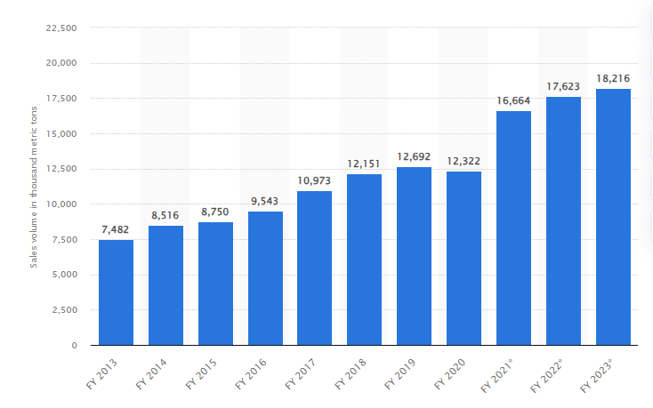
Figure 1.2: Sales volume of steel from FY 2013 to 2023
(Source: Sun, 2023)
The productivity and sales of Tata Steel are rising day by day. It is observed in the above diagram that the sales volume of this organization is rising. In FY13, its sales volume was 7482 thousand metric tons (Sun, 2023). An effective business strategy and proper technique helped the organization to gain positive outcomes. However, there was a slight fall in the business in 2020 due to the harsh impact of the pandemic. It was recovered and raised to 18216 thousand metric tons in 2023 (Tatasteel.com, 2023). Its manufacturing strategy is influential in raising its productivity. This leads them to focus on the security of raw materials (Sun, 2023). It further leads them to manufacture cost-effective products.
It prioritizes its raw materials, human resources, and all other factors necessary for business development. Tata Steel pays attention to its employees and provides training to make them more efficient. It has invested around 1.9 billion Indian rupees for providing better training to its employees (Sun, 2023). This is effective to make employees more productive. Despite that, it pays attention to raising its share value. Its share value brings a high amount of sum to the organization. In FY23, it gained ₹0.07 billion per share (Sun, 2023). This reflects the quality of business done by Tata Steel. On the other hand, the capacity of the organization and its profitability is influential to the growth of its business.

2. Market analysis

2.1 PESTEL Analysis (India Vs UK)
PESTEL of India

Political factor
- Political stability index (-2.5 weak/2.5 strong) and the latest value is -0.62 (Theglobaleconomy.com, 2023)
- Foreign trade policy (2023) is influential in the export and import of goods (Pib.gov.in, 2023)
- Schemes like the EPCG, amnesty and merchanting trade (Pib.gov.in, 2023)
Economic Factors
- GDP of India: The current GDP of India was $3.18 lakh crore in 2021 (Data.worldbank, 2023)
- Consumer Prices Index (CPI): currently raised to 179 (Tradingeconomics, 2023).
- 6.6%growth in the labour cost index (Globaldata, 2023).
- Rank India in labour cost was 155 (Globaldata, 2023)
- The corporate tax rate is 25% when it opts for Section 115BA (Incometax.gov.in, 2023)
- The rate of inflation was 6.7% in 2022 (Macrotrends.net, 2023)
Socio-cultural Factors
- The population of India was 142.86 crore (Indiatoday.in, 2023)
- The employment rate was 46.3% in 2021 (Globaldata.com, 2023)
- The unemployment rate was 7.33% as of 2022 (Macrotrends.net, 2023)
Technological Factors
- Government investment in technological advancement: Arrival of many software in the market like Microsoft, Amazon and Apple.
- Availability of 5G network
Environmental Factors
- Environment Protection Act 1986 (Cpcb.nic.in, 2023)
- Maintenance of sustainability
- Waste management
Legal Factors
- Labor law 1970 (Ncib.in, 2023)
- Factories Act 1948 (Indiacode.nic.in, 2023)
- Minimum wage act of 1948 (Labour.gov.in, 2023)
- Industrial establishment act 1946 (Clc.gov.in, 2023)
PESTEL of UK
Political factors
- The political stability index (-2.5 weak/2.5 strong) Latest value is 0.54 (Theglobaleconomy.com, 2023)
- The Trade and cooperation act affected the trade implementation of UK (Gov.uk, 2023)
- The Comprehensive and Progressive Agreement for Trans-Pacific Partnership (CPTPP) affected trade in UK (Commonslibrary.parliament.uk, 2023).
Economic Factors
- The current GDP of UK is $3.69 trillion (Worldpopulationreview.com, 2023)
- The CPI increased by 7.9% in June 2023 (Ons.gov.uk, 2023).
- The corporate tax rate is 25% from the FY 2023 (Taxsummaries.pwc.com, 2023)
- The rate of inflation was 6.4% in June 2023 (Ons.gov.uk, 2023)
Socio-cultural Factors
- The population of UK was 67.62 million in January 2023 (Kemp, 2023)
- The employment rate in UK was 76% in May 2023 (Researchbriefings.files.parliament.uk, 2023)
- The unemployment rate in UK was 4% (Commonslibrary.parliament.uk, 2023)
Technological Factors
- Availability of high-tech infrastructure.
- 5g Network is available in the market.
- Implementation of AI is effective for the business.
- Environment protection act 1990 (Legislation.gov.uk, 2023)
- Maintenance of sustainability and reduction of waste.
- Climate change
- Awareness about reverse logistics.
Environmental Factors
- Environment protection act 1990 (Legislation.gov.uk, 2023)
- Maintenance of sustainability and reduction of waste.
- Climate change
- Awareness about reverse logistics.
Legal Factors
- Labor law, which focuses on the Factories Act, of 1948 (Nhglobalpartners.com, 2023)
- Employee Protection Act 1996 (Hse.gov.uk, 2023)
- Employment rights act 1996 (Legislation.gov.uk, 2023)
- Employment relation Act 1999 (Legislation.gov.in, 2023)
- Equality Act 2010 (Legislation.gov.uk, 2023)
Analysis
Political factors
Its components are influential on the market development of Tata Steel. Despite that, foreign trade policy also affected its business (Pib.gov.in, 2023). The maintenance of foreign trade policy supported the organization in running the business smoothly.
The Trade and Cooperation act and the CPTPP are influential in business expansion. It acts as a barrier to an organization while expanding business. It leads to the generation of trade barriers, which generates obstacles in the expansion of business (Commonslibrary.parliament.uk, 2023). Thus it can be said that the market of India is favourable for the development of the business of Tata Steel. However, UK market is unfavourable for expanding the business.
Economic Factors
Tata Steel was concerned about corporate tax, labor costs, foreign trade policy, and many others. Corporate tax is paid based on income level, which is 26% of total income if earning is below 10 million and it is supposed to be 27.82% if the income is between 10 to 1000 million (Taxsummaries.pwc.com, (2023). This organization pays 55.72% of its profit in the form of tax. This lays a positive impact on the business development of Tata Steel (Bqprime.com, 2023). Despite that, the awareness about labor costs and the inflation rate helped Tata Steel to earn profit. GDP of UK, its corporate tax and its rate of inflation affect business organizations. The low labour cost and availability of products at low prices leads Tata Steel to gain a favourable market in India, however, UK market is unfavorable as it has a high labour cost rate of employment.
Socio-cultural Factors
This factor is significant to enhance the business performance of the organization. This factor includes the rate of employment and unemployment (Macrotrends.net, 2023). It also consists of the population of India and UK. The rate of unemployment and employment are significant components of the Socio-Demographic factor. 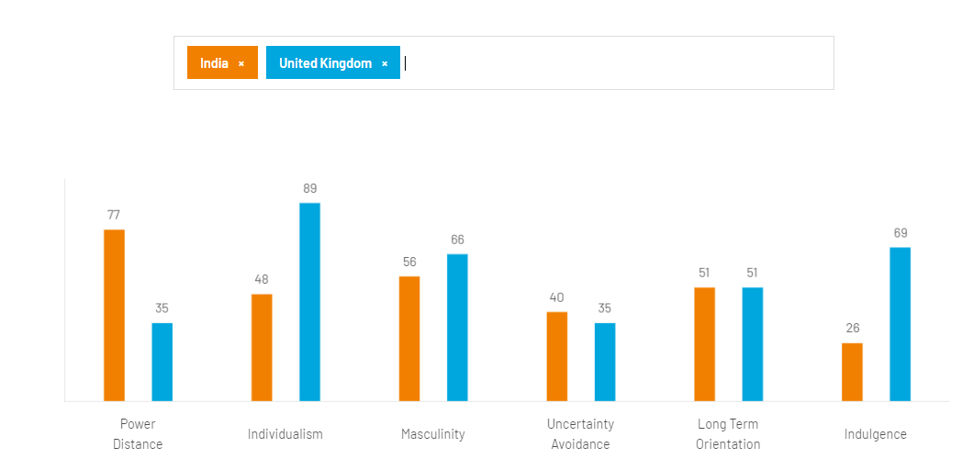
Figure 2.1.1: Cultural differences between UK and India
(Source: Hofstede-insights.com, 2023)
The above diagram reflects the cultural differences between two nations namely India and UK. The cultural dimension model of Hofstede is effective to analyse the differences based on culture. Power distance, individuality, masculinity, uncertainty avoidance, long term orientation and indulgence are the elements that reflect differences.
Power distance
India has a high rank in power distance and this reflects the appreciation toward top down structure (Hofstede-insights.com, 2023). On the other hand, UK has a low rank in power distance which reflects the attitude to maintain equality in society; hence, it reflects the favourable market in UK for Tata Steel.
Individualism
UK has a high score in Individualism, which reflects the unavailability of unity. This affects the workplace thus, this significant unfavourable market for the business of Tata Steel in UK.
Masculinity
UK ranks high in masculinity in comparison to India, which signifies the value for success and achievements, thus, it signifies favourability for Taa Steel to expand its business.
Uncertainty avoidance
The high rank in uncertainty avoidance reflects a society that values the things they have and struggles hard to achieve success in the future. The hard work for achieving success helps Tata Steel to gain success hence; it has favourable for their business.
Indulgence
The high score in indulgence reflects UK society that enjoys every moment. However, in long-term orientation, they have similar ranks (Hofstede-insights.com, 2023). The analysis of this dimension shows that the culture develops a favourable market for expanding its business.
Long-term orientation
Both nations has equal ranks in this dimension, which reflects both India and UK are equally favorable for expanding their business.
Technological Factors
The technological factor supported the growth of the business of Tata Steel and helped it to gain better outcomes. Despite that, the technological factors have less influence on the business expansion of Tata Steel. However, it generates a favourable market in UK market for having advanced technology in comparison to India.
Environmental Factors
Maintenance of the environment protection act supported Tata Steel to remain away from issues related to the environment and nature. The maintenance of sustainability and being concerned about protecting the environment supported them to maintain corporate social responsibility (CSR). The environment protection act (1990) states to protect the environment and bring sustainable development. This analysis signifies that India has a favourable market than UK.
Legal Factors
The organization can run smoothly by being concerned about all sorts of legal issues. This includes being concerned about maintaining the labor law, equity act, employees protection act and others (Ncib.in, 2023). The maintenance of labor law supported Tata Steel to manage employees and other workers efficiently. This factor helped Tata Steel to stay away from legal issues. The organization is concerned about these acts and laws. It is concerned about protecting employees and maintaining equity in the organization (Hse gov.uk, 2023). However, a lack of knowledge about UK labor laws leads Tata Steel to gain an unfavorable market in UK.

2.2 Critical comparison: marketing context of tata steel in UK vs India
Tata Steel, a global steel manufacturing conglomerate, operates in diverse markets such as the United Kingdom (UK) and India. This report will critically analyze and compare the marketing strategy context of Tata Steel in aspects of economic, cultural communities, political, legal, socio-demographic factors, and practical-ethical reach in both nations.
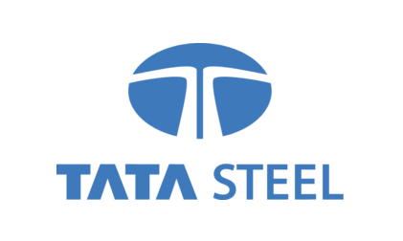
Figure 2.2 Tata Steel
(Source: Shastri, 2021)

2.2.1 Cultural Communities with Human Aspects
The marketing strategy in India involves community engagement, showcasing Tata Steel’s commitment to social responsibility. For instance, the company’s initiatives in education and healthcare resonate deeply with local communities (Saraswathy, 2021). In India, Tata Steel also holds a very revered position, deeply rooted in national identity, fostering all social responsibilities. Its marketing accentuates this legacy, aligning with values and addressing social needs.
Conversely, Tata Steel's cultural standing in UK differs. It is often seen as an employer and contributor to local economies. Marketing in UK focuses on highlighting Tata Steel's sophisticated audiences. The human aspect emphasizes the company's role as a major employer, supporting local livelihoods. Contrastingly (Saraswathy, 2021), Tata Steel in UK is perceived as an important economic contributor, valuing technological innovations and quality.

2.2.2 Economic Fundamentals with Marketing Strategies
The underlying economic conditions have a significant impact on how Tata Steel approaches marketing. The market needs for steel in building and construction tasks in India is driven by the country's quickly expanding commerce and urbanization (Shastri, 2021). The focus of Tata Steel's commercialization in this country is on offering answers to India's growing city problems.
Tata Steel’s marketing strategies are needed throughout UK's economic development for mature industry sectors like aeronautical and manufacturing. The cultural groups and personal characteristics particular to each country have a tremendous impact on the commercial setting of Tata Steel in UK and India (Shastri, 2021). The company is highly respected within India and is seen as a representation of India's growth and prestige. The business's advertising strategy in India focuses on neighborhood-focused projects and emphasizes its dedication to social good, healthcare, and literacy (LO7_global_marketing_comms-page 2). Tata Steel strengthens its reputation as a good corporate citizen that actively contributes to the development of the country through participating with regional cultural communities.
In contrast, Tata Steel's positioning in UK is distinct because of its vast opportunity in the market. It is perceived primarily as an economic entity, contributing to local economies and employment.
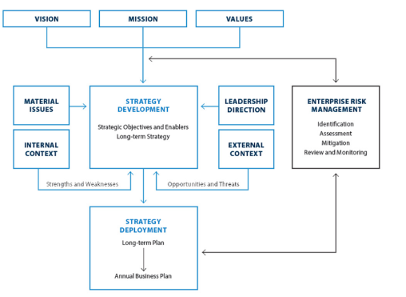
Figure 2.2.2 In-depth Analysis of the Marketing Strategy of Tata Steel
(Source: Shastri, 2021)

2.2.3 Political and Legal Views
The political and legal landscape influences Tata Steel's operations and marketing strategies. In India, government policies and support for infrastructure projects impact Tata Steel's strategic focus on the "Make Market Efforts" (Sreekumar and Pratap, 2022). The marketing strategy of Tata Steel in UK and India is gradually shaping by divergent political and legal perspectives. In India, the Indian government prioritizes every growing infrastructure which plays a pivotal role. Tata Steel's marketing strategy aligns with initiatives like "Make in India", capitalizing on domestic production to resonate with the nationalist sentiments and government visions (Business, 1AD). In UK, stability and adherence to regulations provide a conducive environment for Tata Steel's operations.
The focus is on complying with the stringent standards to ensure a positive market image.
Conversely, Tata Steel operates within the stable political and legal frameworks of UK and India. The aim is to provide the best in the markets of these two nations hence, the people of the nation can easily taste the amalgamation of power and product equally, and for this purpose, the company is continuously trying its best to serve all its customers and audiences (Business, 1AD). The contrasting political and legal views influence Tata Steel’s marketing strategy approach in each country, necessitating tailored strategies that navigate the distinct government and regulatory landscapes while maintaining the company’s brand integrity in the market.

2.2.4 Socio-Demographic Factors
Market segments and goods from the company Tata Steel are shaped by the Socio-Demographics (accounts 2019-20, n.d.). The young population of the nation India drives the perfect infrastructure sector by increasing scale and urbanization. One of the best strategies from Tata Steel is the advanced facility of growing the average class in India with the spirit of Tata Steel's socio-demographic vision which helps in growing socially as well as demographically in the nation and market (Rahman and Singh, 2019). In UK, an aging population demands the maintenance and renovation of existing structures.

2.2.5 Practical and Ethical Reach

Tata Steel’s strategies encompass practical and ethical dimensions in India, practically involving partnerships for efficient distribution in a vast diverse market. Ethically, Tata Steel engaged in sustainability initiatives and community welfare programs and projects (www.tatasteel.com, 2019). Tata Steel’s marketing strategies in UK and in India are characterized by a delicate balance between practical considerations and ethical imperatives. In India, practicality involves forming strategic partnerships and spreading networks to grow the business in this vast market effectively.
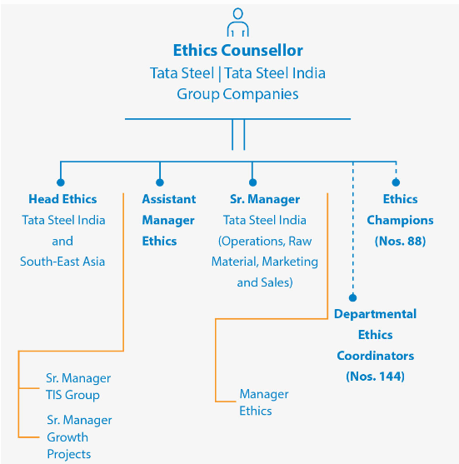
Figure 2.2 Representing the Ethics chain in the system
(Source: Tatasteel.com, 2019)

In UK, practicality pertains to optimizing supply chains and distribution networks. Ethical marketing focuses on sustainable sourcing, reducing carbon footprint, and maintaining high labour standards (Tatasteel.com, 2019). Conversely, in UK, practicality revolves around optimizing supply chains and distribution channels for maximum efficiency. Ethical dimensions emphasize sustainable sourcing, carbon footprint reduction, and stringent adherence to labor standards. This dual approach ensures Tata Steel maintains a competitive edge while upholding its commitment to ethical business practices in both nations. By weaving practicality and ethics together, Tata Steel tailors its marketing efforts to address local challenges and aspirations, fostering a positive brand image and sustainable growth.

3. International marketing strategy crafting

3.1 Porter's five forces
Components | Criteria | Impact
Bargaining power of suppliers | There are many suppliers in the market in UK and India. Thus, it gets the opportunity to shift to others. However, the quality of supplied goods is also a matter of concern. | Moderate
Bargaining power of customers | There are diverse competitors thus, the gains priority and affects its business in India and UK. | High
Threat of new entrants | The entry in the new market needs huge capital thus; it is not much influential on its business. | Low
Threat of substitute goods | The substitute goods include aluminium, which is also used by its customers. | Moderate
Competitive rivalry | It's competitors are CRU and CMS Cepcor and their performance influences the business (growjo.com, 2023) | High
Table: Impact of Porter’s five forces
(Source: Self-created)

3.2 SWOT Analysis
Strengths | Weaknesses
- A strong brand reputation  - Technological advancements helped to bring innovation in the organization.  - Vertical integration in Operation  - Financial stability  - Global presence  - Extensive distribution channel  - Diversified product portfolio | - Dependency on steel  - Price of raw materials including iron ore and coal  - Waste management  - Market competition  - High level of debts
Opportunities | Threats
- Rising demand for steel in infrastructure and construction industry  - Adoption of sustainable practices  - Demand for steel products in automotive and aerospace industry  - Demand for steel in renewable energy  - Expansion in new market | - Intense competition  - Trade barriers  - Shifting to alternate products like aluminium  - Geopolitical risks that develop barriers in expanding business  - Fluctuation in the price of steel
Table: SWOT Analysis
(Source: Self-created)

3.3 STP Analysis of India vs UK

3.3.1 STP of India
Demographic
Tata Steel targets diverse demographics, catering to both young urban professionals seeking modern living spaces and middle-class families investing in residential properties (Pro, n.d.). It also serves industrial sectors requiring steel for infrastructure development and manufacturing.
Geographic
Tata Steel strategically focuses on rapidly urbanizing regions like metropolitan areas and emerging industrial centers across India (Pro, n.d.). This enables tailored marketing for specific regional construction and development needs.
Psychographic
As opined by (Pro, n.d.) Tata Steel focuses on the psychographic area for India to make the nation more promoting towards sustainable steel solutions which are prominently more appealing than any other steel companies for its environmentally worried audiences and industries.
Behavioural
Tata Steel prioritizes and addresses the behavior of heavy industries like manufacturing and construction companies. It serves them by giving the required amount or bulk supply of steel for large-scale projects in India.

3.3.2 STP of UK
Demographic
Tata Steel targets professionals and businesses focused on the automotive, aerospace, and engineering sectors (Pro, n.d.). It focuses on decision-makers with high income and purchasing authority, tailoring its offerings to meet the specific needs of these industries.
Geographic
Tata Steel's geographic segmentation centers around industrial clusters and key cities like London, Birmingham, and Manchester (Pro, n.d.). It strategically positions itself to serve businesses located in these areas, capitalizing on their demand for specialized steel products.
Psychographic
Tata Steel aligns with the psychographic traits of technologically-driven industries by showcasing its advanced manufacturing processes and innovation (Lecture 5 segmentation, targeting and positioning, slide-4). It emphasizes its role as a reliable partner in cutting-edge projects, resonating with businesses valuing quality and innovation.
Behavioural
Tata Steel targets businesses exhibiting a need for precision engineering and high-quality steel (Lecture 5 segmentation, targeting and positioning, slide-4). Its marketing emphasizes the durability, reliability, and precision of its products, appealing to industries that require consistent performance and adherence to stringent standards.
Targeted market
In India, Tata Steel targets a wide range of customers, including government infrastructure projects, real estate developers, and various industrial manufacturers. The emphasis is on affordability and quality to capture the diverse market segments (Pro, n.d.). In UK, Tata Steel targets high-value customers in specialized sectors. Its marketing efforts concentrate on showcasing technological superiority, sustainability, and adherence to stringent quality standards, which resonates with the sophisticated needs of the targeted industries. For both nations, the target is to fulfil all its customer needs and demands along with growing the whole business globally and in the respective countries too. Its targeted customers are the automotive, construction, aerospace and engineering industries in both indie and UK.
Positioning
In India, Tata Steel positions itself as a driver of nation-building, providing essential steel solutions for rapid urbanization and infrastructure growth. Its marketing messaging emphasises its role in shaping a modern India (Pro, n.d.). Conversely, in UK, Tata Steel positions itself as a premium provider of specialised steel products for critical industries. The focus is on highlighting innovation, reliability, and contribution to the local economy. It considers customer based strategy for positioning in the UK and low cost strategy for positioning in the Indian market.
Tata Steel employs a better STP analysis to navigate the distinct markets of UK and India. By effectively segmenting the markets, targeting the right customer segments, and positioning its offerings appropriately, Tata Steel maximises its marketing impact, fostering growth and maintaining a competitive edge in both countries.

3.4 Perceptual map

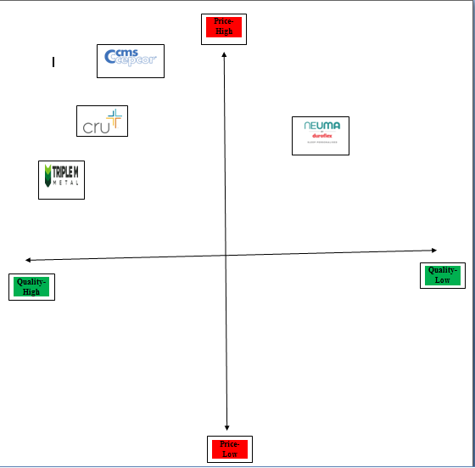

Figure 3.4.1: Competitors of Tata Steel in UK

(Source: Self-created)

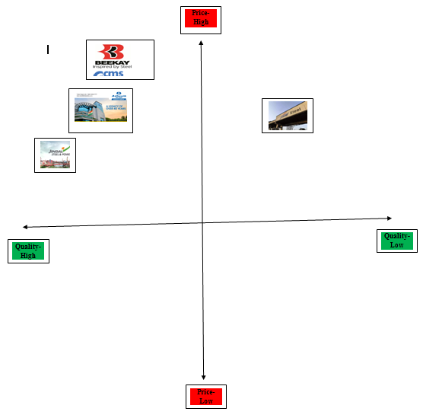
Figure 3.4.2: Competitors of Tata Steel in India
(Source: Self-created)
These diagrams reflect the perceptual map where it describes its competitors in UK and Indian markets. The similarities and differences are observed between these maps. The similarities state that in both nations it has significant competitors that affect its business. However, the difference states that in the Indian market, it gets high competition in comparison to UK. In the Indian market, it competes with steel and aluminium companies. On the other hand, in UK market, it competes with other industries too.

3.5 Critically discussing similarities, as well as differences
The market of UK and India has some similarities and differences. The PESTEL analysis of UK and India helped to identify those differences and similarities. It is found that both nations are concerned about maintaining regulations. The rate of unemployment in both nations is less than the employment rate. However, the unemployment rate in India is 7.33%, which is more than the unemployment rate in UK (Macrotrends.net, 2023). This supports Tata Steel to gain labor at a low cost in India, in comparison to UK. It is also observed that the rate of Inflation in both nations has a slight difference. The inflation rate in India is 6.7%, whereas UK has 6.4%. This is effective for international business as it affects the cost of goods and services.
The similarities between these two nations include the maintenance of laws. Both India and UK maintain the labor law, employee protection acts, employment relation act and employment rights act (Legislation.gov.in, 2023). Maintenance of these laws supports running a business peacefully. The maintenance of foreign trade policy supports business organizations to implement international marketing.

3.6 Relating Strategies, as well as organizational approaches
Tata Steel is concerned about the adoption of an effective strategy for expanding its business. The manufacturing strategy of Tata Steel is concerned with raw materials (Tatasteel.com, 2023). This strategy supports the organization in gaining a competitive advantage by bringing cost-effective goods. Along with this strategy, it adopts an organizational approach, which states about bringing innovation (Tatasteel com, 2023). The edge-cutting technology supports this organization to develop sustainable business enterprises.

3.7 Marketing mix strategy 4ps
Place
The company in UK and in India tries to distribute its channels and branches along with it also tries to serve the customers as soon as possible, and for this, the company chooses to set up the main branch in a good place for the reach anywhere (Shastri, 2021). Collaborating with the local partners, and suppliers the company tries to reach and deliver its products timely.
Product Adaptation
In India, the product adaptation strategy from the marketing mix strategy in Tata Steel Company delivers a vast range of products offered in the nation hence; the company can cater its best to its customers (Shastri, 2021). The company aims to provide new innovations through every project with quality work and products. The products of Tata Steel include wire rods, steel, and ores. It implements a customer-focused strategy for branding in India, whereas in UK it considers a reduction of carbon emission strategy for branding.
In UK, the nation and the company mainly focus on the development of the nation as well as infrastructures such as aeronautics, and automotive engineering. In UK (Shastri, 2021), people want advancements and performance, durability along with sustainability in its products from the company.
Price
Lately, there has been a surge in Steel demand, presenting abundant prospects for the company. Tata Steel possesses cutting-edge technologies, allowing them to optimize production costs while upholding quality benchmarks. The firm procures raw materials both domestically and globally, operating several ore mines nationwide. These factors empower Tata Steel to offer competitive pricing and ensure customer retention (Shastri, 2021). The company also tries to maintain the premiums in all of its products in the market along with superior quality and performance of the steel.
Promotion
The promotion for both countries is focusing on the highlight segment of technological development as well as infrastructure development for both nations along with sustainable practices for the nation's economy (Shastri, 2021). The company also follows as well as focuses on brand awareness, and promotions, with all the trusted targeted sectors in the company through posters and outdoor advertisements.

3.8 Distribution Channels
Distribution channels in India include (Singh et al. 2022):
- Government distributors
- Retailers B to C
- Private Sector Consumers.
- Direct Dealers.

Distribution channels in UK include (Singh et al., 2022):
- Online Platform for information on products
- Known Dealers and Outlets
- Builder Contracts and dealerships
- Partnerships and Collaborations

3.9 Directional development
Directional development is the vision that the company is aiming for some years to provide as well as betterment in the future for both mentioned countries (Narendran, n.d.). The development includes infrastructure, construction, and setting up new firms. Sectors like aerospace and automotive.
Market entry matrix
The adoption of the Ansoff model will be effective in malaise the market and entering into this market. This includes market penetration, product development, market development and diversification (Corporatefinanceinstitute.com, 2023). The market penetration focuses on Bearings and tube divisions. Product development focuses on steel coils and corrugated steel. The market development focuses on international markets and alliances and mergers. However, it is not going to diversify in the near future. Market development acts as the crucial component that supports Tata Steel to enter into a new market. Hence, this strategy lays an advantage for entering into a new market and expanding business. However, it brings disadvantages as it does not provide information about sales and profits.

4. Implementation of the market development plan

4.1. Plan for a successful marketing strategy
The organization needs to develop an effective plan to develop its business. This plan includes the adoption of an effective marketing strategy, which supports expanding the business in a new market. It needs to set the objective for setting the plan. STP and marketing mix strategy will help to analyze the market efficiently. Tata Steel is focused on growing its capacity (Tatasteel.com, 2023). This plan will support Tata Steel to raise its steel-making capacity and pay attention to maintaining business ethics to avoid ethical issues.

4.2. Ethical and Practical Approaches (markets of India and UK)
Maintenance of ethics leads a business organization to make fair decisions and maintain a positive atmosphere in the organization. This consists of three significant concepts that lead to maintaining business ethics. These are ethical concerns, ethical challenges, and social responsibility (Ethics.pptx, slide 1). This considers avoiding unfair and deceptive marketing practices that mislead an individual. The plan for a successful marketing strategy maintained ethics. It will collect information by maintaining proper procedures. Maintenance of ethics will also help the organization to stay away from misrepresentation and false impressions (Ethics.pptx, 3). Hence, it will focus on maintaining confidentiality with private information and no person would be forced to be the customer. It will also follow industrial regulations and its principles while implementing the plan.

5. Recommendation
Tata Steel has adopted an effective strategy for growing its business and maintaining the availability of raw materials. Despite that, it is necessary to implement some other strategy, which can support the expansion of the business in the new market.
Recommendation to implement a market development strategy
It can be recommended that the market development strategy can be effective to strengthen the business of Tata Steel. This states about selling existing goods and services into a new market. Tata Steel has a good place in the Indian market. This strategy can support the organization to sell its products to a new market and expand the business. It can also support gaining foreign currency and help business expansion. Hence, the implementation of this strategy can support Tata Steel in raising its business.

6. TOWS strategy
The implementation of TOWS can be effective to analyse the threats that arise in the market. It considers analysing the threats, which include market competition and advanced technology. The opportunities are then utilised to mitigate those threats and overcome weaknesses (Scribd.com, 2023). This can further support to generate a strong position in the market.

6. Conclusion
It can be concluded that the expansion of business in the international market requires following effective tactics. Thus, the adoption of an effective strategy supported Tata Steel to analyze the market. It included external market analysis, STP analysis and the 4 Ps. These three techniques supported Tata Steel in analysing the market and adopting an effective marketing strategy. The PESTEL analysis of UK and India led the organization to learn about significant factors, which are effective on its business.
The PESTEL analysis of India helped to learn about the influence of GDP, CPI, unemployment and employment rate, inflation rate, and corporate tax of India. It also supported the impact of different regulations on business expansion. Despite that, it helped to analyse the effectiveness of all these factors on the business environment of Tata Steel in India. On the other hand, PESTEL analysis of UK was supported to analyse the impact of all these factors and how they generate barriers to the expansion of business in UK market. It has also described similarities and differences in the market of UK and India.

References
Bqprime.com, (2023), Tax paid by Tata Steel, Available at: https://www.bqprime.com/business/reliance-and-sbi-to-tcs-top-tax-paying-companies-of-fy23 [Accessed on: 10th August 2023]
Business, O. (1AD). THE BIG STORY 1: Outlook Business. https://www.outlookbusiness.com/. Available at: https://www.outlookbusiness.com/the-big-story-1/lead-story-8/tata-steel-is-the-original-make-in-india-story-tv-narendran-6802 [Accessed 10 Aug. 2023].
Clc.gov.in, (2023), Industrial employment act, Available at: https://clc.gov.in/clc/acts-rules/industrial-employment-standing-orders-act-1946#:~:text=This%20Act%20is%20to%20require,certifying%20Authority%20for%20its%20Certification. [Accessed on: 10th August 2023]
Commission.europa.eu, (2023), TCA of UK, Available at: https://commission.europa.eu/strategy-and-policy/relations-non-eu-countries/relations-united-kingdom/eu-uk-trade-and-cooperation-agreement_en [Accessed on: 10th August 2023]
Commonslibrary.parliament.uk, (2023), The Comprehensive and Progressive Agreement for Trans-Pacific Partnership (CPTPP), Available at: https://commonslibrary.parliament.uk/research-briefings/cbp-9121/ [Accessed on: 10th August 2023]
Commonslibrary.parliament.uk, (2023), Unemployment rate in UK, Available at: https://commonslibrary.parliament.uk/research-briefings/cbp-9366/#:~:text=Key%20figures&text=The%20UK%20unemployment%20rate%20was,the%20inactivity%20rate%20was%2020.8%25. [Accessed on: 10th August 2023]
Corporatefinanceinstitute.com, (2023), Ansoff model, Available at: https://corporatefinanceinstitute.com/resources/management/ansoff-matrix/ [Accessed on: 18th August 2023]
Cpcb.nic.in, (2023), Environment protection act, Available at: https://cpcb.nic.in/env-protection-act/#:~:text=It%20empowers%20the%20Central%20Government,was%20last%20amended%20in%201991. [Accessed on: 10th August 2023]
Data.worldbank, (2023), GDP of India, Available at: https://data.worldbank.org/indicator/NY.GDP.MKTP.KD.ZG?locations=IN [Accessed on: 10th August 2023]
Geels, F.W. and Gregory, J. (2023). Low-carbon reorientation in a declining industry? A longitudinal analysis of coevolving contexts and company strategies in UK steel industry (1988–2022). Energy Research & Social Science, 96, p.102953. doi:https://doi.org/10.1016/j.erss.2023.102953.
Globaldata (2023), Labour index, Available at: https://www.globaldata.com/data-insights/macroeconomic/labor-cost-index-lci-of-india-2137635/ [Accessed on: 10th August 2023]
Globaldata.com, (2023), Employment rate of India, Available at: https://www.globaldata.com/data-insights/macroeconomic/employment-rate-in-india-2137608/ [Accessed on: 10th August 2023]
Gov.uk, (2023), TCA of UK, Available at: https://www.gov.uk/government/publications/trade-and-cooperation-agreement-implementation-report-january-2021-to-december-2022/uk-eu-trade-and-cooperation-agreement-implementation-report-1-january-2021-to-31-december-2022#:~:text=The%20TCA%20was%20signed%20on,force%20on%201%20May%202021. [Accessed on: 10th August 2023]
growjo.com, (2023), Competitors of Tata Steel, Available at: https://growjo.com/company/Tata_Steel_in_Europe [Accessed on: 18th August 2023]
Hofstede-insights.com, (2023), Cultural differences between India and UK, Available at: https://www.hofstede-insights.com/country-comparison-tool?countries=india%2Cunited+kingdom [Accessed on: 18th August 2023]
Hse.gov.uk, (2023), Employee protection act, Available at: https://www.hse.gov.uk/involvement/prepare/law/empprotection.htm#:~:text=All%20your%20workers%20are%20protected,of%20their%20length%20of%20service. [Accessed on: 10th August 2023]
Incometax.gov.in, (2023), Corporate tax rate in India, Available at: https://www.incometax.gov.in/iec/foportal/help/company/return-applicable [Accessed on: 10th August 2023]
Indiacode.nic.in, (2023), The factories act, Available at: https://www.indiacode.nic.in/bitstream/123456789/1530/1/A1948-63.pdf [Accessed on: 10th August 2023]
Indiatoday.in, (2023), Current population of India, Available at: https://www.indiatoday.in/india/story/india-population-2023-most-populous-in-world-land-per-capita-cricket-pitch-2362073-2023-04-19 [Accessed on: 10th August 2023]
Kemp, S., (2023) Population of UK, Available at: https://datareportal.com/reports/digital-2023-united-kingdom#:~:text=The%20United%20Kingdom's%20total%20population,of%20the%20population%20is%20male. [Accessed on: 10th August 2023]
Labour.gov.in, (2023), Minimum wage act, Available at: https://labour.gov.in/sites/default/files/theminimumwagesact1948_0.pdf, [Accessed on: 10th August 2023]
Legislation.gov.uk, (2023), Employment relation act, Available at: https://www.legislation.gov.uk/id/ukpga/1999/26 [Accessed on: 10th August 2023]
Legislation.gov.uk, (2023), Employment rights act, Available at: https://www.legislation.gov.uk/ukpga/1996/18/contents [Accessed on: 10th August 2023]
Legislation.gov.uk, (2023), Environment protection act, Available at: https://www.legislation.gov.uk/ukpga/1990/43/contents [Accessed on: 10th August 2023]
Legislation.gov.uk, (2023), Equity act, Available at: https://www.legislation.gov.uk/ukpga/2010/15/contents [Accessed on: 10th August 2023]
Macrotrends.net, (2023), Inflation rate in India, Available at: https://www.macrotrends.net/countries/IND/india/inflation-rate-cpi#:~:text=India%20inflation%20rate%20for%202022,a%200.21%25%20decline%20from%202018. [Accessed on: 10th August 2023]
Macrotrends.net, (2023), Unemployment rate, Available at: https://www.macrotrends.net/countries/IND/india/unemployment-rate#:~:text=Unemployment%20refers%20to%20the%20share,a%202.48%25%20decline%20from%202020. [Accessed on: 10th August 2023]
Narendran, T. (n.d.). Purpose-driven growth Chief Executive Officer & Managing Director. TataSteel. Available at: https://www.tatasteel.com/media/18368/tata-steel-brsr.pdf [Accessed 10 Aug. 2023].
Ncib.in, (2023), Labour law, Available at: https://ncib.in/pdf/ncib_pdf/Labour%20Act.pdf [Accessed on: 10th August 2023]
Nhglobalpartners.com, (2023), Labour law, Available at: https://nhglobalpartners.com/uk-employment-law-uk-labor-law/#:~:text=In%20the%20UK%2C%20employees%20usually,30%20minutes%20for%20a%20break. [Accessed on: 10th August 2023]
Ons.gov.uk, (2023) CPI in UK, Available at: https://www.ons.gov.uk/economy/inflationandpriceindices/bulletins/consumerpriceinflation/june2023#:~:text=The%20Consumer%20Prices%20Index%20(CPI,of%200.8%25%20in%20June%202022. [Accessed on: 10th August 2023]
Ons.gov.uk, (2023) Inflation rate in UK, Available at: https://www.ons.gov.uk/economy/inflationandpriceindices/bulletins/consumerpriceinflation/june2023#:~:text=The%20CPIH%20inflation%20rate%20is,when%20it%20was%20also%206.5%25. [Accessed on: 10th August 2023]
Pib.gov.in, (2023), Trade policy of India. Available at:https://pib.gov.in/PressReleaseIframePage.aspx?PRID=1912572#:~:text=The%20Key%20Approach%20to%20the,E%2DCommerce%20Developing%20Districts%20as [Accessed on: 10th August 2023]
Pro, E. (n.d.). Tata Steel Ltd Marketing Segmentation Targeting Differentiation Positioning Solution. embapro.com. Available at: https://embapro.com/frontpage/marketingstpcoanalysis/10612-tata-steel-ltd [Accessed 10 Aug. 2023].
Rahman, H. and Singh, R. (2019). (PDF) AN OVERVIEW OF CSR TAKEN BY TATA GROUP. ResearchGate. Available at: https://www.researchgate.net/publication/334416766_AN_OVERVIEW_OF_CSR_TAKEN_BY_TATA_GROUP [Accessed 10 Aug. 2023].
Researchbriefings.files.parliament.uk, (2023), Employment rate in UK, Available at: https://researchbriefings.files.parliament.uk/documents/CBP-9366/CBP-9366.pdf [Accessed on: 10th August 2023]
Saraswathy, B. (2021). M&As by Business Groups and Market Competition: A Study of Tata Steel. The Antitrust Bulletin, 66(2), pp.236–251. doi:https://doi.org/10.1177/0003603x21997027.
Scribd.com, (2023), TOWS analysis of tata steel, Available at: https://www.scribd.com/doc/131590377/Tata-Motors-SWOT-TOWS-CPM-Matrix [Accessed on: 10th August 2023]
Shastri, A. (2021). In-depth Marketing Strategy of Tata Steel | IIDE. IIDE. Available at: https://iide.co/case-studies/marketing-strategy-of-tata-steel/#Tata_Steels_Competitor_Analysis [Accessed 10 Aug. 2023].
Singh, D., Singh, A., Omar, A. and Goyal, S.B. (2022). Business Intelligence and Human Resource Management: Concept, Cases, and Practical Applications. Google Books. CRC Press. Available at: https://books.google.co.in/books?hl=en&lr=&id=kGB7EAAAQBAJ&oi=fnd&pg=PA207&dq=Distribution++ways+of+Tata+Steel+in+the+uk+&ots=x6NzjAtxVV&sig=7iu9BqJX1s8U58AaVvizfbEpMlk&redir_esc=y#v=onepage&q&f=false [Accessed 10 Aug. 2023].
Singh, H. (n.d.). Distribution Network Tata Steel | PDF | Retail | Sales. Scribd. Available at: https://www.scribd.com/presentation/488321599/Distribution-Network-Tata-Steel [Accessed 10 Aug. 2023].
Sreekumar, H. and Pratap, S. (2022). Forging the nation state: an advertising history of Tata Steel, India. Journal of Historical Research in Marketing, 14(3), pp.351–373. doi:https://doi.org/10.1108/jhrm-07-2021-0034.
Sun, S., (2023), Employees of tata steel, Available at: https://www.statista.com/statistics/755041/india-number-of-employees-of-tata-steels/ [Accessed on: 10th August 2023]
Tatasteel.com, (2023), Approaches of Tata Steel, Available at: https://www.tatasteel.com/investors/integrated-report-2018-19/organizational-overview.html [Accessed on: 10th August 2023]
Tatasteel.com, (2023), Growth strategy of Tata Steel, Available at: https://www.tatasteel.com/corporate/our-value-chain/business-model-strategy/#:~:text=Following%20a%20growth%20strategy%20of,making%20capacities%20across%20the%20Group. [Accessed on: 10th August 2023]
Tatasteel.com, (2023), Product of tata steel, Available at: https://www.tatasteel.com/media/newsroom/press-releases/india/2020/tata-steel-launches-galvanova-a-new-generation-steel/#:~:text=Tata%20Steel%20has%20launched%20a,Emerging%20Corporate%20Accounts%20(ECAs) [Accessed on: 10th August 2023]
Tatasteel.com, (2023), the Business strategy of Tata Steel, Available at: https://www.tatasteel.com/corporate/our-value-chain/business-model-strategy/#:~:text=Our%20manufacturing%20strategy%20has%20always,producer%20of%20steel%20in%20Asia. [Accessed on: 10th August 2023]
Tatasteel.com, (2023), Value chain of Tata Steel, Available at: https://www.tatasteel.com/corporate/our-value-chain/business-model-strategy/#:~:text=Our%20manufacturing%20strategy%20has%20always,producer%20of%20steel%20in%20Asia. [Accessed on: 10th August 2023]
Tatasteel.com, (2023). accounts 2019-20, T.S.-I. report & annual (n.d.). TATA STEEL. . Available at: https://www.tatasteel.com/investors/integrated-report-2020-21r/opportunities.html [Accessed 10 August 2023].
Tatasteel.com. (2019). Tata Steel - Global Steel Company Pioneering in Steel Manufacturing. Available at: https://www.tatasteel.com/investors/integrated-report-2017-18/ethics-and-governance.html [Accessed 10 Aug. 2023].
Taxsummaries.pwc.com, (2023), Corporation tax rates of India, Available at:https://taxsummaries.pwc.com/india/corporate/taxes-on-corporate-income [Accessed on: 10th August 2023]
Taxsummaries.pwc.com, (2023), Corporate tax rate in UK, Available at: https://taxsummaries.pwc.com/united-kingdom/corporate/taxes-on-corporate-income#:~:text=General%20corporation%20tax%20rates,year%20beginning%201%20April%202022). [Accessed on: 10th August 2023]
Theglobaleconomy.com, (2023), Political stability index, Available at: https://www.theglobaleconomy.com/United-Kingdom/wb_political_stability/#:~:text=Political%20stability%20index%20(%2D2.5%20weak%3B%202.5%20strong)&text=The%20latest%20value%20from%202021,to%20compare%20trends%20over%20time. [Accessed on: 10th August 2023]
Theglobaleconomy.com, (2023), Political stability index, Available at: https://www.theglobaleconomy.com/India/wb_political_stability/#:~:text=Political%20stability%20index%20(%2D2.5%20weak%3B%202.5%20strong)&text=The%20average%20value%20for%20India,194%20countries%20is%20%2D0.07%20points. [Accessed on: 10th August 2023]
Tradingeconomics, (2023) CPI, Available at: https://tradingeconomics.com/india/consumer-price-index-cpi [Accessed on: 10th August 2023]
Worldpopulationreview.com, (2023), GDP of UK, Available at: https://worldpopulationreview.com/countries/by-gdp [Accessed on: 10th August 2023]

