

Postgraduate/Distance Learning
Assignment coversheet & feedback form

THIS SHEET MUST BE THE FIRST PAGE OF THE ASSIGNMENT YOU ARE SUBMITTING (DO NOT SEND AS A SEPARATE FILE)

For completion by the student:
Student Name: Whitney Hill / 2209673@student.uwtsd.ac.uk
Module code: HPCA 7028  Module title: Sacred Skies | Student ID number: 2209673 |  |  | Educational support needs:  Yes/No
Module tutor: Dr Bernadette Brady, Dr Darrelyn Gunzburg, Dr Nicholas Campion

Assignment due date: 4 April 2024
If your module has multiple submissions please indicate which piece of work this is.

1st 2nd 3rd 4th 5th 6th
I confirm that this is my original work and that I have adhered to the University policy on plagiarism.
Signed …Whitney Hill…………………………………………………………
Email submission: if you are submitting this form via email, please tick this box □
(as a substitute for your signature) to confirm that you agree to the above declaration.
Assignment Mark
Final Mark | WILL BE GIVEN ON TURNITIN

NB. All marks are provisional until confirmed by the Final Examination Board.

PLEASE NOTE: ALL COMMENTS WIL BE POSTED ON TURNITIN

For completion by Marker 1 :
Comments:

Marker’s signature: |  |  | Date:
For completion by Marker 2/Moderator:

Comments:

Marker’s Signature: |  | Date:
AGREED INTERNAL MARK (where necessary):

Comment on process of arriving at agreed mark:

External Examiner’s comments (if relevant)

External Examiner’s Signature: |  | Date:

  - Explore the cultural significance of the myth of Venus and the descent of Ishtar
  - The Mythologized Astronomical Cycle of Venus

Word count: 3059

Introduction
This essay explores the myth of Inanna’s descent into the underworld in the context of the astronomical phenomenon of the planet Venus as morning and evening star.
Inanna is a goddess originally worshipped in Sumer, a Mesopotamian civilization that existed from 2600-1850 BCE. One of the myths associated with this goddess was ‘Inanna’s Descent to the Nether World’, telling the story of the goddess’s visit to her sister in the underworld for reasons unknown, where she is put to death then resurrected and restored to heaven with the assistance of her messenger and two sexless beings. This myth may be an attempt to explain Venus’s cycles of visibility and invisibility by framing it as a story of Inanna’s descent and resurrection.

Myth as an Explanation of the Sky
First, the use of myth as a vehicle for explaining celestial phenomena must be established. In writing on ‘cosmic architecture’ as a major theme of world mythology in general, Roy Willis says,

‘In myth the visible world of everyday life is always part of a larger whole. Most traditions describe the normally invisible components of the universe as a world above, or heaven, which is the abode of superior beings, gods or divine ancestors; and an underworld, peopled by the dead and by subterranean spirits.’

Additionally, ‘celestial bodies commonly appear in myth as living beings, variously divine, human or animal.’ This general function of myth offers a foundation for its use as an explanatory vehicle for the movements of a planet as proposed here, one which may have imparted cultural values. As noted by anthropologist Clifford Geertz, meanings are stored in symbols which, ‘dramatized in rituals or related in myths, are felt somehow to sum up, for those for whom they are resonant, what is known about the way the world is…and the way one ought to behave while in it’ and that these symbols derive power ‘from their presumed ability to identify fact with value at the most fundamental level, to give to what is merely actual, a comprehensive normative import.’ In the case of Inanna, the myth of her descent is potentially exactly this: a way to sum up, via symbolization in the form of a goddess and the associated religious framework, not only an understanding of how the physical world works but potentially warnings or social lessons as well.
For example, upon reaching Ereshkigal’s throne in the underworld, Inanna ‘was turned into a corpse, The corpse was hung from a stake’ where it hung for three days and nights’ after which ‘Sixty times the food of life, sixty times the water of life [the kalaturru and kurgarru] sprinkled upon it, Inanna arose’ and ascended from the underworld. She dies, is restored, and recovers her place in the heavens. Joseph Henderson suggests that this is a journey of sacrifice: ‘Here the journey is a kind of mystery in which Inanna accomplishes the quest of herself and emerges as one reborn from a symbolic sacrifice and death’ with the sacrifice being ‘the symbols of worldly power (her garments and jewels)’. However, since this Sumerian version of the myth does not say why Inanna went into the underworld, speculations on the original, deeper cultural or social meanings must be set aside in favour of examining the connection to observed celestial phenomena with regard to Venus and the myth’s possible attempts to explain them.

The Astronomical Cycle of Venus
Determining whether the myth of Inanna’s descent is indeed connected to Venus’s heliacal setting and rising cycle first requires an understanding of the astronomical cycles of the planet to provide insight as to why it would have been remarkable enough to merit creating a story. As Venus (and Mercury) are closer to the Sun than Earth, ‘from a terrestrial view they are never located far from the Sun’, both completing orbits of the Sun faster than Earth. As a result, over the course of their orbits both planets appear to reach a point of maximum elongation (distance from the Sun) where their forward movement appears to stop, or station, in the sky before they appear to move backward in what astrologers call retrograde motion before stationing again and appearing to resume forward motion. In the apparent forward and backward travel through the night sky, Venus eventually reaches the position of the Sun either between the Sun and the Earth (inferior conjunction) or on the side of the Sun opposite to the Earth (superior conjunction) and appears to disappear from the night sky for a period of three days to two or more weeks (depending on the season) during the inferior conjunction to rise as a morning star, and about 50 days during the superior conjunction, after which it rises as an evening star. The inferior conjunction occurs while Venus is retrograde, the superior while Venus is direct. To have such a bright, notable, and relatively swift-moving body apparently disappear from the night sky for roughly two months would likely be of great import to an ancient stargazing people, hence this paper’s hypothesis that the phenomenon was captured in myth and associated with a prominent goddess.
To visualize this cycle and better understand what Sumerian observers may have seen in a general sense, using the app Stellarium Web can demonstrate an upcoming instance of the superior conjunction (with dates from Astro-Seek’s Venus Rose Calculator). First, we have the last day of visibility, with Venus just visible in the East on 28 April 2024, as shown in Figure 1.

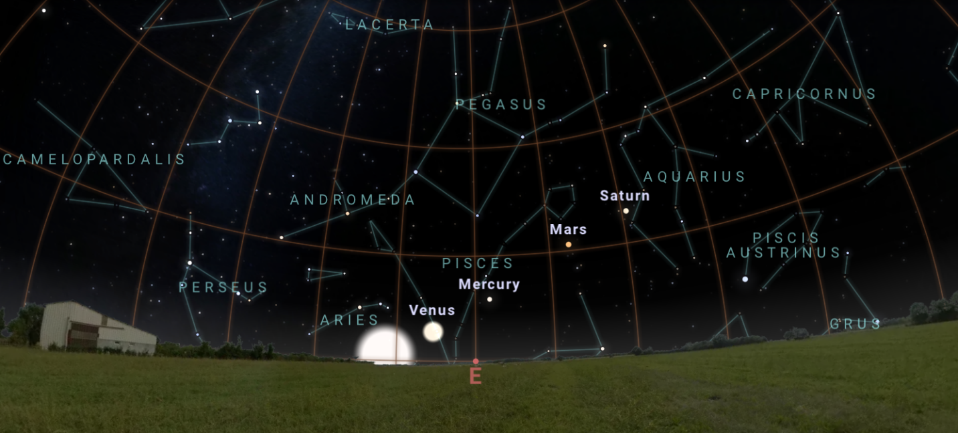
Figure 1: Venus’s last morning appearance in Durham, NC, USA at sunrise on 28 April 2024. Image from Stellarium Web [accessed 10 Mar 2024].

After this, Venus is traveling too close to the Sun to be seen at night (which is, of course, when the Sun, and therefore Venus as well, is below the horizon). Figure 2 below shows Venus conjoined to the Sun on 5 June 2024, rendering Venus impossible to see because it is ‘behind’ the Sun at sunrise from an Earthbound viewer’s perspective.

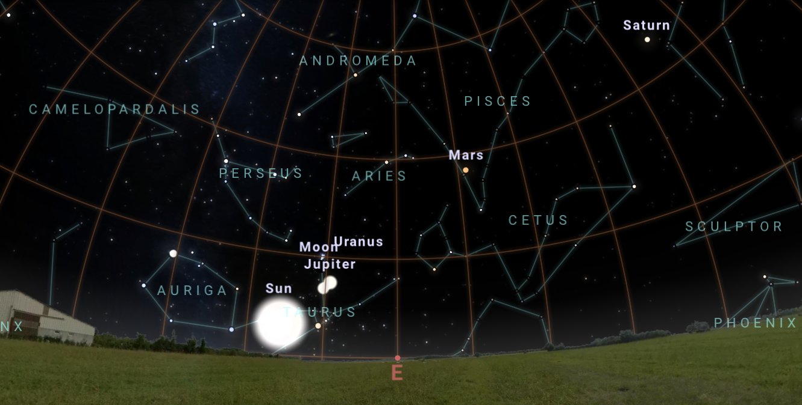
Figure 2: Venus’s superior conjunction in Durham, NC, USA at sunrise on 5 June 2024. Image from Stellarium Web [accessed 10 Mar 2024].

Finally, on 10 July 2024—68 days later—Venus gains enough distance from the Sun to be visible to Earthbound observers again, this time to the West at sunset (Figure 3).

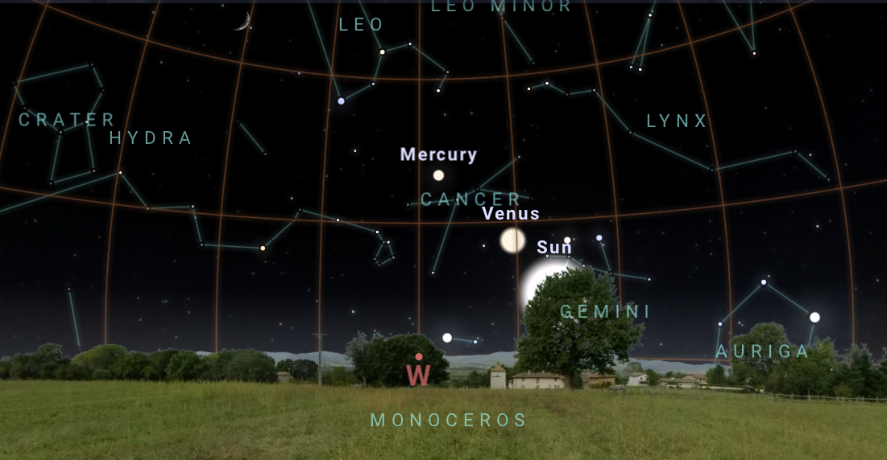
Figure 3: Venus visible in Durham, NC, USA at sunrise on 10 July 2024. Image from Stellarium Web [accessed 10 Mar 2024].

Although examined from a different date and time than the original myth, this dance through the sky still provides a visual understanding of the possible foundation for the myth of Inanna’s descent into the underworld. Venus appears as a morning star after a brief period of invisibility and stations direct, is in forward motion for about 263 days until approaching a threshold, then seems to disappear from the sky for about two months. Then the planet reappears in the evening, after the Sun has set. This appears to have a direct connection with Inanna departing the heavens and being trapped in the underworld.
The myth itself introduces Inanna’s goals with a set of opposites: ‘The goddess, from the “great above,” she set her mind towards the “great below.” … Inanna abandoned heaven, abandoned earth, to the nether world she descended’ and later the goddess announces herself saying, ‘“I am Inanna of the place where the sun rises.”’ In the first part of the introduction, the reader is given associations of above, heaven, and earth for Inanna. If she is the goddess of the ‘great above’ and ‘of the place where the sun rises’, i.e. the East, it may be inferred that the ‘great below’ and the nether world could be associated with the West. If that is indeed the case, the planet Venus gradually appearing to get closer to the Eastern horizon at sunrise before disappearing, as a morning star, and then re-appearing in the West as an evening star after the extended period of invisibility in the superior conjunction, could give an indication of where the planet-goddess has been: stuck in the nether world, the place opposite heaven as West is opposite East.
It is additionally notable that the ‘sixty times’ the food and water of life were said to be sprinkled on Inanna’s corpse roughly align with the 68 days of the upcoming period of Venus’s invisibility (which can be as long as 80 days). However, further research into the average length of this period would need to be conducted to see if there is a stronger connection to the myth.
With Venus appearing to cyclically ‘die’ or disappear, only to reappear again, there is a connection between the cycles of this planet and the goddess she is associated with.

The Astronomical Cycle of Mercury
The astronomical cycle of Venus seems to provide a reasonable foundation for connecting it to a myth. However, there is another planet which also seems to disappear from the sky: Mercury. A brief comparison of Mercury’s astronomical cycles can help to confirm assertions about the connection of the myth of Inanna’s descent with the cycles of Venus, rather than Mercury.
Mercury has a much faster revolution around the Sun (88 days) and synodic interval (averaging 116 days). When it conjoins the Sun, it’s only invisible for about two weeks—a far less dramatic amount of time than Venus’s two-month disappearance. While the planet Mercury also has a morning and evening cycle, the relatively ‘wild’ cycle of Mercury and the relative brilliance of Venus—the brightest and therefore most visible of the planets—makes it more likely that it is indeed Venus’s cycle that is immortalized in myth.

The Moon
It must be noted that not everyone associates the Venusian cycle with Inanna. In an introduction to a chapter on death and rebirth as cycles of nature, Henderson instead sees a connection with the moon:

‘In the seven stages of Inanna’s descent, we find a reference to the phases of the moon: through its waning (death) and waxing (rebirth) it completes a cycle, which then recurs indefinitely.’

While the theme of renewal and resurrection remains associated with Inanna, a different celestial cycle is proposed. However, given that the monthly dark moon is not so dramatic an event as Venus’s apparent disappearance from the sky and subsequent heliacal rising, taken in tandem with documented connections between Inanna and Venus, this connection between Inanna’s descent and the Moon is likely incorrect.
With an understanding of the celestial phenomena established, the connection between Inanna and Venus must also be established.

Linking Inanna to Venus
This idea that the myth of Inanna’s journey into the underworld reflects the cycles of Venus requires evidence that not only was Inanna indeed linked to Venus as posited above, but also that the Sumerians had some knowledge that Venus as morning and evening star were the same body.
Edwin Krupp, an astronomer and expert in archeoastronomy, writes that, ‘Omen texts from the First Babylonian Dynasty (ca. 1900-1660 B.C.) confirm that the old Mesopotamian skywatchers understood that Venus as the morning star and as the evening star were the same thing.’ Although the Babylonian civilization followed that of Sumer, they inherited much from the Sumerians, whose culture was highly influential on later Mesopotamian civilizations such as the Akkadians and the Babylonians: J.R. Porter says that elements including the godly pantheon and mythology ‘remained essentially unchanged throughout all the vicissitudes of Mesopotamian history.’
Indeed, scholar David Brown writes that in a seal

‘dating to the early third millennium BC a series of five Sumerian signs refer to the “festival (ezen) Inana, evening/morning star (celestial body)” which suggests strongly that at this very early time Inana was identified with a heavenly body that was known to appear both in the morning and the evening. In other words the morning and evening “stars” were not thought to be different. This single heavenly body was, of course, Venus.’

Similarly, Krupp also writes that, ‘References to Venus as early as 3000 B.C. are known from evidence at Uruk, an important early Sumerian city in southern Iraq.’ Additionally, he notes, ‘Inanna is Venus, later known as Ishtar, and the Uruk tablets specify her identity with the symbol for “star”: an eight-pointed star.’ These examples demonstrate that the goddess Inanna was linked to the planet/star Venus (not Mercury or the Moon), and that there was an understanding that Venus appearing on the horizon in the evening was the same celestial body as Venus appearing in the morning. Furthermore, as noted previously, given Mercury’s relative dimness and more erratic transits Brown is likely correct in saying that the star appearing at both morning and evening is Venus.
In evaluating another Sumerian myth, Inanna and Šukaletuda, Jeffrey Cooley also sees a connection between Inanna and Venus:

‘Since the requisite knowledge of Venus’ movements was probably in place at the time Inana and Šukaletuda was composed, it does appear as if Inana’s movements within the story could be related to regular Venus phenomena, specifically referring to Venus’ celestial movements over a single synodic period.’

Cooley also notes that, ‘Given the fact that her next appearance is probably in the east…it seems likely that Inana’s movements in the prologue are describing the interval between her last appearance in the west (Ω) to just before her first eastern visibility (Γ)’, adding that, ‘If the goddess is returning from the underworld, she must be in the process of rising.’ Although this latter statement would seem to make a connection between the inferior conjunction—with Venus rising in the East rather than the West, as posited earlier in this paper—the visual phenomena is similar enough to draw the same conclusions. Additionally, it may be that two separate myths were created to explain the disappearances of two different lengths, given the inferior conjunction is so much shorter than the superior conjunction. These connections from a second, contemporaneous myth of the same goddess offer further evidence that ancient stargazers, noting the periodic disappearance of a bright body from the sky, attempted to explain it in myths associated with the same goddess.
Also of interest is that Inanna must shed seven items: her crown, wig, measuring rod, necklace, ring, breastplate, and cloak, leaving herself—her body—as an eighth ‘item’. More research could investigate whether this is connected to the symbol of the eight-pointed star, further strengthening associations between the planet and the goddess, and between these and the myth.
If it is the case that the Sumerians both associated Inanna with Venus and were aware of Venus as being both a morning and an evening star, the myth of Inanna descending into the underworld and disappearing for a time only to be resurrected may be an effort to explain an astronomical phenomenon via myth, thereby making an intimate connection between sky and culture and exploring themes of cyclical resurrection.

Conclusion
With myth being a vehicle to explain the nature of the larger world, it seems likely that the myth of Inanna’s descent into the nether world would be an example of Willis’s ‘celestial architecture’ theme. Whether this myth connects to any particular social or cultural values for the Sumerians is outside the scope of this paper, but there is a case for its function in noting and explaining the movements of Venus. The observable motions, disappearance, and appearance of the planet align with elements of the story, and there are some details which seem to further support a direct connection. Additionally, there are other myths of Inanna which also seem to reflect the movements of the planet Venus. Therefore, it is likely that in reading the story of the goddess’s descent, readers are gaining a glimpse into how the Sumerians conceptualized and made sense of the sky.

Bibliography
Augustine, Pallas K., Venus Cycle & Venus Calculator Guide (27 February 2022) <https://www.nineofwands.com/blog/venus-cycle-calculator> [accessed 2 Mar 2024]

Brown, David, Mesopotamian Planetary Astronomy-Astrology: Cuneiform Monographs 18, CM 18 (Groningen: Styx Publications, 2000)

Cooley, Jeffrey L., ‘Inana and Šukaletuda: A Sumerian Astral Myth’, Kaskal: Rivista di storia, ambienti e culture del Vicino Oriente Antico, vol 8. (2008), pp. 161-172 <https://www.academia.edu/1247599> [accessed 16 March 2024]

European Southern Observatory, Synodic period (the cycle of Venus) (March 2007), <https://www.eso.org/public/outreach/eduoff/vt-2004/Education/edu1app4.html> [accessed 2 Mar 2024]

Geertz, Clifford, The Interpretation of Cultures, 3rd edn. (New York: Basic Books, 2000)

Henderson, Joseph L, and Maud Oakes, ‘Death and Rebirth as Cycles of Nature: The Descent of Inanna’, in The Wisdom of the Serpent: The Myths of Death, Rebirth, and Resurrection, (Princeton: Princeton University Press, 1990), pp. 15–31 <https://doi.org/10.2307/j.ctv131bwfw.8> [accessed 17 February 2024]

Henderson, Joseph L, and Maud Oakes, ‘Death and Rebirth as Cycles of Nature: The Myths’, in The Wisdom of the Serpent: The Myths of Death, Rebirth, and Resurrection, (Princeton: Princeton University Press, 1990), pp. 99–138 <https://doi.org/10.2307/j.ctv131bwfw.8> [accessed 17 February 2024]

Kramer, S.N. (trans), ‘Inanna’s Descent to the Underworld’ in ‘Sumerian Myth and Epic Tales’ in Pritchard, James B. (ed.), Ancient Near Eastern Texts Relating to the Old Testament, (Princeton: Princeton University Press, 1969), pp. 52-57 <https://www.jstor.org/stable/j.ctt19wccw4.6> [accessed 6 February 2024]

Krupp, E.C., Echoes of the Ancient Skies: The Astronomy of Lost Civilizations (Garden City, NY: Dover Publications, 2003)

Porter, J.R., ‘The Middle East’, in World Mythology: The Illustrated Guide ed. by Roy Willis (Oxford: Oxford University Press, 2006), pp. 56-67

Soural, Petr, Mercury Cycles - Astrology Online Calendar 2024 (2024), <https://horoscopes.astro-seek.com/mercury-cycle-promethean-epimethean-astrology-calendar> [accessed 2 March 2024]

Soural, Petr, Venus Rose Cycle - Astrology Online Calculator 2023 (2023), < https://horoscopes.astro-seek.com/venus-cycle-5-petals-of-venus-online-astrology-calendar> [accessed 10 March 2024]

Stellarium Labs, Stellarium Web (2024) <https://stellarium-web.org/> [accessed 10 March 2024]

Time and Date AS, Distance, Brightness, and Size of Planets (2023) <https://www.timeanddate.com/astronomy/planets/distance> [accessed 24 Feb 2024]

Willis, Roy, ‘Great Themes of Myth’, in World Mythology: The Illustrated Guide, ed. by Roy Willis (Oxford: Oxford University Press, 2006), pp.17-34

J.R. Porter, ‘The Middle East’, in World Mythology: The Illustrated Guide, ed. by Roy Willis (Oxford: Oxford University Press, 2006), pp. 56-67 (p. 57).
S.N. Kramer (trans), ‘Inanna’s Descent to the Underworld’ in ‘Sumerian Myth and Epic Tales’ in Ancient Near Eastern Texts Relating to the Old Testament, ed. by Pritchard, James B. (Princeton: Princeton University Press, 1969), pp. 52-57.
Kramer, ‘Inanna’s Descent to the Underworld’, p. 52.
Roy Willis, ‘Great Themes of Myth’, in World Mythology: The Illustrated Guide, ed. by Roy Willis (Oxford: Oxford University Press, 2006), pp.17-34 (p. 20).
Willis, ‘Great Themes of Myth’, p. 20.
Willis, ‘Great Themes of Myth’, p. 21
Clifford Geertz, The Interpretation of Cultures, 3rd edn. (New York: Basic Books, 2000), p.137.
Geertz, The Interpretation of Cultures, p. 137.
Kramer, ‘Inanna’s Descent to the Underworld’, p. 55.
Kramer, ‘Inanna’s Descent to the Underworld’, p. 55.
Joseph L. Henderson and Maud Oakes, ‘Death and Rebirth as Cycles of Nature: The Descent of Inanna’, in The Wisdom of the Serpent: The Myths of Death, Rebirth, and Resurrection, (Princeton: Princeton University Press, 1990), pp. 15–31 <https://doi.org/10.2307/j.ctv131bwfw.8> [accessed 17 February 2024], p. 16.
Henderson, ‘Death and Rebirth as Cycles of Nature’, p. 17.
Brown, Mesopotamian Planetary Astronomy-Astrology, p. 83.
Brown, Mesopotamian Planetary Astronomy-Astrology, p. 83.
Cooley, Jeffrey L., ‘Inana and Šukaletuda: A Sumerian Astral Myth’, Kaskal: Rivista di storia, ambienti e culture del Vicino Oriente Antico, vol 8. (2008), 161-172 (p.165) <https://www.academia.edu/1247599> [accessed 16 March 2024].
European Southern Observatory, Synodic period (the cycle of Venus) (March 2007), <https://www.eso.org/public/outreach/eduoff/vt-2004/Education/edu1app4.html> [accessed 2 Mar 2024].
Pallas K. Augustine, Venus Cycle & Venus Calculator Guide (27 February 2022) <https://www.nineofwands.com/blog/venus-cycle-calculator> [accessed 2 Mar 2024].
Stellarium Labs, Stellarium Web (2024) <https://stellarium-web.org/> [accessed 10 March 2024].
Petr Soural, Venus Rose Cycle - Astrology Online Calculator 2024 (2024), < https://horoscopes.astro-seek.com/venus-cycle-5-petals-of-venus-online-astrology-calendar> [accessed 10 March 2024].
European Southern Observatory, Synodic period (the cycle of Venus).
Kramer, ‘Inanna’s Descent to the Underworld’, p. 53.
Kramer, ‘Inanna’s Descent to the Underworld’, p. 54.
Cooley, ‘Inana and Šukaletuda’, p.164.
Brown, Mesopotamian Planetary Astronomy-Astrology, p. 84.
Petr Soural, Mercury Cycles - Astrology Online Calendar 2024 (2024), <https://horoscopes.astro-seek.com/mercury-cycle-promethean-epimethean-astrology-calendar> [accessed 2 March 2024]
Brown, Mesopotamian Planetary Astronomy-Astrology, p. 68.
Time and Date AS, Distance, Brightness, and Size of Planets (2023) <https://www.timeanddate.com/astronomy/planets/distance> [accessed 24 Feb 2024].
Joseph L. Henderson and Maud Oakes, ‘Death and Rebirth as Cycles of Nature: The Myths’, in The Wisdom of the Serpent: The Myths of Death, Rebirth, and Resurrection, (Princeton: Princeton University Press, 1990), pp. 99–138 (p. 99) <https://doi.org/10.2307/j.ctv131bwfw.8> [accessed 17 February 2024].
E.C. Krupp, Echoes of the Ancient Skies: The Astronomy of Lost Civilizations (Garden City, NY: Dover Publications, 2003), p. 307.
Porter, World Mythology, p. 58.
David Brown, Mesopotamian Planetary Astronomy-Astrology: Cuneiform Monographs 18, CM 18 (Groningen: Styx Publications, 2000), p. 67.
Krupp, Echoes of the Ancient Skies, p. 303.
Krupp, Echoes of the Ancient Skies, p. 303.
Cooley, ‘Inana and Šukaletuda, p.165.
Cooley, ‘Inana and Šukaletuda’, p. 166.
Cooley, ‘Inana and Šukaletuda’, p. 167.
Kramer, ‘Inanna’s Descent to the Underworld’, p. 54.

