DS1 Raymond

My Screenshots/Photos
- Please add 4–6 screenshots or photos of your digital life.
- You can use your phone or laptop.
- For each screenshot, write one or two sentences explaining what it shows.

TikTok
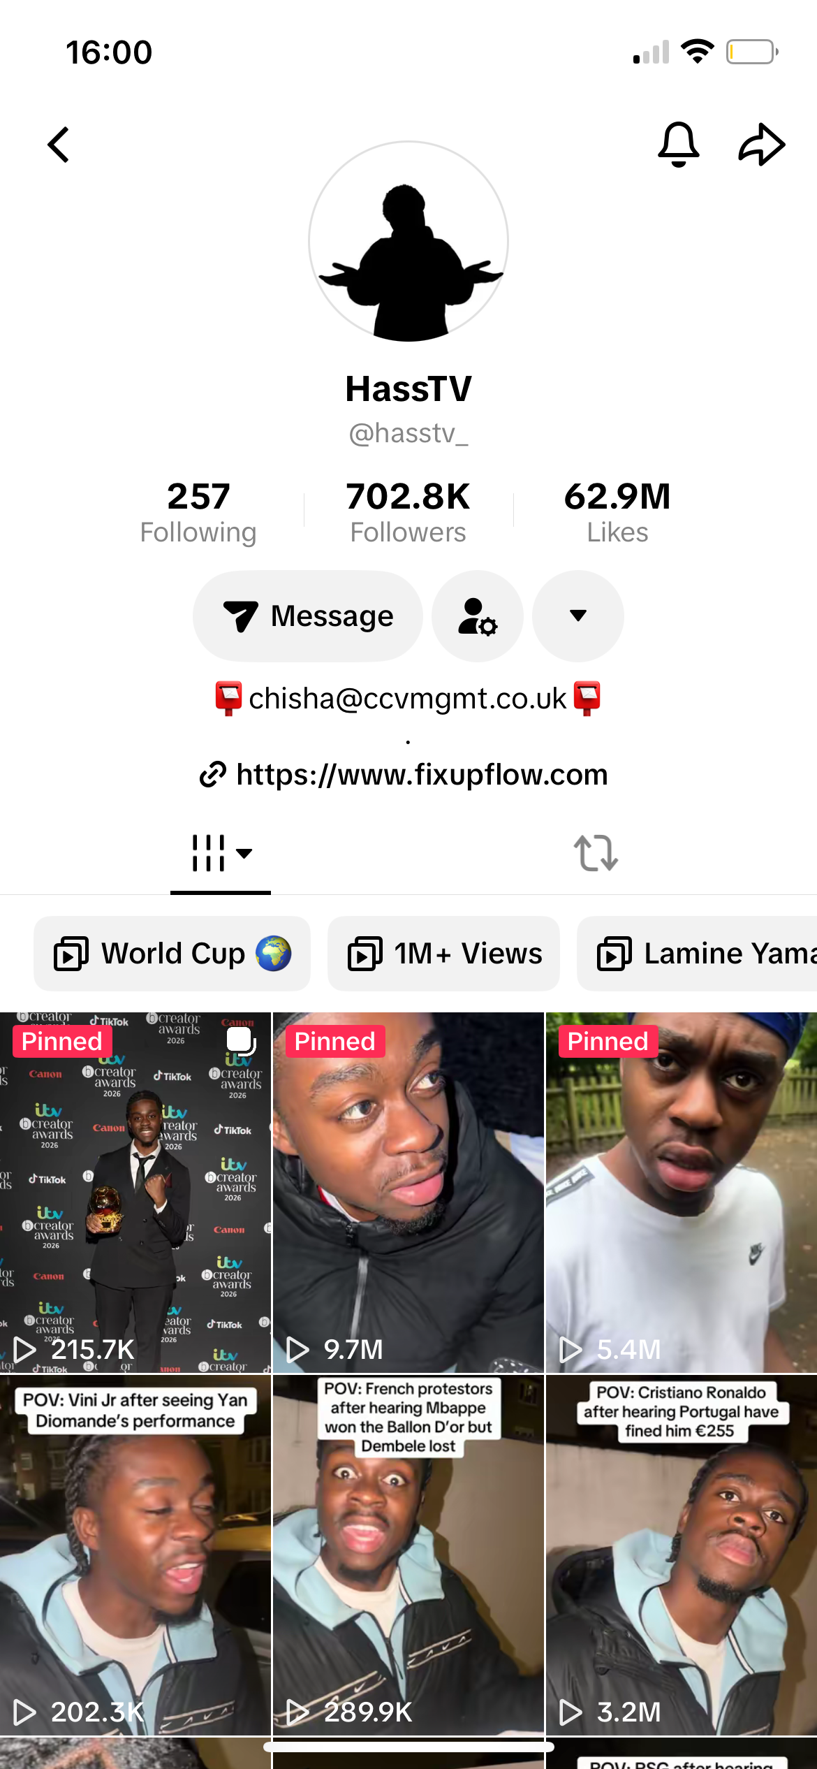
[IThis is a platform called TikTok. I use this digital tool to send videos to friends and family it’s a good way to connect and with friends sharing each other videos for example this is one of my favriote tiktok creators which brings me joy and laughter with his content I get to keep in the loop using this app to keep update when they upload.

Instagram
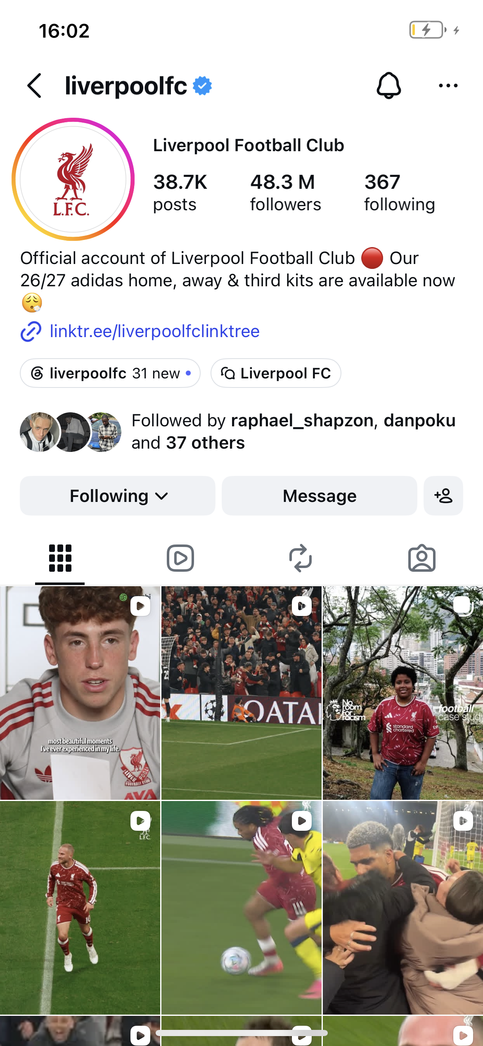
[I use this digital tool Instagram to keep up with my favourite football team Liverpool using this digital I get to check are next matches watch videos and keep update with all the news of the players and fixtures and social media content surrounding the club]

Wowcher
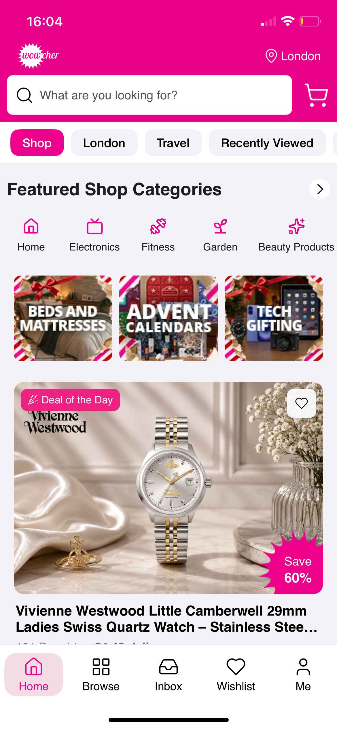
This is also an important digital tool I use in my life I use this digital tool too check the latest deals promotions. A example of this I used this tool to buy a spa deal for a loved one which she really appreciated so this is a tool which benefits me and helps with my digital structure

Gymshark
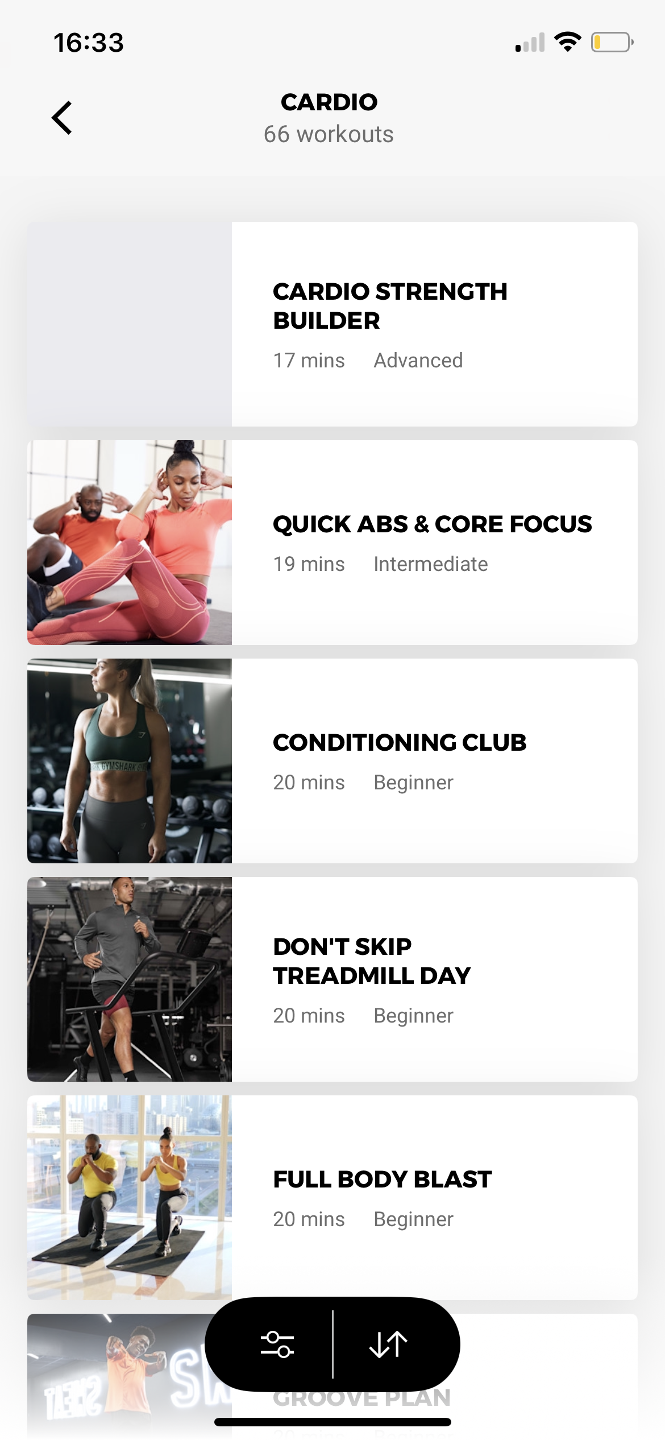
I use this digital tool every time I go gym it has different exercises I can use which really helps me to exercise and gives me a clear structure and program I want to use a example of this I said I want to lose weight and it gave me a plan and program ]

Couch 5k
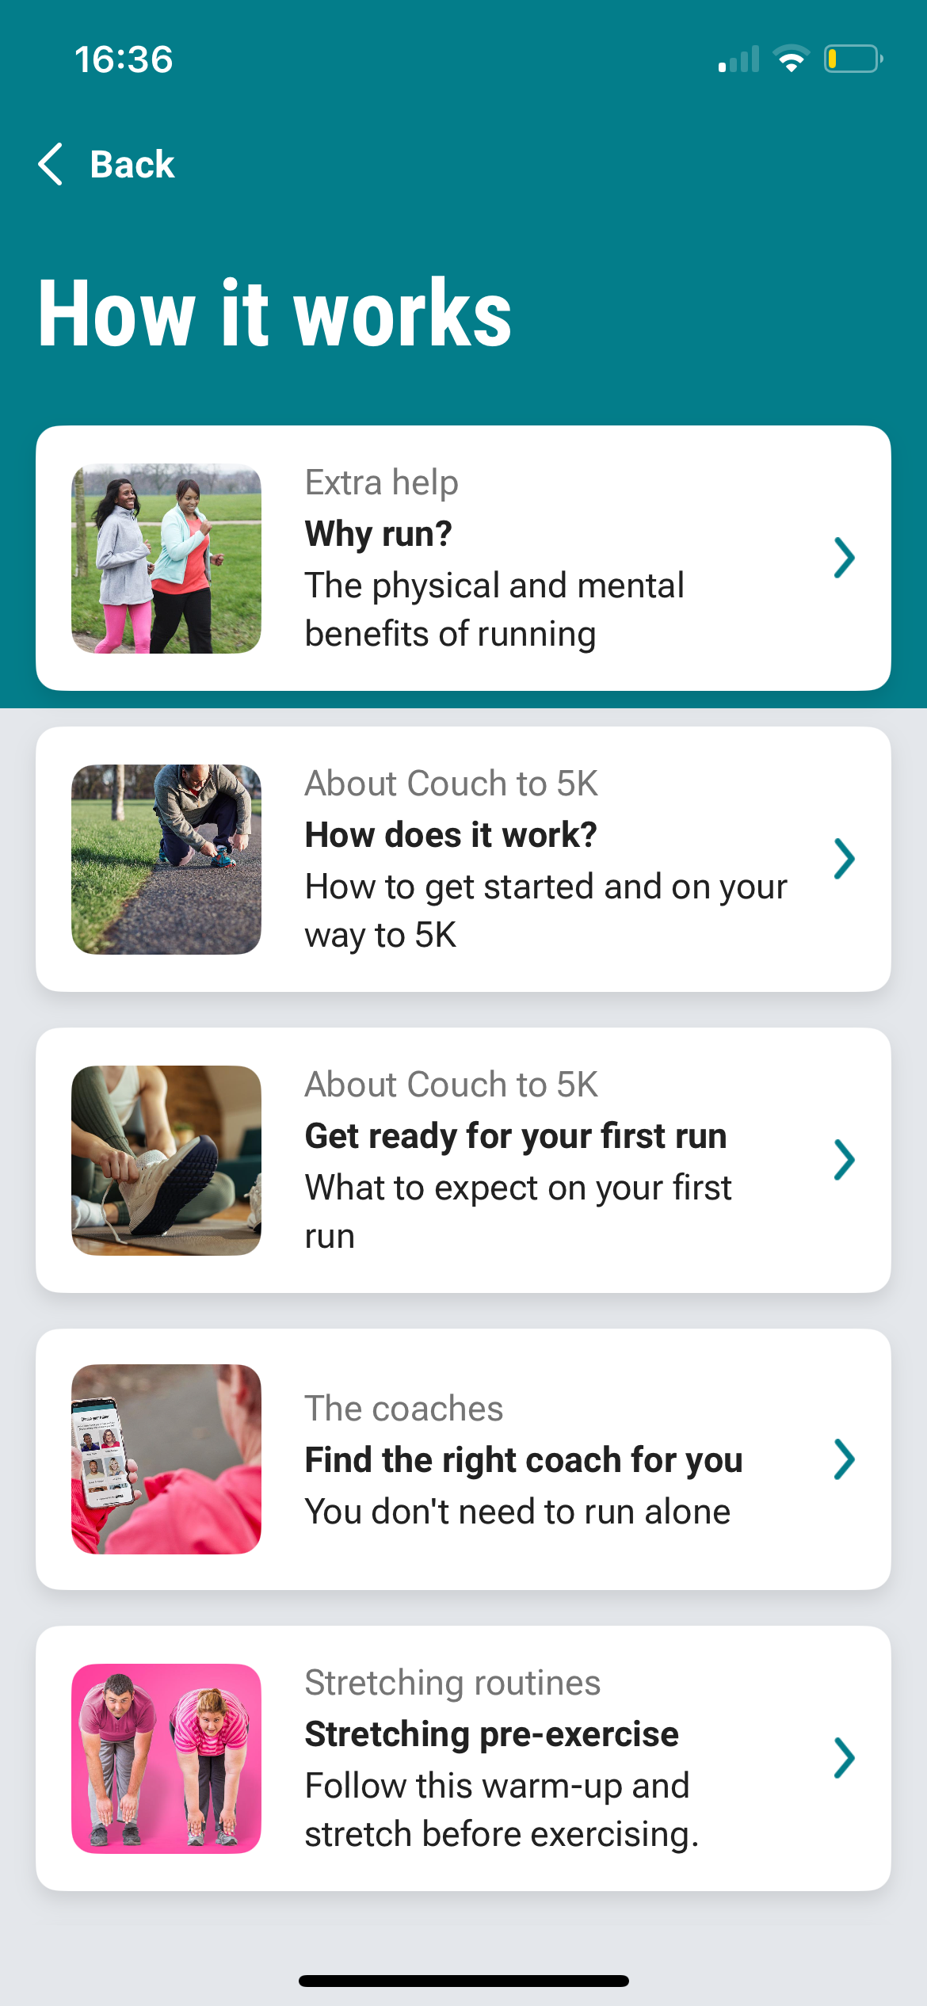
[I use this app in my digital life when I want to go for a nice run at the park this digital tool helps me and sets me up with my own trainer who communicates and motives me with a digital sound which keeps me calm and helps me with the run nice and smoothly.

Trainline

[this is also a very important digital tool which helps me buy train tickets and also gives me the route where I want to travel to]

My Short Reflection
- Write 5–8 simple sentences about your digital life.
- You can use the sentence starters below if helpful.
I have come to the realisation that using Instagram, TikTok, Wowcher, couch5k, trainline and gym shark really helps to shape my digital life using these digital tools.I feel confident using all these different tools and want to continue to improve using these apps as it brings a sense of happiness and plays a important role in my digital life and these tools has made me realise it can help shape me for my module .

Sentence starters
- I use digital tools to …
- I feel confident when I …
- I want to improve …
- I often use these tools: …
- I sometimes feel nervous about …
- I hope this module will help me …
- Digital skills are important for me because …
You can write more if you want.

Submission Checklist
Before you submit, please check:
​​​ ☐ I added 4–6 screenshots
☐ I wrote short sentences for each screenshot
☐ I wrote my short reflection
☐ My work is my own
☐ My file opens correctly
​​☐ My file opens correctly

