
Skills for the Workplace
Module Assignment Submission
Student Name: | Alyson Downes
Student Number: | 2024912
Module No: | BMSK4007
Module Title: | Digital Skills and Personal Branding

Statement of Confirmation of Authenticity
By the act of making this submission, the student declares that this is the work of the student named above. The work has not, in whole or in part, been knowingly presented elsewhere for assessment, or where assessment has been built on a previous assessment, this has been identified. Where materials have been used from other sources it has been properly acknowledged. If this statement is untrue, the student acknowledges that an assessment offence has been committed.
Attention is drawn to the plagiarism and unfair practice policies of both the University and of ILM.
Permission for ILM to use this script
ILM uses learners’ submissions – on an anonymous basis – for assessment standardisation. By submitting, both the centre and the learner agree that ILM may use this script on condition that identifying information is removed. However, if you are unwilling to allow ILM use this script, please refuse by ticking the box: □

Table of Contents
What has been the impact of 21st Century Technologies on the modern workplace? 3
Evaluate the appropriate use of modern technologies and social media in the workplace generally 4
Explore the use of modern technologies and social media in own workplace 4
How can Personal branding help YOU? 5
Your LinkedIn Profile to promote your Personal Brand 6
Evaluate the value of other social media platforms to enhance networking and career prospects 8
Examine the impact of Personal Branding on your own employability 9
Discuss personal and professional security and safety online. 10
Appendix 1 13

What has been the impact of 21st Century Technologies on the modern workplace?

The 21st century has seen a huge increase in both the use and the availability of technology, which has undoubtedly had an impact on how, and even where, we work (Holland & Bardoel, 2016). Advances in technology have seen an increase in productivity and efficiency (Dukes, 2019), as well as increased collaboration made possible by developments in communication technology such as email, instant messaging platforms and video conferencing technology, all of which mean we’re now able to connect with people anywhere at any time.
A blog on F450c.org (2021) gives some examples of technologies utilised by almost all modern workplaces, such as wi-fi internet, communication tools such as Skype, Zoom and Teams, as well as cloud-based storage systems. It is technologies such as these that have contributed to an increase in different ways of working, such as remote working and hybrid working. In 2019, according to a report by Felstead and Reuschke (2020) 4.7% of people in employment were already working remotely. This number rose dramatically during the pandemic and the onset of lockdowns. By April 2020 43.1% of employees worked exclusively from home. The Office of National Statistics (2020) reported that 46.6% of people worked remotely at least some of the time for the same period, and of those, 86% did so as a result of the pandemic. This would not have been possible were it not for this century’s technology. The rise in remote working means employers have a much wider pool of potential candidates to choose from, and candidates have a wider selection of jobs they can apply for now that location is no longer a deal breaker.
There is of course, a negative side. The increase in automation that comes with advances in technology will undoubtedly have an impact on job availability, and not in a good way. An article by Gleeson (2019) discusses a report called ‘Harnessing Automation for a Future that Works’, which concludes that current technology has the potential to eliminate over one billion jobs worldwide. More negative impacts can be increased distractions (FactSuite, 2019), an ‘always on’ lifestyle, the risks of data security (Sintellyapp, 2021) and less face-to-face interactions with colleagues.
However on the whole, when utilised appropriately, advances in technology have more of a positive impact in the workplace than a negative one. Technology such as project management software has helped businesses become far more organised (Prasad, 2018), employees are able to work faster and with more precision which has raised productivity, more automation has improved cost management, and technology such as fingerprint and facial recognition has improved security. There is also a positive impact on the environment with more and more workplaces moving towards becoming paperless.

Evaluate the appropriate use of modern technologies and social media in the workplace generally

The vast majority of businesses now have a social media presence, and it’s easy to see why. There are now 3.78 billion social media users worldwide, and this figure is growing (Mohsin, 2021). Social media can help businesses with advertising and promotion, enable them to engage with customers and potential customers, get customer feedback, and even recruit staff (Business.Gov.AU, 2021). Being able to get customer feedback is, on the whole, a positive thing. However it can also have a downside. Social media can mean that it is more difficult for businesses to contain negative publicity. Unfortunately people are far more likely to share a negative experience than a positive one, and bad reviews can damage a company’s reputation and drive away potential clients (Adam, 2021). Despite this, up to 90% of marketers say that social media has a positive effect on their brand (Bhat, 2018). A visible social media presence can help businesses to increase website traffic and have a positive impact on brand awareness.
Social media is also an extremely useful tool for job seekers. An article in Forbes (Castrillon, 2021) states that 92% of companies are now using social media for hiring, and 68% of recruiters have said that job seekers should have a LinkedIn profile. It’s also thought that up to 70% of employers use social media to screen potential candidates, and 43% even use it to check on current employees (Working Solutions, 2020). It is therefore extremely important that people are careful with how they use social media and probably a good idea that personal profiles are not set to public and privacy settings utilised appropriately.
Facebook is still the most popular social media site, with 2.7 billion monthly active users, up from 2.27 billion in 2019 (Walker-Ford, 2021). Instagram comes in second with 1.16 billion, Twitter has 353 million, and LinkedIn 350 million.

Explore the use of modern technologies and social media in own workplace

I work for DVSA (Driver Vehicle Standards Agency). Since my start date, I have worked on a laptop. It was explained to me when I started that we were encouraged not to leave the laptops in our lockers overnight, and it was good practice to take them home each night and bring them with us every morning in case of an emergency, car trouble for example, which would mean we were unable to get to the office. If we had our laptop with us, we would be able to work from home that day. Of course when the pandemic hit, it also meant that we were able to start working from home without delay. We also use Microsoft Teams. At first it was predominantly used as an easy way to save and share files that the Team all needed to work on, however when we started working remotely, it also became our main communication source. In short, the fact that my workplace has embraced the use of 21st century technology, has meant that we were able to continue working throughout the pandemic, and has now changed the way that we’ll work in the future, with the company embracing hybrid working as our new normal.
DVSA do have a social media presence and regularly post on their Facebook and Twitter profiles. They also have an Instagram page and a LinkedIn profile, but they are not utilised as much as the other two. DVSA use social media as a way to keep people informed of the work they are doing as an agency. There has been an increase in negative comments and feedback across social media channels of late, due to people’s frustrations with the recent fee increases, and driving test backlog that has only gotten worse because of the pandemic. This was discussed during a recent webinar held with our directors, with some staff suggesting that it may be a good idea to turn off comments so that this could be avoided as it does not look great. However the directors were keen to avoid this as they believe it is good practice for businesses to be prepared to listen to their customers, both the good and the bad, and I agree.
We also use Yammer as an internal social media platform where staff can connect with one another. This is used in many different ways by different people. Some staff like to share pictures of recipes of their pets, others share information about any news or upcoming events, and some just like to have a little moan about aspects of their job with people that understand. Regardless of how people choose to use the platform, and even though I do not use it myself, I do believe it is a positive thing.

How can Personal branding help YOU?

Amazon Founder Jeff Bezos once said, ‘Your personal brand is what other people say about you when you’re not in the room’ (Young, 2021). Personal branding is essentially marketing a person the way that you would market a brand (Henderson, 2019). It is the way in which a person promotes themselves. It is a person deciding how they want to come across to the world, how they would like to be perceived, and acting accordingly. Many people already have some form of personal brand without realising it. If a person types their name in to the google search bar, they will most likely find some results, and these will contribute to their personal brand and people’s perception of them. Personal branding is a way of controlling what is out there. Personal branding can be used as a way to promote oneself, and to demonstrate skills or knowledge in a particular field (Heitzman, 2019). A good place to start with developing a strong personal brand is with social media accounts. Social media accounts should be kept up to date, and any old content that does not have a positive effect on a person’s professional image should be removed. There should be consistency across all social media platforms. Successful personal branding is also achieved by a person identifying their area of expertise or their USP (unique selling point), posting regularly, finding and joining groups that are relevant to their particular industry or topic, and remaining positive and enthusiastic (Digital Marketing Institute, 2017).
Personal branding can help me personally by helping me to identify what makes me unique, showing potential employers what I can bring to the table that other people cannot. It will mean I’m more visible online. It is a great way to network and communicate with others in the same industry, and to get my name out there amongst my peers. Most importantly I feel, it puts me in charge of my digital footprint (Anderson, 2021). It gives me some control over what potential employers will see when they google my name and tells people only what I want them to know.

Your LinkedIn Profile to promote your Personal Brand

Before creating my LinkedIn profile, I thought about what impression I want to give to people who may view it, and what my personal brand actually is. It is important to me to be authentic and honest, so I wanted to show that I am professional, I have experience, and I am qualified in my field. But I also wanted to show a little of my personality. I’m quite outgoing and enthusiastic about what I do, and I love working with people. I also wanted to mention that I am working towards getting my degree, as I feel that shows that I have a willingness to improve myself and the ambition to better myself.
I chose a banner picture that instantly tells people what industry I work in, and I decided I didn’t want my profile picture to be too serious looking. I am a friendly and approachable person, and I wanted to use a photograph that reflects that.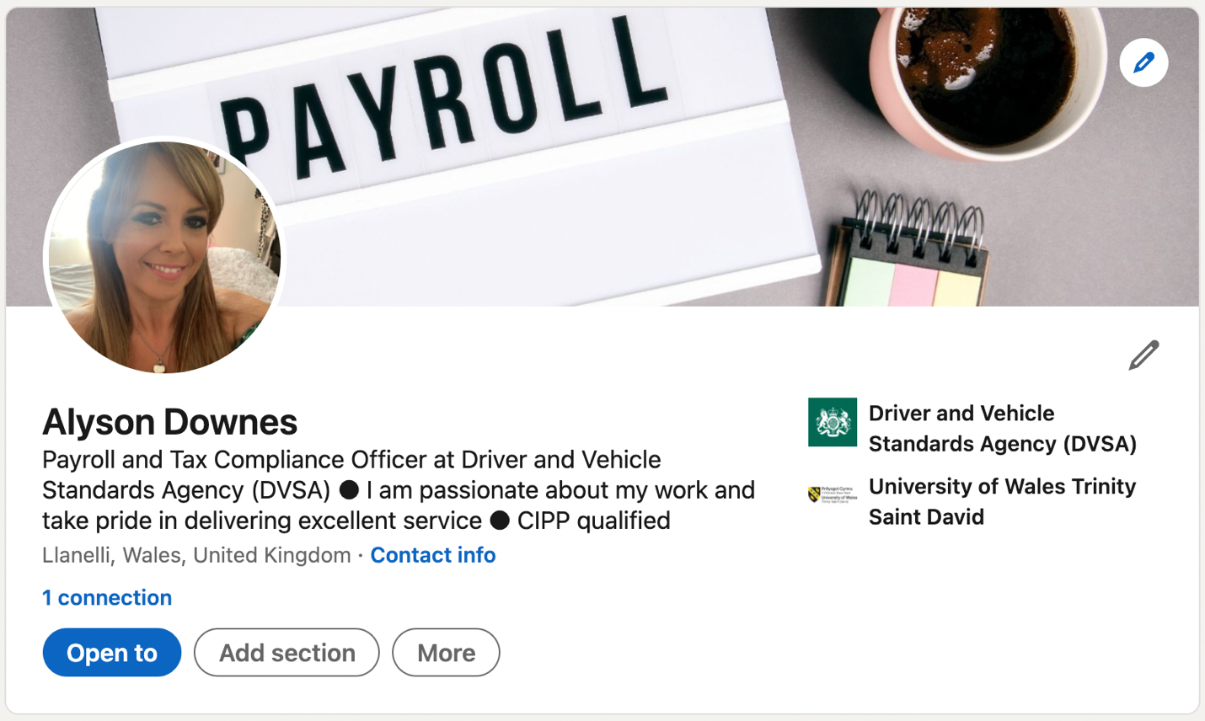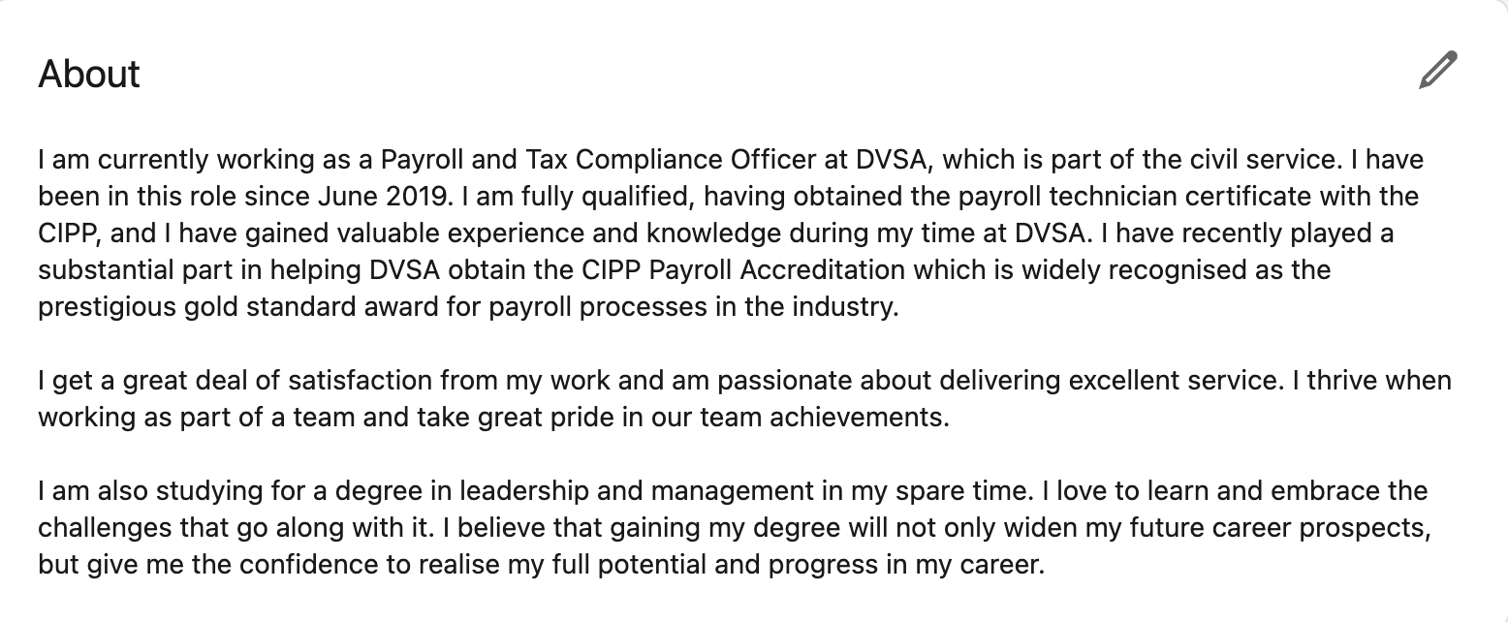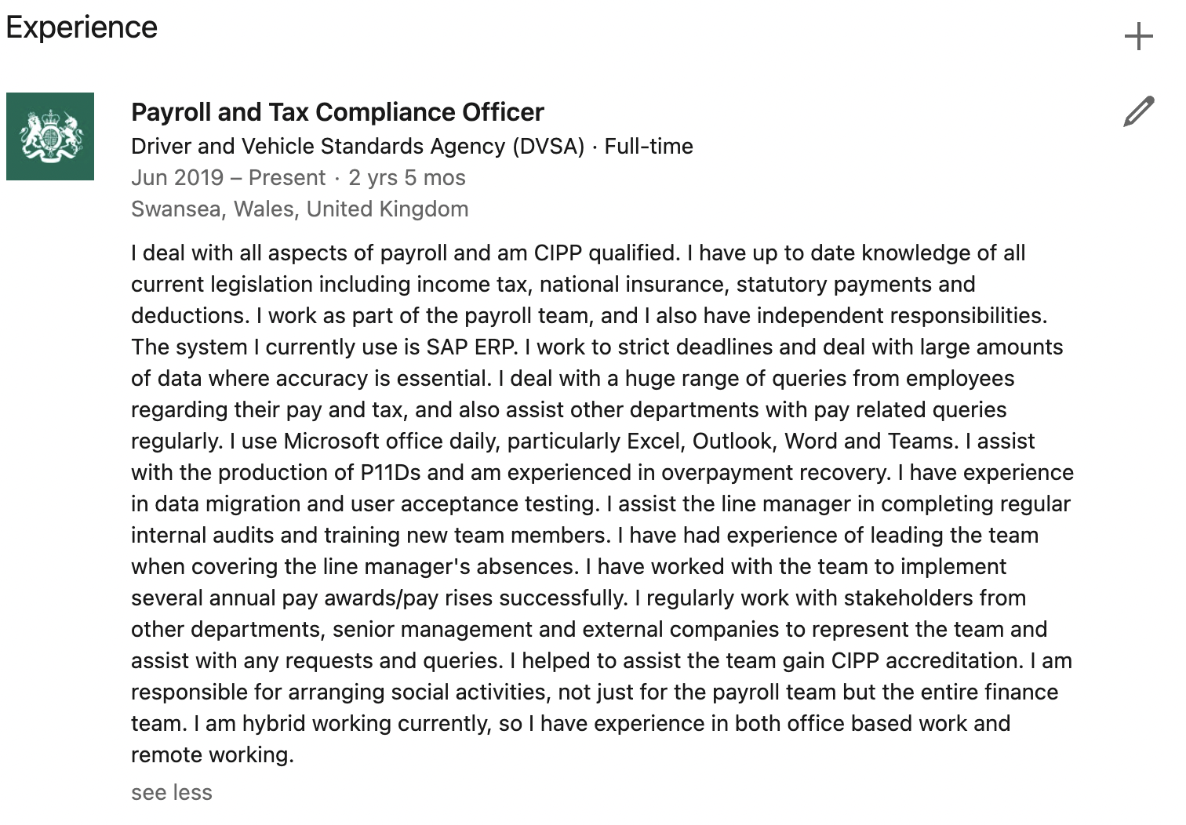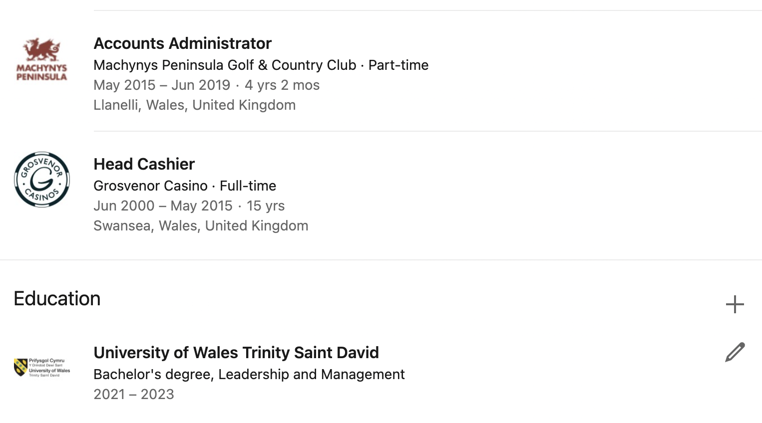

The link to my profile can be found in the appendix.

Evaluate the value of other social media platforms to enhance networking and career prospects

LinkedIn is not the only social media platform that can be used for networking. Facebook is still the largest and most popular platform, boasting 2.7 billion active monthly users (Walker-Ford,2021). Some care should be taken when using Facebook as a professional tool, and boundaries should be established between personal and professional profiles. Facebook can be a good way to connect with other people from the same industry, there are millions of Facebook groups for almost all interests, and these are an excellent way to network. Facebook also enables users to share content and comment on the content of others. Facebook Events can also be a very good way to find networking events in a particular area. All in all, Facebook can be a fantastic tool for networking if utilised correctly and appropriately.
Twitter is another social media platform that can be used professionally. Twitter is known as a micro-blogging website. The platform gives users a 280-character limit for their posts. Users can follow others in their industry, can comment on other users posts as well as sharing their own. They can also ‘re-tweet’ other people’s tweets that they find interesting or worth discussing. Hashtags can also be a useful way to get your posts noticed, or to see what others are saying about a particular topic. Twitter does not have as many features as Facebook and LinkedIn, however regularly tweeting your thoughts and ideas on any particular topic can be a great way to get noticed by others in the field.
Instagram can also be a useful tool for some people. As Instagram is primarily for sharing photos, it is particularly useful for those who have a product to sell, such as cake making businesses who can share pictures of their finished products, or photographers who can use the site to showcase their talent. As the second largest social network after Facebook, it is certainly a platform worth utilising.
There is also MeetUp for finding like mind professionals to meet in real life. Quora a site predominantly for asking and answering questions can be a good place to share knowledge. And Slack. Not just a messenger app, it also has communities where like-minded professionals can discuss a variety of topics (Trier, 2021).

Examine the impact of Personal Branding on your own employability

Studies have shown that personal branding is positively related to both career satisfaction and perceived employability (Gorbatov, Khapove and Lysova, 2019). Personal branding is about identifying, promoting, and positioning oneself professionally. I believe that it is something that will help me to think about what sets me apart from others in my field, and what my unique qualities are. Every person has a personal brand and an online persona whether they’re aware of it or not. Thinking about my personal brand has made me more conscious of this, and far more careful about what I post and who I share information with online. Creating my LinkedIn profile made me very aware of how I want to come across to other professionals. I have never been comfortable with self-promotion and discussing things that I’m good at, so this is not something that I found easy, but writing my profile and talking about my skills and knowledge, made me see that I have experience in a far wider range of tasks than I thought, and I do have skills that prospective employers will find valuable. I do feel that a lack of confidence is one of my biggest weaknesses, and as personal branding can help with self-awareness and therefore self-assuredness (Aruda, 2021), I feel like it is something that will help me extensively in that area. If I can believe in myself, then I have a far better chance of getting employers to believe in me. I also believe that having a better idea of who I am and what I bring to the table will improve my performance in job interviews and give me more awareness of how I come across and how I want to be perceived. Personal branding is not limited to social media platforms and my online presence. It is also something that can be used during networking events when meetings peers, and even in job applications, cover letters and CVs.

Discuss personal and professional security and safety online.

Along with advances in technology, comes risk, so it is important that people are aware of how to stay safe online. Personal and professional information should not be shared with strangers, and one way of avoiding this is to utilise the privacy settings on web browsers, mobile operating systems and social media platforms (Kaspersky, 2021). Safe browsing should be practiced at all times and internet connections should be secure. Care should be taken when using a public wi-fi connection, and purchases should only ever be made from secure sites. Care should also be taken when meeting people online and interacting with strangers. People are not always who they say they are, and fake social media profiles are a popular way for hackers to obtain personal information.
The National Cyber Security Centre (NCSC, 2021) also recommends using strong passwords, and separate passwords for different accounts. A good way to create and remember many different passwords is to use a password manager app. Software and apps should be kept up to date, two factor authentication should be used where possible and smartphones and tablets should always have a screen lock set up.
Every time a person visits a website, makes an online purchase or does anything else online, they share data. Data protections laws are put in place to ensure this data is used properly and legally, and these are covered in the Data Protection Act 2018 (DOA 2018) and the UK General Data Protection Regulation (UK GDPR) (ICO, 2021). The legislation means that companies have a duty to ensure all personal data is processed lawfully and fairly, only collected for legitimate reasons, is accurate and kept up to date, kept in a way that permits identification, and is processed securely.

References

Adam, 2021. The Impact of Negative Social Media Reviews on Businesses [Online] Available at: https://www.netreputation.com/negative-social-media-impacts/ (Accessed 9th October 2021)
Anderson, A. 2021. 5 Reasons Why You Need A Personal Brand [Online] Available at: https://thebritishschoolofetiquette.com/5-reasons-why-you-need-a-personal-brand/ (Accessed 10th October 2021)
Aruda, W. 2021. 9 Amazing Benefits of Personal Branding [Online] Available at: https://www.forbes.com/sites/williamarruda/2021/03/21/9-amazing-benefits-of-personal-branding/?sh=1ac471487a7e (Accessed 12th October 2021)
Bhat, U. 2018. 6 Positive Effects of Social Media on Your Business [Online] Available at: https://www.cloohawk.com/blog/6-positive-effects-social-media-marketing-your-business (Accessed 8th October 2021)
Business.Gov.AU, 2021. Social Media for Business [Online] Available at: https://business.gov.au/online/social-media-for-business (Accessed 7trh October 2021)
Digital Marketing Institute, 2017. 10 Steps to Building Your Personal Brand on Social Media [Online0 Available at: https://digitalmarketinginstitute.com/blog/10-steps-to-building-your-personal-brand-on-social-media (Accessed 9th October 2021)
Dukes, E. 2019. Technology in the Workplace Can Help Grow your Business [Online] Available at: https://www.iofficecorp.com/blog/5-ways-technology-has-changed-the-modern-workplace (Accessed 1st October 2021)
F450c.org, 2021. Top 8 Technological Indispensables of Modern Workspaces [Online] Available at: https://f450c.org/technology-in-the-workplace/ (Accessed 8th October 2021)
FactSuite, 2019. Negative Impact of Technology in the Workplace [Online] Available at: https://factsuite.com/blog/negative-impact-of-technology-in-the-workplace/ (Accessed 9th October 2021)
Felstead, A and Reuschke, D (2020) Homeworking in the UK: before and during the 2020 lockdown. WISERD Report, Cardiff: Wales Institute of Social and Economic Research.
Available at: https://wiserd.ac.uk/sites/default/files/documents/Homeworking%20in%20the%20UK_Report_Final_3.pdf
(Accessed 2nd October 2021)

Gleeson, P. 2019. How is Technology Impacting the Changes in the 21st Century Workplace? [Online] Availabel at: https://smallbusiness.chron.com/technology-impacting-changes-21st-century-workplace-3357.html (Accessed
10th October 2021)

Gorbatov, S. Khapova, S. Lysova, E. 2019. Get Noticed to Get Ahead: The Impact of Personal Branding on Career Success Available at: https://www.frontiersin.org/articles/10.3389/fpsyg.2019.02662/full (Accessed 10th October 2021)

Heitzman, A. 2019. What is Personal Branding and 4 Reasons Why it’s Important [Online] Available at: https://www.searchenginejournal.com/what-is-personal-branding-why-important/327367/#close (Accessed 7th October 2021)

Henderson, G. 2019. What is Personal Branding? [Online] Available at: https://www.digitalmarketing.org/blog/what-is-personal-branding (Accessed 7th October 2021)

Holland, P & Bardoel, A. 2016. The Impact of Technology on Work in the Twenty-First Century [Online] Available at: https://www.tandfonline.com/doi/full/10.1080/09585192.2016.1238126 (Accessed 1st October 2021)
ICO, 2021. Introduction to Data Protection [Online] Available at: https://ico.org.uk/for-organisations/guide-to-data-protection/introduction-to-data-protection/introduction-to-data-protection/ (Accessed 10th October 2021)
Kaspersky.com, 2021. Top 10 Internet Safety Rules & What Not to do Online [Online] Available at: https://www.kaspersky.com/resource-center/preemptive-safety/top-10-preemptive-safety-rules-and-what-not-to-do-online (Accessed 10th October 2021)
Mohsin, M. 2021. 10 Social Media Statistics You Need to Know [Online] Available at: https://www.oberlo.co.uk/blog/social-media-marketing-statistics (Accessed 9th October 2021)
Office for National Statistics. (2020) Coronavirus and Home Working in the UK [Online].
Available at: https://www.ons.gov.uk/employmentandlabourmarket/peopleinwork/employmentandemployeetypes/bulletins/coronavirusandhomeworkingintheuk/april2020
(Accessed 2nd October 2021)

Prasad, A. 2018. 10 Ways Technology Has Reshaped the Modern Workplace [Online] Available at: https://www.quickfms.com/blog/how-technology-has-reshaped-the-workplace (Accessed 5th October 2021)

Sintelly, 2021. 5 Advantages and Disadvantages of Technology in the Workplace [Online] Available at: http://www.sintelly.com/articles/advantages-and-disadvantages-of-technology-in-the-workplace (Accessed 9th October 2021)

Trier, R. 2021. 6 Professional Networking Sites: LinkedIn Alternatives [Online] Available at: https://www.weidert.com/blog/professional-networking-sites-platforms-b2b (Accessed 10th October 2021)

Walker-Ford, M. 2021. The 8 Best Social Media Platforms to Market your Business in 2021 [Online] Available at: https://www.socialmediatoday.com/news/the-8-best-social-media-platforms-to-market-your-business-in-2021-infograp/595834/ (Accessed 10th October 2021)

Working Solutions Recruitment Specialists, 2020. Social Media Screening in Recruitment [Online] Available at: https://www.workingsolutions.co.uk/blog/social-media-screening-in-recruitment (Accessed 9th October 2021)

Young, M. 2021. What Jeff Bezos Says About Personal Branding [Online] Available at: https://pronounce.media/press-release/what-jeff-bezos-says-about-personal-branding/love-social-media/2021-06-04/3892 (Accessed 10th October 2021)

Appendix 1

LinkedIn profile:
https://www.linkedin.com/in/alyson-downes-507a18221/

DVSA Twitter profile:
https://twitter.com/DVSAgovuk?ref_src=twsrc%5Egoogle%7Ctwcamp%5Eserp%7Ctwgr%5Eauthor

