  Component One: Student Journal (learning log) 750 words +/- 10%  Contribution to Overall Module Assessment: 25% | Student No: | Lavinia Mihaloiu  2113467
 | Module Title: | Hotel Placement- Hotel Administration Front Office Operations
 | Module Code: | BMIH4004
 | Lecturer: | Natalie Brailsford
Reflective Exploration of Graham Gibbs' Model in Hospitality Business Skills

Introduction
By segmenting the event into distinct phases, I can use the Gibbs Model to reflect my front desk placement experience. Graham Gibbs created the Gibbs' Reflective Cycle in 1988 as an organised framework for learning from events. Although Gibbs first recommended using it for recurring events, the stages and concepts also hold true for one-time encounters. (Eldridge, 2023)
Description
At Swansea Marriott Hotel, my placement in the dynamic front office involved managing guest check-ins, check-outs, reservations, and inquiries, collaborating with housekeeping, receptionists, concierge, and managerial staff. Daily challenges were met to ensure a positive guest life cycle. (Tewari, 2016) During check-in, guests received a warm welcome, and their details were recorded for a personalized experience, including reservation confirmation and payment processing. Check-out procedures ensured a smooth departure, settling bills and collecting feedback. Effective communication was vital for managing inquiries about local attractions, hotel amenities, or addressing guest issues promptly. (Barten, 2024)

Feelings
The second stage of the Gibbs Reflective Model involves exploring and analysing the emotions and feelings experienced during the event. (Eldridge, 2023Prior to working at the Swansea Marriott, I was anxious and full of anticipation, not knowing what was ahead. However, the company welcomed me with open arms when I started working in the front office, creating a friendly environment that eased my original concerns. My confidence grew daily as I embraced the role, getting past worries about how both guests and staff would perceive me. The teamwork atmosphere was helpful in building my confidence and fostering the belief that I could manage real-world situations with skill. With the help of a supportive and cohesive team, this event represented a transforming journey from uncertainty to confidence. (Filimonov, 2024)
Evaluation
As the evaluation phase of Gibbs's reflective learning model, potential challenges in hotel front desk operations were identified, such as reservation errors, check-in issues, room assignment problems, key distribution challenges, communication lapses with housekeeping, phone handling concerns, and financial transaction errors. However, in my placement experience, these challenges were effectively mitigated through the collaborative efforts of the staff and my proactive approach to learning. The smooth operation was attributed to the supportive team environment, my personal willingness to adapt, and a quick learning curve. (Bardi, 2011) A hotel's front desk employees, especially the desk clerk, are responsible for a wide variety of tasks. These consist in confirming reservations, checking in visitors, assigning rooms, handing out keys, liaising with housekeeping, taking phone calls, providing information about nearby attractions, managing financial transactions, and acting as a point of contact for the establishment, visitors, and the community. (Bardi, 2011)

Analysis
Throughout my internship, I demonstrated a proactive and adaptable response to everyday issues by skilfully adjusting to the fast-paced front office routine. (Wooll, 2022) By working in unison with my teammates, I enhanced the general effectiveness of front office procedures. My interactions with guests, especially during check-in, demonstrated a positive customer-centric mindset by being friendly and meticulous in every detail. (SuperOffice, 2024) Even though I overcame obstacles with success, I recognise that proactive problem-solving and ongoing communication skill development are still in need of more emphasis. Understanding the value of lifelong learning, I make it a point to keep up with current developments in my field. Assessing and improving time management abilities continues to be a priority for increased output in a busy front desk setting.
Conclusion
Hotels operate through interconnected processes that significantly influence customer experience. Among these, the pivotal processes of admission, education, and placement hold paramount importance, collectively shaping the customer journey and impacting overall satisfaction. (Sturman et al., 2011) My placement experience acted as a trigger for introspection, which helped me identify and accept my shortcomings. It led to the creation of a thorough action plan that outlined specific actions for improvement. In addition to increasing my self-awareness, this proactive strategy has prepared the ground for a deliberate and targeted path towards both professional and personal development. After accepting these realisations, I have a clear plan on how to improve my abilities and competences, which will make my future career path more skilful and durable.
Action Plan
I'll concentrate on training my emotional intelligence because I understand how important it is for teams to communicate effectively. (Seagal et al., 2023) Furthermore, I want to improve my ability to set priorities and foresee the requirements of my visitors by taking proactive steps to handle possible problems before they arise. To maintain flexibility and competence in the always changing hospitality landscape, I'm dedicated to keeping up with industry trends and actively pursue further education and professional development.
References:

Bardi, J.A. (2011) Hotel Front Office Management. 5th edn. Hoboken, NJ, Pennsylvania, USA: John Wiley & Sons.

Barten, M. (2024) Front Office Department in hotel: Everything you need to know, Revfine.com. Available at: https://www.revfine.com/front-office-department-in-hotel/ (Accessed: 01 February 2024).

Eldridge, L. (2023) Gibbs reflective cycle : Reflective practice made easy, Cognitive Athlete. Available at: https://cognitiveathlete.co.uk/the-gibbs-reflective-cycle-as-a-leader/ (Accessed: 08 February 2024).

Filimonov, N. (2024) New Job Anxiety: 5 Tips to Boost Your Confidence, EPAM Anywhere. Available at: https://anywhere.epam.com/en/blog/new-job-anxiety-5-tips-to-boost-your-confidence (Accessed: 03 February 2024).

Seagal, J. et al. (2023) Improving Emotional Intelligence (EQ), HelpGuide.org. Available at: https://www.helpguide.org/articles/mental-health/emotional-intelligence-eq.htm (Accessed: 04 February 2024).

Sturman, M.C., Corgel, J.B. and Verma, R. (2011) The Cornell School of Hotel Administration on hospitality: Cutting edge thinking and practice. Hoboken, USA: John Wiley & Sons.

SuperOffice (2024) How to create a customer centric strategy for your business, How to Create a Customer Centric Strategy For Your Business. Available at: https://www.superoffice.com/blog/how-to-create-a-customer-centric-strategy/ (Accessed: 04 February 2024).

Tewari, J.R. (2016) Hotel Front Office: Operations and Management. 2nd edn. New Delhi, India: Oxford University Press.

Wooll, M. (2022) Fast-paced environment: Is it right for you?, BetterUp. Available at: https://www.betterup.com/blog/fast-paced-environment (Accessed: 06 February 2024).

Component Two
Contribution to Overall Module Assessment: 25%
Trip Advisor Review Response 150 words +/-10%
Dear Trevor O,

Thank you so much for your incredibly kind words and for taking the time to share your wonderful experience with us! We are thrilled to hear that your stay at our hotel was nothing short of outstanding.
It warms our hearts to know that our dedicated staff went above and beyond to make your stay memorable. Their smiles and warm welcomes attest to our commitment to providing outstanding service. We truly appreciate your recognition of their efforts.
We are delighted to be your preferred choice, and it's an honour to be considered the best hotel you have stayed in. Your satisfaction is our priority, and we look forward to continuing to exceed your expectations with every visit.
Once again, thank you for choosing us, and we can't wait to welcome you back for another perfect stay.

Best regards,

Swansea Delta Marriott Team

Reference:
Manis, K.T., Wang, Y. and Chaudhry, A. (2020) 5 principles for responding to customer reviews, Harvard Business Review. Available at: https://hbr.org/2020/05/5-principles-for-responding-to-customer-reviews (Accessed: 18 February 2024).

Screenshot of referenced Trip Advisor review used:
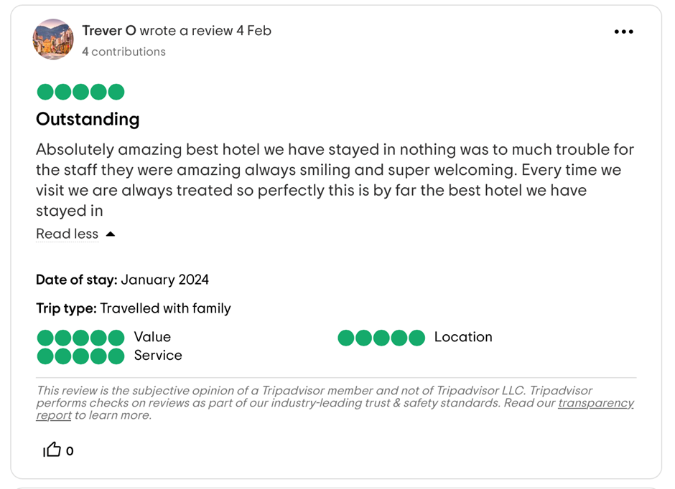
Letter of complaint response 500 words +/- 1-%
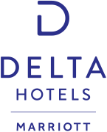

Delta Hotels Swansea
Maritime Quarter
Swansea, Wales, United Kingdom, SA1 3SS
deltahotels@swansea.uk
+44 172-642020
18th of February 2024

Mrs. Joanna Blake
558 Longford Road
Swansea
SA1 2AR

Acknowledgement and Apology for Your Recent Stay

Dear Mrs. Blake,

I hope this letter finds you well. I am writing to express our gratitude for taking the time to share your recent experience with us. Your detailed review has been instrumental in shedding light on areas where we fell short of your expectations during your stay at our hotel.
I also want to express our sincere apologies for the disappointment and dissatisfaction you experienced during your recent stay at our hotel. Please accept our deepest apologies for falling short of the high standards you expected and thank you for bringing these concerns to our attention.
Firstly, I want to address the cleanliness issues you encountered in room 330. It is disheartening to hear that the floors were dirty, there were stains on the bedding, and the bathroom did not meet your expectations. This is certainly not the level of cleanliness we strive to provide, and I want to assure you that we are taking immediate steps to address and rectify this matter. Our housekeeping team will be undergoing additional training to ensure such oversights do not occur in the future.
Regarding the Wi-Fi service, I am truly sorry for the inconvenience you faced due to its unreliability and slow speeds. We understand the importance of a stable internet connection, especially for work purposes, and we are actively working on upgrading our network infrastructure to provide a more seamless and efficient service for our guests.
I deeply regret the disturbance caused by excessive noise during your stay. Every guest deserves a peaceful and restful night, and I apologize for the inconvenience this has caused you. We are revisiting our policies on noise control and implementing additional measures to ensure a quieter and more comfortable environment for our guests.
I am genuinely sorry for the unresponsive and unhelpful service you received from our staff. This does not align with the level of service we aim to provide, and I assure you that corrective actions are being taken. We will be conducting additional training for our staff to reinforce the importance of responsiveness and helpfulness in meeting our guests' needs.
Your feedback is invaluable to us, and we appreciate the opportunity to address these concerns. In the efforts to make amends, we would like to offer you a complimentary two-night stay with us, during which we will ensure that all the issues you raised are fully addressed, and you experience the high standard of service we strive to provide.
I understand that this experience has left you with a negative impression of our hotel, and I want to assure you that we are committed to learning from this situation and making the necessary improvements. We value your patronage and hope to have the opportunity to restore your faith in our hotel.
Please feel free to contact me directly at: +44 1792-642020 to discuss any further details or specific preferences for your complimentary stay. We look forward to the possibility of welcoming you back and providing you with the exceptional experience you rightfully expect from us.
Thank you for your understanding and giving us the chance to make amends.

Sincerely,

Lavinia Mihaloiu
General Manager
Delta Hotels Swansea

References:

Manis, K.T., Wang, Y. and Chaudhry, A. (2020) 5 principles for responding to customer reviews, Harvard Business Review. Available at: https://hbr.org/2020/05/5-principles-for-responding-to-customer-reviews (Accessed: 18 February 2024).

Troyer, J. (2023) Launch your own reputation management platform, Review grower. Available at: https://reviewgrower.com/responding-to-tripadvisor-reviews/ (Accessed: 18 February 2024

Component Three:
Contribution to Overall Module Assessment: 50% (1000 words +/- 10%)
Writing in essay format

Key Skill 1 – Customer Service Skills

The global expansion of the hospitality industry underscores the vital role of guest services, with front desk positions at hotels requiring a multifaceted skill set. Multitasking becomes essential in managing diverse responsibilities, while problem-solving abilities enable the seamless resolution of challenges. Effective communication stands as a cornerstone, facilitating smooth interactions between guests and staff. Together, these skills ensure that front desk personnel contribute significantly to the overall positive experience of guests in the dynamic and competitive landscape of the hospitality sector. (Hognas, 2015)
Being the guest's first point of contact necessitates having outstanding greeting and nonverbal communication skills, which highlights how important having a warm, welcoming manner is. (Jill, 2024) Having strong organisational skills, computer literacy, and attention to detail are essential for effectively handling duties like check-ins and reservations. During busy times, professionalism and stress management help to keep things calm. The friendliness of a guest services staff member plays a pivotal role in shaping the initial impression of a hotel, creating a warm and welcoming atmosphere for guests. Concurrently, adept sales abilities become instrumental in promoting hotel services and effectively upselling, contributing to revenue generation. Moreover, the synergy of effective teamwork and collaboration proves indispensable in ensuring seamless interactions between various hotel departments. By fostering a cohesive environment, these qualities collectively enhance the overall guest experience, establishing the foundation for customer satisfaction and loyalty in the competitive realm of the hospitality industry. (Kandampully et al., 2018)
The capacity to address grievances and show empathy brings a caring touch and raises guest satisfaction.
Resilience, flexibility, and a people-focused mindset are essential for success in this multidimensional profession in the fast-paced world of hospitality. (Doyle, 2020)

Key Skill 2 – Communication Skills

Good communication between employees, visitors, and management is essential in the front office department to foster mutual trust and collaboration. The front office is essential to maintaining lively and good communication because it is the hub responsible for generating money through the sale of hotel stays.
The front desk employees work together internally to provide excellent guest services, managing mail handling, reservations, registration, and personalised services, among other things. In the Food and Beverage Department, for example, the front office conveys guest choices, manages banquet requests, and tracks guest sales, interdepartmental communication is especially important.
The Marketing and Sales Department is also involved in communication, as they use front office data for campaign planning and consumer segmentation. In addition, communication with housekeeping covers security, complaints from guests, and turnover of accommodations in addition to readiness of accommodations. Forecasting attendance, directing guests, disseminating information, and paying city accounts are all part of the cooperation with Banqueting.
To put it simply, providing outstanding guest experiences and streamlining hotel operations depend heavily on effective communication both within the front office and with other departments. (The Bridge Nucleus, 2024)

Key Skill 3 – Organisational Skills

Organisational skills encompass the ability to manage time efficiently, set and achieve goals, and maintain a structured approach to tasks. Classified as soft skills, these non-technical abilities are integral for effective collaboration and contribute to a positive work environment. Time management involves wisely allocating the 24 hours available, prioritizing tasks, and adhering to deadlines. Setting measurable and achievable goals with a clear vision ensures focus and motivation. Prioritizing tasks optimizes productivity, while physical organization, both in the workspace and digitally, minimizes distractions and enhances efficiency. (Henderson, 2024)
The transferable skills play a crucial role in the front office of a hotel, contributing to the seamless operation and positive guest experience. In a dynamic and fast-paced environment, effective time management ensures that front office staff can handle multiple responsibilities simultaneously, such as managing check-ins, reservations, and guest inquiries. Prioritizing tasks is essential for addressing urgent matters promptly and ensuring a smooth workflow. (Shelton, 2023)
In the front office, setting and achieving goals is intricately linked to elevating guest satisfaction, refining the efficiency of check-in and check-out processes, and optimizing overall operational effectiveness. A defined vision and measurable objectives serve as guiding principles, steering the team towards the consistent delivery of excellent customer service. By focusing on these goals, the front office not only enhances the overall guest experience but also cultivates a reputation for seamless operations and guest-centric service in the competitive hospitality landscape. (Hollander, 2023)
Physical organization in the front office is indispensable for managing guest information, ensuring the accuracy of reservations, and facilitating smooth check-ins and check-outs. A well-organized workspace not only minimizes errors but also contributes to the professionalism of the front office staff, creating an efficient and welcoming environment for both guests and team members. (Baum & Devine, 2007)

Key Skill 4 – Problem Solving Skills

Problem solving skills are indispensable in various graduate roles, requiring a blend of logic and imagination to decipher situations and devise intelligent solutions. The best problem solvers not only address existing issues but also proactively anticipate and prevent potential future problems. Linked to analytical abilities, creative thinking, adaptability, and resilience, problem-solving encompasses a lateral mindset and initiative. In a team context, effective problem-solving demands strong teamworking and influencing skills, essential for garnering support for proposed solutions. Crucially, identifying problems often sparks entrepreneurial ideas, making problem-solving a vital component of innovation and leadership in the professional realm. (Lewis, 2023)
Problem-solving abilities are critical in the front office of a business to guarantee seamless operations and uphold a favourable customer experience. Front desk employees deal with a variety of issues, such as answering questions from visitors and resolving conflicting reservations. When interpreting circumstances and coming up with clever ideas to quickly fix problems, both logic and creativity are use. In addition to resolving immediate issues, proactive problem-solving foresees and minimises any future issues, all of which help to ensure a flawless visitor experience. To gain support for suggested ideas, collaborative problem-solving within the team necessitates effective communication and persuading skills. In the end, the front office's ability to solve problems improves productivity, client happiness, and the company's reputation. (Chalupa & Chadt, 2021)

Reference List

Baum, T. and Devine, F. (2007) ‘Skills and training in the hotel sector: The case of front office employment in Northern Ireland’, Tourism and Hospitality Research, 7(3–4), pp. 269–280. doi:10.1057/palgrave.thr.6050046.

Chalupa, S. and Chadt, K. (2021) ‘The perception of soft skills and their training at Hotel Front – office in connection to covid-19 pandemics’, TEM Journal, pp. 517–521. doi:10.18421/tem102-05.

Doyle, A. (2020) Important hotel front desk/guest services job skills, Live About. Available at: https://www.liveabout.com/hotel-front-desk-guest-services-skills-list-2062408 (Accessed: 15 February 2024).

Henderson, R. (2024) The top 10 organizational skills to put on your resume in 2024, Jobscan. Available at: https://www.jobscan.co/blog/organizational-skills/ (Accessed: 28 January 2024).

Hognas, S. (2015) The importance of the first impression in hotel customer ..., Theseus. Available at: https://www.theseus.fi/bitstream/handle/10024/96496/Sandra_Hognas.pdf?sequence=1%26isAllowed=y (Accessed: 20 February 2024).

Hollander, J. (2023) 3 examples of smart goals in the hospitality industry, Hotel Tech Report. Available at: https://hoteltechreport.com/news/smart-goals (Accessed: 25 January 2024).

Jill (2024) The top 10 receptionist skills [updated 2023], Visitor ... Available at: https://vizito.eu/blog/the-top-10-skills-that-every-receptionist-needs/ (Accessed: 27 January 2024).

Kandampully, J., Zhang, T. and Jaakkola, E. (2018) ‘Customer experience management in hospitality’, International Journal of Contemporary Hospitality Management, 30(1), pp. 21–56. doi:10.1108/ijchm-10-2015-0549.

The Bridge Nucleus (2024) Front Office Management - Communication, Tutorials point. Available at: https://www.tutorialspoint.com/front_office_management/front_office_management_communication.htm Accessed: 20 February 2024).

