

Implementing and Evaluating 802.1x Wired Device and User Authentication

By
Peter Evans
1810610@student.uwtsd.ac.uk

Supervisor: Nitheesh
Second Marker: Munyaradzi

Project submitted as part of the requirement for the award of BSc (Hons) Computing (Advanced Networks and Cyber Security)

July 2022

DECLARATION

I, Peter Evans declare that I am the sole author of this Project; that all references cited have been consulted; that I have conducted all work of which this is a record, and that the finished work lies within the prescribed word limits.

This work has not previously been accepted as part of any other degree submission.

FORM OF CONSENT

I Peter Evans hereby consent that my Project, submitted in candidature for the B.Sc. (Hons) Computing (Advanced Networks and CyberSecurity) degree, if successful, may be made available for inter-library loan or photocopying (subject to the law of copyright), and that the title and abstract may be made available to outside organisations.

Abstract:

Network security is continuously evolving with new threats and vulnerabilities found every day. Corporate data is a high target for cyber criminals. Network administrators are fighting a battle to keep data confidential, maintain it’s integrity and availability. Security is a broad subject however, one way to mitigate the risk is to introduce security at the edge of the network. 802.1x is a type of authentication and authorisation protocol to secure against unauthorised devices and users joining the network. Devices and users are required to authenticate and if successful, strict authorisation policies are applied to prevent lateral movement.
Research of the topic includes case studies, technical articles, and best practises in implementing a zero-trust architecture based around 802.1x port authentication and authorisation. The report follows a real-life scenario of a Health Care Organisation where network security has always been an afterthought. Therefore, this report evaluates the implementation of wired 802.1x using Cisco Identity Services Engine into a predominantly Cisco and Microsoft Windows environment.
The objectives will be to review industry credible literatures to form a better understanding of the requirements and end goal. Identifying problems with substandard security before implementing a solution into a test environment to evaluate the findings. By implementing 802.1x the aim is to secure the network against unauthorised supplicants, while allowing authorised devices and users access to the required corporate resources and nothing else. The evaluation will highlight the benefits, concerns, and impact of implementing the solution into a live environment.

Contents
1. Introduction 5
1.1 Small to Medium Enterprise Campus Network 5
1.2 Large/International enterprise Network 6
1.3 Wired Networks 7
1.4 Wireless Networks 7
1.5 Wired Authentication 802.1x 8
1.6 Network Security 9
1.7 Protocols 9
1.8 Aim and Objectives 11
2. Literature Review 12
3. Research Methodology 19
3.1 Research framework 19
3.2 Inductive vs Deductive vs Abductive 20
3.3 Qualitative vs Quantitative 21
3.4 Evaluation Criteria 21
3.5 Gantt Chart 21
3.6 Contingency planning 22
3.7 Summary 22
4. Design 23
4.1 Background Information 23
4.2 Problem Formulation 24
4.3 Proposal & Design 24
4.4 Requirements 26
4.4.1 Hardware and Software 27
4.4.2 Evaluation Criteria 27
5. Implementation 28
5.1 Topology 28
5.2 Configuring Cisco ISE 30
5.3 TACACS+ and RADIUS 30
5.4 Directory Services 31
5.5 Configure a network switch NAD 32
5.6 Configure a Workstation device 33
5.7 Configure a MAB Device (IP Phone) 34
5.8 Policy Sets, Authentication and Authorisation. 35
5.9 Evaluation 36
5.9.1 Scenario 1 37
5.9.2 Scenario 2 38
5.9.3 Scenario 3 39
5.9.4 Final notes 39
6 Conclusion. 40
7 Reflection 41
7.1 Personal Reflection 41
7.2 Organisational Reflection 43
8 References 44
9 Appendix 47

Introduction

Local area networks provide connectivity for users to essential services within a building or campus. A wide area network combines multiple LANs providing connectivity between many buildings and campus’.
These networks come in all shapes and sizes and there isn’t a one solution fits all approach. The basics of a network are to allow devices and users to communicate and share information. These networks are the Digital Infrastructure for businesses to operate.
The smallest and least complex networks are referred to as SOHO (Small Office, Home Office) networks. UK telecommunication companies are constantly expanding and upgrading the infrastructure which has made broadband access cheaper and widely available. This affect has increased the popularity of SOHO networks for home and small businesses [1]. The simplest topology design would be: ISP provided internet, modem/router, firewall, switch and a wireless access point. Most ISP provided routers now incorporate all the functions mentioned previously into a single hardware device.
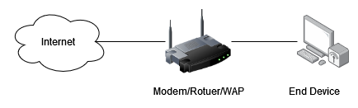
Figure 1 – Example of a simple SOHO network with an all-in-one Modem/Router/Wireless Access Point
A remote satellite site could make use of a SOHO network by utilising a feature such as a site-to-site VPN. This feature allows an organisation to present its network to another site over an encrypted tunnel. In affect the remote satellite site becomes part of the organisation network allowing secure communication and management.

Small to Medium Enterprise Campus Network

As the number of connected devices grows so does the number of network management devices. A small to medium enterprise network consisting of a single campus will generally deploy a 2-tiered design.
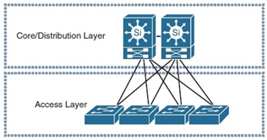
Figure 2 – A 2-tiered archetecture model. A collapsed core/distribution layer.
A 2-tiered design as shown in Figure 2 starts to see the all-in-one devices as provided to SOHO sites be split up into dedicated roles. The Access layer provides end user connectivity generally at Layer 2 of the OSI model [2] with fast switching capabilities. A collapsed core and distribution layer provides Layer 3 routing, IP connectivity.
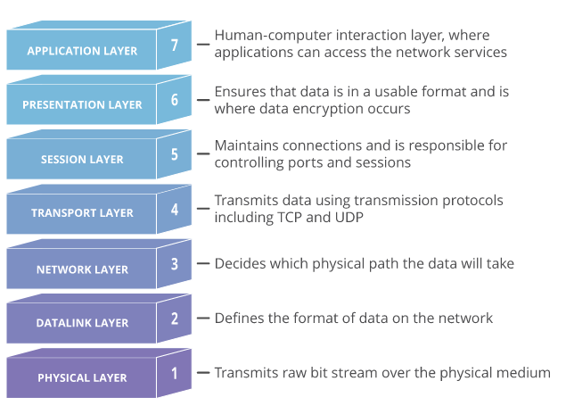
Figure 3. OSI Model displaying the Layers and a brief explanation [3].
Layer 2 the Data Link Layer provides network connectivity to devices on the same network. Switching is used to move frames between devices using their unique MAC address. To forward frames outside of the local network, Layer 3 is required. Layer 3 the Network Layer is responsible for transferring data between two or more different networks by grouping smaller frames into packets. This process is known as routing.
As opposed to a flat SOHO network which may only have a single network, a Medium sized network may have multiple networks or sub networks at its campus. To provide connectivity between these subnets a distribution/router device is required. The collapsed core/distribution device is responsible for the backbone of the network providing connectivity to the access layer, routing to external networks and routing between internal or virtual local area networks VLANs. This design starts to include the basics of redundancy, eliminating single points of failure. However, the limiting factor will be cost vs return in investment, with smaller business unable to allocate the necessary resources.

Large/International enterprise Network

A step up from a medium campus network, a large or international enterprise will have several campus networks, remote sites and home users all interconnected. At this level the solutions vary massively. Progressing from the 2-tiered design the next logical step is 3 tiered [4]. This hierarchical design separates the collapsed core/distribution layers into 2 separate layers. The benefits of having single role devices are to improve performance, scalability, and the reliability of the network.
The access layer function remains the same as mentioned previously. Distribution devices focus on communication between all the access devices providing aggregation, inter VLAN routing, access lists, load balancing and quality of service polices. The core layer function is to provide back bone connectivity between all the distribution devices and provide external communication whether WAN circuit to another site or access to the Internet.
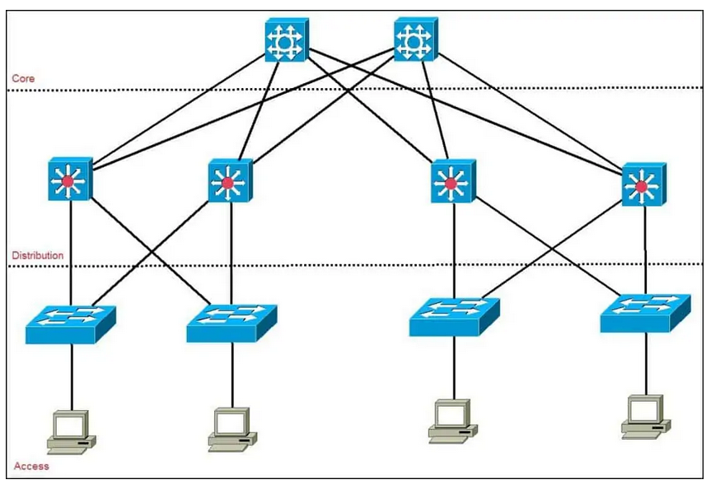
Figure 4. A 3-tiered network design. Core, Distribution and Access.
All network designs mentioned above provide 2 means of connection, wired and wireless. Each one comes with its own complications when it comes to network security, but both provide an essential service to any organisation.

Wired Networks

Wired network as the name suggests relies on a tethered connection. A user device connects to the network via an ethernet cable. IEEE 802.3 ethernet cable specifications are produced by the IEEE working group [5]. Experimental ethernet began in 1973 with the first IEEE standard being defined in 1983 as 802.3. Ethernet cabling has gone through many iterations with the latest being 803.3cv and with future iterations up to 802.3dg planned.
There are 3 common types of cable, fibre optic, copper twisted pair and coaxial. Each type has a subcategory, for example Fibre Optic uses single and multi-mode cabling with different grades, OS1, OM1, OM2 etc. The classification of twisted copper pairs is explained by Yang [6] detailing the differences from category 1 to 7 along with the difference between unshielded and shielded twisted pair (UTP and STP). These cables make up the physical medium to connect devices and relates to layer 1 of the OSI model [3].

Wireless Networks

Wireless local area network or WLAN provides wireless connectivity by utilizing radio frequency to transmit data. As with wired networks IEEE set the standards starting with 802.11 with the latest iteration being 802.11ax and a future proposed 802.11be [7].
An access point provides an end user device access to the network. Generally, the access point would be wired back to an intermediary device such as a switch. Wireless networks should be configured with a user authentication protocol. The protocols in order of least to most secure are Wired Equivalent Privacy (WEP) which has been superseded by Wi-Fi Protected Access (WPA) and later WPA2. WPA2 uses Advanced Encryption Standard (AES) as opposed to RC4 in WEP due to security weaknesses [8]. WPA2 allows pre-shared-key authentication or a RADIUS authentication server method.
Consumer grade equipment provided by an Internet Service Provider (ISP) for home or SOHO deployments most commonly support WPA2 personal also known as WPA-PSK (Wi-Fi Protected Access Pre-Shared Key). WPA2-PSK can provide adequate security providing the key is at least 20 characters [9]. For larger deployments such as in an enterprise organisation WPA2 802.1x is the preferred method. 802.1x uses extensible authentication protocol (EAP).
EAP is preferred because the device is provided with individualised access, meaning no pre shared key. Revoking access to single and multiple devices or users is simplified without having to revoke access to all devices simultaneously. The supplicant device sends the data via EAP to the Network authentication device such as a wireless access point or switch which forwards the request via RADIUS to an Authentication Server. In turn allowing network security personnel to implement a remote authentication dial-in user service (RADIUS) [10].

Wired Authentication 802.1x

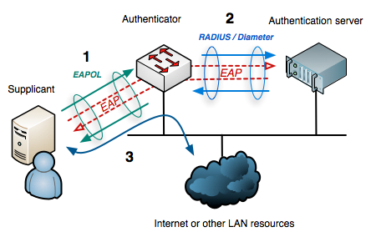
Figure 5. 802.1x authentication flow[10]
802.1x authentication discussed previously in wireless user authentication can also be applied to wired devices. Adding another layer of security to the network by first authenticating the device and then the user. A RADIUS server provides a central management interface to manage devices, users, monitor threats and vulnerabilities.
RADIUS operates a Client/Server Model. The client sends information to a RADIUS server. The server receives the information in the form of a request and replies with either an Access-Accept, an Access-Reject or in some cases an Access-Challenge message. The server is also able to act as a proxy to pass the information onto other RADIUS servers. The EAP information before being sent from the Network Authentication Devices to the Authentication Server is encrypted using RSA MD5 method to prevent threat actors capturing username and password information. The RADIUS clients and server authenticate using a Pre-Shared-Key PSK [11].
RADIUS servers provide the benefits of querying many different data sources. For example, in an Enterprise Environment system administrators may leverage Active Directory to manage domain user and devices which provides an accurate database for RADIUS to query against. The RADIUS Authentication Server queries an Active Directory Server using the Kerberos protocol [12]. Kerberos is used to prove the identity between 2 or more devices securely (mutual authentication).

Network Security

Historically network security replied on good physical security measures. With the rapid proliferation of mobile computing and IoT devices network engineers have had to rethink and re design network security. A survey conducted by Kang, Baek et al [13] in a hospital environment concluded that the demand for IoT in Health Care is constantly increasing.
With more technology being added to a network, resources and security become an ever-increasing concern. Absolute security does not exist according to Kaeo [14]. New attacks will be created, new and old technology contain vulnerabilities, software bugs and even human error will always be a risk to network security. Kaeo’ article on Cryptography contains a lot of information on securing a network referring to the OSI model and various layers. Encryption methods are covered in depth, such as DES and AES before discussing identity technology’s, authentication, authorisation, and accounting.

Protocols

For a device or user to authenticate onto a network various protocols were developed. As with encryption methods and wireless security above there is a clear evolution of protocols to meet the demands and address vulnerabilities. Password Authentication Protocol, Challenge Handshake Protocol and Extensible Authentication Protocol are all used in Point-to-Point Protocol (PPP) authentication mechanism. PPP communication protocol is used to connect 2 devices and authenticating with a simple username and password. Most people will have used PPP authentication without realising it. Home ISPs often supply modem/routers preconfigured with PPPoE Point-to-Point Protocol over Ethernet which authenticates the home user with the ISP backbone and thus providing connectivity.
Password Authentication Protocol PAP is one method used for authentication for PPP. It’s very simplistic and very insecure. PAP communicates the username and password in plain text. It is never recommended to use PAP as an authentication protocol.
Challenge-Handshake Authentication Protocol CHAP is the second method used in PPP. CHAP works on a server/client model. A client attempting to authenticate will be sent a challenge by the server. The client will reply to the challenge however it first hashes the password before sending. Unfortunately, CHAP is vulnerable as the hash password is stored on the server. A man in the middle attack could intercept the hash and re-use it. This protocol isn’t recommended.
Microsoft released a version of CHAP named MS-CHAP which is a slight improvement over CHAP due to mutual authentication therefor the client is assured that it is communicating with the authorised server and not a threat actor. Mutual authentication is an important factor reassuring the user that they are connecting to a valid network.
Extensible Authentication Protocol (EAP) is a framework used for authentication. WPA2-Ent (802.1x) uses the EAP framework in 802.11 wireless authentication. EAP can also be used in wired networks, EAP over LAN (EAPOL) is used for 802.1x wired authentication between a supplicant and a NAD. The NAD then encapsulates the message using RADIUS further encrypting it using the PSK. Using EAP allows each device and user supplicant to have individualised credentials to authenticate onto the network as opposed to WPA2-PSK, where a single pre-shared key is used for all devices.
There are 3 main types of EAP authentication. EAP-PAP, PEAP-MSCHAPv2 and EAP-TLS. EAP-PAP is redundant due to its slow and less secure means of transporting credentials. PEAP-MSCHAPv2 is the successor to PAP providing message encryption and mutual authentication benefits. MSCHAPv2 still requires the user and/or device to enter credentials to authenticating making it a target for man-in-the-middle, social engineering/phishing and stolen credential attacks [15]. EAP-TLS is the most secure of the 3, using device and/or user certificates to authenticate which almost completely eliminates the risk from the attacks mentioned previously. Figure 6 below compares the 3 methods.
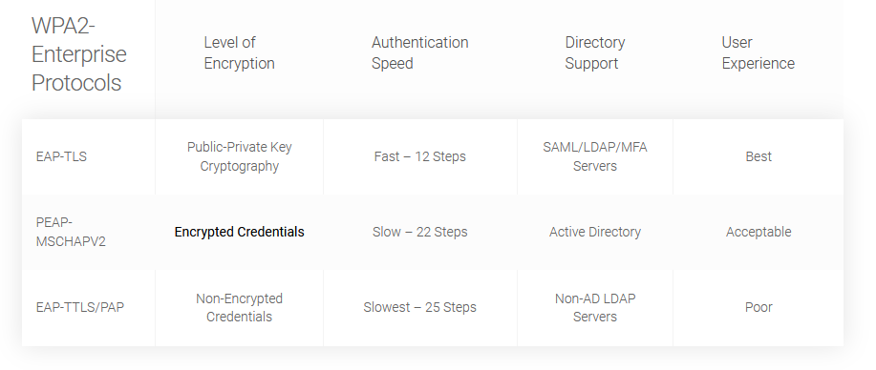Figure 6. WPA2-Ent EAP authentication methods [15].
Network authentication can use many different protocols. As Moore’s law suggests, computer transistors double every 2 years thus become more powerful and cheaper. With more compute cycles it becomes easier and quicker to crack authentication passwords. For example, WEP vulnerabilities allow for a simple dictionary attack. Even a weak WPA2-PSK can easily be cracked using AWS cloud services to brute force 400,000 passwords a second [16].
Due to the vulnerabilities of the protocols above AAA was developed. Authentication, Authorization and Accounting protocol is used for 802.1x and port-based authentication, it provides a centralised platform to manage and authenticate local and remote devices and users. A NAD uses RADIUS to encapsulates the EAP messages and forward them to an authentication server. The NAD and RADIUS server use a pre-shared key to encrypt the communication using RSA MD5.
Network security is a preventative measure to protect data from malicious intent. Configuring security at the edge of the network closest to the threats is one way to reduce un-authorised access and raise the security posture of a network. However, this alone isn’t sufficient but a part of a larger Organisational configuration.

Aim and Objectives

The aim of this project is to investigate and evaluate 802.1x authentication for devices and users and include options to authenticate legacy devices.
OBJECTIVES:
- Review academic and industry credible literatures focusing on 802.1x authentication and network security.
- Identify the Problem with substandard security and investigate authentication for devices that do not support 802.1x.
- Propose research methods to design and implement a system to authenticate devices and users and prevent un-authorised access to the network. Focusing on a Zero Trust model.
- Design a proof-of-concept and implement the into a test environment. Evaluate 802.1x and document the benefits and any shortcomings.
- Analyse the security benefits and compare them to current situation. Identify any concerns or limitations.
- Explorer future expansion and scalability possibilities and discuss the outcome.

Implementing a new security protocol into an environment requires careful planning. This report will cover relevant literature reviews relating to network security, device, and user authentication methods.
With the knowledge and ideation from the literature review a research and development methodology will be identified using the research onion. The methodology will define the procedure used in developing and implementing the solution by meeting the objectives and aim.
The design and implementation phase will consist of defining a solution to implement the 802.1x authentication protocol. A review of the topology design highlighting the decisions made thus far contributing to meeting the deliverables and objectives. The implementation phase consists of the installation of the hardware and the configuration. The theory is put to practise. A working model is implemented and evaluated referring to the deliverables and objectives.
The conclusion will summarise the findings, benefits and any short comings of the design and implementation.

Literature Review

A literature review was carried out on the topic of network security focusing on 802.1x authentication.
The report is to evaluate device and user authentication, therefore research into the pros and cons, design, technical knowledge required to produce and implement a working model to evaluate. The review will cover firsthand experiences to provide high level insights into the benefits and any short falls. Technical discussions around security and performance along with an explanation of protocols and finally design and technical guides to successfully implement a working model.

Matthew Mahoney (Head of ICT at Aneurin Bevan Health Board) states in his success story Using Cisco Software-Defined Access enabled his organization to deliver patient care faster while maintaining better security standards [17]. Cisco SDA is a relatively new concept of detaching the control plane from the physical hardware, leaving the data plane behind. Deploying SDA is resource intensive even more so in a brown field deployment into a 24/7 health care environment.

Aneurin Bevan University Health Board strategic aim was to bring patient care closer to the patient’s home. Part of the strategy is heavily reliant on IoT, remote monitoring medical devices and mobile solutions. With those 3 terms Network Security becomes a concern. In 2018 a regulation was released to boost the level of security of networking information systems that provide essential services [18], the NHS amongst them. Mahoney along with other NHS organisations must meet these strict criteria in order to protect the data.

A major project provided the necessary funding for ABUHB to design and implement a Cisco SDA network. Part of the SDA deployment required Cisco ISE (Identity Service Engine) to manage device and user authentication and policies. Due to the events of COVID19 pandemic, the ICT Team had to accelerate their deployment of ISE which led to compromises to speed up the roll out of the IoT medical devices. As such MAB (Mac Address Bypass) authentication alongside 802.1x. MAB is an alternative form to authenticate devices which may not support 802.1x such as some medical or ‘dumb’ IoT devices.

Mahoney states that the organisation’s security posture has improved with greater visibility of users and devices, threat management and segmentation to prevent lateral movement. The article strengthens the reasoning around investing in network security to meet the strategic aims which has seen a large increase in IoT devices. Additional benefits of using SDA, Cisco ISE has seen improvements with reducing the time it takes for clinic staff to access the data they require due to proactive response to network analytics rather than being reactive.

With all network security there is a fine balance between security and usability. ABUHB seem to have found that fine balance which has enabled them to meet the demands of the strategic aim and conforming to NIS Regulations 2018.

A rural community Hospital in Ontario recently invested in replacing an aging network infrastructure. [19]. Grove Memorial Community Hospital provides health care to a growing community however the network infrastructure is no longer able to keep up and provide the services the staff need. A business digitalization design was created to improve clinical workflow and support the delivery of better patient care.

GMCH had identified the issues of an unreliable network which was prone to outages causing staff to revert to slower inefficient paper-based processes. Inefficiencies had a direct impact on patient care.
The final challenge was security. With technologies evolving and IoT medical devices becoming more common place so have cyber-attacks. Patient data is considered high value and therefor a target for attacks.

A Cisco partner developed and certified the design to construct, install and integrate a modern Cisco network. The article discusses deploying a zero-trust model and leveraging Cisco ISE to provide 802.1x authentication along with secure guest Wi-Fi. Extensive monitoring allows the team to identify threats and vulnerabilities and to tailor security polices at the user edge of the network. The Zero trust nature of authenticating devices and users and using policy-based security improves the security posture.

The success story provides first-hand insights and benefits into modern network security. The previously identified issues were addressed, security has been improved with the added benefit of positively impacted patient safety by providing faster and more accurate patient outcomes.

A common theme on the previous success stories revolves around redesigning outdated networks to comply with current security demands. Both articles implemented zero-trust architecture for both devices and users which limits all access until authentication conditions are met. Zero Trust is evolving with cyber and network security focusing on protecting information. Zero Trust Architecture by Scott Rose, Oliver Borchert, Stu Mitchell and Sean Connelly [20] introduces principles to assume no implicit trust is granted to an asset or user based on their location.

Zero Trust implies that any device or user has zero implicit permissions until authentication and authorisation has taken place. Even then it is continually evaluated. Privileges are assigned to carry out the required task without having broader access to un-needed resources preventing or restricting lateral movement.

There are variations in ZTA implementation dependent on the Organisational needs. Using software defined access SDA, a network manager could utilise Layer 7 of the OSI model to produce an overlay network which forms part of software defined networking and intent-based networking. SDA is heavily dependent on 802.1x. The authentication procedure identifies the device and user and assigns them policies providing them with access to the resources they require and nothing more.

The article reviews threats associated with ZTA and while the risk is never eliminated the overall risk is reduced. One of the threats discussed is Denial-of-Service. ZTA relies on network devices contacting an authentication authority such as RADIUS server. If an attacker caused disruption, then no device or user will be able to authenticate and access resources. Phishing attacks are another threat due to the possible credentials being stolen. In this case a ZTA can only provide limitations to the attack moving laterally within the network rather than eliminate it entirely. Phishing can be overcome using EAP-TLS and certificate-based authentication but comes with its own complexities.

Physical location security is obsolete and no longer a factor in security. The evolution of how users now access corporate data has changed and with it network security Allowing remote users, BYOD and cloud-based assets has become a necessity. Physical and virtual infrastructure both require security. Researching, Implementing and Evaluating 802.1x authentication is one such evolution to improve the security posture. Organisations have had to evolve and adopt more advanced network security designed around ZTA.

Network and Cyber Security discussions are all based on the CIA triad, Confidentiality, Integrity and Availability. Nair [21] article researches strategies to fortify and develop standards for securing IoT, medical devices and systems. Medical devices and IoT devices are becoming more common place in organisations. With more devices joining corporate networks, security threats are increasing. The CIA triad is a foundation to building security policies, crucial to meet cyber security needs. Confidentiality safeguards information and imposes restriction on access. Integrity is the assurance against unauthorised manipulation of data. Availability is reliable access to information when needed by authorised assets only.
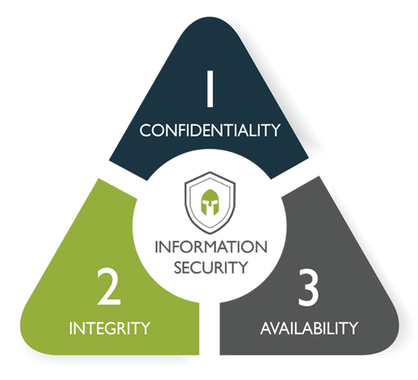
Figure 7. CIA Triad – Confidentiality, Integrity and Availability[22].

Nair explains that the effective use of public key infrastructure (PKI) benefits an organisation to maintain the CIA triad. 802.1x authentication can leverages PKI by using a certificate (EAP-TLS) to authorise a user or device for network access. A RADIUS server is used to confirm the certificate authenticity each time it connects to the network. Using 802.1x authentication for both devices and users raises the security posture of the network. 802.1x also allows policy-based access which in turn provides granular control over what each device and user can access.

Three most common vulnerabilities in healthcare are user authentication deficiencies, endpoint leakage and excessive user permissions. All three of these threats can be addressed by using stricter device and user policies using least privilege permissions and a zero-trust policy on both devices and users. Threats derived from poor manufacturing in IoT devices is an issue. Nair pushes the ownership of security back to the manufacture by encouraging them to implement a Trusted Platform Module (TPM) which performs cryptographic functions. This negates the need of implementing lax security measures at an organisation to allow vulnerable devices.

The CIA Triad appears in other literatures regarding Network and Cyber Security. An analysis of security protocols for wireless networks by He [23] agrees with Nair that the CIA triad is the foundation of building security policies upon. Wi-Fi networks must create a secure channel for communication in an insecure environment. By treating all environments as insecure and developing polices to maintain the CIA triad only then can data be transmitted securely. Wi-Fi networks use various authentication protocols, most commonly Wired Equivalent Privacy (WEP), Wi-Fi Protected access pre-shared key v1 and v2 (WPA, WPA2) and WPA2-Ent. WEP uses a RC4 cypher to encrypt messages, however this cypher is vulnerable to a brute force password attack as demonstrated by the FBI [24].

WPA2 pre-shared key as the name suggests uses a pre-shared key between the wireless access point and the device connecting. A strong PSK reduces the risk of a brute force attack. WPA2-PSK is often found in home and small office setups.

Not being able to centrally manage or individualise access is a limitation of WPA2-PSK. Fortunately, WPA2-Ent using 802.1x and RADIUS overcomes this limitation.

WPA2-Ent uses the EAP framework for authentication. Each device and user are individualised allowing for policies to be applied individually therefor limiting access to corporate resources on a per device or per user basis. WPA2-Ent three main authentication protocols are EAP-TLS, PEAP-MSCHAPv2 and EAP-PAP. He [23] confirms that the weakest protocol is EAP-PAP, the credentials are sent in plain text and provides slow authentication speeds. PEAP-MSCHAPv2 is the successor to PAP in that the credentials are sent encrypted, it also offers mutual authentication meaning the network the supplicant is joining can be validated using a 4-way handshake. Finally, EAP-TLS offers the most secure authentication method using PKI. Public Key Infrastructure providing the most secure and quickest method. EAP-TLS mitigates man in the middle attacks as it eliminates the need for credentials while certificates can’t be duplicated or stolen. According to IBM’s X-Force Threat Intelligence Index Man-in-the-Middle Attacks account for 35% of all exploitation activities [25], EAP-TLS helps combat this risk.

As with Wireless security, Wired networks also possess protocols and methods to protect them against un-authorised access. Smith [26] Describes using 802.1x security for wired devices. In his article Smith uses a Windows device in-built RADIUS function as a go-between for the NAD in this case a switch and an Active Directory Server. Wireless networks are often secured preventing an un-authorised devices from connection, why shouldn’t wired networks have the same protection?

Historically physical network security relied on limiting physical access, locked doors, security guards etc. Wired networks are defenceless against plug in attacks with DHCP granting an IP address and access. Other protocol or methods need to be used to prove authenticity. 802.1x security mitigates this risk by requiring the device to authenticate before the user. Initially the device is given an IP address however a strict policy or access control list prevents the device communicating with anything else preventing lateral movement.

Using policy-based authentication has other benefits such as using profiling to determine operating system version, virus software and any other configurable profile. These profiles determine the eligibility of the device to join the network. With 802.1x providing continuous authentication the device is constantly being monitored against the criteria. Any changes then the device can be quickly blocked and denied access. Vance [27] discusses why NAC (Network Access Control) tools are used to detect all devices and users on a network, profiles them and enforcing policy based access. Cisco ISE is an example of a NAC tool ensuring compliance. Vance [27] explorers use cases and concludes how critical NAC is for IoT and Medical Devices, giving administrators visibility and enforcing strict policies onto devices with the highest risk of vulnerabilities and attacks.

Smith[26] introduces RADIUS and PEAP protocols both used for device and user authentication. Protected Extensible Authentication Protocol encrypts and carries the authentication traffic between the supplicant and directory service. Remote Authentication Dial-In User Service encapsulates the PEAP traffic and facilitates the communication between NAD (in most cases the switch) and a directory service usually Active Directory. The article discusses in depth on how to configure 802.1x using Cisco 2950 switch, Windows XP and Windows Server 2003, all of these systems are depreciated however the high-level design is similar to modern day systems using the same protocols. A very basic switch configuration and supplication configuration is included (figure 8).

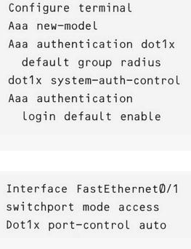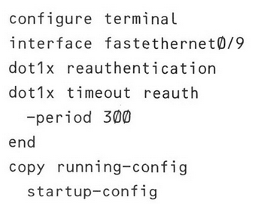
Figure 8. A sample switch configuration to enable 802.1x by Smith [26]

AAA new-model refers to which authentication methods can be grouped. In this case associates a RADIUS server with an authentication method.
AAA authentication dot1x, default group radius associates the 802.1x authentication with a RADIUS group.
Dot1x system-auth-control globally enables 802.1x authentication on switchports.
Dot1x port-control auto places the port in an unauthenticated state until authentication takes place between the supplicant and the authentication server.
Dot1z reauthentication and timeout reauth settings are used to query the supplication periodically for re-authentication.

With higher security profiles comes negative aspects. Smith highlights that all workstations need to be configured to allow 802.1x something which isn’t enabled by default. A work around for organisations with many assets is to use Group Policy Object to push the configuration to the supplicants. This article explorers the technical configuration around 802.1x authentication, although the Operating systems used in the example are depreciated the overall configuration is a starting point in enabling a more secure authentication protocol.

Software Defined networking is the current gold standard for network administrators. It’s a new approach to network management giving administrators more control, measurements and insights into the network. SDN separates Control and Data Planes. Security in SDN is heavily reliant on 802.1x. Devolving IEEE 802.1X authentication capability to data plane in software‐defined networking (SDN) architecture is a paper written by Kamal Benzekki and Abdeslam El Fergougui published by London: Hindawi Ltd [28]. The paper is above and beyond the scope of this report however the authors discuss network security, CIA triad and the requirements for 802.1x authentication while focusing on scalability and the future of Enterprise Networking. The paper brings together all the aspects discussed previously and how each one compliments one another.

Benzekki and Fergougui suggest delegating 802.1x to the switch rather than relying on the SDN software to provide authentication. Using switches closest to the supplicants ensures no unauthorised access is granted to any device thus securing the door into the network. The flexible authentication protocol offers dynamic VLAN assignment, policy-based access control lists or dACL discretionary access control lists to limit device and user authorisation by micro segmentation. Micro segmentation uses VLANs to create smaller broadcast domains limiting devices communicating with other devices outside of its own broadcast domain.

The proposed network architecture contains 3 elements. Supplicant, the device trying to gain access. The Authenticator is typically a switch or middleman, and its function is to forward authentication information to the authentication server based on RADIUS protocol. Authentication Server is used to authenticate the credentials or certificate sent by the authenticator. Typically, the credentials are checked against a directory service such as Active Directory.

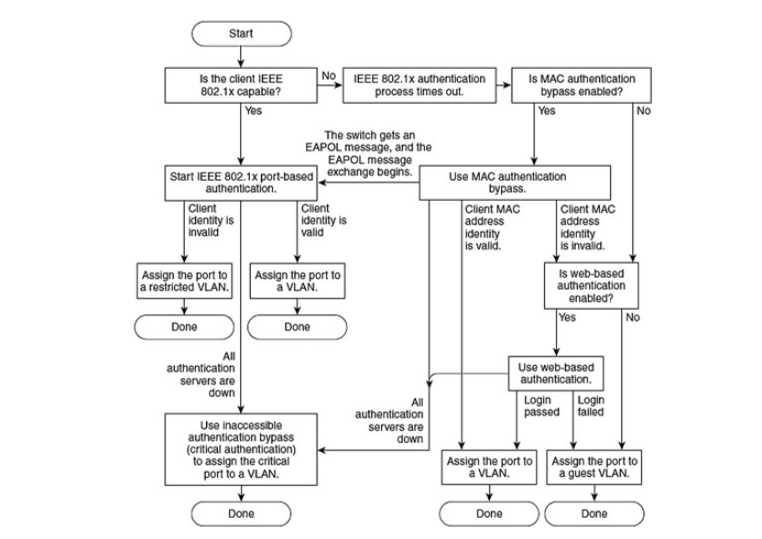
Figure 9. A Global IEEE 802.1x authentication flow chart with MAB [28].

Figure 9 is a flow chart provided by Benzekki and Fergougui shows the flow of authentication using both 802.1x, MAB (Mac Address Bypass) and Web based authentication. While web-based authentication hasn’t been considered in this report, it’s possibly an alternative to MAB and an option to authenticate guests.

Optimising network performance and improving security. IEEE 802.1x uses port-based authentication. Evidence of performance figures suggests performance is optimal with low latency. Therefore 802.1x port-based authentication introduces no delays and provides low latency authentication and has no noticeable negative impact on devices or users authenticating onto the network over no device authentication and basic user authentication.
The review has discussed the need for modernising a network, security based around the CIA triad and Wired/Wireless networks protection. An article by Smith [26] supports Benzekki and Fergougui suggestion on protecting a network by first authenticating a wired device before a user account using 802.1x.
Technical guides provide end users with the ability to implement and troubleshoot manufacturer specific offerings. As part of the literature review technical guides were requested from Cisco. Wired 802.1x Deployment Guide [29] is a very detailed guide for deploying 802.1x wired authentication using Cisco switches along with Identity Services Engine. While the literature is biased towards Cisco equipment the basis of deployment is the same. At Layer 2 of the OSI model, 802.1x offers port based and Identity based access control at the user edge of the network improving the security. As networks become indispensable for businesses, the need to protect them and maintain the CIA triad increases.
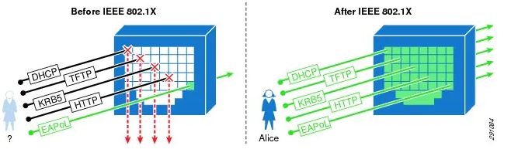
Figure 10. Comparison with and without 802.1x Identity based access [29].

Cisco highlight the benefits: -
Visibility: Provides greater insights into the network associating a user and device with an IP address, MAC address, Switch and Port.
Security: Strongest method of authentication.
Identity: Dynamically deliver customised policies and profiles to an identity whether it’s the user, device or both.
Transparency: 802.1x can be deployed without end user interaction or complicated user procedures.
Limitations: -
Legacy endpoints: devices that do not support 802.1x will need an alternative method of authentication.
Delays: Strong authentication will always come at a cost of speed, however as the previous literature has covered, the speed is unnoticeable to the end user with benefits far outweighing the limitation.
The technical guide covers all aspects of the deployment supporting the information gathered from other sources in greater detail. The guide will be referred to for design and implementation.

Network security is ever evolving. Outdated hardware and poor configuration are exposing the network to unauthorised access. The global IOT market has seen devices double in the last 5 years from 6.1 billion to 12.2 billion. It’s estimated that it will double again in the next 3 years [30]. With more devices joining the network the number of vulnerabilities increase and the more resources are required to manage the network. Implementing network security should be a high priority, having a security guard at the edge of the network will provide initial protection.
Using individualised authentication and authorisation limits lateral movement. Continuous monitoring and assessing all devices and users joined to the network provides assurance. 802.1x will provide these requirements which has been common in wireless networks and is now a necessity in wired networks.

Research Methodology

A research methodology provides guidance to address the question while providing the necessary path to evidence the research process.
The proposal is to Implement and Evaluate 802.1x wired device and user authentication. The process is to gather industry credible information to develop the knowledge required to implement the best solution for secure authentication and then evaluate the design. The evaluation will form the basis for the recommendations to secure the network.

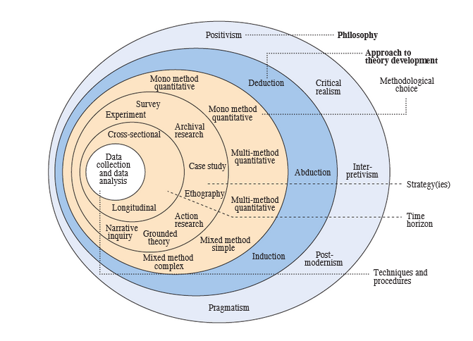
Figure 11. Research Onion [31]

Research framework

Research methodology is dependent on what type of project or report is being developed. The research onion by Saunders, Lewis and Thornhill [31] aims to explain different layers when conducting research and create a structured approach to developing the report.

Inductive vs Deductive vs Abductive

- Inductive research – to generate a theory from research. There is a conclusion, so a theory or hypothesis is generated to prove it.
- Deductive research – start with a theory, dissect, test and build upon it. If the premise is true, then the conclusion must be true. The product either agrees or disagrees with the theory or title.
- Abductive research – has a known premise, proposals and testing are used to generate a conclusion.
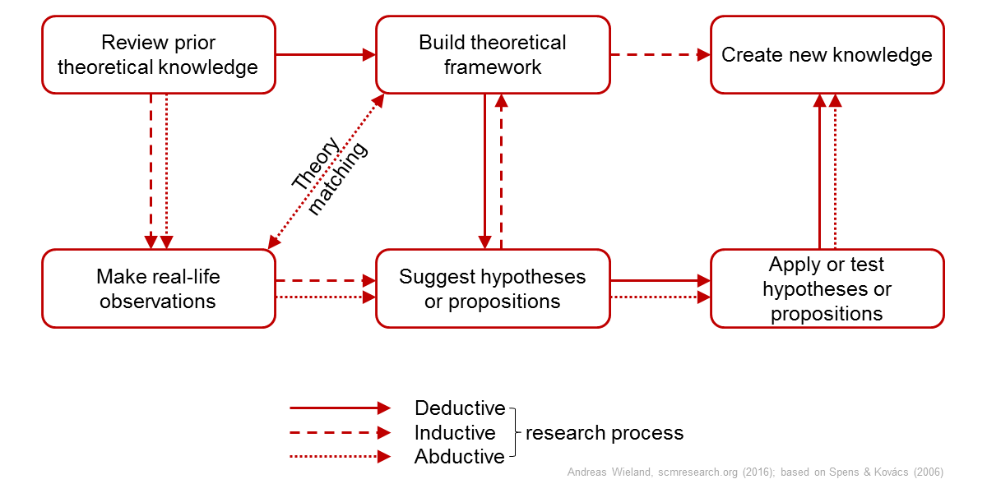
Figure 12 – Inductive, Deductive and Abductive research flow diagram [32]

This research project has a clear conclusion of evaluating and implementing network security. Following the flow diagram above (figure 12) the project starts by reviewing theoretical knowledge, gathering real life observations in the form of case studies and literatures. With the knowledge gained, propose a solution to the problem by designing, implementation and testing. Therefore, the research method that best fits is abductive research. A known premise is used to generate a conclusion based on the evaluation of 802.1x authentication which proves that implementing network security will boost the overall security posture of an organisation that currently lacks or uses outdated methods.
Following the abductive approach, data collection points to qualitative data rather than quantitative. Qualitative studies allow for creativity, flexibility, and varied interpretations. The literature review has shown that any evidence from case studies and knowledge articles can be subjective. The results and conclusions can vary based upon different needs. For example, gathering security best practises, or interpreting manufacturing vs organisational best practises will be different depending on organisational type, resources, network topology etc. Complex technical integrations can deviate from guides depending on engineer experience and knowledge where creative thinking is required.
A strategy will outline the process of carrying out the implementation and evaluation. An experimental design measuring cause-effect and action research allows testing of variables. In this case the variables will be current real life network security vs implementing a solution to increase security posture, 802.1x and documenting the results. Although a case study strategy can also be used as discussed above, case studies can be subjective and bias in their findings, whereas a cause-effect result provides a true or false outcome. The evaluation will be a snap-shot study, the evaluation will compare cross sectional as the network is now vs having 802.1x implemented. Alternatively, a longitudinal time horizon can be used. If live environment implementation phase takes place, then longitudinal, i.e. recording the finds over a longer time period would be beneficial as all networks are built and designed differently. This will allow for more accurate results tailored to the specific environment/organisation. For the purposes of this report and concluding the results a cross-sectional process will be used because a test/controlled environment will be used for the evaluation rather than full implementation into a live environment.

Qualitative vs Quantitative

A research project requires capturing data. The two main methods are qualitative and quantitative, and their collection methods differ. The literature review along with the technical documentation are used to evidence the research and there for qualitative data is the chosen method.
Qualitative studies rely on documentation and personal accounts in response to the study. Case studies are a form of qualitative data used to evidence the direction of the project highlighting the benefits from other people’s first-hand experiences.
Technical documentation and manufacturers best practises are other forms of data. Used as reference when planning and implementing but also evidence to support the study outcome.
There are some disadvantages to qualitative data. The data can be subjective and requires interpretation, whereas quantitative data is numerical, used to test variables where the answers are usually true or false. Therefor the data can be made quantifiable compared to open-ended and individualised experiences of qualitative data.

Evaluation Criteria

The study will be deemed a success when it meets all the objectives. Reviewing literature relevant to the subject provides qualitative data to support the need for network security and the information required to implement a solution that meets the organisational requirements. While qualitative data is subjective, gathering information from many sources that all support the same conclusion provides accuracy and credibility to any statements made.

Gantt Chart

The project is estimated to take 21 weeks to complete. A Gantt Chart is included (Appendix 1).
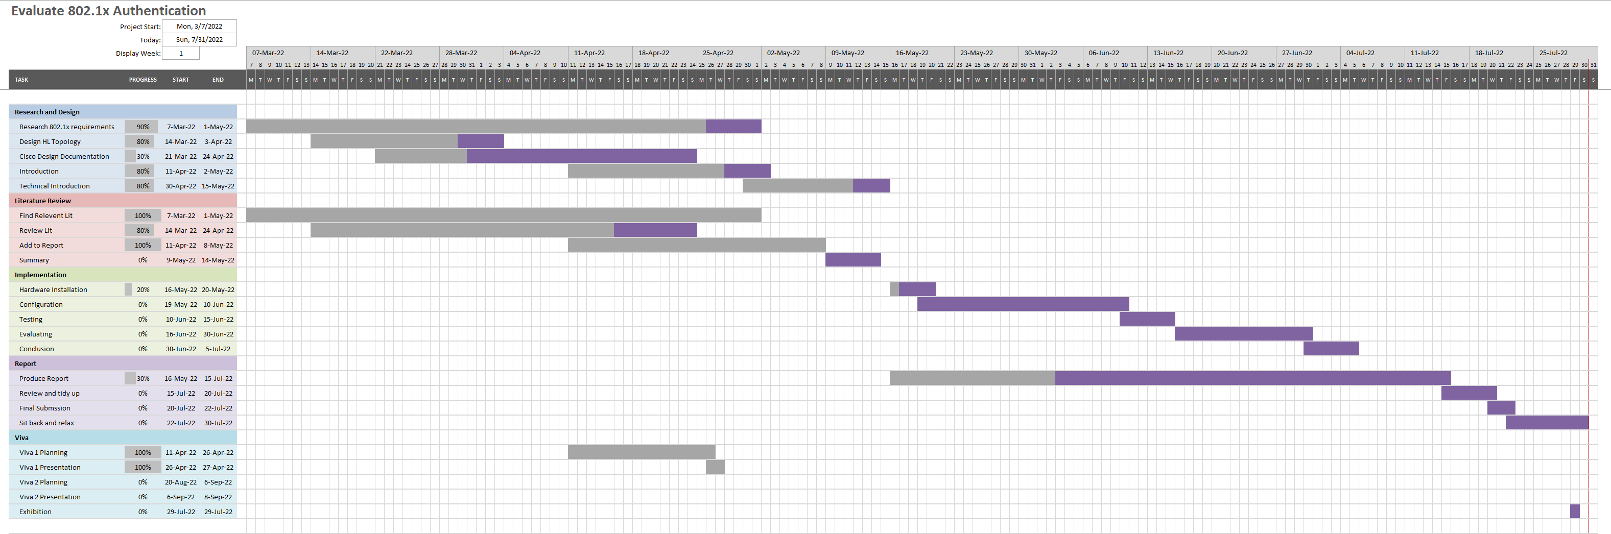
Figure 13. Gantt Chart of Project Plan
A significant period of time is allocated to literature and research review. Building up the knowledge and understanding of the project is key to progressing with the design and implementation stages. The implementation revolved around gathering the resources, in this case hardware and configuring it with time allocated for trial and error to find a solution that met the criteria. Finally, time is allocated to producing the report, evaluating, and summarising the findings.

Contingency planning

To complete the report an evaluation of the implementation is required. As a contingency if the implementation isn’t successful for any reason the evaluation will need to be based on the research and industry credible resources collected in the literature review.

Summary

The Saunders et al research onion defines stages or layers researchers must progress through to develop a research proposal. The clearly defined layers help the researcher to gather the information, sampling theories/size from the correct sources to meet the aim and complete the objectives. Additional resources such as a Gantt chart is an essential project management tool to display the timeline. Highlighting key stages and deadlines to keep the project on track. Without a structured approach the methodology and the project can become unjustified, chaotic and prone to errors.

Design

Background Information

Network security is a preventative measure to protect data from malicious intent. Security breaches are common with several happening every day. Everyone is responsible for protecting data, maintaining the confidentiality, integrity and availability (CIA Triad) Nair [21], explains that the top three most common vulnerabilities in healthcare are user authentication deficiencies, endpoint leakages and excessive user permissions. Adopting stricter network security authentication can reduce all 3.
Figure 14 represents the Top 10 Industries that were targeted by Ransomware. Health accounting for 12% of the targets. Health Care information is valuable with millions of records being sold on the black market [33]. While 802.1x authentication won’t necessarily prevent the attacks, adopting a stricter, more controlled authentication method will help increase the security posture and could potentially mitigate some risk.

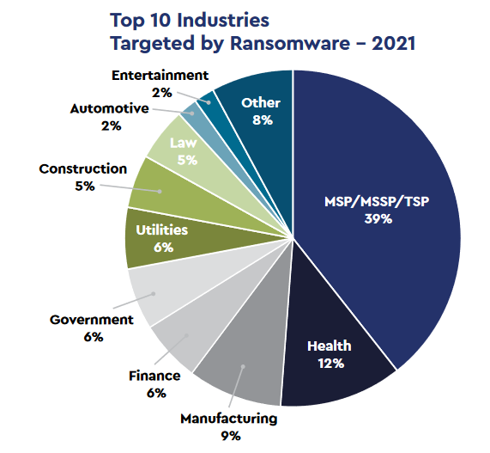
Figure 14 – Connectwise Top 10 Ransomware attacks by Industry.

Problem Formulation

The research is based upon an NHS organisation where network equipment and security has always been an afterthought. The literature review has examined how important network security is and why it is important to keep medical data confidential.

The current process of accessing digital resources:
- Device patches into a data port.
- The Device is allocated an IP address, default gateway and DNS servers.
- If the device is a BYOD, it has full unrestricted internet access. No web filtering. Full access to network resources, although most are restricted by domain user account. If the user is authorised, they can access organisational data on a personal, unprotected, and unchallenged device (figure 15).
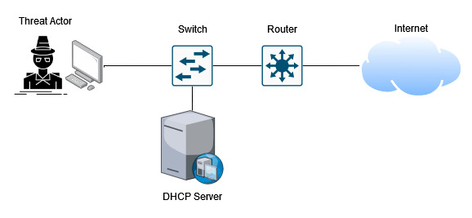
Figure 15. Flow process of current network access
While most residential configurations allow any device to connect to a home network, the network is generally located inside the home behind locked doors limiting physical access. Organisations that allow public and third parties access to the buildings need a way to secure against physical access threats as demonstrated in figure 15.

Proposal & Design

The issues identified in the problem formulation are common to many organisations, referring to the literature review where physical security is no longer enough to prevent unauthorised wired access.
The proposal is to Implement 802.1x wired security which challenges the device and users before granting or denying network access. One step closer to a Zero Trust Architecture.
The flow chart (figure 16) looks convoluted however the process is simple with minimal latency.
- Device patches into a wall port. The NAD (network authentication device) usually the switch will challenge the device. Device credentials are sent using EAPoL. The device can either authenticate using a certificate using EAP-TLS or by Active Directory group membership using PEAP MSCHAPv2.
- The NAD forwards the request using RADIS to an authentication server (AS).
- The AS queries the device against profiles created in Cisco ISE and active directory (AD).
- The AS replies to the NAD with a dACL (downloadable access control list) which is applied to the switchport. This limits access to resources as define by AS and AD
- If the device doesn’t support 802.1x the MAC address is queried against a whitelisted MAC database and then follows points 3-4 above, this is known as MAC address bypass (MAB). Devices such as IP phones and printers will likely use MAB.
- If the device is unknown the NAD doesn’t apply a dACL to the switchport and therefore the supplicant has no access.
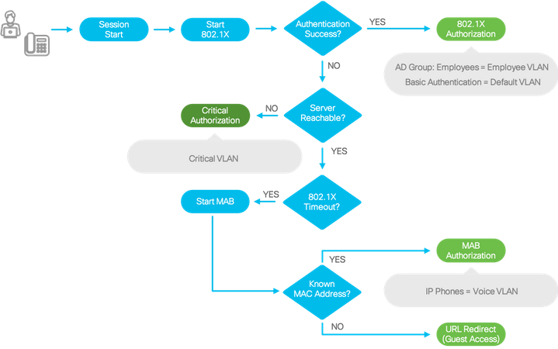
Figure 16. Proposed authentication flow chart.

A basic design shown in figure 17 is used as an overview of the hardware and possible access accept and access reject examples. A domain joined PC can either use certificate-based authentication EAP-TLS or PEAP MSCHAPv2.
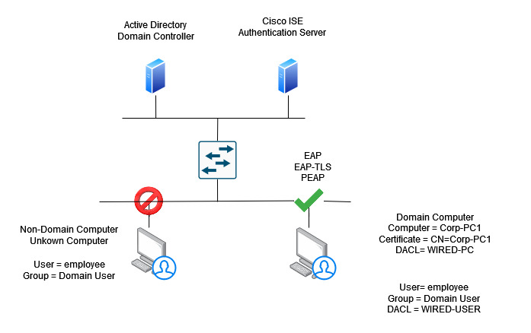
Figure 17. A design showing the flow of an allowed and denied device and user attempting to access the network.
EAP-TLS uses Cisco ISE which holds the CA Root certificate. Each supplicant has an individual device and user certificate installed onto it by group policy. The individual certificates are signed by the CA which are used to authenticate the device. No credentials are sent over the network, only the certificates.
An alternative method for supplicant authentication is PEAP using MSCHAPv2. When a device is joined to AD a certificate is placed in the Trusted Root Certification Authorities store on the device. During negotiations, Cisco ISE sends the device the certificate. If the certificate is matched to one in the Trusted Root CA store, then the device trusts Cisco ISE, mutual authentication. The device then sends a password-based credential to Cisco ISE which is then verified using Active Directory. This password-based credential is created when the device first joins the domain. User authentication takes place by using a unique login and password assign by Active Directory.
Securew2 suggest that EAP-TLS using certificates are far more secure than credential based PEAP-MSCHAPv2 authentication method due to certificates not being transferable or able to be stolen because they are linked to an identity. Whereas stolen PEAP-MSCHAPv2 credentials can be stolen and used on any device [34].
Once the device and client have been authenticated, authorization takes place which provides the device and user with permissions to access the resources based on their Cisco ISE and Active Directory profile. This can be configured using dynamically assigned Access Control Lists.

Requirements

Hardware and Software

To meet the aim and objectives an evaluation of the security implementation is required. To produce a working example hardware and software will be required.
- A domain joined device that supports 802.1x
- A non-domain device, BYOD
- A device to test MAB authentication, example IP Phone.
- Cisco switch that supports 802.1x port-based authentication
- Cisco Identity Services Server
- Access to Active Directory
Funding will not be required. The requirements above are readily available.

Evaluation Criteria

The implementation can be done in a several ways. Cisco best practises will be followed however, adaptions may be required to tailor it to the organisation. These will be documented to allow others to re-create the same implementation and evaluation. The criteria to evaluate will be based upon device authentication and whether access-accept or access-reject is presented to the correct devices. Cisco ISE logs will be used to evidence the outcomes.
To evaluate the implementation the below requirements must be met
- An authorised device is allowed to access resources
- An un-authorised device is blocked from accessing any resources
- An authorised device that does not support 802.1x is allowed access using MAB

As a network admin, who oversees the network. The requirements above must be met along with seamless integration and no additional login delays. Adding any further authentication or authorisation delays to users and devices would be seen as an overall negative impact.

Implementation

Topology

Topology shown in figure 18 depicts the layout of the devices in the test environment which will be used for evaluation.
Pete-Test-Switch will be the NAD configured with 802.1x port-based authentication. 3 Devices will be used to check 802.1x and MAB authentication with a 3rd device used to simulate an unauthorised device. Cisco ISE, DHCP and a File share are located in a Data Centre.
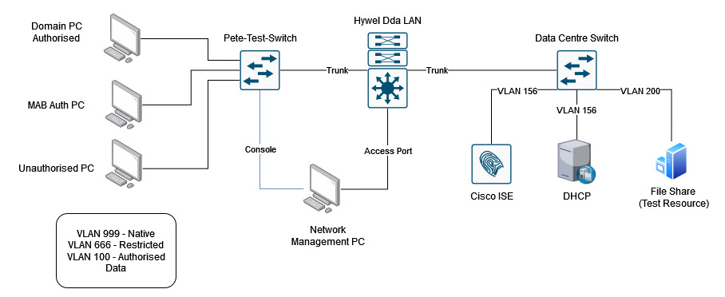
Figure 18. Physical topology of test environment for 802.1x and MAB authentication.
Authentication stages
Step 1
- A supplicant device is connected to the network via a layer 2 switch.
- An Access Control List on the NAD is configured to only allow the device to communicate with DHCP. All other communication is denied.
- The DHCP issues the device with an IP address and allowed to communicate with Cisco ISE.

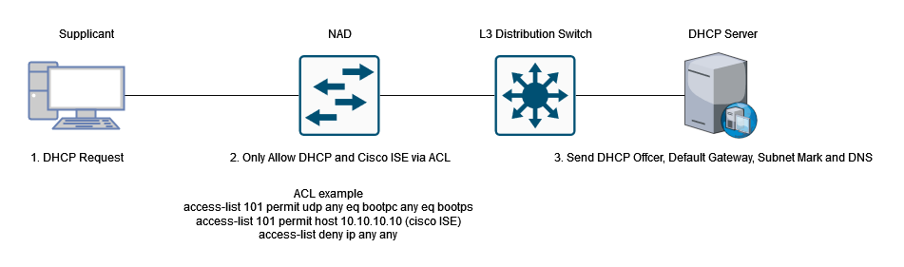
Figure 19. Supplicant patches into network port. Requested DHCP address.
Step 2
- Supplicant sends EAPoL request either EAP TLS or PEAP-MSCHAPv2
- NAD receives EAP frames and encrypts them using the RADIUS PSK.
- Cisco ISE receives RADIUS request and interrogates the EAP request.
  - Does the device exist in either MAB Database.
  - or External Identity Group (Active Directory).
- External ID group exists in Active Directory, Cisco ISE queries with AD.
- If Cisco ISE acknowledges Access-Accept a dACL I sent to NAD to permit access. Access can be limited by linking AD groups to dACL.
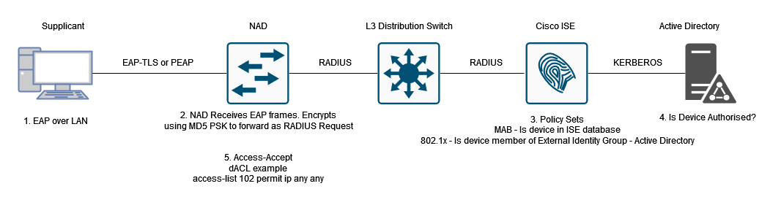
Figure 20. Device Authentication and Authorisation using Cisco ISE Policy Sets and dACL.

Step 3
- User Supplicant sends EAPoL request either EAP-TLS user certificate or PEAP-MSCHAPv2 credentials.
- NAD receives EAP frames and encrypts them using the RADIUS PSK.
- Cisco ISE receives RADIUS request and interrogates the EAP frames
  - Does the user match a Cisco ISE Local user.
  - Does the user match an Active Directory user.
- Active Directory is quires using KERBEROS protocol. Is the user authorised.
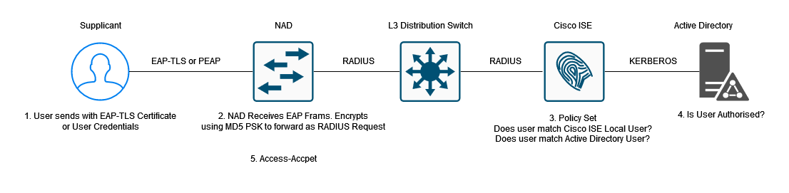
Figure 21. User Authentication and Authorisation using Cisco ISE Policy Sets and Active Directory.

The Authentication and Authorisation flows above provide a simplified overview at each step. Limiting initial access to DHCP and Cisco ISE only provides port based security. Steps 2 and 3 follow the authentication and authorisation flow first authenticating the devices before authenticating and authorising the user while using dACLs and Active Directory Groups to limit access to resources and lateral movement. Progressing towards a Zero Trust Architecture. Although the above is an oversimplification, configuration is GUI lead with suggested templates.

Configuring Cisco ISE

Cisco Identity Services Engine is a powerful network management tool. For the evaluation Cisco ISE hardware SNS-3615-K9 server is being deployed on version 3.1.0.518. While 2 physical servers and 2 virtual servers have been deployed in a cluster this is only a requirement of the organisation due to its size (figure 22).
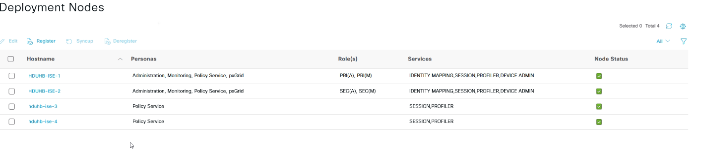
Figure 22. Evidence of 4 Cisco ISE nodes deployed.

TACACS+ and RADIUS

Cisco ISE offers network device authentication using the TACACS+ protocol. Large-scale networks benefit from a centralised user management system. Terminal Access Controller Access-Controlled System (TACACS) is used to process administrator accounts, manage authorisation, and collect information for accounting or AAA. TACACS has 3 iterations, the most recent being TACACS+ developed by Cisco and released as an open standard in 1993 [35]. For the purposes of this report TACACS+ has been configured to allow ease of management for NADs (Figure 22).
Radius configuration is enabled using a PSK needed for 802.1x communication between the NAD and Cisco ISE. Each NAD can have an individualised PSK to improve security or a single global PSK.
The NAD in figure 23 will be used for the evaluation.
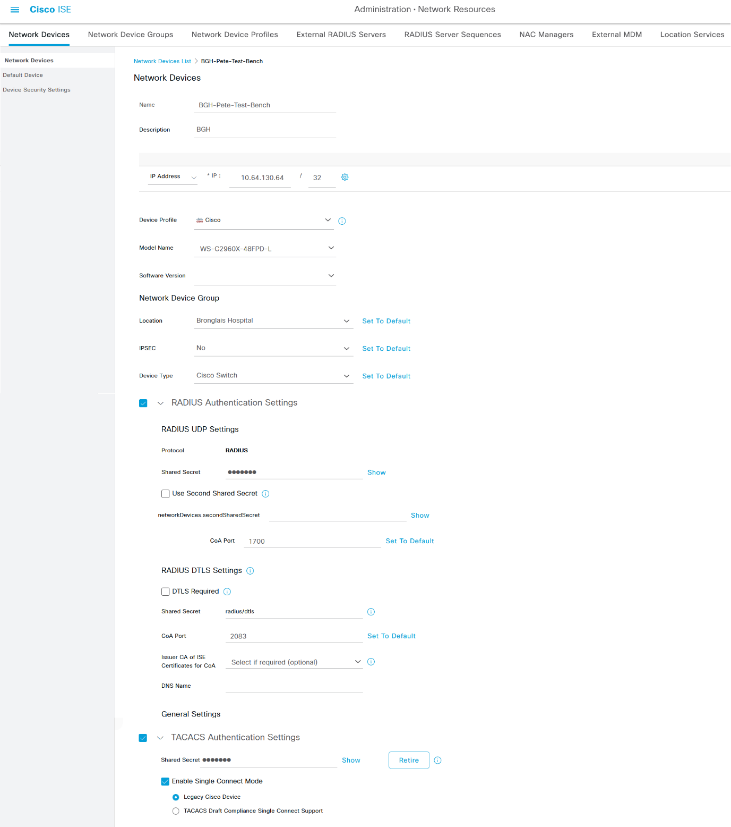
Figure 23. Network Device Administration configuration for TACACS+ and Radius.

Directory Services

Active Directory contains a database of devices and user accounts configured by IT administrators which can be referenced when a supplicant attempts to authenticate onto the network. Cisco ISE has been configured to use two identity sources. The primary source is Active Directory. Cisco ISE uses the Kerberos protocol (TCP/UDP 88) to query Active Directory Domain Controllers. A guide provided by Cisco.com [36] was used to configure the integration. The secondary source is Cisco ISE itself. Not all device support 802.1x or active directory. In this case a database of whitelisted MAC addresses has been created in Cisco ISE. This provides devices with MAB authentication (MAC Address Bypass). Cisco ISE also allows creation of local user accounts within ISE. When configuring Policy Sets Cisco ISE can query against Active Directory Users or Local Users. A benefit of being able to create local users is that if a device requires network access but not access to corporate resources. An example would be a Medical IoT device which only requires internet access to communicate with a single Cloud Service.

Configure a network switch NAD

A Cisco Catalyst layer 2 switch will be used for the Network Authentication Device. The organisation is predominantly Cisco and therefore are readily available.
A Cisco Catalyst 2960x 48 port poe switch with firmware version 15.2(7)E2 has been chosen for testing.
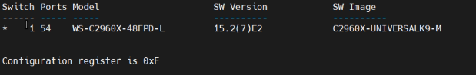
Figure 24. Cisco Catalyst 2960x Switch information.
The switch has a basic configuration to allow communication with Cisco ISE as configured previously.
To access the switch a console cable is used with SSH software, MobaXterm version 22.0.
Enabling AAA and RADIUS Communication with Cisco ISE
Define a RADIUS Server i.e. Cisco ISE
aaa group server radius RADIUS-ISE
server name CISCO-ISE-TEST

aaa authentication dot1x default group RADIUS-ISE
aaa authorization network default group RADIUS-ISE
aaa accounting dot1x default start-stop group RADIUS-ISE

dot1x system-auth-control
radius server CISCO-ISE-TEST
address ipv4 99.99.99.99 auth-port 1645 acct-port 1646
key randomMD5ISEkey

Two Gigabit ethernet copper ports configured for 802.1x authentication. One port will have the authentication open command allowing all devices to be authenticated but monitored with Cisco ISE. Second port will be configured with authentication closed, access only granted with an Access-Accept Message from Cisco ISE.
Basic port configuration
interface gigabitethernet x/x/x
switchport access vlan x
switchport mode access
authentication control-direction in
authentication event fail action next-method
authentication event server dead action reinitialize vlan x
authentication event server dead action authorize voice
authentication host-mode multi-auth
authentication order mab dot1x
authentication priority dot1x mab
authentication port-control auto
authentication periodic
authentication timer reauthenticate server
authentication violation restrict
mab
dot1x pae authenticator
dot1x timeout tx-period 10
spanning-tree portfast edge

authentication open

Configure a Workstation device

A Dell Laptop with Microsoft Windows 10 Enterprise installed on it will be used for testing. The device is joined to an Active Directory domain and configured as a standard user device.
Windows 10 supports 802.1x wired authentication however, it is disabled by default. To enable it a service needs to be enabled and the network interface configured.
Services.msc > enable Wired AutoConfig

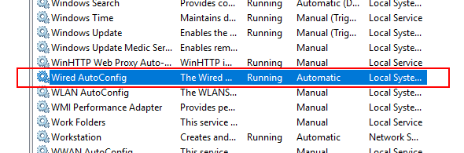
Figure 25. Windows 10 Services enabling Wired Autoconfig

Enable Authentication on the ethernet interface. Access control panel > network adapter Properties > Authentication.
Enable IEEE 802.1x authentication. PEAP is selected by default which will be the required authentication method used for Cisco ISE. Figure 26.
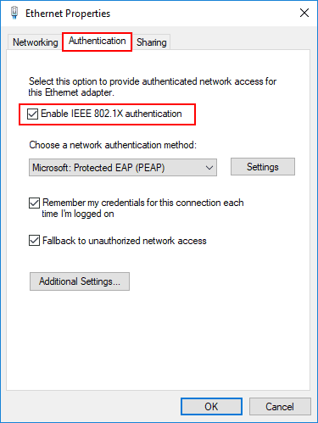
Figure 26. Ethernet interface 802.x1 configuration.
In an environment that has Active Directory, the configuration can be enabled using group policy and deployed to all devices easily using a central management console.

Configure a MAB Device (IP Phone)

Testing MAB authentication requires a Device which natively doesn’t support 802.1x. For the purposes of this project a NEC Philips IP Phone will be used. The device won’t exist in Active Directory therefor a local ISE group will need to be created.
Cisco ISE offers the options of Profiling Devices. An IP-Phone profile exists by default however, the NEC Philips device requires whitelisting. Profiling a device adds an additional layer of security against MAC spoofing attacks. In this case a NEC Philips Phone has been added to the Logical profile with MAC Address 00:60:B9:79:13:10. Cisco ISE profiling will check the supplicant against conditions in the profiling policies assigned to the Logical Profile [37]. An attacker would need to match both the MAC address and the profiling conditions making it more difficult for MAC address spoofing alone to be successful (Figure 26).

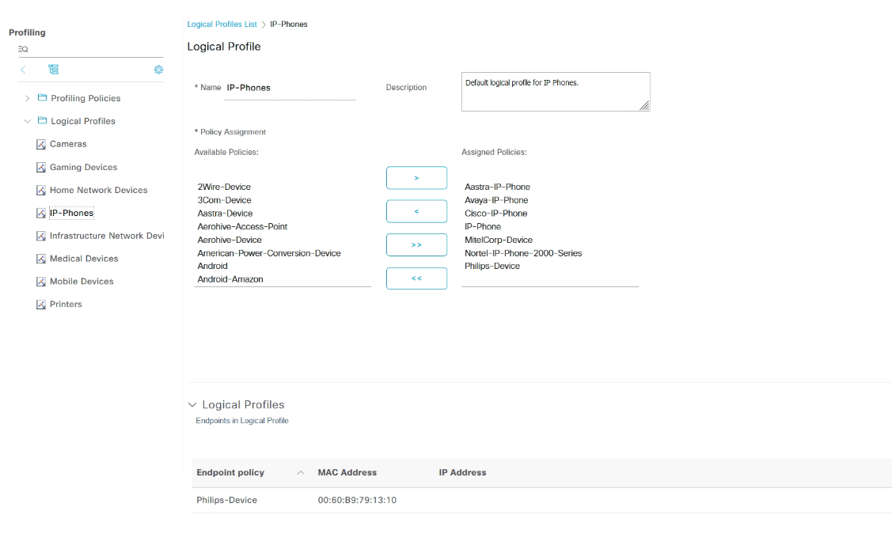
Figure 27. Cisco ISE Device Profiling IP Phone for MAB Authentication.

Policy Sets, Authentication and Authorisation.

Final stage of implementation is bringing everything together.

A Policy set is created in Cisco ISE (figure28).
The first condition requires that the NAD is a member of the Cisco Switch Device Group and is limited to EAP-TLS and PEAP-MSCHAPv2 protocols. Any other protocols will instantly be denied access.
Authentication is restricted to Wired_MAB using Internal Endpoints (Cisco ISE database) and Wired_802.1x. using both Active Directory Users/Devices and Internal Users. If either of these two conditions aren’t met Authentication returns, Access-Rejected.
Authorisation contains 4 policy conditions.
MAB-IP-Phone. If the device matches Enpoints-LogicalProfile = IP Phones, the device is granted access. The Result is to send a dACL to the NAD to restrict access to the Voice VLAN and communication with the Voice controller only.
AuthZ-Device. If the device matches Endpoint Identity Group = HDD-Allowed-Devices, the device is granted access. In this scenario HDD-Allowed-Devices is an Active Directory group which contains one of the test laptops.
AuthZ-User. If the user account is a member of an Active Directory Group (name removed for security) AND the Device matches Endpoint Identity Group = HDD-Allowed-Devices the user is granted access. The AND option is added to prevent Users using an unauthorised device with their user credentials.
Default. The last rule in the list is a default Deny Access. If a supplicant doesn’t match any of the policies above then Deny Access.
Figure 28. Cisco ISE Wired Authentication and Authorisation Policy sets with conditions and results

Evaluation

With all devices configured and connected the next steps are to test the authentication against the evaluation criteria to meet the objectives and overall aim.
A test bench (figure 29) shows the Cisco Catalyst 2960x 48 port poe switch, two Dell Windows 10 Laptops and an NEC Philips IP Phone. These devices will allow testing of the various scenarios. All devices will use wired connections for the testing. PEAP-MSCHAPv2 will be the EAP protocol of choice for this project. Using credential-based authentication isn’t as secure as EAP-TLS however for testing provides the same functionality and end goals.
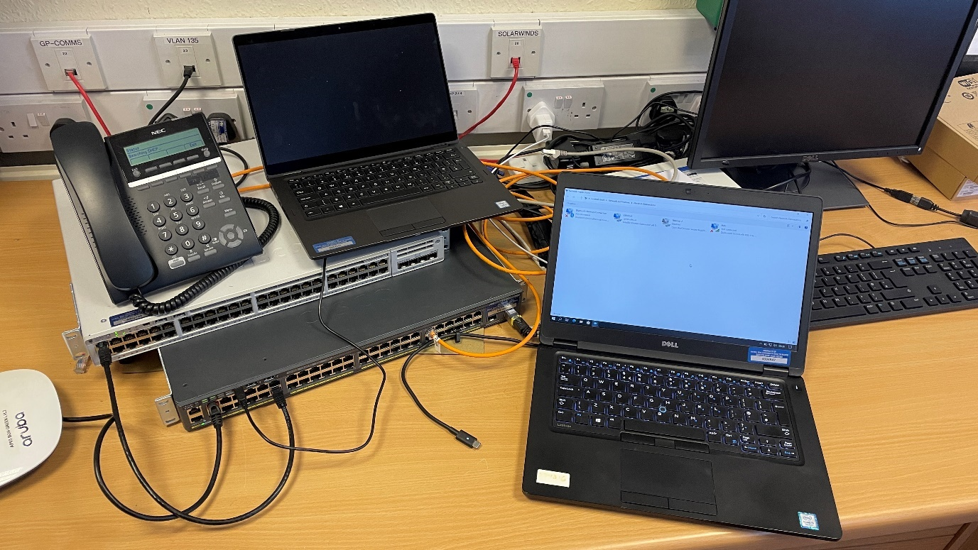
Figure 29. Project test bench showing the NAD, two supplicant 802.1x devices and an IP Phone used for MAB testing.

Scenario 1

A Dell laptop running Microsoft Windows 10 Enterprise connected to Active Directory. The Device is a member of the HDD-Allowed-Devices group. User A is an authorised user allowed access to corporate resources.
Results
Device matches the Wired Auth Policy as the request came from NAD Cisco Switch.
Device matches Authentication Policy 802.1x auth, AD and Internal Users.
Device matches AuthZ-Device. The device is a member of Endpoint Identity Group – HDD-Allowed-Devices. Authorisation policy is to allow access.
User matches AuthZ-User. The user is a member of an Active Directory Group. The group is referenced in the Policy and therefore permits access.
Figure 30 displays the Cisco ISE Authentication details. Supplicant Device is matched to ID group HDD-Allowed-Devices. Method dot1x and protocol used PEAP-MSCHAPv2. NAD device Pete-Test-Bench and port number. The username was omitted for security and is matched against ID store – Active Directory.
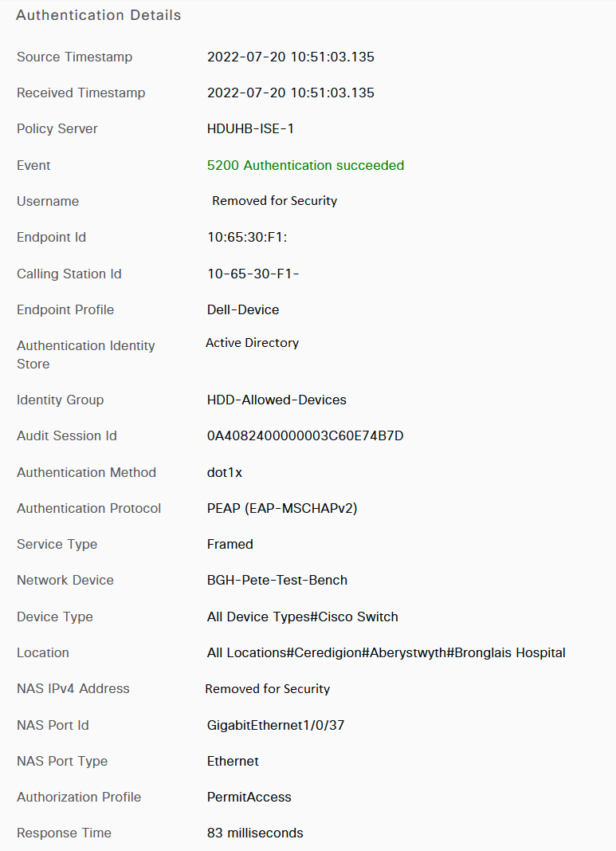
Figure 30. Log from Cisco ISE showing Successful Authentication.

Scenario 2

The second Dell laptop running Microsoft Windows 10 Enterprise NOT connected to Active Directory. The device is unknow to the organisation. User A is an authorised user allowed to access corporate resources.
Results
Device matches the Wired Auth Policy as the request came from a NAD Cisco Switch
Device matches the default authentication profile due to 802.1x being enabled on the device.
Device matches the default authorisation profile and therefore the device is denied access.
Figure 31 displaying the Cisco ISE log shows Authentication Failed. The device is hitting the 802.1x auth policy, however it doesn’t match any of the authorisation policies and therefore hits the default policy which is deny access. As with the previous scenario the device is using dot1x and PEAP-MSCHAPv2. Same NAD and Port as Scenario 1.
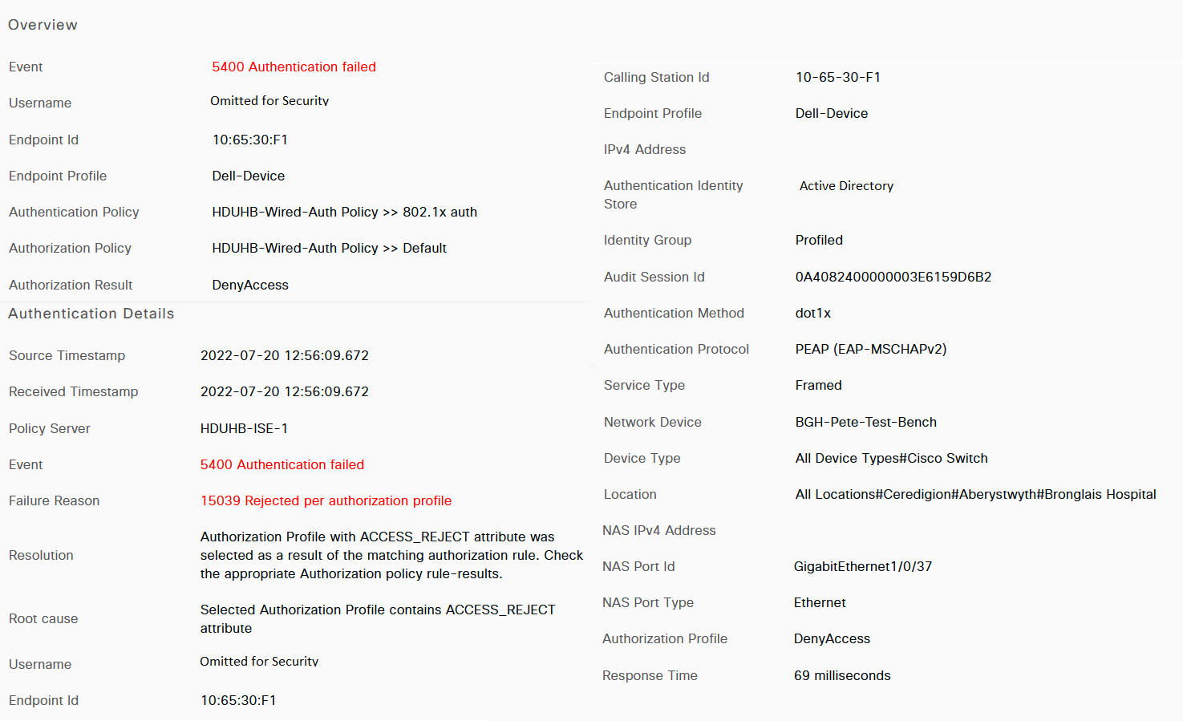
Figure 31. Log from Cisco ISE showing failed authentication

Scenario 3

Third device is a NEC Philips IP Phone. The MAC address of the Phone has been added to a Cisco ISE logical profile (Figure 27). The phone is using a POE port (power over ethernet) which powers on the phone.
Results
Device matches the Wired Auth Policy as the request came from a NAD Cisco Switch.
Device matches Wired MAB authentication profile which references Internal Endpoints
Device matches MAB-IP-Phone authorisation policy as the phone matches the Logical Profile – IP Phone. Access is granted.

Implementation notes

The 3 scenarios performed as expected meeting the evaluation criteria. The table figure 32 shows an overview of what policies each type of device was hitting and the result. Scenario 2 could be expanded upon. An unknown device with a known user could match a BYOD (bring your own device) policy which could allow access to the internet but no corporate resources. However, this wasn’t in scope of the report. Appendix 2 is a video demo showing the results of a single device before being whitelisted as authorised and post whitelisted. The demonstration shows a successful and failed authorisation attempt.

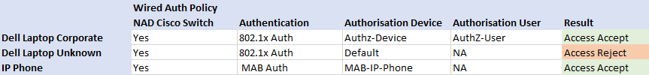
Figure 32. Results from 3 test devices showing which Policies were hit.

Conclusion.

For the project to be deemed a success all the objectives must be met along with the aim.
Implementing and Evaluating 802.1x wired authentication is a broad subject. This report introduced the basics of networking from Small Office to Enterprise Organisations.
The literature review began with a review of recent case studies and success stories strengthening the reasoning behind implementing physical security at the edge of the network. The case studies referred to the CIA triad which is what the organisational policies for network security are based upon.
Exploring deeper into authentication security several sources explained the acronyms and protocols used. Sources agreed that 802.1x boosts network security however not all devices support it. An alternative is MAB authentication which has its own benefits and security issues.
Although the report following Cisco best practises the problem formalisation is based on a real-life organisation and current issues. The implementation and evaluation were based on a test environment designed to capture a controlled number of variables.
The deliverables were based on the results from the test scenarios conducted in section 5.9. The evaluation criteria focused on a small sample size as identified in the research methodology. Even though the sample size was small, all similar devices of the same types tested would produce the same results. However, to improve upon the results a more diverse and larger sample size would be beneficial to explore “what if” scenarios with a broader range of device types.
The report along with the literature reviews focused on raising the security posture of the network. Comparing the problem formulation with the implementation results concluded and is supported by the literature that enabling this type of security at the user edge has had a positive impact raising the security posture.
No negative latency was introduced by enabling 802.1x or MAB authentication. All response times were recorded less than 100ms (figure 30, 31) which considering that the Cisco ISE server and Active Directory Domain Controllers were based at a remote site over an MPLS network would cause no noticeable login delays to end users.
Research showed that enabling a single security method is often not enough and it should be used alongside other methods thus layering security. An example would be port-based security limiting MAC address or limiting broadcast and multicast traffic to mitigate a DDOS attack against the authentication server.
802.1x has provided additional benefits. Implementing Cisco ISE allows Network administrators to have a greater visibility of what devices are connecting. Monitoring devices allows administrators to be pro-active in identifying threats rather than re-acting to potential breaches.
The implementation was based on using PEAP-MSCHAPv2 however, the research indicated that EAP-TLS provides better overall security. Unfortunately, due to resourcing and issues with third party managed Certificate Authorities EAP-TLS wasn’t included in the final evaluation. Although this has no impact on completing the objectives and aims, it would have been beneficial to directly compare PEAP-MSCHAPv2 and EAP-TLS in the test environment.
The research concluded that by enabling 802.1x authentication either by using PEAP-MSCHAPv2 or EAP-TLS has secured the edge of the network. Bringing together the CIA triad and adopting a zero-trust architecture to deploy policy-based restrictions on devices and users has dramatically improved security. Limiting network access at the edge for devices and limiting lateral movement for devices and users within the network.
The project met all the objectives and the overall aim.

Reflection

Personal Reflection

The proof of concept was a success. Implementing 802.1x had the desired effect of increasing the security posture. The project is based on evaluating the implementation into a controlled test environment. All the variables were easily controlled with no unknowns. For example, a small number of devices were chosen to test, domain PC using 802.1x, MAB auth on an IP phone and a BYOD device. While these devices performed as expected, If the sample size was much larger with unknown devices the outcome may differ. For example, in a large organisation with 1000’s of devices implementing a closed authentication policy will likely generate problems. Unknown devices which are authorised to access corporate resources being falsely blocked and vice versa which in a medical environment could be catastrophic.
In a brown field deployment, Cisco best practises advise enabling open/monitor mode authentication to generate the logs and identify any false deny access responses before enabling closed authentication mode. This will allow devices to access company resources even if the device/NAD receives an access-reject response. The objective would be to allow Cisco ISE to build a database of connected devices along with successful and failed authentication attempts. Network administrators would be provided with deeper insights enabling a comprehensive list of profiled devices which are connecting to the network.
The desired effect in increasing the security posture by implementing physical security is similar to what Wireless networks already have. While this accomplished what was set out in the aim and objectives this alone is not enough to protect a network. Weaknesses in MAB authentication could allow an attacker to spoof an authorised device MAC address thus gaining access. This is where additional design and implementation of stricter ACLs and other security measures are required to prevent lateral movement. While outside of the scope for this project these would be the natural next steps.
Bring your own device was touched on briefly. Organisations have adopted a BYOD policy in some situations. While this NHS Organisation does accept Wireless BYOD to a degree, there are tight controls over what those devices can access. To develop this project further BYOD devices will need to be incorporated into the wired network design using Cisco ISE to strictly control access to resources.
While enabling physical security features will help towards negating an attack, it’s also important to consider written Policies and Procedures. The end goal is to produce a Zero Trust Network however, physical measures require the support of Policies, and this is where the CIA triad is key. These policies would tie in with the policy-based access implemented by Cisco ISE.
Network security is an endless process. As security companies release the means to protect networks, criminals find ways to exploit them. The implementation of 802.1x in this project is simplistic. Cisco ISE has much more to offer including device profiling, dACLs to name a few. The project has highlighted the benefits of this technology which the organisation is keen to develop further. Device monitoring and insights give a much clearer picture as to what devices are connected to the network.
Administrators now have better control while improving security. Future plans are to integrate Cisco ISE with Software defined wide area networks and local access modernising the network while focusing on security. 220

Organisational Reflection

The report has developed the necessary skills to be confident in designing and implementing 802.1x and MAB authentication and authorisation methods. The organisation is keen to develop this further with testing underway.
Cisco ISE is a powerful tool. While Wired Authentication is still being explored, Wireless authentication is currently being migrated from the Wireless LAN controller to Cisco ISE. A single pane of glass to manage the entire network estate of over 12,000 devices will provide network administrators and stakeholders the assurance of security and performance.
The Organisation will directly benefit from the additional knowledge and understanding of advanced authentication protocols especially in a security focused environment. Securing data and keeping up with the trend is key to mitigating the risk of a Cyber-attack.

References

[1] “Successfully implementing a SOHO network - ProQuest.” https://www.proquest.com/docview/191056706?accountid=130472&parentSessionId=EnKCghUp0oADMJgtSblGzAY%2Fb0h8DZ8%2FlAzwBVUzlIo%3D&pq-origsite=primo (accessed Mar. 08, 2022).
[2] “OSI Model Reference Chart.” https://learningnetwork.cisco.com/s/article/osi-model-reference-chart (accessed Aug. 24, 2021).
[3] “What is the OSI Model? | Cloudflare.” https://www.cloudflare.com/en-gb/learning/ddos/glossary/open-systems-interconnection-model-osi/ (accessed Mar. 15, 2022).
[4] “Campus Network for High Availability Design Guide - Cisco.” https://www.cisco.com/c/en/us/td/docs/solutions/Enterprise/Campus/HA_campus_DG/hacampusdg.html (accessed Apr. 22, 2021).
[5] “IEEE standard for Ethernet. Amendment 4, Physical layer specifications and management parameters for 1 Gb/s operation over a single twisted-pair copper cable.,” APA 7th Ed., p. 211, 2016.
[6] M. Yang, Y. Sun, X. Pan, H. Wan, and X. Lu, “Development and Prospect of Twisted Pair Cables,” IOP Conf. Ser. Earth Environ. Sci., vol. 170, no. 4, Jul. 2018, doi: 10.1088/1755-1315/170/4/042126.
[7] “IEEE 802.11, The Working Group Setting the Standards for Wireless LANs.” http://www.ieee802.org/11/ (accessed Jun. 30, 2020).
[8] S. Banik and S. Jha, “Some security results of the RC4+ stream cipher,” Secur. Commun. Networks, vol. 8, no. 18, pp. 4061–4072, Dec. 2015, doi: 10.1002/SEC.1323.
[9] R. Moskowitz, “Weakness in Passphrase Choice in WPA Interface - Wi-Fi Networking News,” 2003. https://wifinetnews.com/archives/2003/11/weakness_in_passphrase_choice_in_wpa_interface.html (accessed Mar. 15, 2022).
[10] O. P. Sarmiento, F. G. Guerrero, and D. R. Argote, “Basic security measures for IEEE 802.11 wireless networks Fundamentos prácticos de seguridad en redes inalámbricas IEEE 802.11,” AGOSTO DE, vol. 28, no. 2, pp. 89–96, 2008.
[11] C. Rigney, S. Willens, A. Rubens, and W. Simpson, “Remote Authentication Dial In User Service (RADIUS),” Netw. Work. Gr. RFC 2865, 2000, [Online]. Available: https://www.hjp.at/doc/rfc/rfc2865.html
[12] “Kerberos 5 Release 1.19.3.” https://web.mit.edu/kerberos/krb5-1.19/ (accessed Jul. 12, 2022).
[13] S. Kang, H. Baek, E. Jung, H. Hwang, and S. Yoo, “Survey on the demand for adoption of Internet of Things (IoT)-based services in hospitals: Investigation of nurses’ perception in a tertiary university hospital,” Appl. Nurs. Res., vol. 47, pp. 18–23, Jun. 2019, doi: 10.1016/j.apnr.2019.03.005.
[14] M. Kaeo, Designing Network Security, 2nd ed. Indianapolis: Cisco Press, 2004. [Online]. Available: https://books.google.co.uk/books?hl=en&lr&id=qoA9rLLmi3wC&oi=fnd&pg=PR8&dq=designing+network+security&ots=9n72zubF0r&sig=wi15ms852jGp4kI62GESlA7FH9Y&redir_esc=y#v=onepage&q=designing network security&f=false
[15] “WPA2-Enterprise Authentication Protocols Comparison.” https://www.securew2.com/blog/wpa2-enterprise-authentication-protocols-comparison (accessed Apr. 26, 2022).
[16] J. Finkle, “Amazon cloud can help hack WiFi networks - expert | Reuters,” Reuters, 2011. https://www.reuters.com/article/amazon-hacking-idINN0720306120110107 (accessed Apr. 05, 2022).
[17] M. Mahoney, “Using Cisco Software-Defined Access to Deliver Patient Care Faster,” 2020. https://upshotstories.com/stories/using-cisco-software-defined-access-to-deliver-patient-care-faster (accessed Feb. 15, 2022).
[18] “The NIS Regulations 2018 - GOV.UK.” https://www.gov.uk/government/collections/nis-directive-and-nis-regulations-2018 (accessed Mar. 29, 2022).
[19] “Solutions - Groves Memorial Community Hospital transforms the patient experience - Cisco.” https://www.cisco.com/c/en/us/solutions/collateral/industries/groves-memorial-hospital-case-study.html (accessed Feb. 15, 2022).
[20] S. Rose, O. Borchert, S. Mitchell, and S. Connelly, “Zero Trust Architecture,” Aug. 2020, doi: 10.6028/NIST.SP.800-207.
[21] L. E. Healthcare and M. Jul, “’ Almost every discussion of cyber security relates back to the confidentiality , integrity and availability ( CIA ) triad ’,” no. Jul, pp. 1–3, 2019, Accessed: Mar. 22, 2022. [Online]. Available: https://www.proquest.com/docview/2258754341?parentSessionId=AvAdejVrKdFRDMR4zwQynb5%2FHo5ddEo%2BEh7%2FACCuqfQ%3D&pq-origsite=primo&accountid=130472
[22] “What is the CIA triad? - Comtact.” https://comtact.co.uk/what-is-the-cia-triad/ (accessed Jun. 21, 2022).
[23] C. He, “ANALYSIS OF SECURITY PROTOCOLS FOR WIRELESS NETWORKS A DISSERTATION SUBMITTED TO THE DEPARTMENT OF ELECTRICAL ENGINEERING AND THE COMMITTEE ON GRADUATE STUDIES OF STANFORD UNIVERSITY IN PARTIAL FULFILLMENT OF THE REQUIREMENTS FOR THE DEGREE OF DOCTOR OF P,” 2005, Accessed: Feb. 15, 2022. [Online]. Available: https://www.proquest.com/dissertations-theses/analysis-security-protocols-wireless-networks/docview/304979404/se-2?accountid=130472
[24] “FBI Teaches Lesson In How To Break Into Wi-Fi Networks | Network Computing.” https://www.networkcomputing.com/wireless-infrastructure/fbi-teaches-lesson-how-break-wi-fi-networks (accessed Apr. 26, 2022).
[25] “IBM Security X-Force Threat Intelligence Index | IBM.” https://www.ibm.com/security/data-breach/threat-intelligence/ (accessed Jul. 19, 2022).
[26] R. Smith, “Wired 802.1x Security - ProQuest,” Secur. Adm., vol. 5, no. 2, pp. 1–7, 2005, Accessed: Mar. 08, 2022. [Online]. Available: https://www.proquest.com/docview/215121325?accountid=130472&parentSessionId=cbchAPNOHtKqzUbbPvDNzqbDFpg0aAa507YplJ0W9Ck%3D&pq-origsite=primo
[27] J. Vance, “What is NAC and why is it important for network security?: NAC plays a key role in Zero Trust network access (ZTNA), and is a powerful tool for securing IoT devices and protecting mobile and remote workers,” Network World (Online), 2022. https://www.proquest.com/trade-journals/what-is-nac-why-important-network-security/docview/2642491585/se-2?accountid=44888 (accessed Jul. 26, 2022).
[28] K. Benzekki, A. El Fergougui, and A. El Belrhiti El Alaoui, “Devolving IEEE 802.1X authentication capability to data plane in software-defined networking (SDN) architecture,” Secur. Commun. Networks, vol. 9, no. 17, pp. 4369–4377, Nov. 2016, doi: 10.1002/SEC.1613.
[29] “Wired 802.1X Deployment Guide - Cisco.” https://www.cisco.com/c/en/us/td/docs/solutions/Enterprise/Security/TrustSec_1-99/Dot1X_Deployment/Dot1x_Dep_Guide.html (accessed Mar. 01, 2022).
[30] “Number of connected IoT devices growing 18% to 14.4 billion globally.” https://iot-analytics.com/number-connected-iot-devices/ (accessed Jun. 21, 2022).
[31] A. T. Prof Mark Saunders, Dr Philip Lewis, Research Methods for Business Students, 8th ed. London: Harlow: Pearson Education Limited., 2016.
[32] K. M. Spens and G. Kovács, “A content analysis of research approaches in logistics research,” Int. J. Phys. Distrib. Logist. Manag., vol. 36, no. 5, pp. 374–390, 2006, doi: 10.1108/09600030610676259/FULL/XML.
[33] “Hackers are stealing millions of medical records – and selling them on the dark web - CBS News.” https://www.cbsnews.com/news/hackers-steal-medical-records-sell-them-on-dark-web/ (accessed Apr. 26, 2022).
[34] “EAP-TLS vs. PEAP-MSCHAPv2: Which Authentication Protocol is Superior?” https://www.securew2.com/blog/eap-tls-vs-peap-mschapv2-which-authentication-protocol-is-superior (accessed Jul. 19, 2022).
[35] “TACACS+ Configuration Guide - Configuring TACACS [Cisco Cloud Services Router 1000V Series] - Cisco.” https://www.cisco.com/c/en/us/td/docs/ios-xml/ios/sec_usr_tacacs/configuration/xe-16/sec-usr-tacacs-xe-16-book/sec-cfg-tacacs.html (accessed May 17, 2022).
[36] “Active Directory Integration with Cisco ISE 2.x - Cisco.” https://www.cisco.com/c/en/us/td/docs/security/ise/2-2/ise_active_directory_integration/b_ISE_AD_integration_2x.html (accessed May 17, 2022).
[37] “ISE Profiling Design Guide - Cisco Community.” https://community.cisco.com/t5/security-knowledge-base/ise-profiling-design-guide/ta-p/3739456 (accessed Jul. 19, 2022).

Appendix

Appendix 1 – Gantt Chart

Appendix 2 – Demo video showing failed and successful authentication attempts in the test environment.

https://youtu.be/K18xpH56ddw

