

Network Operating Systems and Services (NOSS)
(ACCA5023)

Dr. Nitheesh Murugan Kaliyamurthy

Paul Newman 1805494

Contents
Task 1: BUILDING A VIRTUAL LAN USING TYPE 2 HYPERVISOR MANAGEMENT SOFTWARE 5
Client One 5
Server One 11
Client Two 16
Server Two 19
Task 2: DEPLOYING A NETWORK DIRECTORY SERVICE AND CREATING AND UNDERSTANDING ACTIVE DIRECTORY NETWORK OBJECTS 24
Task 3: Observations 25
Hypervisors 25
Cloud computing 25
DNS Domain Name Systems 25
Active Directory (AD) 25
Ping 25
Server Management 25
Firewall 25
Firewalls are a system of preventing hostile and dangerous attacks and web sites from accessing your pc, the Firewall examines the TCP/IP traffic at the entry/exit ports by creating filters and controls to block or allow the information from entering the pc. [6] 25
PAE/NX 26
OOBE 26
Bibliography 27

Figure 1 Configuring Client One on VB Manager 5
Figure 2 Start screen Client One 5
Figure 3 Client One changing language to UK 6
Figure 4 Client One Region of use set up 6
Figure 5 Client One Configuring for keyboard type 6
Figure 6 Client One Signing in screen 7
Figure 7 Client One Domain 7
Figure 8 Client One adding in an administrator 7
Figure 9 Client One Password creation 7
Figure 10 Client One Security questions 8
Figure 11 Client One finished Security questions 8
Figure 12 Client One Permission 8
Figure 13 Client One more Security Questions 9
Figure 14 Client One sending info to Microsoft 9
Figure 15 Client One Loading screen 9
Figure 16 Client One Loaded and working 10
Figure 17 Client One Adapter change 10
Figure 18 Server One Language set up 11
Figure 19 Server One OS set up 11
Figure 20 Server One Administrator password settings 12
Figure 21 Server One New password 12
Figure 22 Server One up and running 12
Figure 23 Server One Networks Set up 13
Figure 24 Server One Public Network Virtual Switch 13
Figure 25 Server One Changing Name 13
Figure 26 Server One Name Changed 13
Figure 27 Server One TCIP C configuration 13
Figure 28 Server One Subnet Mask 14
Figure 29 Server One Adapter 2 update 14
Figure 30 Server One PrivetNet One set up 14
Figure 31 Server One Ip Address 14
Figure 32 Server One Conformation Screen 14
Figure 33 Server One Shut Down screen 15
Figure 34 Client Two Cloning Setup 16
Figure 35 Client Two Naming of Net 16
Figure 36 Client Two Sub Masking 16
Figure 37 Client Two renaming to Client Two 17
Figure 38 Client Two final Cloning set up 17
Figure 39 Client Two Cloning screen start up 17
Figure 40 Client Two Configure set up 18
Figure 41 All Servers and Clients are shut down 18
Figure 42 Server One Settings 18
Figure 43 Server Two Cloning start up 19
Figure 44 Server Two name changed 19
Figure 45 Server Two final Cloning options 19
Figure 46 Server Two Cloning Loading Screen 20
Figure 47 Server Two finished Cloning 20
Figure 48 Server Two renaming to publicNet 20
Figure 49 Server Two Adapter 2 change name 21
Figure 50 Server Two PrivetNet setup 21
Figure 51 Server Two TCPIP Address 21
Figure 52 Turning off Firewall 21
Figure 53 Turning off Firewall 22
Figure 54 Testing ICMP Server Two to Client Two (PrivetNet2) 22
Figure 55 Pinging Server One from server Two (PublicNet) 22
Figure 56 Pining Client One from Server One (PrivatNet1) 23

Task 1: BUILDING A VIRTUAL LAN USING TYPE 2 HYPERVISOR MANAGEMENT SOFTWARE

Client One

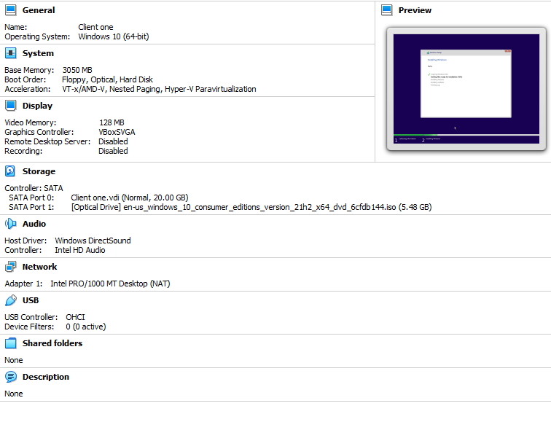
Figure 1 Configuring Client One on VB Manager

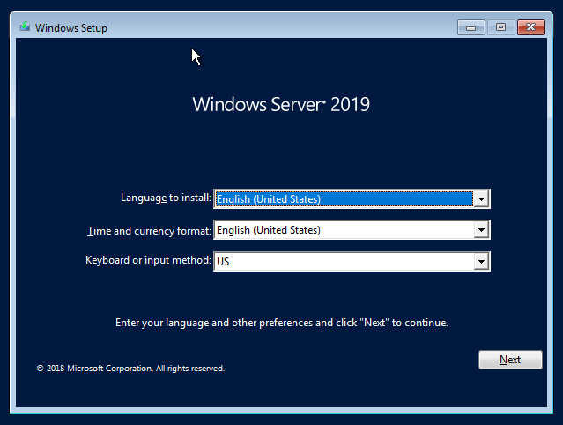
Figure 2 Start screen Client One

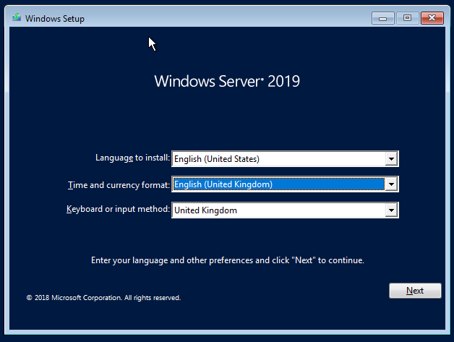
Figure 3 Client One changing language to UK

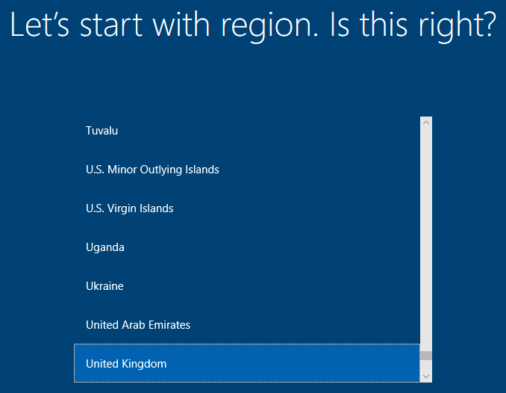
Figure 4 Client One Region of use set up

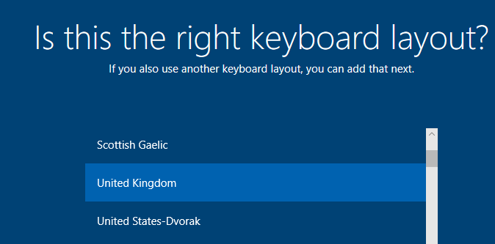
Figure 5 Client One Configuring for keyboard type

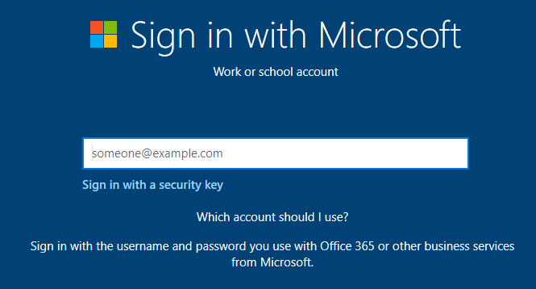
Figure 6 Client One Signing in screen

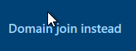
Figure 7 Client One Domain

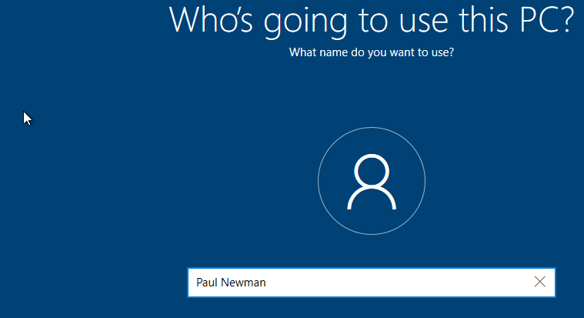
Figure 8 Client One adding in an administrator

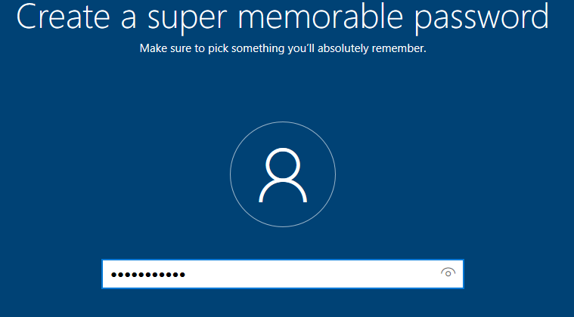
Figure 9 Client One Password creation

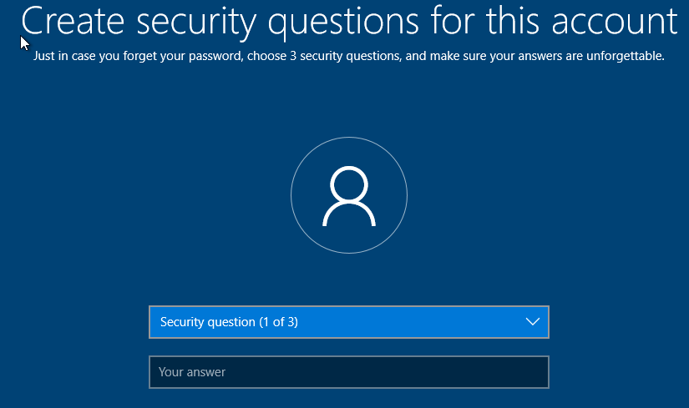
Figure 10 Client One Security questions

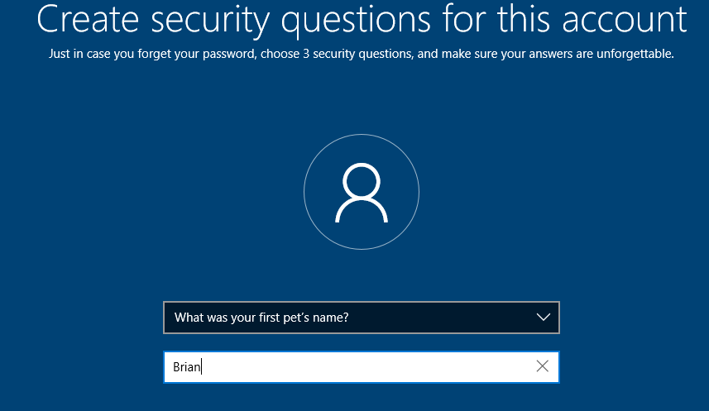
Figure 11 Client One finished Security questions

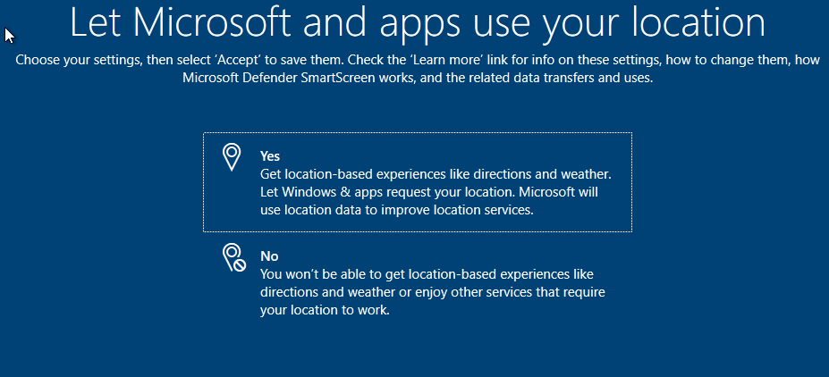
Figure 12 Client One Permission

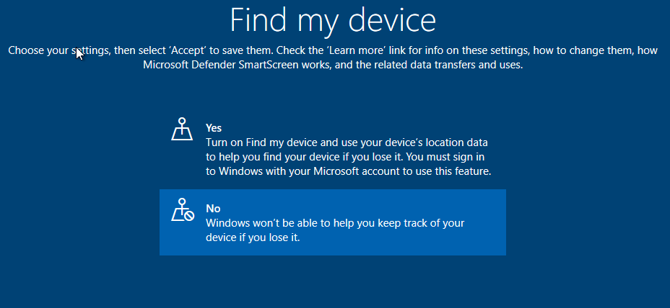
Figure 13 Client One more Security Questions

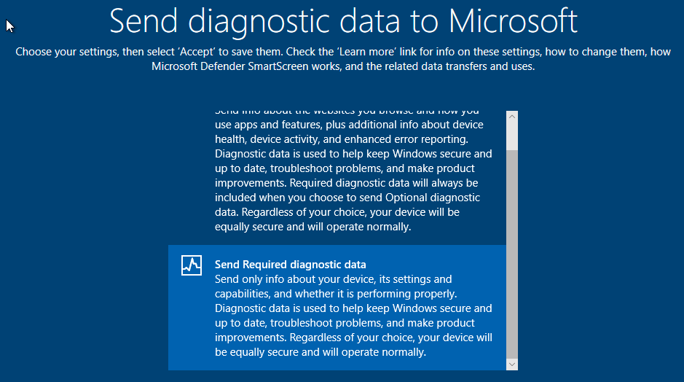
Figure 14 Client One sending info to Microsoft

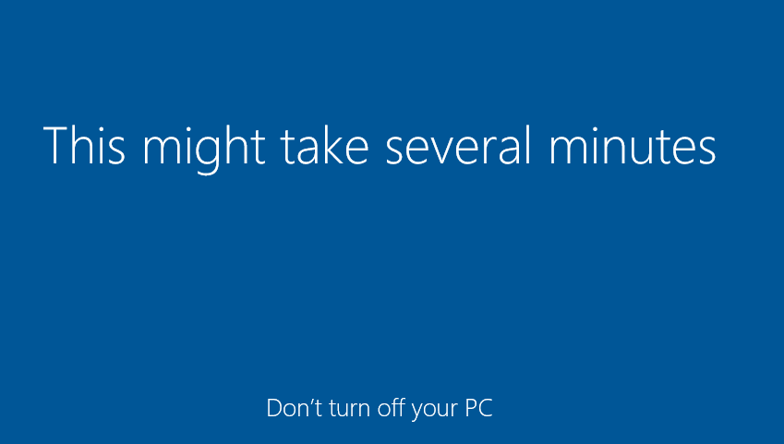
Figure 15 Client One Loading screen

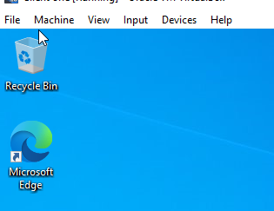
Figure 16 Client One Loaded and working

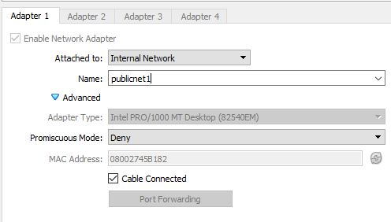
Figure 17 Client One Adapter change

Server One

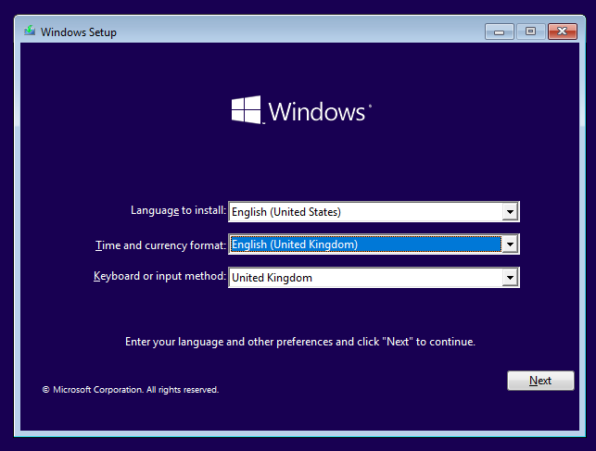
Figure 18 Server One Language set up

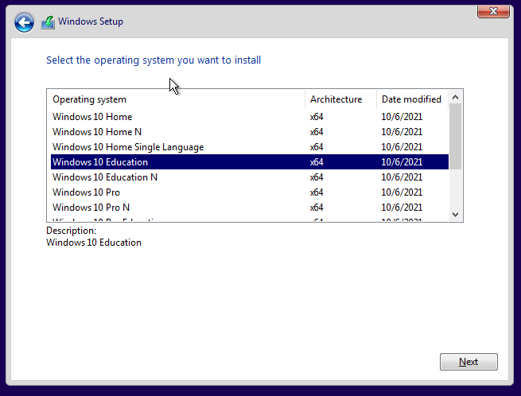
Figure 19 Server One OS set up

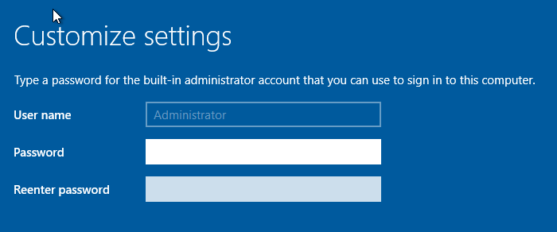
Figure 20 Server One Administrator password settings

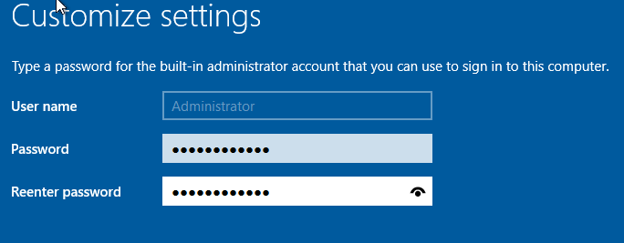
Figure 21 Server One New password


Figure 22 Server One up and running
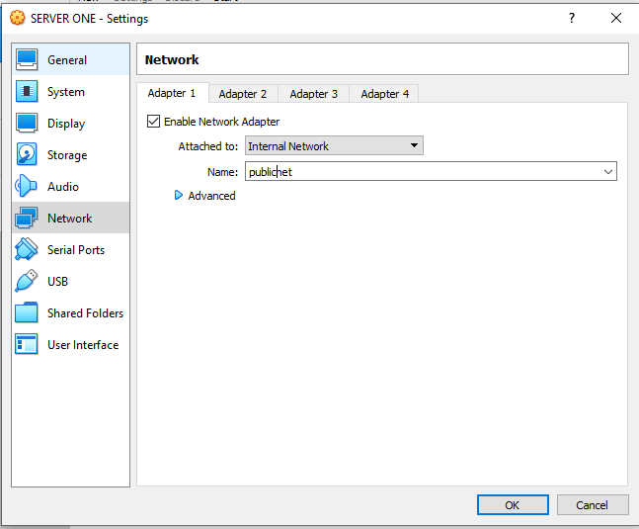
Figure 23 Server One Networks Set up

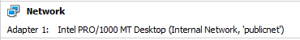
Figure 24 Server One Public Network Virtual Switch

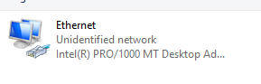
Figure 25 Server One Changing Name


Figure 26 Server One Name Changed

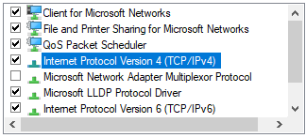
Figure 27 Server One TCIP C configuration

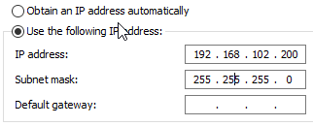
Figure 28 Server One Subnet Mask

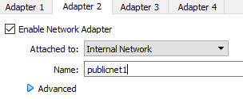
Figure 29 Server One Adapter 2 update


Figure 30 Server One PrivetNet One set up

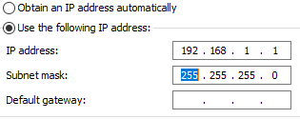
Figure 31 Server One Ip Address

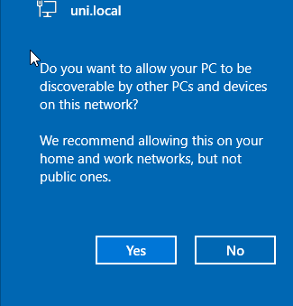
Figure 32 Server One Conformation Screen

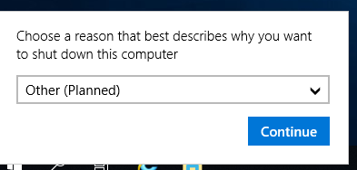
Figure 33 Server One Shut Down screen

Client Two

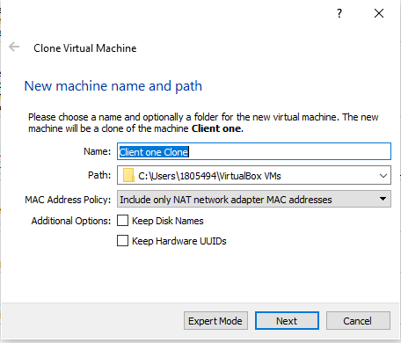
Figure 34 Client Two Cloning Setup

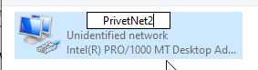
Figure 35 Client Two Naming of Net
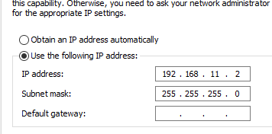
Figure 36 Client Two Sub Masking

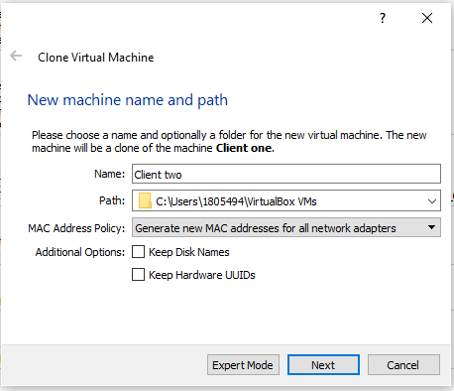
Figure 37 Client Two renaming to Client Two

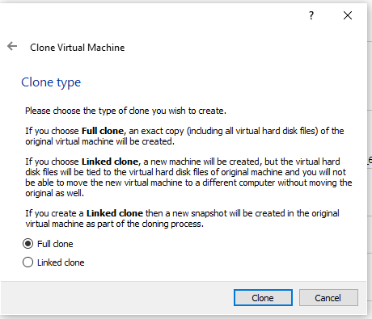
Figure 38 Client Two final Cloning set up

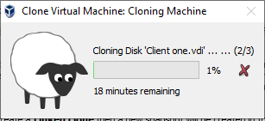
Figure 39 Client Two Cloning screen start up

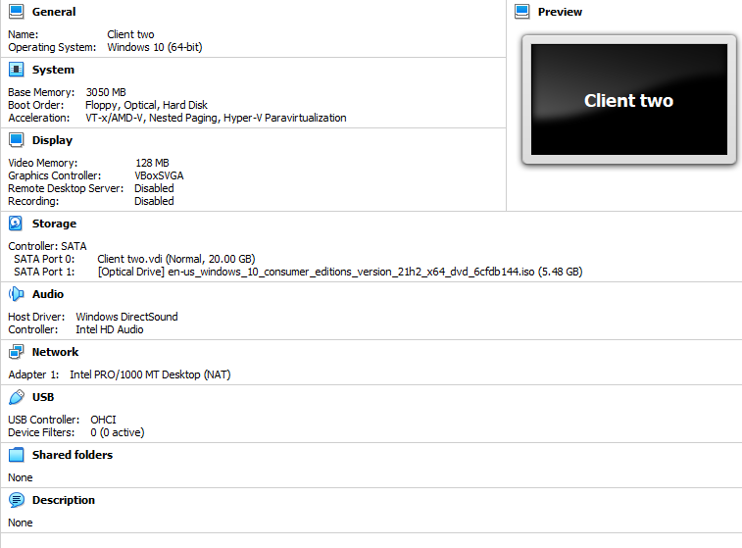
Figure 40 Client Two Configure set up

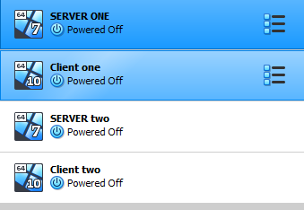
Figure 41 All Servers and Clients are shut down

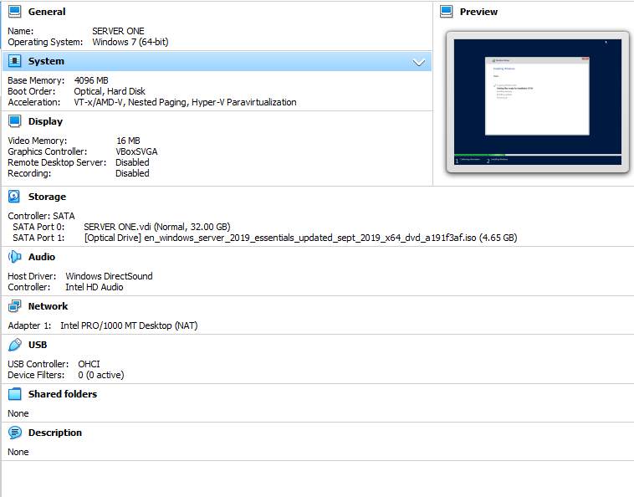
Figure 42 Server One Settings

Server Two

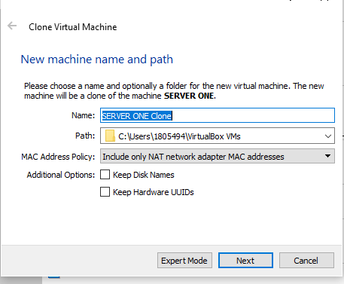
Figure 43 Server Two Cloning start up

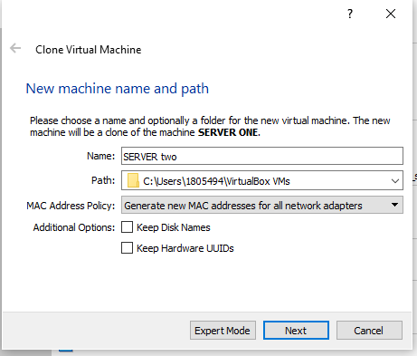
Figure 44 Server Two name changed

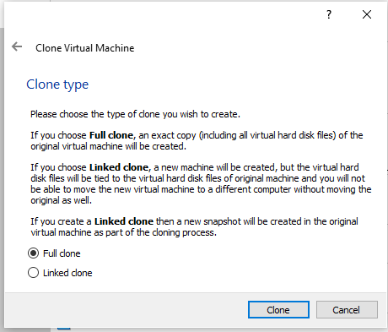
Figure 45 Server Two final Cloning options
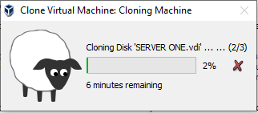
Figure 46 Server Two Cloning Loading Screen

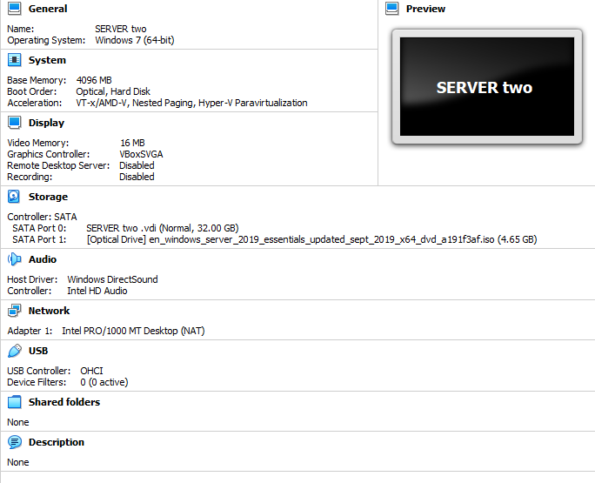
Figure 47 Server Two finished Cloning

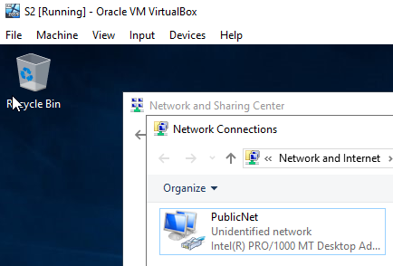
Figure 48 Server Two renaming to publicNet

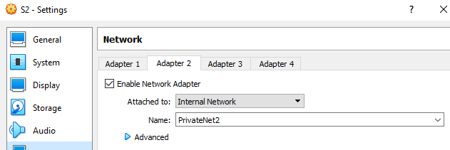
Figure 49 Server Two Adapter 2 change name

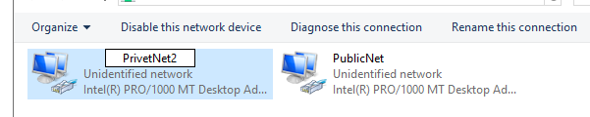
Figure 50 Server Two PrivetNet setup

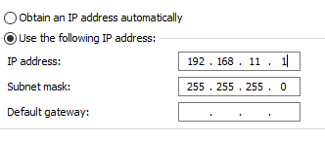
Figure 51 Server Two TCPIP Address

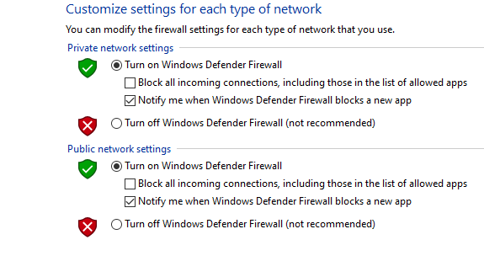
Figure 52 Turning off Firewall

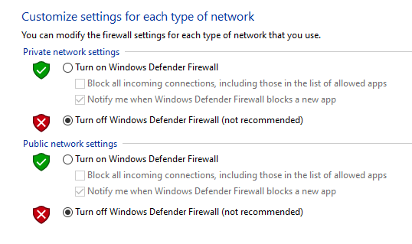
Figure 53 Turning off Firewall

- This process was repeated on all other clients and servers to facilitate ping operations (ICMP)

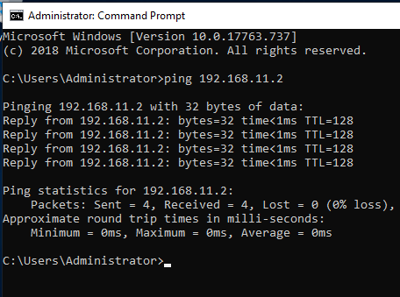
Figure 54 Testing ICMP Server Two to Client Two (PrivetNet2)

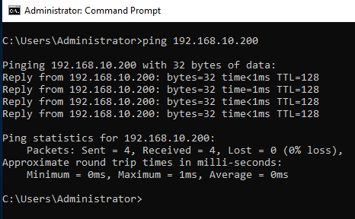
Figure 55 Pinging Server One from server Two (PublicNet)

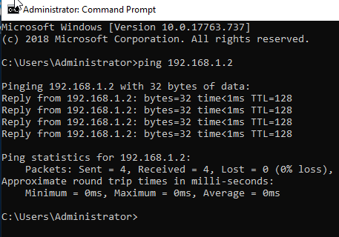
Figure 56 Pining Client One from Server One (PrivatNet1)

Task 2: DEPLOYING A NETWORK DIRECTORY SERVICE AND CREATING AND UNDERSTANDING ACTIVE DIRECTORY NETWORK OBJECTS

Task 3: Observations

Hypervisors
Hypervisors are virtualisation techniques that allow many operating systems to run at the same time on a host machine, A hypervisor allows a guest machine to use a virtual platform so they can operate, the host machine will monitor and will implement the execution of the guest machine operating system. [1]
- Hypervisor type One
Type One is a basic layer of soft-were that is installed directly on to the physical server and underlying hard-were, the type one is excellent at performance and very stabile as it does not run inside any operating system which is why it called a bare-metal hypervisor [2].
- Hypervisor type Two
Type Two runs inside the operating system of the host machine, it is a VM manger it runs on a physical machine normally on Windows, Mac and Linux this is [2].

Cloud computing
Cloud computing stated with the birth of personal home computers where it was commonplace to have centralized mainframes, but due to mainframe administrators who controlled them would often cause bottle necking to restrike the flow of data. Cloud computing opened workloads across workloads without bottlenecking, which made it faster and cheaper with a lot more flexibility [3].

DNS Domain Name Systems
Computers all have an IP address when connected to the internet, the IP address is used to identify each computer (host) to each other, domain name is used to identify what network interface the host is using DNS is a database worldwide [4].

Active Directory (AD)
Active directory provides a way to coordinate resources from a network to be able to present them to centralized information, most directories were made for certain applications. Developers created the incentive to provide a way for integration into other systems. [5]

Ping
Ping is the time it takes for a packet to leave a computer and touch another computer in milliseconds.

Server Management

Firewall

Firewalls are a system of preventing hostile and dangerous attacks and web sites from accessing your pc, the Firewall examines the TCP/IP traffic at the entry/exit ports by creating filters and controls to block or allow the information from entering the pc. [6]

PAE/NX
Physical Address Extension (PAE) enables 32-bit processors for access to more than 4 GB Physical memory, the PAE/NX makes the PAE and NX checks the host CPU to see if a VM will be exposed.
No Execute (NX) The CPU knows to make parts of the memory safer from programs by executing code to prevent an attack. [7]

OOBE
Windows Out of Box Experience (OOBE) when a user turns on their pc for the first time they will have a number of screens that will require them to accept all the agreements and license’s in order to connect to the internet. [7]

Bibliography

[1] | S. A. A. Sharkh, "Scaling cloud resources under different virtualization," hypervisors types with regards to machine utilization, p. 75, August 2014.
[2] | "phoenixnap," 2021 Copyright phoenixNAP, [Online]. Available: https://phoenixnap.com/. [Accessed 14 03 2022].
[3] | M. Kavis, "ARCHITECTING THE CLOUD," in DESIGN DECISIONS FOR CLOUD COMPUTING, Published by John Wiley & Sons, Inc., Hoboken, New Jersey., 2014.
[4] | L. Dostálek, "DNS in Action," in A detailed and practical guide to DNS, 2006 Packt Publishing, First published: March 2006.
[5] | W. Glenn, Windows Active Directory, Microsoft Press.
[6] | D. C. Brewer, Picture Yourself Networking Your Home or Small Office, course technolagy.
[7] | "superuser.com," superuser, [Online]. Available: https://superuser.com/. [Accessed 18 03 2022].

