Associate to Leader: Investigating Informal Leadership Pathways and Career Progression in Amazon's Warehouse Environment
Ancuta Selaru 1918834

WUTSD
8/05/2026

Table of Contents
CHAPTER ONE: INTRODUCTION 4
1.1 Significance of the Study 6
1.2 Structure of the Dissertation 6
1.3 Chapter Summary 7
CHAPTER TWO: LITERATURE REVIEW 8
2.1 Introduction to Chapter 8
2.2 Theoretical Framework 8
2.2.1 Transformational Leadership 8
2.2.2 Path-Goal Theory 9
2.2.3 Situational Leadership 9
2.3 Empirical Studies 10
2.3.1 Concept of Informal Leadership Pathways 10
2.3.2 The Role of Step-Up Leads and Process Guides in Facilitating the Development of Associates into Formal Leadership Positions 12
2.3.3 The Role of Informal Leadership in Associate Skills Development, Performance, and Career Progression 13
2.3.4 The Perceptions and Experiences of Associates Regarding Their Transition from Informal Leadership Roles to Formal Supervisory Positions 15
2.3.5 Informal Leadership and Emotional Intelligence 16
2.3.6 Recommendations for Enhancing Informal Leadership Pathways to Better Support Associate Development 18
2.4 Research Gap 18
2.5 Conceptual Framework 19
2.6 Chapter Summary 20
CHAPTER 3: RESEARCH METHODOLOGY 21
3.1 Introduction to Chapter 21
3.2 Research Rationale 21
3.3 Research Philosophy 21
3.4 Research Approach 22
3.5 Research Design 23
3.6 Data Collection Method 24
3.6.1 Sample Size and Sampling Method 25
3.7 Data Analysis 26
3.8 Ethical Considerations 27
3.9 Limitations of Study 27
3.10 Reliability and Validity 27
3.11 Chapter Summary 28
CHAPTER FOUR: FINDINGS AND ANALYSIS 28
4.1 Chapter Introduction 28
4.2 Qualitative Analysis 29
4.2.1 Participant Information 29
4.2.2 Thematic Analysis 29
4.2.3 Theme 1: Informal Leadership Roles and Selection Pathways 30
4.2.4 Theme 2: Skills Development, Confidence, and Work Performance 30
4.2.5 Theme 3: Leadership Under Target Pressure and Emotional Intelligence 31
4.2.6 Theme 4: Career Progression, Barriers, and Improvement of Informal Leadership Pathways 32
4.3 Quantitative Analysis 33
4.3.1 Respondent Profile and Background Characteristics 33
4.3.2 Descriptive Statistics of Main Variables 35
4.3.3 Reliability Analysis 35
4.3.4 Correlation Analysis 36
4.3.5 Multiple Regression Analysis 37
4.4 Discussion 38
4.5 Chapter Summary 39
CHAPTER FIVE: CONCLUSION AND RECOMMEDNATIONS 40
5.1 Introduction to Chapter 40
5.2 Summarized Outcome of Study 40
5.3 Recommendations 44
5.4 Implications of Study 45
5.4.1 Theoretical Implications 45
5.4.2 Practical Implications 45
5.5 Limitations and Recommendations for Future Researchers 46
CHAPTER SIX: APPENDICES 47
Appendix A: Interview Participant Information 47
Appendix B: Survey Graphs 48
Appendix C: Additional SPSS Tables 52
CHAPTER SEVEN: References 53

CHAPTER ONE: INTRODUCTION
The rapid growth of e-commerce has transformed warehouse operations into highly competitive and performance-driven environments where speed, efficiency, and accuracy are essential to organizational success. Companies such as Amazon have developed advanced fulfilment systems capable of processing thousands of customer orders daily while maintaining strict delivery targets and operational standards. However, behind these technological systems is a workforce operating under constant pressure to achieve productivity metrics, maintain quality standards, and adapt to continuously changing operational demands (Vallas, 2023). In these environments, leadership has become increasingly important, not only through formal managerial structures but also through informal relationships and employee-led support systems.
Within Amazon fulfilment centers, associates are expected to work within fast-paced environments where teamwork, communication, and adaptability directly influence operational performance. Although managers and supervisors oversee warehouse activities, many associates rely heavily on experienced coworkers for daily support, guidance, and problem-solving assistance. Informal leadership roles such as Step-Up Leads and Process Guides have therefore become important operational positions within warehouse environments. These employees support workflow coordination, answer operational questions, mentor associates, and assist managers during periods of high demand (Douglas et al., 2024).
From a personal workplace perspective, informal leadership often develops naturally within operational teams rather than through formal promotion alone. Associates who consistently support others, remain calm under pressure, communicate effectively, and demonstrate reliability frequently become influential figures within their teams. During busy shifts or operational disruptions, coworkers naturally turn toward experienced associates for reassurance and direction. This demonstrates that leadership within fulfilment centers is not always connected to formal job titles but can emerge through trust, confidence, and practical workplace experience. The significance of informal leadership has increased because career progression within warehouse environments can often appear difficult or unclear to frontline employees. Many associates believe that advancement opportunities depend heavily upon performance metrics, operational visibility, or managerial relationships rather than leadership capability or interpersonal skills. As a result, informal leadership positions such as Step-Up Leads and Process Guides have become important transitional roles between operational work and permanent leadership positions. These roles allow employees to demonstrate communication skills, emotional intelligence, decision-making ability, and operational awareness within real working environments (Mphaluwa et al., 2025).
At the same time, Amazon’s warehouse operations are strongly influenced by algorithmic management systems and productivity tracking technologies. Employees are continuously monitored through scanning systems, productivity dashboards, and performance metrics that evaluate efficiency and output levels. Although these systems support operational control and productivity improvement, they can also create highly pressurized working conditions where interpersonal leadership qualities may be undervalued compared with measurable performance outcomes (Zhang et al., 2025). Consequently, employees attempting to progress into leadership positions must balance operational performance with people-centered leadership behaviors.
The transition from associate to leader therefore involves both formal and informal development processes. Employees are required not only to maintain strong performance results but also to develop communication skills, emotional intelligence, confidence, and the ability to support others during stressful operational situations. Informal leadership pathways help associates gradually build these skills through direct exposure to leadership responsibilities within everyday warehouse activities. However, despite the practical importance of these pathways, limited academic research has explored how employees personally experience informal leadership development within Amazon fulfilment centers.
This dissertation investigates informal leadership pathways and career progression within Amazon’s warehouse environment. The study specifically examines how Step-Up Leads and Process Guides contribute to employee development, how associates perceive leadership opportunities, and how emotional intelligence and workplace relationships influence progression into formal supervisory roles. In addition, the research explores barriers affecting fair access to leadership opportunities and identifies recommendations for improving career progression systems within fulfilment centers. The rationale for conducting this study is both practical and academic. From an organizational perspective, companies such as Amazon increasingly depend upon internal talent development to maintain operational sustainability and employee retention. Understanding how informal leadership pathways support employee development may help organizations improve workforce engagement, leadership preparation, and fairness within promotion systems. Academically, the study contributes to leadership and organizational research by examining leadership development within highly structured and algorithmically managed workplaces, an area that remains underdeveloped in existing literature.
The study adopts a mixed-method approach combining quantitative surveys and qualitative interviews. Quantitative findings provide measurable insight into employee perceptions regarding leadership development and career progression, while qualitative interviews explore the personal experiences of associates involved in informal leadership roles. Combining these methods provides both statistical evidence and deeper contextual understanding of leadership development within Amazon’s warehouse environment. Overall, this dissertation argues that informal leadership pathways play a significant role in supporting employee development and career progression within Amazon fulfilment centers. However, the effectiveness of these pathways depends upon transparency, emotional intelligence, organizational support, and equal access to leadership opportunities. By examining these issues, the study contributes toward a broader understanding of leadership development within modern warehouse operations.

1.1 Significance of the Study
This study contributes to understanding leadership development within highly structured warehouse environments. Existing leadership literature mainly focuses on formal management systems, while less attention has been given to informal leadership emergence within operational settings such as Amazon fulfilment centres. The study therefore contributes to discussions surrounding workplace leadership, employee progression, emotional intelligence, and organizational development. The research is also practically significant because organizations increasingly depend upon internal employee development to support operational performance and retention. Understanding how informal leadership pathway’s function may help organizations improve leadership preparation, fairness, and employee engagement.
From a personal workplace perspective, the study highlights the experiences of frontline associates whose operational contributions are often overlooked despite their importance in maintaining workflow stability and team support.

1.2 Structure of the Dissertation
Chapter One introduces the study and outlines the background, research problem, aim, objectives, and significance of the investigation. Chapter Two critically reviews literature relating to informal leadership, emotional intelligence, algorithmic management, and career progression within warehouse environments. Chapter Three explains the research methodology, including research philosophy, design, sampling, data collection, and analytical procedures. Chapter Four presents the findings and analysis obtained from surveys and interviews. Chapter Five provides conclusions, recommendations, limitations, and implications for future research and organizational practice.

1.3 Chapter Summary
This chapter introduced the research by discussing the growing importance of informal leadership pathways within Amazon’s warehouse environment. The chapter highlighted how Step-Up Leads and Process Guides support operational coordination, employee development, and career progression within highly pressurized fulfilment centres. The discussion also emphasized the role of emotional intelligence, communication, and workplace relationships in leadership development. The chapter established the rationale, objectives, and significance of the study while identifying the need for further research into informal leadership development within algorithmically managed workplaces.

CHAPTER TWO: LITERATURE REVIEW

2.1 Introduction to Chapter
The literature on informal leadership routes and career trajectories in Amazon warehouse settings studies how employee advancement and progression occur in a highly structured, algorithmically controlled employee base. Although the leadership development strategy of Amazon is usually formalized, most employees take an informal leadership development path to leadership, based on informal networks, the development of skills, and adaptive behaviors at the team level. Compared to formal managerial roles, informal leadership is becoming a key issue of determining motivation, job satisfaction, and overall performance in warehousing and logistics. Research has dwelled upon numerous areas such as how frontline employees negotiate the hierarchical organization, contribution of self-directed skill development, and the impact of informal power on team cohesion. This literature overlaps with larger debates on the subject of leadership in workplaces fueled by technology, the effects of algorithmic management on agency among employees, and how workers can invest in career growth in high-performance, labor-intensive settings, such as the warehouses at Amazon.

2.2 Theoretical Framework

2.2.1 Transformational Leadership
Transformational leadership is dynamic in nature, in which leaders inspire and motivate their followers in order to encourage them to improve on their performance and overall motivation as well. This type of leadership provides an atmosphere that promotes cooperation, self-improvement, and co-development (Agazu, Kero, and Debela, 2025). Transformational leadership is based on the idea of promoting creativity, innovation, and continuous improvement. Abdul-Azeez, Ihechere, and Idemudia (2024) also state that transformational leaders can influence the promotion of a culture based on risk-taking and creativity. Transformational leaders achieve this by encouraging their followers to think beyond the box, make calculated risks, and learn, which aids in the development of new products and services and has made the organization competitive.
Kim, Yang, and Lee (2023) verify this notion by demonstrating that inspirational communication at the daily level among peers could reduce stress and ensure high service quality. Their study shows that transformational leadership is not just a top-to-bottom hierarchical type of flow but may also be horizontal between peers. This implies that charisma and vision can be shared at all levels and not from the leaders to the teams. The example of the Amazon leadership model, in which step-up leaders promote the best practices and create the environment of continuous improvement, is one of the brightest illustrations of the application of transformational leadership to practice.

2.2.2 Path-Goal Theory
The path-goal theory states that leaders can improve the performance of their followers by making sure that the path is clear, eliminating barriers and recognizing rewards that are tied to particular objectives. This theory argues that leaders must enhance the performance of their followers by making the steps to success simpler and that the path is not obstructed (Itesa and Burchell 2025). Al-Jaberi et al. (2021) demonstrated that supportive and participative leadership actions positively influenced absenteeism during the COVID-19 disruptions, as they simplified the safety procedures and made it easier to understand the eligibility of bonuses among the employees. This is a strategy that goes in tandem with the path-goal theory, where a leader should focus on open communication and transparency more so when uncertain about something.
More research has been conducted on the ways in which leadership styles differ in different situations, e.g., gender or organizational context. Fabac, Kokot and Bubalo (2022) concluded that the women leaders were more inclined to support leadership styles which had a direct impact on the performance of their teams and job satisfaction. Itesa and Burchell (2025) also emphasized that the path-goal leadership styles were associated with a reduced turnover intention, particularly in the case of the introduction of flexible work schedules, a flex-time or compressed working week. These results highlight the importance of leadership style and work arrangement in retention of employees. The process guides in Amazon, who troubleshoot and make the operation efficient, are one such applying path-goal leadership to deliver better throughput and retention.

2.2.3 Situational Leadership
According to the situational leadership theory, a good leader should change his or her style of leadership based on the levels of readiness and abilities of followers. According to this theory, the approach taken by a leader is most effective when the leader approaches the situation based on the needs of that situation (Junaedi and Ali, 2025). The study of Aslam et al. (2022) has revealed that adaptive leaders could encourage employees during the uncertainties of the COVID-19 pandemic by modifying their approach when the situation required it. The fact that they can adjust their leadership style to the circumstances allows them to remain highly engaged and performant among employees.
In other works by Junaedi and Ali (2025), it is reported that situational leadership has a positive influence on employee performance, which is especially relevant when job satisfaction and organizational citizenship behavior mediate this association. Informal leaders in the case of Amazon demonstrate situational leadership styles whereby they would change their approach depending on the workload and demand at that time. As an example, when times are good, these leaders give directive guidance that is clear and requires compliance with safety measures, whereas when the times are slow, they give supportive coaching so as to ensure associates are motivated. According to Xuecheng, Iqbal, and Saina (2022), this flexibility is exercised, as the real-time metrics on the fulfilment-center dashboards of Amazon also enable leaders to act dynamically to different work conditions.

2.3 Empirical Studies

2.3.1 Concept of Informal Leadership Pathways
Informal leadership paths are characterized as a leadership style that emerged outside of the formal hierarchy and is apt to be due to interpersonal relations, trust, and power over peer workers. These studies have also found that informal leaders tend to gain influence because of their social capital, that is, the demonstration of the quality of a leader in the sense of mentorship, motivation and guidance without titles or power (Abdul-Azeez et al., 2024). These leaders are, in most cases, found at the center of influence, where they provide support and direction within the team settings where they establish a sense of teamwork and trust towards them. Agazu et al. (2025) confirm that informal leadership may be useful in enhancing employee engagement, but Al-Jaberi et al. (2021) find its impact on employee team performance and structure particularly in unstable work environments.
Vallas (2023) discusses the phenomenon of informal leadership in the Amazon warehouses and how relational relationships among colleagues result in the creation of leadership rather than the establishment of a hierarchical power structure. Workers who gain confidence and establish a sense of teamwork among others are more likely to become leaders even though there are no managerial positions. The article by Vallas (2023) demonstrates how these relationships are formed by the organizational culture at Amazon, where formal leadership structures can be suppressive of the employees. However, the study is limited in that it only highlights relational aspects without giving consideration to the entire organization and technology where leadership is also created. On the other hand, Zhang et al. (2025) focuses on the issue of algorithmic management and its effect on informal leadership. They believe that the atmosphere created by Amazon of technology does not merely monitor its performance but promotes informal leadership by rewarding the high performers through algorithmic metrics. The Andreoli-Versbach (2024) study is a significant addition to the observation of leadership emergence in Amazon, as it points to the way performance incentives can be employed using the technological systems to foster leadership. However, Zhang et al. (2025) fail to consider emotional and interpersonal components of leadership such as motivation and relationship-building, which form the focus of informal leadership functions.
In addition to the relational and technological relationships between leaders and their followers discussed by Vallas (2023) and Zhang et al. (2025), Barkat et al. (2024) also indicate that, in shaping informal leadership, the transformational leadership behaviors that are mentoring, giving guidance, and empowering peers are to be taken into account. Their study confirms that the employees who possess transformational leadership qualities are more effective in influencing their fellow employees and creating teamwork among them when they lack formal power. This perspective acknowledges emotional intelligence (EI) and interpersonal skills as concerns not to be overlooked in the formation of leaders. However, the second weakness that Barkat et al. (2024) have found in the Amazon warehouse context is that informal leaders are not able to introduce a long-term change to the setting due to the lack of formal authority. This remark is in response to the limitation of Zhang et al. (2025) such that the informal leaders may be limited to the extent to which they can make structural changes despite influencing the groups.
As an extension of this argument, Mphaluwa et al. (2025) highlights the importance of emotional intelligence (EI) as the factor of informal leadership development within the Amazon warehouse environment. This is because, according to them, emotional regulation, empathy and social skills in leadership can be used to aid in enhancing leadership capacity, but on their own, they cannot be used to achieve growth in their career without organization. Mphaluwa et al. (2025) believe that formal career development programmers and training opportunities should support informal leadership development to ensure that informal leaders of Amazon have an opportunity to develop within the hierarchical system of their organization. The observation adds value to Barkat et al. (2024), who observe that informal leaders need to be surrounded by favorable organizational structures that support their development. The combination of these studies means that the existing model of performance-orientated Amazon has the potential to hamper the emergence of informal leaders unless it is complemented by an equivalent structural and developmental one.
Articles by Vallas (2023), Zhang et al. (2025), Barkat et al. (2024), and Mphaluwa et al. (2025) can be used to comprehend the informal leadership dynamics of the Amazon warehouse environment. However, the two studies are restricted. Vallas (2023) is far more relationship-orientated, and Zhang et al. (2025) talk about the application of algorithmic systems and neglecting emotional and interpersonal leadership qualities. Barkat et al. (2024) focus on transformational leadership without considering the issues that informal leaders must endure in the absence of formal powers. According to Mphaluwa et al. (2025), emotional intelligence is important, yet it requires formal organizational support to enhance real career development. All these studies culminate in a combination of relational dynamics, technology, emotional intelligence, and organizational support wherein an understanding of the phenomenon of informal leadership development in the warehouses of Amazon as a whole is obtained.

2.3.2 The Role of Step-Up Leads and Process Guides in Facilitating the Development of Associates into Formal Leadership Positions
Process Guides and Step-Up Leads are largely involved in helping associates become formal leaders in the warehouse settings. Such positions allow associates to have practical experience in leadership and develop requisite competencies that lead to career development. As Cretskens et al. (2025) note, employee well-being and leadership development are two inseparable concepts, and supportive leadership roles such as Step-Up Leads create the environment in which the associates can flourish and train to take a formal leadership role. These positions are the initial step to career growth, as they offer a beneficial introduction and mentorship, as well as a learning opportunity.
Besides, Douglas et al. (2024) claim that, in logistics work, leadership positions at the operational level can be a key point of contact between employees and high-level management. The process guides and process steps can be used to provide this bridge and provide practice with leadership roles, which includes making decisions and coordinating a team. This practical life experience makes associates better prepared to accept formal positions.
Furthermore, Ekren (2026) mentions the current changes in modern logistics systems, where employees should be empowered through various programs of staff development with a strong emphasis on responsibility and initiative. Through such programs, the associates are able to show their potential in leadership, which is essential in the upward movement in organized settings. Step-Up Leads and Process Guides is a program that provides the necessary background of equipping employees with the skills needed prior to starting formal leadership roles that would promote long-term career growth within the warehouse environment.
The career growth in the warehouse environments at Amazon is influenced by formal programs and informal self-directed growth. The step-up leads and the process of transferring the associates to formal leadership roles by cultivating the required working skills and promoting team building are key elements to consider. Such informal leadership opportunities, Vallas (2023) notes, are often regarded as having been acquired through peer-to-peer contacts, rather than through managerial directives. Step-up leads are employed by Amazon to enable associates to acquire these skills through demonstrating complex tasks to employees and showing they have leadership potential before formal promotions. This informal mentorship acquires very essential significance in the workplace, where the pressure is high and speed and precision are paramount, like in Amazon warehouses.
On the other hand, the performance-orientated ones are the transactional leadership theories, such as the one presented by Bass (1990). These transactional frame models are efficient and task-orientated behaviors coinciding with the Amazon culture as a metrics-based company. The limitation of this approach, however, is that it might be insensitive to the light skills that accompany informal leadership, such as emotional intelligence and team building. As the warehouses of Amazon become increasingly dependent on algorithmic management systems, as it is mentioned in Zhang et al. (2025), the integration of the two performance metrics, as well as the acquisition of emotional intelligence skills, is crucial to the mechanism of step-up leads that will enable the associates to become more formal employees in the new leadership roles. The personal development balance of this task center is the secret to the successful career development of the Amazon associates.

2.3.3 The Role of Informal Leadership in Associate Skills Development, Performance, and Career Progression
The informal leadership role in developing associate skills, enhancing performance, and supporting career development is critical in warehouse environments. In their study, Giacomelli et al. (2025) investigate the connection between well-being and operational performance, demonstrating that employees who possess informal leadership attributes, including mentoring and motivating colleagues, tend to perform better and are more satisfied with their jobs. The informal leaders impact their colleagues by creating a positive work climate, which directly affects their performance and personal growth. These behaviors, in turn, lead to further career advancement because informal leaders are frequently regarded as the potential applicants to the formal leadership roles because of the interpersonal skills and the capacity to lead other people demonstrated.
Nevertheless, Granulo et al. (2024) note that this could have a negative side and state that the implementation of algorithms in managerial activities can lead to the decreasing of the prosocial motivation of employees as one of the most common motivators of informal leadership. The inbuilt drive that gives rise to informal leadership may also be destroyed by algorithmic supervision since employees become less concerned with assisting others or cultivating leadership qualities and more attentive to achieving performance goals. This may influence their personal growth as well as their career growth in the organization. Guerrero-Valle (2025) looks at the embodied experiences of employees and offers an insight into how informal leadership influences the feeling of agency and purpose in the workers in their work. This qualitative method highlights the role of informal leadership in the empowerment of associates and skill development as well as job satisfaction, which is essential in career advancement.
Hosen et al. (2024) also dwells on the significance of training and development programs saying that career development in warehouses is often encouraged by the presence of trainings and opportunities a worker is offered to take up informal leadership positions. Nevertheless, the informal leadership routes are not necessarily officialized, which states that employees can acquire leadership skills through work, though they may not necessarily have formal ways to the high-ranking official posts. Research such as the one by Jameel et al. (2025) and Jung et al. (2024) demonstrate that supportive leadership and motivational orientation influence innovative working behavior and job results in a positive way, which supports the notion that informal leadership positively influences the development of skills, as well as the promotion of the career within the warehouse environment.
Informal leadership is highly important in acquiring skills, performance and career development in the fulfilment centers of Amazon. The informal leaders are frequently recognized by the skill to affect the course of actions, mentorship, and the ability to effectively solve problems despite the lack of official authority (Barkat et al., 2024). Informal leaders can be used in the high-performance environment of Amazon to fill the gaps in official leadership and assist associates in learning new tasks. These executives contribute to ongoing education, which is one of the elements of the operational success of Amazon (Douglas et al., 2024). The interpersonal relations between the informal leader and their colleagues help in the establishment of the collaborative environment, which is very crucial in enhancing the work performance and creation of the culture of constant improvement.
Nevertheless, the weaknesses of informal leadership in the performance-based system of Amazon can be observed. The system of reward is often predetermined by algorithmic management and performance metrics and is harmful to the organic emergence of informal leaders (Zhang et al., 2025). Moreover, the value of emotional intelligence and interpersonal skills, which are very important in informal leadership development, is sometimes neglected by the fact that Amazon stresses quantifiable performance. Although articles by Mphaluwa et al. (2025) and Hosen et al. (2024) indicate the importance of emotional intelligence, including empathy and self-regulation, they also point to the possibility that this performance standard at Amazon may limit the expression of these leadership traits. Therefore, more coordinated leadership development involving technical skills and emotional intelligence is needed in both formal and informal leadership development.

2.3.4 The Perceptions and Experiences of Associates Regarding Their Transition from Informal Leadership Roles to Formal Supervisory Positions
The shift between informal leadership positions and formal supervisory roles can be a major change to the associates in the warehouse settings (Junaedi et al. 2025). Liu et al. (2025) discuss the emergence of the informal leaders of the staff, who can be innovative in their behavior, as it can become a springboard to their becoming formal leaders. The peers normally trust such informal leaders, and these are the individuals who can be the best supervisors (Theodore et al. 2025). Nevertheless, Ma et al. (2023) also emphasize that emotional labor might be a problematic part of this transition, as the emotional pressure of being a leader of peers may influence job satisfaction and the final performance results. When informal leaders are forced to assume a more direct role in leadership, they might find it hard to make a balance between the personal relationship that they have formed with their peers and their leadership capacity (Fabac et al. 2022).
Nguyen et al. (2023) state that perceived organizational support is vital in this transition. When the organization is supportive of its employees, they will easily manage the transition to formal leadership positions. This favor could exist in terms of mentorship, training and career development paths. Nguyen et al. (2025) also point out that transformational leadership and informal coaching can be crucial during this transition, as they can assist employees in gaining trust in their supervisorial functions.
On the other hand, Nilsson et al. (2025) argue about the consequences of algorithmic management that could cause the emergence of psychological stress and prevent the formation of informal leadership. The inflexible surveillance mechanisms can defeat the emotional intelligence quotient and interpersonal relationships required of informal leaders to succeed in formal offices. Hence, it is essential to balance the requirements of algorithmic monitoring with the development of informal leadership traits to make the transition successful.
The process of associates at Amazon undergoing a shift between informal leadership and formal supervisory roles is complex. Such transitions are usually characterized by a necessity to operate not only within the formal organizational frameworks but also within the informal systems of influence. According to Usman and Garavan (2026), organisational support, HR policies and status striving play a critical role in determining career progression at Amazon, particularly among informal leaders. Excellent associates in informal leadership are the ones who will be at the frontier of their career growth, and the shift to formal supervisory lifestyles will initiate the need to be formally acknowledged as leaders.
The problem is the recognition of informal leadership. Although Vallas (2023) elaborates on how informal leadership can be manifested through social interactions among associates, this is not necessarily how the formal arrangement of leadership at Amazon works. The move between informal and formal positions is one of the events that demonstrate that the self-initiated leadership actions demonstrated by the associates and the expectations determined by the hierarchical management system at Amazon have little in common. This is exacerbated by the performance-orientated culture at Amazon, which emphasizes more on getting quantifiable outcomes rather than on the subjective aspects of leadership, including the ability to mentor and build a team (Zheng et al., 2025). This brings to the fore the necessity of enhanced integration of informal leadership recognition into the formal career progression processes of Amazon.

2.3.5 Informal Leadership and Emotional Intelligence
Emotional Intelligence (EI) is vital in knowing how informal leadership develops, particularly in the warehouse setting of Amazon, whereby employees are usually under pleasureful situations (Ferdman, 2020). According to Cheng et al. (2025), the role of empowering leadership and emotional labor in the context of leadership emergence in frontline employees is crucial. According to Nguyen et al. (2025), the employees with high emotional intelligence levels are placed in a better position to develop relationships and create trust in their groups despite their lack of an office in that the emotional intelligence levels of the employees are strong and are characterized by self-awareness, regulation of emotions, and empathy, as well as social skills. In an environment that requires employees operating in a warehouse, with a high rate of workers often being heavily monitored regarding performance and the many metrics, EI can be used to enable informal leaders to relate to their peers, promote cooperation and influence group dynamics (Mitschelen et al. 2025). Such leaders will have greater opportunities to inspire and encourage people not by their position but by their talent to control emotions, understand colleagues, and create a favorable working atmosphere.
Informal leadership, in this meaning, is one which largely relies on EI since it gives individuals the ability to take on leadership positions depending on the ability to manage interpersonal relationships and give directions, even without any managerial titles (Laubengaie et al. 2024). High EI informal leaders are able to relieve tensions at the workplace, keep morale, and assist colleagues to overcome tough challenges (Barkat, et al. 2024). This does not only improve the immediate work environment but can have a great influence on their career path as well (Rai et al. 2025). They become invaluable to their teams, and this may result in promotion of careers through appreciation by both the managers and the other employees. As an illustration, such employees may be casually assigned the role of go-to individuals when it comes to solving issues or mentoring, which opens the door to being a leader in the future of the organization (Schinnenburg et al. 2025).
As emotional intelligence is a decisive consideration in leadership growth, Mphaluwa et al. (2025) warned that EI might not be viable in long-term career growth, particularly in a well-organized company such as Amazon. According to Cretskens et al. (2025), it is possible to influence interpersonal relationships and the potential of a worker to become a leader through emotional intelligence, although it needs to be supported by the organization and formal career development opportunities. Within the warehouse setting at Amazon, where progress is frequently linked to satisfying extremely high-performance standards, emotional intelligence has to be complemented by career development initiatives, training exposure, and support by the formal management structure to establish a long-term leadership development ladder (Giacomelli et al. 2025). Without this supplementary provision, the employees might have a hard time converting their emotional intelligence into concrete career advancement since the focus is more on performance and results and not on individual leadership potentials.
As Mphaluwa et al. (2025) remark, in organizations where the hierarchies are rigid, like Amazon, the leadership ladder tends to be less pliable and may be limited by external forces, such as the algorithmic management systems where the qualities of leadership are focused on counting the results, rather than the soft skills of the leadership, like emotional control or empathy. Within this paradigm, even the employees who have a high EI rating might not be able to overcome the walls of the formal system without any conscious organizational actions in identifying and developing leadership skills that are not determined by raw performance rates (Granulo et al. 2024).
As a solution to this disparity, Cheng et al. (2024) suggest combining emotional intelligence and Human Resource Management (HRM) approaches that encourage development in leadership. In this way, organizations will be able to develop an environment in which emotional intelligence is not only a personal resource but also a well-known and appreciated ability that can help get ahead in a career. The practices of HRM that focus on emotional intelligence may equip the employees with the means to further their interpersonal skills, and at the same time, they provide the formal training, mentoring, and feedback which help them advance in their careers (Zayid et al. 2024). This dualism would enable informal leaders to develop within the organizational structure so that they will not be constrained by the rigid structures that may hinder their growth.

2.3.6 Recommendations for Enhancing Informal Leadership Pathways to Better Support Associate Development
Amazon must to leverage informal leadership more into its formal leadership so as to better support associate development (Zhu et al. 2018). The reviewed literature provides a range of recommendations. Amazon would improve the contribution of emotional intelligence to leadership development programs. Mphaluwa et al. (2025) observe that emotional intelligence plays a crucial role in ensuring good communication and collaboration within a team, which are the main attributes of informal leadership. Emotional intelligence training together with technical skills training would give the associates a complete leadership toolkit and make them ready to assume formal leadership positions (Sürücü et al. 2020).
Second, the alignment of performance indicators with leadership growth objectives should be increased. In as much as algorithmic management is strong in providing performance tracking, it fails to consider the relational aspect and mentoring that defines informal leadership (Zhang et al., 2025). A less radical option, where informal leadership within the company is determined by performance appraisal and career growth programs, would provide associates with a clear route to formal leadership. The study by Cheng et al. (2024) can inform companies like Amazon that sustainable HRM practices are useful in the development of the career of the employees. When the principles of transformational leadership are brought to the existing HR practice at Amazon, one can achieve informal leadership and promote a personal and organisational objective.

2.4 Research Gap
Although the available literature has given useful insights into understanding how informal leadership has been developed in the warehouse setting of Amazon, there are a number of gaps that need to be filled. Kittel et al. (2021) and Douglas et al. (2024) emphasize that the efficiency-focused culture at Amazon has stifled informal leadership but do not discuss how informal leadership can develop regardless of such constraints or how informal leadership can be acknowledged by formal systems. Likewise, Zhang et al. (2025) address the idea of algorithmic management but do not discuss the emotional or interpersonal aspects of leadership. Moreover, Mphaluwa et al. (2025) recognize the significance of emotional intelligence but claim that without the support of the organization, it is not enough, although they fail to support how the hierarchical and performance-based organizational models of Amazon prevent this support. Von Eben-Worlee et al. (2025) investigate career development but mostly target the supply chain executives, as the specific problem of warehouse workers remains uninvestigated to a considerable extent. This shows that there is a necessity of further, more in-depth research on both the formal and informal development of leadership at diverse levels within the Amazon workforce, especially the frontline workers (Rozmysłowicz, 2023).

2.5 Conceptual Framework
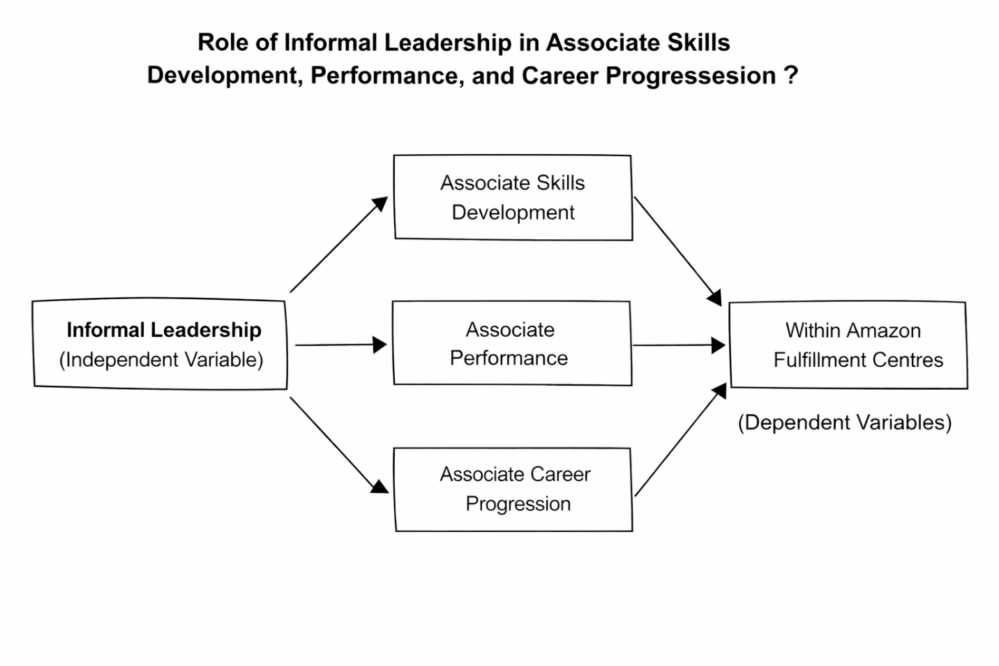
Figure 2 Conceptual Framework
The conceptual framework diagram demonstrates the correlation between informal leadership and the major results in the warehouse setting of Amazon, namely, the development of the skills of associates, their performance, and their career growth (Yao et al. 2025). The independent variable (IV) in this model is informal leadership, which manifests itself by being influenced by peers and mentored and guided in leadership without any formal systems of authority. It is a leadership style that is important in defining the skillfulness and ability of associates, and this helps in their development.
As the diagram shows, informal leadership has a positive effect on the development of associate skills, allowing employees to improve their technical and personal skills, mentoring their colleagues and learning on their own. Such enhancement of skills, in turn, has a direct impact on the performance of associates and creates an environment in which the employees will be more prepared to meet the expectations of the operations. It also highlights the connection between informal leadership and the rise of people in the organization because employees who take up the informal leadership roles are more likely to get recognition and climb up the organizational ladder.
Finally, the framework illustrates the effect of informal leadership on the overall dynamics in the Amazon fulfilment centers and indicates its effects on the personal development, work performance, and professional development of employees. With informal leadership being identified and encouraged, Amazon will be able to provide better conditions in terms of associates' promotion, leading to personal and company triumph.
Second, the alignment of performance indicators with leadership growth objectives should be increased. In as much as algorithmic management is strong in providing performance tracking, it fails to consider the relational aspect and mentoring that defines informal leadership (Zhang et al., 2025).

2.6 Chapter Summary
The chapter entailed the dynamics of informal leadership paths and career development in the Amazon warehouse setting. It explained the effects of organizational cultures, algorithmic management, and hierarchical structures on informal leadership development. The importance of emotional intelligence (EI) in developing leadership without authority is noted, and it is important to stress the interpersonal skills and emotional control. The chapter also discussed the drawbacks of current research, indicating a gap in the knowledge of the special problems of employment of warehouse workers in comparison with the supply chain executives. The chapter presented the importance of combination of emotional intelligence and HRM practices to facilitate the career advancement and leadership development within highly structured environments.

CHAPTER 3: RESEARCH METHODOLOGY

3.1 Introduction to Chapter
This chapter provides a discussion of the mixed method employed in this study, which used both quantitative surveys and qualitative interviews to have a clear picture of informal leadership channels and career development in the warehouse setting at Amazon. The quantitative part is a survey, which will help to gather quantifiable information about the perceptions of employees regarding leadership development and career advancement. The qualitative part will be based on in-depth interviews, which will help examine the personal, nuanced experiences of workers. The research employs Saunders's Research Onion Model as the research guide, which enables the researcher to have a systematic method of conducting research which has balanced theory and practice. The choice of this model was based on its flexibility, which aligns the two research methods with the study's objectives and enhances the strength of the findings.

3.2 Research Rationale
The increasing significance of informal leadership in the work environment, particularly in Amazonian fulfilment centers, motivates this study. Since formal leadership systems might not capture the subtle roles played by employees, informal leadership provides a second avenue of growing associates and advancing their careers. This study seeks to address the issue of how informal leadership promotes the development of skills among associates, the development of performance, and promotion among people within Amazon. These dynamics will be useful for learning how informal leadership could be used to promote employee motivation, retention, and organizational performance, which will eventually lead to a more conducive and efficient work environment.

3.3 Research Philosophy
Research philosophy is the general belief about developing and proving knowledge, which uses the methods of research (Matthews and Ross, 2014). It impacts the way researchers design, collect and interpret the results. A number of research methods are based on philosophical assumptions, and different philosophies offer a unique perspective on reality, knowledge, and truth. Positivism and interpretivism are the two major schools of research philosophy, but pragmatism has received considerable interest in recent years.
According to this philosophy, knowledge is considered to be based on observable phenomena, and reality is objective and measurable. Scholars in this methodology tend to conduct research by quantitative means and concentrate on testing hypotheses and statistical works (Ahmad et al., 2019). Among the strengths, the possibility of obtaining generalizable and reliable conclusions has to be mentioned. Its weakness, however, is that it is not able to record the aspects of subjective experiences, emotions, and human behavior (Basias & Pollalis, 2018). Comparatively, this interpretivism philosophy focuses on comprehending the world as perceived by the participants, taking into account subjective experiences and social situations. It is very heavy on qualitative research techniques, including interviews and ethnography (Bryman and Bell, 2015). The characteristic of interpretivism is the ability to dig deeper into the meaning and insights. Nevertheless, its weaknesses are the relevance of researcher bias and the impossibility to generalize research (Braun and Clarke, 2013).
Another approach is pragmatism, which is a combination of qualitative and quantitative methodologies but concentrates on practical outcomes and solutions. It provides a chance to be flexible regarding the selection of research strategies, as methods that can be the most efficient in responding to research questions can be chosen (Creswell and Hirose, 2019). Pragmatism is especially applicable when the problem under consideration requires a comprehensive perspective and the researcher can integrate numerical data with profound and context-heavy information. The weakness it has, however, lies in its inability to be coherent across various methodologies and the possibility of conflicting results (Bauer and Scheim, 2019). Nevertheless, pragmatism gives the flexibility to examine a problem from various perspectives, which is appropriate in research studies where statistical evidence and detailed views of the participants are essential. Pragmatism has been selected in this study because it is applicable to the objectives of the study. Pragmatism allows exploring both quantitative surveys and qualitative interviews through the combination of these two methods and would offer a comprehensive view of informal leadership routes at Amazon (Basias & Pollalis, 2018; Baur, 2019). The application of mixed methodology is consistent with the objective of the study focusing on the general trends and the depth of contextual knowledge about the development of leadership in one of the most structured and algorithmic settings. The flexibility of pragmatism guarantees the ability of the research to conform to the dynamics of the real-world work settings, which will add depth and applicability of the findings.

3.4 Research Approach
The research approach is described as the method employed by the researchers to respond to the research problem and direct the data collection and analysis process in general (Baur, 2019). The major methods are deductive, inductive, and abductive reasoning, each of which has its own advantages and disadvantages. The Deductive Approach starts with a theory or hypothesis and goes on to test it by the use of data. It is top-down, and each general premise results in specific conclusions. Such strengths as the possibility to test existing theories and generate the results that can be generalized are included (Kumar, 2019). Nonetheless, its weakness is that it is rigid and therefore does not adapt easily to new discoveries that might emerge in the process of conducting research (Ghanad, 2023). Conversely, inductive reasoning begins with observations and constructs theories/generalizations based on the patterns present in the data. This is an effective approach to learning new phenomena and creating theories using a bottom-up approach (Mitchell and Education, 2018). Its advantage is that it is flexible and capable of new discoveries; however, the weakness is the possibility of subjectivity and the inability to generalize the findings (Field, 2018).
The abductive method unites deductive and inductive reasoning. It is initiated by unfinished observations, and the researcher makes the best possible judgement or hypothesis based on the evidence he/she has (Jamieson et al., 2023). Its benefit is that it facilitates the transition between theory and data and is thus very applicable to complex, real-world problems that need a subtle perception (Hochbein and Smeaton, 2018). The weakness of the abductive approach, however, is that it can draw speculative conclusions that have to be further confirmed (Noyes et al., 2019). The abductive method has been identified in this research, which made it possible to explore informal patterns of leadership in the Amazon warehouse environment where the current theories might not be complete in explaining the peculiarities of the employees' experiences. This method is flexible in being able to change the theories as new information is acquired, especially in the mixed-methods paradigm where quantitative and qualitative data are combined (Jain, 2021). Although the speculative nature in this approach can be considered its weakness, its applicability and effectiveness in offering practical suggestions in complex settings support its use (Kittur, 2023).

3.5 Research Design
Research design can be described as the plan and framework which provides the researcher with how to collect, analyze and interpret data. It will be important in making sure that the research problem is being dealt with effectively and that the findings are valid and reliable. Qualitative research design is an in-depth exploration of a phenomenon, typically by unstructured or semi-structured methods such as interviews, observations or focus groups. The advantage of qualitative studies is that they can be used to give in-depth and rich information about the experiences, behavior, and motivation of the participants. Nevertheless, its subjectivity is the primary weakness of the method because the results are made up of non-numerical data and cannot be applied to a bigger population (Schukajlow et al., 2018). Also, the qualitative data might be costly in analysis and might create biases related to the interpretation of the researcher (Solomon & Mrad, 2022).
Quantitative research design involves the use of statistical data gathering and statistical analysis to either test a hypothesis or measure variables. It is widely applied in order to measure the relationships or the prevalence of the phenomenon, using surveys or experiments. The most important advantage of quantitative research is that it creates generalized findings and provides objective data regarding trends or patterns (Pallant, 2020). However, it is not deep enough to understand the origins of these trends, hence limiting its prospects to the complexity of human behavior (Stockemer et al., 2019).
The mixed methods of research design is a combination of quantitative and qualitative methods and approaches, which provides a holistic approach to the research problem. The combination of the two types of data used enables a more comprehensive insight into mixed methods, as the quantitative aspect of such research offers generalizability data, and the qualitative aspect allows one to dive deeper into the reasons or drivers of the phenomenon (Saunders, Lewis, and Thornhill, 2015). This is the advantage of this method as it gives quantity and richness to the knowledge of complex phenomena. Nevertheless, the combination of both data types can be complicated and can cause a lack of consistency or challenges related to making conclusions (Thomas, 2017; Surucu and Maslakci, 2020).
In this case, a mixed-methods approach has been selected because it will provide both general trends and detailed information about informal leadership in Amazon warehouses. With the help of quantitative surveys, the prevalence of informal leadership can be examined, and qualitative interviews provide insights into the lived experiences of an employee that can be used to put the numerical results into perspective (Schukajlow et al., 2018). Such a combination makes the research offer a comprehensive picture, and the results obtained become credible and rich in context (Schukajlow et al., 2018; Pallant, 2020).

3.6 Data Collection Method
Both primary data collection techniques, which are surveys and interviews, have been used in this study to provide detailed information on informal leadership career avenues within the Amazon warehouse setting. These methods are selected according to their complementary nature that enables obtaining general trends and profound information about the topic under discussion (Ahmad et al., 2019).
The survey technique is used because it is a quantitative method of collecting information of a significant number of respondents. The use of surveys makes it possible to gather numerical data which can be analyzed statistically, thus being reliable and generalizable (Ahmad et al., 2019). The questionnaire was carried out online using Google Forms; the form is user-friendly and facilitates distribution and collection of data. The approach will offer effective and scalable data collection, which is crucial to establish trends, relationships, and patterns in employee experiences (Bloomfield and Fisher, 2019). Nevertheless, the disadvantage of the surveys is that they do not necessarily reflect the context in which the answers were provided since they are usually based on closed-ended questions and answers (Basias and Pollalis, 2018).
Conversely, interviews were carried out as a qualitative approach, which sought to examine further information on the individual experience of the participants in informal leadership. Interviews are a rich and detailed perspective of the emotional and subjective part of leadership development that cannot be represented by surveys (Braun and Clarke, 2013). The interviews were performed by means of email, as the participants were provided with a set of questions to answer. It is low cost and flexible, and the process enables a detailed response because the respondents can use their words to explain what they have experienced. A disadvantage of email interviews is that they might be less detailed and misinterpreted, as face-to-face interviews can be more immediate and personal (Berger, 2018).
Besides, a combination of these two, a survey as a quantitative breadth method and an interview as a qualitative depth method, will allow the study to attain a mixed-method approach. In this way, data can be triangulated, which will make the findings more robust and comprehensive (Bauer and Scheim, 2019). It is especially beneficial that both online surveys and email interviews are utilised to allow the research to target a varied population of participants in an effective and cost-efficient way (Baur, 2019). Both approaches are online, which makes them easy to access and flexible for the participants, thus making the data collection process rich.

3.6.1 Sample Size and Sampling Method
In this research, 150 participants were indicated to be included in the survey, and ten participants were identified to participate in the interviews. The sample to be used in the survey was settled by the requirement of having a large and representative sample to make the quantitative data reliable and applicable. The respondents of the survey were chosen among the employees of Amazon who work in the warehouse settings, comprising both frontline and non-managerial employees who have gone through the informal leadership trajectories. Such a sample size can be used to identify the general trends and patterns of informal development of leadership in various individuals and teams (Stockemer et al., 2019).
In the case of the interviews, the sample size was reduced to 10 respondents who have recently served as Step-Up Leads and/or Process Guides.to provide detailed qualitative data on the lived experiences of informal leadership at Amazon. These interviewees were chosen using their roles and experience regarding informal leadership in the warehouse environment. The selection of the interviewees was intentional to cover a wide range of backgrounds, which is the inclusion of both male and female employees, since the variety of thoughts about informal leadership will be registered (Berger, 2018). This kind of purposive sampling made it possible to gather rich and detailed data that supplements the quantitative results of the survey and get a comprehensive picture of the phenomenon being studied (Baur, 2019).

3.7 Data Analysis
In the case of the quantitative data obtained with the help of the survey, the SPSS (Statistical Package for the Social Sciences) was employed in the data analysis. To analyze the data in a holistic manner, descriptive statistics, frequency analysis, correlation analysis, and regression analysis were used. The descriptive statistics provided a summary of the responses of the survey and were used in summarizing the demographic characteristics of the participants (Pallant, 2020). The frequency analysis helped in determining the most repeated responses and patterns in the responses of the participants and obtained information on the prevalence of some informal leadership behaviors in the warehouse environment (Stockemer et al., 2019). Also, correlation and regression analysis were performed in order to investigate possible correlations between many variables, including the effects of informal leadership on career development, and the magnitude and the direction of the relationships (Ghanad, 2023). Such statistical techniques have been selected due to the fact that they are an effective and objective means to measure the data, which makes it easier to analyze the tendencies and make general conclusions based on a big sample (Basias & Pollalis, 2018).
In the qualitative data that was gathered as a result of interviews, a thematic analysis was carried out. Thematic analysis is a powerful approach that allows detecting, evaluating, and presenting patterns (themes) in qualitative data (Braun & Clarke, 2013). The reason for using this method is that a thorough and adaptable understanding of the experiences and perceptions of the participants in informal leadership can be achieved, and the richer aspects, which are impossible to reveal just by quantitative analysis, may be discovered. The thematic analysis allows the researcher to classify and give meaning to this information in a manner that presents the research objectives, thereby providing a more comprehensive insight into the phenomenon (Berger, 2018).

3.8 Ethical Considerations
This research study adhered to ethical guidelines to ensure the protection of participants' rights. All participants provided informed consent in the presence of information about the purpose of the study, its methodology, and the risks associated with it. The respondents were told their data was confidential and only used for research. The research also made sure that it was voluntary, and the subjects had the freedom to pull out any time without any penalty. Ethical issues pertaining to the protection of data were strictly observed, and no personal identifying information was gathered during the surveys or interviews. Moreover, the research guaranteed that it was honest and faithful in writing the results without misrepresenting or manipulating data (Pallant, 2020). This ethical behavior assisted in creating trust with the participants and ensured credibility and validity of the research.

3.9 Limitations of Study
Although it is a comprehensive and well-researched study, it has a number of limitations. To begin with, the interviews had a fairly small sample size of 10 participants, and it is possible that the results are not applicable to the whole population of the Amazon warehouses. Despite the survey involving 150 participants, the data can still be biased because of self-report or selection of the participants. Moreover, although quantitative analysis is an ideal source of reliable data, it might not align with personal experiences that can be more profoundly revealed in qualitative methods. Finally, time was another factor that limited the time of data collection, which might have limited the opportunity to investigate long-term informal leadership development trends (Bauer and Scheim, 2019).

3.10 Reliability and Validity
Reliability and validity in this study were of essence in ensuring that one comes up with credible and accurate findings. To increase reliability, a mixed-method research strategy was used, which involved surveys, interviews and observations so that there could be triangulation of data sources. This method was used to provide consistency and cross-verify results. Pilot testing was done to work on the instruments, and inter-rater reliability was achieved by ensuring that various researchers coded qualitative data independently as they maintained consistency in analysis. In terms of validity, there was content validity, which was guaranteed through expert feedback, as the survey and interview questions covered all the aspects of informal leadership and career progression. Construct validity was also ensured because the research was based on the existing theories of leadership, and the right questions were used to measure the intended concepts. The internal and external validity were improved by the possibility to control potential confounding factors such as age and tenure and by drawing a diverse sample, respectively, which adds to the increase in the generalizability of the study. The pre-testing of the participants also guaranteed the face validity, making sure that the questions were clear and relevant. Finally, there was the use of respondent validation (or member checking), where the respondents were asked to validate their answers, and this way, the findings were representative of the respondents. All these strategies made the results of the study reliable and valid.

3.11 Chapter Summary
This chapter has addressed the research methodology, design and ethical issues which informed this study. It was implemented as a mixed-methods study, which consisted of conducting quantitative surveys and qualitative interviews to represent the wide trends and detailed information on informal leadership trajectories in an Amazon warehouse setting. The analyzer of the data was SPSS, and the survey used descriptive statistics, frequency analysis, correlation and regression analysis in order to investigate relationships between the variables. In the case of the qualitative interviews, thematic analysis was used to derive patterns and themes in the information. The rights of the participants were taken into account, and the ethical principles of informed consent, confidentiality and voluntary participation were adhered to during the study. The chapter also pointed to the weaknesses of the research, such as sample size and data collection through the internet, that can impact the generalizability of findings.

CHAPTER FOUR: FINDINGS AND ANALYSIS

4.1 Chapter Introduction
This chapter presents the findings and analysis for the study on informal leadership pathways and career progression in Amazon’s warehouse environment. It begins with qualitative evidence from 10 interview participants and then presents quantitative survey results from 150 respondents. The 10 interviews were sufficient because repeated responses across role, selection, pressure, and progression issues indicated thematic saturation. The quantitative section reports frequency results, descriptive statistics, reliability testing, correlation analysis, and multiple regression. The chapter then discusses the findings against the literature and research objectives before summarizing the main implications for informal leadership development.

4.2 Qualitative Analysis

4.2.1 Participant Information
The qualitative sample included ten anonymized participants coded P1 to P10. Participants represented associates, Process Guides, and Step-Up Leads, which allowed the analysis to include both direct and observed informal leadership experiences. Their role profiles and experience levels are provided in Table A1 in Appendix A to protect confidentiality while maintaining analytical transparency.

4.2.2 Thematic Analysis
Themes were generated through a hybrid thematic process. The research objectives and interview guide provided deductive direction, while repeated meanings in the transcripts allowed inductive refinement of the final four themes.
Table 4.1: Thematic Coding Summary
Theme | Core Codes | Analytical Focus
Theme 1: Informal Leadership Roles and Selection Pathways | daily support; task coordination; manager visibility; performance; experience; fairness | How participants understood Step-Up and Process Guide roles and how associates entered them.
Theme 2: Development Skills, Confidence, and Work Performance | communication; problem-solving; decision-making; confidence; teamwork; productivity | How informal leadership developed individual capability and supported operational outcomes.
Theme 3: Leadership Under Target Pressure and Emotional Intelligence | targets; rates; support; calmness; listening; empathy; conflict handling | How leaders balanced performance demands with people-centered behavior under pressure.
Theme 4: Career Progression, Barriers, and Improvement of Informal Leadership Pathways | promotion; unclear pathway; feedback; training; formal recognition; opportunity | How participants assessed Step-Up roles as routes into formal leadership and proposed improvements.

4.2.3 Theme 1: Informal Leadership Roles and Selection Pathways
This theme was developed from participants’ descriptions of daily leadership work and the routes through which associates entered Step-Up or Process Guide roles.
P1 stated that “They help organize work, answer questions, explain tasks, and make sure associates understand what needs to be done during the shift.”
This shows that informal leadership was experienced as practical coordination rather than authority. Step-Up leaders translated operational expectations into immediate floor-level guidance, which made them visible sources of support during routine work.
P4 illustrated that “A Step-Up leader helps coordinate the team during the shift. The role involves giving instructions, checking progress, helping associates with problems.”
This confirms that informal leaders functioned as intermediaries between associates and managers. Their influence depended on being trusted by the team and being able to stabilize work when operational direction was needed.
P2 explained that “People who communicate well, support others, and build good relationships with managers are more likely to be offered Step-Up opportunities.”
This response shows that selection was not based only on performance. Visibility and manager relationships also shaped access, which may disadvantage capable associates who are less socially connected or less confident in promoting themselves.
P9 added that “Strong performance is important, but leadership potential is also shown through reliability, communication, and how the person treats colleagues.”
This reflects a broader understanding of leadership potential, but it also exposes a fairness risk. If relational visibility is not supported by transparent criteria, selection can appear subjective and may be interpreted as favoritism.

4.2.4 Theme 2: Skills Development, Confidence, and Work Performance
This theme was developed from responses linking informal leadership with workplace learning, confidence formation, and improved operational awareness.
P3 stated that “Informal leadership develops technical understanding, communication, time management, and problem-solving. It also teaches people how to priorities issues.”
This indicates that learning occurred through direct responsibility rather than classroom instruction. The role created experiential learning because associates developed capability by solving live problems and making real-time operational judgements.
P7 observed that “Step-Up work develops communication, confidence, patience, and decision-making. Technical knowledge is necessary, but the bigger challenge is dealing with people fairly.”
The quote shows that development was both technical and interpersonal. Participants viewed fairness, patience, and communication as leadership skills, which suggests that informal learning extended beyond process knowledge into people management.
P6 stated that “They learn that leadership is not only about giving instructions but also about accepting responsibility for outcomes.”
This shifts informal leadership from simple task direction to accountability for collective results. It also explains why participants linked Step-Up exposure with confidence, because responsibility required them to think beyond individual productivity.
P10 explained that “They begin to think about team performance, safety, and process quality rather than only their own task.”
This shows that Step-Up and Process Guide roles widened associates’ operational perspective. Informal leadership therefore helped participants connect performance, safety, and quality as related outcomes rather than separate workplace expectations.

4.2.5 Theme 3: Leadership Under Target Pressure and Emotional Intelligence
This theme was developed from repeated references to balancing rates, targets, stress, and people-centered behavior under operational pressure.
P1 stated that “Step-Up leaders try to balance support and targets, but performance pressure is always present.”
This shows that informal leaders operated in a constant tension between support and output. The role was therefore developmental, but it also placed pressure on associates who lacked full managerial authority.
P3 added that “Balancing people and targets is difficult, but both are connected. If associates are unsupported, performance can drop.”
This response suggests that support was treated as a condition of performance, not as a separate concern. However, expecting informal leaders to manage this balance without formal authority may create an unfair emotional and operational burden.
P7 explained that “A calm tone, respectful language, and patience can make a major difference during stressful shifts.”
This indicates that emotional intelligence shaped how associates experienced pressure. Calm communication helped reduce anxiety and allowed performance expectations to be communicated without damaging morale.
P10 stated that “Effective leaders are calm, approachable, and consistent. They should listen before responding and avoid showing frustration in front of the team.”
This demonstrates that participants value self-control and listening as practical leadership behaviors. Emotional intelligence therefore operated as a stabilizing resource within a target-driven environment.

4.2.6 Theme 4: Career Progression, Barriers, and Improvement of Informal Leadership Pathways
This theme was developed from participants’ views on whether Step-Up roles created a credible route into permanent leadership.
P1 stated that “Step-Up roles can help people progress because they provide practical leadership experience. However, the pathway is not automatic.”
This shows that informal leadership was viewed as useful but uncertain. Participants recognized developmental value, but they also questioned whether experience reliably converted into promotion.
P3 explained that “Process Guide experience helps with promotion because it gives practical examples for interviews and applications.”
This indicates that informal roles supplied evidence of leadership capacity. However, this evidence is only valuable if managers record it, discuss it, and connect it to formal development routes.
P5 recommended that “The company should record Step-Up experience formally as part of employee development.”
This recommendation addresses fairness directly. Formal recording would reduce dependence on memory, visibility, and informal impressions, which can otherwise advantage associates who are already noticed by managers.
P8 proposed that “I would introduce a simple expression-of-interest system for Step-Up roles. This would allow associates to show interest openly.”
This proposal would make opportunities more transparent and reduce the risk of bias. Overall, participants saw informal leadership as valuable but incomplete unless supported by clear criteria, feedback, and recognition.

4.3 Quantitative Analysis

4.3.1 Respondent Profile and Background Characteristics
Table 4.2: Combined Frequency Results for Respondent Profile and Key Survey Items
Variable | Category | Frequency | %
Current role | Associate | 71 | 47.3%
Current role | Other | 2 | 1.3%
Current role | Permanent Team Leader | 10 | 6.7%
Current role | Process Guide | 42 | 28.0%
Current role | Step-Up Lead | 25 | 16.7%
Tenure | < 6 months | 19 | 12.7%
Tenure | 6-12 months | 32 | 21.3%
Tenure | 1-3 years | 61 | 40.7%
Tenure | 3+ years | 38 | 25.3%
Step-Up experience | No | 21 | 14.0%
Step-Up experience | Yes, multiple times | 76 | 50.7%
Step-Up experience | Yes, once or twice | 53 | 35.3%
Selection basis | Top performers | 46 | 30.7%
Selection basis | Experienced employees | 39 | 26.0%
Selection basis | Manager recommended | 35 | 23.3%
Selection basis | Volunteers | 14 | 9.3%
Selection basis | Not clear | 16 | 10.7%
Pressure response | Balance metrics and team support | 89 | 59.3%
Pressure response | Focus more on supporting people | 25 | 16.7%
Pressure response | Focus only on metrics | 21 | 14.0%
Pressure response | It depends on the person | 15 | 10.0%
Emotional intelligence importance | Not important | 15 | 10.0%
Emotional intelligence importance | Slightly important | 30 | 20.0%
Emotional intelligence importance | Moderately important | 28 | 18.7%
Emotional intelligence importance | Very important | 37 | 24.7%
Emotional intelligence importance | Essential | 40 | 26.7%
Main barrier | Unclear selection process | 38 | 25.3%
Main barrier | Focus on metrics over skills | 33 | 22.0%
Main barrier | Lack of opportunities | 32 | 21.3%
Main barrier | Favoritism | 20 | 13.3%
Main barrier | Lack of confidence | 17 | 11.3%
Main barrier | Other | 10 | 6.7%

Table 4.2 shows that the survey sample had strong relevance to informal leadership analysis. Associates formed the largest group (47.3%), followed by Process Guides (28.0%) and Step-Up Leads (16.7%). Most respondents had worked for one to three years (40.7%), while a further 25.3% had more than three years of experience. This indicates that many respondents had sufficient exposure to warehouse operations. The Step-Up experience results were particularly important because 50.7% had performed Step-Up roles multiple times and 35.3% had performed them once or twice. Therefore, the quantitative sample was not detached from the research topic, as most respondents had direct experience of informal leadership practice.
The same table also shows how respondents understood leadership access and barriers. Step-Up roles were most commonly linked with top performers (30.7%), experienced employees (26.0%), and manager recommendation (23.3%). This trend indicates that both performance and managerial visibility influenced the selection. Most of the respondents (59.3% of the respondents) under target pressure indicated that Step-Up leaders strike a balance between metrics and team support, which supports a positively oriented perception of informal leadership behavior on the whole. EI was significant as well, with 24.7% considering it very important and 26.7% considering it essential. However, barriers remained visible, particularly unclear selection processes (25.3%), focusing on metrics over skills (22.0%), and lack of opportunities (21.3%).

4.3.2 Descriptive Statistics of Main Variables
Table 4.3: Descriptive Statistics for Main Survey Scales
Scale | Mean | Std. Deviation
Access and selection | 3.450 | 0.955
Skill development | 3.384 | 1.126
Performance outcomes | 3.441 | 1.130
Leadership balance | 3.623 | 1.083
Emotional intelligence | 3.453 | 0.994
Career progression | 3.453 | 1.183

Table 4.3 indicates that all composite variables recorded mean scores above the neutral midpoint of 3.00. Leadership balance produced the highest mean (3.623), suggesting that respondents generally believed Step-Up leaders could manage target demands while maintaining people’s support. Career progression (3.453), emotional intelligence (3.453), access and selection (3.450), and performance outcomes (3.441) were also positive. The implication is that informal leadership was not experienced only as extra workload; it was also associated with perceived support, capability, and advancement. Skill development had the lowest meaning (3.384), which may indicate uneven access to learning opportunities across departments. The standard deviations also show variation, meaning that informal leadership experiences were positive overall but not consistent for all respondents.

4.3.3 Reliability Analysis
Table 4.4: Reliability Results for Survey Scales
Scale | No. of Items | Cronbach’s Alpha | Decision
Access and selection | 2 | 0.734 | Acceptable
Skill development | 3 | 0.899 | Strong
Performance outcomes | 4 | 0.929 | Strong
Leadership balance | 2 | 0.834 | Strong
Emotional intelligence | 2 | 0.772 | Acceptable
Career progression | 2 | 0.859 | Strong

Table 4.4 confirms that the survey scales were reliable for further analysis. The value of Alpha was between 0.734 and 0.929 meaning that the internal consistency is acceptable to strong. The reliability score of performance outcomes was the best (0.929) followed by skill development (0.899) and career progression (0.859). The balance of leadership was also good (0.834) and emotional intelligence (0.772) and access, and selection (0.734) were also good. Composite scale variables are likely to be used in correlation and regression tests, as these results support this method. The evidence of reliability enhances the belief that the items in each scale possessed corresponding constructs at all times.

4.3.4 Correlation Analysis
Table 4.5: Pearson Correlations with Career Progression
Predictor Variable | Pearson r with Career Progression | Significance
Access and selection | 0.426 | p < 0.001
Skill development | 0.333 | p < 0.001
Performance outcomes | 0.455 | p < 0.001
Leadership balance | 0.321 | p < 0.001
Emotional intelligence | 0.428 | p < 0.001

Table 4.5 shows that all predictor variables had positive and statistically significant relationships with career progression. Performance outcomes had the strongest association (r = 0.455, p < 0.001), followed by emotional intelligence (r = 0.428, p < 0.001) and access and selection (r = 0.426, p < 0.001). Skill development (r = 0.333, p < 0.001) and leadership balance (r = 0.321, p < 0.001) were also significant but weaker. These results indicate that respondents who rated informal leadership positively were more likely to perceive Step-Up roles as supporting career progression. However, correlation does not prove causation, so the findings should be interpreted as evidence of association rather than proof that informal leadership alone causes promotion.

4.3.5 Multiple Regression Analysis
Table 4.6: Regression Model Summary and ANOVA
Statistic | Result
R | 0.579
R Square | 0.335
Adjusted R Square | 0.312
F | 14.518
df | 5, 144
Significance | p < 0.001
Durbin-Watson | 1.857
Table 4.7: Regression Coefficients Predicting Career Progression
Predictor | B | Std. Error | Beta | t | p | VIF
Access and selection | 0.269 | 0.107 | 0.217 | 2.508 | 0.013 | 1.620
Skill development | 0.079 | 0.082 | 0.075 | 0.961 | 0.338 | 1.311
Performance outcomes | 0.287 | 0.082 | 0.274 | 3.481 | 0.001 | 1.339
Leadership balance | 0.125 | 0.082 | 0.115 | 1.519 | 0.131 | 1.234
Emotional intelligence | 0.157 | 0.109 | 0.132 | 1.437 | 0.153 | 1.823

Table 4.6 shows that the regression model was statistically significant, F (5,144) = 14.518, p < 0.001. The model explained 33.5% of the variance in career progression, with an R Square value of 0.335 and an adjusted R Square of 0.312. Table 4.7 shows that access and selection significantly predicted career progression (B = 0.269, p = 0.013), while performance outcomes were the strongest significant predictor (B = 0.287, p = 0.001). The combined model showed that skill development and emotional intelligence had a positive but non-significant relationship with leadership balance. The emotional intelligence might have not been relevant since its performance did not isolate the access-selection outcomes as well as performance outcomes and thus people skills were relevant but were partly absorbed by more prominent promotion related aspects.

4.4 Discussion
The results confirm Objective 1 by indicating that Step-Up Leads and Process Guides helped with developing associates by enabling them to coordinate daily, solve problems, and translate managerial expectations into action on the floor. This is consistent with Vallas (2023) who posits that leadership in Amazon warehouses is often informal and occurs due to peer relationships and not through hierarchy. Douglas et al. (2024) also demonstrate that the operational leadership in logistics becomes a mediating factor between personnel and the top management. Nevertheless, Zhang et al. (2025) offer an opposing opinion and emphasize that algorithmic systems might priorities apparent measures instead of relational leadership. The current results build upon this discussion by demonstrating that both performance and visibility influenced selection to generate beneficial opportunities and raise the concerns of fairness at the same time.
Objective 2 is also supported by the results since both datasets related informal leadership to the development of skills, confidence, and performance outcomes. Giomelli et al. (2025) suggest that informal leadership behaviors can help to improve the work climate and the working performance as it helps colleagues. Hassen et al. (2024), again, emphasizes that career advances in warehouse labor response can be attributed to the access to education and management. Comparatively, Granulo et al. (2024) warn that algorithmic management can suppress prosocial motivation in cases where employees are mainly driven by performance objectives. This paper summarizes all these sides: the results of the surveys and the style of the participants both showed that performance results were the most effective predictors of career advancement, as compared to skill development alone.
Objective 3 is supported by the report that links transition into leadership to a difficult emotional and operationally beneficial process. Mphaluwa et al. (2025) argue that emotional intelligence helps informal leaders to build trust and deal with pressure and maintain relationships within a team. Cheng et al. (2025) also attributes the empowering leadership to the emotional labor among frontline employees, and this is why calmness and listening were highly regarded in the interviews. Nevertheless, Nilsson et al. (2025) note that algorithmic management may enhance psychological pressure and limit informal growth of leaders. This is the reason emotional intelligence was found to be important in correlation except regression because its effect could be contingent on the formal support and encouragement of such behaviors by the organization.
The results also affirm Objective 4 by finding out the areas of improvement to enhance informal leadership channels. Nguyen et al. (2023) focus on the concepts of organizational support, mentoring, and training assisting the employees in dealing with the transitions to leadership positions. Career commitment is also associated with developmental HRM practices and status recognition by Usman and Garavan (2026). The author believes that sustainable HRM can facilitate development among employees in an organization where the development systems are visible and organized (Cheng et al., 2024). The present findings therefore indicate that Amazon should not rely only on informal recognition or manager discretion. A clearer expression-of-interest process documented Step-Up experience, and regular feedback would make progression more transparent and reduce perceived bias.

4.5 Chapter Summary
This chapter found that informal leadership was generally viewed as beneficial but not fully formalized as a career pathway. The qualitative themes showed that Step-Up Leads and Process Guides supported coordination, skills development, confidence, emotional control, and operational awareness. Positive relationships were supported by quantitative results with career progression, and regression identified performance outcomes and access-selection as the most predictive variables. The discussion showed that these findings allow endorsing the objectives of the research, yet also indicate the issue of visibility, inequity, and the inadequate formalization of the informal leadership experience.

CHAPTER FIVE: CONCLUSION AND RECOMMEDNATIONS

5.1 Introduction to Chapter
This chapter concludes the study by summarizing the main findings on informal leadership pathways and career progression within Amazon’s warehouse environment. It is an awareness of the role that Step-Up Leads and Process Guides play in the development of associates' skills and in their work performance, emotional intelligence and progression to formal leadership roles. The chapter also reflects on the aims of the study and how results can answer the questions of the study. Based on qualitative and quantitative evidence, some practical recommendations are suggested to sustain informal leadership pathways, ensure equity in selection, boost training, and ensure better career progression. The chapter concludes with a description of the study's limitations and suggestions for future studies.

5.2 Summarized Outcome of Study
The study revealed that Step-Up Leads and Process Guides are an important element of helping associates advance into formal leadership roles in Amazon's warehouse. The roles are designed as a steppingstone between the ordinary associate roles and permanent supervisory roles. Results indicated that Step-Up Leads and Process Guides manage daily activities, clarify tasks, resolve operational issues, assist associates, and help employees execute management directives. It enables associates to shift their focus from what they can create on their own towards the performance of the team, process quality, safety and the rest of the shift consequences. Informal leadership is thus a means of on-the-job training to be used alongside classroom training.
The research also revealed that these roles are opportunities for associates to experience leadership in the early stages of their career before they are placed in formal supervisory roles. Associates develop communication and decision-making abilities, prioritization, responsibility and accountability through Step-Up and Process Guide work in a real warehouse environment. This is crucial as Amazon's fulfilment centers are performance-focused, fast-paced and structured. Development of leadership in such a context is not to be based solely on the formal promotion pathways. It also has to be raised in normal duties and working out problems. Step-up and process guide roles thus establish an informal leadership succession by enabling the associates to prove their reliability, confidence, problem-solving skills, and their ability to support associates when they are stressed.
But this track is not clear or consistent. Step-up roles are available for development but may not be apparent. Survey results revealed that selection was frequently related to the top performance, experience and manager recommendation and that some respondents felt the process was unclear. This generates a fairness problem: If associates are not aware of how to access a career path of informal leadership, then it cannot be an effective pathway. The qualitative results also indicated that the visibility of managers and relationships at work also had an impact on those who was offered Step-Up opportunities. Therefore, if they are not visible to managers, or if they don't believe they have confidence in presenting themselves, they may be overlooked. Hence, Step-Up Leads and Process Guides can facilitate the process of leadership development, but this effect is limited if informal recognition and managerial preference are particularly strong in the selection of leaders.
The study also revealed that informal leadership enhances associates' skill development, job performance and felt career advancement positively. Participants described informal leadership as enhancing technical knowledge, communication skills, time management, problem-solving, patience, confidence and decision-making skills. These skills are directly applicable to warehouse leadership, as both the informal leader and the individual must support fellow workers as they strive to maintain a working environment. The results confirmed that associates in Step-Up and Process Guide positions start to grasp the broader issues of safety, quality, team output, and responsibility for the team's outcomes in the workplace. This indicates that informal leadership becomes developed in both practical and interpersonal skills.
This conclusion was confirmed by the quantitative results. The descriptive statistics revealed that the respondents' opinions were positively inclined towards informal leadership in all the main survey variables, as they were all with scores above the neutral point of the scale. Respondents had the highest mean score for leadership balance, indicating they felt Step-Up leaders were most able to handle performance pressure/team support. The mean values of the constructs of career progression, emotional intelligence, access and selection and performance outcomes were all positive. This reveals that informal leadership was not a burden or a burden on the shoulders alone. It was also considered to be a development opportunity by many of the respondents. The results of the reliability test also corroborated the findings, as all the scales used in the survey were acceptable to good Cronbach's alpha ranging from 0.734 to 0.929. This means that the survey measures were reliable enough to be used for analysis.
The correlation results also revealed that there was a positive correlation between informal leadership and career advancement. The career progression was positively and significantly correlated with all the predictor variables. Performance outcomes had the highest correlation, followed by emotional intelligence and access and selection. Other noteworthy factors were skill development and leadership (although to a lesser degree). These results indicate that associates who had a positive attitude towards the informal leadership roles were more likely to agree that Step-Up roles facilitated career progression. The result, however, should be interpreted with caution, as correlation does not equal causation. The study cannot assert that informal leadership implies automatic promotion. Rather, it demonstrates that informal leadership is meaningfully linked to associates' perceived career development, particularly when associates' performance outcomes are better, opportunities are more available, and leadership behaviors are more positive.
The results of regression brought a more critical interpretation. The entire model was statistically significant and accounted for 33.5% of the variance in career progression. This has significance as it indicates that the chosen factors accounted for an important portion of the respondents' experience of career progression. But the only individual predictors of significance were access and selection and performance outcomes. Performance outcomes accounted for the highest level of prediction (career progression), and access and selection also significantly predicted career progression. The skills development, leadership balance and emotional intelligence were positive values but were not significant statistically in the regression model. This suggests that, when considering performance and access, those factors – skills, emotional intelligence and balanced leadership – do not predict progression on their own. The suggestion is that Amazon's non-formal leadership route seems to place a greater emphasis on obvious leadership abilities and opportunity than on softer leadership skills. While informal leadership has a positive effect on development, measurable output, visibility and management recognition can have a significant impact on progression.
The study also revealed that associates generally found Step-Up and Process Guide experience beneficial to their career development but not necessarily as a steppingstone to formal leadership. Participants gained an understanding that informal leadership positions offer real-world applications in interviews, applications and promotion. This indicates that informal positions are contributors to associates' leadership experiences. But the results revealed uncertainty regarding the formal documentation, regular recognition and explicit linkage of this experience with promotion. This leaves the sense of leadership work out of the way and of not being officially recognized as leader material.
The qualitative results indicated that informal leadership was felt to be empowering and challenging. Step-up and process guide roles provided are associated with confidence, visibility and a sense of responsibility. Associates were trained to assist their peers, deal with stress, effectively communicate and consider broader team success. Concurrently, emotional and operational stress arose as a result of the transition into the role. Participants described the challenge of Step-Up leaders holding a balance between support and targets and frequently not having full authority. This is more important as informal leaders were expected to be able to influence informal colleagues and deal with shift-level issues but not always have formal authority or structured support like permanent supervisors. Thus, there is a possibility that informal leaders will provide stress as well as development.
Emotional intelligence also played an important role in comprehending this change. Calmness, patience, respectful communication, listening, and consistency were valued in the participants. These practices enabled informal leaders to deal with challenging changes and set standards for their performance without affecting morale. Emotional intelligence thus acted as a balancing mechanism in a target-driven environment of a warehouse. The regression results, however, indicated that when the other factors were added to the model, there was no independent relationship between emotional intelligence and career progression. The resulting message is an important one: emotional intelligence can enhance team experiences and could be important to associate but might not be adequately recognized in formal promotion structures. This means that there may be a mismatch between what associates think is good leadership and what the organization formally recognizes in the form of promotion decisions.
Fairness concerns also influenced the transition from informal to formal leadership. There were some participants that felt the selection for Step-Up was based on performance, reliability, and communication, and others who felt that it was based on manager recommendation and visibility. This raised issues of subjectivity and potential favoritism. The survey results confirmed this concern, as three key barriers were identified: unclear selection process, focus on metrics rather than skills, and lack of opportunities. So, associates viewed informal leadership as being useful but not sufficient. It does support their leadership identity and provides some practical experience; however, the pathway to formal supervision is not clear without the implementation of clear criteria, feedback mechanisms and formal recognition.
The results indicate that, as the leader of the world's largest online retailer, Amazon should not simply depend on informal recognition, manager discretion, and visibility of performance in determining who is a future leader. One great enhancement would be to have Step-Up and Process Guide pathways defined by explicit selection criteria. It is important that associates are aware of the characteristics, actions, expectations and experiences needed to gain access to these roles. This would help to eliminate the confusion and prevent the impression of favoritism or informal relationships in the granting of opportunities. An open process of expressing interest would enable associates to express their interest without waiting for the managers to notice them.

5.3 Recommendations
- Amazon ought to institutionalize Step-Up Lead and Process Guide opportunities by clear selection as findings demonstrates that informal leadership is frequently relying on peer pressure, mentoring and direction without official authority, yet this method may be limited by the access determined by hierarchy or by algorithmic performance systems (Vallas, 2023; Zhang et al., 2025). Thus, Amazon ought to implement transparent eligibility requirements, an expression-of-interest mechanism and supervisor feedback to ensure associates know how to join these positions.
- Emotional intelligence should also be incorporated in informal leadership training at Amazon as findings highlight that emotional regulation, empathy and social skills are important for informal leadership, especially in high-pressure warehouse environments (Mphaluwa et al., 2025). However, emotional intelligence might not produce sustainable career development unless it is supported by organizations. Thus, Step-Up Leads and Process Guides must be provided with brief communication training, conflict management, listening, fairness and motivation of the team.
- One more suggestion is to document Step-Up and Process Guide experiences in the records of employee development. The results describe that informal leadership enhances the skills of associates, performance and career advancement through technical knowledge, teamwork, and problem-solving development (Hosen et al., 2024; Barkat et al., 2024). Certain informal paths are, however, not always formalized, and because of this, employees are not able to translate leadership experience to promotion opportunities. A written record of progress would bring fairness and evidence-based progression.
- Amazon ought to match performance measures with leadership development objectives as well. The results state that algorithmic management can be applied when it is necessary to monitor performance but may fail to consider mentoring, relational support and emotional intelligence (Zhang et al., 2025). That is why, besides the productivity measures, coaching behavior, peer support, reliability and team building should also be taken into consideration as the determinants of the promotion.
- Lastly, Amazon ought to develop organized mentoring and feedback systems. The theory of path-goal helps to support the concept that leaders enhance performance by defining the paths to follow, eliminating barriers and connecting effort to rewards (Itesa and Burchell, 2025). Frequent feedback would minimize confusion; associates would realize their leadership preparedness, and informal leadership would become more of a definite route into the more formal supervisory positions.

5.4 Implications of Study

5.4.1 Theoretical Implications
The study brings new insights into the field of informal leadership, demonstrating that leadership can be manifested in temporary work teams created with peers in a very structured warehouse setting. It takes transformational leadership and path-goal theory, plus situational leadership, one step further by demonstrating that leadership exists in the informal leader, the step-up lead and the process guide, who led, support and coordinate associates in their day-to-day operations. The findings also indicate that informal leadership is relational and structural and is influenced by systems of performance and by emotional intelligence, as well as by opportunities in the operational workplaces in which leadership is developed.

5.4.2 Practical Implications
The research is of practical relevance for Amazon and other organizations that have fulfilment centers. It demonstrates the roles of Step-Up and Process Guide in the development of associate confidence, skills, work performance and career progression. The study results also indicate that such advantages are restricted in the absence of clarity in selection processes and/or in the case of informal leadership experience not being documented. Amazon can apply these learnings to the introduction of transparency in selection criteria, leadership development, providing feedback, and keeping a record of development. This would create more equitable, predictable and effective informal leadership ladders and improve the support and identification of future supervisors.

5.5 Limitations and Recommendations for Future Researchers
Due to the nature of the study, however, it is limited to the context of Amazon's warehouse operation, and the results might not be generalizable to other sectors or organizations. Self-reported surveys and interview data also were used in the research, which could contain personal bias or socially desirable answers. The sample was helpful in providing some insight, but a larger sample from a wider range of fulfilment centers would enhance generalizability. Researchers in the future should look at other Amazon locations or consider adding other logistics providers to determine if informal leadership routes exist and work in the same manner. It is also recommended that longitudinal research be conducted to determine if Step-Up and Process Guide promote overtime. Other possible relationships, such as those between gender, ethnicity, department type and informal leadership opportunities, should also be explored in future studies.

CHAPTER SIX: APPENDICES

Appendix A: Interview Participant Information
Table A1: Interview Participant Information
Participant | Role | Informal Leadership Experience | Length of Service
P1 | Associate | Step-Up Lead experience | 6-12 months
P2 | Associate | Observed Step-Up Leads | 1-3 years
P3 | Process Guide | Process Guide experience | 1-3 years
P4 | Step-Up Lead | Step-Up Lead experience | 1-3 years
P5 | Associate | Previous Step-Up experience | 3+ years
P6 | Process Guide | Process Guide experience | 3+ years
P7 | Step-Up Lead | Recent Step-Up experience | 6-12 months
P8 | Associate | Worked with Process Guides | 1-3 years
P9 | Step-Up Lead | Longer Step-Up experience | 3+ years
P10 | Process Guide | Process Guide experience | 1-3 years

Appendix B: Survey Graphs
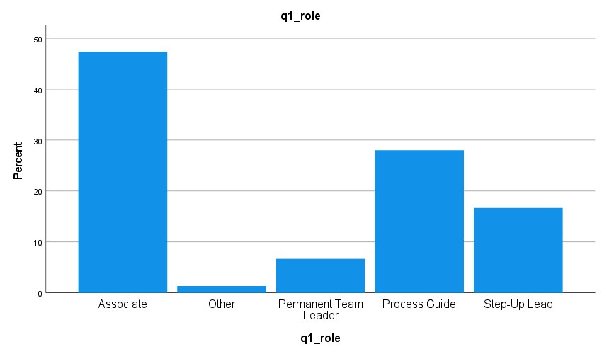

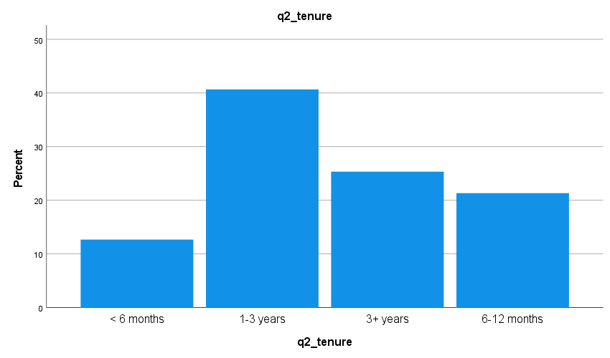

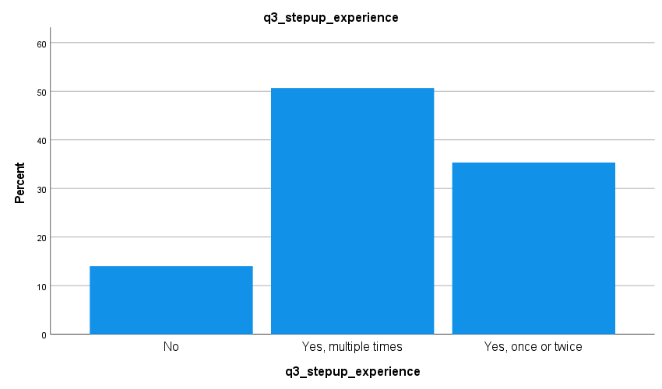

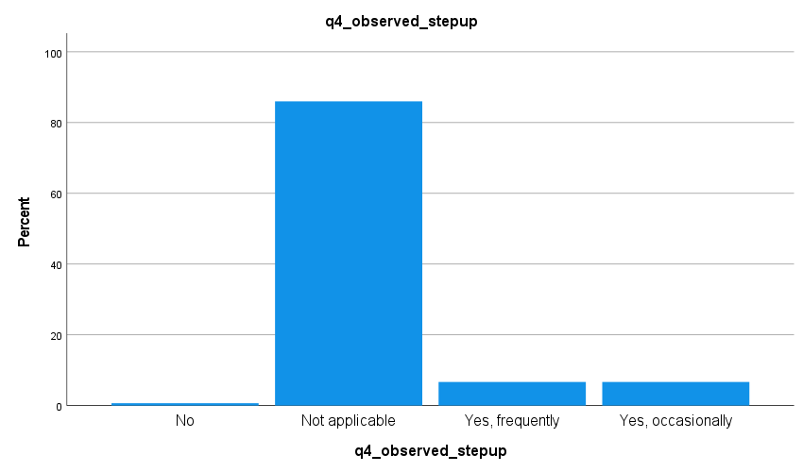

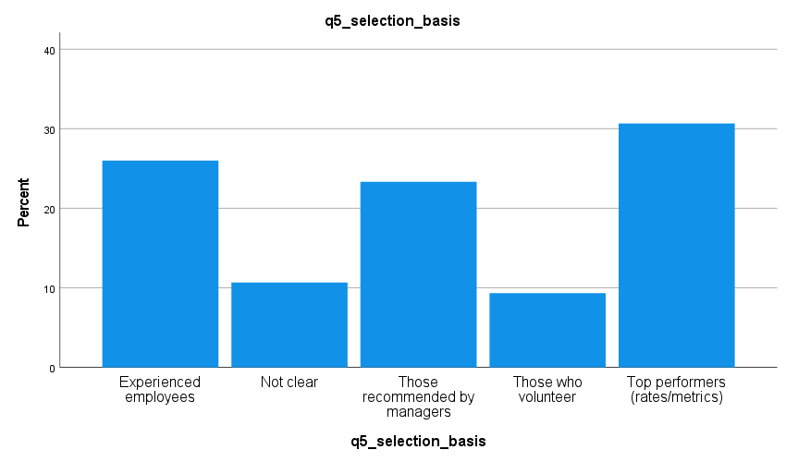

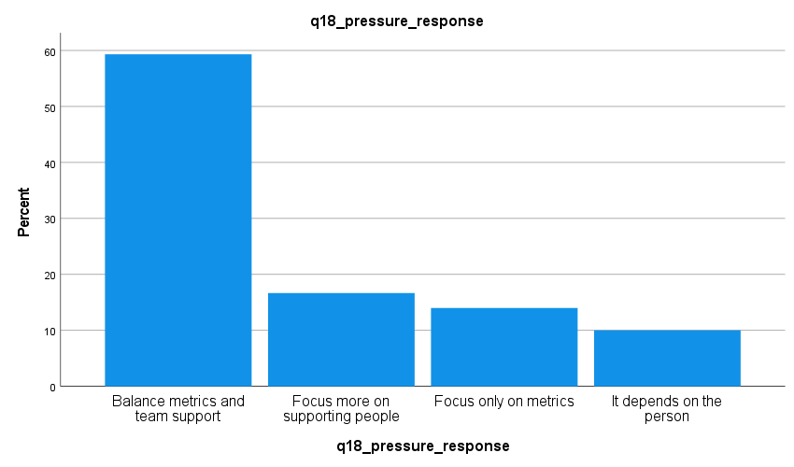

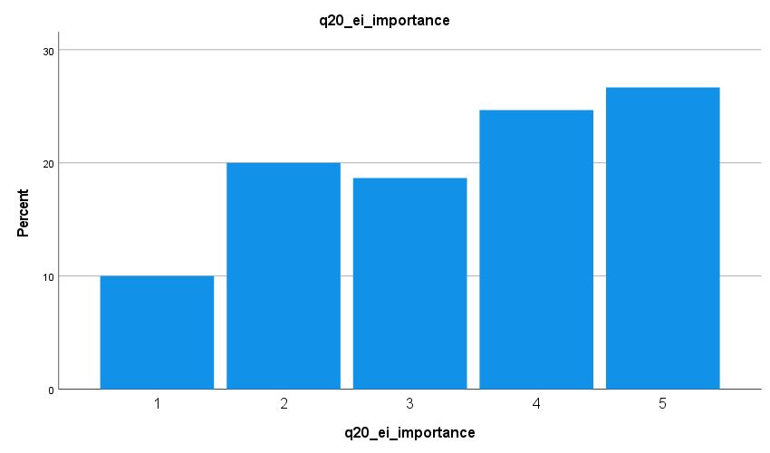

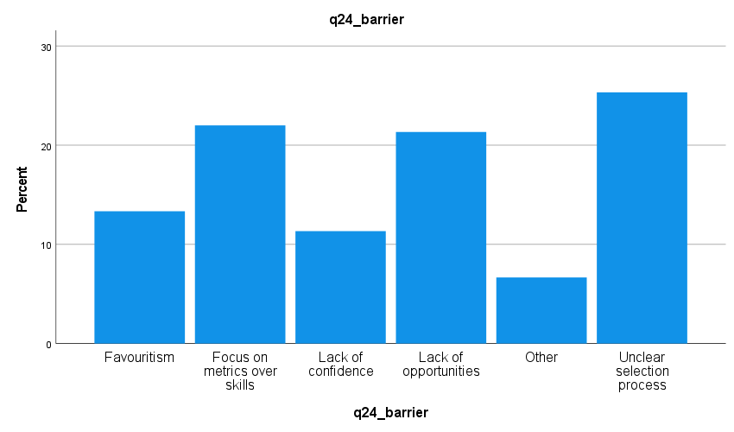

Appendix C: Additional SPSS Tables
Table C1: Observed Step-Up Experience Frequency
Category | Frequency | %
No | 1 | 0.7%
Not applicable | 129 | 86.0%
Yes, frequently | 10 | 6.7%
Yes, occasionally | 10 | 6.7%
Table C2: Regression Collinearity Statistics
Predictor | Tolerance | VIF
Access and selection | 0.617 | 1.620
Skill development | 0.763 | 1.311
Performance outcomes | 0.747 | 1.339
Leadership balance | 0.810 | 1.234
Emotional intelligence | 0.548 | 1.823

CHAPTER SEVEN: References

Abdul-Azeez, O., Ihechere, A.O. and Idemudia, C. (2024) ‘Transformational leadership in SMEs: driving innovation, employee engagement, and business success’, World Journal of Advanced Research and Reviews, 22(3), pp. 1894–1905.
Agazu, B.G., Kero, C.A. and Debela, K.L. (2025) ‘Transformational leadership and firm performance: a systematic literature review’, Journal of Innovation and Entrepreneurship, 14(1), p. 29.
Ahmad, S., Wasim, S., Irfan, S., Gogoi, S., Srivastava, A., & Farheen, Z. (2019). Qualitative v/s. quantitative research-a summarized review. population, 1(2), 2828-2832.
Al-Jaberi, M. et al. (2021) ‘Path-goal leadership styles during COVID-19’, Journal of Business Research, 137, pp. 159–170.
Amazon UK. (2025). Amazon work experience: Introducing the Step Up programme. About Amazon. Available at: https://www.aboutamazon.co.uk/news/working-at-amazon/step-up-work-experience-amazon#:~:text=The%20Step%20Up%20+%20Partner%20programme%20offers,Trust%2C%20Media%20Trust%2C%20and%20Forces%20For%20Employment. [Accessed 2 July 2025].
Amazon. (2025). Our Upskilling Commitments. About Amazon. Available at: https://www.aboutamazon.com/workplace/upskilling-commitments [Accessed 2 July 2025].
Andreoli-Versbach, P. (2024). Interplay between Amazon Store and Logistics.
https://www.tandfonline.com/doi/full/10.1080/17441056.2024.2312494
Accessed March 6, 2026.
Barkat, W., et al. (2024). Transformational Leadership and Frontline Managers’ Work Engagement.
https://www.tandfonline.com/doi/abs/10.1080/15332845.2024.2282217
Accessed March 6, 2026.
Basias, N., & Pollalis, Y. (2018). Quantitative and qualitative research in business & technology: Justifying a suitable research methodology. Review of Integrative Business and Economics Research, 7, 91-105. https://journals.sagepub.com/doi/abs/10.1177/0741713617739347?casa_token=o9mTr3wOIQAAAAAA:UhYKQHH-xCg5Nl6c-s4os4zZnBIioL2FncArrKXPdDF9UzMJsXMmc2_PVfMEaEH0CGZZ7NN2MS_S&casa_token=z6E46CA91p4AAAAA:aCVe7_AKBT8JwUAq077uVn5_lw2eooTzOu7RfKiQmJkQIRHMptQNWAgew3UKmnV5YwIagjtPGedl
Bauer, G. R., & Scheim, A. I. (2019). Methods for analytic intercategorical intersectionality in quantitative research: Discrimination as a mediator of health inequalities. Social Science & Medicine, 226, 236-245. https://www.sciencedirect.com/science/article/pii/S0277953618306889
Baur, N. (2019, June). Linearity vs. circularity? On some common misconceptions on the differences in the research process in qualitative and quantitative research. In Frontiers in Education (Vol. 4, p. 53). Frontiers Media SA. https://www.frontiersin.org/articles/10.3389/feduc.2019.00053/full
Berger, A. A. (2018). Media and communication research methods: An introduction to qualitative and quantitative approaches. Sage Publications.
Bloomfield, J., & Fisher, M. J. (2019). Quantitative research design. Journal of the Australasian Rehabilitation Nurses Association, 22(2), 27-30. https://search.informit.org/doi/abs/10.3316/INFORMIT.738299924514584
Braun, V. and Clarke, V., (2013) Successful qualitative research: A practical guide for beginners. Sage; London
Bryman, A. and Bell, E. (2015) Business research methods. Fourth edition. Cambridge, United Kingdom ; New York, NY, United States of America: Oxford University Press.
Cheng, B., et al. (2024). Promoting Employee Career Growth: The Benefits of Sustainable HRM Practices.
https://onlinelibrary.wiley.com/doi/abs/10.1111/1744-7941.12371
Accessed March 6, 2026.
Cheng, P., et al. (2025). Empowering Leadership and Frontline Employees’ Emotional Labor.
https://www.frontiersin.org/journals/psychology/articles/10.3389/fpsyg.2025.1437736/full
Accessed March 6, 2026.
Creswell, J. W., & Hirose, M. (2019). Mixed methods and survey research in family medicine and community health. Family medicine and community health, 7(2), e000086. https://pmc.ncbi.nlm.nih.gov/articles/PMC6910743/
Cretskens, I., et al. (2025). Towards an Increase in Employee Well-Being in Warehouses.
https://www.tandfonline.com/doi/abs/10.1080/00207543.2025.2560528
Accessed March 6, 2026.
Douglas, M. A., et al. (2024). People First, Mission Always: A Tension-Centered Perspective on Logistics Work.
https://onlinelibrary.wiley.com/doi/10.1111/jbl.12393
Accessed March 6, 2026.
Douglas, M. et al. (2024) ‘Leadership coordination in fulfilment operations’, Journal of Supply Chain Management, 16(3), pp. 201–219.
Douglas, M., Richards, T. and Green, J. (2024) ‘Operational leadership and employee progression within logistics environments’, International Journal of Logistics Management, 35(2), pp. 210–227.
Ekren, B. Y. (2026). Warehousing 5.0 for the Future of the Logistics Industry.
https://www.tandfonline.com/doi/full/10.1080/00207543.2026.2617791
Accessed March 6, 2026.
Fabac, R., Kokot, K. and Bubalo, I. (2022) ‘Leadership styles and employee engagement in operational workplaces’, Journal of Organizational Psychology, 18(4), pp. 112–126.
Fabac, R., Kokot, K. and Bubalo, I. (2022) 'Path-goal theory–leadership styles and their changes during the COVID-19 pandemic', Interdisciplinary Description of Complex Systems: INDECS, 20(4), pp. 349–374.
Ferdman, B.M. (2020) ‘Inclusive leadership: the fulcrum of inclusion’, In Inclusive Leadership, pp. 3–24. Routledge.
Field, A. (2018) Discovering Statistics Using IBM SPSS Statistics. 5th edn. London: Sage.
Ghanad, A. (2023). An overview of quantitative research methods. International journal of multidisciplinary research and analysis, 6(08), 3794-3803.
Giacomelli, M., et al. (2025). An Investigation into Picking Norm Times and Well-Being.
https://www.tandfonline.com/doi/full/10.1080/00207543.2025.2564269
Accessed March 6, 2026.
Granulo, A., et al. (2024). Deployment of Algorithms in Management Tasks Reduces Employees’ Prosocial Motivation.
https://www.sciencedirect.com/science/article/pii/S0747563223004454 Accessed March 6, 2026.
Guerrero-Valle, J. (2025). Embodied Narratives of Amazon Workers: A Critical Cartography.
https://www.sciencedirect.com/science/article/abs/pii/S0016718525001964 Accessed March 6, 2026.
He, V.F., von Krogh, G. and Sirén, C. (2022) ‘Expertise diversity, informal leadership hierarchy, and team knowledge creation: a study of pharmaceutical research collaborations’, Organization Studies, 43(6), pp. 907–930.
Hersey, P., & Blanchard, K. H. (1969). Life cycle theory of leadership. Organizational Dynamics, 1(1), 35-45. https://doi.org/10.1016/0090-2616(69)90020-0
Hochbein, C., & Smeaton, K. S. (2018). An exploratory analysis of the prevalence of quantitative research concepts in journal articles. International Journal of Education Policy and Leadership, 13(11). https://ijepl.journals.publicknowledgeproject.org/ijepl/index.php/ijepl/article/download/765/190
Hosen, S., et al. (2024). Training & Development, Career Development, and Work Performance.
https://www.sciencedirect.com/science/article/pii/S240584402311111X
Accessed March 6, 2026.
House, R. J. (1971). A Path-Goal Theory of Leader Effectiveness. Administrative Science Quarterly, 16(3), 321-339. https://doi.org/10.2307/2391905
Itesa, U. and Burchell, J. (2025) ‘Leadership styles and flexible work arrangements as determinants of turnover intention for IT professionals’, Business Management Research and Applications: A Cross-Disciplinary Journal, 4(1).
Jain, N. (2021). Survey versus interviews: Comparing data collection tools for exploratory research. The Qualitative Report, 26(2), 541-554. https://search.proquest.com/openview/6bbd0e7f4fcb5c2b0b1f1a9f52506d21/1?pq-origsite=gscholar&cbl=55152&casa_token=1CagIimCDzAAAAAA:mtMx4jRDh0C4UImZWqCmP7WkNy6RSnML_leCYOru80Q0DYdC_ljoxsiNysh7xnSXZ4Y3SzO9
Jameel, A., et al. (2025). The Influence of Supportive Leadership on Employees’ Innovative Work Behavior.
https://www.frontiersin.org/journals/psychology/articles/10.3389/fpsyg.2025.1565408/full Accessed March 6, 2026.
Jamieson, M. K., Govaart, G. H., and Pownall, M. (2023). Reflexivity in quantitative research: A rationale and beginner's guide. Social and Personality Psychology Compass, 17(4), e12735. https://compass.onlinelibrary.wiley.com/doi/abs/10.1111/spc3.12735
Jo, H. and Shin, D. (2025) ‘The impact of recognition, fairness, and leadership on employee outcomes: a large-scale multi-group analysis’, PloS One, 20(1), p. e0312951.
Junaedi, E. and Ali, J. (2025) ‘The Influence of Situational Leadership Style and Work Orientations on Employee Performance in Jakarta Islamic Banking Industry’, ITQAN: Journal of Islamic Economics, Management, and Finance, 4(1), pp.11-22.
Jung, J. H., et al. (2024). The Interactive Influence of Frontline Employee Motivational Orientation on Work Outcomes.
https://journals.sagepub.com/doi/abs/10.1177/10946705231190012
Accessed March 6, 2026.
Kim, J.K., Yang, J.J. and Lee, Y.K. (2023) ‘The impact of transformational leadership on service employees in the hotel industry’, Behavioral Sciences, 13(9), p. 731.
Kittel, A.F., Kunz, R.A. and Seufert, T. (2021) ‘Self-regulation in informal workplace learning: influence of organizational learning culture and job characteristics’, Frontiers in Psychology, 12, p. 643748.
Kittur, J. (2023). Conducting Quantitative Research Study: A Step-by-Step Process. Journal of Engineering Education Transformations, 36(4), 100-112. https://sciresol.s3.us-east-2.amazonaws.com/srs-j/jeet/pdf/Volume-36/Issue-4/Final%20Mrge%20JEET%20April%202023-101-113.pdf
Kumar, R., (2019) Research methodology: A step-by-step guide for beginners. Sage Publications Limited.
Laubengaier, D. A., et al. (2025). The Role of Formal and Informal Learning in Developing an Organizational Learning Culture.
https://www.tandfonline.com/doi/full/10.1080/08956308.2025.2534317
Accessed March 6, 2026.
Liu, T., et al. (2025). Employee Leadership Emergence and Informal Leader Innovative Behavior.
https://pmc.ncbi.nlm.nih.gov/articles/PMC12024018/
Accessed March 6, 2026.
Macf, C., et al. (2023). The Spillover Effect of Emotional Labor: How It Shapes Frontline Employee Outcomes.
https://journals.sagepub.com/doi/10.1177/21582440231191791 Accessed March 6, 2026.
Matthews, B., and Ross, L. (2014). Research methods. Pearson Higher Ed.
Mehner, L., et al. (2025). How to Maximize the Impact of Workplace Training.
https://www.tandfonline.com/doi/full/10.1080/1359432X.2024.2319082
Accessed March 6, 2026.
Miller, J. W. (2024). Job Gain and Job Loss Dynamics in the Truck Transportation Sector.
https://onlinelibrary.wiley.com/doi/10.1111/jbl.12391
Accessed March 6, 2026.
Mitchell, A., & Education, A. E. (2018, July). A review of mixed methods, pragmatism and abduction techniques. In Proceedings of the European Conference on Research Methods for Business & Management Studies (pp. 269-277). https://books.google.com/books?hl=en&lr=&id=gU9mDwAAQBAJ&oi=fnd&pg=PA269&dq=quantitative+research+method+survey&ots=Evf0cZiWR1&sig=rj7syxE8N1Jt76SduSmPswR5FPM
Mitschelen, A., et al. (2025). Workplace Learning During Organizational Onboarding.
https://www.frontiersin.org/journals/organizational-psychology/articles/10.3389/forgp.2025.1569098/full
Accessed March 6, 2026.
Mohajan, H. K. (2018). Qualitative research methodology in social sciences and related subjects. Journal of economic development, environment and people, 7(1), 23-48. https://www.ceeol.com/search/article-detail?id=640546
Mohajan, H. K. (2020). Quantitative research: A successful investigation in natural and social sciences. Journal of economic development, environment and people, 9(4), 50-79. https://www.ceeol.com/search/article-detail?id=939590
Mphaluwa, G., et al. (2025). How Do Leadership Styles Influence Employee Engagement and Work Outcomes?
https://www.nature.com/articles/s41599-025-05707-w Accessed March 6, 2026.
Mphaluwa, P., Daniels, S. and Ncube, T. (2025) ‘Emotional intelligence and informal leadership development in warehouse operations’, Journal of Workplace Learning, 37(1), pp. 41–58.
Nardi, P. M. (2018). Doing survey research: A guide to quantitative methods. Routledge.
Nguyen, C. N., et al. (2023). Frontline Employees’ Turnover Intentions in Tourism and Hospitality: A Systematic Review and Future Research Agenda.
https://www.sciencedirect.com/science/article/pii/S2211973623001253
Accessed March 6, 2026.
Nguyen, G. T., et al. (2025). Employee Informal Coaching and Job Performance in Higher Education: The Role of Perceived Organizational Support and Transformational Leadership.
https://journals.plos.org/plosone/article?id=10.1371%2Fjournal.pone.0320577
Accessed March 6, 2026.
Nguyen, H., Tran, P. and Vo, M. (2025) ‘Leadership transition and emotional labor within operational teams’, Leadership and Organization Development Journal, 46(2), pp. 144–159.
Nilsson, K. H., et al. (2025). Algorithmic Management and Occupational Health.
https://www.sciencedirect.com/science/article/pii/S0925753525000888
Accessed March 6, 2026.
Nilsson, K. H., et al. (2025). Algorithmic Management Is Associated with Psychological Distress and Other Health Outcomes.
https://pmc.ncbi.nlm.nih.gov/articles/PMC12672710/
Accessed March 6, 2026.
Noyes, J., Booth, A., Moore, G., Flemming, K., Tunçalp, Ö., & Shakibazadeh, E. (2019). Synthesising quantitative and qualitative evidence to inform guidelines on complex interventions: clarifying the purposes, designs and outlining some methods. BMJ global health, 4(Suppl 1), e000893. https://gh.bmj.com/content/4/Suppl_1/e000893.abstract
Noyes, J., Booth, A., Moore, G., Flemming, K., Tunçalp, Ö., & Shakibazadeh, E. (2019). Synthesising quantitative and qualitative evidence to inform guidelines on complex interventions: clarifying the purposes, designs and outlining some methods. BMJ global health, 4(Suppl 1), e000893. https://gh.bmj.com/content/4/Suppl_1/e000893.abstract
Pallant, J. (2020). SPSS survival manual: A step by step guide to data analysis using IBM SPSS
Qi, L., et al. (2025). How and When Does Front-Line Employees’ Emotional Intelligence Influence Service Creativity?
https://journals.sagepub.com/doi/10.1177/19389655251341172
Accessed March 6, 2026.
Rai, A., et al. (2024). How Supportive and Challenging Behaviors of Leaders Influence Employee Thriving at Work.
https://www.sciencedirect.com/science/article/abs/pii/S0148296323007981
Accessed March 6, 2026.
Rozmysłowicz, M. (2023). A Case Study of Practices at Amazon Warehouses in Poland.
https://illej.unibo.it/article/view/18084
Accessed March 6, 2026.
Saunders, M., Lewis, P. and Thornhill, A. (2015) Research methods for business students. 7th Ed. New York: Pearson Education.
Schinnenburg, H., et al. (2025). Re-Focusing Talent Management: Frontline and Essential Workers.
https://www.sciencedirect.com/science/article/pii/S1053482225000154
Accessed March 6, 2026.
Schinnenburg, H., Weber, A. and Keller, J. (2025) ‘Workplace mentoring and employee career progression’, Human Resource Development International, 28(1), pp. 70–89.
Schukajlow, S., Kaiser, G., & Stillman, G. (2018). Empirical research on teaching and learning of mathematical modelling: A survey on the current state-of-the-art. ZDM, 50, 5-18.
Shabbir, M., et al. (2025). Front-Line Employee Attitudes and Their Turnover Intentions: Role of Affective Commitment and Job Satisfaction.
https://fujbe.fui.edu.pk/index.php/fujbe/article/view/1066
Accessed March 6, 2026.
Solomon, M. R., and Mrad, M. (2022). Fashion and luxury marketing. Sage. https://books.google.com/books?hl=enandlr=andid=BX1lEAAAQBAJandoi=fndandpg=PP1anddq=Burberry,+Primark,+ASOS,+Next,+Clarks+lack+of+sustainabilityandots=mOU5i-3UBPandsig=72Y3bvIbHDx6OsPyG8CKgU4Kwaw
Stockemer, D., Stockemer, G., & Glaeser, J. (2019). Quantitative methods for the social sciences (Vol. 50, p. 185). Cham, Switzerland: Springer International Publishing. https://link.springer.com/content/pdf/10.1007/978-3-319-99118-4.pdf
Sürücü, L., & Maslakci, A. (2020). Validity and reliability in quantitative research. Business & Management Studies: An International Journal, 8(3), 2694-2726.
Taherdoost, H. (2022). What are different research approaches? Comprehensive review of qualitative, quantitative, and mixed method research, their applications, types, and limitations. Journal of Management Science & Engineering Research, 5(1), 53-63. https://hal.science/hal-03741840/document
Theodore, N. (2025). The E-Commerce Labour Regime: Amazon and Beyond.
https://www.scienceopen.com/hosted-document?doi=10.13169%2Fworkorgalaboglob.19.2.0011
Accessed March 6, 2026.
Thomas, G. (2017). How to do your research project: A guide for students. Sage.
Usman, M., & Garavan, T. (2026). Responsible Leadership and Front-Line Employees’ Career Commitment: The Roles of Status Striving and Perceptions of Developmental HRM Practices.
https://www.tandfonline.com/doi/abs/10.1080/09585192.2026.2626341
Accessed March 6, 2026.
Vallas, S. (2023) ‘Workplace control and informal leadership in Amazon warehouses’, Work, Employment and Society, 37(5), pp. 1180–1197.
Vallas, S. P. (2023). How Workers Respond to Amazon’s Production Regime.
https://journals.sagepub.com/doi/10.1177/23780231231216286
Accessed March 6, 2026.
von Eben-Worlée, H., et al. (2025). Careers of Supply Chain Executives: Insights, Unknowns, and Future Directions.
https://onlinelibrary.wiley.com/doi/full/10.1111/jbl.70024 Accessed March 6, 2026.
Xuecheng, W., Iqbal, S. and Saina, B. (2022) ‘Leadership adaptability and operational performance in fulfilment centers’, Journal of Business Research, 144, pp. 522–531.
Yao, W., et al. (2025). Can Employee Training Stabilise the Workforce of Frontline Employees?
https://www.mdpi.com/2075-5309/15/2/183
Accessed March 6, 2026.
Zayid, H., et al. (2024). How Do Algorithmic Management Practices Affect Workforce Well-Being?
https://www.mdpi.com/2076-328X/14/12/1123
Accessed March 6, 2026.
Zhang, M. M., et al. (2025). The Rise of Algorithmic Management and Implications for Work and Employment.
https://onlinelibrary.wiley.com/doi/10.1111/ntwe.12343
Accessed March 6, 2026.
Zhang, Y., et al. (2025). The Influence of Customer Gratitude Expression on Frontline Employees’ Career Growth.
https://journals.sagepub.com/doi/abs/10.1177/21582440251356031
Accessed March 6, 2026.
Zhang, Y., Li, M. and Carter, D. (2025) ‘Algorithmic management and employee leadership opportunities in warehouse environments’, New Technology, Work and Employment, 40(1), pp. 88–105.
Zheng, F., Kumar, A. and Lee, J. (2025) ‘Performance culture and career progression in e-commerce logistics’, International Journal of Human Resource Studies, 15(2), pp. 97–114.
Zheng, T., Glock, C., & Neumann, P. (2025). Human Robot Collaboration in Warehousing Operations: A Sociotechnical Analysis.
https://www.sciencedirect.com/science/article/pii/S2405896325012066
Accessed March 6, 2026.
Zhu, M., Sari, A., & Lee, M. M. (2018). A systematic review of research methods and topics of the empirical MOOC literature (2014–2016). The Internet and Higher Education, 37, 31-39. https://www.sciencedirect.com/science/article/pii/S1096751617304657

