Table of Contents
Introduction 2
Main Body 3
Sustainable Development 3
Natural ecosystems: Past the point of no return 3
Affluence 3
Overpopulation 5
Conclusion 8
Recommendations 8
Bibliography 9

Introduction
Humanity is currently facing unprecedented challenges, from the cost-of-living crisis to global warming, and if these challenges are not dealt with correctly, they could have a serious adverse effect on humanity's future. The World Economic Forum (WEF) (2023) has compiled a list of humanity's ten most serious risks in the next decade. The risks originate from different sectors and are categorised into five different categories; these are economic, environmental, geopolitical, societal and technological. The risk category that poses the most substantial risk, according to WEF (2023) is environmental. Environmental factors account for six of the ten leading global risks, with societal accounting for two and geopolitical and technological accounting for one each. Not only are the environmental risks the most prevalent risks in the top 10 they are also the most severe. As seen in Figure 1, the four most severe risks are all environmental.
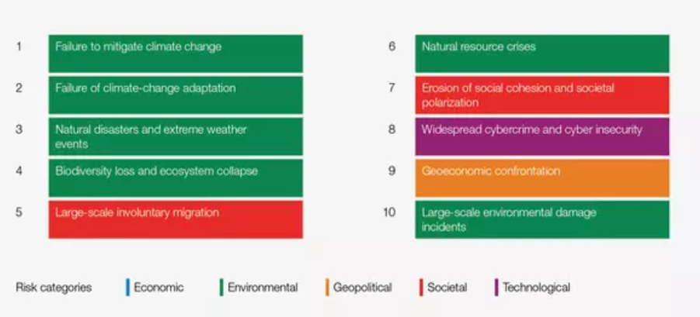
Figure 1 - Global risks ranked by severity over the next ten years (WEF, 2023)

This report aims to evaluate and further investigate the risks identified in the report published by WEF, determine their causes, and evaluate them using leading economic theories to recommend the most suitable action to prevent these risks from becoming a reality. The cause of many of these risks and the primary debate between leading theorists, is centred around the finite materials on Earth and the rate at which these resources are being consumed. The overarching theories that will be discussed in this report are the Malthusian, neo-Malthusian and neoclassical economic theories.

Main Body

Sustainable Development
Sustainable Development is crucial for the prosperity of future generations. According to the Brundtland Commission (1987), “Sustainable development is a development that meets the needs of the present without compromising the ability of future generations to meet their own needs” (p.41). In an effort to combat the current ever-growing risks to humanity, the 2030 Agenda for Sustainable Development was introduced. At the heart of the 2030 Agenda is the 17 Sustainable Development Goals (SDGs). These are a set of goals introduced to “end poverty, protect the planet and improve the lives and prospects of everyone, everywhere” (United Nations, n.d., para. 1). The 17 goals were introduced in 2015 and were the heart of the 2030 Agenda which set out a 15-year plan to achieve the 17 SDGs by 2030 (United Nations, n.d.). Sustainable development is also viewed as the equity between generations (intergenerational equity). Sustainable development requires the use of resources that can be replenished like for like and relies on the premise that economic growth and environmental quality must not be competing goals. The 17 SDGs are all linked to either resource scarcity prevention, limiting Gross Domestic Product (GDP) growth and population management, all of which link back to the Malthusian and Neoclassical economic theories.

Natural ecosystems: Past the point of no return
As previously mentioned, the most significant risks over the next decade are environmental. Six of the ten greatest global risks are environmental, which highlights the current damage and potential for further damage to the environment. This also signifies the need to be more sustainable and responsible going forward. The risk with the perceived highest severity is the failure to mitigate climate change. According to the Met Office (2023), rising global temperatures will have serious repercussions for both humanity and nature due to its effect on climate systems globally. Some examples of the effects climate change will have on climate systems include warmer environments, melting ice and glaciers, rising sea levels and more severe weather events. These changes in climate systems will also cause a loss of biodiversity, damage to water supplies and infrastructure and also deplete food resources (Met Office, 2023).

Affluence

According to the United Nations (n.d.-a), there are seven main contributors to climate change. These are generating power and manufacturing goods using fossil fuels, deforestation, transportation, food production, fossil fuel-powered energy for homes and overconsumption. According to the United Nations (n.d.-a), one of the main problems is affluence, with the top 1% wealthiest people in the world accounting for more greenhouse gas emissions than the poorest 50% combined. Many studies argue that the primary contributors to negative global impacts are technological change as well as per-capita consumption (Haberl et al., 2020). The increase in per capita consumption has grown at a rate whereby the positive effects created by improved technology are unable to outweigh the negative effects of consumption (Weidmann et al., 2020). Findings showed that staggeringly the top 0.54% of the wealthiest people globally account for more lifestyle-related greenhouse gas emissions (14%) compared to the bottom 50% of earners (10%) (Otto et al., 2019). Weidmann et al. (2020) also found that the top 10% of earners globally account for between 25 and 43% of the overall negative environmental impact. These statistics highlight the effect that affluence has on environmental damage.

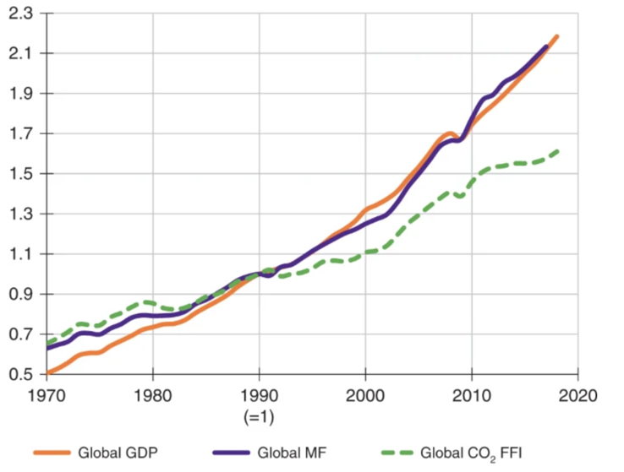
Figure 2 - Relative change in main global economic and environmental indicators from 1970 to 2017 (Wiedmann et al., 2020)
These findings somewhat disprove the neoclassical theory of the Kuznets curve. This theory argues that improved economic growth is in fact beneficial for the environment. In comparison, the Ehrlich-commoner model, a neo-Malthusian theory has a contrasting view, which states that increasing population (P), affluence (A) and technology (T) all play a role in the damage to the environment (I), I=PAT. This Ehrlich-commoner model was based on the theory created by Paul Ehrlich, who believed that the sole contributor to resource depletion and environmental degradation was the increasing population (Holdren, 2016). Barry Commoner refuted this claim, despite acknowledging the role population growth had to play in resource depletion and environmental degradation, he believed that modern technology and affluence also played a significant role in the damage to the environment (Holdren, 2016).

As shown in Figure 2, there is a clear correlation between an increase in global GDP with an increase in global material footprint (MF) and CO2 emissions from fossil fuels. Despite this correlation, the rate at which pollutants are being exerted is reducing compared to GDP growth, thus the Kuznets curve could prove to be true if CO2 emissions continue to decline at a faster rate than GDP. If the point is reached whereby the pollutants eventually begin to decrease while GDP continues to increase the Kuznets Curve could become a reality. One of the criticisms of the curve is that it does not look at the pollutants we face today, however, it can still be applied and may well become a reality.

According to Haberl et al. (2020), the current benefits of technological advancements in reducing emissions and overall environmental impacts are outweighed by the negatives of affluence. The growth in affluence globally is increasing at a faster rate compared to the environmental benefits that new technology provides. It is anticipated that this trend is unlikely to change in the future, especially as new technologies also have their own negative impacts on the environment (Weidmann et al., 2020). O’Connor (2015) also states energy efficiency provided by new technologies does not necessarily lead to reduced emissions; however, it does provide the resources needed to improve our energy supply. To calculate the true energy savings, the rebound effect must be utilised. The rebound effect looks at the direct rebound effect of energy savings as well as the indirect rebound effect. The indirect rebound effect looks at how the money that is saved is subsequently spent. The money saved could be spent on something that harms the environment as a result of its production, thus the initial savings are made redundant (O’Connor, 2015). This method will provide a true representation of the benefits that improved technology will have on environmental health.

Overpopulation

Another factor leading to resource scarcity and environmental degradation is the ever-growing population (Maja & Ayano, 2021). Due to the continually increasing population and limited resources available, resource scarcity and the degradation of the Earth's ecosystems are inevitable unless suitable measures are implemented (Bretschger, 2013). Resource scarcity and population growth are considered to be connected and both must be addressed, alongside the continuous risk of climate change (Maja & Ayano, 2021). The global population reached 8 billion in November 2022, up from 2.5 billion in the 1950s and is expected to continually increase to its peak of 10.4 billion in the 2080s (United Nations, 2022). According to Maja and Ayano (2013), the growing population means there is greater demand for resources which means that not only will there will be a reduction in the quantity but also the quality of these natural resources. These issues will be more significant in higher populated countries due to overexploitation and more intensive farming (Maja & Ayano, 2013).

Thomas Malthus’ theory supports the belief that the increasing population is linked with resource scarcity. The Malthusian theory states that the food supply will deplete because the population is growing faster than the resources can be replenished (Unat, 2020). Malthus believed that food growth was linear and the population would grow exponentially (De Sherbinin et al., 2007). Malthus recognised that as the population increases, the output also increases until the point at L1 is reached, which is the optimum between population and output (De Sherbinin et al., 2007). After this point, the returns are diminishing, until eventually the point at L2 is reached, which is the Malthusian trap. This is the point whereby there are not enough resources to supply the population unless measures are implemented to counteract this.
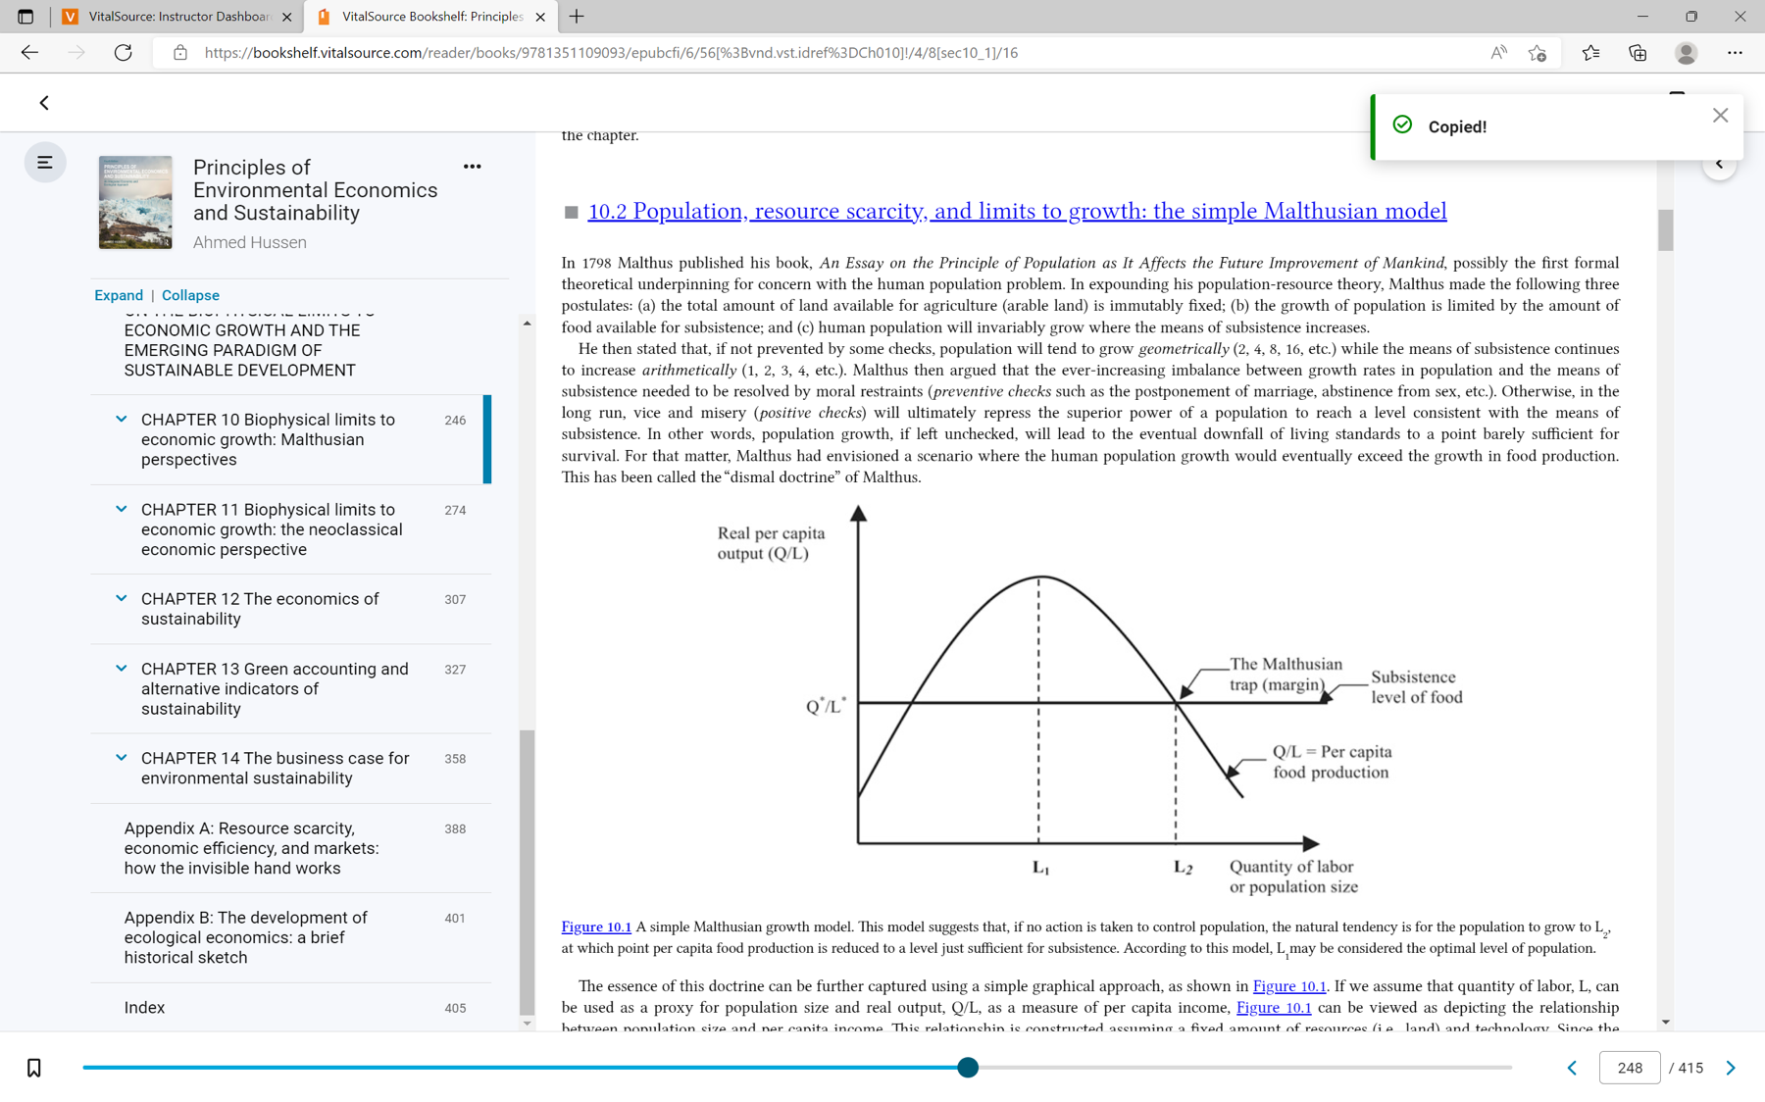
Figure 3 - The Malthusian Theory
High birth rates and an increasing population could cause a reduction in resources as stated by the Malthusian theory. However, there are some criticisms of this theory, mainly the that the theory overlooks the fact that we are continually monitoring the population and implementing measures accordingly, such as more readily available contraception (Liu & Raftery, 2020). For example, in El Salvador, there was an evident link between the increase in access to contraception with the reduction in fertility rates. Liu and Raftery (2020) found that birth rates in Salvador decreased from 5.44 births per woman in the 1970s when just 28% of women were using contraception, compared to 2.27 births per woman when 61% of women were using contraception. Another factor that the Malthusian theory failed to consider was the fact that women would become more educated which also contributed to the decrease in fertility rates (Liu & Raftery, 2020).

According to Kim (2016), educated women have lower fertility rates than non-educated women. This is down to various factors, including that educated women are more physically able to birth a child and also want fewer children due to their career aspirations. Educated women can also provide their children with better care at home, which leads to the child having better overall health, leading to lower mortality rates and subsequently reducing the need to have more children. It was also discovered that at the early stages of a country's development, women that had been educated would utilise modern contraceptive measures more often than non-educated women (Kim, 2016). An example of these findings is shown in Taiwan, whereby the government made it compulsory for children to attend school up until aged nine, up from age six previously. It was found that an increase in maternal education by just one year decreased the infant mortality rate between 7 and 9% (Chou et al., 2010).

These findings are supported by the theory of demographic transition, which states that growth can help combat a nation's overpopulation. Statistics tend to support the theory of demographic transition, for example, the United States and the United Kingdom both have fertility rates of 1.6, whereas less developed countries such as Niger and Somalia have birth rates of 6.9 and 6.4 respectively (The World Bank, 2022). According to Nargund (2009), developed countries tend to have lower birth rates due to the superior health care available which in turn requires people to have fewer children as the mortality rate is lower. In more developed countries children are also seen as more of an economic burden, and within more developed countries many people are more focused on their professional careers and thus have children later on in life. The opportunity to focus on a career or access to health care is often limited in less developed countries (Nargund, 2009). Based on these findings it could be argued that development could in fact reduce population growth, which supports the theory of demographic transition.

Another problem that a growing population has is increased consumption. This requires more land to be used for agricultural and fossil fuel mining purposes. According to the Food and Agriculture Organisation (2020), five billion hectares of the Earth's land is used for agricultural purposes, which equates to 38% of the global land surface and with an increasing population this figure is likely to increase, causing a greater loss to biodiversity and greater harm to ecosystems. According to the World Wildlife Fund (WWF) (n.d.), agriculture is the leading source of pollution in many countries worldwide, not just because of CO2 emissions but also from pesticides, fertilizers as well as other chemicals. Agriculture also has a huge impact on water quality globally. The agriculture sector consumes nearly 70% of the planet's freshwater, and increased agriculture will lead to further water quality degradation and excessive water use. 75% of people below the poverty line also rely on agriculture as a source of income, this alongside subsidies provided by governments means producers are expanding further into untouched land causing greater biodiversity loss. Regarding climate change, the livestock sector alone is estimated to be accountable for 18% of all greenhouse emissions, this alongside deforestation are significant contributors to climate change (WWF, n.d.).

Conclusion
In conclusion, environmental risks pose the greatest threat to mankind as identified by the WEF. All of the environmental threats identified by the WEF are the result of human activity. The release of harmful pollutants into the atmosphere alongside increased demand for natural resources has caused environmental degradation and increased resource scarcity. Overpopulation increases the demand for finite resources such as fertile land and fossil fuels, however, economic growth and affluence also play a role in the degradation of natural resources and environmental ecosystems. Unless appropriate measures are adhered to, then it will not be possible to achieve the 17 SDGs, and the environmental risks identified by the WEF will be inevitable.

Recommendations
- The first proposed solution is to introduce a scheme whereby countries with high GDPs must be required to pay a tax to counteract their damage to the environment. The higher the GDP the greater the tax. The revenue from these taxes should then be put towards sustainable development, for example investing in new technologies such as renewable energy sources.

- The second proposed recommendation is to provide subsidies to people that are over-reliant on agriculture as a source of income. This in turn will prevent agriculture from being their only source of income, which will lead to less farming and less farmed land. This will help to preserve biodiversity, reduce climate change and maintain healthy freshwater systems.

- The final recommendation is to further support developing countries, focusing primarily on fertility rates as well as sustainable agriculture. High fertility rates and an over-reliance on agriculture are evident in developing countries, therefore, measures must be implemented to combat these issues. Education and financial support must be provided for local farmers to enable them to farm more sustainably. Education and contraception also need to be readily available for people in LDCs to help control the population. Alongside this, better healthcare infrastructure needs to be implemented in LDCs to reduce the child mortality rate.

Bibliography
Bretschger, L. (2013). Population Growth and Natural-Resource Scarcity: Long-Run Development under Seemingly Unfavourable Conditions. The Scandinavian Journal of Economics, 115(3), 722–755. https://doi.org/10.1111/sjoe.12017
Brundtland Commission. (1987). Report of the World Commission on Environment and Development: Our Common Future. In United Nations. United Nations. Retrieved May 5, 2023, from https://sustainabledevelopment.un.org/content/documents/5987our-common-future.pdf
Chou, S., Liu, J., Grossman, M., & Joyce, T. (2010). Parental Education and Child Health: Evidence from a Natural Experiment in Taiwan. American Economic Journal: Applied Economics, 2(1), 33–61. https://doi.org/10.1257/app.2.1.33
De Sherbinin, A., Carr, D., Cassels, S., & Jiang, L. (2007). Population and Environment. Annual Review of Environment and Resources, 32(1), 345–373. https://doi.org/10.1146/annurev.energy.32.041306.100243
Food and Agriculture Organisation. (2020, May 7). Land use in agriculture by the numbers. Food and Agriculture Organization of the United Nations. Retrieved May 8, 2023, from https://www.fao.org/sustainability/news/detail/en/c/1274219/
Haberl, H., Wiedenhofer, D., Virág, D., Kalt, G., Plank, B., Brockway, P. E., Fishman, T., Hausknost, D., Krausmann, F., Leon-Gruchalski, B., Mayer, A., Pichler, M., Schaffartzik, A., Sousa, T., Streeck, J., & Creutzig, F. (2020). A systematic review of the evidence on decoupling of GDP, resource use and GHG emissions, part II: synthesizing the insights. Environmental Research Letters, 15(6), 065003. https://doi.org/10.1088/1748-9326/ab842a
Holdren, J. P. (2016). Brief History of IPAT. The Journal of Population and Sustainability, 2(2), 66–74. https://doi.org/10.3197/jps.2018.2.2.66
Kim, J. (2016). Female education and its impact on fertility. IZA World of Labor. https://doi.org/10.15185/izawol.228
Liu, D., & Raftery, A. (2020). How Do Education and Family Planning Accelerate Fertility Decline? Population and Development Review, 46(3), 409–441. https://doi.org/10.1111/padr.12347
Maja, M. M., & Ayano, S. F. (2021). The Impact of Population Growth on Natural Resources and Farmers’ Capacity to Adapt to Climate Change in Low-Income Countries. Earth Systems and Environment, 5(2), 271–283. https://doi.org/10.1007/s41748-021-00209-6
Met Office. (2023). Effects of climate change. Retrieved May 1, 2023, from https://www.metoffice.gov.uk/weather/climate-change/effects-of-climate-change
Nargund G. (2009). Declining birth rate in Developed Countries: A radical policy re-think is required. Facts, views & vision in ObGyn, 1(3), 191–193. Retrieved May 8, 2023, from https://www.ncbi.nlm.nih.gov/pmc/articles/PMC4255510/#:~:text=The%20social%20structure%2C%20religious%20beliefs,rates%20are%20low%2C%20birth%20control
O’Connor, P. (2015, November 5). What is the Rebound Effect? — Energy Efficiency, Part 2. The Equation. https://blog.ucsusa.org/peter-oconnor/energy-efficiency-what-is-the-rebound-effect-946/
Otto, I. M., Kim, K. M., Dubrovsky, N., & Lucht, W. (2019). Shift the focus from the super-poor to the super-rich. Nature Climate Change, 9(2), 82–84. https://doi.org/10.1038/s41558-019-0402-3
Rodrigues, J. (2015, October 29). How China’s one-child policy ended in failure. The Guardian. Retrieved May 1, 2023, from https://www.theguardian.com/world/from-the-archive-blog/2015/oct/29/china-one-child-policy-failure-archive-1979-2016
The World Bank. (2022). Fertility rates, total (births per woman). World Bank Open Data. Retrieved May 8, 2023, from https://data.worldbank.org/indicator/SP.DYN.TFRT.IN?end=2020&most_recent_value_desc=true&start=1960&view=chart
Unat, E. (2020). A review of Malthusian theory of population under the scope of human capital. Focus on Research in Contemporary Economics (FORCE), 1(2), 132-147. Retrieved from https://www.forcejournal.org/index.php/force/article/view/14
United Nations. (2022). Population: Our growing population. Retrieved April 29, 2023, from https://www.un.org/en/global-issues/population
United Nations. (n.d.-a). Causes and Effects of Climate Change | United Nations. https://www.un.org/en/climatechange/science/causes-effects-climate-change#:~:text=Fossil%20fuels%20%E2%80%93%20coal%2C%20oil%20and,of%20all%20carbon%20dioxide%20emissions.
United Nations. (n.d.). The Sustainable Development Agenda. Retrieved May 5, 2023, from https://www.un.org/sustainabledevelopment/development-agenda/
Wiedmann, T., Lenzen, M., Keyßer, L. T., & Steinberger, J. (2020). Scientists’ warning on affluence. Nature Communications, 11(1). https://doi.org/10.1038/s41467-020-16941-y
World Economic Forum. (2023). The Global Risks Report 2023. Retrieved April 28, 2023, from https://www3.weforum.org/docs/WEF_Global_Risks_Report_2023.pdf
WWF. (n.d.). Impact of Sustainable Agriculture and Farming Practices. World Wildlife Fund. Retrieved May 8, 2023, from https://www.worldwildlife.org/industries/sustainable-agriculture#:~:text=Agriculture%20is%20the%20leading%20source,in%20the%20environment%20for%20generations.

