EFFECTIVE TEAM WORKING AND COMMUNICATION
(BMSW4002_LON)
Student Name: Gratiela Beatrice Anghel
Student ID: 1921637
University of Wales Trinity Saint David
Teacher name: Saqib Shamim

MODELS OF COMMUNICATION AND COMMUNICATION SKILLS

- Models of communications:
Definition: Models of communication are the ways with you can communicate with someone and to explain someone your ideas and what you are thinking and the human feelings. (Steven, 2018)
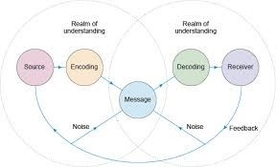
Fig. 1
(https://www.open.edu/openlearn/money-business/business-strategy-studies/retail-marketing/content-section-3.2)
According to George Bernard (n.d.), effective communication means that two people speaking (sender and receiver) understand each other. These refer to how we transmit information, what feelings we express and ideas, information. You can clearly convey the information you want and say, and so you can complete a conversation in which both people understand each other, and everything goes well.
Effective communication is when both parties (transmitter and receiver) have understood each other’s ideas, information. It usually happens that we miss the information, and the conversation is not exactly what we expected. We can say information, and the other person understands something else, erroneous information, and this affects both of them. This can happen not only at work, but also at school, at meetings, even as a couple, this can happen everywhere if we are not careful. Then the poor communication will be, but we will talk about this a little below. (Bernard, n.d.)
Many of us believe that efficient communication is not so easy, so they need someone to help them learn to communicate to avoid any problems. The moment yiu try to strike up an effective and clear conversation with anyone, the person you are addressing could appreciate your information, can gain confidence and the discussion will go very well. (Bernard, n.d.)

According to McQuaid (2017), the influences of communication are:
- Source Effects
- Encoding Errors
- Channel Issues
- Receiver Effects
- Decoding Effects
- Feedback

- The source effects refer to the credibility that you demonstrate and share, also the attractiveness that you demonstrate in relation to the subject in question. (McQuaid, 2017)
- The coding errors are about minimizing the people to whom you are addressing. (McQuaid, 2017)
- Channel broadcasts can be verbal in that actual discussion, as well as non-verbal, which includes gestures, facial expressions.
- Decoding refers to how you as a receiver listen to what the transmitter is saying. (McQuaid, 2017)
- Receiver effects refer to how the receiver hears, understands, stores and processes the transmitter information.
- Feedback refers to the evaluation of the conversation and what opinions we have about it. (McQuaid, 2017)
According to Chris Drew (2020), there are more types of model's communication, include:
- Aristotle’s model (Drew, 2020): This scheme means a scheme to initiate your communication skills, analyzing things which creates problems.
- Lasswell’s model (Drew, 2020): This is a basic scheme for you to analyze communication characteristics by asking questions.
- Shannin-Weaver model (Drew, 2020): is among the most important communication models, which can create problems between receiver and transmitter.
- Berlo’s models (Drew, 2020): This as a type of communication that is based on four stagers: Channel, source, receiver and Message.
- Channel: It includes the senses of hearing, seeing, touching, smelling. (Drew, 2020)
- Source: This includes the sender’s communication skills and science. (Drew, 2020)
- Receiver: It includes attitude, knowledge. (Drew, 2020)
- Message: The elements of the message include content, structure and code. (Drew, 2020).
- The Westley and Maclean model (Drew, 2020): These refer to our communication which is altered by environmental, cultural and personal records.
- Berglund’s transactional model (Drew, 2020): It highlights the role of public and exclusive meanings that mark our message.
- Communication skills (Candidate, n.d.)
Definition: The ability to share feelings and thoughts effectively. (Candidate, n.d.)
According to Pharel (2018), communication skills are skills that you use when you want to follow certain instructions. Communication skills involve listening, sympathizing and speaking. (Pharel, 2018)
According to Pharel (2018), communication skills allow you to understand and be understood by others. They can add to, but are not limited to, simple communication, providing and receiving strict evaluation and public speaking.
Examples and explanations of communication skills:
- Listener
Being a good listener to the person talking to you means that you have a good communication skill. Nobody likes to talk to someone and be ignored. (Improvement, 2020).
- Nonverbal communication
Your body language, eye contact and voice accent matter a lot to the information you are trying to send to the person you are talking to. Also, beware of nonverbal warnings, they can make the person you are talking to feel uncomfortable. For example, if the person is not looking at you, it means that the person is missing something or even the truth. (Aristotle, 2019).
- Clarity and Conciseness
Good verbal communication mean respecting the other. Try to send your essay as short and to the point as possible. Say what you definitely want, whether you are talking to someone in person, on their mobile phone they will understand what you are saying. If you do not speak for a specific purpose and the person does not understand, then a communication problem will occur. (Improvement, 2020).
- Friendliness
According to Stephan (2018), in a friendly tone, a personal question, you will inspire your listener to engage in an open and decent communication with you. It is important to be polite in all your companies, at work, everywhere.
- Trust
According to Chris (2019), being positive in communication with others is a very important thing. Positivity shows to your listener that you believe what you say. Avoid speaking badly or using non-verbal communication with disrespectful gestures.
- Empathy
It is good to appreciate others and, in the team, to consider the ideas of others. Active listening can help you think about what your conversational college thinks. (Chris, 2019).
- Opening
According to Chris (2019), when two people communicate it is good for them to have an open mind. Be open to listening and sympathizing with the other person’s view.
- Respect
According to Chris (2019), people will be more open to communicating with you if you give them resect and if you appreciate their points. When talking to someone it is good to say names to get more attention.
- Opinion
According to Chris (2019), an important skill in communication is to be available to give opinions and have opinions. Employers should frequently look for ways to provide good feedback to employees.
- Poor communication (Anna Kinsey, 2019)
Definition: According to Kinsey (2019), poor communication is that communication in which the transmitter and receiver do not understand each ither in speech. This happens when the receiver or transmitter, or even both people, does not know how to communicate, uses disrespectful gestures or does not transmit their ideas to the object and precise.
I believe that in any relationship, communication is a key to a strong relationship at work. According to Kinsey (2019), this information can be accompanied by customers. Communication can be established in almost every workplace. There are several ways of poor communication in a workplace, and if not a significant number of works are needed to discover and solve them in their own business.
According to Kinsey (2019), there are poor communication problems:
- Workplace stress: At the time of care, workplace stress occurs, the employer does not produce the work at the end. Poor communication can create a feeling because the list of activities is urgent, causing you to feel stressed and overwhelmed. Caregivers are worried during the day to get stressed, which affects their families, and no one wants that. (Kinsey, 2019)
- Unmet needs and expectations: Lack of communication offers many problems at work. The teams lost the deadline, the clients lost the programs, and during the project, a project did not take care of their roles. When employees no longer know what their tasks are, then they are wrong and disappoint their employers. (Kinsey, 2019)
- Arguments and other changes related to objects: When opening messages to create an accusatory message, for growth should be worrying and stressful for this, you need to be able to learn at a managerial level. (Kinsey, 2019)
- Low morale and high turnover: When people face intense emotions, they spend more time working, but do nothing. Productivity decreases and they can no longer cope with work. (Kinsey, 2019)
- Dissatisfied customers: Dissatisfied customers may be a sign of poor communication. When workers do not follow all work policies and do not all the ok, employers will get angry, and everything is organized, and everyone does it. Work in time so that no one has to lose. (Kinsey, 2019)
- Passive-aggression and sarcasm: When you are aggressive or sarcastic at work, you can annoy the people and create problems. Instead of responding sarcastically to something you consider a problem be serious about what you think about the problem. (Kinsey, 20190
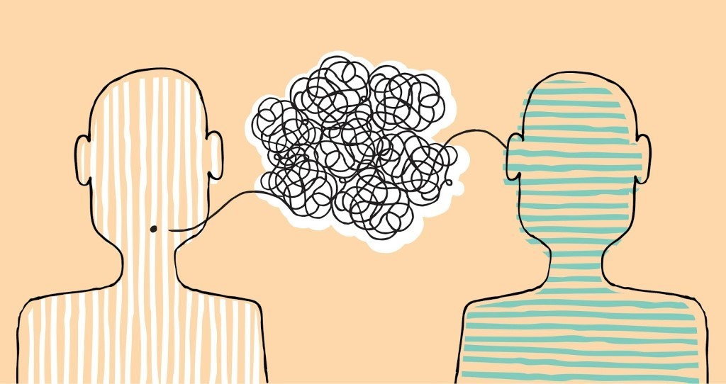
Fig. 2
(http://blog.my12stepstore.com/could-poor-communication-skills-be-thwarting-your-recovery/)

EXAMPLE OF POOR COMMUNICATIN FROM MY PERSONAL LIFE
Here is a personal example from real life.
I work as a supervisor. In my turn, I have a boss as well, a foreman, who gives me orders and I in turn give that orders to my workers. One day the workers had to repair some pipes in a garden. I talked to the workers, told them what to do and they did the work. Then the foreman called me and asked me about the work, which I told him that the work it’s ready and I sent to him a picture with it and he said that the work it’s not good. As in that hole where the pipes are, it had to be covered with sand. I told him that he didn’t told me that I had to order the sand. Then he realized that he forgot to tell me that I had to order sand to cover the hole.
This is an example of poor communication, because that day, due to the lack of communication from my desire to lose a day of work and implicitly money.
If poor communication can have a negative and critical impact, then good communication can have a good effect on workers in that filed.
CONCLUSION
So, I think that you can write on a piece of paper your work goals and projects and analyze to see how things are. Use email and messaging applications. Treat others with good behavior, respect and give them credibility so that everything is fine at work. Make a written list of preferences for periods when there is a lot of work and set an alarm to remind you of what you have to do each day. Also, I think that you can do listening activities with you collogues and see what consumers’ wishes are. Create a culture of achievement and communication, self-care and emotional management skills.
In my opinion, I believe that at work there should be friendship and everyone should get along with everyone, and work should be well done. This is only possible by being a very good communicator. According to Steve (2018), we must learn to communicate professionally and to perfect out skills to be understanding and patience at your workplace. We must be meticulous not to have problems with miscommunication, because if we do not communicate there will be a lot of problems with solving the project, and the team will no longer understand each other. So, it is good to apply all the dexterity we have in communication and to avert miscommunication as that things go well. Steve (2018)
Reference List
‘As time passed, we have developed increasing more’. Steven (2018). https://helpfulprofessor.com/communication-models/. Accessed by 20 August 2020.
‘Communication is a fact of life, especially in the workplace’ Anna Kinsey (2019) .https://smallbusiness.chron.com/effects-poor-communication-business-345.html. Accessed by 20 August 2020.
‘Good communication can achieve results that far exceed their technical skills’. Aristotle (2019). https://kandidataasia.com/6-signs-of-poor-communication-skills-and-how-to-improve-them/ . Accessed by 20 August 2020.
‘We must learn to communicate professionally’. Britannica (n.d.). https://www.britannica.com/topic/communication/Models-of-communication. Accessed by 20 August 2020.
‘We must be meticulous not to be miscommunicated’ Drew (2020). https://www.praccreditation.org/resources/documents/APRSG-Comm-Models.pdf. Accessed by 20 August 2020.
' Communication is a core part of the human experience. And yet, we still struggle with it’. Geroge Bernard (n.d.). https://thenextweb.com/insider/2015/11/08/why-lack-of-communication-has-become-the-number-one-reason-people-quit/. Accessed by 20 August 2020.
Image Fig. 1 https://www.open.edu/openlearn/money-business/business-strategy-studies/retail-marketing/content-section-3.2 . Accessed by 20 August 2020.
Image Fig. 2 http://blog.my12stepstore.com/could-poor-communication-skills-be-thwarting-your-recovery/ . Accessed 20 August 2020.

