
Skills for the Workplace
Module Assignment Submission
Student Name: | Alyson Downes
Student Number: | 2024912
Module No: | BMSK6005
Module Title: | Coaching and Mentoring Skills in the Workplace

Statement of Confirmation of Authenticity
By the act of making this submission, the student declares that this is the work of the student named above. The work has not, in whole or in part, been knowingly presented elsewhere for assessment, or where assessment has been built on a previous assessment, this has been identified. Where materials have been used from other sources it has been properly acknowledged. If this statement is untrue, the student acknowledges that an assessment offence has been committed.
Attention is drawn to the plagiarism and unfair practice policies of both the University and of ILM.
Table of Contents
Introduction 3
Explain the similarities and differences between coaching and mentoring within an organisational context. 3
Coaching 3
Mentoring 4
Similarities and Differences 5
Critically explore the knowledge, skills, attitude and behaviours needed by an effective coach or mentor. 6
Knowledge 6
Skills 7
Attitude 9
Behaviours 10
Critically assess a model or process that should be followed when formally coaching or mentoring. 12
The Disney Strategy 12
References 15
Appendix A 21
Appendix B 22
Appendix C 23
Appendix D 24

Introduction
Part one of this assignment will seek to define coaching and mentoring in a workplace context and explore both the similarities and the differences between them.
Part two will critically explore the knowledge, skills, attitudes and behaviours that are required to be an effective coach in the workplace, and part three will offer a critical assessment of Disney’s coaching model, and how it might be used within an organisation.

Explain the similarities and differences between coaching and mentoring within an organisational context.

Coaching and mentoring in the workplace, are development techniques used by employers. When used effectively, they can enhance the knowledge, skills and performance of employees in relation to specific skills and goals (CIPD, 2022).

Coaching
Workplace coaching is a professional, helping relationship, which focuses on the goals of the coachee (Passmore & Lai, 2019). It is based on reciprocal actions between both parties. There is a two-way exchange of information: the coach responds to the coachee's needs, while the coachee receives support in the form of thoughtful questioning, active listening, or specific guidance (Schultz, 2022).
Coaching is a non-directive form of development that can provide employees with the opportunity to assess their strengths, as well as areas that need improvement. As well as focusing on specific skills and goals, coaching can also have an impact on an individual’s personal traits, such as confidence or social interaction. The aim of coaching, is to produce optimal performance and improvement. Coaching is a skilled activity that is usually delivered by trained professionals (CIPD, 2022).
Coaching is based on the belief that each individual has the answer to their own problems. Coaches are not required to be a subject expert; their job is to unlock the employee’s potential. Therefore, arguably the key skill required by the coach, is asking the right questions (Skills You Need, 2019).
Workplace coaching has benefits for both employers and employees (Institute of Coaching, n.d). For individuals coaching can help establish, and take action, towards goals. It can increase self-confidence and job satisfaction and can define strategies for overcoming obstacles (Herrity, 2023). For organisations, coaching employees can improve staff retention, improve employee engagement, helps to identify and develop employees with leadership potential, and increases motivation (Weston-Smyth, 2021).
Additionally, a survey of over 1000 UK professionals found that 79% of workers believe coaching to be beneficial for adopting new technology and new ways of working, and 84% of employees believe coaching should be a part of every organisation’s management and development strategy (Merrick, 2019).
Coaching is usually used to address a specific concern, for example, a coach could seek to improve communication skills in an employee, to ensure they are better able to connect with their team. The coach will ask open ended, Socratic questions, and practice active listening when communicating with the employee, while encouraging the same in response. The coach can also observe and deliver feedback and offer support and guidance to the employee to inspire confidence and thus enable their communication skills to grow.

Mentoring
Mentoring in the workplace typically refers to a relationship in which a more experienced employee shares their knowledge and expertise with a less experienced colleague, in order to encourage their professional growth (CIPD, 2022).
Mentoring is a learning relationship, in which the mentor and mentee share knowledge and skills through role-modelling, developmental conversations and experience sharing. The relationship is an inclusive two way partnership that values differences and can cover a wide range of contexts (EMCC Global, 2023).
A mentor is used as a guide, that can help an individual develop and learn more rapidly than they would on their own. A mentor will usually have considerable experience in the mentee’s business sector (Skills You Need, 2019).
Like coaching, workplace mentoring programmes can be extremely beneficial to both individuals and organisations (Indeed Editorial Team, 2023b). Organisational benefits include, a more positive company culture, a more diverse range of ideas, stronger leaders, and happier staff (Beheshti, 2019). While mentees benefit from increased knowledge, increased motivation and job satisfaction, being encouraged and empowered, as well as developing a broader perspective on career progression and opportunities (Half, 2021).
Furthermore, research found that 97% of employees with a mentor found them valuable, while employees that received mentoring were promoted five times more often than those who did not (Cronin, 2023).
In practice, an example of workplace mentoring could be an experienced employee taking a colleague with less experience in the field under their wing and guiding them in their role. The mentor would offer advice on how to approach their work, share knowledge and give feedback, as well as introduce them to influential colleagues and resources within the organisation. Through regular conversations and check-ins the mentor and mentee could develop a strong working relationship based on mutual respect.

Similarities and Differences
Coaching and mentoring are focused on development, and although they may have different goals and approaches, there are similarities between the two (Miller, 2022). Both rely on building a relationship, usually one to one, and both seek to enhance an individual’s skillset and knowledge and provide a safe setting for honest sharing (ECI Training, 2022. Appendix A). Coaching and mentoring require a commitment from all parties if they are to succeed, and both coachees and mentees require self-discipline and self-awareness (Sword, 2022).
There is also a similarity in the skills required to be an effective coach and mentor. Both require strong active listening skills, and excellent questioning techniques, such as the ability to clarify and reframe questions effectively, as well as empathy and the ability to deliver constructive feedback. There is also a need for trust between both parties if they are to be effective (CIPD, 2022).
An empirical study found similarities between the processes of coaches and mentors, in that they both require confidentiality, idea assessment and a comparable meeting environment. Furthermore, there are parallels between the extent of the relationship between both parties, and levels of engagement (Klofsten & Oberg, 2008).
Arguably, one of the most obvious differences between the two is the time commitment required. Coaching is often a short-term arrangement that focuses on a fixed set of objectives, while mentoring is usually longer term with some variability regarding the outcomes (Miller, 2022). Mentoring usually focuses on the future, broadening an individual’s horizons, and career development, unlike coaching which tends to focus on the present, and solving immediate problems (Skills You Need, 2019).
Additionally, mentoring is usually directive, while coaching is non-directive (Southern, 2018) (Appendix B). Simply put, this means that coaches help a person to solve their own problems, by questioning, reflecting and listening, while mentors solve an individual’s problems for them. They do this by instructing, telling, and offering advice and guidance (Southern, 2018).
Clutterbuck (2008), identified the main differences between the two to be that while coaching usually seeks to address performance in a specific aspect of an employee’s work, mentoring is often broader, and more holistic in its approach to career progression. This is a fair assessment.

Critically explore the knowledge, skills, attitude and behaviours needed by an effective coach or mentor.

Knowledge
Coaches need a broad range of knowledge to be effective. However, contrary to popular belief, they do not necessarily need expert knowledge of the sector in which the coachee operates (MacLennan, 2017). This seems reasonable, since coaching is not typically used to develop functional or technical knowledge in the coachee’s chosen field, but to address specific performance issues, or as a development tool. Bringing behavioural changes and identifying skill gaps is usually what the coachee is seeking to achieve (Pandit, 2018). A leadership coach for example, is often used to improve interpersonal and communication skills in company leaders. The coaching technique used for this would not need to be industry specific (Indeed Editorial Team, 2022).
This theory is supported by a US study, which found no correlation between a coach’s specific industry knowledge or professional background, and the attainment of the coachee’s goals (Chin et al, 2015).
However not all research agrees with this perspective. A 2016 survey of coachees, found that ‘experience within my industry’ was ranked as the third most important characteristic in an effective coach (Blackman & Hay, 2016) (Appendix C). Additionally, a further study found that when it comes to selecting a coach, even though all participants agreed that an external coach would be perceived to have a broader range of coaching knowledge and psychological expertise, 76% of people saw insufficient knowledge of the company, its culture, and the industry, as a negative thing (Wasylyshyn, 2003). This is important because even if it’s not true, a potential coachee’s perception that the coaching relationship will not be as effective under these circumstances, could have a negative impact on the process before it has even begun.
An in depth knowledge of coaching techniques, models and styles is arguably the most important knowledge base for an effective coach. (Stout-Rostron et al., 2009). It can also be useful for coaches to have an understanding of human behaviour and learning styles, to enable them to assess the most effective method of bringing out positive changes in the coachee (Turesky & Gallagher, 2011). This makes sense, particularly within the modern, increasingly diverse workplace. If coaches have an awareness of a wide range of learning styles, as well as a wide range of coaching models or techniques, it can ensure the most effective process is used, based on the coachee’s individual preferences and style (Fleming & Baume, 2006). This is likely to achieve a more successful outcome than relying on one particular coaching strategy, as a model that works well for some people, might not be suitable for everyone (Sutton, 2023). For example, a coachee whose preferred learning style is ‘doing’ may be better suited to self-directed learning techniques, and questions that ask them what actions they think they should take in specific situations in order to achieve their goals. Whereas those who learn more effectively by ‘observing’, may respond more positively to reflection exercises, and questions that ask them how they’ve reacted to situations in the past, and how they could improve their response next time (Hutchinson, 2017).
Yet not everyone agrees with this idea. In fact, there is even some debate as to whether or not learning styles even exist (Carroll, 2022). Riener & Willingham (2010), dismiss learning styles as simply being a preference of the learner, and state that there is no evidence to suggest that catering to these preferences has a better learning outcome. Pashler et al. (2008), agree with this theory, with their research producing almost identical results. That being said, there is no denying that each individual is different, and effective coaches should take this into consideration when deciding on the most beneficial processes to use. If a coachee prefers to learn visually, a good coach should be able to adapt their technique to accommodate this, particularly if the coachee believes this to be the most effective way for them to make progress.
Perhaps it could be argued that the potential coachee’s perspective of what knowledge is required, that is the most important predictor of whether or not coaching enables them to reach their goals. If the coachee is open to the idea that industry knowledge is not important, places no importance on learnings styles, and instead believes that coaching knowledge, following a proven process and the coach’s coaching experience are what matter, then a positive outcome is more likely. However, if the coachee has doubts about these factors, it could create an unconscious bias against the coaching techniques offered, as well as the coach themselves, and therefore have a negative impact on results. Further research surrounding coachee perception and coaching results would be beneficial and could provide a better understanding of the correlation between the two.

Skills
There are many skills required to be an effective workplace coach. Effective coaches need excellent communication skills. Communicating with transparency and clarity, helps to gain the trust of the coachee, manage their expectations clearly, and enable them to give and receive constructive feedback clearly. Active listening, is another essential skill for effective coaching. Coaching relies on asking, not telling. Actively listening ensures the coach fully understands the needs of the coachee (Indeed Editorial Team, 2022b). All of these skills are vital, however, arguably, the most vital skill needed for a coach to be successful, is a strong questioning technique, and Socratic questioning is the most effective technique a coach can use for getting results (Schultz, 2022).
Questioning is rarely thought of as a skill. However successful coaching depends on asking the right questions. Socratic questioning is a type of open ended questioning that encourages reflection and guides the coachee towards discovering their own beliefs and the underlying assumptions behind them (Sutton, 2023b). The difference between normal questioning techniques, and Socratic questioning, is that Socratic questioning is disciplined, systematic, deep, and usually focuses on theories, issues, problems and foundational concepts, making it ideal for use in coaching (Paul & Elder, 2007). Using this method enables the coachee to reach their own conclusions rather than being given a solution (Neenan, 2009). This is important, as the principal objective of a coach, is to encourage the coachee to solve their own problems, and find their own strategy to reach their goals, therefore Socratic questioning can be a fundamental tool in ensuring a successful outcome. As Socrates himself said ‘I cannot teach anybody anything, I can only make them think’ (Alaili, 2021). Socratic questioning encourages the coachee to analyse their thoughts and beliefs, and challenges them to consider alternative perspectives. This promotes critical thinking, and enhances decision making ability (Paul & Elder, 2007).
In practice, some examples of Socratic questioning might be ‘Could you explain that point further?’ or ‘What do you mean by that?’ when the goal is clarification. If the coach wishes to challenge an assumption or opinion, they may ask ‘Is there a different point of view?’ or ‘Is there any other way of looking at this?’. When seeking to find reasons or evidence, the coach could ask ‘Why do you think this happened?’ or ‘Do you have an example, of this in real life?’ (Sener, 2021). If a coachee is lacking confidence for example, by asking probing questions, the coach can get to the root cause of the self-doubt, which will enable them to work towards overcoming it.
A case study by Hew & Cheung (2014), found that Socratic questioning techniques have a significant impact on an individual’s ability to think critically. Although it should be noted that the study was conducted on students, so caution should be used when evaluating the significance for coaching, the results are encouraging nonetheless, considering that critical thinking can improve decision making ability (Paul & Elder, 2007).
However Socratic questioning may not always be an appropriate method for a coach. Socratic questioning requires a skilled facilitator who can effectively guide the conversation if it is to have the desired result. Without this, there is a risk of the conversation becoming side-tracked, leading to a loss of focus and progress (Simon, 2021). Additionally, the use of Socratic questioning can sometimes feel intrusive for a coachee, as it may feel as though their core beliefs are being challenged, leading to resistance and defensiveness (Pica, 2021). This is an important point, as it may result in Socratic questioning becoming counter-productive, and hindering progression.
Furthermore, there is very little reliable research available that evidences the effectiveness of Socratic questioning in workplace coaching. Without expert agreement on what exactly what constitutes good Socratic questioning, it is very difficult to gain empirical research that can determine if it is any more effective than alternative questioning techniques (Kazantzis et al., 2018).
Based on the evidence available, it can be asserted that the Socratic method of questioning, when used appropriately, can be extremely effective for workplace coaching. It does this by encouraging critical thinking and reflection, both of which lead to better decision making ability, enabling the coachee to reach their desired goals. However it is important to be aware that not everyone will respond positively, and it should be used in individuals who are more sensitive to avoid defensiveness. It is also important to note that most of the evidence in support of Socratic questioning is anecdotal, as there is a distinct lack of empirical research on the use of the technique in workplace coaching. This would be a fruitful area for further work.

Attitude
Effective workplace coaches must have a positive attitude if they are to get the best results from their coachee (Schultz, 2021). Whilst there are many important attitudinal attributes a coach should possess, such as confidence, being open-minded and having a willingness to learn themselves, it is an overall positive attitude that is key (Brouwer, 2018). A positive attitude entails exhibiting an optimistic, supportive and proactive mindset, and involves fostering a culture that promotes perseverance, motivation and resilience. One of the advantages of a positive attitude, is the safe environment it creates, ensuring the coachee feels supported. This results in individuals being more likely to respond positively to coaching and feedback (Driver, 2011). This makes sense, being that positivity tends to be contagious. If the coachee feels that their coach believes in them and their ability to achieve their goals, it is reasonable to assume this will have a positive impact on how they see themselves.
An example for this might be a coach who is working with an employee who struggles to meet targets. Instead of focusing on what the individual is doing wrong, the coach should help the employee to assess why this is happening and enable them to find a solution. They should ask them what they can do differently, and what will help them achieve a better outcome. They should offer encouragement, praise, and show confidence in their ability. The result of this should be that the coachee also stops focusing on the negatives, and feeling as though they are doing something wrong. Having someone that believes them in them should increase their confidence and their motivation and increase their chances of finding a successful solution to reach their goal.
A review by Lai & McDowall (2014) found that a coach’s attitude during the coaching process has a significant impact on the coachee’s emotions and reactions, both of which were recognised as key turning points to facilitate the motivation for change and improvement. Therefore it can be stated that if a coach has a positive attitude during the coaching process, this will have a positive effect on the coachee’s emotions and motivate them to achieve their desired outcome.
However, too much positivity in a coach could be counterproductive. There is a possibility of the severity of issues becoming minimised, making the coachee feel as though their valid concerns are being dismissed. There is also a risk of creating unrealistic expectations, leading to frustration and disappointment, when those expectations are not met (Bierema et al.,2022). If a coach is overly focused on finding positive facets, they run the risk of overlooking root causes of any underlying issues that require attention (Grant, 2013). Furthermore, there is a risk of cultivating a culture of toxic positivity, resulting in a work environment that ignores problems and encourages denial rather than constructive action (Grant, 2013). These are all interesting arguments that suggest a coach should be flexible in their approach, rather than attempting to remain positive at all times.
Additionally, research has found that too much emphasis on positivity can lead to a suppression of negative emotions, and a denial of challenges and difficulties. This can lead to a failure to address underlying issues (Schein, 2014). The coach’s desired outcome should be to help the coachee overcome and work through their issues, not deny them completely, which would be unlikely to have the desired result. There is also very little empirical research to support the idea that a positive attitude in coaching will lead to better outcomes, and this can vary depending on situational and individual factors (Luthans et al., 2007).
To summarise, whilst a positive attitude is undoubtedly an important attribute for a workplace coach, it is important to view this with a critical eye. It is vital for the coach to maintain a balance between positivity and impartiality to avoid overlooking any potential issues that need to be addressed. An unbiased approach, and the ability to be flexible depending on the individual personality and situation is vital for creating a safe and supportive environment that encourages growth and development, whilst acknowledging both the strengths and weaknesses of the coachee.

Behaviours
Effective coaching requires specific behaviours that create a supportive and empowering learning environment. Effective coaches should be trustworthy, as this will ensure the coachee feels comfortable enough to be honest and open, both of which are important for a successful outcome (Indeed Editorial Team, 2023a). Coaches should also behave in a way that exhibits high emotional intelligence, particularly empathy. Developing strong relationships with employees requires understanding and the ability to relate to them. Empathy helps coaches to better understand employees’ emotions, feelings and challenges, making them feel confident in opening up about their issues (Batista, 2015). However the ability to adapt coaching styles, to meet the individual needs, learning styles and preferences of the coachee means that adaptability is arguably the most desirable behavioural trait required to be an effective coach. Adaptable behaviour involves being flexible and responsive, using a wide range of coaching techniques, and being open to feedback (Parsloe & Wray, 2000). This is a reasonable assertion, being that no two people are the same. What works well for one person, will not work for everyone, and if a coach is able to adapt their behaviour in response to a person’s needs, there is a much higher chance of success.
Adaptable behaviour allows coaches to tailor their coaching style to suit the individual needs of each employee, which helps to maximise their potential and improves their performance (Elliot & McCullick, 2019). Coaching involves a constant process of adjusting, adapting, and accommodating the individual needs and preferences of employees. An adaptable coach can ensure that coaching is tailored to suit the diverse backgrounds, personalities, and abilities of employees effectively. Such coaches can create a more inclusive and supportive work environment that encourages employees to work to their full potential (Brotman et al., 2007). Moreover, adaptability enables the coach to adjust their coaching strategies to overcome any unforeseen challenges or obstacles that may arise during the coaching process. This ultimately helps to improve the employee's performance while enabling the coach to achieve their coaching objectives effectively (Yukl & Mahsud, 2010). This is relevant, as each individual has different strengths and weaknesses, and a coach with one, structured approach will not be effective for everyone. The ability to tailor their programme to meet individual needs is therefore essential.
In practice, this might look like a coach incorporating more active listening and using Socratic questioning techniques in a coachee who is introverted to ensure they feel comfortable enough to open up. However if the coach is faced with an individual who struggles with motivation, they may need to use a more structured and directive approach, to avoid the risk of them losing concentration or becoming bored. This flexibility will ensure the coachee is engaged in the process and is able to reach their maximum potential.
Research appears to agree with the adaptable approach to coaching. A 2015 study found that effective workplace coaching must be tailored to each individual to achieve a successful outcome (Robbins, 2015). The study found that when a coach provided guidance and feedback specific to an individual’s needs, it resulted in better performance and job satisfaction. Similarly, a separate study conclude that having flexible coaching strategies allowed coaches to engage more meaningfully with coachees (Almeida & Martinez, 2016). This is relevant, given that coaching is not likely to be effective without a strong, mutually respectful relationship between the coach and coachee.
There is, however, some criticism of this style of coaching. Adaptable behaviour in a coach places emphasis on flexibility and adapting to the needs of the employee, however this approach can only be effective if the coach has an adequate understanding of individual needs, and a variety of coaching techniques, which is not always the case (Sternberg, 2010). It is also more time-consuming to tailor coaching techniques to each individual, meaning it can be more expensive. This can be a major barrier to the adoption of adaptable coaching within organisations (De Vries et al., 2010). Additionally, too much focus spent on the individual, can limit the focus on the goals of the organisation (Boyatzis, 2008). This is relevant, because ultimately, if a coach is being hired by an organisation to work with employees, it is reaching organisational goals that is the ultimate objective, and too much emphasis on individual needs can take the focus away from that. Furthermore, there is little evidence-based practice of adaptability in workplace coaching. It has not been adequately researched, and there is a lack of empirical evidence to support its impact on employee performance and coaching outcomes (Fitzgerald & Berger, 2002).
Although these criticisms are valid, it is important to note they are not criticisms of the importance of adaptable behaviour itself. Adaptable behaviour is important for workplace coaches because it encourages a more personalised and effective coaching approach that enables them to support employees in achieving their professional goals. The main criticism is that it is very difficult for a coach to adapt their techniques effectively, and while this is true, it does not mean it is not desirable for them to do so. Further empirical research on the impact of adaptable behaviour in a coach would be of value to further support this conclusion.

Critically assess a model or process that should be followed when formally coaching or mentoring.

The Disney Strategy
The Disney strategy, is a neuro-linguistic programming (NLP) technique that can be used in coaching to create behavioural strategies that support the coachee in accessing and integrating creativity in order to achieve their desired goals (IGD Learning, 2020). The process was created as a tool for brainstorming and innovation and has developed into a useful coaching technique. The strategy involves three separate stages. The Dreamer, The Realist and The Critic. As ideas are created and developed, both the coachee and the coach are required to step into different mindsets and are required to analyse and reflect at each stage in order to come up with effective strategies to approach problems or projects (Dilts, 1995). After all three stages are complete, an action plan can be created. It is an effective coaching model, as it involves everything that is required for coaching to be successful. Setting clear goals and creating a well-defined plan on how they can be achieved.
The first phase of the model is The Dreamer phase. The purpose of this step is to encourage the coachee to explore their goals and aspirations without limitations or constraints. In this step, the coach asks open-ended questions to understand the coachee's vision for their career and their workplace objectives (Attridge, 2015). Goal setting is an important part of coaching, and most coaching models have a similar step in their process. For example the first stage of the GROW model, is ‘goal’ and is also the step in which the coachee outlines what they want to achieve (Palmer, 2022). It would be very difficult for coaching to have a successful outcome, if the coachee does not have a clear idea of what they want to achieve.
An example of The Disney Strategy in practice, could be an employee that works in sales, who is having difficulty reaching their targets, so is working with a coach to find a solution to this. In this stage of the process, the coach will encourage the individual to think creatively and come up with some innovative ways to engage with clients. No idea is off the table at this point, the employee will be encouraged to avoid thinking of any limitations and pitfalls. The employee might suggest creating personalised marketing materials to impress clients, or hosting events that showcase what the organisation can provide for their clientele.
Next is The Realist phase. This is where the coach helps the coachee to examine the reality of their current situation, and takes the ideas generated in the dreamer phase, and assesses their feasibility and practicality. This involves identifying the coachee's strengths, weaknesses, opportunities, and challenges. The coach asks questions to help the coachee assess their current position and the obstacles they face, and come up with potential solutions (Attridge, 2015). This is comparable to the second stage of the GROW model, ‘reality’ and is an important step of the coaching process (Palmer, 2022). Without self-awareness and a realistic approach, it is difficult for coaching to be effective, so again, this is vital.
In the working example discussed above, this would be the stage where the coach will encourage the employee to consider how realistic their suggestions are. They will consider factors such as time and resource required to create the personalised marketing materials, or the logistics challenges of hosting an event.
In the third step, The Critic phase, the coach encourages the coachee to consider any potential pitfalls or drawbacks of their plan. Ideas generated in the first phase are looked upon with a critical lens to identify possible flaws. This step involves exploring potential risks, issues, and concerns that may arise, and is also the stage in which individual goals are refined to ensure they are in alignment with the goals of the organisation. The coach helps the coachee identify potential problems and brainstorm solutions (Attridge, 2015). Although this is similar to the third stage of GROW, ‘options’, there are also some differences. The GROW model encourages looking at other options as alternatives at this stage, rather than just analysing the pitfalls and potential solutions of the first ideas. This could be considered an important step, and the Disney model could improve further if it were to introduce a similar phase.
Revisiting the working example, this third stage is where the coach will encourage the employee to think critically about their ideas and consider any potential pitfalls. The employee will consider the costs and risks involved with implementing their ideas.
Finally, when all three stages are complete, the coach helps the coachee develop an action plan to achieve their objectives. The action plan includes specific, measurable, achievable, relevant and time-bound (SMART) goals. The coach and coachee work together to break down these goals into measurable steps, timelines and identify and resources that may be required (Making Goals Come Alive, 2018). Once more, this is comparable to the final stage of GROW, ‘wrap-up’, the point in which the coaching is drawing to a close, different options have been explored, and the coachee has a clearer idea of how they can be achieved.
There are clear similarities between the Disney Strategy and the GROW model in each of the phases, and both models provide an effective framework for coaching in the workplace. There are some differences however, with the Disney model having more of a focus on creativity, while the GROW model is more organised and systematic. It could also be argued that Disney’s model is more simplistic. It does not provide any strategies for dealing with unexpected challenges, for example, and unlike the GROW model, does not work through different potential approaches that offer the coachee a wider range of options to reach their goals. There is also an assumption that the coach and coachee can easily shift between The Dreamer, Realist and Critic roles, which may not always be the case.
The Disney Strategy could also be improved further by looking at the OSKAR model, the final step of which, is ‘review’. In this step, progress towards goals and changes implemented as part of the coaching plan are reviewed and discussed. This can be a useful stage in the coaching process, as the coach and coachee can reflect upon what changes are working, and if any adaptations are required along the way.
Overall, whilst there are certainly improvements that could be made to the process, the Disney Strategy is an effective tool that can be used by coaches to help the coachee transform their dreams into a strategic action plan, identify and overcome obstacles, and achieve their career goals.

References

Alaili, A. (2021). I cannot teach anybody anything, i can only make them think – Socrates. Entrepreneur Post. https://www.entrepreneurpost.com/2021/12/19/i-cannot-teach-anybody-anything-i-can-only-make-them-think-socrates (Accessed 25th April 2023)

Almeida, J., & Martinez, E. (2016). Adaptability as a key competency for workplace coaches: An empirical study. International Journal of Coaching Science, 9(1), 29-39. (Accessed 1st May 2023)

Attridge, H. (2015). Using Walt Disney’s Technique | ALCN. Academy of Leadership Coaching & NLP. https://nlp-leadership-coaching.com/using-walt-disneys-technique-to-model-a-path-to-creative-success/#:~:text=The%20purpose%20of%20the%20Disney,at%20turning%20fantasies%20into%20reality. (Accessed 1st May 2023)

Beheshti, N. (2019, January 23). Improve Workplace Culture With A Strong Mentoring Program. Forbes. https://www.forbes.com/sites/nazbeheshti/2019/01/23/improve-workplace-culture-with-a-strong-mentoring-program/?sh=4921154676b5 (Accessed 22nd April 2023)

Bierema, L. L., Sim, E., He, W., & Cox, A. B. (2022). Double jeopardy: the paradox and promise of coaching women leaders from a critical feminist perspective. Gender in Management: An International Journal. https://doi.org/10.1108/gm-07-2022-0239 (Accessed 1st May 2023)

Blackman, A., & Hay, R. (2016). What makes a coach effective?. (Accessed 23rd April 2023)

Boyatzis, R. E. (2008). Competencies in the 21st century. Journal of Management Development, 27(1), 5–12. https://doi.org/10.1108/02621710810840730 (Accessed 1st May 2023)

Brotman, L. E., Liberi, W. P., & Wasylyshyn, K. M. (2007). Executive coaching: The need for standards of competence. (Accessed 1st May 2023)

Brouwer, J. (2018). The impact of positive coaching. International Journal of Coaching Psychology, 9(1), 10-24. (Accessed 28th April 2023)

Carroll, P. (2022, August 12). Learning Styles Don’t Actually Exist, Studies Show. Foundation for Economic Education. https://fee.org/articles/learning-styles-don-t-actually-exist-studies-show/#:~:text=%E2%80%9CThere%20is%20no%20credible%20evidence,will%20lead%20to%20better%20learning.%E2%80%9D (Accessed 23rd April 2023)

Chinn, A. T., Richmond, J. P., & Bennett, J. L. (2015). Walking a mile in an executive’s shoes: The influence of shared client-coach experience on goal achievement. International Coaching Psychology Review, 10(2), 149–160. https://doi.org/10.53841/bpsicpr.2015.10.2.149 (Accessed 23rd April 2023)
CIPD. (2022). Coaching and Mentoring | Factsheets | CIPD. https://www.cipd.co.uk/knowledge/fundamentals/people/development/coaching-mentoring-factsheet#gref (Accessed 17th April 2023)

Clutterbuck, D. (2008). What’s happening in coaching and mentoring? And what is the difference between them? Development and Learning in Organizations. https://doi.org/10.1108/14777280810886364 (Accessed 22nd April 2023)

Connolly, R. (2023, February 12). How to use the NLP Disney Strategy - Pegasus NLP. Pegasus NLP. https://nlp-now.co.uk/use-disney-strategy/?doing_wp_cron=1682966972.2925488948822021484375 (Accessed 1st May 2023)

Cronin, N. (2023). Mentoring Statistics: The Research You Need to Know. Guider. https://guider-ai.com/blog/mentoring-statistics-the-research-you-need-to-know/ (Accessed 22nd April 2023)

De Vries, M. F. R. K., Guillén, L., Korotov, K., & Florent-Treacy, E. (2010). The Coaching Kaleidoscope. In Palgrave Macmillan UK eBooks. Palgrave Macmillan. https://doi.org/10.1057/9780230281790 (Accessed 1st May 2023)

Dilts, R. (1995). Strategies of genius. (Accessed 1st May 2023)
Driver, M. (2011). Coaching positively. McGraw-Hill Education (UK). (Accessed 28th April 2023)

ECI Coaching. (2022, January 5). Coaching Versus Mentoring – What’s The Difference? - Executive Coach International. Executive Coach International -. https://ecicoaching.com/2021/12/20/coaching-versus-mentoring-whats-the-difference/ (Accessed 22nd April 2023)

Elliott, J. M., & McCullick, B. A. (2019). Exceptional adaptability in collegiate coaching. Sports Coaching Review, 8(3), 199-223. (Accessed 1st May 2023)

EMCC Global. (2023). Mentoring – EMCC Global. https://www.emccglobal.org/leadership-development/leadership-development-mentoring/ (Accessed 17th April 2023)

Fitzgerald, C., & Berger, J. (2002). Executive coaching : practices & perspectives. In Published in 2002 in Palo Alto CA by Davies-Black Pub. (Accessed 1st May 2023)

Fleming, N., & Baume, D. (2006). Learning Styles Again: VARKing up the right tree!. Educational developments, 7(4), 4. (Accessed 23rd April 2023)

Grant, A. M. (2013). Give and take: a revolutionary approach to success. Choice Reviews Online, 51(01), 51–0556. https://doi.org/10.5860/choice.51-0556 (Accessed 1st May 2023)

Half, R. (2021, October 20). How Mentoring in the Workplace Can Strengthen Your Company. How Mentoring in the Workplace Can Strengthen Your Company. https://www.roberthalf.com/blog/management-tips/how-mentoring-relationships-help-strengthen-your-company (Accessed 22nd April 2023)

Herrity, J. (2023). 10 Benefits of Coaching in the Workplace (With Definition). Indeed Career Guide. https://www.indeed.com/career-advice/career-development/benefits-of-coaching (Accessed 22nd April 2023)

Hew, K. F., & Cheung, W. (2014). Improving Social Studies Students’ Critical Thinking. In Springer briefs in education (pp. 59–78). Springer Nature (Netherlands). https://doi.org/10.1007/978-981-287-089-6_4 (Accessed 25th April 2023)

Hutchinson, K. (2017, December 8). Coaching to Your Client’s Learning Style - International Coaching Federation. International Coaching Federation. https://coachingfederation.org/blog/coaching-clients-learning-style (Accessed 23rd April 2023)

IGD Learning. (2020, June 5). Working collaboratively: The Disney Strategy [Video]. YouTube. https://www.youtube.com/watch?v=FyOBk0filqs (Accessed 1st May 2023)

Indeed Editorial Team. (2022). What is a leadership coach? How to become one and FAQ. Indeed Career Guide. https://uk.indeed.com/career-advice/career-development/leadership-coach (accessed 23rd April 2023)

Indeed Editorial Team. (2022b). Essential Coaching Skills for Strong Leadership. Indeed Career Guide. https://www.indeed.com/career-advice/career-development/coaching-skills (accessed 25th April 2023)

Indeed Editorial Team. (2023a). How to Coach at Work: Steps and Skills for Success. Indeed Career Guide. https://uk.indeed.com/career-advice/career-development/how-to-coach-at-work (Accessed 1st May 2023)

Indeed Editorial Team. (2023b). Benefits of mentoring for mentors, mentees and organisations. Indeed Career Guide. https://uk.indeed.com/career-advice/career-development/benefits-of-mentoring (Accessed 22nd April 2023)

Institute of Coaching. (n.d.). Benefits of Coaching | Institute of Coaching. https://instituteofcoaching.org/coaching-overview/coaching-benefits (Accessed 22nd April 2023)

Kazantzis, N., Beck, J. S., Clark, D., Dobson, K. S., Hofmann, S. G., Leahy, R. L., & Wong, C. W. (2018). Socratic Dialogue and Guided Discovery in Cognitive Behavioral Therapy: A Modified Delphi Panel. International Journal of Cognitive Therapy, 11(2), 140–157. https://doi.org/10.1007/s41811-018-0012-2 (Accessed 26th April 2023)

Klofsten, M., & Öberg, S. (2008). Coaching versus mentoring: Are there any differences? In Proceedings of the 16th Annual High Technology Small Firms Conference and Doctoral Workshop 2008. https://doi.org/10.3990/2.268488396 (Accessed 22nd April 2023)

Lai, Y., & McDowall, A. (2014). A systematic review (SR) of coaching psychology: Focusing on the attributes of effective coaching psychologists. International Coaching Psychology Review, 9(2), 118–134. https://doi.org/10.53841/bpsicpr.2014.9.2.118 (Accessed 28th April 2023)

Luthans, F., Avolio, B. J., Avey, J. B., & Norman, S. P. (2007). POSITIVE PSYCHOLOGICAL CAPITAL: MEASUREMENT AND RELATIONSHIP WITH PERFORMANCE AND SATISFACTION. Personnel Psychology, 60(3), 541–572. https://doi.org/10.1111/j.1744-6570.2007.00083.x (Accessed 1st May 2023)

MacLennan, N. (2017). Coaching and mentoring. Taylor & Francis. (Accessed 23rd April 2023)

Making Goals Come Alive. (2018). In Positive Coaching. https://positivecoach.com/wp-content/uploads/2018/09/Chapter-7-Making-Goals-Come-Alive.pdf (Accessed 2nd May 2023)

Merrick, L. (2019). Benefits of Coaching, research and reality. Coach Mentoring. https://www.coachmentoring.co.uk/blog/2018/10/benefits-of-coaching-research-reality/ (Accessed 22nd April 2023)

Miller, V. (2022). Coaching vs Mentoring. CPD Online College. https://cpdonline.co.uk/knowledge-base/business/coaching-vs-mentoring/#:~:text=Although%20they%20may%20have%20different,require%20self%2Ddiscipline%20and%20awareness. (Accessed 22nd April 2023)

Neenan, M. (2009). Using Socratic Questioning in Coaching. Journal of Rational-emotive & Cognitive-behavior Therapy, 27(4), 249–264. https://doi.org/10.1007/s10942-007-0076-z (Accessed 25th April 2023)

Palmer, A. (2022). 4 of the Very Best Coaching Models All in One Place. Making Business Matter (MBM). https://www.makingbusinessmatter.co.uk/coaching-models/ (Accessed 2nd May 2023)

Pandit, Y. (2018). Coach and Industry Knowledge. www.linkedin.com. https://www.linkedin.com/pulse/coach-industry-knowledge-y-v-lakshminarayan-pandit (Accessed 23rd April 2023)

Parsloe, E., & Wray, M. (2000). Coaching and Mentoring: Practical Methods to Improve Learning. Work Study, 49(6). https://doi.org/10.1108/ws.2000.07949fae.002 (Accessed 1st May 2023)

Pashler, H., McDaniel, M. A., Rohrer, D., & Bjork, R. A. (2008). Learning Styles. Psychological Science in the Public Interest, 9(3), 105–119. https://doi.org/10.1111/j.1539-6053.2009.01038.x (Accessed 23rd April 2023)

Passmore, J., & Lai, Y. (2019). Coaching psychology: Exploring definitions and research contribution to practice? International Coaching Psychology Review, 14(2), 69–83. https://doi.org/10.53841/bpsicpr.2019.14.2.69 (Accessed 18th April 2023)

Passmore, J. (Ed.). (2015). Excellence in coaching: The industry guide. Kogan Page Publishers. (Accessed 23rd April 2023)

Paul, R. J., & Elder, L. (2007). Critical Thinking: The Art of Socratic Questioning. Journal of Developmental Education, 31(1), 36. https://www.questia.com/library/journal/1P3-1447133181/critical-thinking-the-art-of-socratic-questioning (Accessed 25th April 2023)

Pica, A. (2021). Socratic Questioning for Product Dialogue | Anthony Pica. https://anthonypica.com/journal/socratic-questioning-for-productive-dialogue (Accessed 26th April 2023)

Riener, C., & Willingham, D. T. (2010). The Myth of Learning Styles. Change: The Magazine of Higher Learning, 42(5), 32–35. https://doi.org/10.1080/00091383.2010.503139 (Accessed 23rd April 2023)

Robbins, N. (2015). A study of effective coaching in the workplace. Journal of Business and Management, 22(2), 39-47. (Accessed 1st May 2023)

Schultz, J. S. (2022). What Is Coaching in the Workplace and Why Is It Important? PositivePsychology.com. https://positivepsychology.com/workplace-coaching/ (Accessed 18th April 2023)

Sener, K. (2021). The Power of Coaching and Socratic Questioning. www.linkedin.com. https://www.linkedin.com/pulse/power-coaching-socratic-questioning-kadir-sener#:~:text=Questions%20on%20%E2%80%9CReason%20or%20Evidence,you%20come%20to%20that%20conclusion%3F (Accessed 25th April 2023)

Simon. (2021). How to Use Socratic Questioning Technique. The Right Questions. https://therightquestions.co/the-socratic-method-questioning-technique/ (Accessed 26th April 2023)

Skills You Need. (2019). What is Coaching? | SkillsYouNeed. https://www.skillsyouneed.com/learn/coaching.html#:~:text=Coaching%20involves%20the%20belief%20that,what%20is%20inside%20their%20head. (Accessed 20th April 2023)

Sternberg, R. J. (2010). RETRACTED ARTICLE: The Nature of Creativity. Creativity Research Journal, 18(1), 87–98. https://doi.org/10.1207/s15326934crj1801_10 (Accessed 1st May 2023)

Stout-Rostron, S., Van Rensburg, M. J., & Sampaio, D. (2009). Business Coaching International: Transforming Individuals and Organizations. (Accessed 23rd April 2023)

Sutton, J., PhD. (2023). 12 Effective Coaching Models to Help Your Clients Grow. PositivePsychology.com. https://positivepsychology.com/coaching-models/#home (Accessed 23rd April 2023)

Sutton, J., PhD. (2023b). Socratic Questioning in Psychology: Examples and Techniques. PositivePsychology.com. https://positivepsychology.com/socratic-questioning/ (Accessed 25th April 2023)

Sword, R. (2022, November 24). How to Develop Coaching and Mentoring Skills. The Hub | High Speed Training. https://www.highspeedtraining.co.uk/hub/coaching-and-mentoring-skills/ (Accessed 22nd April 2023)

Turesky, E. F., & Gallagher, D. L. (2011). Know thyself: Coaching for leadership using Kolb’s Experiential Learning Theory. The Coaching Psychologist, 7(1), 5–14. https://doi.org/10.53841/bpstcp.2011.7.1.5 (Accessed 23rd April 2023)

Wasylyshyn, K. M. (2003). Executive coaching: An outcome study. Consulting Psychology Journal: Practice and Research, 55(2), 94–106. https://doi.org/10.1037/1061-4087.55.2.94 (Accessed 23rd April 2023)

Weston-Smyth, L. (2018). The Benefits of Coaching: 9 Ways It Makes Your Organization Excel. www.linkedin.com. https://www.linkedin.com/pulse/benefits-coaching-9-ways-makes-your-organization-lorna-weston-smyth (Accessed 22nd April 2023)

Yukl, G., & Mahsud, R. (2010). Why flexible and adaptive leadership is essential. Consulting Psychology Journal: Practice and Research, 62(2), 81–93. https://doi.org/10.1037/a0019835 (accessed 1st May 2023)

Appendix A

Similarities and differences between coaching and mentoring

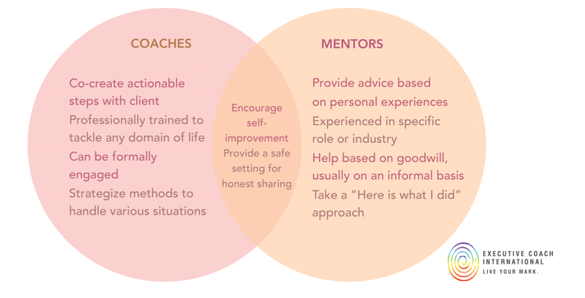
(ECI Coaching, 2022)

Appendix B

The spectrum of coaching and mentoring

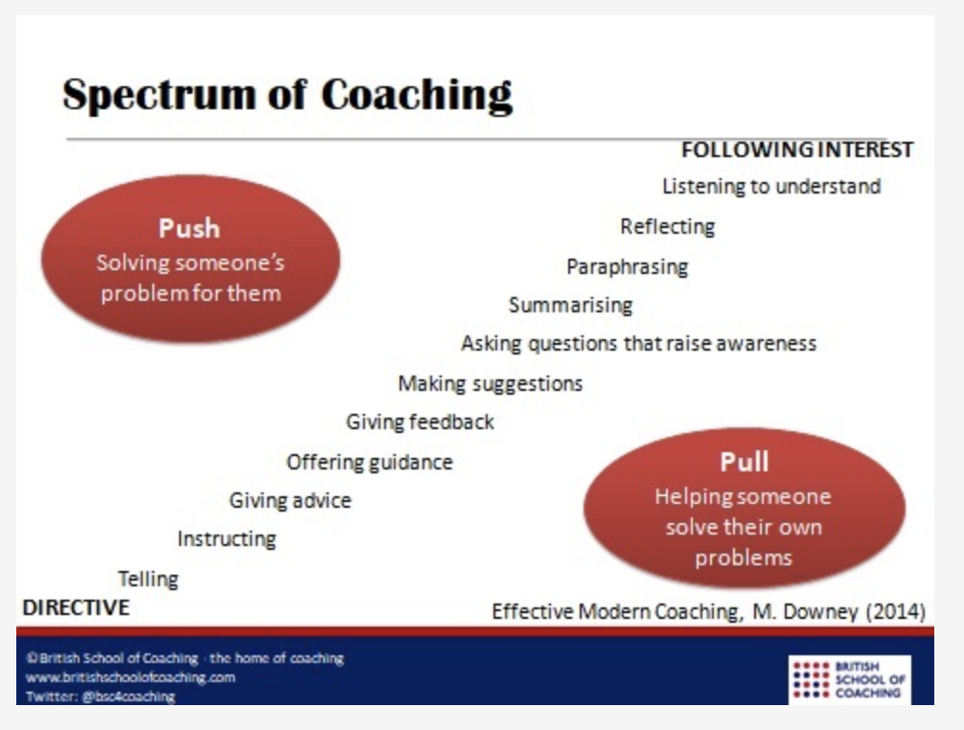

(Southern, 2018)

Appendix C

A survey of coachee’s opinion on the most desirable characteristics in a coach

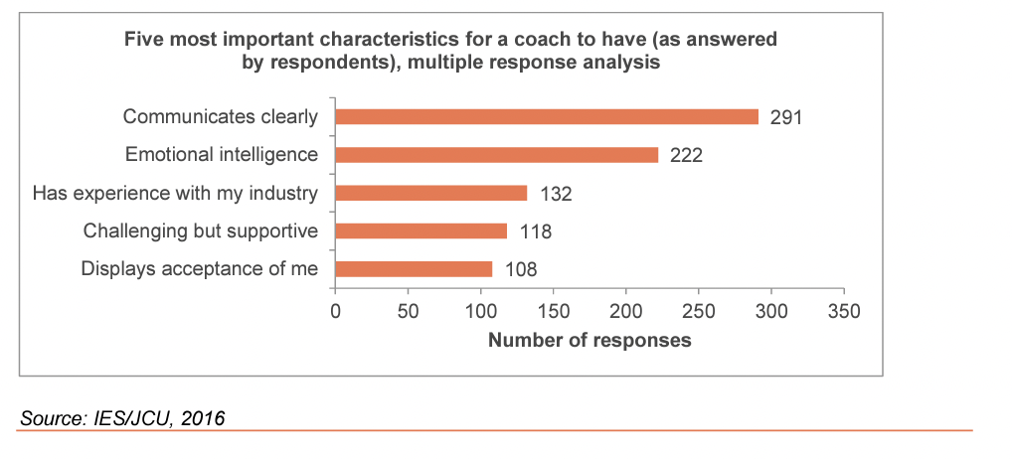
(Blackman & Hay, 2016)

Appendix D

Disney’s coaching model – ‘The Disney Strategy’
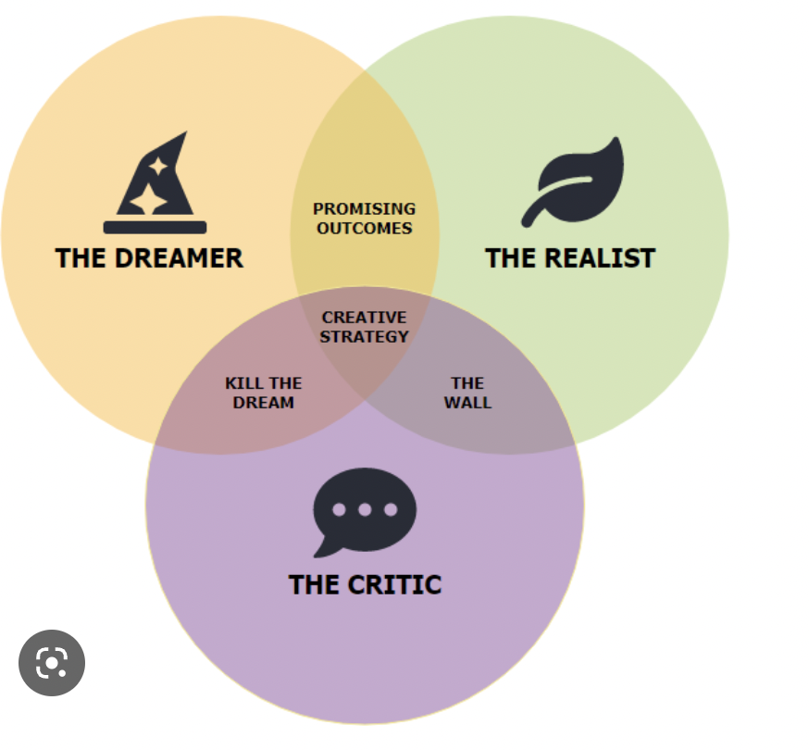
(Connolly, 2023)

