Comments for Clarity
Context:
You work in a small company that provides support services to business clients.
Your manager has asked you to review a short update that will be shared internally after a team meeting.
The update is meant to inform staff about recent issues and next steps.
Your task is not to fix the text yet, but to add comments where the meaning is unclear or where a reader might have questions.
Step 1: Open the Review Menu.
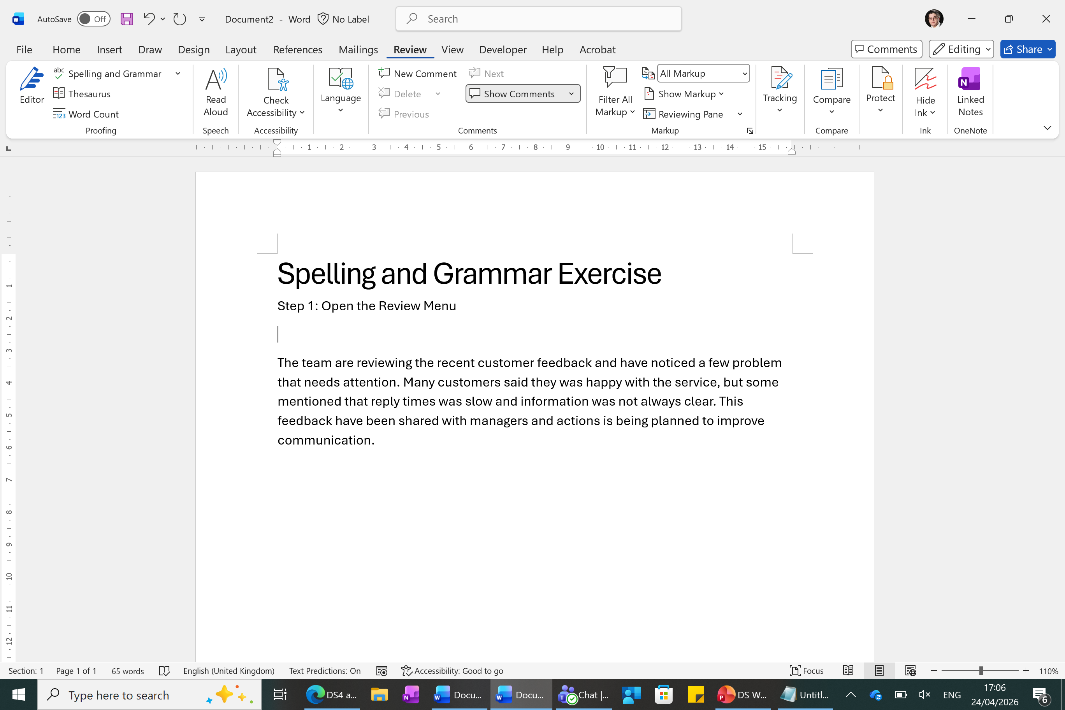
Step 2: Find the New Comment command
Step 3: Read the update draft text below. Add comments for clarity.
Following the recent review, the team agreed that changes were required to how certain tasks are managed. Some adjustments will be made in the short term, while other actions will depend on further agreement. This should help improve the process and reduce similar issues going forward.

Track Changes for Revising Text
Context updated:
After reviewing the draft, the manager added that recent problems included slow replies to customer emails, unclear responsibility when tasks were passed between teams, and customers feeling unsure about next steps. The update needs to reflect this more clearly.
Step 1: Open the Review Menu.
Step 2: Turn on Track Changes
Step 3: Read the updated draft text below. Use the new information to guide your edits. Make small, clear changes only using Track Changes. Track changes will appear in colour.
Following the recent review, the team agreed that changes were needed to improve customer response times, particularly when replying to emails, and to make internal task handover clearer. Some adjustments will be made in the short term, including clearer guidance for staff and faster updates for clients, while other actions will require further agreement between teams. These changes are intended to improve communication with customers and ensure expectations are clear.

