
Moynul Ali | 2205390 | ACAA5003

The Shard, from an Italian mind in the heart of London.
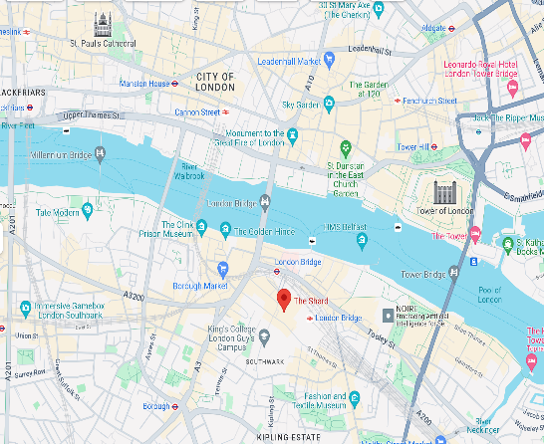
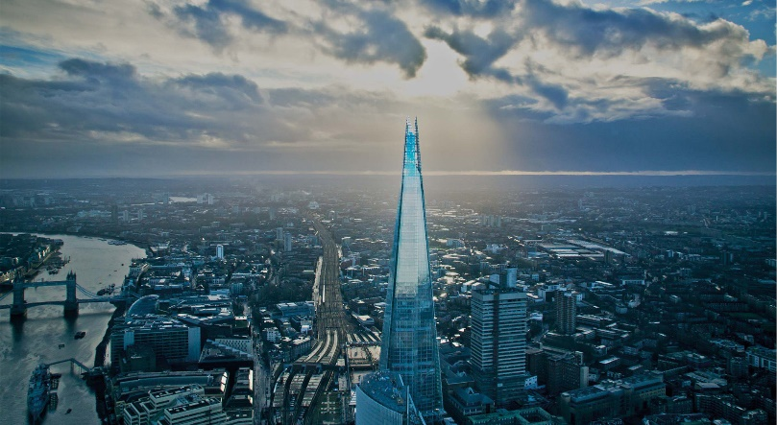
Figure 2: A map showing where is located The Shard ©GoogleMaps
Figure 1: Showing the urban context of the Shard. ©Michel Denance’

1.0 Introduction and history of The Shard site
In the centre of London, among the best that modern architecture creates, there is a tower that towers over all other buildings – The Shard, a modern architectonic wonder. It is a 310 meter tall and 72 storeys magnificent skyscraper surrounded by a glass façade. The Shard is the highest above the ground building in the United Kingdom as well as the Western Europe and has become one of the symbols of the city, changing its silhouette completely (The Shard: Inspiring change, 2022). The Shard’s location has a remarkable background. The building is situated in the London Bridge Quarter, where the old Southwark Towers used to be. These towers, built in the 1970s, had to be torn down due to being antique and challenging to manage. In 1998, the location was considered as an area with high development potential, and the London entrepreneur Irvine Sellar and his partners have decided to make “something marvellous out of the awful space between them”. The creators call it a vertical city that would have everything – retail and office space, a hotel and flats, restaurants, and a separate sightseeing platform (Unknown, 2012). However, the idea was new and was nowhere to be seen before – it was a pure utopia regarding modern architecture and urbanism. Irvine Sellar, who was the primary owner of Sellar Properties Ltd appointed Renzo Piano, an Italian architect, defined and convinced him to bring this vision to life with his mind and art.

1.1 The Shard in Modern Architecture
The significance of The Shard in the modern architecture in the world is enormous. In the first instance, the shard is the tallest building in the Western Europe. Indeed, its height makes it visible to the entire world, one can see it at far distance. This massive design and creation stand for human genius and technical advancements. Moreover, the shard is uniquely designed in modern architecture (Zeballos, 2012). The building exceeded mixed-use patterns, and for the first-time buildings can be used for more than one specific purpose. The structure is built in this unique manner, and it has hotels, multiple flats, and offices. The Shard installation transformed our understanding of cities development office builders’ interests of cities and how it can accommodate more than two uses (Piano, 2018). The shard has become part of our sociological system since it is a tourist destination of millions in London every year.
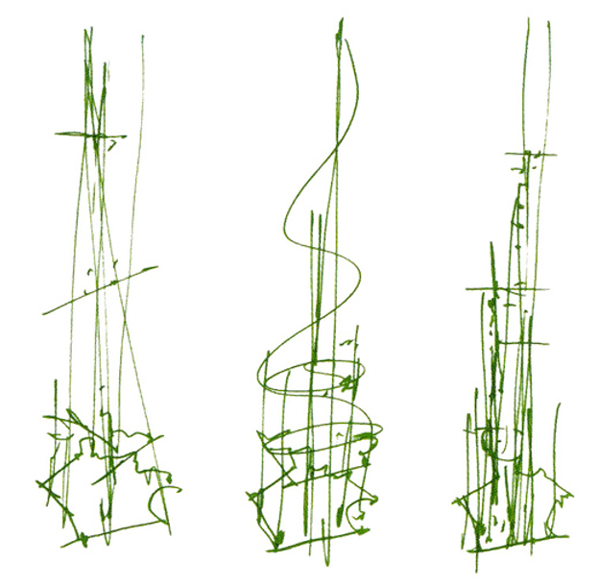
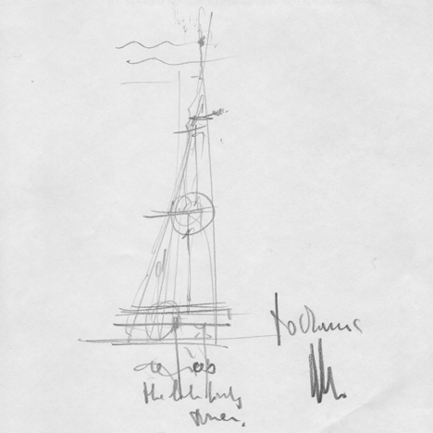
Figure 4: Initial sketches showing the form of the shapes ©Renzo Piano
Figure 3: Initial Sketches of Renzo’s Building ©Renzo Piano

1.2 The Shard's Exterior, Interior Design, and Material Selection
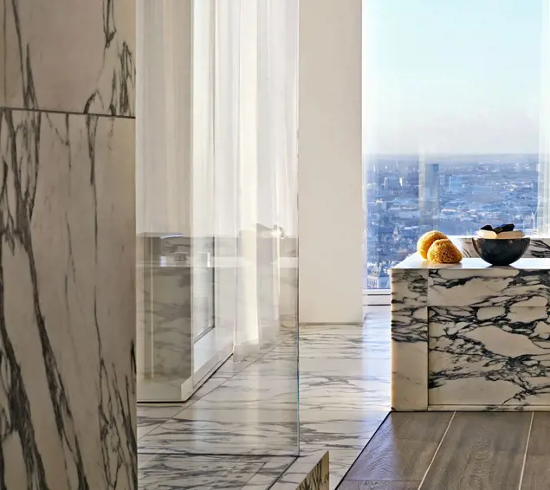
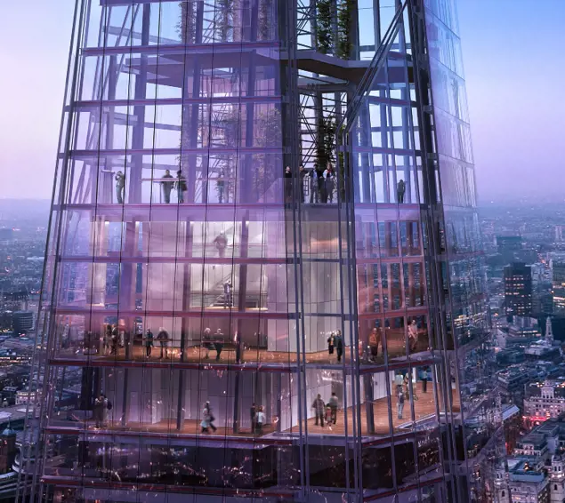
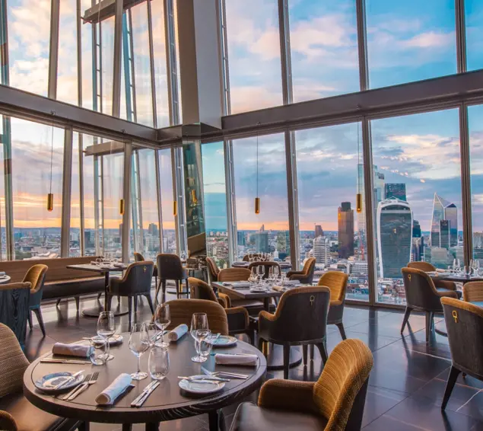
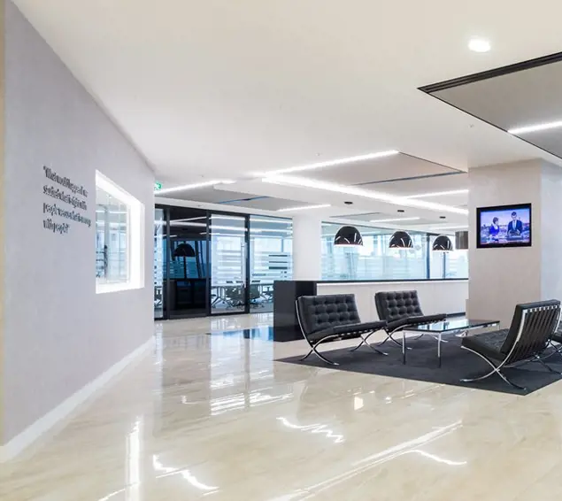
The exterior of The Shard is sleek and modern. The building is primarily composed of a glass façade. With at least 11,000 glass panels that is the same area as eight football pitches or two and a half Trafalgar Squares, that creates a reflective and ethereal exterior (Lisa, 2023). While the glass does serve a functional purpose; for example, ensuring the maximum amount of natural light and allowing visitors to view London from every angle, it is clearly designed to be aesthetically pleasing. The same can be said for The Shard’s interior design. As with any office building or mixed-use building, The Shard is designed to be functional and flexible to suit its various tenants’ needs (Fairs and Fairs, 2020). Unlike most office buildings throughout the world, The Shard was also designed to be luxurious. The materials used, including glass, steel, concrete, and natural stone, which are meticulously arranged to form a cohesive design. The tapering silhouette of the structure, clad in a façade of low-iron glass panels, is designed to reflect the sky, and create a magnificent visual experience (Douglas, 2011). One of the structure’s most remarkable features is its vantage point, which is fully accessible to the public and located on the 72nd floor. From this high up, visitors can enjoy vistas of visual favour and vast urban landscapes, which showcase London’s diverse architectural history. The lift itself is designed with an unimpeded view of the grainy walls up to the view, meaning that visitors can enjoy the same view as soon as they arrive at the top of the observation deck. There are a total of 36 lifts within the walls of the building, all travelling at speeds of up to 6 metres a second (The Sanbrooke Adventures, 2019).
Figure 5: showing the interior of a office ©Michel Denance’
Figure 6: Showing a picture of restaurants and bar ©Michel Denance’
Figure 7: Observing deck ©Michel Denance’
Figure 8: Luxurious flat with some marble decorations ©Michel Denance’

1.3 The Design Philosophy Behind The Shard
The Shard’s design philosophy is based upon the idea of innovation, sustainability, and a new dynamic urban landmark. The architect, Renzo Piano, aspired to create a building that was visually appealing while also being “green” (Zeballos, 2012). The Shard is inspired by the cathedral spires of London and the masts of tall ships drawn by the 18th century Venetian painter Canaletto, as well as the building emerging from the river Thames (Piano, 2018). Furthermore, the reason why a pyramid shape was chosen is because the architect believes it could give kind a gentle presence on the neighbourhood. The glass is cut away from it to make less obvious and to reflect the sky a white look rather than the scary dark of 99 percent of tall buildings. This is also manifested in contrast functions and activities with the city replicating a “vertical city”. This idea is demonstrated with The Shard’s various functionalities: retail spaces, entertainments, residential units, a hotel, offices, and observation galleries (The shard: Inspiring change, 2022). Piano’s design philosophy also includes the desire to integrate the structure with the urban setting. Renzo Piano’s philosophies of design is to make The Shard a place of interchange. It was also his desire for people to not only go there to visit but also to work, eat, sleep like a normal town centre that can be found in every UKs cities having restaurant, place to work, and a hotel but in this case the architect made a unicum (Piano, 2018). The Shard has to be most tightly closed windowed focus to maximise floor space and capture pale London light. The pyramid idea does stand up emotionally, for Piano. It seems at odds with his previous work, the style of it is not like The Shard, but also it does integrate in term of new materiality and style concept evolving of the architect. Piano’s concept for a building also reflected his desire to have it be sustainable and environmentally friendly. The Shard also provides so many other pro green, sustainable elements such as high-performance facade which is eco-friendly which would mean less heat gain and cooling is needed, community natural ventilation at opened areas around the external; enabled by its rotating floors slab which function eight sloping glass facades, the “shards”, opening vents in the gaps or “fractures”, which in return provides natural ventilation to garden area below; and not to mention uses of natural light sources to save energy and consumption (AAI, 2013). Another philosophical aspect is the reflection of the sky into the glass façade create a sense of fluidity and connection with outside world.

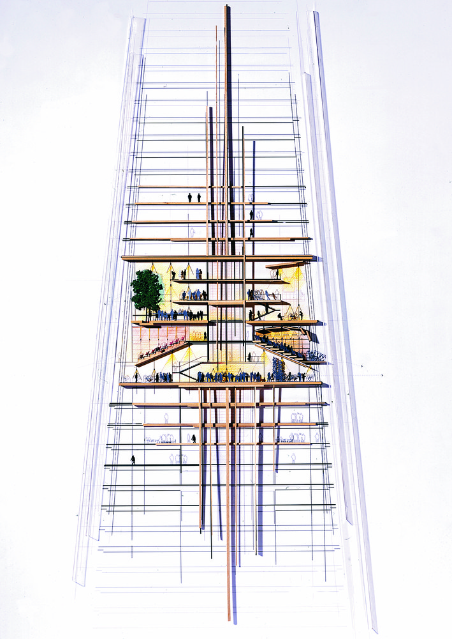
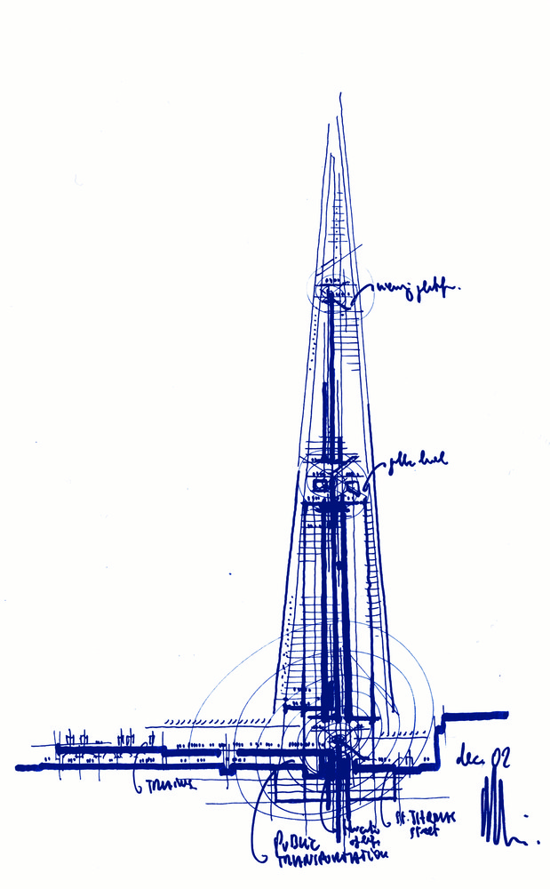
Figure 10: Section with the urban context ©Renzo Piano
Figure 9: Section of the Winter Garden ©Renzo Piano

1.4 The Functional Layout
The Shard has a functional and well-designed layout suitable for its purposes. The structure has defined zones that are exclusive to a particular use. For example, the building has multiple entrances depending on the access flows and the exact location the entry is intended. On the southern lower floor, there is an entrance for visitors into the skyscraper. The entrance will get you to the zero level, where you find the ticket office, the passes with metal detector, and the automatic lifts on which you will ride to the 33rd floor (Lamont, 2020). After that, one can take other lifts to the panoramic points at the 68th and 74th. One the first floor of the building, on the same level with the principal access to the train station of the London bridge, one finds the main entrance of the building, which enters into a vast courtyard covered in Carrara white marble (Lisa, 2023). Given its evident shape, the surface of the lower floors is wider and versatile, to then decrease gradually toward the upwards. This feature has allowed a better destination of the interior spaces that, in this sense, have seen the concentrating the location of commercial areas and offices to the lower axis; precisely from the 4th to the 28th floor, able to totally rely on the close relation with the London Bridge railway station that the homonymous subway stop of the Jubilee and Northern line. Above, between the 29th and 31st floor, al the center of the building, there are restaurants and bars, as well as various recreational areas, while from the 32nd to the 52nd floor there is the Shangri-La Hotel, with its 175 rooms. The 33rd floor is almost entirely service rooms and spaces that the visitors must go through to change lift when they want to climb or descend. From the 53rd to the 65th floor, the spaces, which have a declining area, are instead destined to 12 private residences of varying size which enjoy a panoramic view on four sides. From the 68th story is accessed the highest bar inside the structure from which, in addition to a protected view, it is possible to reach by a last staircase or through a second elevator the 72nd story, the last accessible to the public and containing the panoramic terrace partially open and intended to hold tourists. There is a second outdoor bar and a much larger space covered with artificial grass, where a 360-degree view of the city is taken from 244 meters of height, which makes it the highest observation platform in the United Kingdom. Above, from the 73rd to the 95th story is left only the metallic structure that constitutes the summit valley that, up to the 87th level, houses the technical and service rooms not accessible to the public and containing the control equipment of the lifts, different installations of the structure, antennas for radio and telecommunication, decorative projectors for the emission of light of colour, and the red light reserved for aviation safety (Federico, 2020). Also, the building is served by a network of escalators and lift systems which enhance ease movement of people from one floor to another (Parker, 2013).

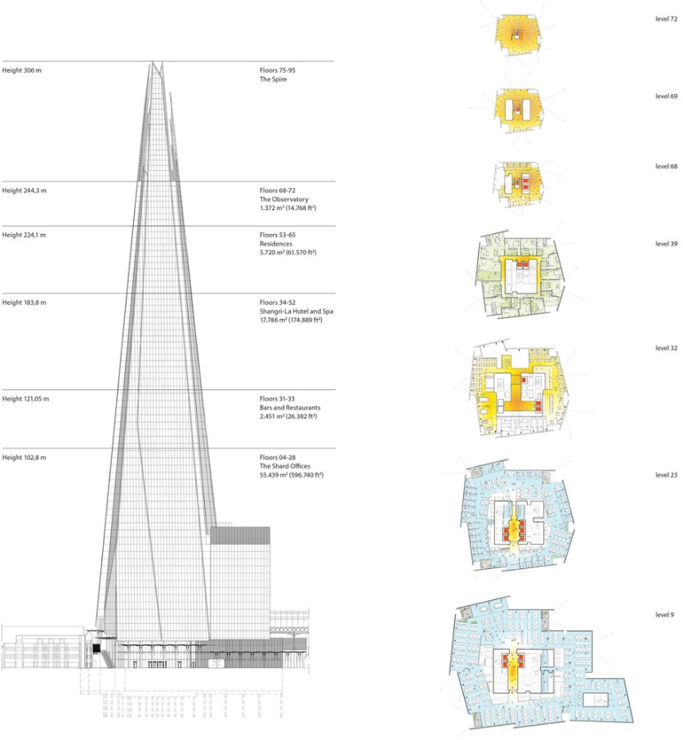
Figure 11: Elevation with floors layout and plans of some levels ©Renzo Piano Building Workshop

1.5 The Shard's Interaction with Its Urban Environment
The Shard’s design acknowledges that it is an urban structure and aims to strengthen the identity of the surrounding city. It has been designed vertically and smoothly, which allows it to stand out from the low-rise buildings around it and visually become a focal point (AAI, 2013). Finally, the Shard is built around one of the city’s most critical transportation nodes, an additional factor in enhancing its role as a connecting force in the urban grid. Conversely, the building projects blast at night when it is lit. The view becomes an eye catcher, the observation deck is blasting like it is heaven built. Furthermore, the public area filled with numerous facilities in The Shard’s design makes the place more than vibrant, and the building has been tuned by orientation, as the other building in a unique conical form in a city makes it more prominent, it could also mean that this shape or this type of building is not what the surrounding building ‘asked’ to be built?
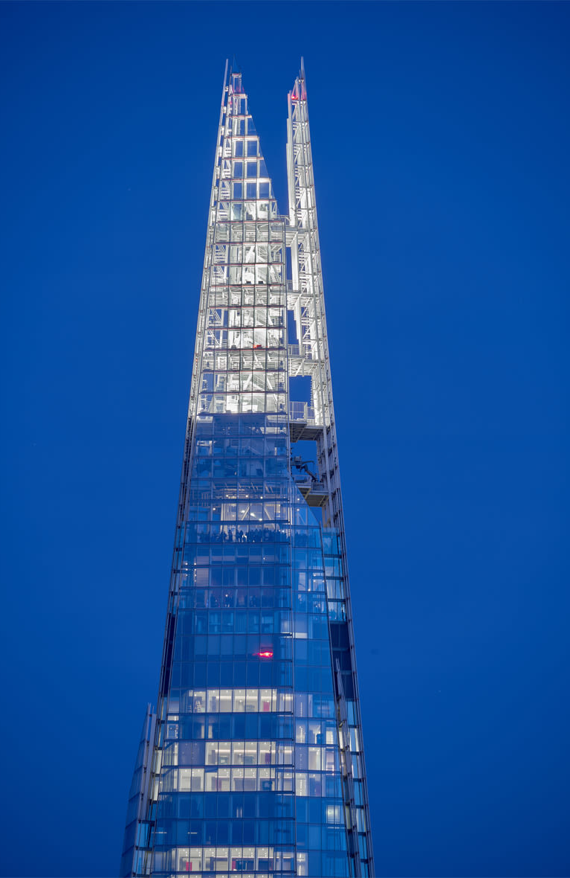
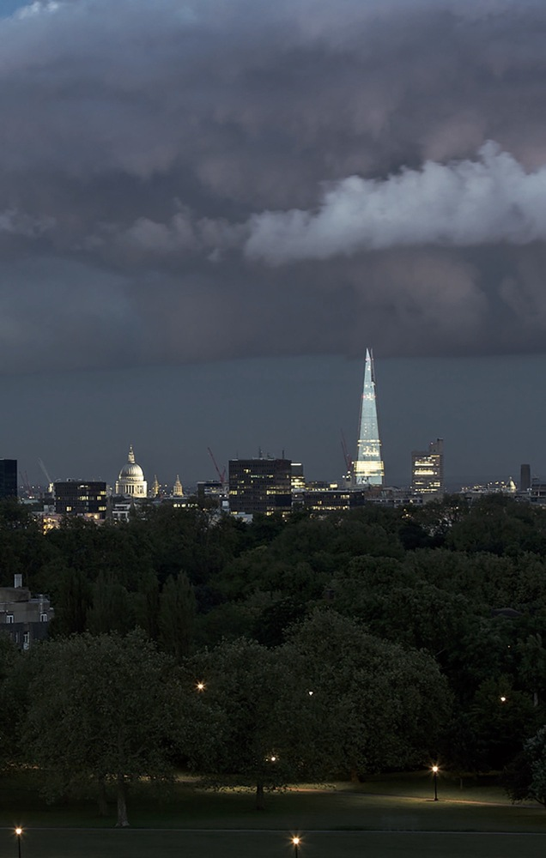
Figure 13: A close view of the “shards” at night time ©Michel Denance’
Figure 12: Urban context of the Shard night time, over taking most of the nearby buildings ©Michel Denance’

1.6 Public Perception of The Shard
The public’s reaction to The Shard has been mixed. For some, the building’s architecture is remarkable, and it makes a statement or an image in the London skyline. They liked its extraordinary architecture in the way it stands out in the city. For others, The Shard is an anomaly. They thought it looks so bad and that it disrupts the aesthetic that the area possesses, like stated earlier. English Heritage (EH) is the national heritage watchdog and opposed the proposal vehemently because it thinks that it will disrupt views of St Paul’s Cathedral and be visible inside the Curtain wall of the Tower of London (Davey, 2002). But in this case the Mayor of London of that time Mr Ken Livingstone, opposed to the EH merely and because of this little political help The Shard got its planning approval (Dewar, 2020).

1.7 Critical Analysis and Conclusion
It is undeniable that The Shard has many positive qualities, however, some downsides are also present. One of the arguments in favour of The Shard is its architectural aspect. The Shard’s design and the way it looks on the London skyline certainly capture attention. It has a unique, modern, and distinctive clear silhouette. The building uses a significant amount of glass, which creates a nice clean look and lets the natural light through. As a result, the building has a bright and friendly appearance. Furthermore, The Shard’s architectural advantages extend to the inside of the building. It is built to accommodate many people, and each one has its work or living space carefully planned. Not to mention another pro that the building brought more than 5,000 jobs (The Financial Times, 2024). One of the arguments against The Shard is how it changes the look of the area, bringing a lot of tourists also mean a huge number of congestions in Southwark area throughout of the day. Is this typology of building is needed in one of the worlds crowded capital city where it does generate lots of congestion? (Pope and Gitay, 2021). On the other hand, The Shard has been a very controversial project since the beginning. Some critics argued that its massive physical presence overshadows and downgrades the historical value of adjacent buildings around the area like the world-famous London Bridge and St. Paul’s Cathedral. Moreover, the construction of The Shard deprives many from particular points of view and sunlight in the vicinity. Piano’s architecture is essentially one of making and experiment, with the latter driven much more by technologies of making. The architecture of The Shard skyscraper resemblance can also be tracked to the 9th-century Great Mosque of Samarra in Iraq, the tallness of Gothics cathedral. In conclusion, The Shard has lot of in common with past but with a touch of modernity. Also, it cannot be denied that The Shard represents an architectural landmark in London. The structure, materials, and design all combine to make The Shard one of the significant symbols in architecture for now and for the generation who eventually going to take as a inspiration for their buildings. The functions of The Shard as a modern vertical city are a statement of the future of architectural meaning and city planning. Additionally, the criticism above of its architecture and its fitting into London’s space signifies rational architecture critique. It is seen that the building downgrades the beauty of its neighbouring building; on the other hand, it is viewed from a modernity and development side, that is, sky is the limit. The Shard is a symbol of how creative design can make beautiful structures with advanced foundation and design techniques. In addition, The Shard symbolizes the rapidly changing architectural designs in cities all over the world. Therefore, The Shard has undeniably made a mark in the building architecture world, and it is one of the iconic symbols found in London’s skyline together with other skyscrapers like the Gherkin, the Walkie-Talkie, and the Cheese Grater.

References –

AAI, A. (2013) The Shard - Adamson and AAI. Available at: https://www.adamson-associates.com/project/the-shard-at-london-bridge/. (Accessed: March 21, 2024).
Davey, P. (2002) London shard, The Architectural Review. London: Emap Limited, pp. 30–31.

Denance, M (2022) – Images of The Shard Available at: https://www.rpbw.com/
Dewar, D. (2020) Former mayor claims Shard as greatest achievement in office, Planning Resource. Available at: https://www.planningresource.co.uk/article/1410700/former-mayor-claims-shard-greatest-achievement-office.
Douglas, L. (2011) Vertical city [the Shard’s structure], Engineering & technology. Institution of Engineering and Technology (IET), pp. 66–68. Available at: https://doi.org/10.1049/et.2011.0910. (Accessed: March 17, 2024).
Fairs, M. and Fairs, M. (2020) 'Interview: Renzo Piano on the Shard,' Dezeen, 23 November. https://www.dezeen.com/2012/05/18/interview-renzo-piano-on-the-shard/.
Federico (2020) The Shard: La Scheggia di Londra - niiprogetti.it. https://www.niiprogetti.it/the-shard-la-scheggia-di-londra/ (Accessed: March 9, 2024).
Jacobs, E. and Hill, A. (2024) 'The Financial Times,' https://www.ft.com/, 18 March. https://ig.ft.com/sites/shard-skyscraper-secret-life/. (Accessed: March 21, 2024).
Lamont, T. (2020) 'Renzo Piano: my inspiration for the Shard,' The Guardian, 23 September. https://www.theguardian.com/artanddesign/2012/dec/30/shard-renzo-piano-inspiration (Accessed: March 16, 2024).
Lisa, L. (2023) The Shard. https://suzannelovellinc.com/blog/the-shard/ (Accessed: March 17, 2024).
Parker, J. (2013) Engineering The Shard, London. Available at: https://www.icevirtuallibrary.com/doi/10.1680/cien.12.00036. (Accessed: March 21, 2024).
Piano, R. (2018) Renzo Piano : the art of making buildings. London: Royal Academy Of Arts.

Pope, V. and Gitay, H. (2021) “Climate resilience and sustainability: Objectives and aspirations,” Climate Resilience and Sustainability, 1(2). doi:10.1002/cli2.9.
The Sanbrooke Adventures (2019) Visiting the view from the Shard in London. https://www.youtube.com/watch?v=EhIq1YhwLC0 (Accessed: March 19, 2024).
The Shard: Inspiring change (2022). Available at: https://www.the-shard.com/. (Accessed: March 21, 2024).
Unknown, (2012) 23 facts about the Shard. Available at: https://www.theguardian.com/uk/2012/jul/05/23-facts-about-the-shard. (Accessed: March 21, 2024).
Zeballos, C. (2012) MY ARCHITECTURAL MOLESKINE®: RENZO PIANO: THE SHARD TOWER AND LONDON'S REGENERATION. Available at: http://architecturalmoleskine.blogspot.com/2012/06/renzo-piano-shard-tower-and-londons.html. (Accessed: March 17, 2024).

